# Chapter 1 ECMiner™ Overview

**ECMiner™** is a **data analytics software** developed by **ECMiner Co., Ltd.** Most of the features of **ECMiner™** are pull-down menus easily accessible to non-technical users. Academics with expertise in analytical algorithms collaborated in the early days of the development **ECMiner™**. Subsequent versions are developed for providing a variety of data management, transforming, and model evaluation for real-world problems.

The key advantage of ECMiner™ is its ability to **handle large-scale data** across various formats such as databases, ECL (a proprietary data structure), TEXT, and EXCEL, making it capable of managing large volumes of data. It offers a **user-friendly interface** with convenient pull-and-drag modeling, allowing users to easily load data, conduct analytics, and modify models by adding or deleting nodes within the analytical schema. ECMiner™ is also **scalable**, with flexible model configurations that can be easily adjusted. Additionally, it provides **diverse analytical features**, including prediction, classification, clustering, Association Rules (AR), a powerful preprocessing node, a data browser, and data visualization through charting.

## 1.1 System Requirements

#### Recommended System Requirements

|  |  |
| --- | --- |
| CPU | Intel® Core i5 |
| Memory | 16 Gbytes |
| Operating System | Windows 10 Professional |
| Hard Disk space | 240MB + (data size x 2) |

#### System Minimum Requirements

|  |  |
| --- | --- |
| CPU | Intel® Core i5 |
| Memory | 16 Gbytes |
| Operating System | Windows 10 Professional |
| Hard Disk space | 240MB + (data size x 2) |
| NOTE The performance of the system may vary depending on the number of users and the size of the database; the database size generally increases by about 500 Mbytes per year, assuming 1 Gbyte for each  year (500 Mbytes x 2) of data entry is typical. | |

## 1.2 Install and Uninstall ECMiner™

#### Install

Download the setup file and run it to install the software. For a trial version, you can download the trial version from the ECMiner Co., Ltd. website at [www.ecminer.com](http://www.ecminer.com). Select Setup Language “English”. Select **[I accept the agreement(A)]** and then click **[Next(N)]**. Choose whether to Create a desktop shortcut or Create a Quick Launch shortcut. ‘Create a desktop shortcut’ is recommended. Installation is processing. It checks the necessary .NET framework version for ECMiner operation. If it is already installed, this display does not come up. The installation is complete. Clicking “ECMiner64.exe”, the program starts.

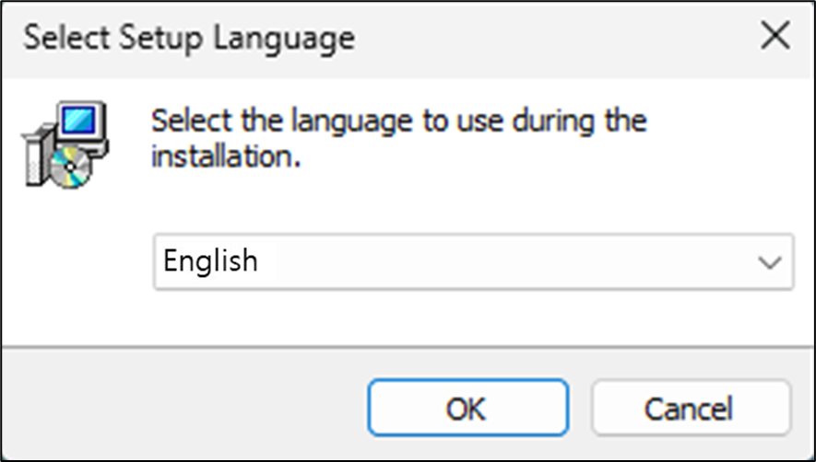

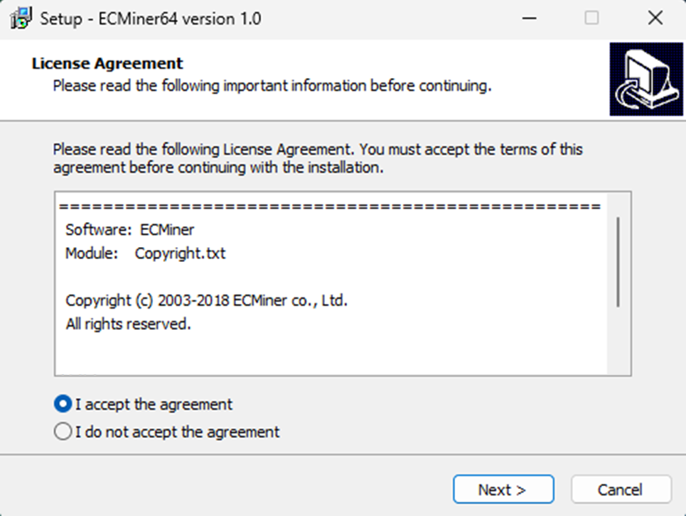

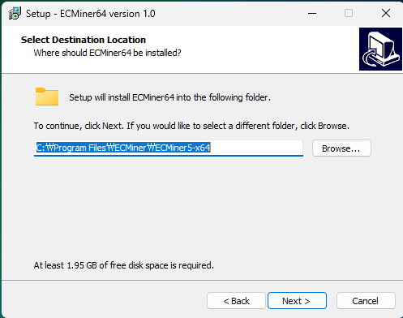

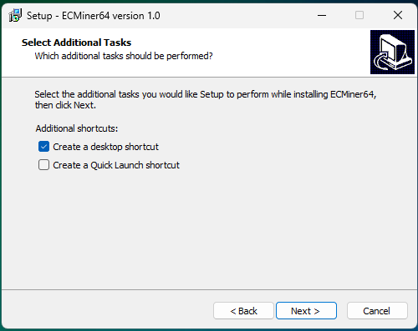

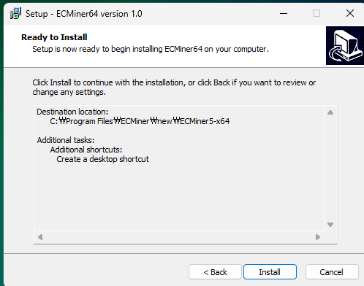

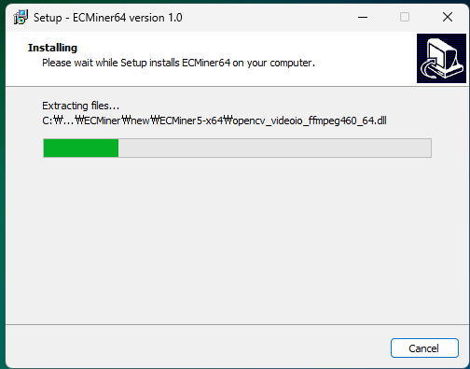

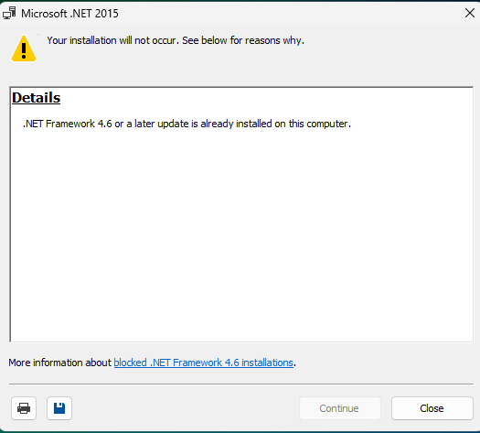

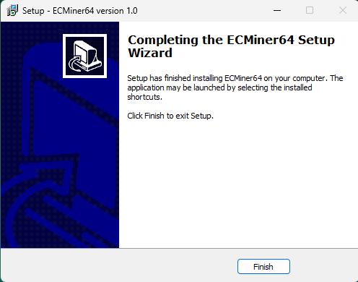  


#### Uninstall

In "Windows Settings (Control Panel)” \_ "Apps > Installed apps", select ECMiner™ and click the 'Uninstall' button

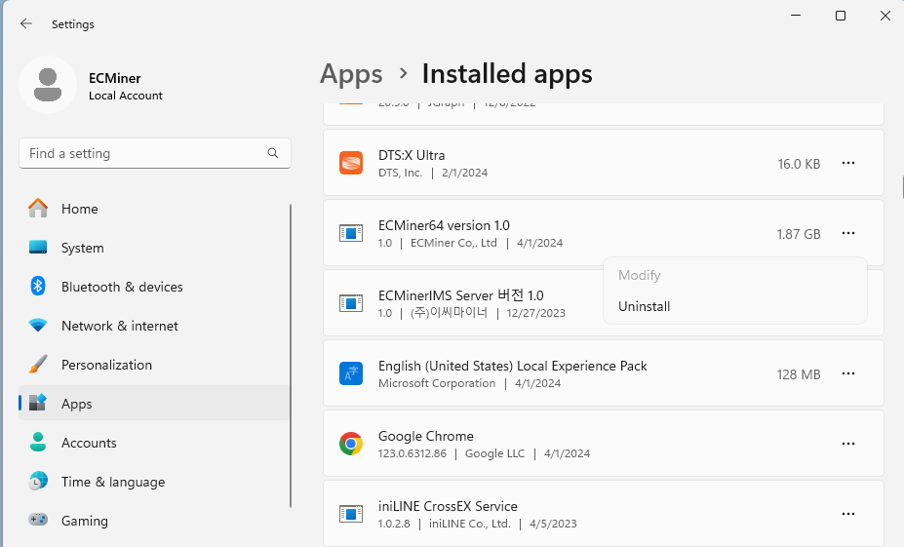

## 1.3 User Interface

ECMiner™ offers a user-friendly interface that allows users to create various analytical models depending on their purpose, and it provides a main window designed to support easy and efficient data mining.

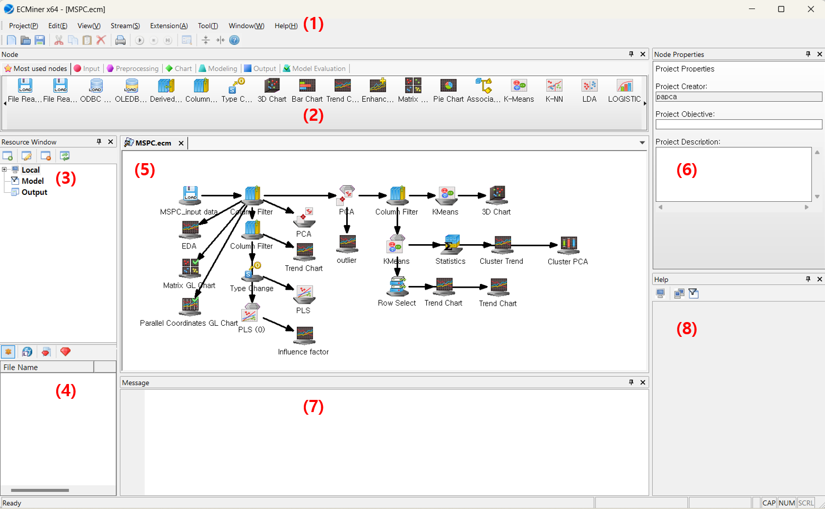

|  |  |  |  |
| --- | --- | --- | --- |
| Num. | Window name | | Description |
| (1) | **Menu** | | Creating/editing/saving project and files |
| (2) | **Node** | | Node for ‘Data’, ‘Chart’, “Modeling’, ‘Output’ and ‘Model Evaluation’. Data loading (data input), data manipulation to filter, derive variables and define indep. & dep. variables. |
| (3) | **Resource Window** | **Resource Menu** | The resource window displays with Local, Model, and Output.   * Local displays the list of the current working folder. * Model stores the current data analytical node. * Output stores the results of executing the current project. |
| (4) | **Resource List** | The window displays the contents of the selected menu (Local, Model, Output) in the Resource menu. |
| (5) | **Workspace** | | Working space for data handling and model configuration |
| (6) | **Node Property** | | Information for data and model specification and output at each node |
| (7) | **Message** | | Log messages about errors and process information |
| (8) | **Dynamic Help** | | The help for the node properties |

### 1.3.1 Menu

The menu is located at the top of the screen. It provides menus such as Project(P), Edit(E), View(V), Stream(S), Extension(A), Tool(T), Window(W), Help(H), and others. View(V) Determines the visibility of the Toolbar, various windows, and the Status bar. Using Extensions(E), You can perform Design of Experiments (DOE) and Probability Distribution analysis, etc. The ECMiner™ main window provides an intuitive interface organized into several functional menus, including Project, Edit, View, Stream, Extension, Window, Help, and Tool. The Project menu allows users to create, open, save, print, and manage projects. The Edit menu supports basic editing actions such as cut, copy, paste, and delete. The View menu controls the visibility of the toolbar, various windows, and the status bar. The Stream menu enables users to add nodes, execute or stop execution, repeat execution, and access folders. The Extension menu facilitates advanced functions like Design of Experiments (DOE) and Probability Distribution analysis. The Window menu manages the arrangement of open windows and projects. The Help menu provides user guidance and ECMiner information, while the Tool menu includes options for environment initialization and other tool-specific settings.

The Tool's Option in ECMiner™ allows users to set up user-specific preferences, including program settings such as date/time format, data reading configurations, and designated file extensions for the resource window; default database settings where users can specify drivers and login information for ODBC or OLE DB connections; and editing frequently used nodes by adding or deleting the most commonly used analytical components. The ECMiner™ Tool Bar provides quick access to essential functions including creating a new project (Ctrl + N), opening an existing project (Ctrl + O), saving work (Ctrl + S), and standard editing operations such as cut, copy, paste, and delete. It also includes commands for printing (Ctrl + P), executing processes (F5), stopping execution (Shift + F5), and partially executing tasks (Ctrl + F5). Additionally, users can access the Data Browser, User Help, and information about the application directly from the toolbar.

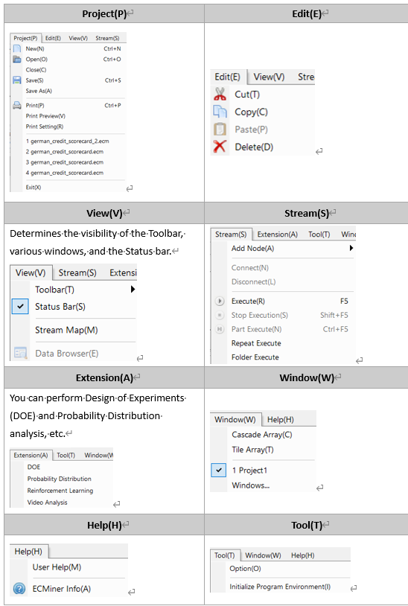

### 1.3.2 Node

Data loading, data preprocessing, modeling and evaluation. Select and drag each node in order in the working space, and connect to each in turn. The node window in ECMiner™ is classified into seven categories: Most Used Nodes, which include frequently used components that can be added or removed through the Tool’s options; Input Node, used to load data; Preprocessing Node, which provides data manipulation functions such as filtering, sorting, and splitting; Chart Node for data visualization; Modeling Node, which includes analytical techniques for prediction, classification, clustering, and AI algorithms; Output Node to save results to a database or file; and Model Evaluation Node for evaluating models, including ROC charts.

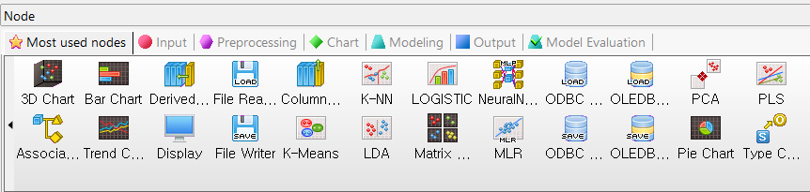

### 1.3.3 Project Window

Start with **Input Node**, **‘Column filter’** and **‘Type change’** to define indep. & dep. Variables, and select either ‘Continuous’ or ‘Discrete’. Connect to modeling node. The project window shows the flow map of the data analysis.

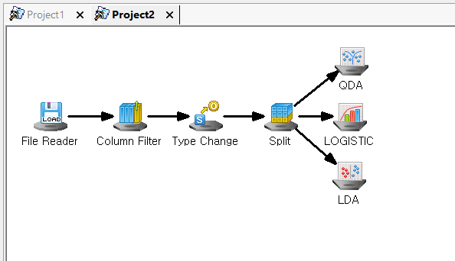

To activate a project in ECMiner™, users can press the tab at the top, and to close a project, they can either select "Project > Close" or click the “X” button. The node window displays various types of icons representing different tasks, including input, preprocessing, chart, modeling, output, model evaluation, and model nodes. In ECMiner™, various icons represent different node types used for data analysis workflows, including Input Nodes for loading data, Preprocessing Nodes for tasks like filtering and splitting, Chart Nodes for visualizations, Modeling Nodes for applying predictive or classification models, Output Nodes and Model Evaluation Nodes for saving results and assessing model performance, and additional Model Nodes. These visual indicators help users quickly identify the function of each node in the workspace. Right-clicking within the project window brings up a context menu that displays all available menu nodes. A newly added feature in the latest version, 'Insert Memo,' enables users to make notes while configuring nodes and projects.

### 1.3.4 Node Properties

In ECMiner™, the properties window displays information related to the project or the selected node. The project properties window allows users to add a memo describing the project's objective and details, while the Project Creator field automatically shows the Windows username of the logged-in user and cannot be edited. For data-related nodes, the properties window reveals variable names and data types, which can be modified. Users can exclude variables using the 'Column Filter' and define dependent and independent variables through the 'Type Change' function.

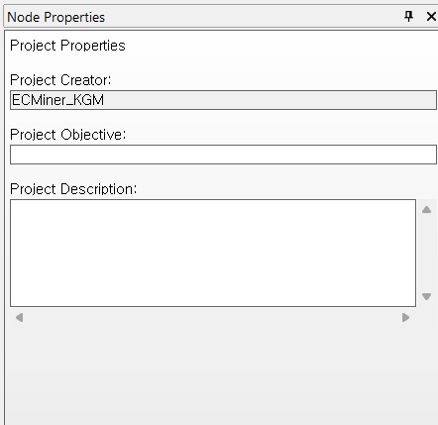

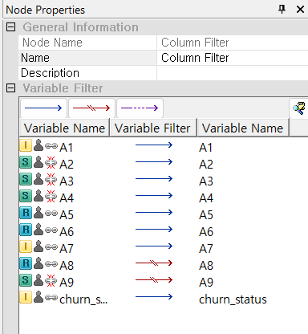

### 1.3.5 Resource Window

In ECMiner™, resources refer to all files associated with data, results, models, and project files. The Resource Menu includes three views: the Local menu displays a list of available files in the resource list; the Model menu shows model files generated from previous runs, allowing users to reuse or remove unneeded models; and the Output menu presents project output results in a sub-tree format, enabling users to select and compare results, save them, or view previously saved outputs. The Resource List dynamically updates based on the selected menu, and files can be filtered using toolbar buttons at the top.

### 1.3.6 Resource Window -Local

In ECMiner™, a task folder is a frequently used folder that users can manually add and rename (alias) for easier identification. Once added, the task folder and its contents appear in the Local menu of the resource window. Users can add, delete, or modify task folders using the toolbar by setting a path and assigning a folder name, and can modify folder details or delete a task folder through corresponding toolbar buttons, with deletion requiring confirmation. Reloading updates the file list, and new folders can be created by right-clicking on the task folder area in the Resource menu. Task folders are useful for project management by consolidating data, project, and model files into a single location, making it easier to understand and manage project contents, and they also support efficient data sharing across different user environments by maintaining consistent folder names. The Resource List reflects the files in the selected task folder, showing various file types such as data files (*.ecl), model files (*.gms), and ECMiner™ project files (\*.ecm), with the icons indicating file types defined in the ECMiner™ options. Files in the task folder can be directly used by dragging and dropping them into the workspace to create Input Nodes.

### 1.3.7 Resource Window -Model

After executing a model stream in ECMiner™, temporary models are automatically listed in the resource window, with each result named identically to the model node used in execution. These temporary model files represent the outcome of the stream and can be deleted from the list by pressing the designated delete button. To save a temporary model for future use, users can press the save button, assign a model name, and specify a path, resulting in a file named "given\_model name.gms" saved in the task folder. Alternatively, users can drag and drop the temporary model into a task folder or subfolder, which opens a dialog box where they can enter a model name and brief description. After confirming the save path and pressing OK, a global model file named "global model name.gms" is created in the selected folder.

### 1.3.8 Resource Window -Output

In ECMiner™, results generated after executing a stream appear in the list when the Output menu is selected. To review a generated output, users can double-click the output in the result list or select one or more outputs and press the corresponding button on the toolbar. The output toolbar offers several functions: opening selected outputs, deleting outputs from the list, closing all open output windows, arranging multiple open output windows in either grid or cascading formats, and similarly aligning multiple selected closed outputs upon opening. Additionally, users can save outputs in the \*.ept format to a specified path or load previously saved output files, which are then listed under the "Other" category. Notably, outputs from the Display Node are treated as data and must be saved as data files in the \*.ecl format using the save function within the Display Node screen, rather than through the output toolbar.

### 1.3.9 Message Window

The Message window displays execution information and errors related nodes during stream execution. In ECMiner™, message types are categorized into five color-coded groups: black for general messages, blue for emphasized messages, pink for general error messages, red for critical error messages, and green (noted as "greed" in the image) for note messages.

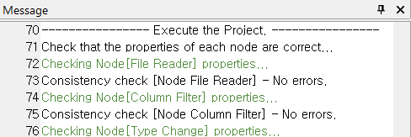

### 1.3.10 Dynamic Help

In ECMiner™, when editing a node’s properties, a brief description of the selected property appears in the Dynamic Help section. The toolbar offers functions such as Toggle Help, which navigates to the help content for the selected node and can be pressed again to return to the Dynamic Help, and Index Search, which opens the help window to search for a specific topic.

### 1.3.11 Window Control

In ECMiner™, all control windows can be repositioned and resized to suit user preferences. To reposition a window, users left-click and hold the title of the control window, then drag it toward the desired location. Central four-direction icons represent positions within another control window, while surrounding four-direction icons represent positions relative to the entire program window. A blue rectangle will indicate the target location, and releasing the mouse button finalizes the move. If released outside these icons, the window opens independently. The workspace position itself cannot be changed. To resize a control window, users can left-click and drag its border when the mouse pointer changes to the resize shape. Closing a control window can be done by pressing the “X” button or selecting "View > Toolbar" from the main menu, and reopening it involves selecting the same menu option. Pressing the “pin” button enables auto-hide, minimizing the control window to the right side of the program; hovering over the tab reveals it temporarily.

## 1.4 Mouse usage

In ECMiner™, a left-click is used to access function menus, a right-click opens support menus, and a double left-click displays results. Nodes can be added to the stream in the Project window through drag and drop. Clicking the left mouse button on a node in the Project window displays its properties, while right-clicking on a node brings up options to connect, disconnect, or delete it. Double-clicking a result icon opens detailed result information in the Output window.

## 1.5 Shortcut key

ECMiner™ supports a comprehensive set of keyboard shortcuts to facilitate efficient workflow across its interface. Basic file operations use shortcuts like Ctrl + N to create a new project, Ctrl + O to open, Ctrl + S to save, and Ctrl + P to print. Execution commands include F5 to execute, Shift + F5 to stop execution, and Ctrl + F5 for partial execution. Menu navigation includes Alt + P for Project with subcommands like Alt + P, N for New or Alt + P, S for Save, Alt + E for Edit functions like Cut (Alt + E, T), Copy (Alt + E, C), Paste (Alt + E, P), and Delete (Alt + E, D), and Alt + V for View controls. Toolbar and window controls are accessible with combinations like Alt + V, T for Toolbar, Alt + V, T, H for Dynamic Help, and Alt + W, C or Alt + W, T for window alignment settings. Stream-related tasks are handled using Alt + S with further actions such as Add Node (Alt + S, A), Connect (Alt + S, N), or Disconnect (Alt + S, L). Tool settings are accessed using Alt + T, with specific actions like Option (Alt + T, O) or Initialize Program Environment (Alt + T, I). Finally, Help is opened with Alt + H, and ECMiner™ Info is available with Alt + H, A. These shortcuts enhance navigation and operational efficiency throughout the ECMiner™ environment.

|  |  |  |  |
| --- | --- | --- | --- |
| Shortcut | function | Shortcut | function |
| Ctrl + N | New | Alt + V, T | Toolbar |
| Ctrl + O | Open | Alt + V, T, S | Standard Toolbar |
| Ctrl + S | Save | Alt + V, T, N | Node |
| Ctrl + P | Print | Alt + V, T, P | Node Properties |
| F5 | Execute | Alt + V, T, E | Resource Window |
| Shift + F5 | Stop Execution | Alt + V, T, H | Dynamic Help |
| Ctrl + F5 | Part Execute | Alt + V, S | Status Bar |
| Alt + P | Project | Alt + V, E | Data Browser |
| Alt + P, N | New | Alt + S | Stream |
| Alt + P, O | Open | Alt + S, A | Add Node |
| Alt + P, C | Close | Alt + S, C | Connect Upon Creating Node |
| Alt + P, S | Save | Alt + S, N | Connect |
| Alt + P, A | Save As | Alt + S, L | Disconnect |
| Alt + P, P | Print | Alt + S, R | Execute |
| Alt + P, V | Print Preview | Alt + S, S | Stop Execution |
| Alt + P, R | Print Setting | Alt + S, N | Part Execute |
| Alt + P, X | Exit | Alt + T | Tool |
| Alt + E | Edit | Alt + T, O | Option |
| Alt + E, T | Cut | Alt + T, I | Initialize Program Environment |
| Alt + E, C | Copy | Alt + W | Window |
| Alt + E, P | Paste | Alt + W, C | Cascade Alignment |
| Alt + E, D | Delete | Alt + W, T | Grid Alignment |
| Alt + V | View | Alt + H | Help |
| Alt + V, T, M | Message | Alt + H, A | ECMiner™ Info |

## 1.6 Program Settings

In ECMiner™, selecting [Tool (T)] – [Option (O)] from the menu opens the Program Settings dialog, which is organized into menu tabs, each displaying an editing window for the selected option. These settings include General Program Settings for configuring defaults such as date/time format, data reading preferences, file extensions for the resource window, and overall program appearance; Default Database Setting for specifying the default driver and login information for ODBC or OLE DB; and Edit Frequently Used Nodes, which allows users to add or delete commonly used nodes. The dialog layout enables users to customize settings selectively according to their needs.

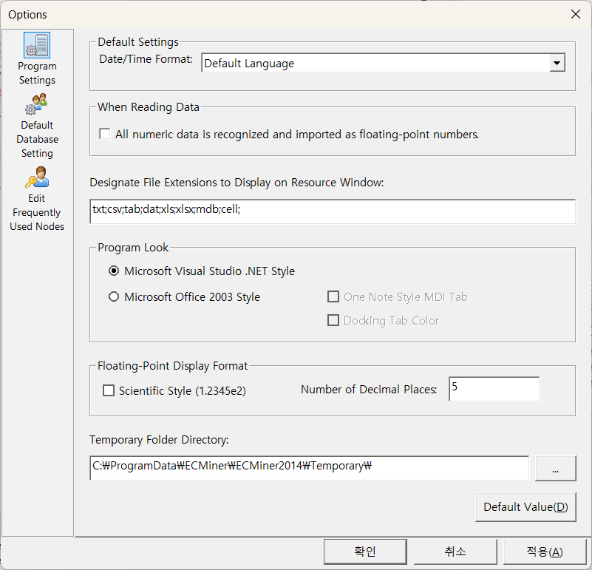

### 1.6.1 Program Settings

When you open the Program Settings window in ECMiner™ via Tool (T) – Option (O), the options are presented in a top-to-bottom order that reflects a logical setup sequence for user environment preferences. The first setting is **Default Settings**, where users can select the **Date/Time Format** based on language or region, which forms the basis for data interpretation and formatting across the application. Next, under **When Reading Data**, users can choose to treat all numeric data as floating-point values, influencing how data is imported and processed. The third section, **Designate File Extensions to Display on Resource Window**, allows users to specify which file types (e.g., \*.ecm, \*.ecl, \*.gms) are visible in the resource panel, aiding file organization and access. Fourth, **Program Look** provides options for customizing the interface style (e.g., Microsoft Visual Studio .NET or Office 2003), allowing users to choose a visual layout that is most comfortable or familiar. Finally, the **Floating-Point Display Format** lets users define how floating-point numbers are shown (e.g., scientific notation) and the number of decimal places, affecting both on-screen displays and reports. This top-down arrangement guides users from general preferences toward more specific data presentation settings.

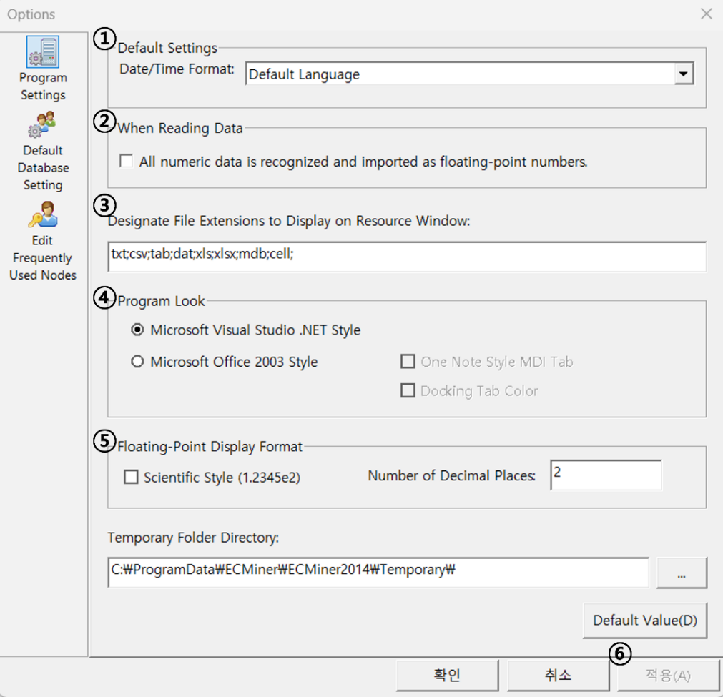

### 1.6.2 Default Database Setting

Selecting **Default Database Setting** from **Tool (T) – Option (O)** opens an options window where users can configure default connection settings for supported databases in ECMiner™, specifically **OLE DB** and **ODBC**. This setup allows users to enter the base driver and login credentials, which will then be used as the default when working with database-related nodes in the Project window, streamlining the process. The configuration is divided into three sections: the first for **OLE DB**, where users can specify the driver, server information, username, and password; the second for **ODBC**, where similar credentials are provided for ODBC driver-based connections; and the third for **Oracle**, which requires the server address and login details. An additional checkbox option enables automatic insertion of these default values whenever database-related nodes are added, ensuring consistency and saving time. This order of settings—from OLE DB to ODBC and Oracle—reflects the flexibility to support multiple database systems and ensures that frequently used credentials are centrally managed.

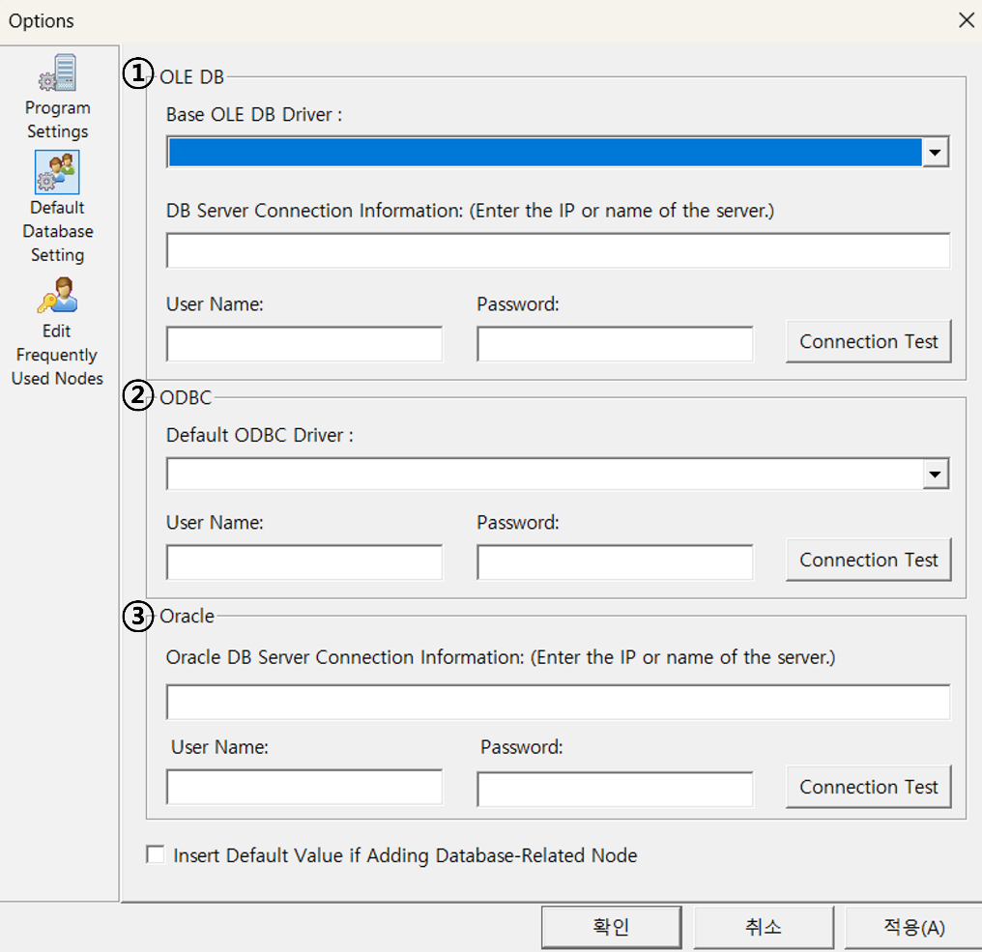

### 1.6.3 Edit Frequently Used Nodes

Selecting **Edit Frequently Used Nodes (Favorites)** from **Tool (T) – Option (O)** opens an options window where users can manage the list of nodes shown under **Most used nodes** in the Node window. In this interface, the upper section (①) displays a list of all nodes supported by ECMiner™, including their names and brief descriptions. Users can add a node to the Most used nodes list by selecting it in section ① and clicking the add button (②). The lower section (④) shows the current list of nodes already added to Most used nodes. To remove a node from this list, users select it in section ④ and press the delete button (③). This setup allows users to quickly access frequently used nodes during analysis by customizing the list according to their preferences. The function buttons used in the **Edit Frequently Used Nodes** window enable users to manage their Most Used Nodes list. The first button, represented by a green plus icon, adds the selected node to the Most Used Nodes list. The second button, shown as a green minus icon, deletes the selected node from the Most Used Nodes list. These buttons provide a quick and intuitive way to customize frequently accessed nodes for efficient workflow.

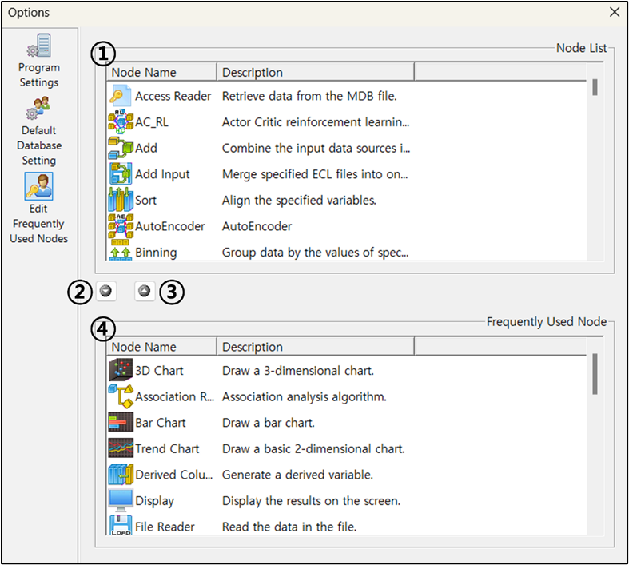

# Chapter 2 Stream

ECMiner™ enables users to easily and conveniently build analytical models by connecting nodes into a stream. A stream is a sequence of connected nodes that forms a workflow, starting from data loading and continuing through preprocessing, analysis, and output. This visual representation simplifies data analytics and allows for flexible modifications even during execution. For example, a typical stream for performing Principal Component Analysis (PCA) would include loading the input data such as production data, preprocessing steps like handling missing values and type conversion, applying PCA, and finally using control charts to monitor the principal components.

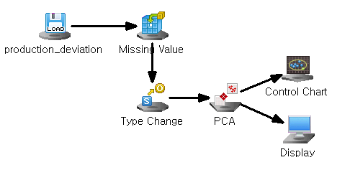

## 2.1 Stream Configuration

In ECMiner™, a stream is constructed by selecting and connecting nodes that represent each step of the data analysis process. Users begin by pulling down nodes such as Input, Preprocessing, Chart, Modeling, and Output into the project window. Each node can be edited by double-clicking it to modify its properties. Nodes are connected by right-clicking and choosing ‘Connect,’ then dragging the arrow to the target node, or alternatively by pressing and holding the middle mouse button and releasing it over the desired node. Nodes can also be added or removed from the project as needed, with deletion performed by selecting a node and clicking “Delete.” To disconnect nodes, users can right-click and select “Disconnect.” When configuring a stream, it’s important to consider that most nodes accept one input and can have multiple outputs, while certain nodes like Merge, Add, and Column Combiner accept multiple inputs. Chart and Output nodes are output-only and cannot be used as inputs. ECMiner™ visually represents these configurations, making it easier for users to understand and manage the analytical workflow.

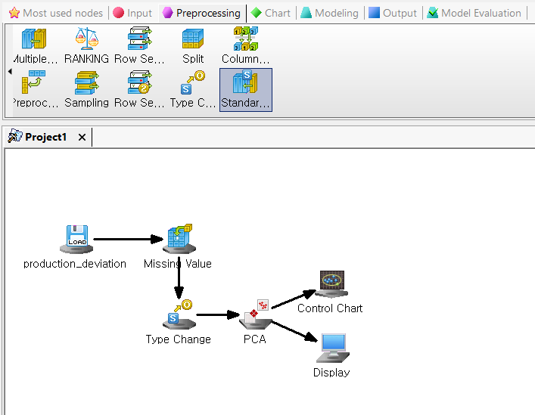

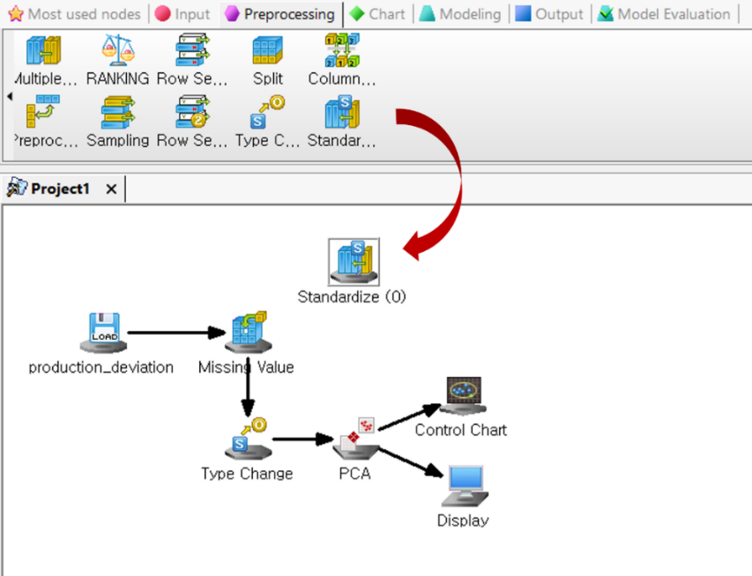

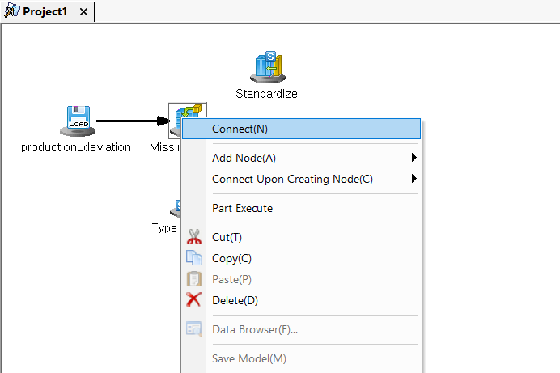

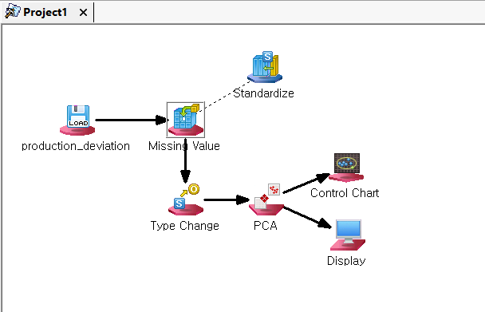

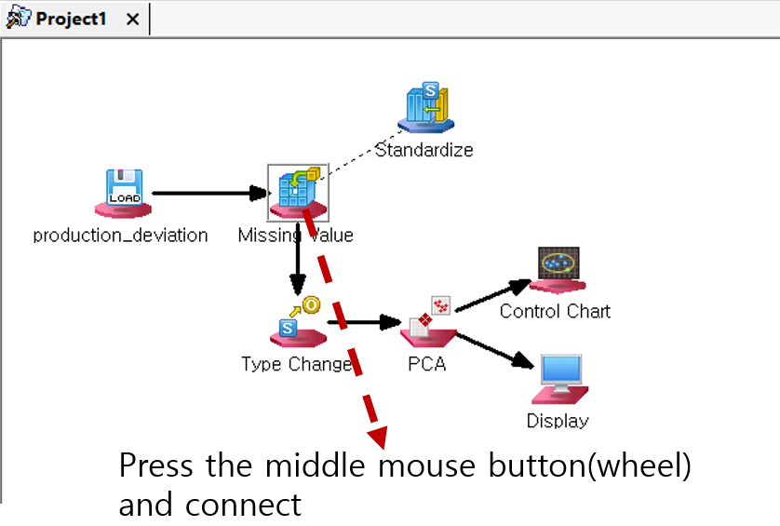

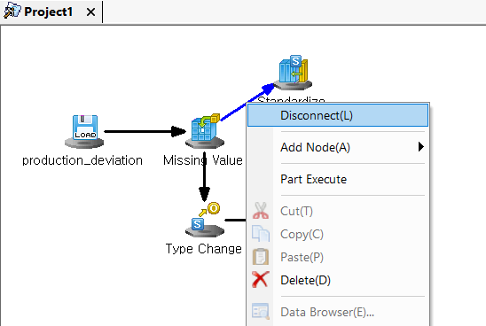

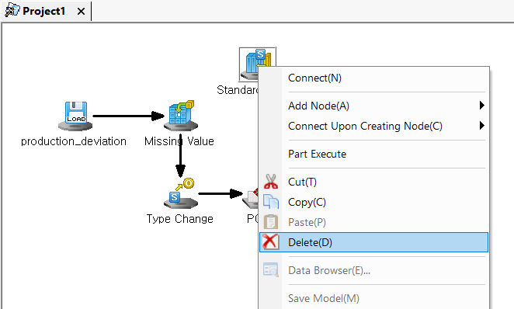

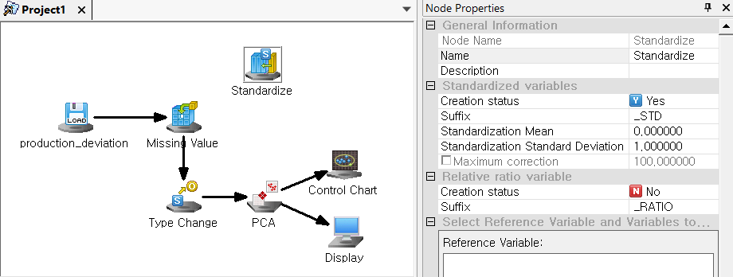

In ECMiner™, nodes are visually classified by both their type and their connection status, which helps users understand the workflow structure within a stream. Each node type—Input, Preprocessing, Chart, Modeling, Output, and Model—has a distinct icon, and each can exist in one of three states: **Origin**, **Connectable**, or **Unconnectable**. The **Origin** icons represent nodes that have not yet been connected. **Connectable** icons indicate that a node is ready to be linked to another node in the stream. **Unconnectable** icons signify nodes that either cannot be connected further or do not meet the criteria for additional connections based on stream rules. This visual system supports error-free node configuration and simplifies stream building by clearly indicating where and how nodes can be linked within the analytical workflow.

## 2.2 Stream Configuration Rules

In ECMiner™, streams are constructed by sequentially connecting nodes such as input, preprocessing, modeling, and output nodes, with flexibility to add or remove nodes as needed. For example, users can import data, apply transformations, and save the results using a configuration like "File Reader → Derived Column → File Writer." When multiple streams exist within the Project window, ECMiner™ automatically determines their execution order, processing them sequentially from top to bottom. A stream will not execute if any node's property is incorrectly specified, in which case the user must correct the node settings based on the error message. Additionally, nodes within a stream follow a one-to-many connection structure, where each node can receive data from one source but can output data to multiple downstream nodes.

## 2.3 Stream Execution

To run a stream in ECMiner™, you can select **[Stream(S)] > [Execute]** from the main menu or press **F5** to execute all streams sequentially, such as streams (1) through (4). If you want to run only a portion of a stream, use **[Stream(S)] > [Part Execute]**. For example, to run only a specific node like node 1 (Split node), select 'Part Execute'; to continue with another node, such as node 2 (RandomForests node), simply select 'Part Execute' again. This allows for flexible and step-by-step execution of individual components within a stream.

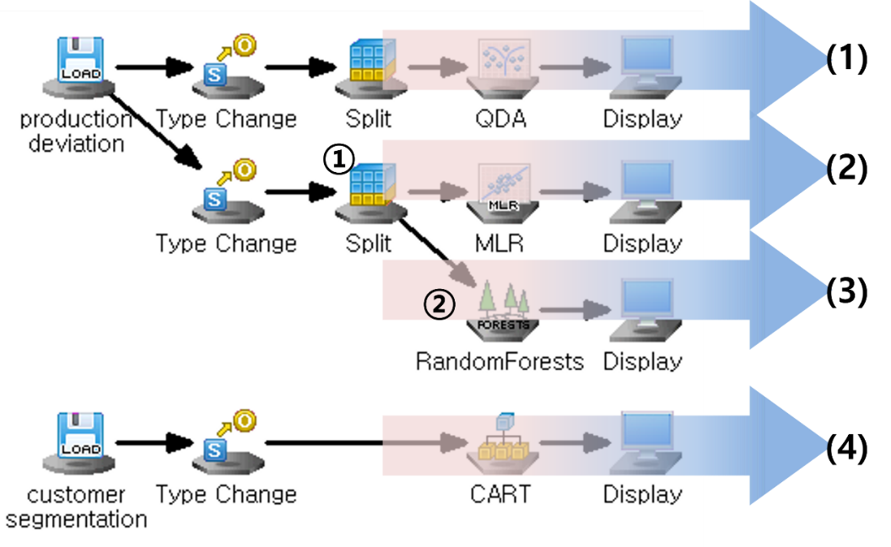

The **Folder Execute** feature in ECMiner™ allows users to apply the same project configuration to multiple files within a designated folder, enabling efficient batch processing. To use this function, first create the desired project in the workspace, then go to **[Menu] > [Stream(S)] > [Folder Execute]**. This opens the Folder Execute window, where you configure the execution settings through several steps: 1) **Input Folder**: Specify the folder path that contains the target files, either by typing it directly or using the search button to browse. 2) **Filter Option - File Extension**: Input the file extension (e.g., \*.csv, \*.ecl) to filter which files in the folder to process. 3) **Filter Option - File Name**: Enter a common file name pattern to further narrow down the files used in execution. 4) **Input/Output Settings**: Define which nodes in the project serve as the input and output nodes by clicking the **Input Node Setting** and **Output Node Setting** buttons. You can also remove output node assignments using the **Output Node Delete** button. 5) **Folder Execution Option**: This optional setting allows you to configure logging for folder execution. Logs are saved by default to the ECMiner™ installation directory and can be rotated daily, weekly, or monthly. Users can also define log file naming conventions (e.g., timestamp-based), set minimum logging levels, specify local time as the reference for timestamps, and adjust the output format, which by default follows: [%Y-%m-%d %H:%M:%S.%i][%s][%t]. These settings allow users to execute their project repeatedly across multiple files while monitoring and managing execution through detailed logs.

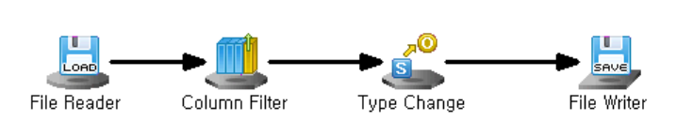

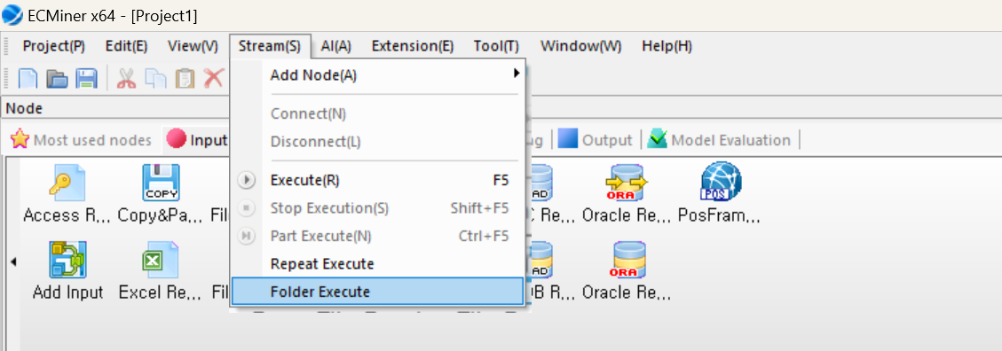

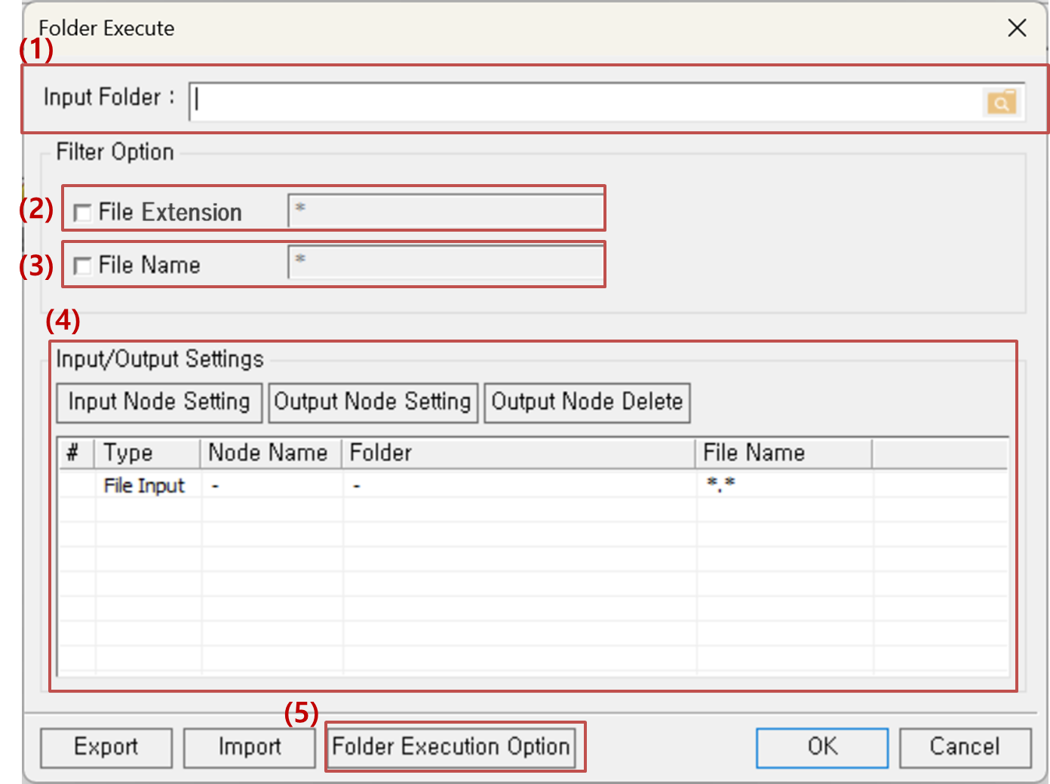

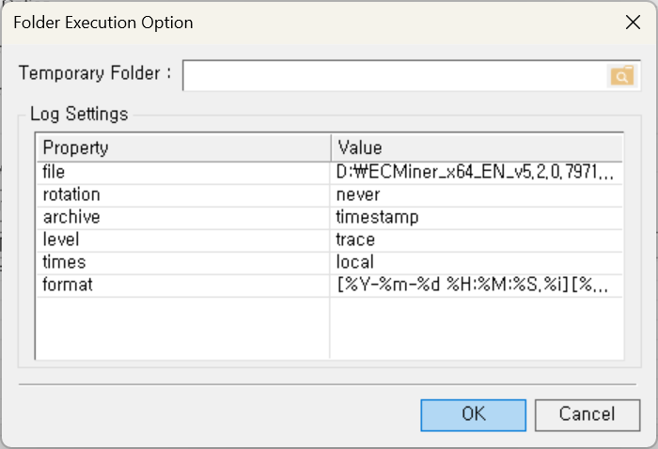

# Chapter 3 Node Description

|  |  |  |
| --- | --- | --- |
| Node Classification | Description | Supported Nodes |
| Input | Load data | ODBC Reader, OLEDB Reader, Access Reader, Excel Reader, Oracle Reader, Oracle Read/Write, File Reader, File Reader2, File Read/Write, Add Input, Copy&Paste Input, Hancell Reader, Image Reader |
| Preprocessing | Define data type, transform, and format.  Filtering and subsetting data | Missing Value, Group By, Multiple Derived Column, Column Reorder, Merge, Standardize, Split, Row Select, Column Combiner, Sort, Fill, Add, Pivot, Derived Column, Sampling, Column Filter, Type Change, COUNTER, RANKING, Group Statistics, Row Select2, Binning |
| Chart | Data visualization with various chart options | 3D Chart, Bar Chart, Contour Chart, Control Chart, Histogram, Matrix Chart, Pareto Chart, Pie Chart, Trend Chart, Statistic Chart, SPC Chart, Box plot, MSPC Chart, Process Contribution Chart, Word Cloud, Radar Chart Matrix, GL Chart, Multi Chart, Correlation Chart, Parallel Coordinates GL Chart, Heat Map GL |
| Modeling | All algorithm nodes for statistical analysis and AI. As a result, Model Node is generated. ECMiner™ supports a total of 41 algorithms. | Adaptive NN, Association Rule, Autoencoder, CART, CCA, CNN, DeepNN, ElmanNet, Factor Analysis, Hierarchical, K-Means, K-NN, LDA, LOF, Logistic, MLR, NaiveBayes, PCA, PCR, PLS, QDA, RBF, RBF DDA, Regularized Regression, RF, RL (AC\_RL, DDPG\_RL, DQN\_RL, PG\_RL, SAC\_RL, TD3\_RL), ScoreCard, SimpleRNN, SOM, SVM, SVR, t-SNE |
| Output | Results. Save as a file or display on the screen | ODBC Writer, OLEDB Writer, Result Pivoting, Oracle DB Writer, Statistics, File Writer, Display, Separated Save |
| Model Evaluation | Compare model performance | Model Evaluation, ROC Chart, Profit Chart |

All nodes in ECMiner™ have properties essential for performing their tasks. Properties are fundamentally composed of a property name and a property value. For example, the File Reader Node requires a property that specifies which file to read, represented by the property name (File Path) and the property value. Each node contains common properties grouped under categories such as General Info., which includes the node’s Name and a Description to provide brief comments about the node’s function. Variable-related properties include designating Variable Type as independent or dependent, Data Type I as integer or real number data, and Data Type II as discrete or continuous data. Variable information—such as names and types—can be edited directly within nodes like the File Reader and Excel Reader. To change a variable name, simply click on the name and enter a new one. To change its data type, select the appropriate type from the available options. For Variable Conditional Selection, users can choose whether to retain previously selected variables or reset and define new ones, specify the data type, and apply wildcard patterns to filter variables by name based on specific conditions. This flexibility ensures precise control over how data is processed in each node.

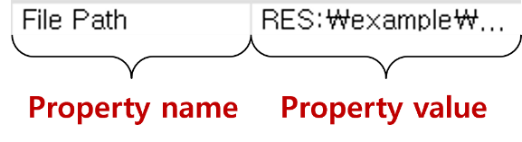

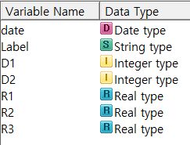

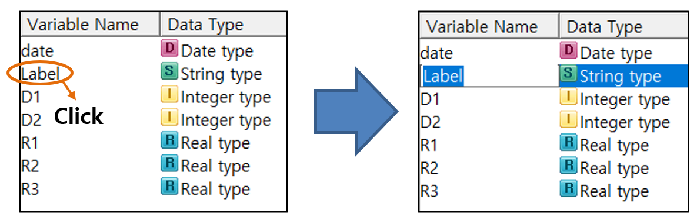

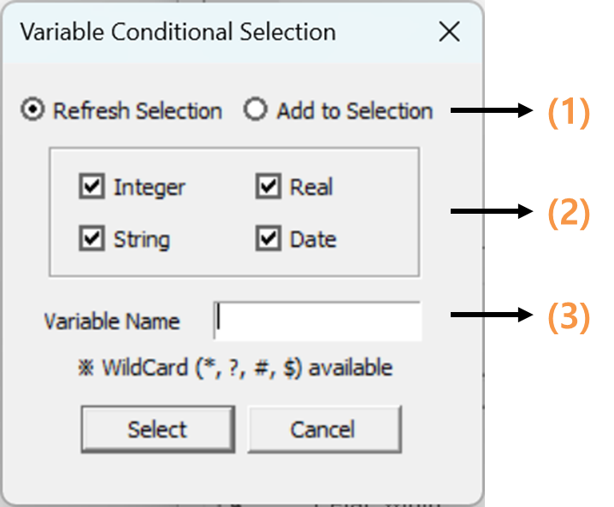

In ECMiner™, wildcards are used for flexible variable name selection during conditional filtering. The system supports four wildcard symbols: the asterisk () represents any string, so "A" matches any variable name starting with "A" and "B" matches any ending in "B"; the question mark (?) stands for a single character, so "A??B" matches four-character names that begin with "A" and end with "B"; the pound sign (#) represents any single digit, so "A##B" matches names like "A12B"; and the dollar sign ($) represents any non-digit character, so "A$$B" matches names like "AbcB" or "AxzB". When using wildcards, note that "" alone matches all variable names, "ABC" selects any name containing "ABC", and simply entering "ABC" will match only that exact name. Additionally, spaces are counted as characters—"\* ABC \*" will match names that contain " ABC " including the space, not just "ABC".

In ECMiner™, Variable Selection Property Control is used in nodes that require the selection of multiple variables. This control is not present in all nodes, only those where variable selection is relevant. It consists of two main components. (1) Function Buttons are provided to assist with variable selection: One button checks all currently selected variables in the list. Another toggles the checked state of selected variables. A third opens the Variable Conditional Selection dialog, allowing users to apply specific conditions (such as data type or name patterns using wildcards) to filter and select variables automatically. (2) The Variable List displays only the variables that are eligible for selection in the given node. Each variable is accompanied by a checkbox, which the user can check to include the variable in the node’s operation. This setup streamlines variable handling and ensures compatibility with the specific analytical function of the node.

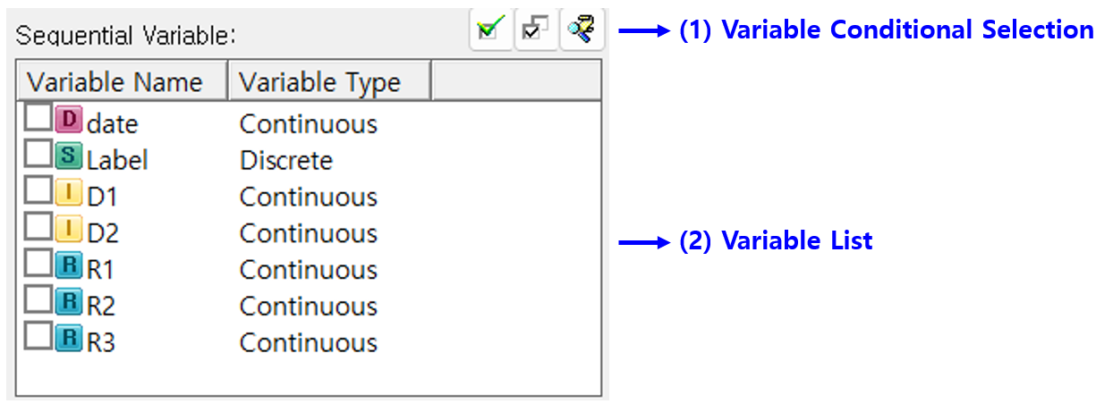

## 3.1 Input Node

ECMiner™ supports a wide range of data sources through specialized input nodes tailored to different formats and technologies. The ODBC Reader Node and OLEDB Reader Node allow data retrieval from databases using ODBC and OLEDB technologies, respectively. The Access Reader Node enables access to MDB files through table selection or custom queries, while the Oracle Reader Node connects to Oracle databases by entering connection details and a query. For Excel files, the Excel Reader Node allows data import by selecting the file. The Oracle Read/Write Node supports reading and concatenating multiple files for future use. The File Reader Node is used to import data from various file formats such as txt, csv, and dat, while File Reader2 Node merges multiple files of the same format. The File Read/Write Node and Add Input Node are used to concatenate ECL files, either column-wise or row-wise, into a single dataset. The Copy&Paste Input Node allows manual data entry, and the Hancell Reader Node handles data from Hancom Hancell files. Lastly, the Image Reader Node supports the loading of image data from individual files or entire folders, enhancing flexibility for visual data processing.

#### Common Properties of the Input Node

All Input Nodes have the following common properties.

|  |  |  |
| --- | --- | --- |
| Property group | Property Name | Description |
| Partial Read | Partial Read Method | Three options: "Read All," "From the beginning," and "Random Sampling."   * Read All   Reads all data from the specified Data Source   * From the beginning   Reads only data specified in the "Partial Read Arguments"   * Randosm Sampling   Selects random records specified in the "Partial Read Arguments" |
| Partial Read Arguments | With **From the beginning**, the argument is the number of observations. With **Random Sampling**, it is the percentage of observations. |

### 3.1.1 ODBC Reader Node

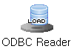

**ODBC Reader Node** uses ODBC (Open Database Connectivity) technology to retrieve data from a database. You can either select a table or view data name to retrieve data directly, or you can input a query to fetch the data.

#### Usage

Click the ‘**ODBC Editing’** button to add a new DSN (Data Source Name) to data source. Enter user name and password to connect selected database. After clicking the ‘**Fetch DB Information**’ button, specify the table or enter a query. Optional: Specify partial read method, Filter the desired table type or schema, Edit query

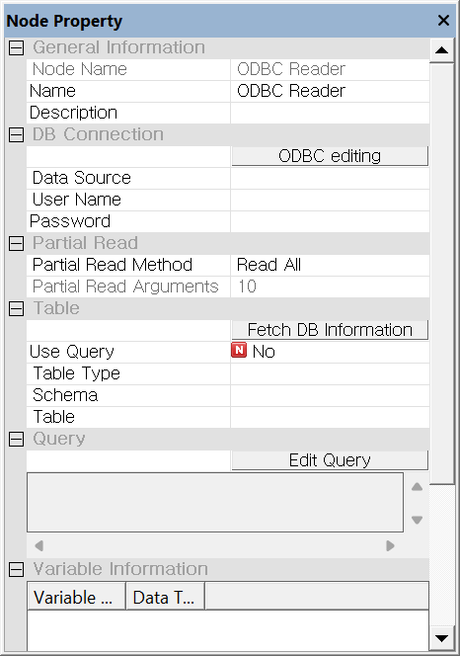

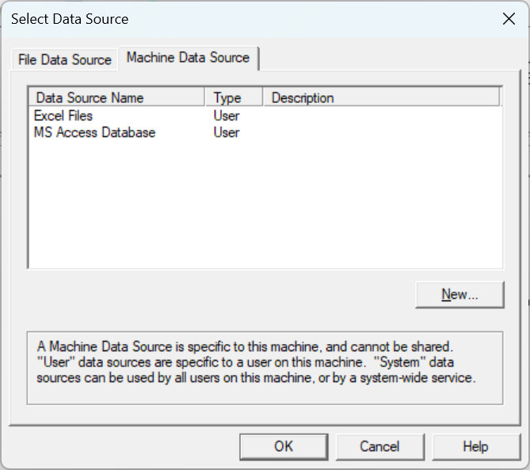

#### Node Properties

|  |  |  |  |  |
| --- | --- | --- | --- | --- |
| Property group | Property Name | Description | Misc. | Note |
| DB Connection | ODBC Editing | Add a new DSN (Data Source Name) for ODBC connections. | button |  |
| Data Source | Displays a list of registered ODBC DSNs on the current PC for selection. | Required |  |
| User Name | Enter the **username** to access the database. |  |
| Password | Enter the user **password** to access the database. |  |
| Partial Read | Partial Read Method | Specifies the method for partially reading the database. | Required | Read All, From the beginning, Random Sampling |
| Partial Read Arguments | With 'From the beginning', the argument is the number of observations. With 'Random Sampling', it is the percentage of observations. |  |  |
| Table | Fetch DB Information | Retrieve information about the database’s schema, tables, views, and other elements from the accessed database. | button |  |
| Use Query | Specify whether to fetch data using a query. |  | Yes, No |
| Table Type | Select the database schema to display in the table attribute. It supports both tables and views. |  | All, Table, View |
| Schema | Display list of table spaces or owners. |  |  |
| Table | Specifies the table from which to import the data. |  |  |
| Query | Edit Query | Activated when the ‘**Use Query’** attribute is set to **'Yes'**. Popping up the query editor, edit, load, and save the query. | button |  |
| Check Query | Check current inputted query. Click the ‘Edit Query’ button to modify it. |  |  |
| Variable Information | Variable Information | Displays the variable name and data type |  |  |

### 3.1.2 OLEDB Reader Node

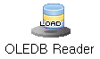

**OLEDB Reader Node** uses OLEDB technology to retrieve data from a database. You can either select a table or view data name to retrieve data directly, or you can input a query to fetch the data. if the database supports both ODBC and OLEDB, it is recommended to use OLEDB.

#### Usage

Select the appropriate driver for the type of database you want to connect to. Enter the DB Server Connection Information, User Name, and Password to connect the database. After clicking the ‘Fetch DB Information’ button, specify the table or enter a query. Optional:Specify partial read method, Filter the desired table type or schema, Edit query.

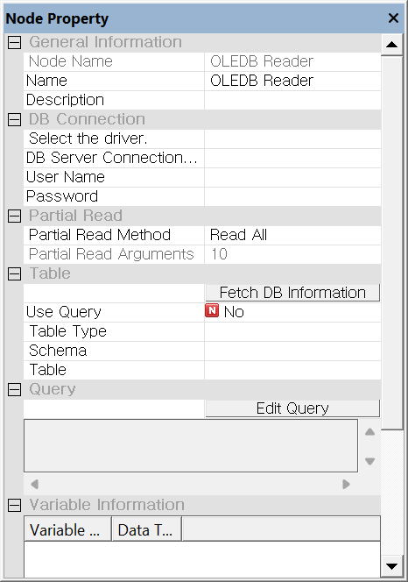

#### Node Properties

|  |  |  |  |  |
| --- | --- | --- | --- | --- |
| Property group | Property Name | Description | Misc. | Note |
| DB Connection | Select the driver | Specifies the appropriate **OLEDB driver** for the type of database you want to connect to. | Required |  |
| DB Server Connection Information | Enter appropriate information to identify the database. For SQL server, enter the IP address of the database server. For Oracle, enter the TNS name. |  |
| User Name | Enter the **username** to access the database. |  |
| Password | Enter the **password** to access the database. |  |
| Partial Read | Partial Read Method | Specifies the method for partially reading the database. | Required | Read All, From the beginning, Random Sampling |
| Partial Read Arguments | With 'From the beginning', the argument is the number of observations. With 'Random Sampling', it is the percentage of observations. |  |  |
| Table | Fetch DB Information | Retrieve information about the database’s schema, tables, views, and other elements from the connected database. | button |  |
| Use Query | Specify whether to fetch data using a query. |  | Yes, No |
| Table Type | Select the database schema to be listed in the table attribute. It supports tables and views. |  | All, Table, View |
| Schema | Display list of table spaces or owners. |  |  |
| Table | Specifies the table from which to import the data. |  |  |
| Query | Edit Query | Activated when the ‘**Use Query’** attribute is set to **'Yes'**. Popping up the query editor, edit, load, and save the query. | button |  |
| Check Query | Check current inputted query. Click the ‘Edit Query’ button to modify it. |  |  |
| Variable Information | Variable Information | Displays the variable name and data type |  |  |

### 3.1.3 Access Reader Node



**Access Reader Node** retrieves data stored in MDB format. You can either select a table to fetch the corresponding data directly or enter a query to retrieve the data.

#### Usage

Enter the file path and user **password** to access the MDB file. After clicking the ‘**Fetch DB Information’** button, specify the table or enter a query. Optional: Specify partial read method, Edit query.

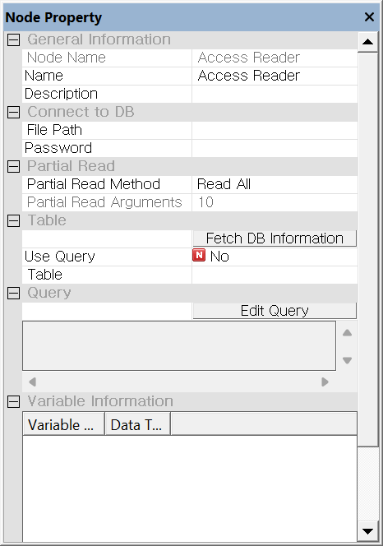

#### Node Properties

|  |  |  |  |  |
| --- | --- | --- | --- | --- |
| Property group | Property Name | Description | Misc. | Note |
| Connect to DB | File Path | Specifies the path to the MDB file. | button |  |
| Password | Enter the **password** to access the MDB. | Required |  |
| Partial Read | Partial Read Method | Specifies the method for partially reading the database. | Required | Read All, From the beginning, Random Sampling |
| Partial Read Arguments | With 'From the beginning', the argument is the number of observations. With 'Random Sampling', it is the percentage of observations. |  |  |
| Table | Fetch DB Information | Retrieve information about the database’s schema, tables, views, and other elements from the connected database. | button |  |
| Use Query | Specify whether to fetch data using a query. |  | Yes, no |
| Table | Specifies the table from which to import the data. |  |  |
| Query | Edit Query | Activated when the ‘**Use Query’** attribute is set to **'Yes'**. Popping up the query editor, edit, load, and save the query. | button |  |
| Check Query | Check current inputted query. Click the ‘Edit Query’ button to modify it. |  |  |
| Variable Information | Variable Information | Displays the variable name and data type |  |  |

### 3.1.4 Excel Reader Node

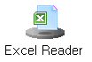

**Excel Reader Node** retrieves data stored in Excel file. You can directly select the file to fetch the corresponding data.

#### Usage

Specifies the path of the Excel File. Select the Worksheet. Optional: Specify the file **Partial Read Method**, Specify the First row is Variable names, Specify the Processing string types for all fields.

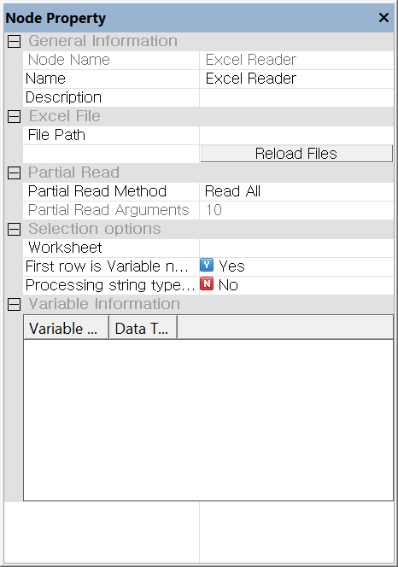

#### Node Properties

|  |  |  |  |  |
| --- | --- | --- | --- | --- |
| Property group | Property Name | Description | Misc. | Note |
| Excel File | File Path | Specifies the path to the Excel File. | button |  |
| Reload Files | Re-import the data if the file was not read properly or you modified the file. |  |
| Partial Read | Partial Read Method | Specifies the method for partially reading the database. | Required | Read All, From the beginning, Random Sampling |
| Partial Read Arguments | With 'From the beginning', the argument is the number of observations. With 'Random Sampling', it is the percentage of observations. |  |  |
| Selection options | Worksheet | Reads the data from the selected worksheet. | Required |  |
| First row is Variable names | Set to **'Yes’,** if the first row is ‘Variable name’. If set to **'No'** even whenthefirst row contains variable names, all variable types may be set as strings. | Auto. | Yes, No |
| Processing string types for all fields | Reads all input data as strings. |  | Yes, No |
| Variable Information | Variable Information | Displays the variable name and data type |  |  |

### 3.1.5 Oracle Reader Node



**Oracle Reader Node** retrieves data from an Oracle database.

#### Usage

Enter TNS Name, Connection account and Account Password to access the database. After clicking the ‘**Fetch DB Information’** button, specify the table or enter a query. Optional: Specify partial read method, Edit variable list, Edit query.

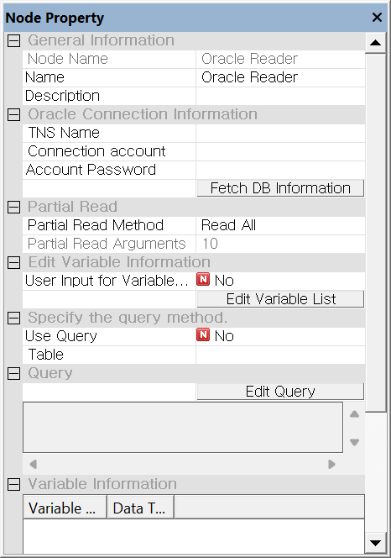

#### Node Properties

|  |  |  |  |  |
| --- | --- | --- | --- | --- |
| Property group | Property Name | Description | Misc. | Note |
| Oracle Connection Information | TNS Name | Enter the TNS name of the Oracle database you want to access to. | button |  |
| Connection account | Enter the name of the database accessed account. | Required |  |
| Account Password | Enter the password for the database accessed account. |  |
| Partial Read | Partial Read Method | Specifies the method for partially reading the database. | Required | Read All, From the beginning, Random Sampling |
| Partial Read Arguments | With 'From the beginning', the argument is the number of observations. With 'Random Sampling', it is the percentage of observations. |  |  |
| Edit Variable Information | User Input for Variable List | Set to 'Yes' to manually type the list of variables. If set to 'No', the column information returned from the database is used. |  |  |
| Edit Variable List | Activate when the **User Input for Variable List** attribute is set to **'Yes'.** And edit the list of variables. | button |  |
| Specify the query method | Use Query | Specify whether to fetch data using a query. |  |  |
| Table | Select the Table. |  |  |
| Query | Edit Query | Activated when the ‘**Use Query’** attribute is set to **'Yes'**. Popping up the query editor, edit, load, and save the query. | button |  |
| Variable Information | Variable Information | Displays the variable name and data type |  |  |

### 3.1.6 Oracle Read/Write Node



**Oracle Read/Write Node** read multiple files with the same format, concatenate them vertically to create data for analysis, and provides a function to save it for future use.

#### Usage

Enter the TNS Name, Connection account and Account Password to access the database. After clicking the ‘Fetch DB Information’ button, specify the table or enter a query. Specify the **File Path** and Reference **Variable** to save. Optional: Specify partialread method, Edits variable list, Edits query.

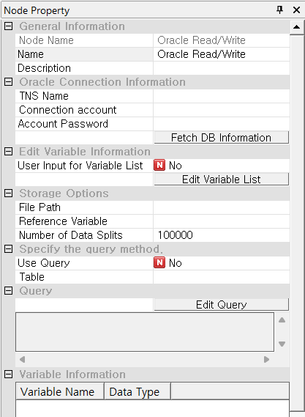

#### Node Properties

|  |  |  |  |  |
| --- | --- | --- | --- | --- |
| Property group | Property Name | Description | Misc. | Note |
| Oracle Connection Information | TNS Name | Enter the TNS name of the Oracle database you want to access to. | button |  |
| Connection account | Enter the name of the database accessed account. | Required |  |
| Account Password | Enter the password for the database accessed account. |  |
| Edit Variable Information | User Input for Variable List | Set to 'Yes' if you want to manually enter the list of variables. If set to 'No', the column information returned from the database is used. | button |  |
| Edit Variable List | Activate when the **User Input for Variable List** attribute is set to **'Yes'.** The variable editor will pop up, allowing you to edit the list of variables. |  |
| Storage options | File Path | Specify the path for the file to be saved. |  |  |
| Reference Variable | Specify the reference variable. |  |  |
| Number of Data Splits | Specify the number of data splits. |  |  |
| Specify the query method | Use Query | Specify whether to fetch data using a query. | button |  |
| Table | Select the Table. |  |  |
| Query | Edit Query | Activated when the ‘**Use Query’** attribute is set to **'Yes'**. Popping up the query editor, edit, load, and save the query. | button |  |
| Variable Information | Variable Information | Displays the variable name and data type to be read |  |  |

### 3.1.7 File Reader Node



File Reader Node retrieves data from files with extensions such as txt, csv, dat, tab, and ecl.

#### Usage

Specifies the path for the file. **Selection options** will be updated automatically, and you will be able to edit them. Optional: If not read correctly, click the ‘**Reload** **Files’** button, Specify partial read method, Edits variable name and variable type from Variable Information.

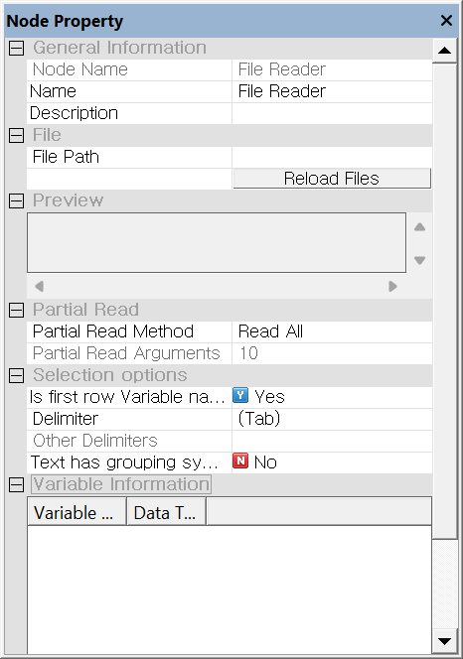

#### Node Properties

|  |  |  |  |  |
| --- | --- | --- | --- | --- |
| Property group | Property Name | Description | Misc. | Note |
| File | File Path | Specifies the path for the file. | Required |  |
| Reload Files | Re-import the data if the file was not read properly or you modified the file. | button |  |
| Preview | View a portion of the specified file. |  |  |
| Partial Read | Partial Read Method | Specifies the method for partially reading the database. | Required | Read All, From the beginning, Random Sampling |
| Partial Read Arguments | With 'From the beginning', the argument is the number of observations. With 'Random Sampling', it is the percentage of observations. |  |  |
| Selection options | Is first row Variable names | Set to **'Yes’,** if the first row is ‘Variable name’. If set to **'No'** even whenthefirst row contains variable names, all variable types may be set as strings. | Auto. | Yes, No |
| Delimiter | Select the type of delimiter. Supported delimiters are tab, space, bar, comma, semicolon, and colon. To use a different delimiter, select the 'Other' option. | Required | (tab), '|', (Space), ',', ';', ':', (Other) |
| Other Delimiter | Set other delimiters in case the property of a delimiter is (Other). |  |  |
| Test has grouping symbols | Specify whether to remove quotation marks from string data that contains them. | Ex: “ABC"🡺 ABC | Yes, No |
| Variable Information | Variable Information | Displays the variable name and data type |  |  |

### 3.1.8 File Reader2 Node



**File Reader2 Node** merges multiple files of the same format by vertically concatenating them to generate a new file.

#### Usage

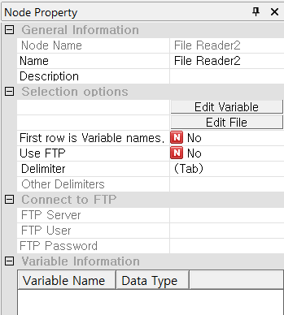 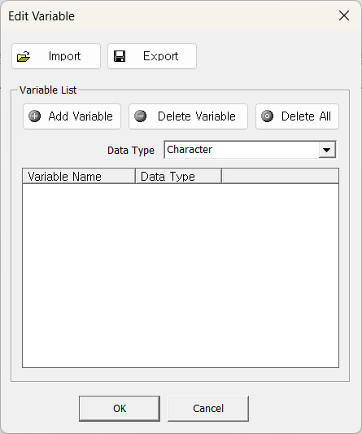 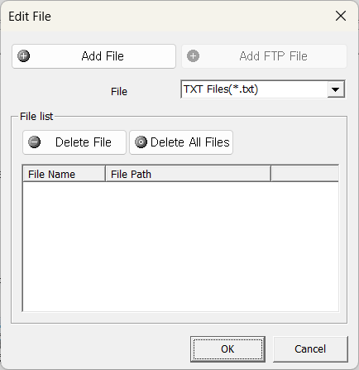

Click ‘**Edit Variable List’** to view or modify the list of variables. Manage variables by adding, deleting, and deleting all variables. Import and export the variable names in data formatted with line breaks for variable parsing. Click ‘**Edit File List**’ to specify folder to load data with a specific extension. The order of variables of the newly added files is in the same order as the previous files. Optional: Specifies delimiter, Specifies FTP.

#### Node Properties

|  |  |  |  |  |
| --- | --- | --- | --- | --- |
| Property group | Property Name | Description | Misc. | Note |
| Selection options | Edit Variable | Edit the list of variables. If a variable does not exist, you can set it manually | Required |  |
| Edit File | Select the data to be imported. |  |
| First row is Variable names | Set to **'Yes’,** if the first row is ‘Variable name’. If set to **'No'** even whenthefirst row contains variable names, all variable types may be set as strings. | Yes  No |
| Use FTP | Set whether to use FTP. | Yes  No |
| Delimiter | Select the type of delimiter. Supported delimiters are tab, space, bar, comma, semicolon, and colon. To use a different delimiter, select the 'Other' option. | (tab), '|', (Space), ',', ';', ':', (Other) |
| Other Delimiters | Set other delimiters in case the property of a delimiter is (Other). |  |  |
| Connect to FTP | FTP Server | Set the FTP server where the file is located. | Required when using FTP |  |
| FTP User | Enter the FTP user ID. |  |
| FTP Password | Enter the FTP password. |  |
| Variable Information | Variable Information | Displays the variable name and data type. |  |  |

### 3.1.9 File Read/Write Node

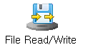

Using the **File Read/Write Node**, vertically concatenate multiple \*.ecl files of the same format to create a new ECL dataset and save it in a \*.ecl file. It is configured to execute both the **File Reader node** and the **File Writer node** simultaneously.



#### Usage

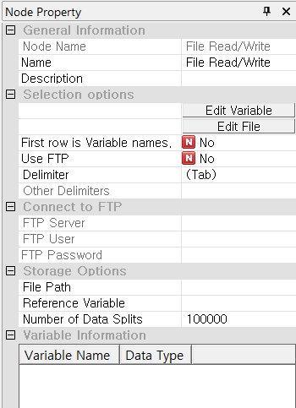  

Clicking ‘**Edit Variable List’** to view or modify the list of variables.Manage variables by adding, deleting variables. Import and export the variable names in data. Clicking ‘**Edit File List**’, specify folder to load data. Ensure the order of variables is the same to generate the desired data. Specify the path and name of the file to be saved. Optional: Specifies delimiter, Specifies FTP, Select whether to save the data separately.

#### Node Properties

|  |  |  |  |  |
| --- | --- | --- | --- | --- |
| Property group | Property Name | Description | Misc. | Note |
| Selection options | Edit Variable | Edit the list of variables. If a variable does not exist, you can set it manually | Required |  |
| Edit File | Select the data to be imported. |  |
| First row is Variable names | Set to **'Yes’,** if the first row is ‘Variable name’. If set to **'No'** even whenthefirst row contains variable names, all variable types may be set as strings. | Yes  No |
| Use FTP | Set whether to use FTP. | Yes  No |
| Delimiter | Select the type of delimiter. Supported delimiters are tab, space, bar, comma, semicolon, and colon. To use a different delimiter, select the 'Other' option. | (tab), '|', (Space), ',', ';', ':', (Other) |
| Other Delimiters | Set other delimiters in case the property of a delimiter is (Other). |  |  |
| Connect to FTP | FTP Server | Set the FTP server where the file is located. | Required when using FTP |  |
| FTP User | Enter the FTP user ID. |  |
| FTP Password | Enter the FTP password. |  |
| Storage Options | File Path | Specify the path and name of the file to be saved. | Required |  |
| Reference Variable | Select the variable to use as a criterion when dividing the data for storage. | Select 'None' as an option. |
| Number of Data Splits | Set how many pieces of data to use as a basis for division. |  |
| Variable Information | Variable Information | Displays the variable name and data type to be read. |  |  |

### 3.1.10 Add Input Node

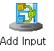

**Add Input Node** combines multiple ECL files with the same data structure by concatenating them row-wise to create a unified dataset.

#### Usage

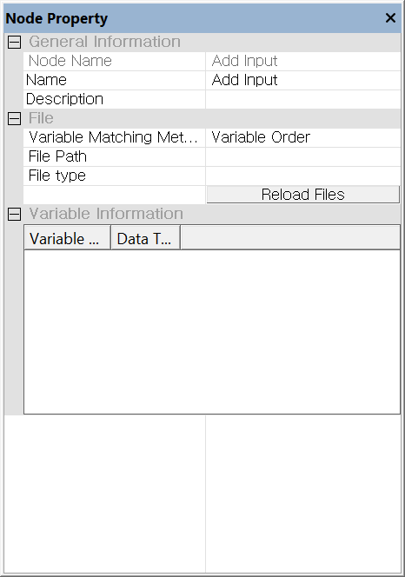

Set the path to the folder containing ecl files of the same format. Select the Variable Matching Method. Use an asterisk (\*) as a prefix or suffix to distinguish file names and specify the **File type**. Click the **Reload Files** button.

#### Node Properties

|  |  |  |  |  |
| --- | --- | --- | --- | --- |
| Property group | Property Name | Description | Misc. | Note |
| File | Variable Matching Method | Two options: " Variable Order", " Variable Name".   * Variable Order   Consider variables with the same order as identical.   * Variable Name   Consider variables with the same name as identical. | Required | Variable Order  Variable Name |
| File Path | Specifies the path for the file. |  |
| File type | Use an asterisk (\*) as a prefix or suffix to specify and distinguish the file type.  If the data files are named "test1, test2, ..." enter "test\*". For files named "1test, 2test, ..." enter "\*test". |  |
| Variable Information | Variable Information | Displays the variable name and data type to be read. |  |  |
| NOTE: In the 'Variable Matching Method', if the 'Variable Name' option is selected and the variables in the input datasets do not match, the unmatched datasets will be filled with blank spaces. | | | | |

### 3.1.11 Copy&Paste Input Node

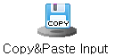

Using **Copy&Paste Input Node**, enter or paste the data you want.

#### Usage

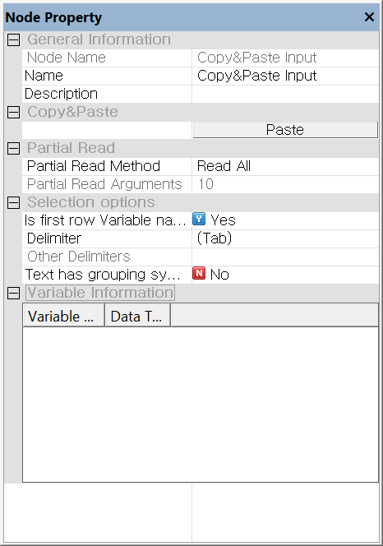

Click **Paste** button to enter data directly or paste it. Optional: Specify the Partial Read Method, Specify whether variable names are on the first line, Specify whether to use text delimiters, modify variable names and types.

#### Node Properties

|  |  |  |  |  |
| --- | --- | --- | --- | --- |
| Property group | Property Name | Description | Misc. | Note |
| Copy& Paste | Paste | Activate a dialog box where you can enter or paste data. | Required | button |
| Partial Read | Partial Read Method | Specifies the method for partially reading the database. | Required | Read All, From the beginning, Random Sampling |
| Partial Read Arguments | With 'From the beginning', the argument is the number of observations. With 'Random Sampling', it is the percentage of observations. |  |  |
| Selection options | Is first row Variable names | Set to **'Yes’,** if the first row is ‘Variable name’. If set to **'No'** even whenthefirst row contains variable names, all variable types may be set as strings. | Auto. | Yes, No |
| Delimiter | Select the type of delimiter. Supported delimiters are tab, space, bar, comma, semicolon, and colon. To use a different delimiter, select the 'Other' option. | Required | (tab), '|', (Space), ',', ';', ':', (Other) |
| Other Delimiters | Set other delimiters in case the property of a delimiter is (Other). |  |  |
| Text has grouping symbols | Specify whether to remove quotation marks from string data that contains them. | ex: “ABC"🡺 ABC | Yes, No |
| Variable Information | Variable Information | Displays the variable name and data type |  |  |

### 3.1.12 Hancell Reader Node



Using **Hancell Reader Node**, retrieves data stored in Hancom Hancell file.

#### Usage

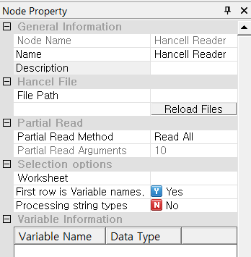

Specify the path to the **Hancom/Hancell file** and select the worksheet. Optional: Specify the Partial Read method for the file.

#### Node Properties

|  |  |  |  |  |
| --- | --- | --- | --- | --- |
| Property group | **Property Name** | **Description** | **Misc.** | **Note** |
| Excel File | File Path | Specifies the path to the Hancom Hancell File. | button |  |
| Reload Files | Re-import the data if the file was not read properly or you modified the file. | Reload Files |
| Partial Read | Partial Read Method | Specifies the method for partially reading the database. | Required | Read All, From the beginning, Random Sampling |
| Partial Read Arguments | With 'From the beginning', the argument is the number of observations. With 'Random Sampling', it is the percentage of observations. |  |  |
| Selection options | Worksheet | Reads the data from the selected worksheet. | Required |  |
| First row is Variable names | Set to **'Yes’,** if the first row is ‘Variable name’. If set to **'No'** even whenthefirst row contains variable names, all variable types may be set as strings. | Auto. | Yes, No |
| Processing string types | Reads all input data as strings. |  | Yes, No |
| Variable Information | Variable Information | Displays the variable name and data type |  |  |

### 3.1.13 Image Reader Node



Using Image Reader Node, retrieve data from image files or a folder containing multiple images.

#### Usage

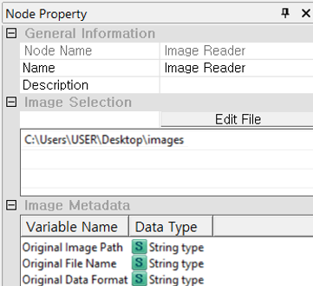

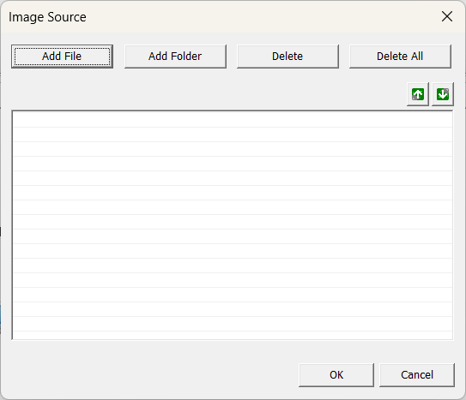

Click Edit Filebutton **to add or modify the image file path**.

#### Node Properties

|  |  |  |  |  |
| --- | --- | --- | --- | --- |
| Property group | Property Name | Description | Misc. | Note |
| Image Selection | Edit File | Use the **Edit File** button to specify the path of the image file. You can select the image list using 'Add File' and 'Add Folder'. | button |  |
| Image Metadata | Image Metadata | Displays the variable name and data type. |  |  |

## 3.2 Preprocessing Node

Data preprocessing is essential step in data analysis. **ECMiner™** provides **Preprocessing Nodes** for data cleaning to handle missing values, remove noise, correcting errors. Normalization, Standardization, Grouping, and Binning is also available.

* [Missing Value](#_3.2.1_Missing_Value_1)  
  For missing values, you may use imputation values (mean, median, or other specified techniques)
* [Group By](#_3.2.2_Group_By)  
  Groups data based on the values of specified variables to create a new dataset.
* [Multiple Derived Variables](#_3.2.3_Multiple_Derived)  
  Applies the same rule to specified variables to create new variables.
* [Column Reorder](#_3.2.4_Column_Reorder)  
  Changes data order
* [Standardize](#_3.2.5_Standardize_Node)  
  Transform data to have a mean of zero and a standard deviation of one or specified value.
* [Merge](#_3.2.6_Merge_Node)  
  Combine two or more data set by key value.
* [Split](#_3.2.7_Split_Node)  
  Divides the data for modeling and evaluation purposes (For example, Train set and Test set).
* [Row Select](#_3.2.8_Row_Select)  
  Selects only the rows where a specified condition is true.
* [Row Select2](#_3.2.9_Row_Select2)  
  A node that groups based on specified key variables and then selects values that meet the condition.
* [Column Combiner](#_3.2.10_Column_Combiner)  
  Combine the multiple results of modeling/model into one.
* [Image Processing Node](#_3.2.11_Image_Processing)

Performs various processing tasks for the images such as detection, extraction, distortion and etc.

* [Image Statistics Node](#_3.2.12_Image_Statistics)

Extracts statistical information of image pixels.

* [Sort](#_3.2.13_Sort_Node)  
  Sort data by a specified variable.
* [Fill](#_3.2.14_Fill_Node)  
  Fill with a specified value if a specified condition is true.
* [Add](#_3.2.15_Add_Node)  
  Combine input data sources into one.
* [Derived Variable](#_3.2.16_Derived_Column)  
  Create a new derived variable
* [Sampling](#_3.2.17_Sampling_Node)  
  Randomly select a specified portion from the entire dataset.
* [Pivot](#_3.2.18_Pivot_Node)  
  Transform data from a detailed, long format into a summary, wide format.
* [Column Filter](#_3.2.19_Column_Filter)  
  Select a subset of data based on specific criteria
* [Type Change](#_3.2.20_Type_Change)  
  Change the type of variable
* [Counter](#_3.2.21_Counter_Node)  
  Add the result of counting by group according to specified variable.
* [Group Statistics](#_3.2.22_Group_Statistics)  
  Compute statistics for different groups or categories within a dataset
* [RANKING](#_3.2.23_RANKING_Node)  
  Calculate ranking for a specified variable
* [Binning](#_3.2.24_Binning_Node)  
  Divide grouping continuous data into discrete intervals
* [Transpose](#_3.2.25_Transpose_Node_1)  
  Swap the rows and columns of data
* [Tagging](#_3.2.26_Tagging_Node)  
  Perform morphological analysis.

### 3.2.1 Missing Value Node

****

**Missing Value Node** imputes the missing values. Replace the missing values for All variables or Continuous variables or Discrete Variables.

#### Usage

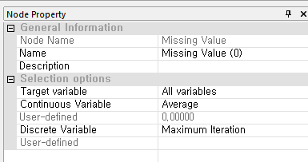

Under the **Selection options** section, set the **Target Variable** by choosing an option from the dropdown menu—**All variables**, **Discrete Variables Only**, or **Continuous Variables Only**—to specify which types of variables the missing value treatment should apply to. Based on this selection, choose an appropriate method for each variable type from the corresponding dropdown menus (e.g., under **Continuous Variable** and **Discrete Variable**) while referring to the *Methods for Replacing Missing Values* manual for guidance. If you select a method that requires a specific replacement value (such as “User-defined”), you must enter the desired value in the adjacent **User-defined** field. For more detailed explanation of each property, please refer to the *Node Properties* manual below.

#### Node Properties

|  |  |  |  |
| --- | --- | --- | --- |
| Property group | Property Name | Description | Note |
| Options | Target variable | Choose which one to replace the missing value | All variables, Discrete Variables Only, Continuous Variables Only |
| Continuous Variable | Option for **continuous** variable | Average, Median, Previous Value, Subsequent Value, Interval Mean, Linear interpolation, Spline Interpolation, User-defined (default 0) |
| Discrete Variable | Options for **Discrete** variable | Maximum Iteration, Minimum Iteration, Previous Value, Subsequent Value |

#### Methods for Replacing Missing Values

|  |  |  |
| --- | --- | --- |
| Type | Value | Description |
| Continuous | Average | Mean value of the variable |
| Median | Median value of the variable |
| Previous Value | Previous value of the continuous variable |
| Subsequent Value | Subsequent value of the continuous variable |
| Interval Mean | (Previous value + subsequent value) / 2 |
| User-defined (default 0) | User-defined value, default is 0 |
| Discrete | Value corresponding to the maximum count, | The most frequent value |
| Value corresponding to the minimum count | The least frequent value |
| Previous Value | Previous value of the discrete variable |
| Subsequent Value | Subsequent value of the discrete variable |

### 3.2.2 Group By Node

****

**Group By Node** specifies the grouping variable and select the variable you want to calculate statistical measure.

#### Usage

In the **Selective Options** section, at least one calculation option must be selected to proceed. “Frequency Calculation” is often enabled by default and assigns a variable name (e.g., G\_CNT) to store the count of records in each group. Users may optionally enable “Calculate Cumulative Count,” “Percentage,” or “Cumulative Percentage” by checking the respective boxes and defining the variable names that will hold the results. Under **Descriptive Statistics**, users can choose to include any combination of statistical measures (e.g., Average, Minimum, Maximum, Variance, Median) by toggling each from “No” to “Yes,” depending on the analysis requirements. Similarly, in the **Date Type Statistics** section, users may choose to compute date-related summaries such as Minimum Date, Maximum Date, and Date Difference. Only the settings that are marked “Yes” will be applied during execution, and all others will be ignored. For **Grouping Variables and Statistical Vairables**, users can select one or more continuous variables from the list to be used in computing the descriptive statistics configured in the node property box. For more detailed explanation of each property, please refer to the *Node Properties* manual below.

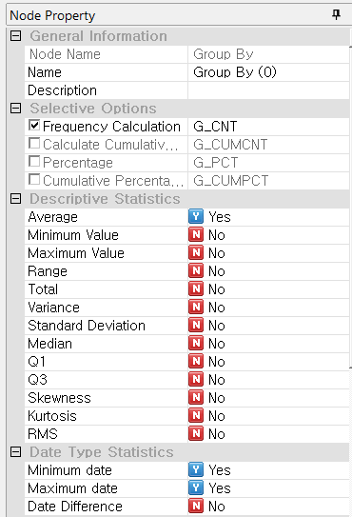

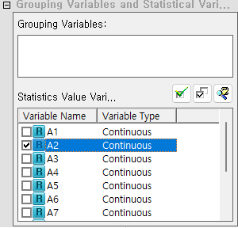

#### Node Properties

|  |  |  |  |  |
| --- | --- | --- | --- | --- |
| Property group | Property Name | Description | Misc. | Note |
| Options | - | Generate derived variables for the values of selected variable. | Required (Select at least one) | Frequency Calculation,  Calculate Cumulative Frequency,  Percentage,  Cumulative Percentage |
| Statistics | Descriptive Statistics | mean, minimum, maximum, total sum, variance, standard deviation, median, Q1, and Q3 to create derived variables. |  |  |
| Date Type Statistics | minimum date, maximum date, and date difference to create derived variables. |  |  |
| Grouping Variables and Variables | Grouping Variables | Select the grouping variable. The grouping variable should be discrete. | Required |  |
| Selected continuous Variables | Select the variable for which you want to calculate descriptive statistics by the grouping variable. | Optional |  |

### 3.2.3 Multiple Derived Column Node

**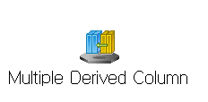**

**Multiple Derived Column Node** applies a common transformation rule to several existing fields to create new fields. During this process, each field is substituted into a common formula, so the data types of the existing fields must match.

#### Usage

In the **Selection options** section, users can define a **Prefix** and/or **Suffix** that will be automatically added to the names of the newly created variables—this helps distinguish derived variables from the original ones and is especially useful when applying the same formula to multiple variables. Under **Variable Selection**, users must check the boxes next to the variables to which the transformation should be applied. The **Edit Formula** section at the bottom allows users to define the mathematical or logical expression that will be applied uniformly to all selected variables. Clicking the “Edit” button opens a formula editor where the expression can be specified. While the prefix/suffix and description fields are optional, selecting at least one variable and defining a formula is required for this node to function properly. For more detailed explanation of each property, please refer to the *Node Properties* manual below.

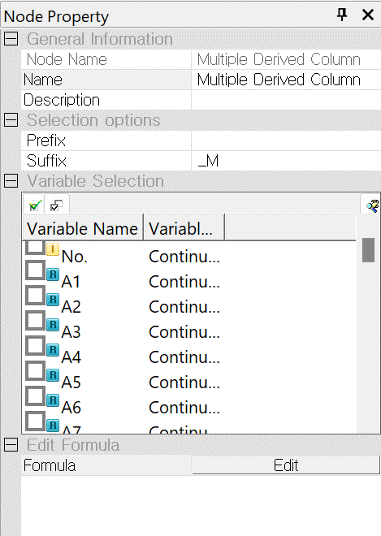

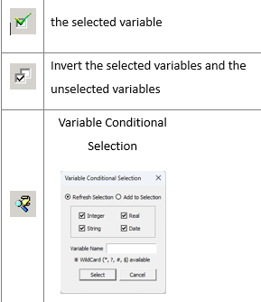

#### Node Properties

|  |  |  |  |  |
| --- | --- | --- | --- | --- |
| Property group | Property Name | Description | Misc. | Note |
| Selection Options | Prefix | Prefix of derived variables | Conditionally Required | Enter at least one of the following : prefix, suffix. |
| Suffix | Suffix of derived variables |
| Variable Selection | Variable Selection | List the names and types of variables. It Select the variable for a new derived variable | Other UI | Refer to the Usage |
| Edit Formula | Formula | Define the variable transformation rules | Refer to the formula editor. |

### 3.2.4 Column Reorder Node

**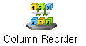**

**Column Reorder Node** changes the variable order.

#### Usage

The Variable Order setting allows users to manually adjust the order of variables during the data processing stage. Users can select a variable and move it up or down by one position but clicking either the first/second up/down button, or move it directly to the top or bottom of the list by clicking the third/last up/down button. Additionally, users can sort the variable names in ascending alphabetical order by clicking the AZ button placed at the right part of the option box, and if needed, reset the variable order to its original state by clicking the circle button place at the right part of the option box. These functions help users easily manage the order of variables as required for analysis or processing tasks. For more detailed explanation of each property, please refer to the *Node Properties* manual below.

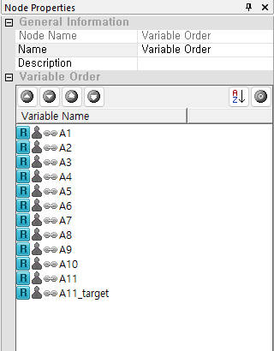

#### Node Properties

|  |  |  |  |  |
| --- | --- | --- | --- | --- |
| Property group | Property Name | Description | Misc. | Note |
| Variable Order | Variable Order | Rearrange the variables according to do user’s preference. |  |  |

### 3.2.5 Standardize Node

**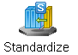**

**Standardize Node** standardizes numerical variables by transforming them to a common scale.

#### Usage

In the **Standardized Variables** section, users must set the **Creation status** to “Yes” to enable the generation of standardized variables. A **Suffix** (e.g., “\_STD”) must be provided to distinguish the standardized versions from the original variables. Users can manually define the **Standardization Mean** and **Standardization Standard Deviation** if custom standardization values are desired or remain with the default settings (defaults are 0 and 1, respectively). The optional **Maximum correction** parameter can be used to cap extreme values, providing a safeguard against outliers. In the **Relative Ratio Variable** section, users can optionally enable the creation of ratio variables by setting the **Creation status** to “Yes” and specifying a **Suffix** (e.g., “\_RATIO”); this step also requires selecting a **Reference Variable**, which will be used as the denominator when calculating ratios. At the bottom, under **Select Reference Variable and Variables to Transform**, users must select at least one **Variable to Transform** from the provided list of continuous variables. If ratio transformation is enabled, a **Reference Variable** must also be chosen. For more detailed explanation of each property, please refer to the *Node Properties* manual below.

**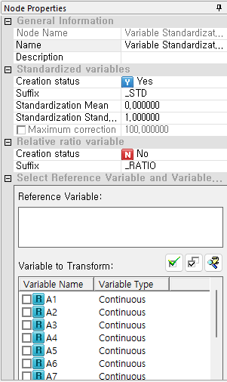**

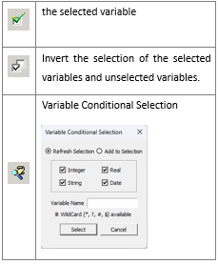

#### Node Properties

|  |  |  |  |  |
| --- | --- | --- | --- | --- |
| Property group | Property Name | Description | Misc. | Note |
| Standardized variables | Status | Choose whether to create a standardized variable |  | To create a new variable for the standardized, select 'Yes' |
| Suffix | Specify the suffix string for a derived standardized variable |  |
| Standardization Mean | Specify the mean value for the standardized variable |  |
| Standardization Standard Deviation | Specify the standard deviation for the standardized variable |  |
| Maximum correction | Select this option if you want the maximum value of the generated standardized variables |  |
| Relative ratio variable | Creation status | Specify whether to create relative ratio variables. | Conditionally Required |
| Suffix | Specify the string to append to the generated relative ratio variables. |  |
| Select Reference Variable | Reference Variable | If no variable is specified, calculations are performed for each record. If a variable is specified, calculations are performed for each category of the specified reference variable. The reference variable must be categorical. | Optional | Refer to the Usage. |
| Variables to Transform | Variable to Transform | Select the variables to transform, which must be continuous. | Required | Refer to the Usage. |

*Note: Relative ratio variables store the value of each row divided by the calculated total sum of the specified variable.*

### 3.2.6 Merge Node

****

Various merging methods are provided, including **Inner Join, Outer Join, Partial Outer Join, Anti-Join**, depending on the purpose of the new data.

#### Usage

In the **Data Source Priority** section, select which dataset should take precedence when duplicate variables exist—this dataset will serve as the primary reference during the merge. You can adjust the priority by changing the dataset order using the up/down arrow buttons. In the **Key Variable Setting** section, define the key variables that determine how records from different datasets are matched by selecting items from the *Possible Key Variable* list and moving them to the *Selected Key Variable* list using the arrow buttons. This step is essential for aligning records across datasets. In the **Merge Method** section, specify the option from the dropdown menu for the **When Variable Names are Duplicated** property. You must also choose a merge type from the dropdown menus- Inner Join, Outer Join, Partial Outer Join, Anti-Join. If using a partial or outer join strategy, you can select specific datasets to include in the final output using the *Data Source to Include* option. Proper configuration of key variables and merge settings ensures accurate and meaningful integration of datasets. For more detailed explanation of each property, please refer to the *Node Properties* manual below.

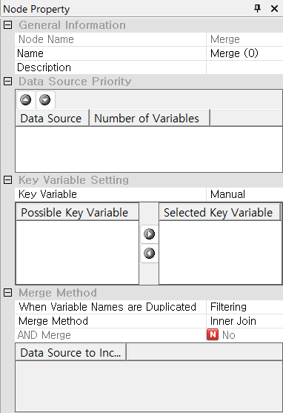

#### Node Properties

|  |  |  |  |  |
| --- | --- | --- | --- | --- |
| Property group | Property Name | Description | Misc. | Note |
| Data Source  Priority | Data Source | A list of data sets. Set their priority of data sets | Other UI | Refer to the Usage. |
| Key Variable Setting | Key variable | Specifies a key variable. If **Manual** is selected, choose the key variable. | Required | Automatic, Manual |
| Select Key variable | Select or delete key variable using icon btn_rightbtn_left | Other UI | Refer to the Usage. |
| Merge Method | When Variable Names are Duplicated | Select the method for handling duplicate variable names | Required | Filtering, Assign Index, Error Occurred |
| Merge Method | Select the merge method. | Inner Join, Outer Join, Partial Outer Join, Anti-Join |
| Data Source to Include | When **Merge Method** is set to **Partial Outer Join,** you can directly select or deselect data sources checking boxes. | Other UI | Refer to the Usage. |

#### Reference: Merge Method

ECMiner™ provides the following Merge Methods.

|  |  |  |
| --- | --- | --- |
| Merge Method | Description | Note |
| Inner Join | Keeps only rows where ‘key variable’ matches in both data sets |  |
| Outer Join | Keeps all rows from both datasets, adding NaN or nulls where no match is found. |  |
| Partial Outer Join | Keep all rows from the data set with the highest priority and add matched rows from the second data set. | You must specify the data sources to include. |
| Anti-Join | Adds rows with non-matching key value from the data sources to the new data source |  |

#### Example

Assume there are two data sources, A and B. Each contains an 'id' column used as the key variable for merging. Data source A additionally has a 'count' column, while data source B has an 'amount' column. Based on the 'id' key, various merging methods such as **Inner Join**, **Outer Join**, **Partial Outer Join**, and **Anti-Join** can be applied.

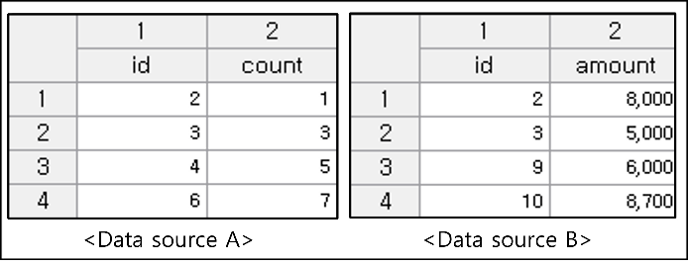

**Inner Join**: Merge only the rows with matching key values, specifically 'id' 2 and 3, from the two data sets. The result is as follows:

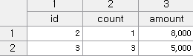

**Outer Join**: For the key field 'id', Data A has key values 2, 3, 4, 6, while Data B has key values 2, 3, 9, 10. Outer Join keeps all rows from both data sets. In this case, <NULL> values are assigned to variables where no data is available.

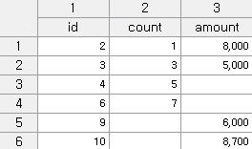

**Partial Outer Join**: Perform an outer join merge on all key values from the two data sources, and then return only the values from the selected data. For example, a partial outer join is with Data A, then the new data is only ‘id’ 2, 3, 4, and 6. By selecting only Data A, Partial Outer Join. By selecting only Data B, Partial Outer Join.

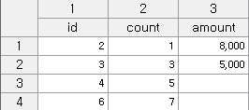

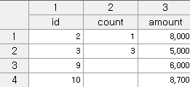

**Anti-Join**: When the primary data is A, remove the rows in Data B that have duplicate key values. In other words, among the key values 2, 3, 4, 6 in A, the duplicates 2 and 3 that are also present in. B are removed, resulting in the following outcome.

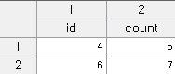

### 3.2.7 Split Node

**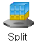**

**Split Node** divides data into either analysis or evaluation sets.

#### Usage

Under the **Selection options** section, the **Analysis / Evaluation** setting specifies the role of the extracted subset, typically *For analysis* when creating a training dataset. The **Partition Size Method** defines whether the split will be based on a percentage or a fixed count of records. In the **Partition Size** section, if *Percentage* is selected, the user must enter a value in the **Partition Size (Percentage)** field to indicate the proportion of records to extract (e.g., 50% of the dataset). If the method is set to *Count*, the **Partition Size (Count)** field must be used to specify the number of records. Only one of these fields is active at a time depending on the selected method. Proper configuration of these options ensures that the dataset is split correctly for subsequent analysis or modeling steps. For more detailed explanation of each property, please refer to the *Node Properties* manual below. For more detailed explanation of each property, please refer to the *Node Properties* manual below.

**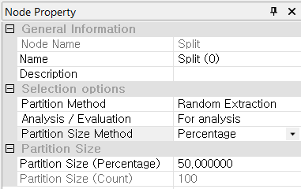**

#### Node Properties

|  |  |  |  |  |
| --- | --- | --- | --- | --- |
| Property group | **Property Name** | **Description** | **Misc.** | **Note** |
| Selection options | Partition Method | Specify how the data is partitioned for analysis/evaluation. Random Extraction is available. | Required | Random Extraction |
| Analysis / Evaluation | Specify whether some of the extracted data will be used for analysis or evaluation. | For analysis, Evaluation |
| Partition Size Method | Specify the method to determine the partition size. | Percentage, Count |
| Partition Size | Partition Size (Percentage) | Activates when the **Partition Size Method** is set to **Percentage** |  | 0<real numbers<100 |
| Partition Size (Count) | Activates when the **Partition Size Specification Methods** set to **Count.** Enters desired data size as an integer. |  | integer |

### 3.2.8 Row Select Node

**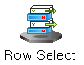**

**Row Select Node** filters rows based on a specified condition.

#### Usage

In the **Selection options** section, the **Condition format** determines how the filter criteria are defined; it is typically set to *User input*, allowing users to manually specify logical conditions. If set to *Remove Rows with Missing* Values, the data rows with all variable data will be selected. To define the filtering rule, click the **Edit** button next to **Selection condition**, which opens a condition editor where expressions can be entered using variable names, comparison operators, and logical statements (e.g., Age > 30 AND Income <= 50000). Only the records that meet the specified condition will be retained in the resulting dataset. This node is essential for extracting targeted subsets of data for focused analysis or preprocessing. For more detailed explanation of each property, please refer to the *Node Properties* manual below.

**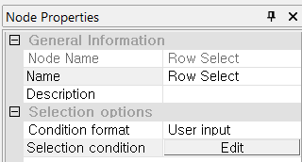**

#### Node Properties

|  |  |  |  |  |
| --- | --- | --- | --- | --- |
| Property group | Property Name | Description | Misc. | Note |
| Selection options | Condition format | Select ‘**User input’** to specify specific conditions, or ‘**Remove Rows with Missing Values’** to remove only missing values. | Required | User input,  Remove Rows with Missing Values |
| Selection condition | When the Condition format is set to ‘**User Input’**. Clicking ‘**Edit**’, the editor window pops up allowing you to enter the criteria to select the desired row from the data. | button | Refer to the **Expression editor**. |
| Conditions Reading Window | Displays the currently entered criteria formula. |  |  |

### 3.2.9 Row Select2 Node

**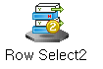**

**Row Select2** **Node** groups data based on the specified key variables and retrieves information that matches the selected variable values.

#### Usage

In the **Selection options** section, users can specify up to ten **Grouping Variables** to define how the dataset should be grouped before selecting rows; any unassigned fields remain as $NotSpecified$, meaning no grouping is applied unless variables are explicitly selected. Once the grouping is set, the **Data Variables** field is used to specify the target variable(s) from which rows will be selected. The **Variable Processing** option defines the selection rule, such as *Maximum value*, which retains only the row(s) within each group that have the highest value for the specified data variable. Other processing options (e.g., minimum, first, last) may also be available depending on the task. This node is particularly useful for tasks like extracting top-performing records per category or simplifying datasets by retaining representative rows within each group. For more detailed explanation of each property, please refer to the *Node Properties* manual below.

**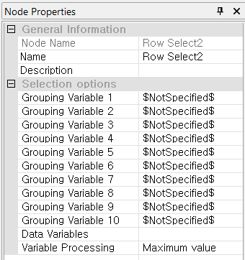**

#### Node Properties

|  |  |  |  |  |
| --- | --- | --- | --- | --- |
| Property group | Property Name | Description | Misc. | Note |
| Selection options | Grouping Variable | Group using specific variables. | Required |  |
| Data Variables | Specifies the data variables to be analyzed by the grouped variables. |  |
| Variable Processing | Specifies how the variable is processed.   * Maximum value: The maximum value for each group. * Minimum Value: The minimum value for each group. * Maximum/Minimum outlier: The values excluding the maximum and minimum for each group in a data variable. * Maximum / Minimum value: The maximum and minimum values for each group in the data variable * Remove Duplicates: The deduplicated values for each group in the data variable. * Remove Duplicates & Eliminate All Zeros: The values that are deduplicated and exclude zeros for each group in the data variable |  |

### 3.2.10 Column Combiner Node

**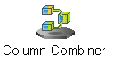**

**Column Combiner Node** combines the multiple results of modeling/model into one. It has the following limitations. Limitations 1. The model or modeling nodes you connect must use the same source data. Limitations 2. You can only connect to Model or Modeling nodes; connections to other types of nodes are not allowed.

#### Usage

Set the stream for the model or modeling task. **Connect the model or modeling nodes** within the stream, whose results you want to bundle together, to the Column Combiner Node. Analyzes the variables of the connected nodes and automatically lists the variables to be used in the Column Combiner Node. Add index numbers if duplicate variable names exist.

**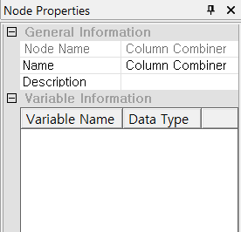**

#### Node Properties

|  |  |  |  |  |
| --- | --- | --- | --- | --- |
| Property group | Property Name | Description | Misc. | Note |
| Variable information | Variable information | Displays information about the variables that are currently combined. |  |  |

### 3.2.11 Image Processing Node

**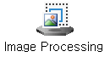**

**Image Processing Node** performs various processing tasks for the input images such as **transformation, classification, detection, recognition, extraction, distortion, modification, enhancement, restoration, compression, filtering**, and more.

#### Usage

In the **Enter Image** section, the **Input Image Path** is automatically set to “Original Image Path” when connected to the **Image Reader Node.** Clicking the **Image Processing Edit** button opens a *ECMiner Image Process Tool* pop-up window where users can define the specific processing tasks to be applied, such as resizing, filtering, or converting image formats. Under the **Image Output** section, if users want to save the processed images, they must enable **Specify Save Path** by switching it to "Yes" and then provide a valid directory in the **Storage Path** field. The **Image Metadata** section displays the variables generated or updated as part of the image processing operation, including their names, data types, and variable types. Defining an input path is required for processing, while saving output images is optional depending on whether the processed files need to be retained externally.

**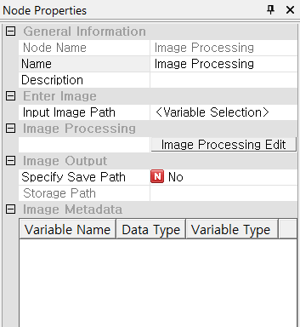**

#### Node Properties

|  |  |  |  |  |
| --- | --- | --- | --- | --- |
| Property group | Property Name | Description | Misc. | Note |
| Enter Image | Input Image Path | Select a valid field that contains the image path information | Required |  |
| Image Processing | Image Processing Edit | Apply various filters to the images. | button | Image Process Tool |
| Image Output | Specify Save Path | Specify the path for the file to be saved. | Optional | Yes, No |
| Storage Path | Displays information about the save path. |  |  |

#### Image Process Tool Usage

The image processing node's user interface is composed of several key areas: **Image List, Output, Filter, and Filter Properties**, all organized around a central **main screen**. The filters in the Image Process Tool are categorized into eight main types as follows 1. **Filter Correction**: A collection of filters that perform basic image processing. 2. **Edge Detection:** A collection of filters that detect boundaries and outline. 3. **Corner Detection**: A collection of filters that detect intersections and corners. 4. **Morphology**: Predefined shape-based filters used to transform and describe the structure of objects within an image, applicable to both binary and grayscale images. 5. **Geometric Transformation**: A collection of filters that perform geometric transformations. 6. **Pyramids**: A method that generates a multi-level image set, with each level having progressively lower resolution, starting from the original high-resolution image. 7. **Arithmetic Transformation**: A collection of filters that perform arithmetic operations. 8. **Miscellaneous**

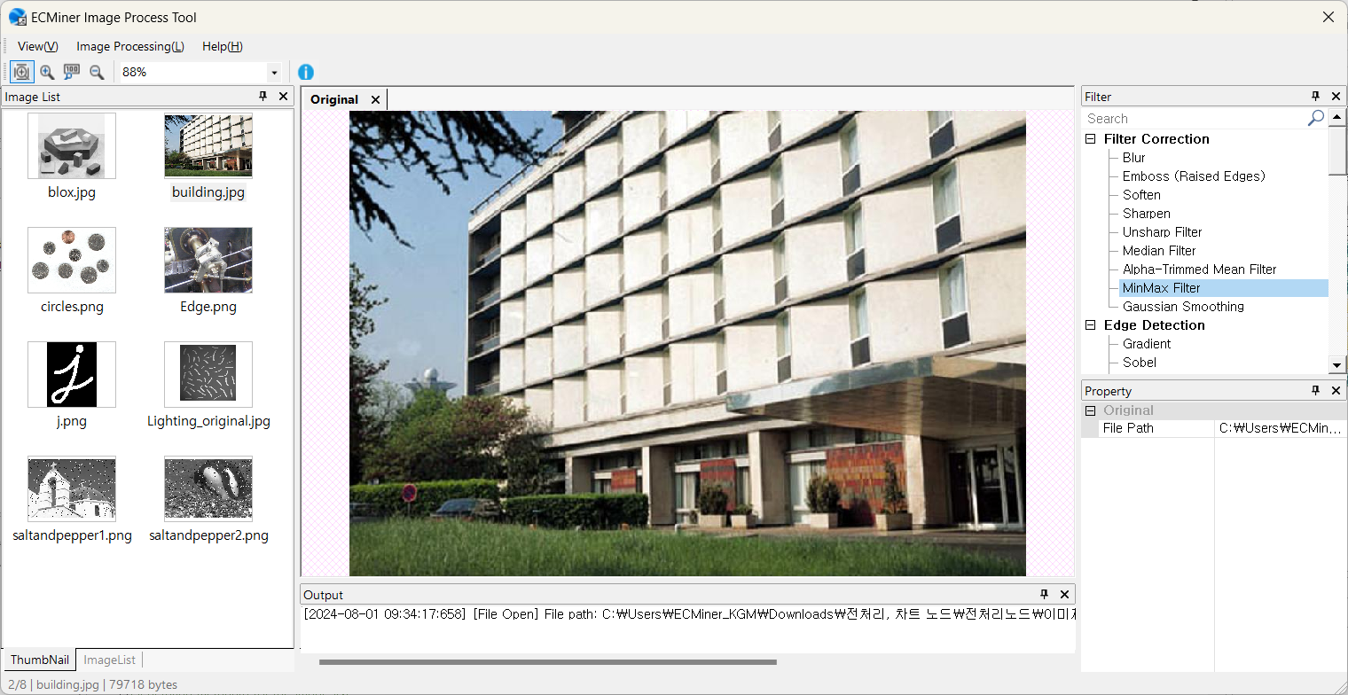

#### Operation Principle of Filters

|  |  |  |  |  |
| --- | --- | --- | --- | --- |
| Category | Filter | | Property | |
| **Name** | **Description** | **Name** | **Description** |
| Filter Correction | Blur | Blur the input image. | Filter Size | Choose from 3x3, 5x5, 7x7, 9x9, 11x11, 13x13 |
| Emboss | Apply an embossing effect to the image to accentuate its edges and create the appearance of a raised surface. | Filter Type | Choose from 135, 90, 45, North, West, South, East, Northeast |
| Soften | Transform the input image to a soft or smooth version. | Filter Type | Choose from Smoothly1,2,3 etc. |
| Sharpen | Enhance the clarity of the input image. | Mask type: | Choose from Sh |
| Unsharp Filter | Removes low-detail elements from the original image and then reapplies them to enhance the sharpness and clarity of edges and details. | Mask Size | Choose from 3x3, 5x5, 7x7, 9x9 |
| Blur Reduction Rate (%) | (Default value: 10.0) |
| Median Filter | Calculates the median value around each pixel in the image, then replaces that pixel value to preserve edges, reduce noise, and improve image smoothness. | Mask Size | Choose from 3x3, 5x5, 7x7, 9x9, 11x11, 13x13 |
| Alpha-Trimmed Mean Filter | Pixels are eliminated according to the designated alpha value in the image, and the average of the remaining values is calculated, thereby effectively mitigating noise and preserving essential image details. | Mask Size | Choose from 3x3, 5x5, 7x7, 9x9, 11x11, 13x13 |
| Alpha Value |  |
| MinMax Filter | Used to remove extreme impulse noise or to highlight features based on brightness differences.  \*Impulse noise: A condition characterized by random scattering of black and white dots. | Mask Size | Choose from 3x3, 5x5, 7x7, 9x9, 11x11, 13x13 |
| Maximum value | Max: Removes dark impulse values to brighten. Min: Removes bright impulse values to darken. |
| Gaussian Smoothing | Replaces the current pixel value in the input image with a weighted average of itself and its neighboring pixel values. | Mask Size | Sigma: (Default value: 1.0) |
| Edge Detection | Gradient | Detects edges in the input image by calculating gradient (derivative) values. | Mask Direction | Choose from x-direction, y-direction, x, y directions |
| Sobel | Detects edges in all directions in the input image, but is more sensitive to edges in diagonal directions and is robust against noise. | Mask Direction | Choose from x-direction, y-direction, x, y directions |
| Mask Size | Choose from 3x3, 5x5, 7x7 |
| Scharr | Enhances the directional accuracy of the Sobel filter, compensating for its limitations. | Mask Direction | Choose from x-direction, y-direction, x, y directions |
| Prewitt | Detects vertical and horizontal edges in the input image. It is fast, but its performance might be lower compared to other methods. | Mask Direction | Choose from x-direction, y-direction, x, y directions |
| Frei-Chen | Equalizes gradients at horizontal, vertical, and diagonal edges. Easily extracts subtle edge details and produces thinner lines, but may incorrectly detect noise as edges. |  |  |
| Roberts | Detects only well-defined edges at a very fast speed. | Mask Direction | Choose from x-direction, y-direction, x, y directions |
| Laplacian | Removes low-frequency (minimal change) and emphasizes high-frequency (significant change) to detect sharp edges in all directions of the input image. | Mask Size | Choose from 3x3, 5x5, 7x7 |
| Canny | Detects edges as a single line by setting upper and lower threshold values. | Mask Size | Choose from 3x3, 5x5, 7x7 |
| Threshold1 | (Default value: 0.2) |
| Threshold2 | (Default value: 0.8) |
| Corner Detection | Minimum Eigenvalue | A corner detection technique that utilizes the minimum eigenvalue in its calculations. | Result Image Format | Choose from Visualize feature points on the original image, View Feature Point Data |
| Mask Size | Choose from 3x3, 5x5, 7x7 |
| Block Size | (Default value: 2) |
| Minimum Detection Value Ratio | (Default value: 0.1) |
| Harris | A technique that detects corners by moving a small window within the object in the image up, down, left, and right, identifying points where there is a significant change in pixel values within the window. | Result Image Format | Choose from Visualize feature points on the original image, View Feature Point Data |
| Mask Size | Choose from 3x3, 5x5, 7x7 |
| Block Size | (Default value: 2) |
| k | (Default value: 0.04) |
| Minimum Detection Value Ratio | (Default value: 0.1) |
| GFTT (Good Features to Track) | A feature detection technique that considers affine transformations for easier tracking. | Result Image Format | Choose from Visualize feature points on the original image, View Feature Point Data |
| Block Size | (Default value: 3) |
| Detection Limit Ratio | (Default value: 0.01) |
| Detection Count Limit | (Default value: 25) |
| Minimum Distance Between Detections | (Default value: 3) |
| FAST | A feature extraction technique designed for extreme speed. | Result Image Format | Choose from Visualize feature points on the original image, View Feature Point Data |
| Threshold | (Default value: 10) |
| Non-Maximum partition suppression | Choose from Use, Not Used |
| Morphology | Erosion | Removes small objects and reduces boundaries in the input image to eliminate unwanted small noise | Kernel Shape | Choose from RECT, CROSS, ELLIPSE |
| Kernel Size | (Default value: 3) |
| Dilation | Expands small objects and enlarges boundaries in the input image to enhance structural features and close small holes. | Kernel Shape | Choose from RECT, CROSS, ELLIPSE |
| Kernel Size | (Default value: 3) |
| Opening | Apply erosion followed by dilation to remove small white noise. | Kernel Shape | Choose from RECT, CROSS, ELLIPSE |
| Kernel Size | (Default value: 3) |
| Closing | Apply dilation followed by erosion to fill or remove small black holes in white objects. | Kernel Shape | Choose from RECT, CROSS, ELLIPSE |
| Kernel Size | (Default value: 3) |
| Binary Threshold | (Default value: 100) |
| Draw Borders | Choose from Yes, No |
| Border Thickness | (Default value: 3.0) |
| R Upper Limit | (Default value: 255) |
| G Upper Limit | (Default value: 255) |
| B Upper Limit | (Default value: 255) |
| Top Hat | Extract small elements and details in the input image, and increase the brightness of objects against a dark background. | Kernel Shape | Choose from RECT, CROSS, ELLIPSE |
| Kernel Size | (Default value: 3) |
| TOP HAT Type | Choose from WHITE, BLACK |
| Gradient | Leaves only the outlines of binary image regions.  The Gradient = Dilate(src) - Erode(src) is identical to subtracting Erode from Dilate. | Kernel Shape | Choose from RECT, CROSS, ELLIPSE |
| Kernel Size | (Default value: 3) |
| Smoothing | This method is primarily used to mitigate noise or damage in an input image or video | Kernel Shape | Choose from RECT, CROSS, ELLIPSE |
| Kernel Size | (Default value: 3) |
| Geometry | Rotation | Rotate the image counterclockwise. | Rotation angle | 0~360 degrees |
| Scaling | Converts the size of the input image to a user-specified size. | Interpolation Method | Choose from Nearest, Linear, Area, Cubic, Lanczos4 |
| Scaling Size | (Default value: 1.0) |
| Super Resolution | Converts a low-resolution input image into a corrected high-resolution image. | Super Resolution Method | Choose from ESPCN, FSRCNN, or LAPSRN. |
| Scaling Size | Choose from x2, x3, or x4. |
| Crop | Cuts the input image to a user-specified size. | Select Area | Crop button |
| Method for Handling Exceptions | Choose from Zero padding, Original Version Only |
| Start of Crop X-value | (Default value: 0) |
| Start of Crop Y-value | (Default value: 0) |
| End of Crop X-value | (Default value: 256) |
| End of Crop Y-value | (Default value: 256) |
| Perspective Transform | Transforms the perspective of the image to a user-selected area. | Select Area | Perspective Transformation button |
| Top Left X-value | (Default value: 0) |
| Top Left Y-value | (Default value: 0) |
| Top Right X-value | (Default value: 256) |
| Top Right Y-value | (Default value: 0) |
| Bottom Left X-value | (Default value: 0) |
| Bottom Left Y-value | (Default value:256) |
| Bottom Right X-value | (Default value:256) |
| Bottom Right Y-value | (Default value:256) |
| Affine Transform | Transforms the input image while preserving the linearity, distance ratio, and parallelism of the image. It supports translations, scaling, rotation, and even shearing and reflection transformations. | Select Area | Affine Transformation button |
| Top Left X-value | (Default value: 25) |
| Top Left Y-value | (Default value: 25) |
| Top Right X-value | (Default value: 204) |
| Top Right Y-value | (Default value: 25) |
| Bottom Left X-value | (Default value: 128) |
| Bottom Left Y-value | (Default value:204) |
| Flip | Flip the input image. | Direction | Choose from X-axis, Y-axis, XY-axis. |
| Translation | Translates the input image. | X-axis | (Default value: 10) |
| Y-axis | (Default value: 10) |
| Log Polar Transformation | Converts from Cartesian to polar coordinates to consistently recognize objects despite changes in rotation or scale. | Direction Method | Choose from Forward, Inverse |
| M | (Default value: 80.0) |
| Pyramids | Up/Down | Applying Gaussian filtering to an image, the pyramid technique adjusts the image size. ‘pyrUp’: x2, ‘pyrDown’: x1/2. | Method | Choose from Up, Down |
| Mean Shift | Mean shift segmentation using image pyramids on the input image. It involves creating an image pyramid at specified levels, and setting the final values using the average spatial values and average color vectors through the spatial window radius and color window radius. However, due to its high computational demand, effective results require using appropriate image sizes and parameter values. | Space Radius | (Default value: 2.0) |
| Color Radius | (Default value: 40.0) |
| Maximum Pyramid Level | (Default value: 3) |
| Arithmetic Operations | Multiply /Divide | Multiplies or divides the input image by a constant value to increase or decrease brightness. | Calculation Method | Choose from Multiplication Operation, Division Operation |
| Calculation Value | (Default value: 1.0) |
| Misc. | Noise Generation | Generates various noises for the restoration of the input image. | Noise type | Choose from Gaussian, Exponential, Poisson, Uniform, Impulse, Salt and Pepper, Multi Gaussian, Laplacian |
| Mean Value | (Default value: 0.0) |
| Standard Deviation | (Default value: 100) |
| Length | (Default value: 1000) |
| Range | (Default value: 0.3) |
| Coefficient | (Default value: -20) |
| Edge Padding | Fills the edges of the image using padding methods. | Padding generation method | Choose from Fill with 0, Edge Value Replication, Mirror, Iteration, Edge Value Exclusion, |
| Padding width | (Default value: 1) |
| Thresholding | Convert pixels brighter than a given threshold to white, and all others to black for binary conversion. | Range Restriction Method | Choose from Binarization, Binarization Color, Inversion, Crop, Zero-Pointing, Zero-Point Color, nversion, OTSU, TRIANGLE |
| Threshold value | (Default value: 90) |
| Specified Value | (Default value: 255) |
| Adaptive Thresholding | Each pixel is compared to the average value of surrounding pixels; if the difference is large, the pixel is treated as an outlier and thresholded accordingly.  Pixels brighter than the adapted threshold are converted to white, and all others to black for binary conversion. | Threshold Method | Choose from Binarization, Binarization Color, Inversion, Crop, Zero-Pointing, Zero-Point Color, nversion, OTSU, TRIANGLE |
| Adaptive Thresh Method | Choose from Average, Gaussian |
| Mask Size | Choose from 3x3, 5x5, 7x7 |
| Maximum value | (Default value: 255) |
| Parameter | (Default value: 5) |
| Hough Line Detection | detect straight lines in an input image. | Canny: Usage Status | Choose from Use, Not Use |
| Canny: Mask size | Choose from 3x3, 5x5, 7x7 |
| Canny: Threshold 1 | (Default value: 0.2) |
| Canny: Threshold 2 | (Default value: 0.8) |
| Hough: Type | Choose from Standard, Probabilistic, Multi-scale |
| Hough: Rho | (Default value: 1) |
| Hough: Theta | (Default value: 180) |
| Hough: Threshold Value | (Default value: 150) |
| Hough: Raw Improvement Value(srn) | (Default value: 0) |
| Hough: Theta Improvement Value(stn) | (Default value: 0) |
| Hough: Minimum Line Length Value | (Default value: 0) |
| Hough: Maximum Line Gap Value | (Default value: 0) |
| Hough Circle Detection | Detect circles in an input image. | DP Value | (Default value: 2) |
| Minimum Distance Value | (Default value: 100) |
| PARAM1 value | (Default value: 200) |
| PARAM2 value | (Default value: 100) |
| Minimum radius value | (Default value: 10) |
| Maximum radius value | (Default value: 0) |
| Use of blur | Choose from Use, Not Use |
| Mask size | Choose from 3x3, 5x5, 7x7, 9x9, 11x11, 13x13 |
| Grayscale | Converts the input color image to a grayscale image. |  |  |
| Color Extraction | Extracts the values corresponding to Red, Blue, and Green from the input image and displays them on the screen. | Color type | Choose from Red, Green, Blue |
| Contours Detection | Finds the contours of an image by identifying boundaries that have the same color or intensity. | Use of Threshold | Choose from Use, Not Use |
| Threshold | (Default value: 127) |
| Contour Detection Mode | Choose from External, List, Ccomp, Tree |
| Contour Approximation Method | Choose from None, Simple, TC89\_L1, TC89\_KCOS |
| Output Method | Choose from Origin, |
| Flood Fill | If adjacent pixels are similar to the reference color, fill the entire area with a single color. | Staring X | (Default value: 0) |
| Staring Y | (Default value: 0) |
| Low Diff | (Default value: 5) |
| High Diff | (Default value: 5) |
| Color | Choose one of 13 colors. |
| Histogram Equalization | Calculate the cumulative sum of the image histogram and normalize it by dividing by the total number of pixels. | Histogram Method | Choosing from Smoothing, Stretching, Sliding |
| Sliding Value | (Default value: 0) |
| Fourier Transform | The Fast Fourier Transform (FFT) is an efficient algorithm that quickly performs the Discrete Fourier Transform and its inverse. It is used in many fields, from digital signal processing to algorithms for solving partial differential equations. | Transformation Method | Choose from Affine transformation, Inverse transformation |
| Change Detection | Compares a pair of selected images pixel by pixel to detect differences. | Comparison File Selection Method | Choose from Next File, Previous File, User-defined |
| Comparison File | Choose from Image List File |
| Threshold | (Default value: 50) |
| Noise Removal Filter | Choose from 1x1, 2x2, 3x3, 4x4, 5x5 |
| View Changes Only | Choose from true, false |
| Change Detection (CNN) | Divides a pair of selected images into patches at the same locations and compares them to detect changes. | Comparison File Selection Method | Choose from Next File, Previous File, User-defined |
| Comparison File | Choose from Image List File |
| Patch size | (Default value: 5) |
| Threshold | (Default value: 50) |
| View Changes Only | Choose from true, false |

### 3.2.12 Image Statistics Node

****

**Image Statistics Node** extracts statistical information about the pixels of image.

#### Overview

The **Image Statistics Node** performs grayscale preprocessing on digital images. After preprocessing, it extracts statistics (**mean, maximum, minimum, median, variance, and standard deviation**) for each pixel's grayscale values (integers from 0 to 255) in the grayscale image. The extracted statistics can be visualized using an output node or chart node.

#### Usage

Connect to an Image Reader Node. Specify the Input Image Path. When used with the Image Statistics Node, connect Image Reader - Image Processing - Image Statistics.

**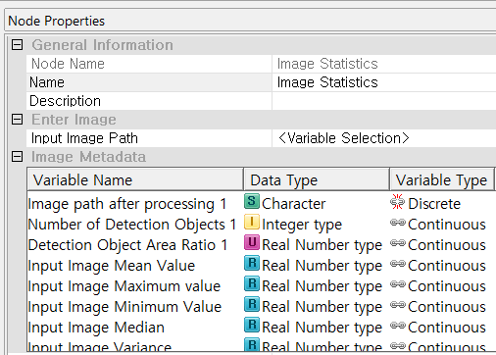**

#### Node Properties

|  |  |  |  |  |
| --- | --- | --- | --- | --- |
| Property group | Property Name | Description | Misc. | Note |
| Enter Image | Input Image Path | Select a valid field that contains the image path information | Required |  |

#### Result

In the Display Node, you can view the information of the original data points and the coordinate information of the map points on the reduced dimension.

**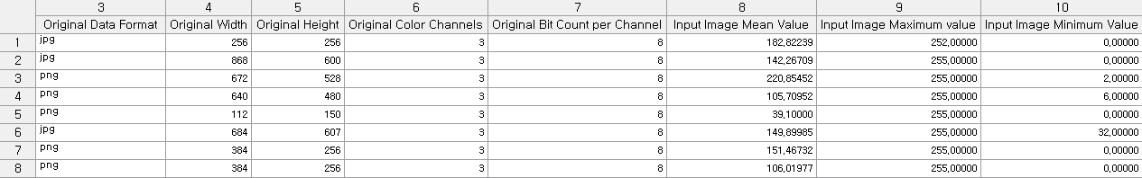**

### 3.2.13 Sort Node

****

**Sort Node** sorts data based on a specified variable.

#### Usage

In the **Sort** section, users must specify at least one **Variable Name** from the dropdown menu to determine the sorting variable. For each selected variable, the **Direction** can be set to either *Ascend* (ascending order) or *Descend* (descending order) using the dropdown menu. Additional variables can be added to define secondary or tertiary sort criteria by clicking the add button on the right, and their order of application can be rearranged using the up/down arrows on the left. This node is essential for preparing data for ordered analysis, grouped reporting, or sequential operations such as lag calculations or cumulative functions. At least one variable must be selected to enable sorting. For more detailed explanation of each property, please refer to the *Node Properties* manual below.

**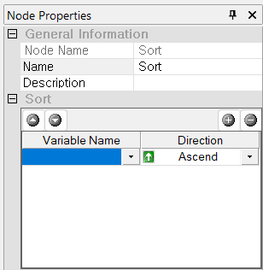**

#### Node Properties

|  |  |  |  |  |
| --- | --- | --- | --- | --- |
| Property group | Property Name | Description | Misc. | Note |
| Sort | Sorting Variables | Specify the variable to sort, the order of sorting, and the sorting direction. | User interface | Ascend, Descend |

### 3.2.14 Fill Node

**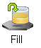**

**Fill Node** replaces values in the data of a specified variable based on conditions

#### Usage

**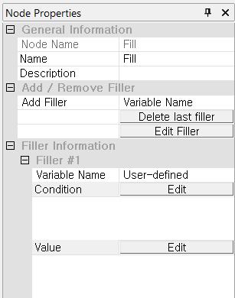**

In the **Add / Remove Filler** section, users must choose the **Add Filler** variable from the dropdown menu to which the filler rule will be applied. Multiple fillers can be added, and existing ones can be removed using the “Delete last filler” button or modified with the “Edit Filler” option. Each configured filler appears under the **Filler Information** section (e.g., *Filler #1*), where the applied conditions can be either user-define or missing values. The **Condition** field opens a condition editor when “Edit” is clicked, allowing users to set logical expressions that determine when the fill value should be used. The **Value** field also requires input via the “Edit” button, where users specify the actual replacement value. This node is especially useful for conditional data transformation, such as assigning flags, filling missing values under specific rules, or recoding variables. At least one filler rule with a condition and value must be defined for the node to function. For more detailed explanation of each property, please refer to the *Node Properties* manual below.

#### Node Properties

|  |  |  |  |  |
| --- | --- | --- | --- | --- |
| Property group | Property Name | Description | Misc. | Note |
| Add / Remove Filler | Add Filler | Select the variable name to which you want to add fillers. |  | List of available variables. |
| Delete last filler | Deletes the last filler that is currently added. | button |  |
| Edit Filler | Select the variable you want to add filler to at once. |  |
| Filler Info. | Filler | Choose whether to set the fill condition as missing values or to create a user-defined condition. If you select **User-defined**, you must provide a conditional statement. |  | User-defined, Missing Values |
| Condition Edit | Edit the fill condition using the expression editor. | button | Refer to the **Expression editor.** |
| Value Edit | Specify the value to be filled when the fill condition is met. |
| Note: When a user-defined condition is specified, the fill operation is executed as long as the result is true, regardless of the form of the entered expression. This means that whether it's a simple conditional statement (e.g., {A} < 1) or an IF ~ ENDIF structure, as long as the outcome is true, the fill will be performed. | | | | |

### 3.2.15 Add Node

****

Add Node combines multiple datasets into a single dataset. There is no limit to the number of datasets, and you can combine the input data sources together as long as memory allows.

#### Usage

When multiple data files are connected to the **Add Node**, they are listed in the **Data Source Priority** section. There is no limit to the number of datasets that can be added. The dataset at the highest priority is used as the **main source**, and other datasets are merged into it. Users can adjust the priority by moving datasets up or down in the list. The **Fields** column shows the variables that will be included when the node is executed. Variables with the same names across different sources are automatically matched and merged. The Add Node combines the selected fields from all connected datasets into a unified structure. Optional settings allow users to control the merging process, including how variables are matched, whether to include only the main source variables or variables from all sources, and whether to add a source index indicating the origin of each record. Through these settings, users can flexibly manage the merging of multiple datasets into a single integrated output. For more detailed explanation of each property, please refer to the *Node Properties* manual below.

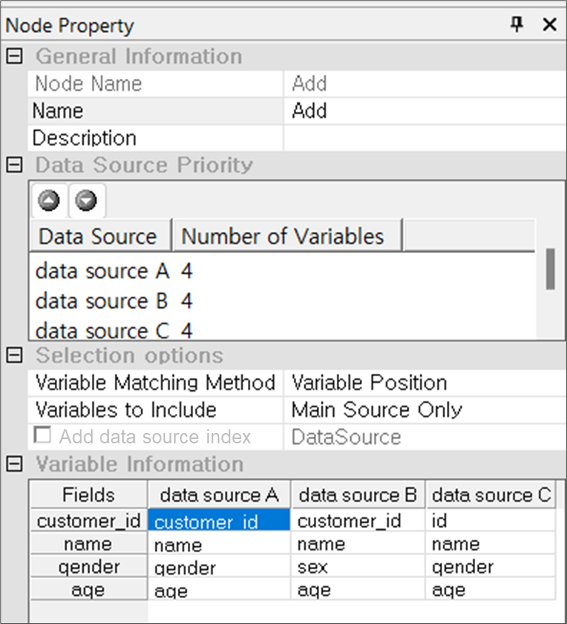

#### Node Properties

|  |  |  |  |  |
| --- | --- | --- | --- | --- |
| Property group | Property Name | Description | Misc. | Note |
| Data Source Priority | Data Source | Specify **the main source**, which serves as the basis for the combine operation in the data sources, to the top position. | Other UI | Refer to the Usage. |
| Selection options | Variable Matching Method | When combining data, choose whether to base for merging on **Variable Name** or **Variable Position**. |  | Variable Name, Variable Position |
| Variables to Include | Specify Variables to Include in the results. | Required | Main Source Only, All sources |
| Add data source index | A column is added for which data source comes from. Data source index is added in each row of data. The default name of the created column is "Data Source", which can be modified. | check-box |  |

### 3.2.16 Derived Column Node

**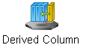**

**Derived Column Node** creates new variables.

#### Usage

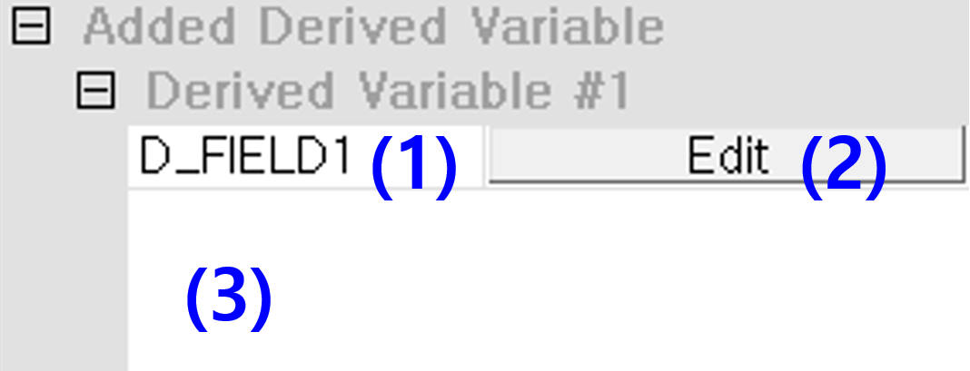

**Derived Variables** are used to **create a new variable based on an existing variable**. You can rename the derived variable by entering a new name in the name field. To define the formula for the derived variable, open the Expression Editor by clicking the Edit button. After entering the formula in the Expression Editor, you can review and verify the formula in the display area. For more detailed explanation of each property, please refer to the *Node Properties* manual below.

#### Node Properties

|  |  |  |  |  |
| --- | --- | --- | --- | --- |
| Property group | Property Name | Description | Misc. | Note |
| Add / Remove Derived Variables | Add Derived Variable | Creates additional Derived Variables. | button |  |
| Delete the last derived Variable | Deletes the most recently added derived variable, but it will not be deleted if it is the only one remaining |  |
| Edit Derived Variables | Delete any unselected derived variable. |  |
| Added Derived Variable | Derived Variable #00 | A list of derived variables that you want to add. |  | Variable name default: D\_FIELD00 (00 is index) |
| Edit | Edit the expressions of derived variables in the editor window. | button | Refer to the Expression editor. |
| Expression Window | View the formulas defined for that derived variable. |  |  |

### 3.2.17 Sampling Node

**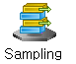**

**Sampling Node** extracts samples from data.

#### Usage

**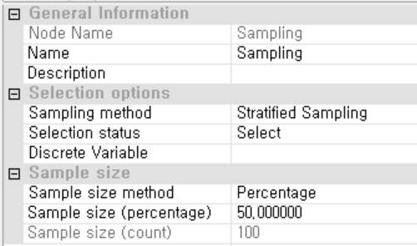**

In the **Selection options** section, users must choose a **Sampling method** from the drop down menu. If the **Selection status** field is set to *Select* it indicates that sampled records will be included in the output, whereas if it is set to *Exclusion* the sampled records will be excluded. In the **Sample size** section, users must define how the sample size is determined by selecting a **Sample size method**—either *Percentage* or *Count*. If *Percentage* is selected, the desired proportion should be entered in the **Sample size (percentage)** field (e.g., 50 for 50% of the data); alternatively, if *Count* is selected, the exact number of records to extract must be specified in the **Sample size (count)** field. Choosing a sampling method and entering a valid sample size are required steps, while specifying a discrete variable is only necessary when using stratified sampling. For more detailed explanation of each property, please refer to the *Node Properties* manual below.

#### Node Properties

|  |  |  |  |  |
| --- | --- | --- | --- | --- |
| Property group | Property Name | Description | Misc. | Note |
| Selection options | Sampling method | Select sampling method. | Required | Random Sampling, Systematic Sampling, Stratified Sampling, From the beginning, Stratified Sampling (Equal Partition) |
| Selection status | Specify whether you want to use or exclude the extracted data. | Select, Exclusion |
| Discrete Variable | Select the discrete variable to be used as the basis for stratified sampling. |  |  |
| Sample size | Sample size method | Specify the method for determining the sample size. | Required | Percentage, Count. |
| Sample size  (percentage) | Set the **Percentage** of samples for sampling. If the calculated sample count is not an integer, it is roundest to integer |  | real numbers from 0 to 100 |
| Sample size (Count) | Set the number(count) of samples for sampling |  | integer |
| NOTE: Description of the sampling method.   * Random Extraction: Extract data randomly using tools such as random number tables. * Hierarchy Extraction: Order every member of the population, extract one sample randomly, and then extract subsequent samples at fixed intervals. (Note: Only up to 50% of the total data can be sampled. Additionally, if the calculated sampling interval is not an integer, it is rounded to the nearest integer.) * Stratified Sampling: Dividing the population into homogeneous subgroups and then randomly sampling from these subgroups based on their sizes. | | | | |

### 3.2.18 Pivot Node

****

**Pivot Node** transforms data by grouping specified variables into columns and rows, and then displays the values of the desired variables based on the specified criteria, excluding the grouped columns and rows.

#### Usage

When you click the **Configure Pivoting Information** button in the properties window, the following window will pop up. Step 1: Specify the file path that will be used as the data source. Step 2: Identify the data format and set the data reading options. Step 3: Specify the Variable Type. Note: Variable name and Type cannot be change in ecl file. Step 4: Specify the data variables with the row and column variables (categorical variables) that will be used for pivoting. Step 5: Review the list of variables generated after pivoting. The pivot information interface in the properties window is as follows: Click Configure Pivoting Information button to set the properties. For more detailed explanation of each property, please refer to the *Node Properties* manual below.

**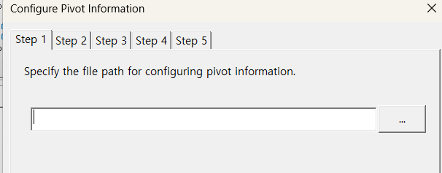**

**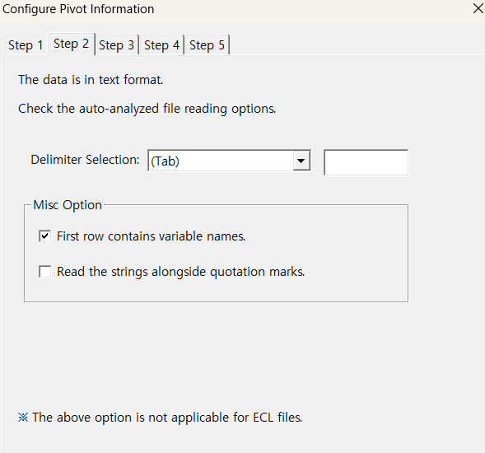**

**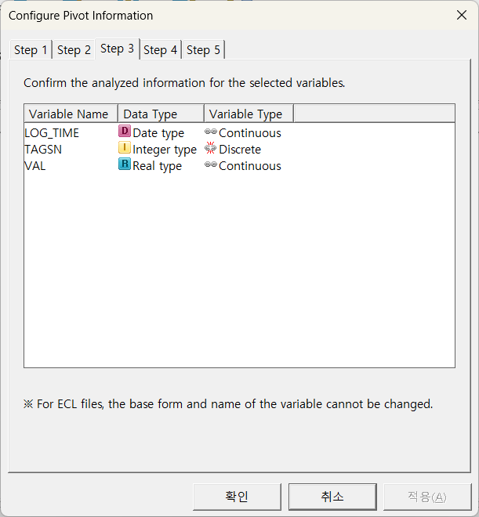**

**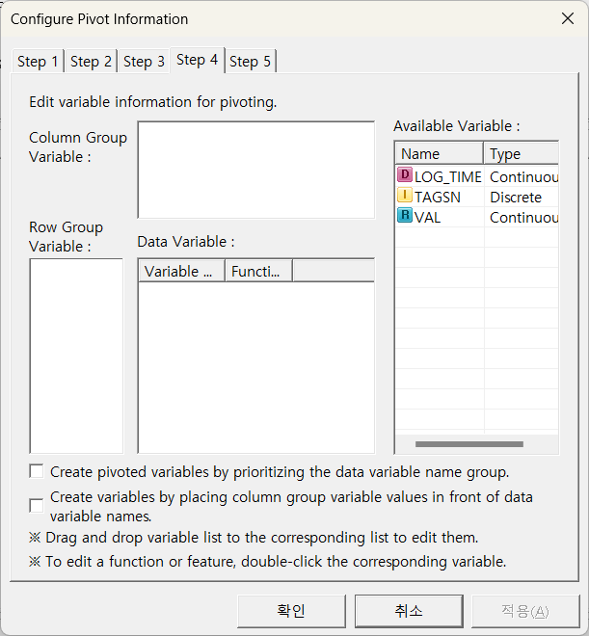**

**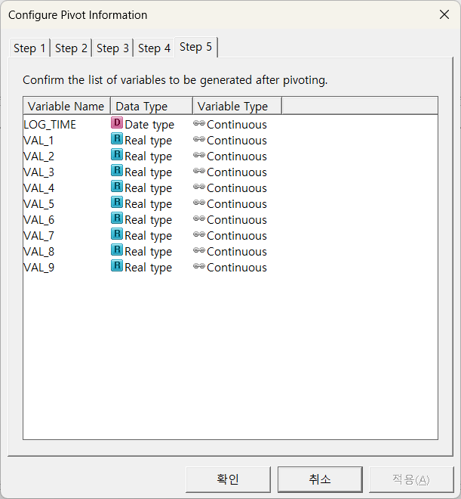**

#### Node Properties

|  |  |  |  |  |
| --- | --- | --- | --- | --- |
| Property group | Property Name | Description | Misc. | Note |
| Selection options | Configure Pivoting Information | Configure pivoting information through the properties window | button |  |

### 3.2.19 Column Filter Node

****

**Column Filter Node** filters out unused variables or renames them. You can select multiple variables for filtering at once by using the Shift and Ctrl keys

#### Usage

**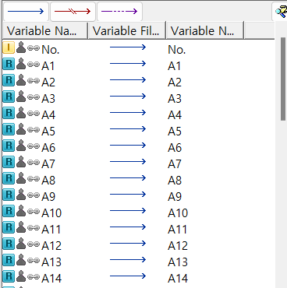**

Column Filter Node has the following **property configuration.** Column Filter Node's interface is divided into two sections: a functional button section for changing properties, and a Variable Information section for viewing the current status of variables. In the Variable Information section, you can also change variable names and attributes. **Function buttons.** The **Use Variable Icon** is used to set the selected variables for use. The **Do Not Use Variable Icon** is used to mark the selected variables as not to be used. The **Exclude During Modeling Icon** is used to exclude the selected variables only during the modeling phase. Additionally, the **Conditional Selection Button** opens the **Variable Conditional Selection Window**, allowing users to select variables based on conditions like variable type (integer, real, string, date) or variable name, using wildcard options. These functions help control which variables are actively involved in different stages of data analysis and modeling. **Variable information.** **Variable Name column** displays variable names and data types. You cannot change the data type. **Variable Type column** changes the variable type as Independent and Dependent in modeling. Double-click the left mouse button to change it. The **Data Type column** displays the statistical types of the variable. Red-marked areas cannot be changed. For other areas, double-click the left mouse button to modify. Select the variable you want to modify in the Variable Information window. Use the functional button to change the variable type, or double-click to make the change. For more detailed explanation of each property, please refer to the *Node Properties* manual below.

#### Node Properties

|  |  |  |  |  |
| --- | --- | --- | --- | --- |
| Property group | Property Name | Description | Misc. | Note |
| Variable Filter | Variable Filter | Allows to modify Usage status of variables. | Other UI | Refer to the Usage. |

### 3.2.20 Type Change Node

**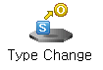**

**Type Change Node** modifies the type of a variable, defining independent or dependent variables, and continuous or discrete types. Multiple variables can be selected and changed simultaneously, and multiple selections can be made using the Shift key and Ctrl key.

#### Usage

**Type Change Node** has the following property configuration interface. The interface has two parts: a functional button for changing properties, and a Variable Information section for displaying the current status of variables**. F**unction buttons. The **Independent Variable Icon** changes the selected variable to an independent variable, while the **Dependent Variable Icon** changes it to a dependent variable. The **Continuous Variable Icon** adjusts the statistical type of the selected variable to continuous, and the **Discrete Variable Icon** changes it to discrete. The **Initialize Variable Icon** resets the type of the variable to its initial state. Additionally, the **Conditional Selection Button** opens the **Variable Conditional Selection Window**, which allows users to select variables based on specific conditions such as variable type (integer, real, string, or date) or variable name using wildcards. These tools help efficiently manage and organize variables during data processing or analysis. **Variable information.** **Variable Name column** displays variable names and data types. You cannot change the data type. **Variable Type column** changes the variable type as Independent and Dependent in modeling. Double-click the left mouse button to change it. The **Data Type column** displays the statistical types of the variable. Red-marked areas cannot be changed. For other areas, double-click the left mouse button to modify. Select the variable you want to modify in the Variable Information window. Use the functional button to change the variable type, or double-click to make the change.For more detailed explanation of each property, please refer to the *Node Properties* manual below.

**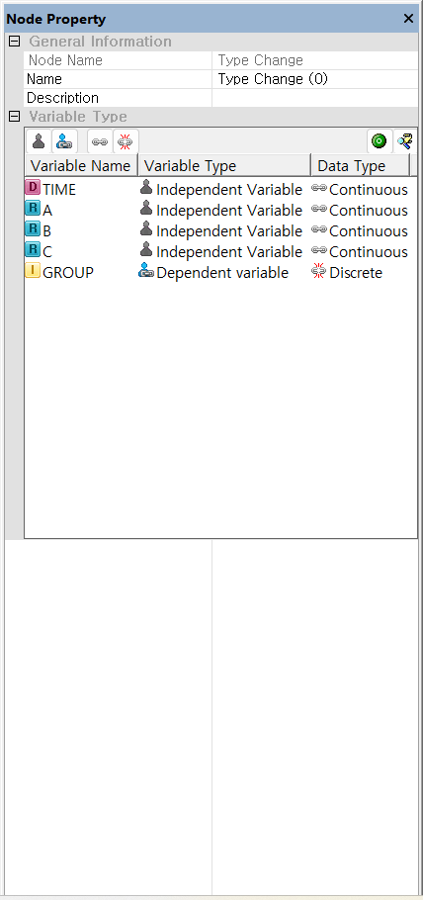**

#### Node Properties

|  |  |  |  |  |
| --- | --- | --- | --- | --- |
| Property group | Property Name | Description | Misc. | Note |
| Data Type | Data Type | Allows to change the type of a variable. | Other UI | Refer to the Usage. |

### 3.2.21 Counter Node



**Counter Node** adds the count results for each group as derived variables according to the specified grouping conditions.

#### Usage

**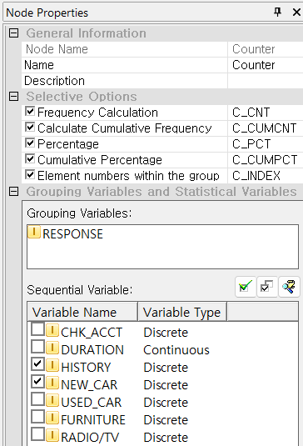** 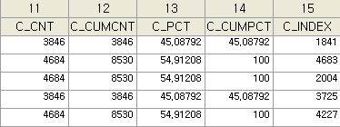

In the **Selective Options** section, users can enable various calculations such as **Frequency Calculation** (C\_CNT), **Cumulative Frequency** (C\_CUMCNT), **Percentage** (C\_PCT), **Cumulative Percentage** (C\_CUMPCT), and **Element numbers within the group** (C\_INDEX), each of which produces a new variable with the specified suffix. These options can be selectively enabled depending on the desired outputs. Under **Grouping Variables and Statistical Variables**, users must define one or more **Grouping Variables** to specify how the data should be partitioned before counting. Additionally, a **Sequential Variable** must be selected from the list to determine the sort order within each group for cumulative and index calculations. This node is especially useful for frequency distribution analysis, ranking within groups, and preparing datasets for further statistical evaluation. At least one grouping and one sequential variable must be selected, and enabling at least one calculation option is required for the node to execute. For more detailed explanation of each property, please refer to the *Node Properties* manual below.

#### Node Properties

|  |  |  |  |  |
| --- | --- | --- | --- | --- |
| Property group | Property Name | Description | Misc. | Note |
| Selection options | Selection options | Adds a derived variable based on the selected value |  | Frequency Calculation, Calculation Cumulative Frequency, Percentage, Cumulative Percentage, Element numbers within the group |
| Grouping Variables and Sequential Variable | Grouping Variables | Specify the grouping variable; it must be discrete | Required |  |
| Sequential Variable | Selecting ‘Element numbers within the group’, assign the element number in the order of the value of the Sequential Variable. | Optional |  |

### 3.2.22 Group Statistics Node

****

**Group Statistics Node** adds a new derived variable based on the selected statistics of the chosen variable according to the specified grouping conditions.

#### Usage

**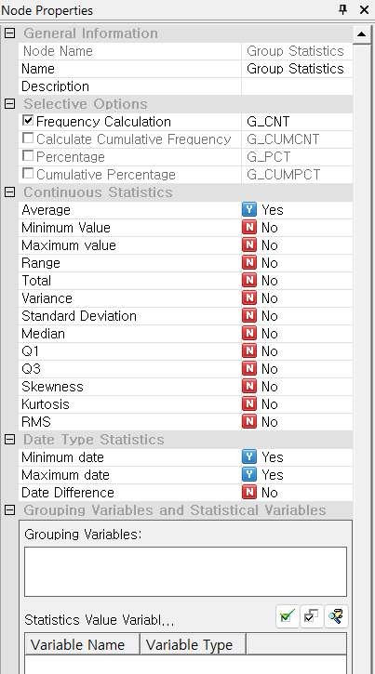**

In the **Selective Options** section, users can choose from several summary outputs, such as **Frequency Calculation** (G\_CNT), **Cumulative Frequency**, **Percentage**, and **Cumulative Percentage**, each generating a new variable with the corresponding suffix. In the **Continuous Statistics** section, users can select one or more statistical measures to compute across groups, including **Average**, **Minimum Value**, **Maximum Value**, **Range**, **Standard Deviation**, and others. These are set individually using "Yes" or "No" toggles. Similarly, in the **Date Type Statistics** section, users can compute **Minimum date**, **Maximum date**, or **Date Difference** where applicable. In the **Grouping Variables and Statistical Variables** section, users must define at least one **Grouping Variable** to specify how the data should be segmented, and one or more **Statistics Value Variables** to indicate which continuous or date-type variables the calculations should apply to. Proper configuration of grouping and statistical value variables is required, while selecting specific statistics and frequency options is flexible depending on the analysis goals. For more detailed explanation of each property, please refer to the *Node Properties* manual below.

#### Node Properties

|  |  |  |  |  |
| --- | --- | --- | --- | --- |
| Property group | Property Name | Description | Misc. | Note |
| Selection options | Selection options | Adds a derived variable based on the selected value |  | Frequency Calculation, Calculation Cumulative Frequency, Percentage, Cumulative Percentage |
| Statistics | Continuous Statistics | Specify which continuous statistical information you want to use to add the derived variable. | Required | At least one selection required,  Average, Minimum Value, Maximum value, Range, Total, Variance, Standard Deviation, Median, Q1, Q3, Skewness, Kurtosis, RMS |
| Date Type Statistics | Specify which date-related statistical information you want to use to add the derived variable. | Optional | Minimum date, Maximum date, Date Difference |
| Grouping Variables and Statistical Variables | Grouping Variables | Specify the grouping variable; it must be discrete. | Required |  |
| Statistical Variables | Select the variable for which you want to check statistical values based on the grouping variable. The statistical value variable must be continuous. | Required |  |

### 3.2.23 RANKING Node



**Ranking Node** calculates rankings and adds them as a derived variable.

#### Usage

In the **Rank Criteria** section, users must select at least one **Variable Name** to define the ranking basis, and set the **Direction** to either *Ascend* or *Descend*, depending on whether higher or lower values should receive higher ranks. Additional variables can be added for secondary sorting using the add button on the right, and the order of variables can be adjusted with the arrow controls on the left. In the **Selection options** section, users must specify the name of the output **Rank Variable**, which will store the computed rank values (e.g., RANK\_VAL). The **Save as String** option allows users to store the rank as a text value if needed, though it is typically kept as numeric. The **Rank Count** determines the maximum number of rank levels to assign; values beyond this count may be grouped or capped depending on the system’s behavior. This node is useful for tasks such as scoring, top-N filtering, and percentile classification. At least one ranking variable and an output rank name must be specified for execution. For more detailed explanation of each property, please refer to the *Node Properties* manual below.

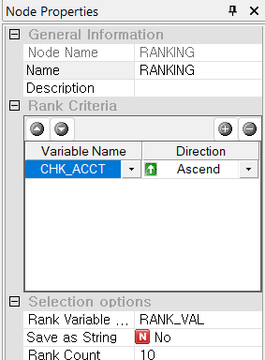

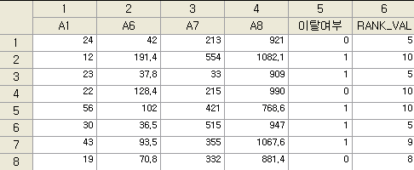

#### Node Properties

|  |  |  |  |  |
| --- | --- | --- | --- | --- |
| Property group | Property Name | Description | Misc. | Note |
| Selection options | Rank Criteria | Specify the variables to be ranked and the ranking direction. | Required | Ascending /Descending |
| Rank Variable Name | Enter the name for the new derived variable created after ranking. |  |
| Save as String | Specify whether to add the ranking variable as a string type. | Optional |  |
| Rank Count | Specify the number of ranks. If the entered value is less than 2, the rank count will be set to the total number of data entries. | Required |  |

### 3.2.24 Binning Node

**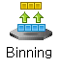**

**Binning Node** segment an independent variable into several intervals. It is used for converting numerical variables into categorical ones or for redefining the categories of discrete variables.

#### Usage

Using **Binning Node**, two datasets are required: bass data to determine the binning criteria and another data to apply the binning. The bass data must have a **discrete dependent variable**, requiring an initial step of saving the data in an ECL file. Clicking "**Edit Binning**" button, you will see the following interface. Load the previously saved ECL file as bass data and Specify the Dependent Variable. Add the Independent Variables and execute binning on each of the variables. <Note> Interval and Interval Number are only for continuous variables. Adjust the intervals based on the charts and statistics. For more detailed explanation of each property, please refer to the *Node Properties* manual below.

**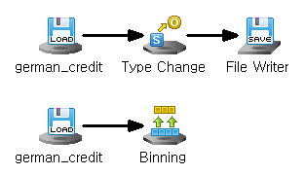** 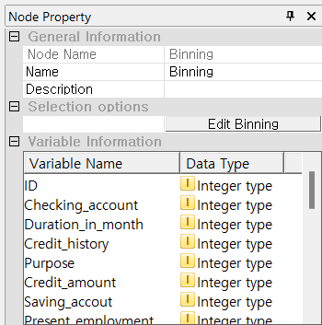

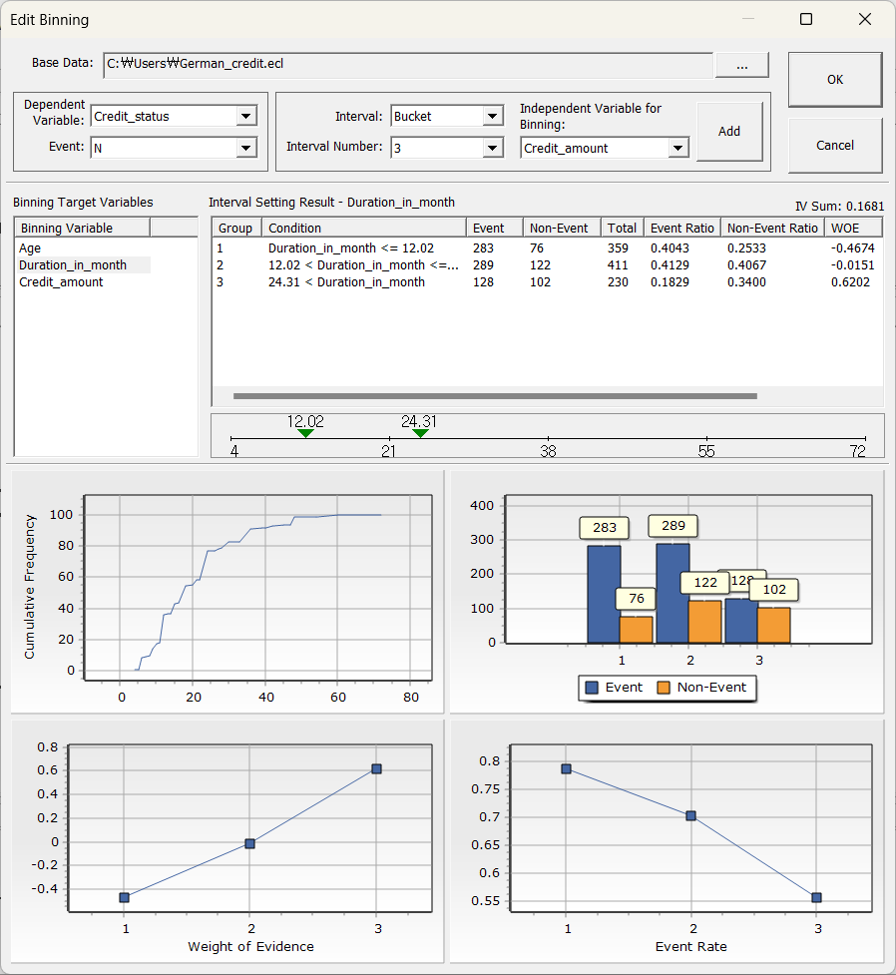



#### Node Properties

|  |  |  |  |  |  |
| --- | --- | --- | --- | --- | --- |
| Property group | Property Name | function | Description | Misc. | Note |
| Selection options | Edit Segmentation | Base Date | Load the ECL file. |  |  |
| Dependent Variable | Select dependent variable values considered as an Event. |  |  |
| Independent Variable | Select independent variable.  -Continuous data splits according to interval conditions such as **Buckets/Quantile** and **Interval Number**.  -Discrete data splits all attributes into separate groups. |  |  |
| Binning Variable | Display the added variable for binning. |  |  |
| Binning Results | Display statistical information for each interval.  Right-click to perform modifications, such as merging or splitting intervals. |  |  |
| Interval | Modify the interval criteria for continuous data. | Right click, drag |  |
| Chart | Display the information for each group. |  |  |

### 3.2.25 Transpose Node

**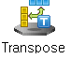**

**Transpose Node** switches the rows and columns of the data.

#### Usage

**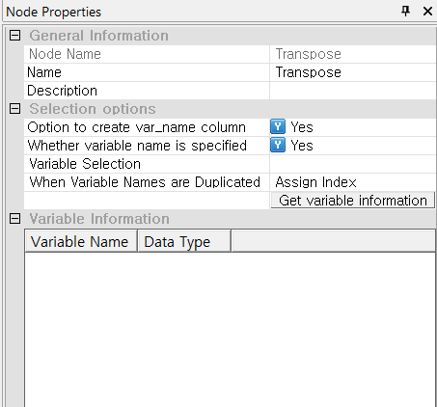**

In the **Selection options** section, the **Option to create var\_name column** setting, when enabled, adds a column that stores the original variable names as values—useful for identifying transposed data. The **Whether variable name is specified** option, if set to "Yes," allows users to select which variables to transpose through the **Variable Selection** interface. The **When Variable Names are Duplicated** option determines how name conflicts are handled in the transposed output; for example, selecting *Assign Index* will append an index to duplicated variable names to prevent errors. Clicking **Get variable information** retrieves metadata for the selected variables, which is then displayed in the **Variable Information** section. Users must specify at least one variable for transposition if variable selection is enabled. This node is essential for reshaping data layouts, especially in scenarios involving multivariate records or time series data. For more detailed explanation of each property, please refer to the *Node Properties* manual below.

#### Node Properties

|  |  |  |  |  |
| --- | --- | --- | --- | --- |
| Property group | Property Name | Description | Misc. | Note |
| Selection options | Option to create var\_name column | Decide whether to add the original data's column names as new variables. | Optional | Yes, No |
| Whether variable name is specified | Decide whether to use specific variable values from the original data as column names for the new data. | Yes, No |
| Variable Selection | Specify the variables to be used as column names. | When specifying column names |  |
| When Variable Names are Duplicated | Specify the handling method in case of duplicate variable names. | When specifying column names | Assign Index, Error Occurred |
| Get variable information | After setting the properties, you must click the **Get variable information** button to retrieve the data. It is necessary to click this button each time the properties are changed. | Required, button |  |
| Example: You can transpose rows and columns, using a specific variable as the column name for the new data, and adding the original column names as a new variable. | | | | |

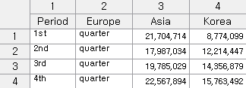

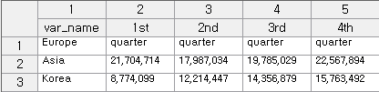

### 3.2.26 Tagging Node

****

**Tagging Node performs morphological analysis by segmenting morphemes and assigning parts of speech**

#### Usage

ECMiner™ can **perform morphological analysis** using its built-in dictionary without any additional configuration options. Optional: Use the User Dictionary File. Specify Variable Name of Result column. When you click the "User Dictionary Registration" button, you will see the following interface. Click the **dictionary registration** button to access the **User-defined Dictionary** and add words that are not in the default dictionary. **The format of the dictionary: (1) Lemma Notation.** Enter the **lemma** and **part of speech**, separated by a tab. You can use standard parts of speech or user-defined parts of speech. **(2) Regular Expression.** Enter the “**Regular Expression”**, **part of speech**, and the **regular expression** separated by tabs. You can use standard parts of speech or user-defined parts of speech.For more detailed explanation of each property, please refer to the *Node Properties* manual below.

**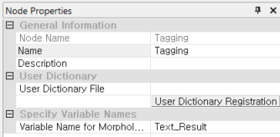**

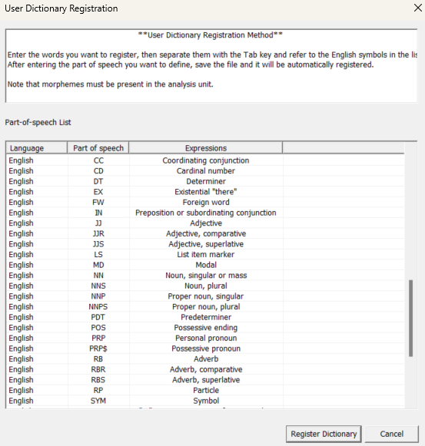

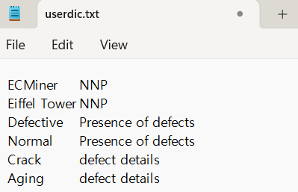

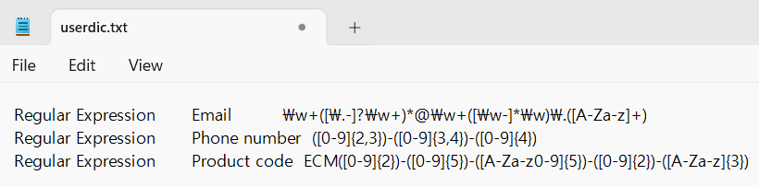

#### Node Properties

|  |  |  |  |  |
| --- | --- | --- | --- | --- |
| Property group | Property Name | Description | Misc. | Note |
| User Dictionary | User Dictionary File | Specify the dictionary file path as needed. | button | Refer to the Usage. |
| User Dictionary Registration | Register morphemes in the dictionary to add new words or specify phrases as morphemes. |
| Specify Variable Names | Variable Name for Morphological Analysis Result | Specify the default names for newly created morpheme and part-of-speech variables. |  |  |

#### Results

Tagging Nodes accepts a string-type variable as input and produces five output columns. **Input sentence**: Input data for morphological analysis. **Text\_Result (Morpheme)**: Morphemes extracted from the input sentence. **Text\_Result (Part of Speech)**: Parts of speech of the morphemes. **English POS of Words**: English part of speech of the morpheme within the phrase. **Sentence English POS (Part of Speech)**: English part of speech of the morpheme within the sentence. \*When there are two or more character-type variables. Assume there is data composed of two character-type variables as follows. You can see that combining two character-type variables from the input data forms the input sentence.

**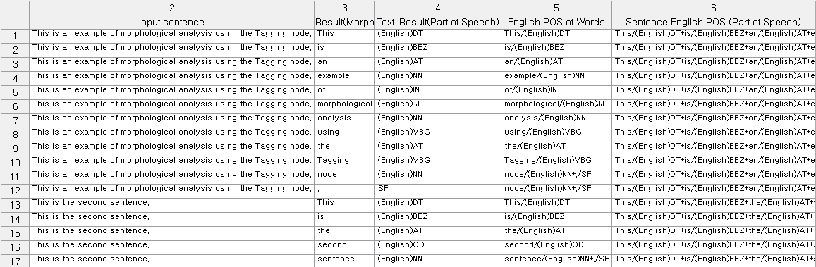**

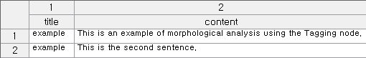

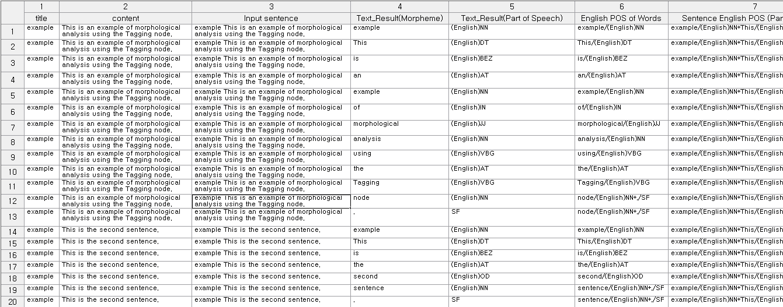

|  |  |  |  |  |  |  |  |  |  |  |  |  |  |  |  |  |  |  |  |  |  |  |  |  |  |  |  |  |  |  |  |  |  |  |  |  |  |  |  |  |  |  |  |  |  |  |  |  |  |  |  |  |  |  |  |  |  |  |  |  |  |  |  |  |  |  |  |  |  |  |  |  |  |  |  |  |  |  |  |  |  |  |  |  |  |  |  |  |  |  |  |  |  |  |  |  |  |  |  |  |  |  |  |  |  |  |  |  |  |  |  |  |  |  |  |  |  |  |  |  |  |  |  |  |  |  |  |  |  |  |  |  |  |  |  |  |  |  |
| --- | --- | --- | --- | --- | --- | --- | --- | --- | --- | --- | --- | --- | --- | --- | --- | --- | --- | --- | --- | --- | --- | --- | --- | --- | --- | --- | --- | --- | --- | --- | --- | --- | --- | --- | --- | --- | --- | --- | --- | --- | --- | --- | --- | --- | --- | --- | --- | --- | --- | --- | --- | --- | --- | --- | --- | --- | --- | --- | --- | --- | --- | --- | --- | --- | --- | --- | --- | --- | --- | --- | --- | --- | --- | --- | --- | --- | --- | --- | --- | --- | --- | --- | --- | --- | --- | --- | --- | --- | --- | --- | --- | --- | --- | --- | --- | --- | --- | --- | --- | --- | --- | --- | --- | --- | --- | --- | --- | --- | --- | --- | --- | --- | --- | --- | --- | --- | --- | --- | --- | --- | --- | --- | --- | --- | --- | --- | --- | --- | --- | --- | --- | --- | --- | --- | --- | --- | --- | --- |
| ***NOTE****: Regular expressions serve as templates to match specific patterns and search terms in data. They are made up of literals (pure letters or numbers), metacharacters (which represent types of characters or character groups), and escape sequences.*   * **Literal**: When only literals are used, without metacharacters and escapes, their representation is identical to the lemma notation. Example) "Regular expression name John Doe" extracts "John Doe" as a morpheme and assigns it the part of speech "name." * Single Character Metacharacters  |  |  |  | | --- | --- | --- | | **Metacharacters** | **Description** | **Examples** | | **\*** | Find at least 0 preceding strings or sub-expressions. | "zo\*" finds "z" and "zoo." | | **+** | Find one or more of the preceding strings or subexpressions. | "zo+" finds "zo" and "zoo" but not "z." | | **?** | Find one or more of the preceding strings or subexpressions.  When a `?` follows other quantifiers like `\*`, `+`, `?`, `{n}`, `{n,}`, or `{n,m}`, the matching pattern becomes non-greedy. Non-greedy patterns seek the smallest possible matching section within the searched string, in contrast to the default greedy patterns, which aim to match as much of the string as possible. | zo? finds "z" and "zo" but not "zoo”.  "o+?" finds one "o" in "oooo," while "o+" finds all the "o"s.  "do(es)?" finds "do" in both "do" and "does." | | **^** | Locates positions at the start of the searched string. When used with the `m` flag for multi-line searching, it also finds positions following `\n` or `\r`.  When used as the first character inside brackets, `^` negates the set of characters. | "^\d{3}" finds three digits at the beginning of the searched string.  "[^abc]" finds any character except for a, b, and c. | | **$** | Locates positions at the end of the searched string. When used with the `m` flag for multi-line searching, it also finds positions before `\n` or `\r`. | "\d{3}$" finds three digits at the end of the searched string. | | **.** | Find all single characters except the newline character `\n`. To find all characters, including `\n`, patterns like `[\s\S]` are used. | "a.c" finds "abc," "a1c," and "a-c." | | **[]** | Square brackets mark the beginning and end of a set, grouping one or more individual characters into a list. | [1-4] finds "1", "2", "3", or "4". [^aAeEiIoOuU] finds any character that is not a vowel. | | **{}** | Quantifiers mark the start and end of an expression and specify the number of times to repeat the sequence when the number of characters cannot be predefined. | a{2,3} finds "aa" and "aaa". | | **()** | Parentheses mark the beginning and end of a subexpression, which can be stored for later use. | A(\d) finds anything from "A0" to "A9", storing the digit for later use. | | **|** | The pipe symbol represents a choice between two or more items. | z|food finds either "z" or "food". (z|f)ood finds "zood" or "food". | | **/** | Slashes mark the beginning and end of a literal regular expression pattern. After the second slash, a single character flag can be added to specify search behavior. | /abc/gi is a literal regular expression that finds "abc". The 'g' flag specifies finding all occurrences of the pattern, and the 'i' flag specifies ignoring case during the search. | | **\** | The following character is indicated as a special character, literal, or octal escape.  To search for a single character meta character, you must escape the character. | \n finds a newline character. \( finds "(". \\ finds "\". \+ finds "+". |  * Composite character-type metacharacters  |  |  |  | | --- | --- | --- | | **Metacharacters** | **Description** | **Example** | | **\b** | Finds word boundaries, which are positions between a word and a space. | "er\b" finds "er" in "never" but not in "verb." | | **\B** | Finds non-word boundaries. | "er\B" finds "er" in "verb" but not in "never." | | **\d** | Finds digits.  Same as [0-9]. | When the searched string is "12 345," "\d{2}" finds "12" and "34." "\d" finds "1," "2," "3," "4," or "5." | | **\D** | Finds non-digit characters.  Same as [^0-9]. | "\D+" finds "abc" and " def" in "abc123 def." | | **\w** | Finds non-digit characters.  Same as [^0-9]. | When the searched string is "The quick brown fox…," "\W+" finds "…" and all spaces. | | **\W** | Finds all characters except A-Z, a-z, 0-9, and underscores.  Same as [^A-Za-z0-9\_]. | When the searched string is "The quick brown fox…," "\W+" finds "…" and all spaces. | | **[xyz]** | It is a character set. Finds any one of the specified characters. | "[abc]" finds "a" in "plain." | | **[^xyz]** | It is a negated character set. Finds any characters not specified. | "[^abc]" finds "p," "l," "i," and "n" in "plain." | | **-a[z]** | It is a character range. Finds characters within a specified range. | "[a-z]" finds lowercase English letters from "a" to "z." | | **[^a-z]** | It is a negated character range. Finds any characters not within the specified range. | "[^a-z]" finds all characters that are not in the range "a" to "z." | | **{n}** | Finds exactly n occurrences, where n is an integer. | "o{2}" does not find the "o" in "Bob" but finds the two "o"s in "food." | | **{n,}** | Finds at least n occurrences, where n is an integer.  "\*" is equivalent to {0,}.  "+" is equivalent to {1,}. | "o{2,}" does not find the "o" in "Bob" but finds all the "o"s in "foooood." | | **{n,m}** | Finds at least n and at most m occurrences, where n and m are integers, and n is less than or equal to m. There should be no space between the comma and the numbers.  "?" is equivalent to {0,1}. | When the searched string is "1234567," "\d{1,3}" finds "123," "456," and "7." | | **(pattern)** | Finds a pattern and stores the matching items.  To find the parenthesis characters ( ), use "\(" or "\)". | "(Chapter|Section) [1-9]" finds "Chapter 5" and stores "Chapter" for later use. | | **(?:pattern)** | Finds a pattern but does not store the matches. That is, the matches are not saved for later use. This is useful when combining parts of the pattern with the "or" character (|). | "industr(?:y|ies)" is the same as industry|industries. | | **(?=pattern)** | It is a positive lookahead. After finding a match, it starts the search for the next match from in front of the matched text. The matches are not stored for later use. | ^(?=.\*\d).{4,8}$ ensures a password is between 4-8 characters and includes at least one digit.  Within the pattern, ".\*\d" finds any number of characters followed by a digit. When the searched string is "abc3qr," it matches "abc3."  ".{4,8}" starts from the front, not the back of the match, finding 4-8 characters. This matches "abc3qr."  "^" and "$" specify positions at the start and end of the searched string. This ensures that if there are characters outside the matched string, it does not count as a match. | | **(?!pattern)** | It is a negative lookahead. It finds search strings that do not match the pattern. After finding a match, it starts the search for the next match from in front of the matched text. The matches are not stored for later use. | "\b(?!th)\w+\b" finds words that do not start with "th."  Within the pattern, "\b" finds word boundaries. When the searched string is " quick," it matches the first space. "(?!th)" finds strings that are not "th," matching "qu."  "\w+" searches for a word from the front of the match. This matches "quick." | | **\cx** | Finds control characters marked with "x". The value of "x" must be within the range of A-Z or a-z. If not, "c" is considered as the literal character "c". | "\cM" finds the Ctrl+M or carriage return character. | | **\xn** | Finds "n", where "n" is a hexadecimal escape value. The hexadecimal escape value must be exactly two digits long. ASCII codes can be used in regex. | "\x41" finds "A". "n" must be exactly two digits, so "\x041" is like writing "\x04" followed by "1". | | **\num** | Finds "n", where "n" is a hexadecimal escape value. The hexadecimal escape value must be exactly two digits long. ASCII codes can be used in regex. | "(.)\1" finds two consecutive identical characters. | | **\n** | Identifies either an octal escape value or a backreference. If there are more than "n" captured subexpressions before "\n", then "n" is a backreference indicating additional repetitions of the subexpression. If "n" is an octal (0-7) and there are not enough preceding captures, then "n" is an octal escape value. | "(\d)\1" finds two consecutive identical digits. | | **\nm** | Identifies either an octal escape value or a backreference. If there are more than "nm" captured subexpressions before "\nm", then "nm" is a backreference. If there are "n" captures before "\nm" and a literal "m" follows, then "n" is a backreference followed by literal "m". If none of these conditions are met, "\nm" finds the octal escape value "nm", assuming "n" and "m" are octal (0-7). | "\11" finds the tab character. | | **\nml** | Finds the octal escape value "nml" where "n" is an octal (0-3) and "m" and "l" are octals (0-7). | "\011" finds the tab character. | | **\un** | Finds "n", where "n" is a Unicode character represented by a four-digit hexadecimal | "\u00A9" finds the copyright symbol (©). |  * Escaping: Unmentioned non-printable characters in metacharacters are also specified by escapes.  |  |  |  | | --- | --- | --- | | **Metacharacters** | **Description** | **Included options** | | **\f** | Form feed character | \x0c and \cL | | **\n** | Line feed character | \x0a and \cJ | | **\r** | Carriage return character | \x0d and \cM | | **\s** | All whitespace characters, including space, tab, and form feed characters. | [ \f\n\r\t\v] | | **\S** | All non-whitespace characters | [^ \f\n\r\t\v] | | **\t** | Tab character | \x09 and \cI | | **\v** | Vertical tab character | \x0b and \cK | |

## 3.3 Chart Node

**Chart Node** is for data visualization. Data visualization is an essential tool, and ECMiner™ provides various charts option.

* [3D Chart Node (√)](#_3.3.1_3D_Chart)  
  Create dynamic 3D charts using data.
* [Bar Chart](#_3.3.2_Bar_Chart)   
  Draw a bar chart using data.
* [Box plot](#_3.3.3_Box_plot)  
  Visualize data distribution with median, quartiles, range, and outliers.
* [Contour Chart](#_3.3.4_Contour_Chart_1)  
  Draw a contour chart using data.
* [Control Chart (√)](#_3.3.5_Control_Chart)  
  Display a control chart to show data distribution.
* [Histogram](#_3.3.6_Histogram)  
  Draw a histogram to assess the distribution of continuous variables.
* [Matrix Chart (√)](#_3.3.7_Matrix_Chart)  
  Visualize data in a matrix format to show correlations between variables.
* [Matrix GL Chart](#_3.3.8_Matrix_GL)  
  Use GP/GPU to explore variations across variables in a matrix chart.
* [MSPC Chart (√)](#_3.3.9_MSPC_Chart)  
  Analyze multiple interrelated variables to monitor process stability and anomalies.
* [Multi Chart](#_3.3.10_Multi_Chart)  
  Compare features of multiple variables simultaneously.
* [Parallel Coordinates GL Chart](#_3.3.11_Parallel_Coordinates)  
  Connect variables across parallel axes to identify data patterns and relationships.
* [Pareto Chart](#_3.3.12_Pareto_Chart)  
  Draw a Pareto chart to visualize the distribution of discrete variables.
* [Pie Chart](#_3.3.13_Pie_Chart)  
  Draw a pie chart to show the relative ratios of discrete data.
* [Process Contribution Chart](#_3.3.14_Process_Contribution)  
  Visualize model data and contributions using the Process and Model Node.
* [Rader Chart](#_3.3.15_Radar_Chart)   
  Display values of multiple variables along radiating axes for comparison.
* [SPC Chart (√)](#_3.3.16_SPC_Chart)  
  Monitor and analyze data fluctuations for process stability and quality control.
* [Statistic Chart](#_3.3.17_Statistic_Chart)  
  Compare statistics of variables, showing changes in statistics at a glance
* [Scatter plot](#_3.3.18_Scatter_plot)  
  Create scatter plots to display trends between variables.
* [Trend Chart (√)](#_3.3.18_Trend_Chart)  
  Create time series charts to display trends.
* [Word Cloud](#_3.3.19_Word_Cloud)  
  Visualize word frequencies in text data with word size proportional to frequency.

ECMiner™ provides data slide bar function to the charts marked (√) in above list. The bar function allows you to match the data to the charts which specifies the distribution and area of specific data within the chart.

The **Chart Toolbar** appears at the top of the charting window and includes several commonly used buttons. The **Edit button** allows users to modify chart properties and access the editing window by right-clicking on the chart and selecting Properties. **The Print, Copy, and Save buttons** are used to print the chart, copy it, or save it as an image file, respectively. The **Extract Data button** enables users to extract data from displayed points and generate a Row Select Node for selecting those points. **Axes Scaling** adjusts both X and Y axes equally, while the Indicator Line toggles vertical and horizontal lines that follow the mouse pointer. **Mark Tip** and **Mark All** respectively toggle the display of a data point marker at the mouse location and markers for all visible points. The **Auto** **Play button** lets users select a number of data points using a slide bar and automatically play through the data at intervals of 1, 5, or 10 seconds. Lastly, **the slide bar** can also be used to manually highlight data within a desired section using a series-specific color. 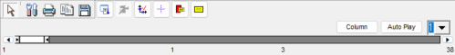

Basic chart operations include several interactive and customization features. Users can move the chart by right-clicking and dragging with the mouse, and zoom into specific areas by dragging a rectangular selection—though this zoom function is not available for Radar Charts, Matrix Charts, Box Plots, or Word Clouds. The **Change Point Size** option allows adjustment of the data point size from 1 to 10, while the **Change Line Size** option modifies the thickness of connecting lines between data points, ranging from sizes 1 to 5. The **Activate/Deactivate Legend** function lets users choose whether to display the chart legend, which can aid interpretation; legends with checkboxes also allow users to show or hide specific data. Finally, the **Properties** option opens the editing window, functioning the same as the **Edit** button in the Chart Toolbar.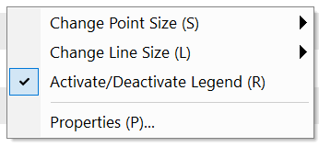

The 3D Chart Toolbar includes five buttons specifically designed for use with 3D charts. The **Rotate** button allows users to rotate the chart by clicking and dragging, while the **Move** button enables repositioning of the chart in the same way. The **Zoom** function lets users zoom in or out by dragging—zooming in is done by dragging from the top left to the bottom right, and reversing the direction restores the original view. The **Depth** button adjusts the depth dimension of the chart through click-and-drag interaction. Finally, the **3D** button toggles the chart display between 3D and 2D modes.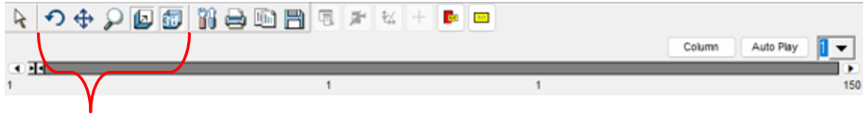

The GL Chart Toolbar functions similarly to the basic chart toolbar, with shared buttons such as **Print**, **Save**, **Indicator**, **Mark Tip**, and **Auto Play**, all performing the same roles as in the standard version. Unique to the GL chart are three additional features: the **Max Range** function, which allows users to input a desired value range and press the Set button to isolate and highlight data within that range; the **Point** option, which adjusts the size of data points (ranging from 3 to 10) specifically for use in Matrix GL Charts; and the **Line** option, which controls the thickness of lines (from size 1 to 10) connecting data points in Parallel Coordinates GL Charts.



### 3.3.1 3D Chart

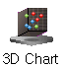

**3D Chart** is for 3D dynamic chart using data.

#### Usage

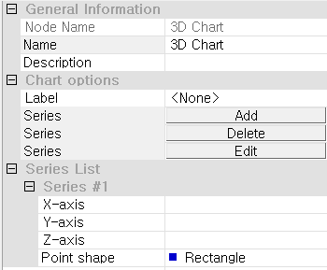

In the **Chart options** section, users can choose a discrete variable from the drop-down menu in the **Label option** to identify a set of variables to be plotted. Use the **Add**, **Delete**, and **Edit** buttons to manage the series configuration. Once a series is added, the **Series List** section displays list of **Series #**, where users must specify variables for the **X-axis**, **Y-axis**, and **Z-axis** to define the 3D coordinate space. Additionally, the **Point shape** option allows customization of the data point marker, such as a rectangle or other shape, to enhance visual distinction. At least one complete series with X, Y, and Z variables must be defined for the chart to render properly. This node is ideal for visualizing complex relationships and distributions across three continuous dimensions. For more detailed explanation of each property, please refer to the *Node Properties* manual below.

#### Node Properties

|  |  |  |  |  |  |
| --- | --- | --- | --- | --- | --- |
| Property group | Property Name | | Description | Misc. | Note |
| Chart options | Label | | Select the variable to label that separate the data with coloring. |  |  |
| Add | | Used to plot multiple series on a single chart. Adds selected series. | button |  |
| Delete | | Deletes last added series. | button |  |
| Edit | | Removes unselected series. | button |  |
| Series List | Series #00 | X-axis | Select a variable for X-axis | Required |  |
| Y-axis | Select a variable for Y-axis | Required |  |
| Z-axis | Select a variable for Z-axis | Required |  |
| Point shape | Point shape: Rectangle, Circular, Triangle, Inverse Triangle, Cross, X-type, Star-Shape, Diamond, Small Dot |  |  |

### 3.3.2 Bar Chart



**Bar Chart** draws a bar chart using data.

#### Usage

In the **Chart options** section, users can configure the **Bar Stack** setting to control how multiple series are displayed—either as *None* (side-by-side), *Stacked*, or *Stacked 100%* bars. The **X-axis format** specifies how categories are arranged along the horizontal axis, typically using a data index or a selected variable. Users must define at least one **Series** using the **Add**, **Delete**, or **Edit** buttons, which will open the configuration for each plotted data group. Under the **Series List**, for each series (e.g., *Series #1*), the user must specify a **Variable** to determine bar height and can optionally assign a **Label** to name the series in the legend. At least one series with a defined variable is required to generate a bar chart. This node is particularly effective for comparing quantities across categories or tracking changes over time. For more detailed explanation of each property, please refer to the *Node Properties* manual below.

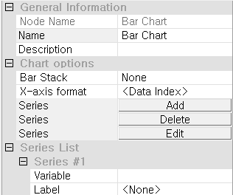

#### Node Properties

|  |  |  |  |  |  |
| --- | --- | --- | --- | --- | --- |
| Property group | Property Name | | Description | Misc. | Note |
| Chart options | Bar Stack | | Specify the type of bar chart. (Disabled when the X-axis type is set to series index due to the nature of the Bar Chart.) | Required | None, Stacked, Stacked 100% |
| X-axis format | | Set X-axis type.  Data Index: Data index values of the specified variables will be used for the X-axis.  Series Index: The chart will be divided by series, which can be identified through the legend | Required | Data Index, Series  Index |
| Add | | Used to plot multiple series on a single chart. Adds selected series. | button |  |
| Delete | | Deletes last added series. | button |  |
| Edit | | Removes unselected series. | button |  |
| Series List | Series #00 | Variable | Specify the variable to be displayed as a bar chart | Required |  |
| Label | Specify the variable to be used as the label. If the type of the specified variable is discrete, this property will be ignored |  |  |
| NOTE: The meaning of a Bar chart varies based on the variable type.   * If the variable is continuous, the x-value represents the data index and the y-value represents the corresponding variable value. * If the variable is discrete (categorical), the x-value represents the category name and the y-value represents the frequency of data in that category. | | | | | |

### 3.3.3 Box plot

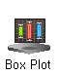

**Box plot** visualize the distribution of data with information of median, quartiles, range, and outliers by Group variable.

#### Usage

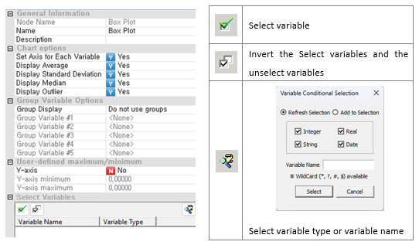

In the **Chart options** section, users can enable features such as displaying the **Average**, **Standard Deviation**, **Median**, and **Outlier** markers for each variable. Enabling **Set Axis for Each Variable** allows each box plot to be drawn on its own Y-axis scale, which is useful when variables differ greatly in range. Under **Group Variable Options**, users can optionally group data by up to five variables; set **Group Display** to *Use groups* if grouping is required, or *Do not use groups* to generate plots for the entire dataset. In the **User-defined maximum/minimum** section, users can manually set Y-axis bounds by toggling the **Y-axis** setting to "Yes" and specifying **Y-axis minimum** and **Y-axis maximum** values—this is optional and useful for standardizing scales across plots. This node is ideal for comparing distributions, detecting outliers, and visualizing data variation across multiple variables or groups. For more detailed explanation of each property, please refer to the *Node Properties* manual below.

#### Node Properties

|  |  |  |  |  |
| --- | --- | --- | --- | --- |
| Property group | Property Name | Description | Misc. | Note |
| Chart options | Set Axis for Each Variable | Decide whether to set separate axes for each variable and draw the chart accordingly. | Required | Yes, No |
| Display Average | Decide whether to display averages on the chart. | Required | Yes, No |
| Display Standard Deviation | Decide whether to display the standard deviation on the chart. | Required | Yes, No |
| Display Median | Decide whether to display the median on the chart. | Required | Yes, No |
| Outlier Display | Decide whether to display outlier on the chart. | Required | Yes, No |
| Group Variable Options | Group Display | Specify the method for displaying group-related variables in the data if such variables are present. | Required | No grouping or Series separation |
| Group Variable #1 | Select the first group variable. |  |  |
| Group Variable #2 | Select the second group variable. |  |  |
| Group Variable #3 | Select the third group variable |  |  |
| Group Variable #4 | Select the fourth group variable |  |  |
| Group Variable #5 | Select the fifth group variable. |  |  |
| User-defined maximum/minimum | Y-axis | Decide whether to use manually specified Y-axis values. | Required | Yes, No |
| Y-axis minimum | Minimum value of Y-axis |  | Real Number |
| Y-axis maximum | Maximum value of Y-axis |  | Real Number |
| Select Variables | Variable List | Specify the variables to be plotted. | Required |  |

**Box plot**: Divides the data into 10 groups based on the two group variables FIELD1 and FIELD4, and draws 10 box plots accordingly when 'Group Display' is set to 'Series'.

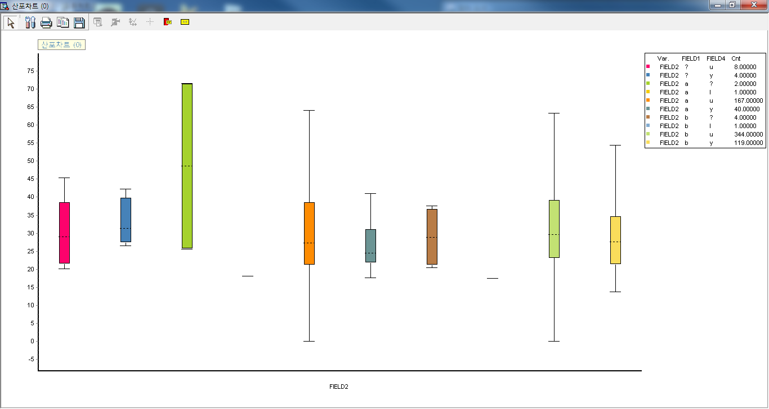

### 3.3.4 Contour Chart

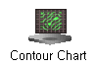

**Contour Chart** draws a contour chart using data.

#### Usage

In the **Chart options** section, users can choose whether to enable **3D Surface** rendering by setting the drop-down menu to “Yes,” which will display a three-dimensional surface instead of a flat contour map. Users must define at least one **Series** using the **Add**, **Delete**, or **Edit** buttons to configure the data to be plotted. In the **Series List**, each series (e.g., *Series #1*) requires the assignment of variables to the **X1-Axis**, **X2-Axis**, and **Y-Axis**, which define the grid and value surface. Additionally, users can choose a **Color pattern** (e.g., *Strongly*) to control the gradient or intensity used to differentiate value ranges in the contour visualization. At least one complete series must be specified to generate the chart, and the selected variables must be continuous to ensure meaningful interpolation across the axes. This node is particularly useful for analyzing spatial or functional patterns in multivariate data. For more detailed explanation of each property, please refer to the *Node Properties* manual below.

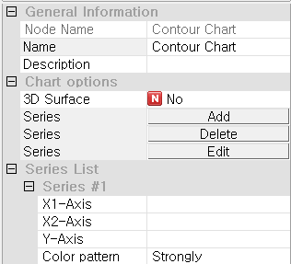

#### Node Properties

|  |  |  |  |  |  |
| --- | --- | --- | --- | --- | --- |
| Property group | Property Name | | Description | Misc. | Note |
| Chart options | 3D Surface | | Specify whether to display in 3D or in 2D. | Required | Yes, No |
| Add | | Used to plot multiple series on a single chart. Adds selected series. | button |  |
| Delete | | Deletes last added series. | button |  |
| Edit | | Removes unselected series. | button |  |
| Series List | Series #00 | X1-Axis | Specify the variable for the X1 axis (first position coordinate). | Required |  |
| X2-Axis | Specify the variable for the X2 axis (second position coordinate) | Required |  |
| Y-Axis | Specify the Y-axis variable, which represents the height. | Required |  |
| Color pattern | Specify the color pattern for the contours on the chart. | Required | Strongly, Weaken, Three Colors, Two Colors, Monochrome |

### 3.3.5 Control Chart

**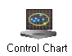**

**Control Chart** displays a control chart Using a control chart, you can see the distribution of data.

#### Usage

In the **Chart options** section, users can optionally assign a **Label** to group data points and enable **Colors by Label** to apply different colors based on that grouping, which aids in identifying trends or shifts across categories. Users must define at least one **Series** using the **Add**, **Delete**, or **Edit** buttons. Within the **Series List**, each series (e.g., *Series #1*) requires a variable for the **X-axis** (typically time or sequence) and a variable for the **Y-axis** (typically a measured value). The **Point shape** can be customized (e.g., Rectangle) for better visual clarity. At least one complete series must be configured to generate the control chart. This node is particularly effective for quality control, identifying outliers, and detecting changes in process stability. For more detailed explanation of each property, please refer to the *Node Properties* manual below.

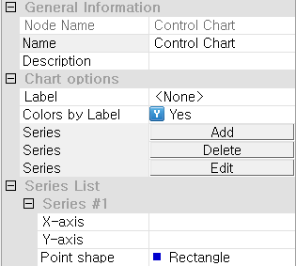

#### Node Properties

|  |  |  |  |  |  |
| --- | --- | --- | --- | --- | --- |
| Property group | Property Name | | Description | Misc. | Note |
| Chart options | Label | | Select the variable to label that separate the data with coloring. |  |  |
| Colors by Label | | Select whether to color by label or by series. |  | Yes, No |
| Add | | Used to plot multiple series on a single chart. Adds selected series. | button |  |
| Delete | | Deletes last added series. | button |  |
| Edit | | Removes unselected series. | button |  |
| Series List | Series#00 | X-Axis | Select a variable for X-axis | Required |  |
| Y-Axis | Select a variable for Y-axis | Required |  |
| Point shape | Point shape: Rectangle, Circular, Triangle, Inverse Triangle, Cross, X-type, Star-Shape, Diamond, Small Dot | Required |  |

### 3.3.6 Histogram



**Histogram** draws a histogram that allows you to assess the distribution of a continuous variable. It is applicable for continuous variables and can simultaneously plot both a normal distribution and a curve.

#### Usage

To draw a histogram, users must first specify the interval method as either *Interval Width* or *Number of Intervals*, and then select a continuous variable for the chart. Various configuration options are available to customize the output. Under **Chart Options**, users can set the number of charts per row if *Create Chart for Each Variable* is enabled. **Group Variable Options** allow users to specify how groups are displayed. If the Y-axis setting is enabled, the **User-defined Maximum/Minimum** section allows manual entry of Y-axis limits. For the **Interval Method**, users can define either the interval width or the number of intervals based on the selected method. **Range Setting** determines how the data range is defined: either automatically using the variable’s maximum and minimum values when *Auto-Configuration* is enabled, or manually by specifying these values when it is disabled. Additionally, users can enable a **Distribution Line** to display a normal distribution curve on the histogram. For more detailed explanation of each property, please refer to the *Node Properties* manual below.

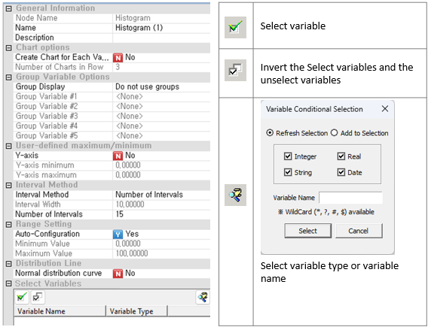

#### Node Properties

|  |  |  |  |  |
| --- | --- | --- | --- | --- |
| Property group | Property Name | Description | Misc. | Note |
| Chart options | Create Chart for Each Variable | Plots multiple charts, one for each variable. | Required | Yes, No |
| Number of Charts in Row | Specify the number of charts to be placed in each row. |  | Natural Number |
| Group Variable Options | Group Display | Specify the method for displaying group-related variables in the data if such variables are present | Required | No grouping, Series separation, or Chart separation |
| Group Variable #1 | Select the first group variable. |  |  |
| Group Variable #2 | Select the second group variable. |  |  |
| Group Variable #3 | Select the third group variable |  |  |
| Group Variable #4 | Select the fourth group variable. |  |  |
| Group Variable #5 | Select the fifth group variable. |  |  |
| User-defined maximum/minimum | Y-axis | Decide whether to use manually specified Y-axis values. | Required | Yes, No |
| Y-axis minimum | Minimum value of Y-axis |  | Real Number |
| Y-axis maximum | Maximum value of Y-axis |  | Real Number |
| Interval Method | Interval Method | Specify the method for determining the data intervals of the specified continuous variable. | Required | Interval Width, Number of Intervals |
| Interval Width | Enabled when the **Interval method** is set to **interval Width**. Calculates the number of data points within each specified interval and draws a histogram |  | Real Number |
| Number of Intervals | Enabled when the **Interval method** is set to **number of sections**. Divides the entire range into the specified number of intervals, calculates the number of data points within each interval, and draws a histogram |  | Natural Number |
| Range Setting | Auto-Configuration | Determine whether to manually specify the minimum and maximum values for the range of the histogram | Required | Yes, No |
| Minimum Value | Enabled when **Auto-Configuration** is set to **No**. Enter the minimum value for the range in which to draw the histogram. |  | Real Number |
| Maximum Value | Enabled when **Auto-Configuration** is set to **No**. Enter the maximum value for the range in which to draw the histogram. |  | Real Number |
| Distribution Line | Normal distribution curve | Specify whether to include a normal distribution curve | Required | Yes, No |
| Select Variables | Variable list | Specify the variables to be plotted as a chart. | Required |  |

### 3.3.7 Matrix Chart

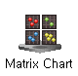

**Matrix Chart** visualizes data in a matrix format. It represents the correlation between multiple variables.

#### Usage

|  |  |  |  |  |  |  |  |
| --- | --- | --- | --- | --- | --- | --- | --- |
|  | |  |  | | --- | --- | |  | Select variable | |  | Invert the Select variables and the unselect variables | |  | Select variable type or variable name | |

To configure the *Matrix Chart* node in ECMiner(TM), users must first choose the **Charting method**, selecting either *Simple Matrix Plot* or *Matrix of Designated Rows for X, Y*, depending on whether the full variable set or paired inputs will be used. In the **Chart options** section, users can optionally enable **Draw Histogram** to include histograms along the axes and specify the **Number of Bins** for histogram resolution. Under **Group Variable Options**, up to five grouping variables can be set to display group-specific patterns or distributions; otherwise, set **Group Display** to *Do not use groups* for unsegmented visualization. If needed, users may activate the **User-defined maximum/minimum** option to manually set axis ranges by enabling Y-axis and/or X-axis control and providing the respective min/max values. Finally, users must select at least one variable under **Select Variable #1**, and optionally define **Variable #2** if the chosen charting method requires a distinct pairing of X and Y variables. Proper configuration ensures effective visualization of variable distributions and relationships in a matrix format. For more detailed explanation of each property, please refer to the *Node Properties* manual below.

#### Node Properties

|  |  |  |  |  |
| --- | --- | --- | --- | --- |
| Property group | Property Name | Description | Misc. | Note |
| Chart options | Charting method | **Simple Matrix Plot**: Scatter plot of X and Y  **Matrix of Designated Rows for X, Y**: Draws a scatter plot with the variable selected in **Variable Selection #1** as the X-axis and the variable selected in **Variable Selection #2** as the Y-axis. | Required | Simple Matrix Plot, Matrix of Designated Rows for X, Y |
| Draw Histogram | For **Matrix of Designated Rows for X, Y.** Determine whether to draw a histogram for each variable. | Required | Yes, No |
| Number of Bins | **For Matrix of Designated Rows for X, Y, set** the number of bins. | Required | Real Number |
| Group Options | Group Display | Display group-related variables in color if they are present in the data. |  | Color by category |
| Group Variable #1 | Select the first group variable. |  |  |
| Group Variable #2 | Select the second group variable. |  |  |
| Group Variable #3 | Select the third group variable. |  |  |
| Group Variable #4 | Select the fourth group variable. |  |  |
| Group Variable #5 | Select the fifth group variable. |  |  |
| User-defined maximum/minimum | Y-axis | Decide whether to use manually specified Y-axis values. | Required | Yes, No |
| Y-axis minimum | Minimum value of Y-axis |  | Real Number |
| Y-axis maximum | Maximum value of Y-axis |  | Real Number |
| X-axis | Decide whether to use manual specified X-axis. Maximum and Minimum values. | Required | Yes, No |
| X-axis minimum | Minimum value of X-axis |  | Real Number |
| X-axis maximum | Maximum value of X-axis |  | Real Number |
| Select Variable #1 | Variable list | Specify variables to be drawn as a matrix chart. |  |  |
| Variable Selection #2 | Variable list | For **Matrix of Designated Rows for X, Y, s**pecify the variables to be plotted in the matrix chart. | Required |  |

#### Results

In a matrix plot, users can choose between two charting methods. The **Simple Matrix Plot** creates a scatter plot in matrix format by using the specified variables interchangeably as both X and Y axes. In contrast, the **Matrix of Designated Rows for X, Y** method generates a matrix-form scatter plot where the variable selected in *Variable Selection #1* is used for the X-axis and the variable in *Variable Selection #2* is used for the Y-axis.

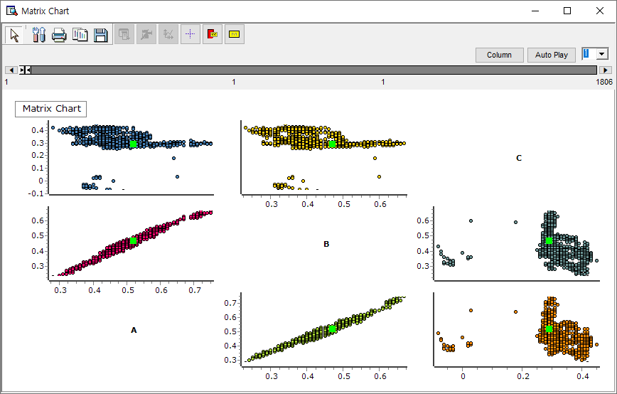

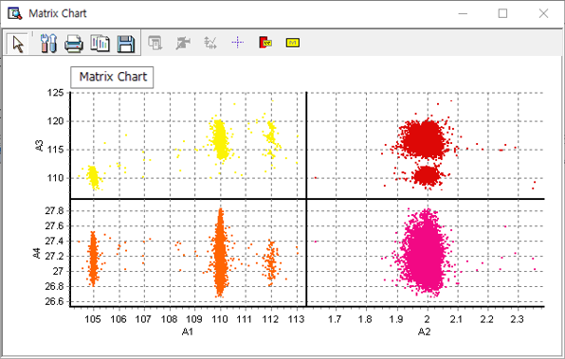

### 3.3.8 Matrix GL Chart

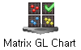

**Matrix GL chart** utilizes GP/GPU to explore variations in observed values across variables, offering an enhanced version of the matrix chart.

#### Usage

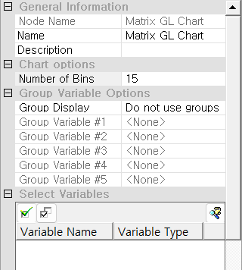

In the **Chart options** section, users can specify the **Number of Bins**, which defines the granularity of histograms or density plots shown in the matrix cells—this value influences the resolution of visual comparisons between variables. Under **Group Variable Options**, users can optionally assign up to five grouping variables to compare subgroup distributions; otherwise, the **Group Display** should remain set to *Do not use groups* for a general overview. In the **Select Variables** section, users must select two or more variables from the dataset to include in the matrix. These variables are used to construct pairwise plots that visualize distribution patterns, correlations, or clusters across all combinations. Selecting appropriate variables and adjusting the bin count allows users to tailor the matrix for exploratory data analysis or outlier detection. For more detailed explanation of each property, please refer to the *Node Properties* manual below.

#### Node Properties

|  |  |  |  |  |
| --- | --- | --- | --- | --- |
| Property group | Property Name | Description | Misc. | Note |
| Chart options | Number of Bins | Set the number of sections of the histogram. |  | natural number |
| Group Variable Options | Group Display | Specify whether to disable group display or Color by category. | Optional | Do not use groups, Color by category |
| Group Variable #1 | Select the first group variable. |  |  |
| Group Variable #2 | Select the second group variable. |  |  |
| Group Variable #3 | Select the third group variable. |  |  |
| Group Variable #4 | Select the fourth group variable. |  |  |
| Group Variable #5 | Select the fifth group variable. |  |  |
| Select Variables | Variable List | Specify at least 3 variables to be plotted. | Required |  |

### 3.3.9 MSPC Chart

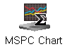

**MSPC Chart** analyzes the impact of multiple interrelated variables on a process, comprehensively monitoring the process's stability, variability, and anomalies.

#### Usage

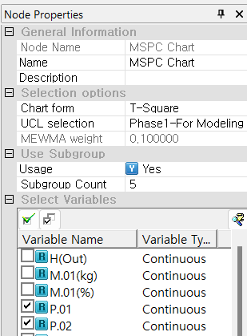

In the **Selection options** section, users must choose a **Chart form** depending on the desired method of variance detection. The **UCL selection** setting defines how the upper control limit is determined; for example, *Phase1–For Modeling* is used when control limits are estimated from an initial modeling phase. If the *MEWMA* chart form is selected, the **MEWMA weight** parameter must also be set to adjust the weighting for exponential smoothing. Under **Use Subgroup**, users can enable subgrouping by setting **Usage** to “Yes” and specifying the **Subgroup Count**, which determines the number of observations within each subgroup for control calculation. In the **Select Variables** section, users must choose two or more continuous variables that will be monitored for multivariate shifts or anomalies. Proper selection of chart type, control limit configuration, and subgrouping is essential to accurately detect process deviations and maintain quality standards in multivariate environments. For more detailed explanation of each property, please refer to the *Node Properties* manual below.

#### Node Properties

|  |  |  |  |  |
| --- | --- | --- | --- | --- |
| Property group | Property Name | Description | Misc. | Note |
| Selection options | Chart form | Select charting method. | Required | T2, MEWMA, generalized variance, T2-generalized variance). |
| UCL selection | Specify the standard of UCL (Upper Control Limit) if you select T2, T2-Generalized Variance. Phase1 is used when creating a model, and Phase2 is used when monitoring new data. |  | Phase1-for modeling, Phase2-for monitoring |
| MEWMA weight | Specify the weight If you select **MEWMA**. |  | 0~1 |
| Use Subgroup | Usage | Select whether to use subgroups. | Required | Yes, No |
| Subgroup Count | Enter the count of the subgroup if Usage is **Yes** |  | natural number |
| Select Variables | Variable List | Specify the variables to be plotted. | Required |  |

**T² Control Chart (Hotelling T² Control Chart)** monitors the mean of multiple variables by considering both individual variation and the correlations between variables, functioning similarly to the X-Bar control chart. It is used to assess multivariate processes, and a T² statistic that exceeds control limits indicates a potential issue. To use this chart, select *T-Square* in the Chart form, choose the variables for multivariate monitoring under *Select Variables*, and specify the type of management limit line in *UCL Selection*. Optionally, users can enter the number of subgroups.

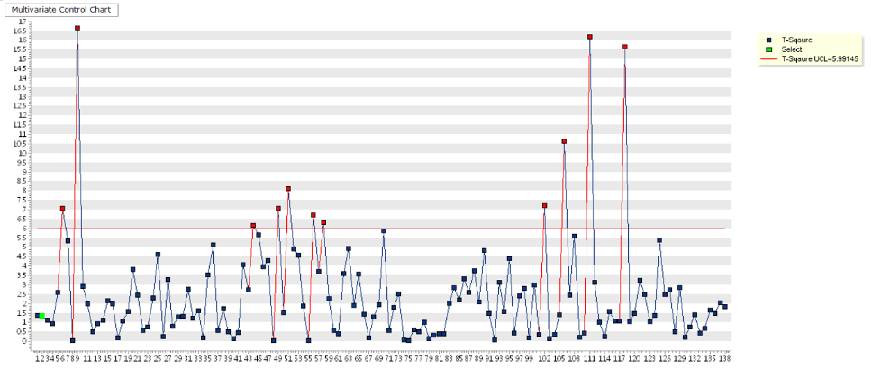

**MEWMA Control Chart (Multivariate Exponentially Weighted Moving Average Control Chart)** is designed to detect small shifts in a process by applying exponentially weighted moving averages, with greater weight given to more recent data points. This increases the sensitivity of the chart, especially when using a smaller smoothing constant. To configure this chart, select *MEWMA* in the Chart form, choose variables under *Select Variables*, and enter a smoothing weight between 0 and 1 (default is 0.1). Optionally, users can input the number of subgroups.

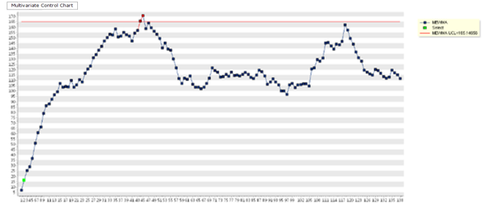

**Generalized Variance Control Chart** monitors the variability among multiple correlated variables, similar in concept to the S control chart. It evaluates process stability through the covariance matrix, and an out-of-control signal is generated when the generalized variance exceeds control limits. To use this chart, select *Generalized Distribution* in the Chart form, choose the variables in *Select Variables*, and define the number of required subgroups.

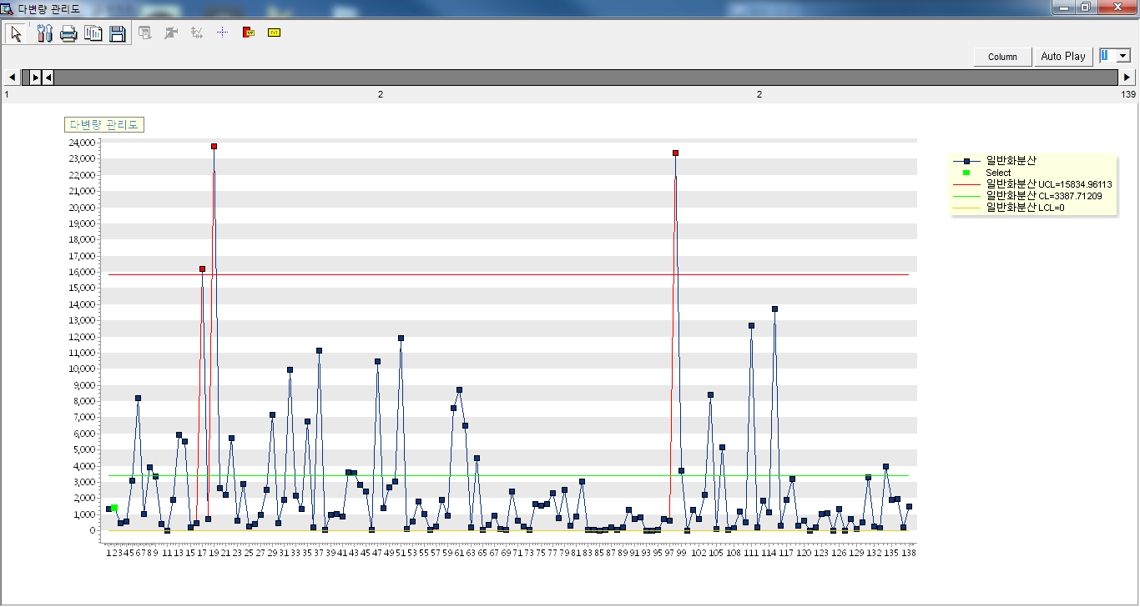

**T²-Generalized Variance Control Chart** combines the monitoring of both the process mean and variability across multiple correlated variables, offering an interpretation similar to a combination of X-Bar and S control charts. It assesses both the mean vector and covariance matrix, and signals an issue when either the T² statistic or the generalized variance exceeds control limits. For setup, select *T-Sq Generalized Variance* in the Chart form, choose variables under *Select Variables*, and set the number of subgroups.

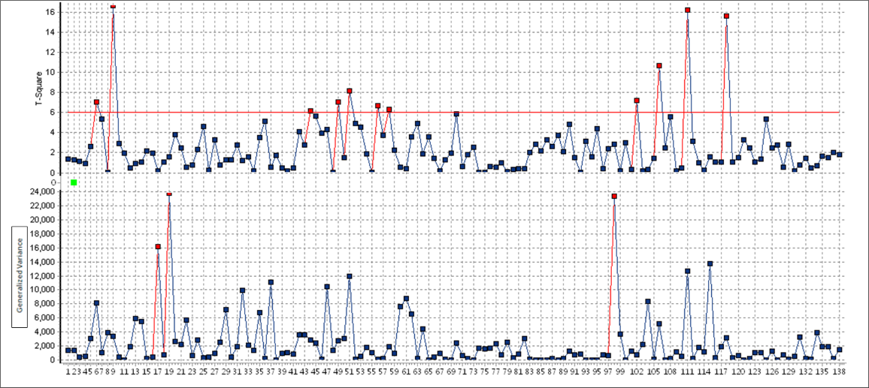

### 3.3.10 Multi Chart

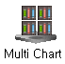

**Multi Chart** is ECMiner's unique chart, designed to easily compare the features of multiple variables simultaneously.

#### Usage

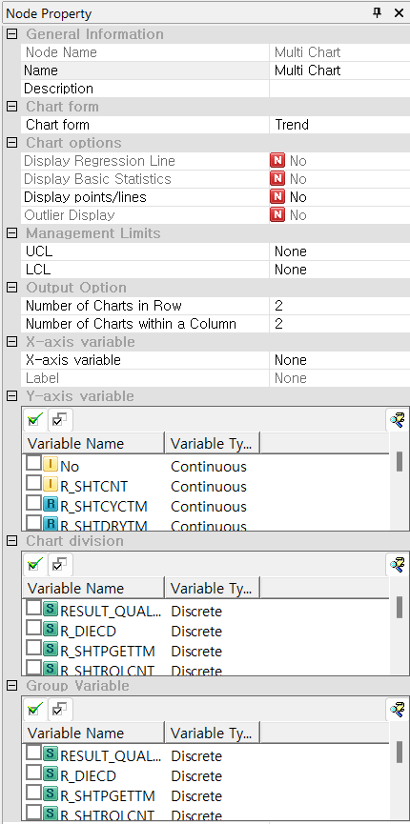

In the **Chart form** section, users select the type of chart to generate which plots variables over time or another sequential axis. In the **Chart options** section, users can optionally enable features like **Display Regression Line**, **Display Basic Statistics**, **Display points/lines**, and **Outlier Display**, depending on the settings of the Chart form section. The **Management Limits** section allows for the optional input of control limits (**UCL** and **LCL**) if applicable to the chart type. Under **Output Option**, users configure the layout by specifying the **Number of Charts in Row** and **Number of Charts within a Column**, which control how charts are arranged in the output panel. Users must specify an **X-axis variable** and can optionally add a **Label** to be shown on the chart. In the **Y-axis variable** section, users select one or more continuous variables to be visualized. The **Chart division** section allows users to define categorical variables to create separate charts for each value or combination of values (e.g., one chart per product type or defect category). Additionally, the **Group Variable** section can be used to layer groupings within each chart, enabling side-by-side or overlaid comparisons. This node is ideal for efficiently comparing multiple metrics across conditions, categories, or time periods in a single organized layout. At least one Y-axis variable must be selected, and configuring X-axis and division/group variables enhances the granularity of the output. For more detailed explanation of each property, please refer to the *Node Properties* manual below.

#### Node Properties

|  |  |  |  |  |  |  |
| --- | --- | --- | --- | --- | --- | --- |
| Property group | Property Name | | Description | | Misc. | Note |
| Chart form | Chart form | | Select a charting method. | |  | Trend,  Data,  Box Plot, Distribution, Correlation |
| Chart options | Display Regression Line | | When the chart form is **Correlation**, select whether or not to display rare lines. | | Yes, No | Simple matrix diagram,  X Y specified matrix diagram |
| Display Basic Statistics | | When the Chart form is **Box Plot**, select whether or not to display basic statistics. | | Yes, No |  |
| Display points/lines | | When the chart form is **Trend** or **Data**, select whether to display dots and lines on the chart. | | Yes, No |  |
| Outlier Display | | When the chart form is **Box Plot**, select whether or not to display outliers. | | Yes, No |  |
| Management Limits | UCL | | When the chart form is **Trend** or **Data**, select the variable to display the upper limit. | | continuous variable |  |
| LCL | | When the chart form is **Trend** or **Data**, select the variable to display the low limit. | | continuous variable |  |
| Output Option | Number of Charts in Row | | Specify the number of charts to be displayed in one row. | | Natural Number | 1~10 |
| Number of Charts within a Column | | Specify the number of charts to be displayed in one column. | | Natural Number | 1~10 |
| X-axis variable | X-axis variable | | When the chart form is **Trend** or **Correlation**, select the variable to use as the X-axis. | | Trend:  Date type, Correlation: Continuous type |  |
| Label | | When the chart form is **Data**, select the variable to use as label. | | discrete variable |  |
| Y-axis variable | Variable List | | Specify the variables to be plotted a chart. | | Required |  |
| Chart division | Variable List | | Specify the variables to be plotted a chart. | | Optional |  |
| Group Variable | Variable List | | Specify the variables to be plotted a chart. | | Optional |  |
|  | |  | |  | | |  |
|  | |  | |  | | |  |

When the node is executed, the configured property values are displayed on a Multi Chart screen, providing a visual interface for analyzing data based on the selected chart form. Users can directly modify various chart options within this screen, and any changes made are automatically reflected in the Node Properties. Depending on the selected chart form, the screen layout and displayed content will vary. For instance, when **Trend** is selected, the screen displays time-series data trends; selecting **Data** shows a general data chart view; choosing **Boxplot** presents the data distribution through quartile-based visuals; using **Distribution** reveals histograms or distribution curves; and selecting **Correlation** illustrates the relationship between variables via correlation plots.

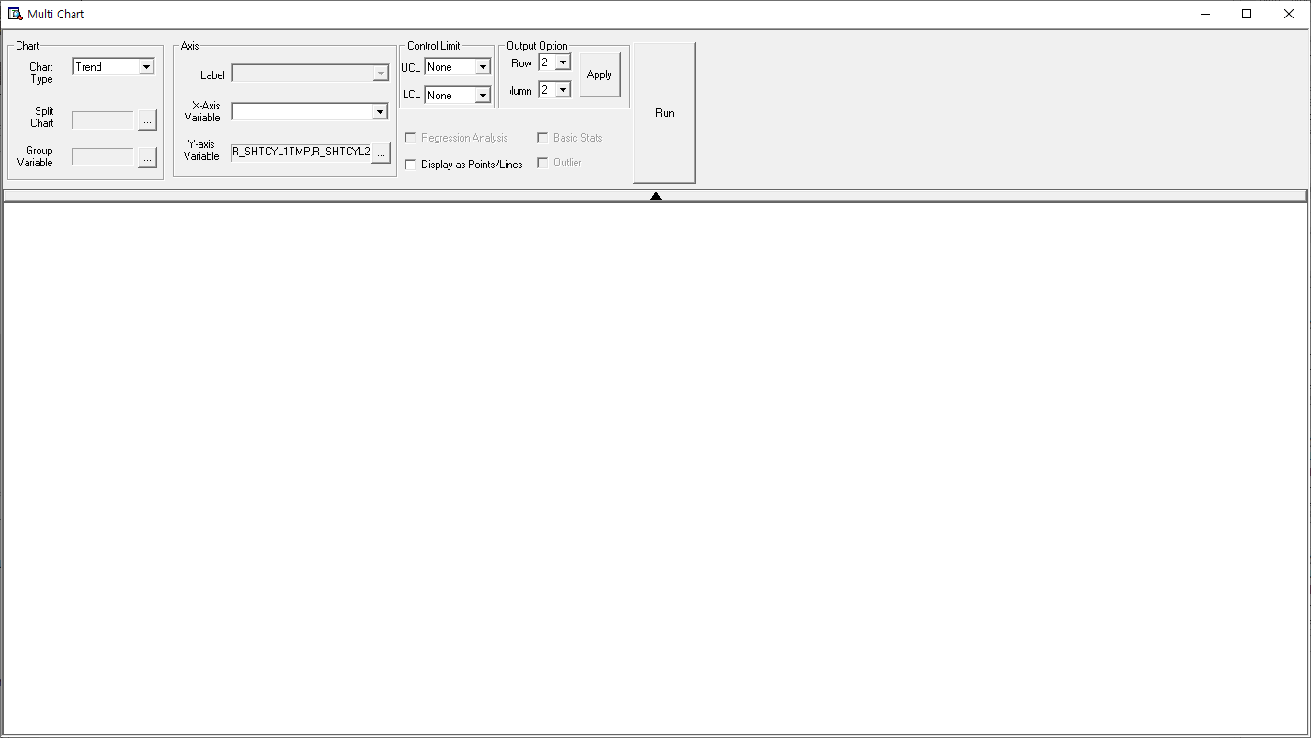

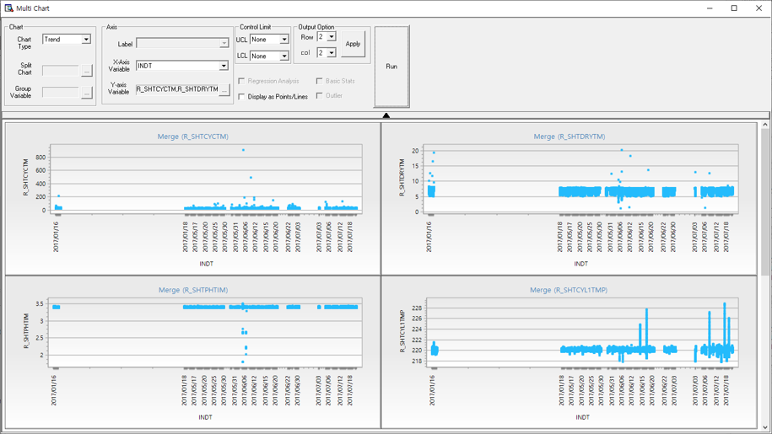

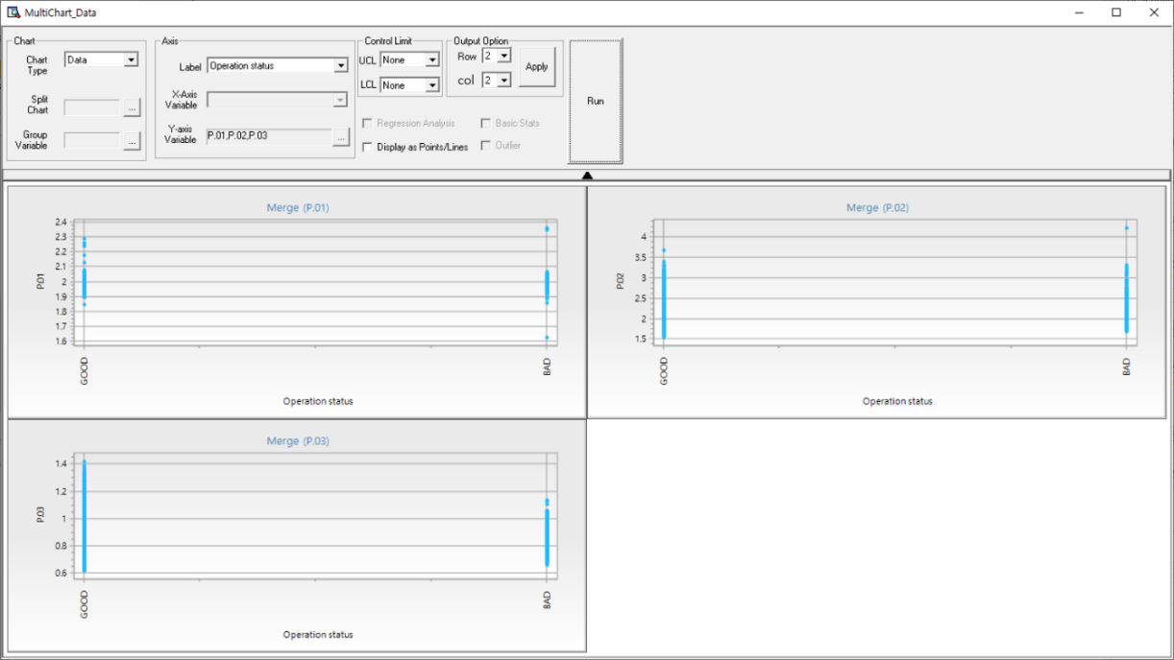

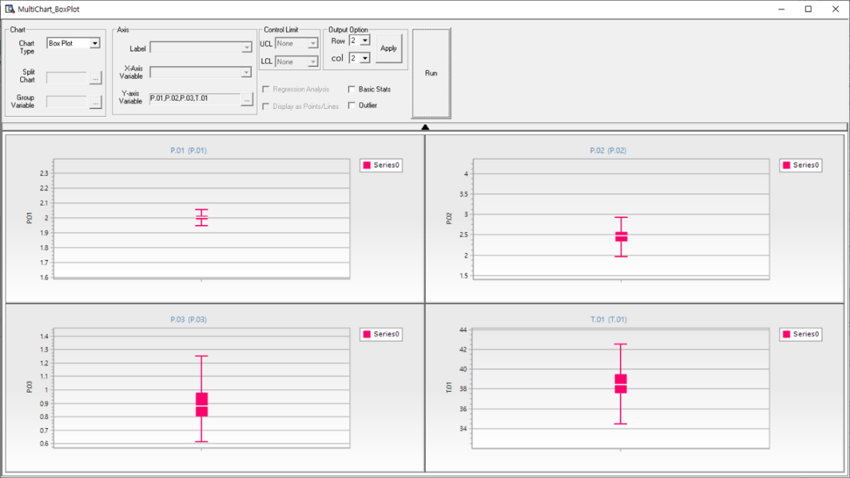

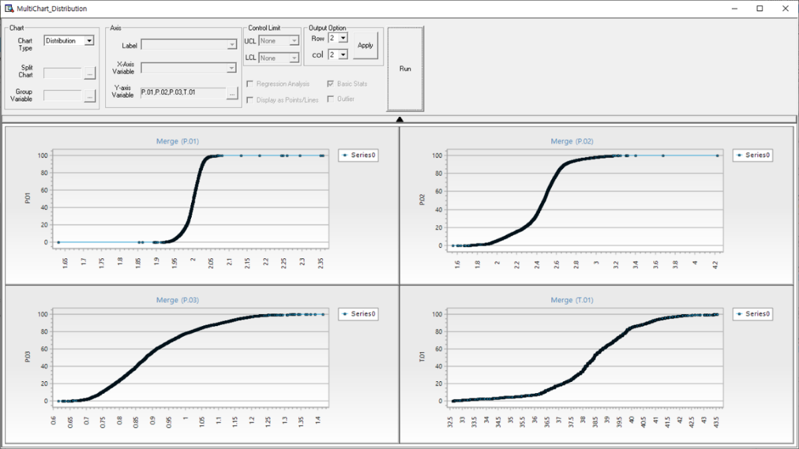

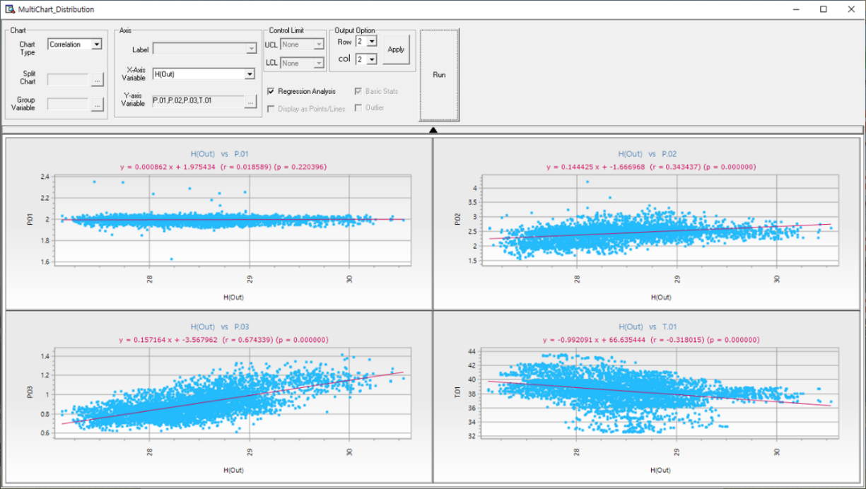

### 3.3.11 Parallel Coordinates GL Chart

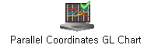

**Parallel Coordinates GL Chart** connects multiple variables as lines across parallel axes, enabling clear identification of data patterns and relationships.

#### Usage

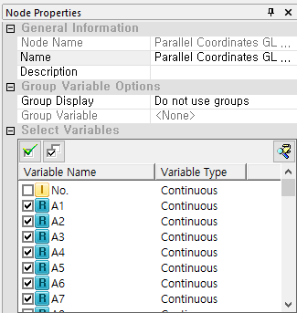

In the **Group Variable Options** section, users can choose whether to display groups by setting **Group Display** to *Color by category* and selecting a *Group Variable*, or leave it as *Do not use groups* for an undivided view. In the **Select Variables** section, users must choose three or more **Continuous** variables from the list to be plotted in the chart. Each selected variable becomes one axis in the parallel coordinates plot, and each data record is represented as a line that intersects the axes at corresponding values. Grouping can enhance the visualization by coloring or separating lines based on categories. At minimum, two continuous variables must be selected for the chart to render, and grouping is optional but useful for comparative analysis. For more detailed explanation of each property, please refer to the *Node Properties* manual below.

#### Node Properties

|  |  |  |  |  |
| --- | --- | --- | --- | --- |
| Property group | Property Name | Description | Misc. | Note |
| Group Variable Options | Group Display | Specify whether to disable group display or Color by category. | Optional | Do not use groups, Color by category |
| Group Variable | Select a group variable. | Optional |  |
| Select Variables | Variable List | Specify at least 3 variables to be plotted. | Required |  |

#### Results

Specify the range for each axis by dragging the wanted range within the bar of the specific variable. Then the selected range will be colored red.

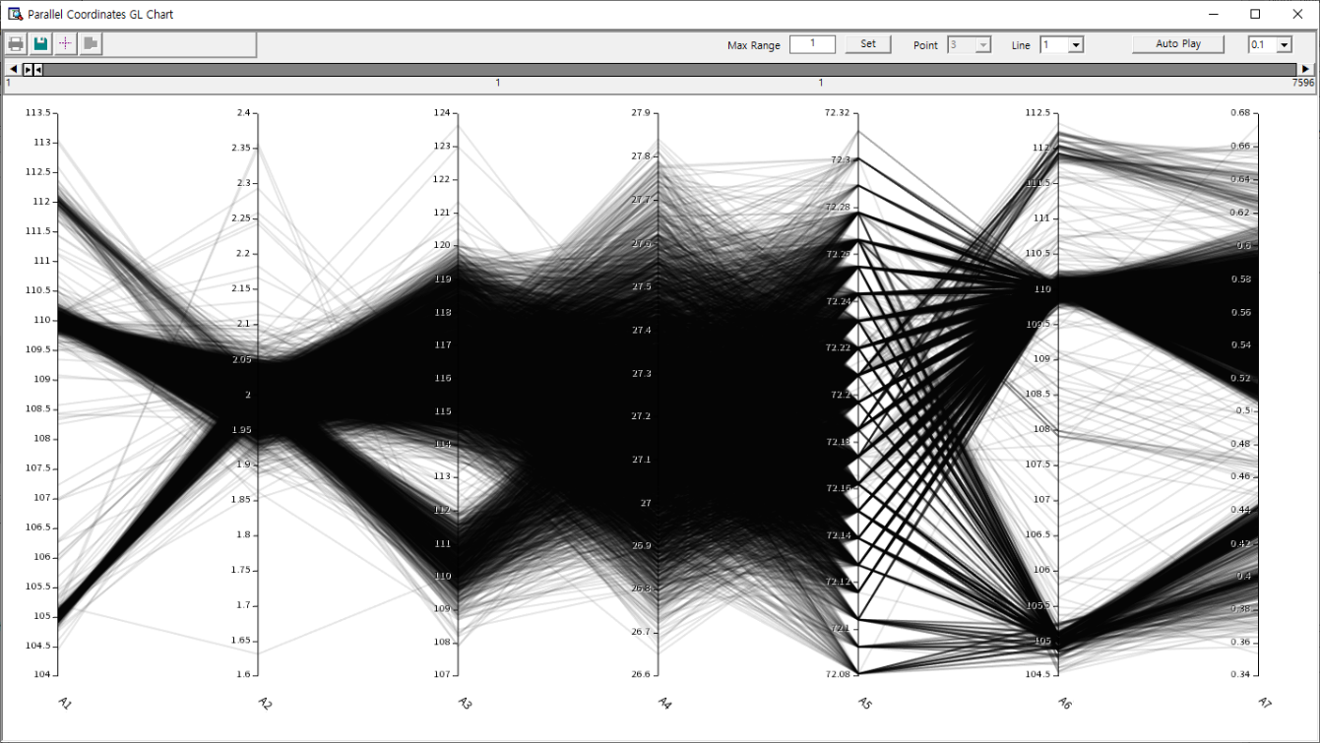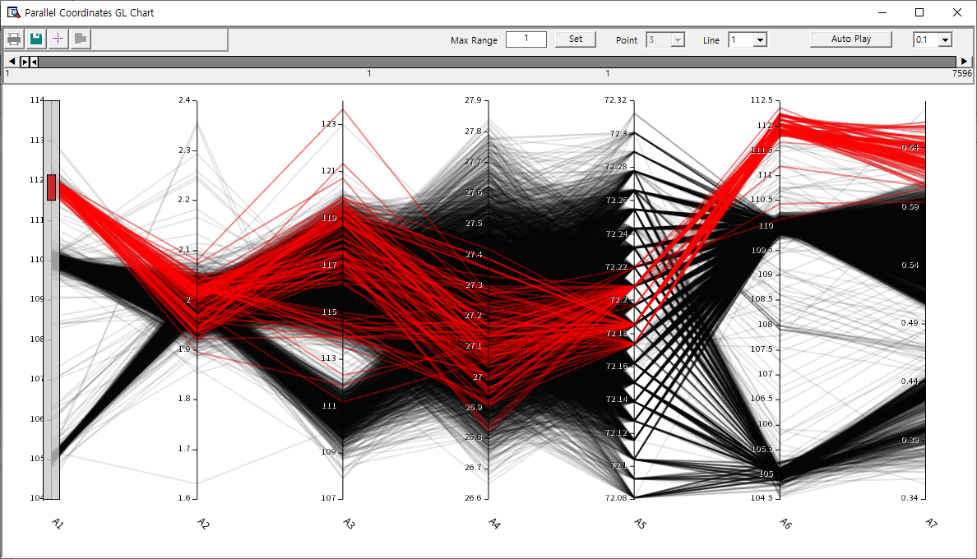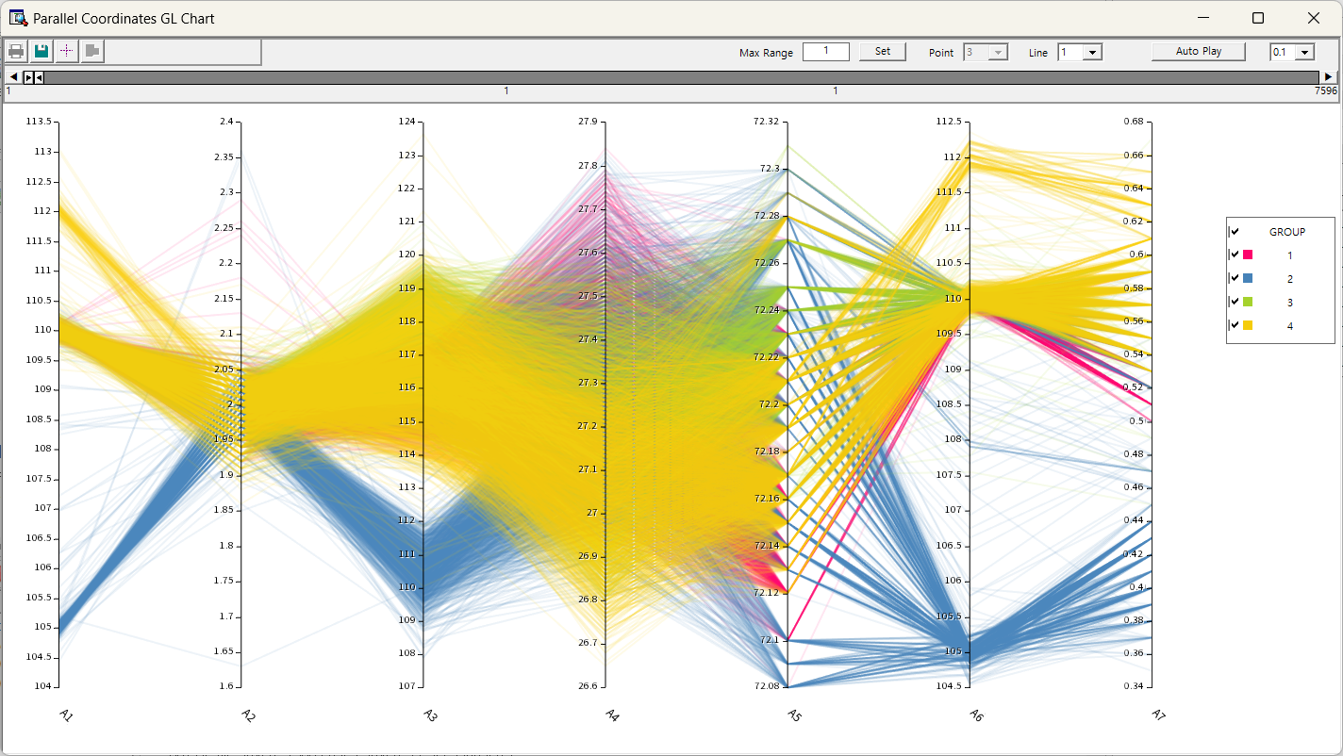

### 3.3.12 Pareto Chart

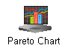

**Pareto Chart** draws a Pareto chart using data. Pareto charts are primarily used to visualize the distribution of data for discrete variables.

#### Usage

Specify the variable to be represented in the chart within the variable properties of the Series List properties window. For optional settings: Specify Label properties, Click the 'Add Series' button as many times as needed to add the required number of series.

In the **Chart options** section, users must specify the **Number of Data Points**, which determines how many of the most significant categories will be displayed in descending order of frequency or value. Users must also define one or more **Series** by using the **Add**, **Delete**, and **Edit** buttons to configure the variables to be plotted. In the **Series List**, for each defined series (e.g., *Series #1*), users must select a **Variable** to serve as the basis for the Pareto analysis and may optionally assign a **Label** for the chart legend. At least one variable must be assigned to generate the chart. This node is especially useful in quality control and root cause analysis, allowing users to focus on the most impactful categories based on the Pareto principle (80/20 rule). For more detailed explanation of each property, please refer to the *Node Properties* manual below.

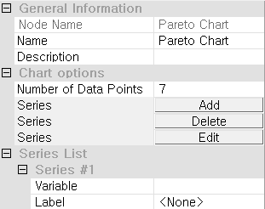

#### Node Properties

|  |  |  |  |  |  |
| --- | --- | --- | --- | --- | --- |
| Property group | Property Name | | Description | Misc. | Note |
| Chart options | Number of Data Points | | Specify the number of data categories to plot. The data categories are sorted in descending order based on quantity, and only the specified number of data categories are plotted. Any remaining data categories are represented as **Other** | Required | Natural Number |
| Add | | Used to plot multiple series on a single chart. Adds selected series. | button |  |
| Delete | | Deletes last added series. | button |  |
| Edit | | Removes unselected series. | button |  |
| Series List | Series #00 | Variable | Specify the variable to be displayed as a bar chart | Required |  |
| Label | Specify the variable to be used as the label. If the type of the specified variable is discrete, this property will be ignored |  |  |

### 3.3.13 Pie Chart

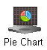

**Pie Chart Node** draws a pie chart using data. Pie charts are primarily used to view the relative ratios of data for discrete variables.

#### Usage

Specify the variable to be represented in the chart within the variable properties.

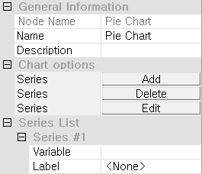

In the **Chart options** section, users must define at least one **Series** by using the **Add**, **Delete**, or **Edit** buttons. Each series represents a data grouping to be visualized as slices of the pie. Within the **Series List**, users must specify a **Variable** that contains the category values to be counted or summed, and may optionally assign a **Label** for display in the chart legend. Only one variable is required to create the chart, making this node ideal for presenting simple proportions or category-based comparisons in an intuitive, easy-to-understand format. For more detailed explanation of each property, please refer to the *Node Properties* manual below.

#### Node Properties

|  |  |  |  |  |  |
| --- | --- | --- | --- | --- | --- |
| Property group | Property Name | | Description | Misc. | Note |
| Chart options | Add | | Used to plot multiple series on a single chart. Adds selected series. | button |  |
| Delete | | Deletes last added series. | button |  |
| Edit | | Removes unselected series. | button |  |
| Series List | Series #00 | Variable | Specify the variable to be displayed as a pie chart | Required |  |
| Label | Specify the variable to be used as the label. If the type of the specified variable is discrete, this property will be ignored |  |  |

### 3.3.14 Process Contribution Chart

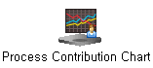

**Process Contribution Chart** draws model visualization using data and Model Node.

**Control Chart**: Displays a dashed ellipse representing the 95% confidence interval and a solid ellipse representing the 99% confidence level. Detect outliers and identify operational deviations through a Control Chart.

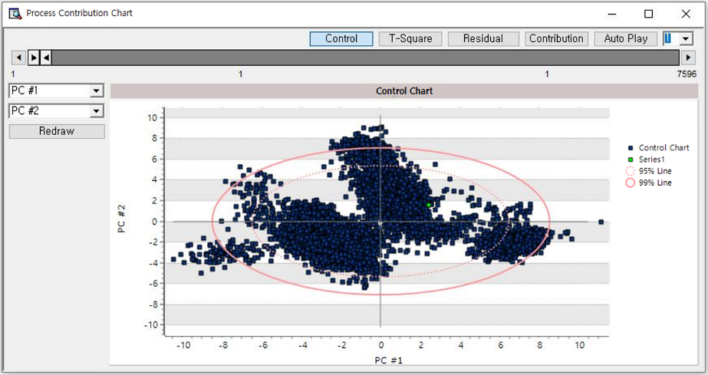

**T-Square plot**: Indicates the extremity of the current state by measuring the T-square value. Use the provided guide line to detect outliers.

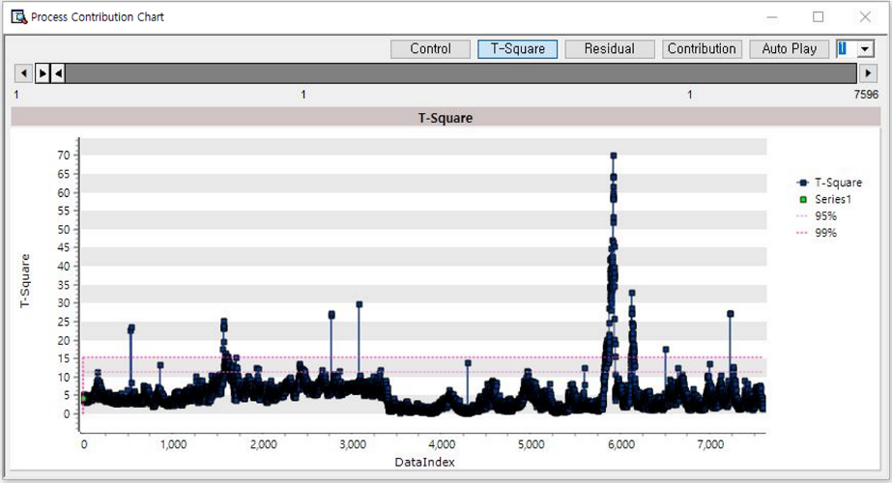

**Residual plot**: Measure the distance of the data from the reduced space using the residual value. Use the provided guide line to detect outliers.

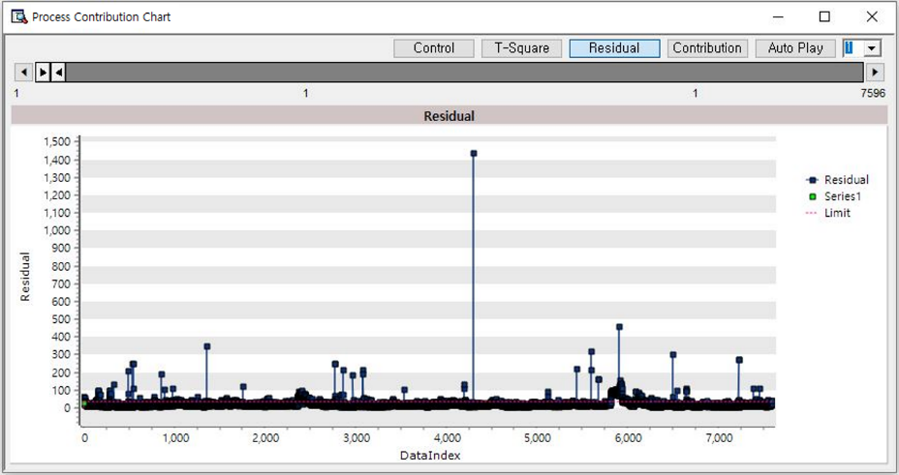

**Contribution plot**: Shows the contribution of variables affecting deviations in the extracted data. Uses red to represent positive correlations and blue to represent negative correlations.

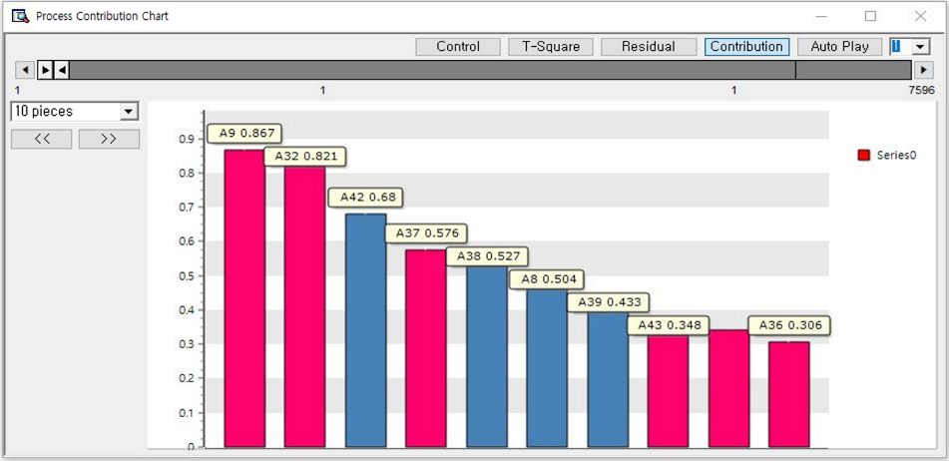

### 3.3.15 Radar Chart

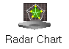

**Radar Chart** displays values of multiple variables along radiating axes from the center for comparison.

#### Usage

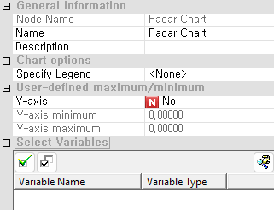

In the **Chart options** section, users can optionally set a **Legend** to identify different data series in the chart. Under **User-defined maximum/minimum**, users may choose to enable manual control of the chart scale by setting **Y-axis** to “Yes” and specifying the **Y-axis minimum** and **Y-axis maximum** values. This is useful when comparing multiple charts using consistent scales. In the **Select Variables** section, users must select three or more continuous variables to define the axes of the radar chart. Each record or group is plotted as a polygon connecting the selected variable values. This node is particularly effective for identifying performance profiles, similarities, and outliers across multiple attributes. Selecting at least two variables is required to generate the chart. For more detailed explanation of each property, please refer to the *Node Properties* manual below.

#### Node Properties

|  |  |  |  |  |
| --- | --- | --- | --- | --- |
| Property group | Property Name | Description | Misc. | Note |
| Chart options | Specify Legend | Specify whether to display the legend or not. | Required | None, Legend Variable |
| User-defined maximum/minimum | Y-axis | Decide whether to use manually specified Y-axis values. | Required | Yes, No |
| Y-axis minimum | Minimum value of Y-axis |  | Real Number |
| Y-axis maximum | Maximum value of Y-axis |  | Real Number |
| Select Variables | Variable list | Specify the variables to be plotted a chart. | Required |  |

### 3.3.16 SPC Chart

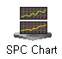

**SPC (Statistical Process Control) chart** is a quality control tool that monitors and analyzes data fluctuations to support process stability and compliance with quality standards.

#### Usage

To create a control chart, users must first select the appropriate chart form based on their data and monitoring objectives. Options include the **XBar-R chart** and **XBar-S chart**, which are used for monitoring the mean and variability of subgrouped data—using range and standard deviation, respectively. The **I-MR chart** is suited for individual measurements and tracks both the process mean and moving range. For smoothing data and detecting subtle shifts, users can choose the **MA chart** (Moving Average) or the **EWMA chart** (Exponentially Weighted Moving Average), which places more emphasis on recent observations. The **CUSUM chart** (Cumulative Sum) is designed to detect small, persistent changes in the process by plotting cumulative deviations from a target value. Attribute control charts include the **P chart** and **NP chart**, used to monitor the proportion or number of defective items, respectively; the **C chart**, which counts defects per unit when opportunities for defects are consistent; and the **U chart**, which measures defects per unit when the number of units varies. Selecting the appropriate chart form ensures effective process monitoring and early detection of variation.

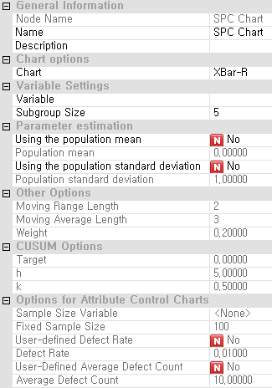

#### XBar-R / XBar-S

Xbar-R chart monitors the mean (X-bar) and range (R) within a subgroup based on samples taken at regular intervals. Xbar-S chart monitors the standard deviation (S) instead of the range (R). The XBar-R chart is used when the subgroup size is between 2 and 5, and the XBar-S chart is used when the subgroup size is 6 or more.

##### Usage

To configure an XBar-R or XBar-S chart, begin by selecting the desired chart type and assigning the appropriate variable for analysis. Next, specify the subgroup size to reflect the structure of your data accurately. If you wish to override the default statistical assumptions, you can enable **Using the population mean** and **Using the population standard deviation** by setting them to *Yes*, then manually input the respective values for a more customized control chart setup.

##### Node Properties

|  |  |  |  |  |
| --- | --- | --- | --- | --- |
| Property group | Property Name | Description | Misc. | Note |
| Chart options | Chart | XBar-R chart or XBar-S. |  |  |
| Variable setting | Variable | Select the variable |  |  |
| Subgroup Size | Size of the subgroup |  |  |
| Parameter estimation | Using the population mean | Decide whether to draw the chart using the population mean. | Default:  No | Yes, No |
| Population mean | Specify the population mean if **Using the population mean** is **Yes** |  | real type |
| Using the population standard deviation | Decide whether to draw the chart using the population standard deviation. | Default:  No | Yes, No |
| Population standard deviation | Specify the population standard deviation if **Using the population standard deviation** is **Yes** |  | real type |

##### Results

* XBar-R chart

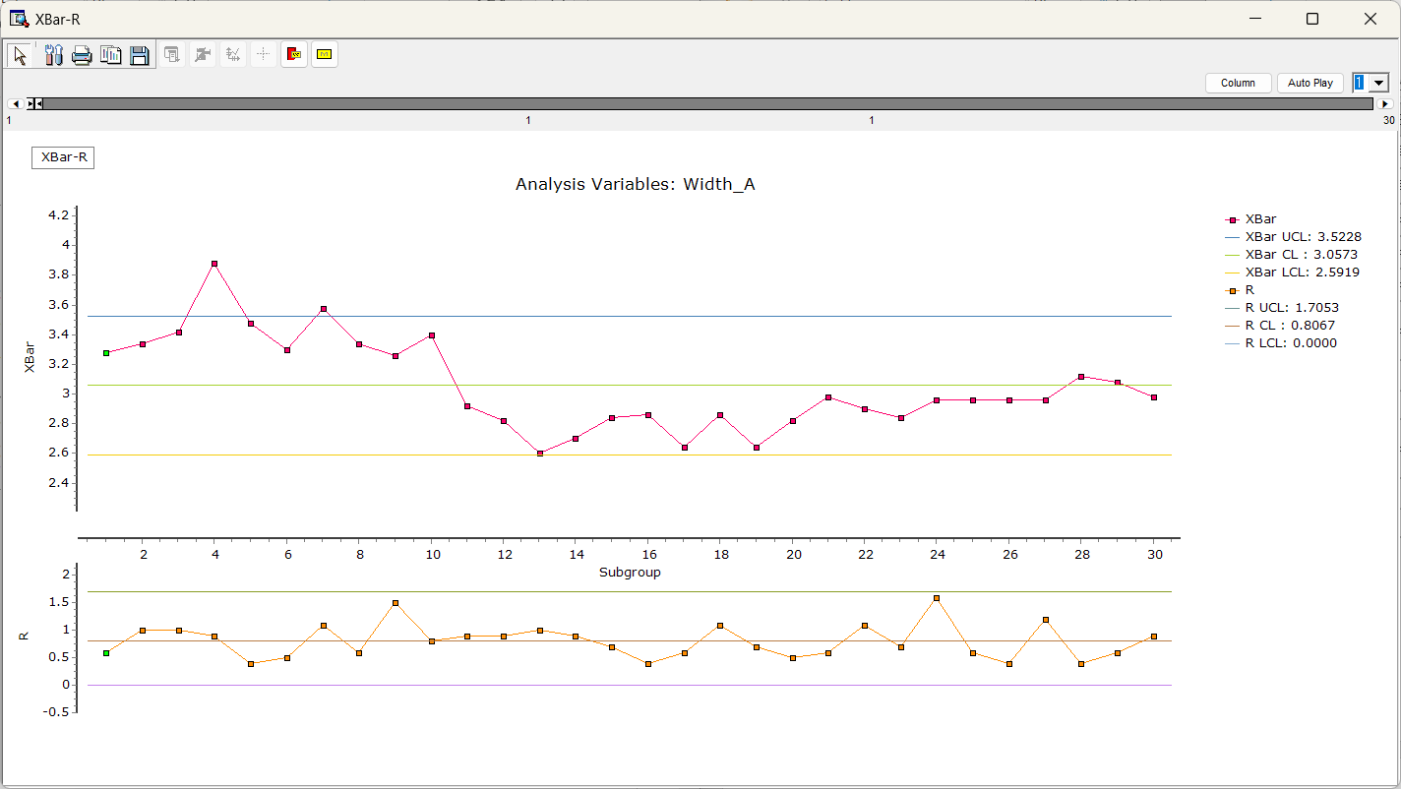

* XBar-S chart

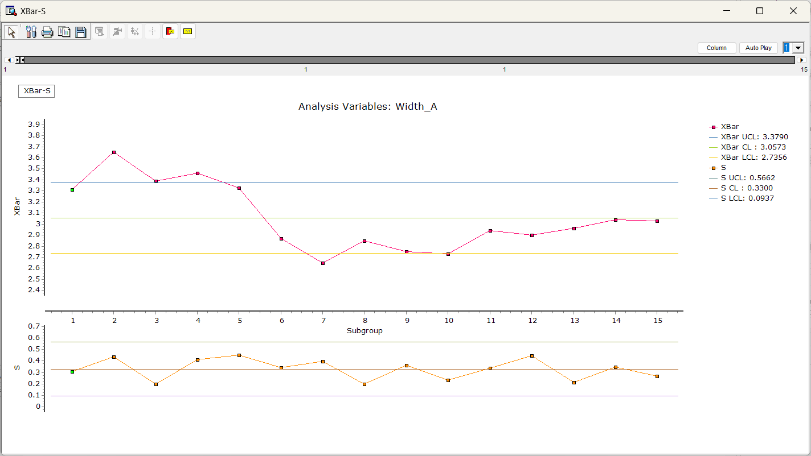

#### I-MR (Individual-Moving Range) chart

The I-MR chart consists of two charts, Individual(I) chart and Moving Range (MR) chart. Individual chart plots individual points over time, and MR chart plots the absolute differences between consecutive individual measurement in moving ranges. It monitors the stability of a process.

##### Usage

To set up an I-MR chart, first select the chart type and choose the variable to be monitored. If you need to use specific population parameters instead of calculated values, set **Using the population mean** and **Using the population standard deviation** to *Yes*, and then enter the desired values manually for more precise control over the chart's behavior.

##### Node Properties

|  |  |  |  |  |
| --- | --- | --- | --- | --- |
| Property group | Property Name | Description | Misc. | Note |
| Chart options | Chart | I-MR chart. | Required |  |
| Variable setting | Variables | Select variables. | Required |  |
| Parameter estimation | Using the population mean | Decide whether to draw the chart using the population mean. | Default:  No | Yes, No |
| Population mean | Specify the population mean if **Using the population mean** is **Yes** |  | real type |
| Using the population standard deviation | Decide whether to draw the chart using the population standard deviation. | Default:  No | Yes, No |
| Population standard deviation | Specify the population standard deviation if **Using the population standard deviation** is **Yes** |  | real type |
| Other Options | Moving Range Length | Set the length of the moving range when using an **I-MR chart**. | Required | real type |

##### Results

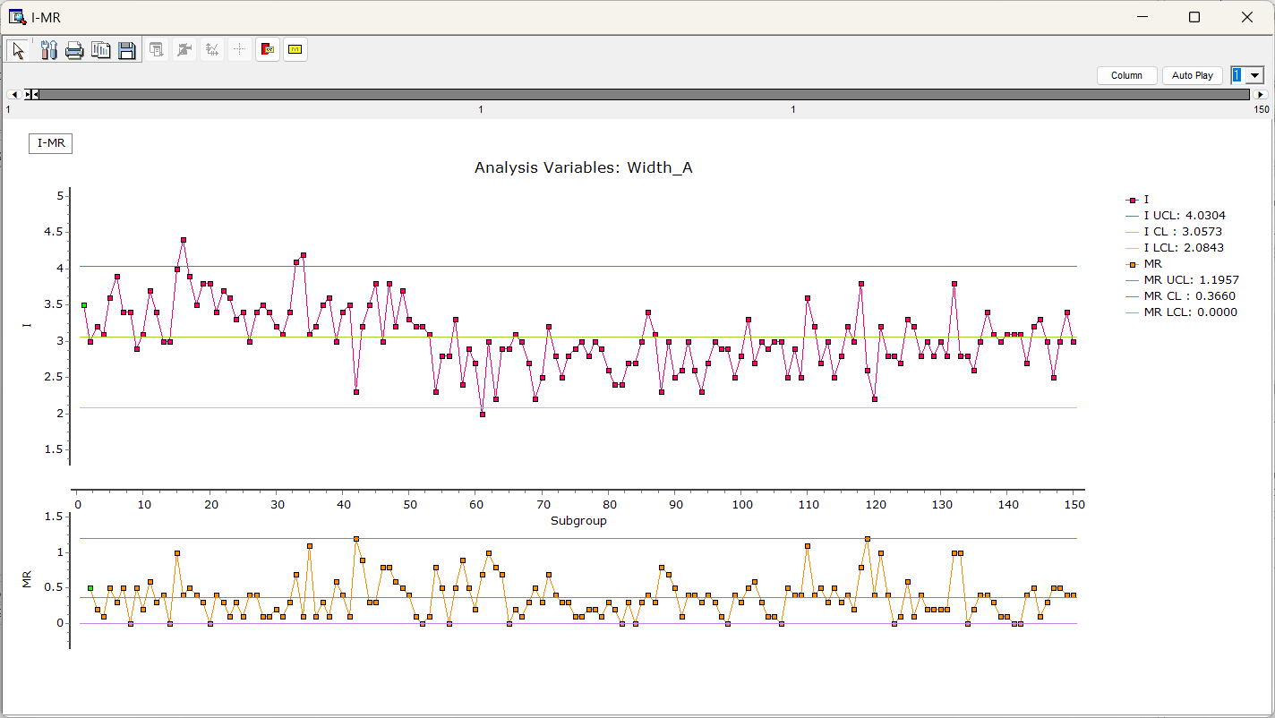

#### MA(Moving Average) / EWMA(Exponentially Weighted Moving Average)

MA chart monitors moving average (MA). EWMA chart monitors exponentially weighted moving average (EWMA). EWMA is similar to MA, but EWMA assigns exponentially decreasing weights to older data points, giving more emphasis to recent data, allowing it to react more quickly to shifts or trends.

##### Usage

To configure an MA or EWMA chart, begin by selecting the desired chart type and choosing the variable for monitoring. Specify an appropriate subgroup size based on your data structure, and enter either the moving average length for the MA chart or the weight value (typically between 0 and 1) for the EWMA chart. If you prefer to use known population parameters, set Using the population mean and Using the population standard deviation to Yes, and manually input the corresponding values. The EWMA chart is particularly effective for detecting small shifts in the process mean, making it more sensitive than the traditional Shewhart chart in such scenarios.

##### Node Properties

|  |  |  |  |  |
| --- | --- | --- | --- | --- |
| Property group | Property Name | Description | Misc. | Note |
| Chart options | Chart | MA chart or EWMA chart. | Required |  |
| Variable setting | Variables | Select variables. | Required |  |
| Subgroup Size | Size of the subgroup | Required | real type |
| Parameter estimation | Using the population mean | Decide whether to draw the chart using the population mean. | Required | Yes, No |
| Population mean | Specify the population mean if **Using the population mean** is **Yes** |  | real type |
| Using the population standard deviation | Decide whether to draw the chart using the population standard deviation. | Required | Yes, No |
| Population standard deviation | Specify the population standard deviation if **Using the population standard deviation** is **Yes** |  | real type |
| Other options | Moving Average Length | Set control limits by entering the length of the moving averange when using an **MA chart**. | Required | real type |
| Weight | Enter weight values when using an **EWMA chart**. | Required | 0≤real number≤1 |
| NOTE: The weight option determines the influence of recent data points. Recent data points have a higher weight, while older data points have progressively lower weights. | | | | |

##### Results

* MA

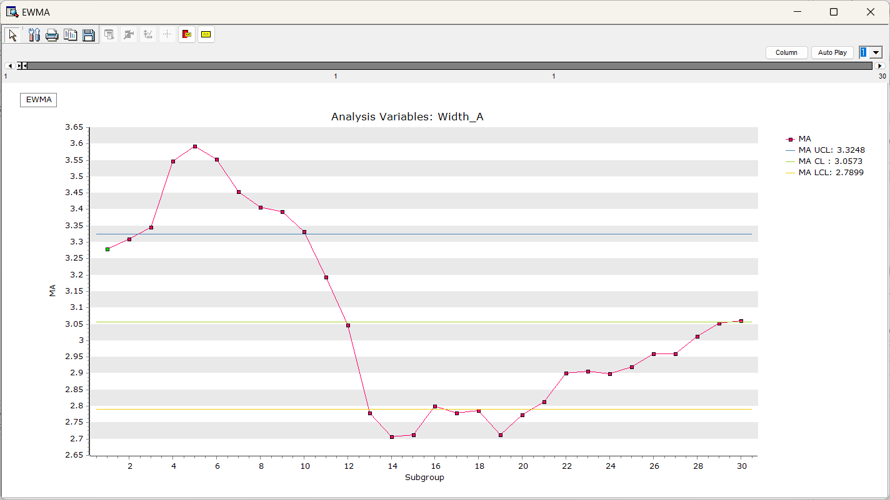

* EWMA

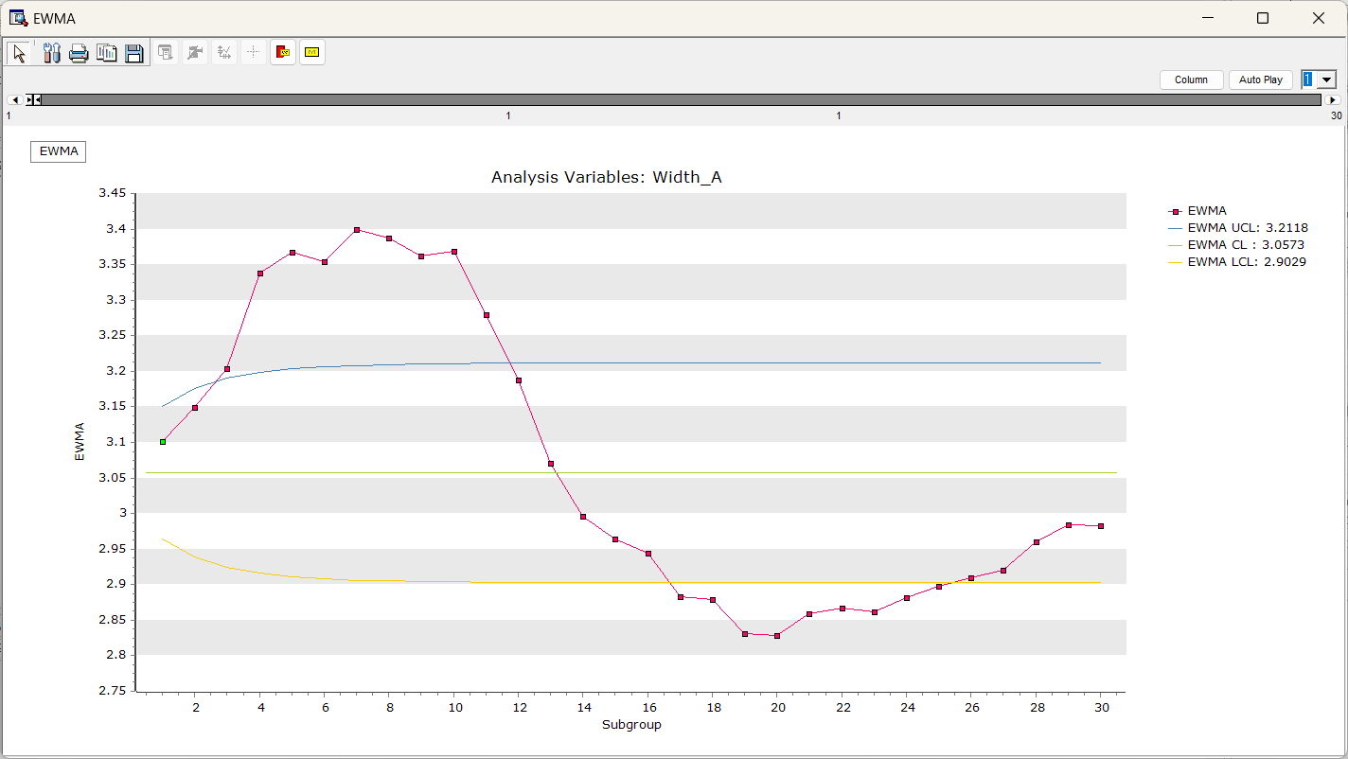

#### CUSUM (Cumulative Sum)

CUSUM chart visualizes cumulative sum of thedifferences between a **target** value and actual measurement. The cumulative sum of deviations makes the chart sensitive to even small changes, allowing for the early detection of process variations.

##### Usage

To set up a CUSUM chart, start by selecting the chart type and choosing the variable to monitor. Define an appropriate subgroup size to match your data. If you need to use a specific population mean, set **Using population mean** to *Yes* and input the desired value. Additionally, configure the chart by specifying the **target value**, **decision interval (h)**, and **reference value (k)**, which are essential parameters for detecting small and persistent shifts in the process.

##### Node Properties

|  |  |  |  |  |
| --- | --- | --- | --- | --- |
| Property group | Property Name | Description | Misc. | Note |
| Chart options | Chart | CUSUM chart. | Required |  |
| Variable setting | Variables | Select variables. | Required |  |
| Parameter estimation | Using the population mean | Decide whether to draw the chart using the population mean. | Required | Yes, No |
| Population mean | Specify the population mean if **Using the population mean** is **Yes** |  | real type |
| Using the population standard deviation | Decide whether to draw the chart using the population standard deviation. | Required | Yes, No |
| Population standard deviation | Specify the population standard deviation if **Using the population standard deviation** is **Yes** |  | real type |
| Other option | Target | Enter the target values. | Required | real type |
| h | The threshold for determining whether a process is out of control. If exceeds this interval, the process would be abnormal state | Required | real type |
| k | value or allowable bound | Required | real type |

##### Results

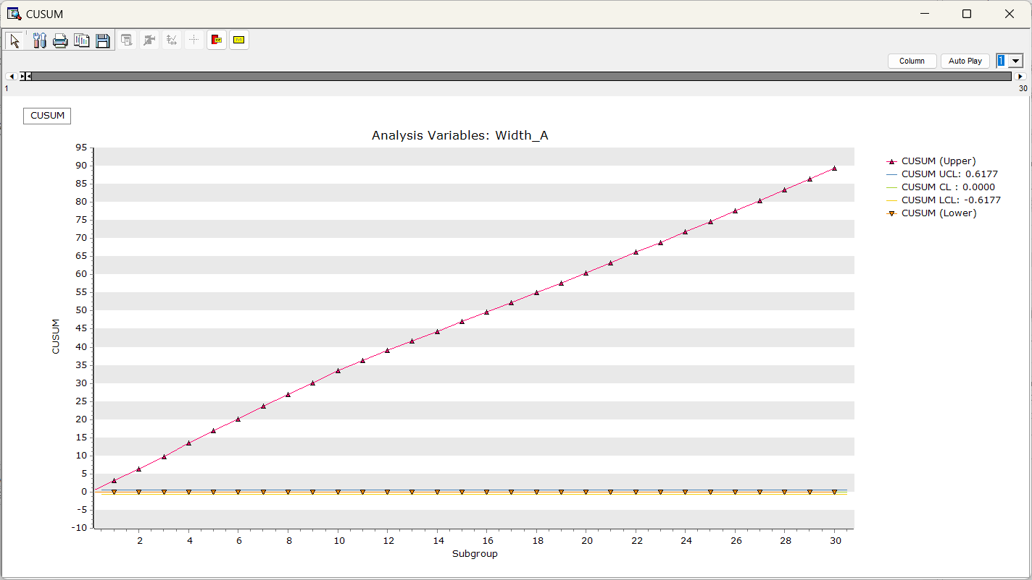

#### P / NP

P chart monitors the proportion of defective items within a subgroup. NP chart monitors the number of defective items within a subgroup. The P chart is used when the sample sizes vary, and the NP chart is used when all sample sizes are constant.

##### Usage

To configure a P chart or NP chart, begin by selecting the appropriate chart type and assigning the variable to be monitored. Specify the correct subgroup size for your analysis. If you are using a P chart and the sample sizes vary across test executions, be sure to define the Sample Size Variable accordingly. These charts are used to monitor the number or rate of defects in each sample group, so a user-defined defect rate is generally not required. However, if you have an expected defect rate, you can set User-defined Defect Rate to Yes and enter the desired value manually.

##### Node Properties

|  |  |  |  |  |
| --- | --- | --- | --- | --- |
| Property group | Property Name | Description | Misc. | Note |
| Chart options | Chart | P chart or NP chart. | Required |  |
| Variables setting | Variables | Select variables. | Required |  |
| Options for Attribute Control Charts | Sample Size Variable | Specify a variable if you choose a **P chart** and the sample size varies. If you choose a **NP chart,** select **<None>.** |  |  |
| Fixed Sample Size | Enter the total number of inspections performed if **Test execution number variable** is **<None>** | Required | real type |
| User-defined Defect Rate | Decide whether to customize the defect rate. | Required | Yes, No |
| Defect Rate | Enter the defect rate if **User-defined Defect Rate** is **Yes** |  | real type |

##### Results

* P chart

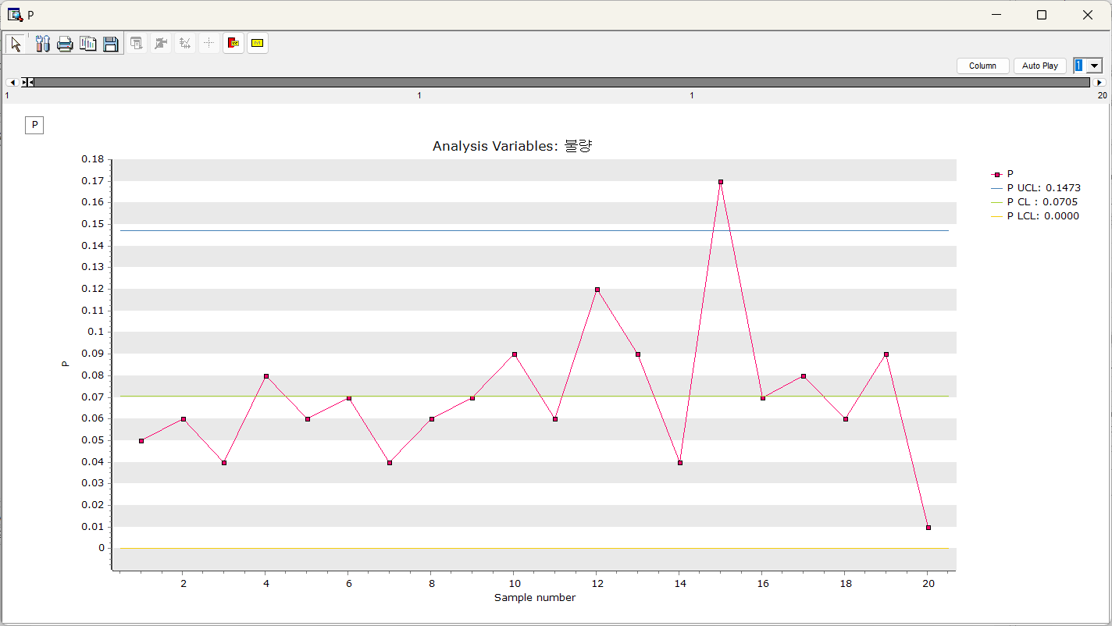

* NP chart

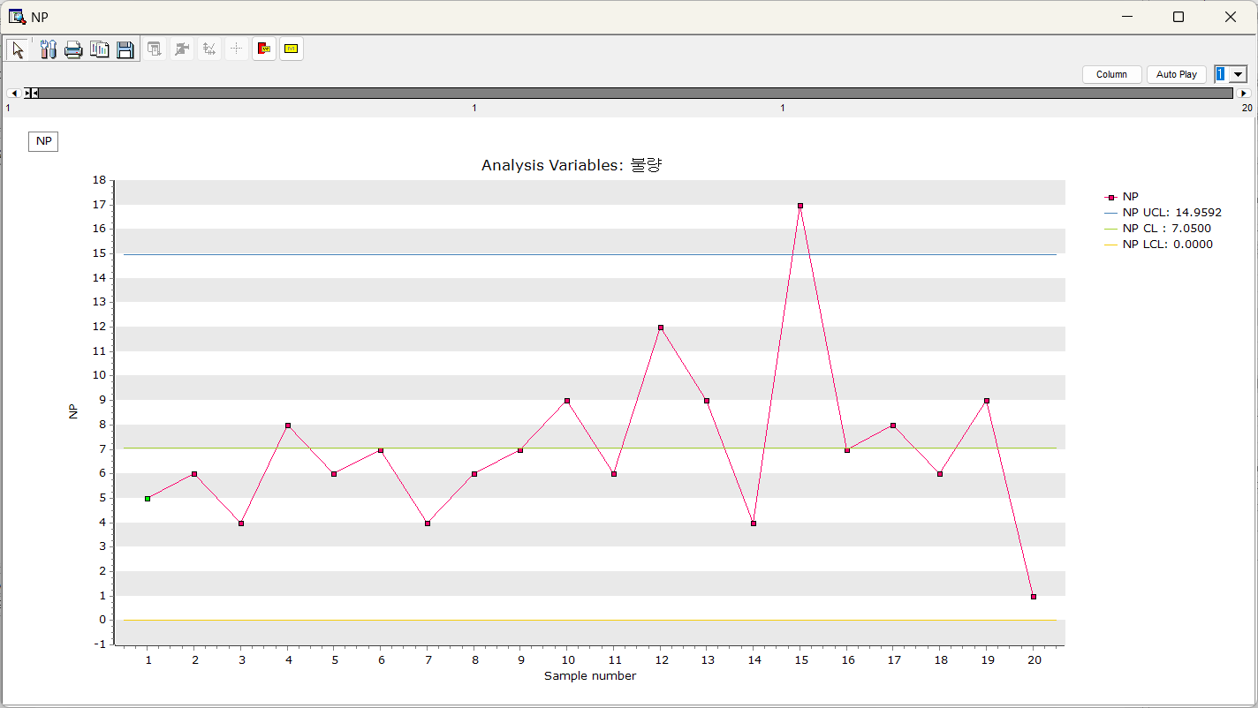

#### C / U

These are charts used to monitor defects in a mass production environment. The C chart monitors the number of defects in a fixed inspection unit, while the U chart monitors the number of defects per unit in varying inspection units.

##### Usage

To configure a C chart or U chart, first select the appropriate chart type and specify the variable to be monitored. Define the suitable subgroup size for accurate analysis. If you are using a **U chart** and the sample sizes vary across test executions, make sure to specify the **Sample Size Variable**. These charts are designed to track the number or rate of defects within each sample group, so specifying a defect rate is typically unnecessary. However, if an expected defect rate is known, you can enable **User-defined Defect Rate** by setting it to *Yes* and manually entering the value.

##### Node Properties

|  |  |  |  |  |
| --- | --- | --- | --- | --- |
| Property group | Property Name | Description | Misc. | Note |
| Chart options | Chart | C chart or U chart. | Required |  |
| Variable setting | Variables | Select variables. | Required |  |
| Other options | Sample Size Variable | Specify a variable if you choose a **U chart** and the sample size varies. If the number of inspections per test is consistent, select **<None>**. | Default:  None |  |
| Fixed Sample Size | Enter the total number of inspections performed if **Test execution number variable** is **<None>** | Required | real type |
| User-Defined Average Defect Count | Decide whether to customize the average defect count. | Required | Yes, No |
| Average Defect Count | Enter the average defect count. if **Customize Average Defect Count** is **Yes** |  | real type |

##### Results

* C chart

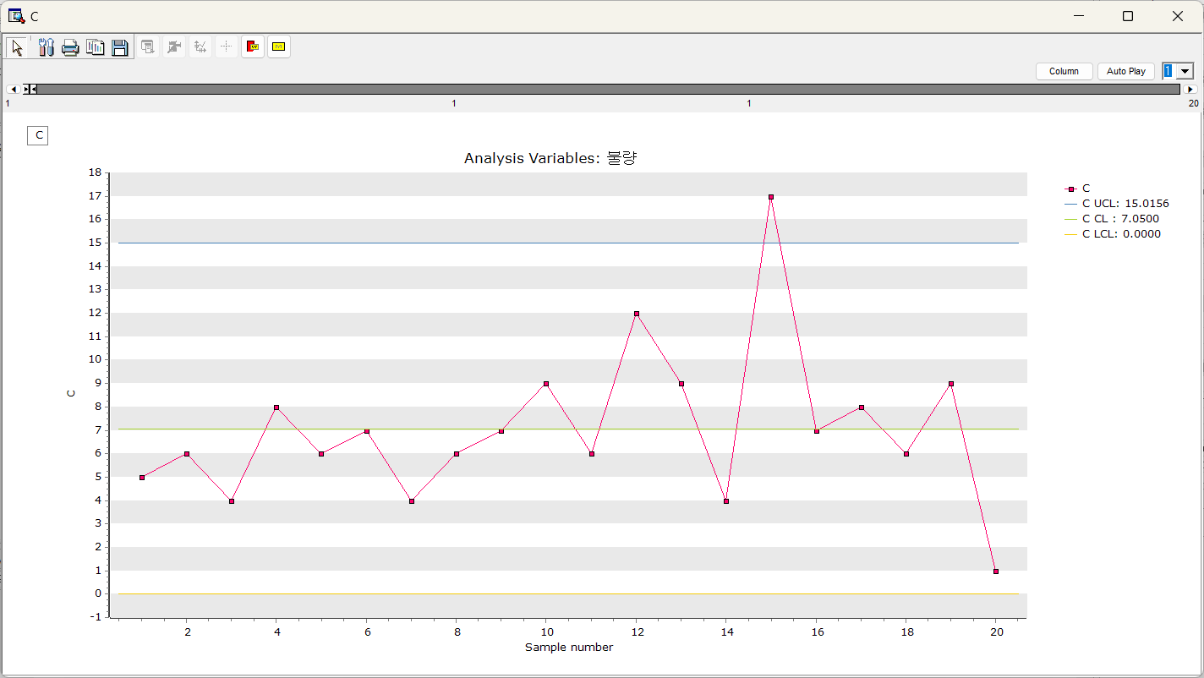

* U chart

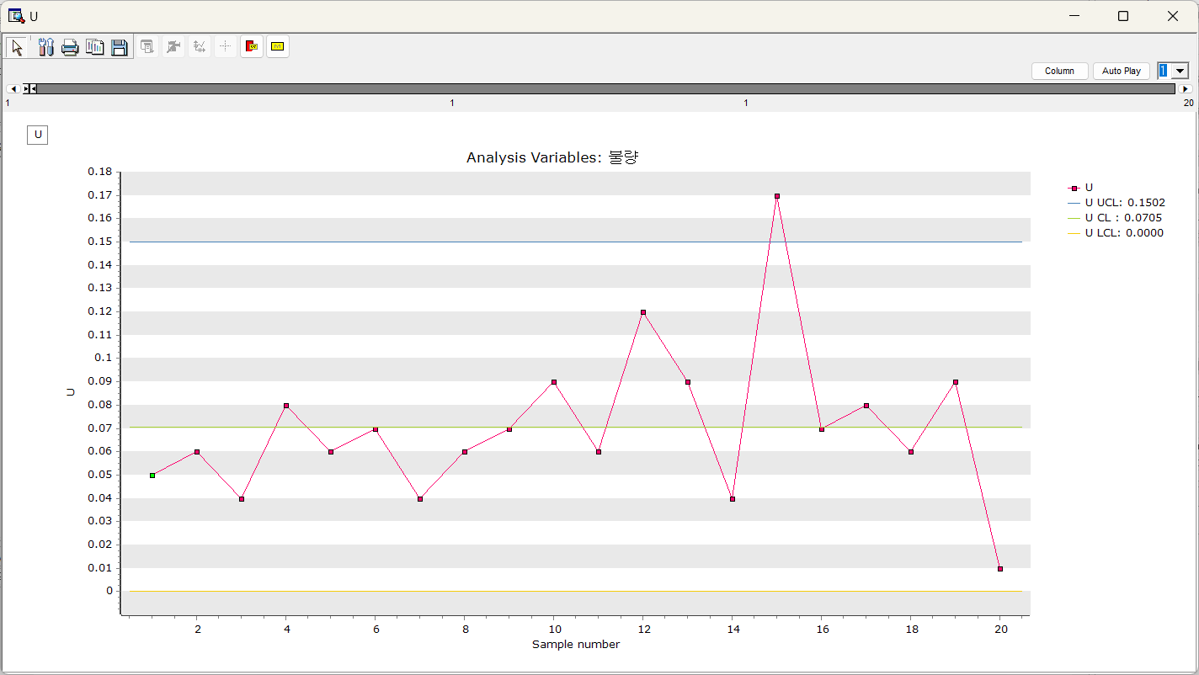

### 3.3.17 Statistic Chart

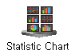

**Statistic Chart** is to draw a chart comparing the statistics of variable. In chart, variables are displayed on the **X-axis** and statistics are displayed on the **Y-axis**, allowing you to see changes in statistics between variables at a glance**.**

#### Usage

For optional settings: Change **Chart options** properties. Change **Select Statistics** properties.

**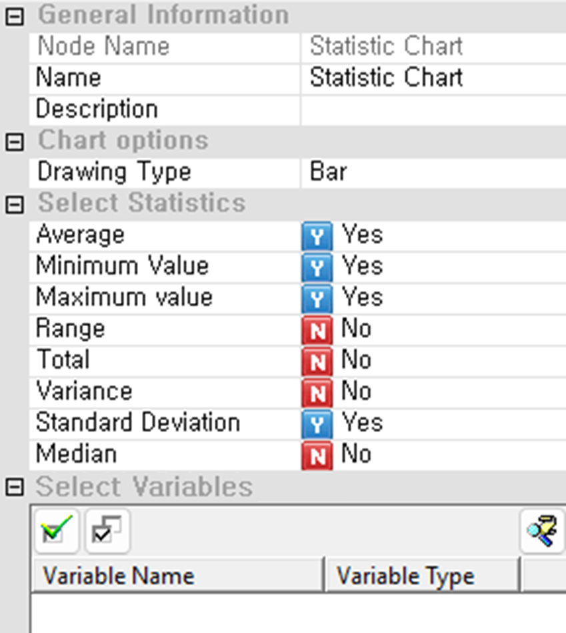**

In the **Chart options** section, users must specify the **Drawing Type**, such as *Bar*, to define the visual style of the chart. Under **Select Statistics**, users can choose which statistical measures to include by toggling each option to “Yes” or “No.” Available options include **Average**, **Minimum Value**, **Maximum Value**, **Range**, **Total**, **Variance**, **Standard Deviation**, and **Median**. These selected metrics will be calculated for each variable and displayed in the chart. In the **Select Variables** section, users must select one or more continuous variables to be analyzed. Each selected variable will contribute its statistics to the chart according to the enabled metrics. This node is particularly useful for comparing the basic characteristics of multiple variables at a glance. Selecting at least one statistic and one variable is required for the chart to be generated. For more detailed explanation of each property, please refer to the *Node Properties* manual below.

#### Node Properties

|  |  |  |  |  |
| --- | --- | --- | --- | --- |
| Property group | Property Name | Description | Misc. | Note |
| Chart options | Drawing Type | Determine the chart output format (Line, Point, Bar). | Required |  |
| Select Statistics | List of statistics | Select the statistic you want to chart (Average, Minimum Value, Maximum Value, Range, Total, Variance, Standard Deviation, Median). | Required |  |
| Select Variables | Variable List | Specify the variables to be plotted. | Required |  |

### 3.3.18 Scatter plot

**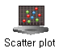**

**Scatter plot** visualizes the relationship between two variables using data, allowing for correlation analysis and pattern identification.

#### Usage

In the **Chart options** section, users must select an **X-variable** that will serve as the horizontal axis. The **Create Axis for Each Variable** option can be enabled to assign individual Y-axes to each selected Y-variable, which is useful when variables differ significantly in scale. Under **Group Variable Options**, users may optionally define up to five **Group Variables** to segment data visually using different colors or symbols; otherwise, the default setting *Do not use groups* will plot all points as a single series. The **User-defined maximum/minimum** section allows users to manually specify Y-axis bounds by enabling the **Y-axis** setting and entering values for **Y-axis minimum** and **Y-axis maximum**, which is helpful for maintaining consistent scaling across charts. In the **Select Y Variable** section, users must select at least one variable to be plotted along the Y-axis. A valid scatter plot requires one X-variable and one or more Y-variables to be specified. This node is ideal for examining correlations, patterns, and trends between continuous variables. For more detailed explanation of each property, please refer to the *Node Properties* manual below.

**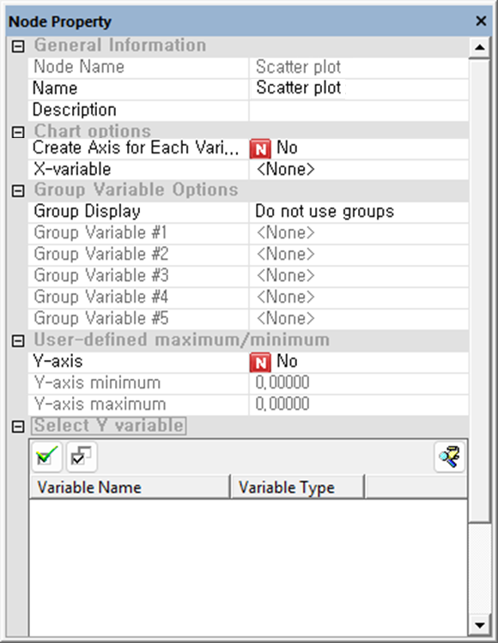**

#### Node Properties

|  |  |  |  |  |
| --- | --- | --- | --- | --- |
| Property group | Property Name | Description | Misc. | Note |
| Chart options | Create Axis for Each Variable | Specify whether to display the Y variable in separate charts for each variable or in a single combined chart. | Required | Yes, No |
| X-variable | Specify the variable for X-axis. |  |  |
| Group Variable Options | Group Display | Specify how to display data groups. | Optional | Separate by Series |
| Group Variable #1 | Select the first group variable. |  |  |
| Group Variable #2 | Select the second group variable. |  |  |
| Group Variable #3 | Select the third group variable. |  |  |
| Group Variable #4 | Select the fourth group variable. |  |  |
| Group Variable #5 | Select the fifth group variable. |  |  |
| User-defined maximum/minimum | Y-axis | Decide whether to use manually specified Y-axis values. | Required | Yes, No |
| Y-axis minimum | Minimum value of Y-axis |  | Real Number |
| Y-axis maximum | Maximum value of Y-axis |  | Real Number |
| Select Variables | Variable list | Specify the variables to be plotted. | Required |  |

#### Output plots

Scatter plot of X and Y

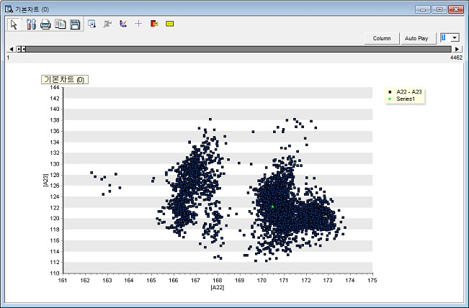

### 3.3.19 Trend Chart

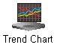

**Trend Chart** is two-dimensional scatter plots or time series charts.

#### Usage

**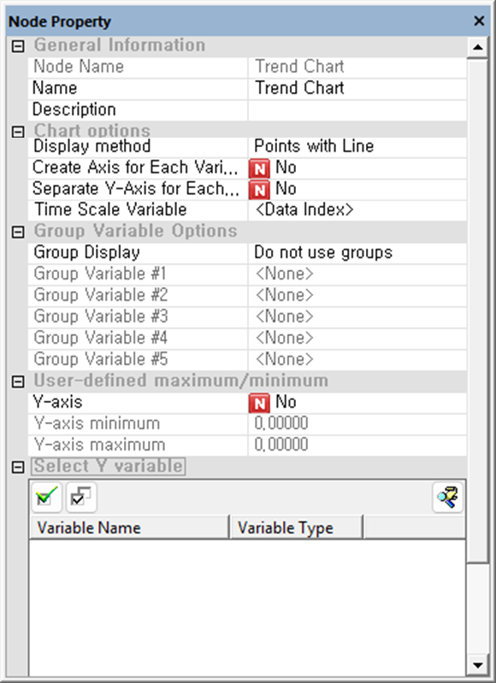**

In the **Chart options** section, users must choose a **Display method** to determine how data points are rendered. The **Time Scale Variable** is set as *Data Index* as default but can be specified if the dataset contains date type variable. Users can also choose to enable **Create Axis for Each Variable** or **Separate Y-Axis for Each Variable** depending on whether the variables should share a single axis or have individual scales, which is helpful when comparing variables with different ranges. Under **Group Variable Options**, up to five **Group Variables** can be assigned to display separate series or lines by group, or users may leave **Group Display** set to *Do not use groups* for unified plotting. The **User-defined maximum/minimum** section allows manual control of the Y-axis range by toggling the **Y-axis** setting to "Yes" and specifying minimum and maximum values. In the **Select Y Variable** section, users must select one or more continuous variables to be plotted along the Y-axis. To generate the chart, a time or index variable and at least one Y-variable must be selected. This node is ideal for monitoring trends, patterns, and fluctuations across time or process stages. For more detailed explanation of each property, please refer to the *Node Properties* manual below.

#### Node Properties

|  |  |  |  |  |
| --- | --- | --- | --- | --- |
| Property group | Property Name | Description | Misc. | Note |
| Chart options | Display method | **Points**: Plot the data at each observation time as dots.  **Line:** Draw a line connecting the values from before and after.  **Points with line**: Plot the data as points at each observation time and connect them with lines. | Required | Points, Line, Points with line |
| Create Axis for Each Variable | Specify whether to display the Y variable in separate charts for each variable or in a single combined chart. | Required | Yes, No |
| Separate Y-Axis for Each Variable | When **Separate Y-Axis for Each Variable** is set to **No, s**pecify whether to use a separate Y axis or a single axis |  | Yes, No |
| Time Scale Variable | For **Time Series** **Y**, specify the time scale variable to use for the X-axis. Use the Data Index if a time scale variable does not exist. |  |  |
| Group Variable Options | Group Display | Specify how to display data groups. | Optional | Separate by Series, Color by category, Display as Label |
| Group Variable #1 | Select the first group variable. |  |  |
| Group Variable #2 | Select the second group variable. |  |  |
| Group Variable #3 | Select the third group variable. |  |  |
| Group Variable #4 | Select the fourth group variable. |  |  |
| Group Variable #5 | Select the fifth group variable. |  |  |
| User-defined maximum/minimum | Y-axis | Decide whether to use manually specified Y-axis values. | Required | Yes, No |
| Y-axis minimum | Minimum value of Y-axis |  | Real Number |
| Y-axis maximum | Maximum value of Y-axis |  | Real Number |
| Select Variables | Variable list | Specify the variables to be plotted. | Required |  |

#### Output plots

Time series chart for Y data in time scale.

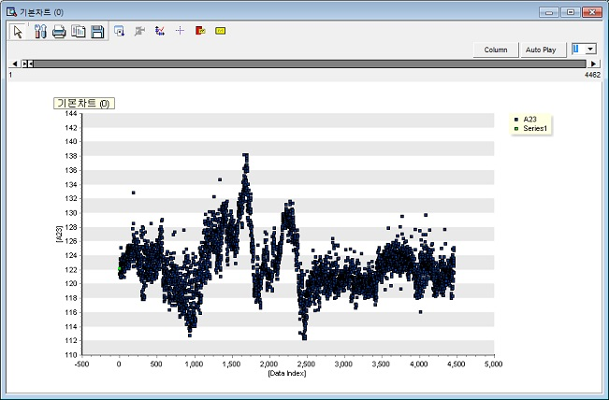

### 3.3.20 Word Cloud



**Word Cloud** is a tool that visually represents the frequency of words in text data. The size of each word is proportional to its frequency.

#### Usage

To visualize word frequency, it is necessary to create two variables: one for the list of words and another for their respective counts.Therefore, use the **Tagging Node** to generate the variable for words, and apply the **Group By Node** to create a variable for the counts of these words. Specify the Word List Variable. The variable should be of character. Specify the Word Count List Variable. The variable should be of numeric. For optional settings: Chart form: Spiral or Typewriter. For more detailed explanation of each property, please refer to the *Node Properties* manual below.

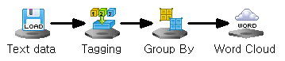

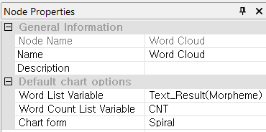

#### Node Properties

|  |  |  |  |  |
| --- | --- | --- | --- | --- |
| Property group | Property Name | Description | Misc. | Note |
| Default Chart options | Word List Variable | Select the variables you want to use in Word Cloud. | character type |  |
| Word Count List Variable | Select a variable with the number of variables used in the word list variable. | Required |  |
| Chart form | Choose either Spiral or Typewriter. | Spiral, Typewriter |  |

#### Results

**Spiral:** Words are positioned at the center of the chart in descending order of frequency, and the size of the words decreases as they move away from the center.  
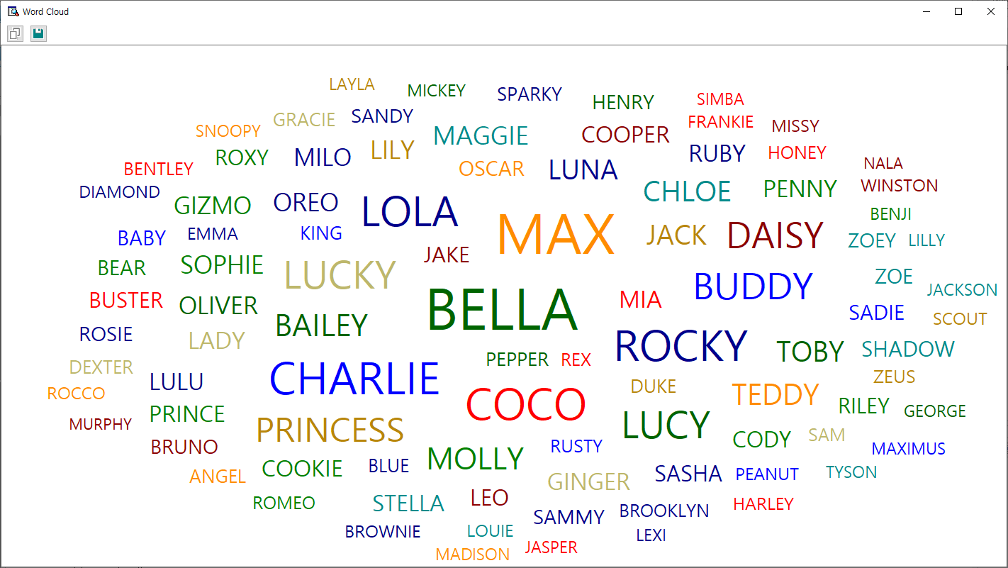

**Typewriter:** Words are listed in order from the most frequent to the least, with their sizes progressively decreasing.

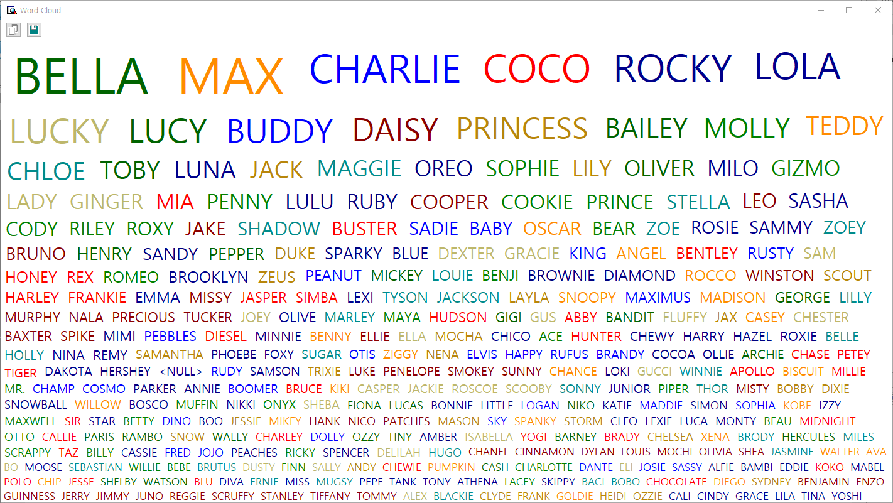

## 3.4 Modeling Node

Modeling Nodes supported by ECMiner™ are the following.

* [Adaptive NN](#_3.4.1_Adaptive_NN)  
  Adjust learning processes or structures to suit input data and the learning environment.
* [Association Rules (AR)](#_3.4.2_Association_Rules(AR))  
  Discover relationships between items in large datasets using the Apriori algorithm.
* [AutoEncoder](#_3.4.3_AutoEncoder)  
  Encode and decode data to produce outputs similar to inputs for compression or anomaly detection.
* [CART](#_3.4.4_CART)  
  Use decision trees for classification and regression tasks.
* [CCA](#_3.4.5_CCA(Canonical_Correlation)  
  Analyze the relationship between two sets of multivariate variables.
* [CNN](#_3.4.6_CNN)  
  Automatically learn features from images to perform tasks like classification and prediction.
* [DeepNN](#_3.4.7_Deep_NN)  
  Use multiple hidden layers in a neural network to understand complex data relationships.
* [ElmanNet](#_3.4.8_ElmanNet)  
  Use recurrent neural networks for predictive analysis with context layers to store past data.
* [Factor Analysis](#_3.4.8_Factor_Analysis)  
  Extract common factors among variables to analyze or connect multiple factors.
* [Hierarchical Clustering](#_3.4.10_Hierarchical_Clustering)  
  Group similar data objects into clusters.
* [K-Means](#_3.4.10_K-MEANS)  
  Partition data into k clusters based on centroid positions.
* [K-NN](#_3.4.11_K-NN)  
  Classify data based on the proximity of nearest neighbors.
* [LDA](#_3.4.12_LDA(Linear_Discriminant)  
  Perform classification by maximizing between-class separation with a linear decision boundary.
* [Local Outlier Factor (LOF)](#_3.4.13_Local_Outlier)  
  Detect outliers by evaluating local density relative to neighbors.
* [Logistic Regression](#_3.4.14_Logistic)  
  Predict categorical outcomes based on input data.
* [MLR](#_3.4.15_MLR)  
  Model the linear relationship between dependent and multiple independent variables.
* [Naive Bayes](#_3.4.16_Naïve_Bayes)  
  Classify data based on the assumption that features are conditionally independent.
* [PCA](#_3.4.17_PCA)  
  Reduce dimensionality by transforming variables into uncorrelated principal components.
* [PCR](#_3.4.18_PCR)  
  Use PCA for dimensionality reduction and handle multicollinearity in regression models.
* [PLS](#_3.4.19_PLS)  
  Reduce predictors into latent variables for dimensionality reduction and regression analysis.
* [QDA](#_3.4.20_QDA)  
  Perform classification with non-linear decision boundaries and class-specific covariance matrices.
* [Random Forest](#_3.4.21_RandomForest)  
  Improve accuracy and stability by combining the output of multiple decision trees.
* [RBF](#_3.4.22_RBF)  
  Use radial basis functions in neural networks for supervised learning.
* [RBF DDA](#_3.4.23_RBF_DDA)  
  Automatically determine the number of RBFs and their values to optimize model performance.
* [Regularized Regression](#_3.4.25_Regularized_Regression)  
  Prevent overfitting by penalizing large coefficients in regression models.
* [RL\_AC](#_3.4.25_RL_AC(Actor_Critic))

Use actor-critic reinforcement learning to update policies and Q functions simultaneously.

* [RL\_DDPG](#_3.4.26_RL_DDPG(Deep_Deterministic)  
  Predict continuous actions with reinforcement learning and separate networks for policy and Q function.
* [RL\_DQN](#_3.4.27_RL_DQN(Deep_Q)  
  Use deep Q networks to estimate action values and perform Q-learning.
* [RL\_PPO](#_3.4.28_RL_PPO(Proximal_Policy)  
  Apply stable policy updates with clipping to improve reinforcement learning.
* [RL\_PG](#_3.4.29_RL_PG(Policy_Gradient))  
  Use policy gradient methods to gradually improve decision-making in reinforcement learning.
* [RL\_TD3](#_3.4.30_RL_TD3(Twin_Delayed)  
  Use twin critic networks to improve reinforcement learning stability and avoid errors.
* [RL\_SAC](#_3.4.31_RL_SAC(Soft_Actor-Critic))  
  Promote action diversity in reinforcement learning with entropy in the value function.
* [ScoreCard](#_3.4.32_ScoreCard)  
  Model the impact of variables on a discrete dependent variable using logistic regression, commonly for credit scoring.
* [Sequential AR](#_3.4.33_Sequential_AR)  
  Discover relationships between products or services over time to find meaningful patterns.
* [SimpleRNN](#_3.4.34_SimpleRNN)  
  Use recurrent neural networks for sequential data processing like time series.
* [SOM](#_3.4.35_SOM)  
  Visualize and interpret high-dimensional data in lower-dimensional spaces using self-organizing maps.
* [SVC](#_3.4.36_SVC)  
  Classify data into predefined categories using support vector machines.
* [SVR](#_3.4.37_SVR)  
  Apply support vector regression for modeling relationships between variables.
* [t-SNE](#_3.4.38_t-SNE)  
  Visualize data classification and distribution in lower dimensions using non-linear dimensionality reduction.

### 3.4.1 Adaptive NN

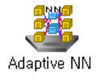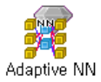

**Neural Network (NN)** is a machine learning model with hidden layers to uncover the complex, non-linear relationships between the data. **Adaptive Neural Networks (Adaptive NNs)** are neural networks that adjust their learning process or structure to suit input data or the learning environment.

#### Overview

A common type of NN is the multilayer feedforward network, which consists of an input layer, one or more hidden layers, and an output layer. In this process, the input signal advances layer-by-layer. Each layer's neurons (or nodes) are connected to those in other layers through connections that have a bias and an adjustable weight. The figure below illustrates the structure of an NN with two hidden layers.

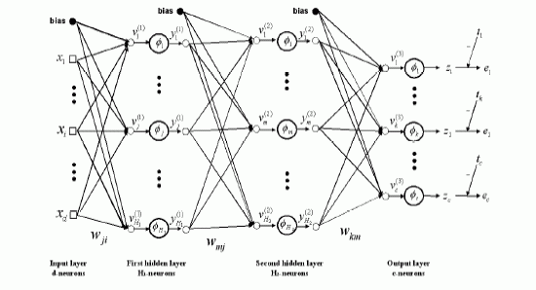

Backpropagation is a widely used algorithm in training artificial neural networks, primarily for minimizing the error by adjusting the weights through gradient descent. consists of two stages; Forward pass: The input is passed through the network layer by layer. It passes through the input and hidden layers in the forward direction. Finally, the network produces output, which is an estimate of the desired output, at the output layer. During the forward pass, the network computes its output, but the weights remain unchanged. Backward pass (Backpropagation): The weights are updated in the backward direction based on the error correction rule (back propagation algorithm). The weights are adjusted so that the network's actual output moves closer to the desired output.

#### Applications

Independent variables must be continuous. Dependent variable can be either continuous or discrete.

#### Usage

Read the data using Input Node. Specify the type of data using Type Change Node. (independent, or target) Connect Type Change Node to Adaptive NN Node and select the options. Connect Adaptive NN Node to Display Node. An example of Adaptive NN stream is as follows. For more detailed explanation of each property, please refer to the *Node Properties* manual below.

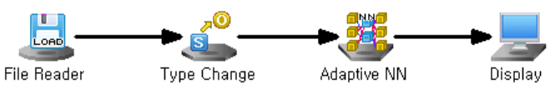

#### Node Properties

|  |  |  |  |  |
| --- | --- | --- | --- | --- |
| Property group | Property Name | Description | Misc. | Note |
| Model File | Save Model File | Decide whether to save model file. | Required | Yes, No |
| Model File Path | Set the path for the model file to be saved. | Conditionally Required |  |
| Selection options | Optimizing Method | Set the method of weight updates. | Required | Steepest Descent. Conjugate Gradient. Levenberg Marquardt. |
| Number of Hidden Layers | Select Number of Hidden Layers. | Required | 1 or 2 |
| Number of nodes in Hidden Layers #1 | Set the number of nodes in the first hidden layer. | Required | 0<integer |
| Number of nodes in Hidden Layers #2 | Set the number of nodes in the second hidden layer. | Required | 0<integer |
| Activation Function of Hidden Layer #1 | Select the activation function of the first hidden layer. | Required | Linear, Tanh, Sigmoid |
| Activation Function of Hidden Layer #2 | Select the activation function of the second hidden layer. | Required | Linear, Tanh, Sigmoid |
| Output Layer Activation Function | Select the activation function of the output layer. | Required | Linear, Tanh, Sigmoid |
| Momentum | Set the degree to which the weight reflects the existing direction of movement if **Optimizing Method** is **Steepest Descent.** | Required | Default:0.90 0≤real number<1 |
| Learning Rate | Set the degree of weight updates if **Optimizing Method** is **Steepest Descent.** | Required | 0<real number≤1 |
| Run Count | Enter the maximum number of iterations. | Required | Default:100, 0<integer |
| Final Target Error | Set the target error at which the algorithm stops iterating once the error between the actual and desired responses is reached. | Required |  |
| Epsilon 1 | Enter Epsilon 1 if **Optimizing Method** is **Levenberg Marquardt.** | Required |  |
| Epsilon 2 | Enter Epsilon 2 if **Optimizing Method** is **Levenberg Marquardt.** | Required |  |
| Structural Optimization | Decide whether to optimize the structure when the **Split Node** is connected. | Required | Yes, No |
| Start Node Count of Hidden Layer #1 | Set the number of starting nodes in the first hidden layer if **Structural Optimization** is **Yes.** | Conditionally Required | 0<integer |
| Increase In Nodes of Hidden Layer #1 | Set the number of nodes to increase in the first hidden layer if **Structural Optimization** is **Yes.** | Conditionally Required | 0<integer |
| Test Case Count of Hidden Layer #1 | Set the number of test cases in the first hidden layer if **Structural Optimization** is **Yes.** | Conditionally Required | 0<integer |
| Start Node Count of Hidden Layer #2 | Set the number of starting nodes in the second hidden layer if **Structural Optimization** is **Yes.** | Conditionally Required | 0<integer |
| Increase In Nodes of Hidden Layer #2 | Set the number of nodes to increase in the second hidden layer if **Structural Optimization** is **Yes.** | Conditionally Required | 0<integer |
| Test Case Count of Hidden Layer #2 | Set the number of test cases in the second hidden layer if **Structural Optimization** is **Yes.** | Conditionally Required | 0<integer |
| *NOTE*  For example, if the number of starting nodes is 1, the number of incremental nodes is 2, and the number of test cases is 4, then we will test for cases 1, 3, 5, and 7. If the number of tests in the first hidden layer is 4 and the number of tests in the second hidden layer is 5, then we will test for a total of 20 cases. | | | | |

#### Results

The analysis Results are displayed by connecting the modeling node to the Display Node. A new column named **“MLPC\_YHAT”** is added to the original data table that represents the predicted value of the model.

**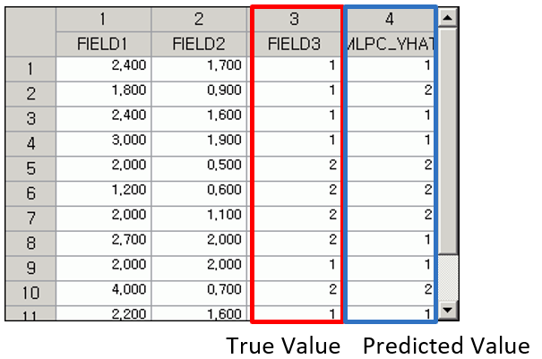**

#### Modeling Result

**Click Modeling Result button in Node Property of the diamond Model node or double click the Model node to view the Results. Various results can be viewed by clicking the different tabs at the bottom of the window.**

Option Information: It shows which options were used when modeling using MLP. This allows you to determine how the Results change when the options are changed. Weight Information: The weight information of the node entering Hidden Layer #1 from the input layer and the weight information of the node entering the output layer from Hidden Layer #1 are displayed.

ANOVA TABLE: **The ANOVA (Analysis of Variance) table** is used in regression analysis to evaluate whether the regression model **explains a significant portion of the variance in the dependent variable**. It breaks down the total variability of the dependent variable into components attributable to the regression model (explained variance) and to residual error (unexplained variance). The **F-statistic tests** the null hypothesis that all regression coefficients are equal to zero (i.e., the model has no explanatory power). A low **p-value** (typically < 0.05) indicates that the model as a whole is statistically significant, meaning at least one predictor variable is useful in explaining variation in the response variable. If the p-value is high, the model is not statistically significant, and interpretation of individual regression coefficients may not be meaningful. The total result of the anova table is displayed in a table format under the **Model Info tab**.

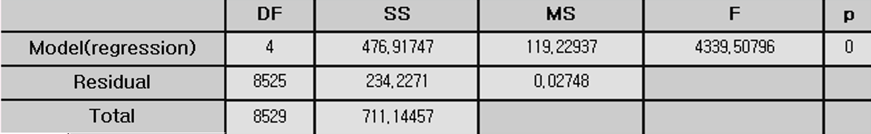

Confusion Matrix: Applicable only for classification. A **confusion matrix** is a table used to evaluate the performance of a classification model by comparing its **predicted class labels** to the **actual class labels**. According to the confusion matrix table the **total number of misclassifications** is calculated as well as the **misclassification rate**. The **misclassification rate** reflects the proportion of incorrect predictions made by the model. Overall, the confusion matrix not only quantifies prediction outcomes but also helps identify specific types of errors, offering valuable insight for **model evaluation and improvement**. This result is displayed in a table format under the **Model Info tab.**

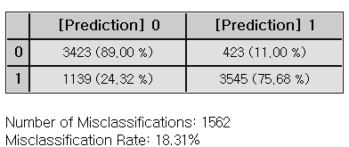

Standard Error Information: This applies only to regression analysis and indicates the fitting and predictive power of the model. It displays four key evaluation metrics – R-squared, Adjusted R2, RMSE, MAE, and MAPE – which represent the error between the original value and the predicted value of the dependent variable. **R-square (coefficient of determination):** It is a value that checks whether the derived regression equation is representative of the measured values. **Adjust R2:** It adjusts the r-squared value by considering the degree of freedom of the model. **RMSE (Root-Mean Square Error):** The square root of the average squared differences between the predicted values and the dependent variable. **MAE (Mean Absolute Error):** The average of the absolute differences between the predicted values and the dependent variable. **MAPE (Mean Absolute Percentage Error):** The average of the absolute differences between the predicted values and the dependent variable as a percentage. $MAPE= \frac{\sum_{i=1}^{n}{\left|{(y}_{i}- \hat{y_{i}}\right)/y_{i}|}}{n}×100$

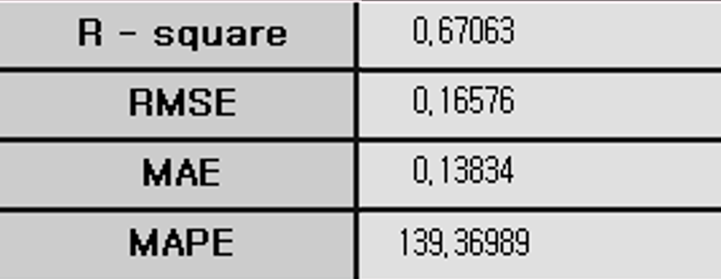

#### Example file

Run “**NN.ecm**”

### 3.4.2 Association Rules (AR)



**Association Rules (AR)** is a techniqueused to discover relationships or patterns between items in large transaction datasets. ECMiner™ provides the Apriori algorithm for **Association Rules (AR).**

#### Overview

**Association Rules (AR)** is an exploratory data analysis method used to identify the relevance of items included in transaction or event. This technique, known as market basket analysis, is used to identify associations between items that frequently co-occur in transactions. Association Rules (AR) is that "if you buy product A, you buy product B as well." This technique can be applied for cross-selling of products, recommendation systems, and fraud detection. However, finding a correlation rule with too granular items can lead to meaningless interpretation, and low-transaction items are more likely to be excluded from rule discovery. Example: "10% of customers who buy shoes buy socks at the same time."

#### Applications

Both continuous and discrete data type are allowed. The following data preprocessing steps are required. **Association Rules (AR)** can be applied only for data withtransactions and items recorded at the point of sale. It is an unsupervised learning method since it does not have a target. The data type of the transactions can be either 0 / 1 (continuous) or by the item names (discrete). The structure of the data file should follow either of the examples below. Continuous data type where 1 is for transaction and 0 is for non-transaction. The options for such data file are recommended to be set as **Transaction (TID) Option = ‘Row is TID’, Item Option = ‘Exist by Number’**. Discrete data type where the transaction information is by the item names. The options for such data file are recommended to be set as **Transaction (TID) Option = ‘sorted by TID’, Item Option = ‘Exist by Item Name’**.

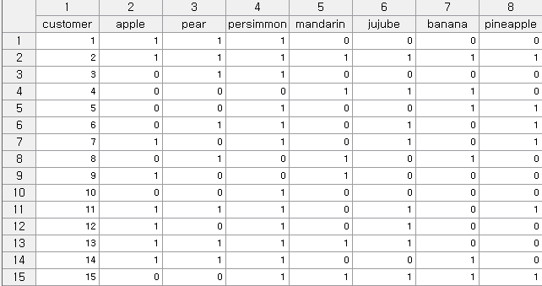

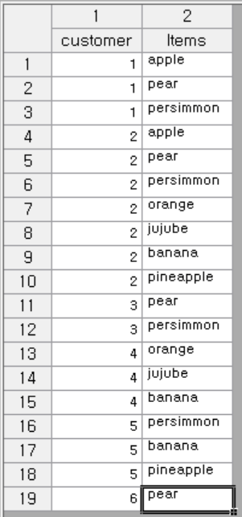

#### Usage

Read the data using Input Node. Connect Input Node to Association Rules (AR) Node select the options. An example of Sequential AR stream is as follows.

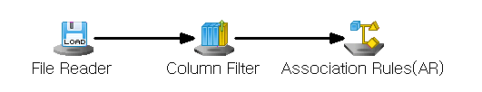

#### Node Properties

|  |  |  |  |  |
| --- | --- | --- | --- | --- |
| Property group | Property Name | Description | Misc. | Note |
| Model File | Save Model File | Decide whether to save model file. | Required | Yes, No |
| Model File Path | Set the path for the model file to be saved. | Conditionally Required |  |
| Selection options | Min Support | Set the minimum support value.  (default value is 0.5) | Required | Natural Number |
| Max Itemsize | Maximum itemset size  The algorithm will generate itemsets of all possible lengths (starting from 1 itemset up to the maximum possible length) | Required | >1 |
| Min Confidence | Minimum confidence value  (default value is 0.5) | Required | 0-1 |
| Result Itemset | Enter the Result Itemset. You can choose either a single outcome or multiple outcomes. | Required | Single Result,  Multiple outcomes |
| Transaction (TID) Option | Choose whether you need to sort by Transaction ID, if it is already sorted, or if you want to view a single row by ID. | Required | Must be sorted by TID, sorted by TID, row is TID |
| Item Option | Select whether the current data type is represented by the number of items or a single transaction by the item name. | Required. | Exists by item name, exists by number |

#### Modeling Result

**Click Modeling Result button in Node Property of the diamond Model node or double click the Model node to view the Results. Various results can be viewed by clicking the different tabs at the bottom of the window.**

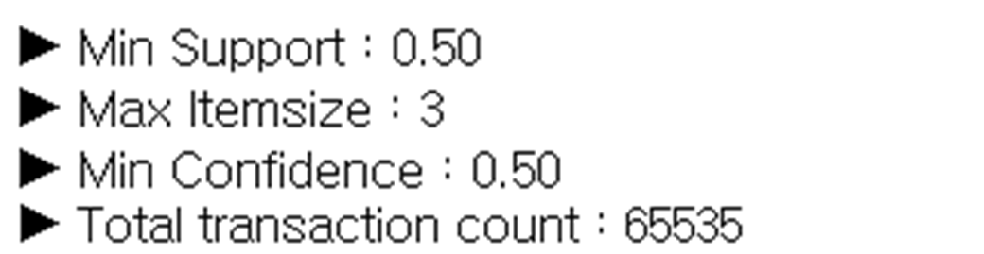

Weight Information is shown in the form of a table. This table summarizes the output of association rule mining, where each row represents a rule identifying patterns of item co-occurrence in transactional data. The **Order** column indicates the rule's position in the sorted list based on a chosen metric. The **Association Rules** column presents the relationship in the format "[antecedent] ---> [consequent]", meaning that when the items in the antecedent appear, the consequent item is likely to follow. The **Number of Items** column shows the total number of items involved in the rule, including both antecedent and consequent. **Confidence (%)** reflects the probability that the consequent appears in transactions that contain the antecedent, with higher values indicating stronger reliability. **Improvement** measures how much more confident the rule is compared to the baseline expectation of the consequent's occurrence; a value above 1 suggests the rule is stronger than chance. Finally, the **Support rate (%)** represents the proportion of transactions in the dataset where both the antecedent and consequent appear together, indicating how frequently the rule occurs in practice.

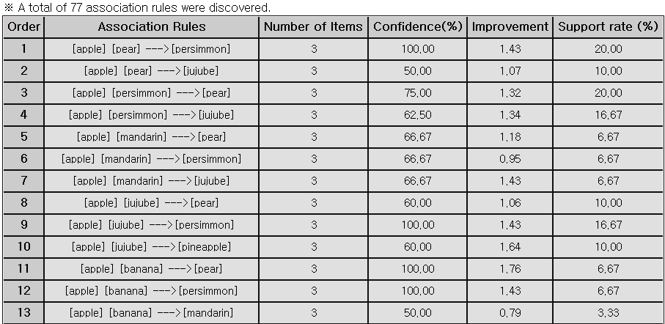

#### Example file

Run the **“AR.ecm“**

### 3.4.3 AutoEncoder



**AutoEncoder** is a type of neural network that produces an output closely resembling the input through encoding and decoding processes. The encoded **Results** can be used for data compression, or you can identify anomalies by comparing the input with the output.

#### Overview

**AutoEncoder** is a type of neural network that compresses and then restores data. The neural network consists of a symmetrical hidden layer that functions as both an encoder and decoder, along with a feature hidden layer that represents the compressed data. You can observe the Results of data compression through the Results of the Feature layer and verify the restoration of the input data through the output layer.

#### Applications

All input nodes must be continuous.

#### Usage

Read the data using Input Node. Connect Input node to AutoEncoder Node and select the options. Connect AutoEncoder Node to Display Node. An example of AutoEncoder stream is as follows.

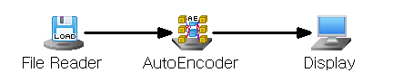

#### Node Properties

|  |  |  |  |  |
| --- | --- | --- | --- | --- |
| Property group | Property Name | Description | Misc. | Note |
| Model File | Save Model File | Decide whether to save model file. | Required | Yes, No |
| Model File Path | Set the path for the model file to be saved. | Conditionally Required |  |
| Selection options | Optimization Technique | Select the Numerical Method to optimize the objective function. | Required | Gradient Descent, AdaGrad, RMSProp, ADAM |
| Hidden Layer Count Configuration | Select Number of Hidden Layers. | Required | 1, 3 |
| Feature Hidden Layer Node Count | Enter the number of nodes in the Feature hidden layer. | Required | natural number |
| Feature Hidden Layer Activation Function | Feature Specifies the activation function of the hidden layer. | Required | Linear, Tanh, Sigmoid, ReLU, Leaky ReLU, ELU |
| Symmetric Hidden Layer Node Count | Enter the number of nodes in the symmetric hidden layer. | Required | natural number |
| Symmetric Hidden Layer Activation Function | Specifies the activation function of the symmetric hidden layer. | Required | Linear, Tanh, Sigmoid, ReLU, Leaky ReLU, ELU |
| Output Layer Activation Function | Specifies the activation function of the output layer. | Required | Linear, Tanh, LogSig, ReLU, Leaky ReLU, ELU |
| Run Count | Enter the maximum number of training iterations. | Required | natural number |
| Final Target Error | Learning stops when the target error is reached. | Required | Real number |
| Batch Size | Set the batch size. | Required | natural number |
| Learning Rate | Set the Learning Rate when learning weights. | Required | Real number |
| Momentum | When calculating the weight for the opposite direction of the gradient, enter the amount of reflection of the direction from the previous step. | Required | Real number |
| Gamma | Specifies the Gamma value used in the RMSProp algorithm. | Required | Real number |
| Beta1 | Specifies the Beta1 value used in the ADAM algorithm. | Required | Real number |
| Beta2 | Specifies the Beta2 value used in the ADAM algorithm. | Required | Real number |

#### Results

The analysis Results are displayed by connecting the modeling node to the Display Node. New columns named **“AE\_Feature#”** are added according to the number of *Feature Hidden Layer Node Count* that represents the **compressed latent features** (also known as encoded representations) produced by the encoder part of the autoencoder. They are lower-dimensional features that capture essential information from the input data. **“AE\_XHAT#”** columns are also created according to the number of variables which represents the reconstructed outputs from the decoder. They represent the model’s attempt to reconstruct the original inputs A1, A2, and A3 using the encoded features. The closer these values are to the original inputs, the better the model performance. In addition, **“AE\_MSE”** column represents the mean squared error values between the original input features and the reconstructed output features.

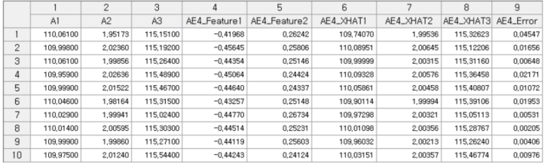

#### Modeling Result

**Click Modeling Result button in Node Property of the diamond Model node or double click the Model node to view the Results. Various results can be viewed by clicking the different tabs at the bottom of the window.** Option Information: It shows which options were used when modeling using Deep NN. This allows you to determine how the Results change when the options are changed. Weight Information: The weight information of the node entering Hidden Layer #1 from the input layer and the weight information of the node entering the output layer from Hidden Layer #1 are displayed.

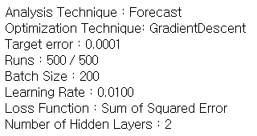

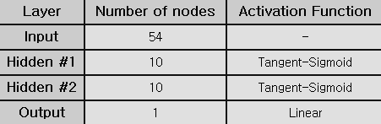

### 3.4.4 CART

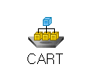

**CART (Classification and Regression Trees)** isa type of decision tree algorithm. CART is used for Random Forests and Gradient Boosted Trees.

#### Overview

**Decision Trees** is a classification model which is interpretable and easy to understand. Tree structure shows the decision-making process. **Growing the Tree:** The data is split recursively at different nodes based on the feature such as splitting criterion, and stopping rule. Gini impurity is used for classification, and LSD (Least Squared Deviation) is used for regression. **Pruning:** The decision tree is stopped from growing before it reaches its maximum complexity. This can be done by setting a limit on the depth of the tree, the minimum number of samples required to split a node, or the minimum gain in impurity reduction needed to make a split. To avoid overfit, pruning is needed. **Classification:** The algorithm creates a classification tree where each node represents a decision rule on a feature.

#### Applications

Decision trees can be used for both classification and regression tasks. The CART algorithm uses different impurity functions depending on the task: Gini, Twoing, or Entropy for classification tasks with discrete target variable, and LSD (Least Squared Deviation) for regression tasks with continuous target variable.

#### Usage

Read the data using Input Node. Specify the type of data using Type Change Node. (independent, or target). Connect Type Change Node to CART Node and select the options. Connect CART Node to Display Node. Additional option: Set the Misclassification Cost and Occupancy ratio. An example of CART stream is as follows.

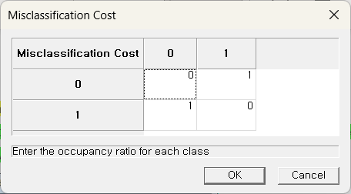 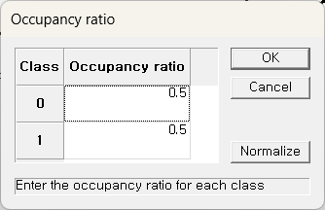

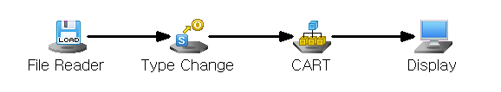

#### Node Properties

|  |  |  |  |  |
| --- | --- | --- | --- | --- |
| Property group | Property Name | Description | Misc. | Note |
| Model File | Save Model File | Decide whether to save model file. | Required | Yes, No |
| Model File Path | Set the path for the model file to be saved | Conditionally Required |  |
| Selection options | Impurity Function | Specify the impurity function  (Default is Gini) | Required | Gini, Twoing, Entropy, LSD |
| Misclassification Cost | ‘Default’ sets the misclassification cost as 1 for correct classifications and 0 for misclassifications across all classes.  To assign different costs to each class, select Custom and specify the values. | Required | Default, Custom |
| Occupancy Input | Occupancy Input refers to the proportion of each class within the data. By default, the same percentage is applied to all classes. | Required | Default,  Custom |
| Criterion | Define whether to build the tree automatically or manually based on the selected options. | Required | Automatic, Manual |
| Min Samples Split | Set the minimum number of data required to split a tree node. Activated when the Criterion option is set to ‘Automatic’. (Default is 5) | Conditionally  Required | Value>0 |
| Pruning | Choose whether to prune the generated tree. Activated when the Criterion option is set to ‘Automatic’. | Conditionally  Required | Yes, No |
| Max Tree Depth | The maximum depth of the tree. Activated when the Criterion option is set to ‘Automatic’.  **Default**: None (nodes are expanded until all leaves are pure or contain fewer than Min Samples Split) | Conditionally  Required | Value>0 |
| Impurity Threshold | A node becomes a stationary node if its impurity is below the specified impurity threshold. Activated when the Criterion option is set to ‘Automatic’. | Conditionally  Required | 0≤value≤1 |
| Impurity Change Threshold | If the impurity change for a node is below the specified threshold, the node is considered a terminal node. Activated only when the Criterion option is set to ‘Automatic’, and Pruning option is set to ‘No’. | Conditionally  Required | 0≤value≤1 |

#### Results

The analysis Results are displayed by connecting the modeling node to the Display Node. A new column named **“CART\_YHAT”** is added to the original data table that represents the predicted value of the model. In addition **“CART\_PROB\_{class}”** and **“CART\_PROB\_{class}”** columns are added according to the number of classification class which represents the probability of the predicted category.

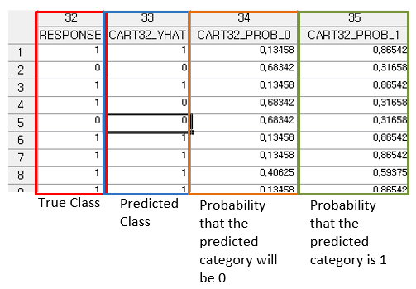

Modeling Result

**Click Modeling Result button in Node Property of the diamond Model node or double click the Model node to view the Results. Various results can be viewed by clicking the different tabs at the bottom of the window.** Option Information: It shows which options were used when modeling using CART. Model Information. Confusion Matrix: Applicable only for classification. A **confusion matrix** is a table used to evaluate the performance of a classification model by comparing its **predicted class labels** to the **actual class labels**. According to the confusion matrix table the **total number of misclassifications** is calculated as well as the **misclassification rate**. The **misclassification rate** reflects the proportion of incorrect predictions made by the model. Overall, the confusion matrix not only quantifies prediction outcomes but also helps identify specific types of errors, offering valuable insight for **model evaluation and improvement**. This result is displayed in a table format under the **Model Info tab.**

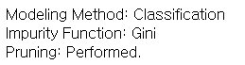

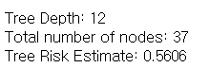

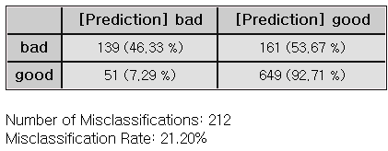

Decision Tree: There are two rules that can be obtained through the tree structure below, and the group is determined by the value of CHK\_ACCT. If the variable CHK\_ACCT is 0.14286, 0.25, 0.37755, 0.65285, it is divided into groups with good credit ratings and can be used as a rule. When CHK\_ACCT is 0.70732, 0.84615, 0.86871, it appears as a group with a bad credit rating. In this case, it can also be used as a rule.

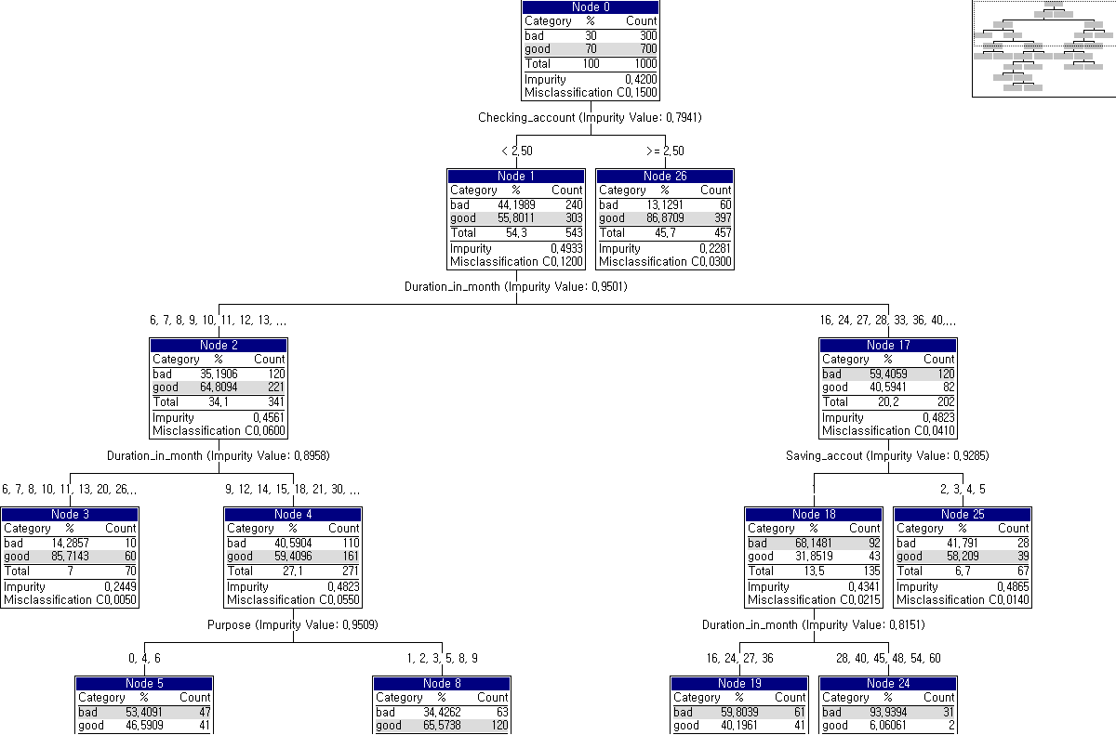

#### Example file

Run “CART.ecm“

### 3.4.5 CCA(Canonical Correlation Analysis) 미배포

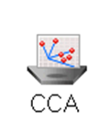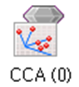

**Canonical Correlation Analysis (CCA)** is a multivariate statistical method that finds the relationship between two sets of multivariate variables.

#### Overview

**Canonical Correlation Analysis (CCA)** is used to identify the linear correlation between two sets of multivariate variables. **CCA** examines the relationships between multiple independent and dependent variables. **CCA** consists of $q$ variables $x_{1}$, $x_{2}$, …, $x_{q}$ and $p$ variables $y_{1}$, $y_{2}$, …, $y_{p}$ aiming to find the dependency relationship between the two sets of variables. In CCA, the new variables $U$ and $V$ are canonical variables generated as linear combinations of the variables in each set, representing the direction that best explains the correlation within each set of variables. The linear combination form for canonical variables $U$ and $V$, which summarize $q$ and $p$ variables, are as follows.

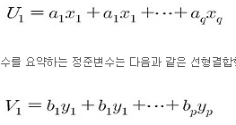



**Matrix Type** option is used when creating canonical variables, allowing you to choose between a **Covariance Matrix** and a **Correlation Matrix**. The **Covariance Matrix** is used when the variables in both sets have the same units or scale, while the **Correlation Matrix** is used when the variables have different units or scales. The **Number of Canonical Correlations** represents the linear combinations that explain the correlations between two sets of variables and can range from 1 to the smaller number of variables in the two sets.

#### Applications

Independent variables must be continuous. Dependent variable must be continuous.

#### Usage

Read the data using Input Node. Specify the type of data using Type Change Node. (independent, or target) Connect Type Change Node to CCA Node and select the options. Connect CCA Node to Display Node. An example CCA stream is as follows.

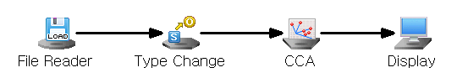

#### Node Properties

|  |  |  |  |  |
| --- | --- | --- | --- | --- |
| Property | Property Name | Description | Misc. | Note |
| Model File | Save Model File | Decide whether to save model file. | Required | Yes, No |
| Model File Path | Set the path for the model file to be saved. | Conditionally Required |  |
| Selection options | Matrix Type | Set the Matrix Type. | Required | Covariance Matrix, Correlation Matrix |
| Number of Canonical Correlations | Set the number of Canonical Correlation Coefficient. | Required | 1 ≤integer≤N (N: Minimum Number of Independent and Dependent variables) |

#### Results

The CCA results and the scores of independent and dependent variables are displayed using Display Node.

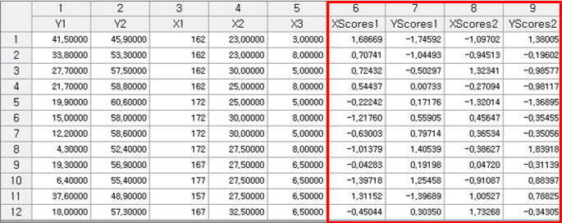

#### Graphic Result

Click Graphic Result in Node Property of Model node to view the charts. The results can also be viewed in the Modeling Result of Model node. Correlation Plot: Indicates the correlation coefficient between independent and dependent variables. Score Plot: Plot of the score values for the independent and dependent variables. Loading Plot: Scatter plot of the loading values for the independent and dependent variables. The loading value is the correlation coefficient between individual variables and the canonical variables.

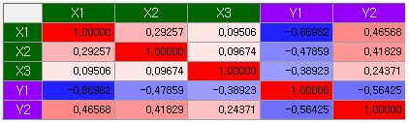

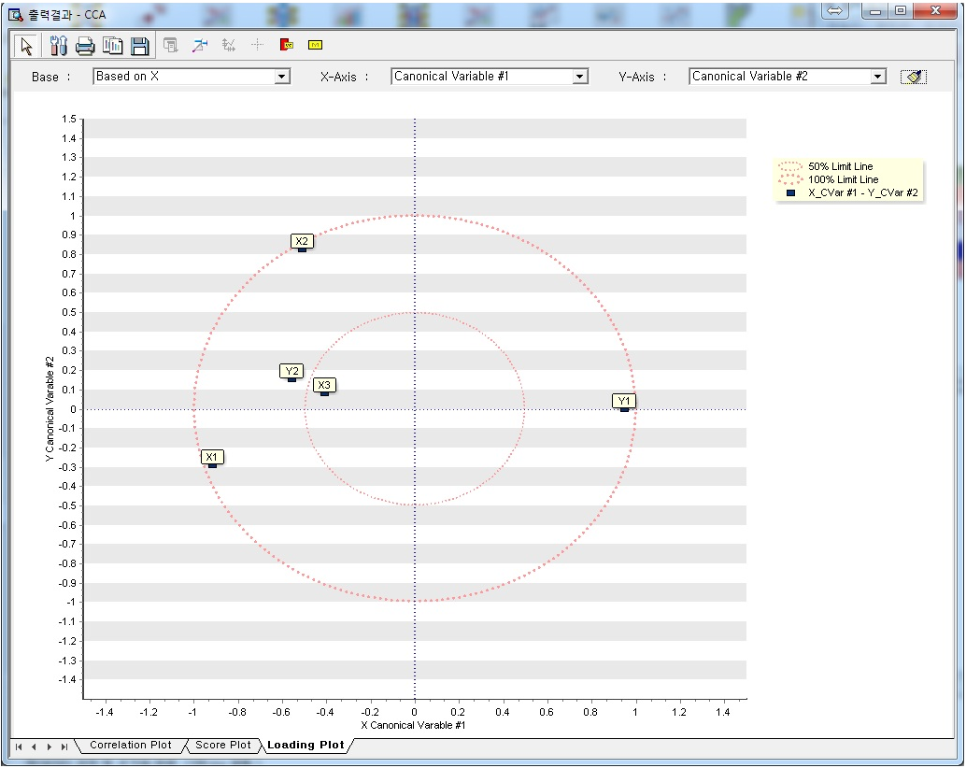

#### Modeling Result

Click Modeling Result in Node Property of Model node to view the results. Canonical Correlation Coefficient Test - Wilks' Lambda Statistic. Wilks’ Lambda statistic for testing the canonical correlation coefficient. Canonical Correlation Coefficient. Coefficient X and Y: The linear combination form of the canonical variables of the independent variables and dependent variables is provided in the form of formulas and tables. Canonical Loading: Canonical loading information between canonical variables and independent variables, as well as between canonical variables of independent and dependent variables, and between dependent variables and canonical variables. Variance Information: It shows how much information each canonical variable explains about the entire data.



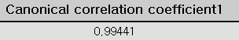



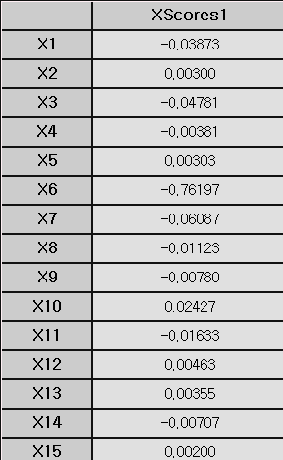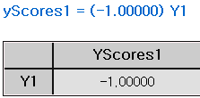

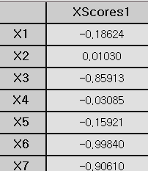

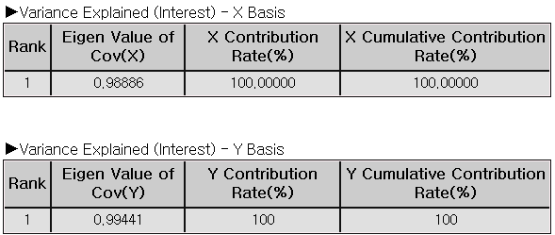

#### Example file

Run the “**CCA.ecm”**

### 3.4.6 CNN

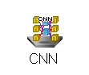

**Convolutional Neural Network (CNN)** is a type of deep learning model that utilizes multiple convolutional and pooling layers to automatically learn features from input images. These features enable CNN to perform tasks such as classification or prediction. CNN excels at understanding the spatial structure within image data, allowing it to identify and extract intricate patterns or structure.

#### Overview

Convolutional Neural Network (CNN) is a machine learning methodology inspired by the similarities between the patterns of connections among neurons and those found in the visual cortex of animals. It is a type of feed-forward neural network that automatically learns features from images through filter or kernel optimization. CNN is widely used for characterizing and classifying of 2D data, such as images, across various field.

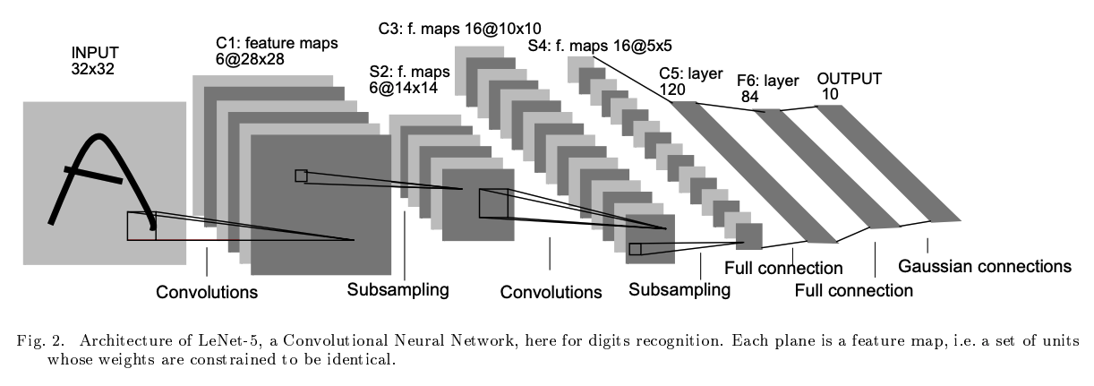

The figure above illustrates a CNN architecture, like LeNet-5, using convolutional and subsampling layers to extract features, and fully connected layers for digit recognition**.** Convolutional neural networks comprise **three primary types of layers**. **Convolution layer:** The convolutional layer is the most important feature of a CNN, applying filters to the previous layer’s feature map to generate a new, more compact, and informative feature map. The filters move across the input with a set stride, controlling the amount of overlap and affecting the size of the output. Padding is often used in convolutional layers to control the output size and preserve information at the edges. In certain CNN architectures like LeNet, AlexNet, and VGGNet, both stride and padding values are fixed for each layer type and cannot be modified. **Pooling layer:** The pooling layer, or sub-sampling layer, reduces the number of weights parameters by down sampling, optimizing computational efficiency and mitigating overfitting. **Fully connected layer**: Finally, the fully connected layer, or classification layer, processes the extracted features and performs classification. The output of the final fully connected layer is a probability map, indicating the likelihood of the input image belonging to each class. The class with the highest probability is considered the final classification result.

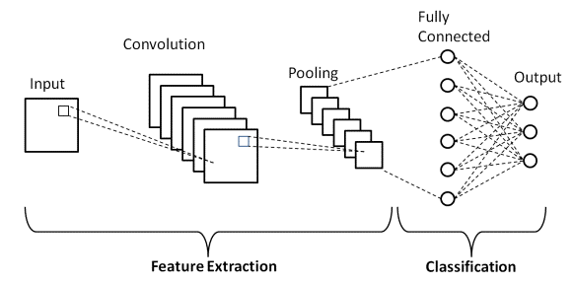

#### Applications

Select a string-type variable from the CNN Node's properties that contains the path to the input image. Set the string-type variable containing the labeling information as the dependent variable.

#### Usage

Read the data using Image Reader Node. Add label column using Preprocessing Node. (Column Filter, Derived Column, etc) Specify the type of data using Type Change Node. (independent, or target) Connect Type Change Node to CNN Node and select the options. Connect CNN Node to Display Node. An example of CNN stream is as follows.

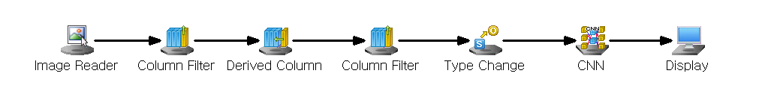

#### Node Properties

|  |  |  |  |  |
| --- | --- | --- | --- | --- |
| **Property group** | **Property Name** | **Description** | **Misc.** | **Note** |
| **Model File** | Save Model File | Decide whether to save model file. | Required | Yes, No |
| Model File Path | Set the path for the model file to be saved. | Conditionally Required |  |
| **Selection options** | Input Image Path Variable | Select the Input Image string-type variable that contains the source path information. | Required | variable name |
| Image Color Space | Decide whether the input image is color or black and white. | Required | Color, black and white |
| Network Type | Specify structure of the convolution neural network for modeling | Required | LeNet-5, AlexNet, VGGNet |
| Use Initial Padding | Decide whether to apply Initial Padding to the Input Image. | Required | Yes, No |
| Top Padding | Sets the initial padding size to be applied to the top of the Input Image if Use Initial Padding is **Yes**.. | Conditionally Required | 0≤Integer |
| Bottom Padding | Sets the initial padding size to be applied to the Bottom of the Input Image if Use Initial Padding is **Yes**... | Conditionally Required | 0≤Integer |
| Left Padding | Sets the initial padding size to be applied to the left side of the Input Image if **Use Initial Padding** is **Yes**. | Conditionally Required | 0≤Integer |
| Right Padding | Sets the initial padding size to be applied to the right of the Input Image if **Use Initial Padding** is **Yes**. | Conditionally Required | 0≤Integer |
| Optimization Technique | Set the method of weight updates. | Required | Gradient Descent with Momentum, AdaGrad, RMSProp, ADAM |
| Learning Rate | Set the degree of weight updates during the Optimization Technique. | Required | 0<real number≤1 |
| Momentum | Set the degree to which the weight reflects the existing direction of movement if **Optimizing Method** is **Gradient Descent with Momentum.** | Conditionally Required | 0<real number≤1 |
| Gamma | Set the rate at which previously updated weights are remembered if **Optimization Technique** is **RMSProp.** | Conditionally Required | 0≤real number<1 |
| Beta1 | Set the degree to which the weight reflects the existing direction of movement if **Optimization Technique** is **ADAM.** | Conditionally Required | 0≤real number<1 |
| Beta2 | Set the rate for remembering previously updated weights if the **Optimization Technique** is ADAM. | Conditionally Required | 0≤real number<1 |
| Batch Size | Set the number of data to update at once in mini-batch gradient descent. | Required | 0<integer≤k (k: number of data) |
| Number of Epochs | Set the number of epochs | Required | 0<integer |

#### Note

Activation Function are sigmoid, Hyperbolic tangent, ReLU, leaky ReLU, linear, and ELU functions.

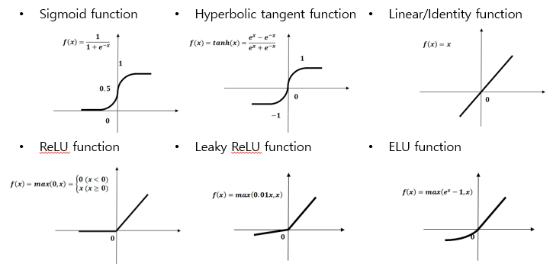

Batch Size: In mini-batch gradient descent, learning is performed by calculating the loss function for each batch. When the batch size approaches the size of the entire dataset, it behaves similarly to one-batch gradient descent, which updates the entire dataset at once. This makes it robust to outliers but weak against local minima. Conversely, when the batch size is closer to 1, the updates become more like stochastic gradient descent, making it less resistant to outliers but better at escaping local minima. By adjusting the batch size, we can balance between outlier resistance and the ability to overcome the local minima problem.

Optimization algorithm: Gradient Descent with Momentum: Weights are updated in a way similar to the concept of inertia, where an object tends to continue moving in the same direction. The closer the Momentum coefficient is to 1, the more it maintains the current direction, while values which are closer to 0 approach standard gradient descent. When the Momentum coefficient is 1, a new gradient is added without changing the current direction. Conversely, if the Momentum coefficient is 0, it is identical to regular gradient descent.

Adagrad: For variables that fluctuate significantly during training, we reduce the learning rate. For instance, if one variable is updated more frequently than another, its learning rate is adjusted accordingly.

RMSProp: Adagrad adjusts the learning rate for each parameter individually, but it can get stuck with a very low learning rate due to accumulating past gradients. RMSprop addresses this by giving more weight to recent gradients, preventing the learning rate from becoming too small too quickly.

ADAM: Adam is a learning method that combines the strengths of momentum and RMSprop. Momentum helps maintain the direction of movement, while RMSprop reduces the learning rate for frequently updated variables. Adam uses two hyperparameters beta1 and beta2. The closer the Beta1 value is to 1, like the momentum coefficient, the more it maintains the direction in which the gradient value is moving. The Beta2 value is a ratio that maintains the size of the gradient before the current point, similar to the gamma value of RMSProp. The closer the Beta2 value is to 1, the greater the influence of reducing the current learning strength due to the previous update time.

Message: Display the batch-wise classification accuracy (%) in the message window for each batch, and show the mean square error and root mean square error for each epoch in the message window.

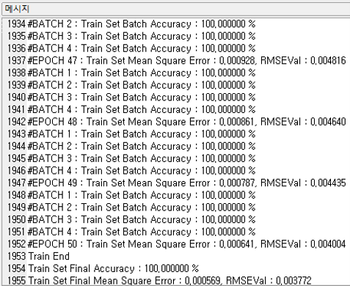

#### Results

The analysis Results are displayed by connecting the modeling node to the Display Node. A new column named **“CNN\_YHAT”** is added to the original data table that represents the predicted classification results for the dependent variable based on input image data. **“CNN\_MaxOut”** indicates the confidence level (classification probability) with which the fCNN model classified the prediction result.

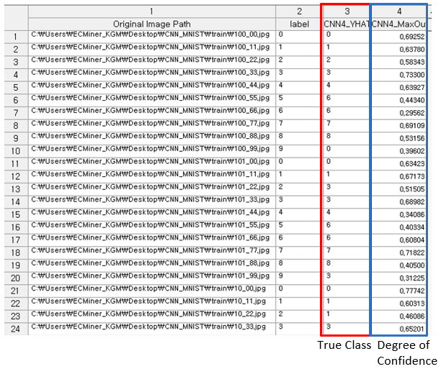

#### Modeling Result

**Click Modeling Result button in Node Property of the diamond Model node or double click the Model node to view the Results. Various results can be viewed by clicking the different tabs at the bottom of the window.** Option Information: It shows which options were used when modeling using CNN. Confusion Matrix: Applicable only for classification. A **confusion matrix** is a table used to evaluate the performance of a classification model by comparing its **predicted class labels** to the **actual class labels**. According to the confusion matrix table the **total number of misclassifications** is calculated as well as the **misclassification rate**. The **misclassification rate** reflects the proportion of incorrect predictions made by the model. Overall, the confusion matrix not only quantifies prediction outcomes but also helps identify specific types of errors, offering valuable insight for **model evaluation and improvement**. This result is displayed in a table format under the **Model Info tab.**

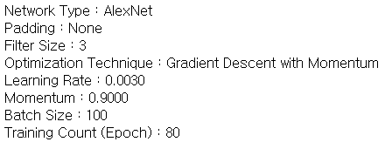

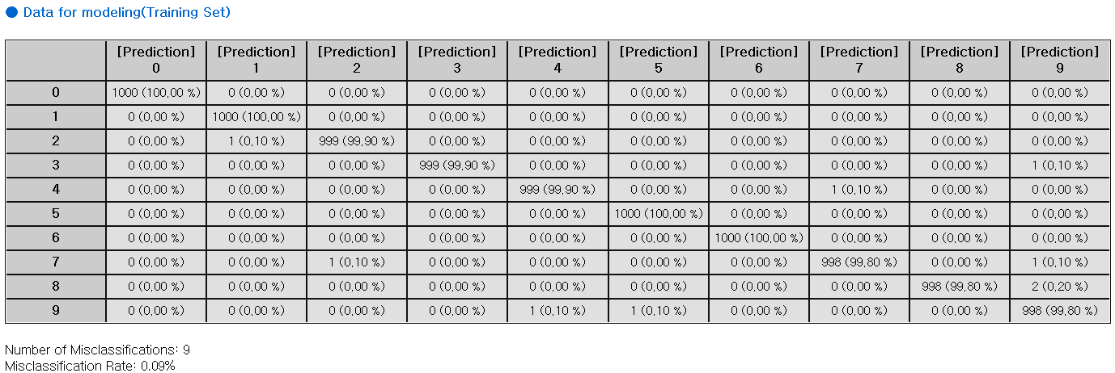

### 3.4.7 Deep NN

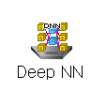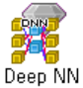

The **Deep Neural Network (Deep NN)** is a type of artificial neural network with multiple hidden layers to understand the complex, non-linear relationships between the data.

#### Overview

A common type of NN is the multilayer feedforward network, which consists of an input layer, one or more hidden layers, and an output layer. In this process, the input signal advances layer-by-layer. Each layer's neurons (or nodes) are connected to those in other layers through connections that have a bias and an adjustable weight. The figure below illustrates the structure of an NN with two hidden layers.



Backpropagation is a widely used algorithm in training artificial neural networks, primarily for minimizing the error by adjusting the weights through gradient descent. consists of two stages:

Forward pass: The input is passed through the network layer by layer. It passes through the input and hidden layers in the forward direction. Finally, the network produces output, which is an estimate of the desired output, at the output layer. During the forward pass, the network computes its output, but the weights remain unchanged.

Backward pass (Backpropagation): The weights are updated in the backward direction based on the error correction rule (back propagation algorithm). The weights are adjusted so that the network's actual output moves closer to the desired output.

#### Applications

Independent variables must be continuous. Dependent variable can be either continuous or discrete. If the dependent variable is discrete, One-Hot Encoding is applied.

#### Usage

Read the data using Input Node. Specify the type of data using Type Change Node. (independent, or target) Connect Type Change Node to DeepNN Node and select the options. Connect DeepNN Node to Display Node. An example of DeepNN stream is as follows.

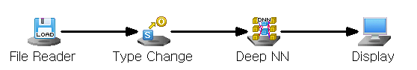

#### Node Properties

|  |  |  |  |  |
| --- | --- | --- | --- | --- |
| Property group | Property Name | Description | Misc. | Note |
| Model File | Save Model File | Decide whether to save model file. | Required | Yes, No |
| Model File Path | Set the path for the model file to be saved. | Conditionally Required |  |
| Selection options | Run Count | Select the maximum number of times to train the dataset. | Required | natural number |
| Final Target Error | Select the minimum error condition for learning to end. | Required | 0<real number |
| Loss Function | Select the type of loss function. If Loss Function is Cross Entropy, SoftMax activation function is automatically applied. | Required | Sum of Squared Error,  Cross Entropy |
| Output Layer Activation Function | Select the activation function of the output layer if Loss Function is Sum of Squared Error. | Conditionally Required | Linear, Tanh, Log Sigmoid, ReLU, Leaky ReLU, ELU |
| Optimization Technique | Set the method of weight updates. | Required | Gradient Descent With Momentum,  ADAM,  Adagrad,  RMSProp |
| Batch Size | Set the number of data to update at once in mini-batch gradient descent. | Required | 0<integer≤k (k: number of data) |
| Learning Rate | Set the degree of weight updates during optimization technique. | Required | 0<real number≤1 |
| Momentum | Set the degree to which the weight reflects the existing direction of movement if Optimization Technique is Gradient Descent with Momentum. | Conditionally Required | 0≤real number<1 |
| Gamma | Set the rate at which previously updated weights are remembered if Optimization Technique is RMSProp. | Conditionally Required | 0≤real number<1 |
| Beta1 | Set the degree to which the weight reflects the existing direction of movement if Optimization Technique is ADAM. | Conditionally Required | 0≤real number<1 |
| Beta2 | Set the rate at which ADAM Optimization Technique remembers previously updated weights if Optimization Technique is ADAM. | Conditionally Required | 0≤real number<1 |
| Selection options  -Hidden Layer Configuration | Add Hidden Layer | Add a hidden layer of the model. | button |  |
| Remove Last Hidden Layer | Remove the last hidden layer of the model. | button |  |
| Selection options  -Hidden Layer # | Number of Nodes | Set the number of perceptron in the hidden layer. | Required | natural number |
| Activation Function | Select the activation function of the hidden layer. | Required | Linear, Tanh, Log Sigmoid, ReLU, Leaky ReLU, ELU |

#### Note

Activation Function are sigmoid, Hyperbolic tangent, ReLU, leaky ReLU, linear, and ELU functions.



Batch Size: In mini-batch gradient descent, learning is performed by calculating the loss function for each batch. When the batch size approaches the size of the entire dataset, it behaves similarly to one-batch gradient descent, which updates the entire dataset at once. This makes it robust to outliers but weak against local minima. Conversely, when the batch size is closer to 1, the updates become more like stochastic gradient descent, making it less resistant to outliers but better at escaping local minima. By adjusting the batch size, we can balance between outlier resistance and the ability to overcome the local minima problem.

Optimization algorithm. **Gradient Descent with Momentum:** Weights are updated in a way similar to the concept of inertia, where an object tends to continue moving in the same direction. The closer the Momentum coefficient is to 1, the more it maintains the current direction, while values which are closer to 0 approach standard gradient descent. When the Momentum coefficient is 1, a new gradient is added without changing the current direction. Conversely, if the Momentum coefficient is 0, it is identical to regular gradient descent.

**Adagrad:** For variables that fluctuate significantly during training, we reduce the learning rate. For instance, if one variable is updated more frequently than another, its learning rate is adjusted accordingly.

**RMSProp:** Adagrad adjusts the learning rate for each parameter individually, but it can get stuck with a very low learning rate due to accumulating past gradients. RMSprop addresses this by giving more weight to recent gradients, preventing the learning rate from becoming too small too quickly.

**ADAM:** Adam is a learning method that combines the strengths of momentum and RMSprop. Momentum helps maintain the direction of movement, while RMSprop reduces the learning rate for frequently updated variables. Adam uses two hyperparameters beta1 and beta2. The closer the Beta1 value is to 1, like the momentum coefficient, the more it maintains the direction in which the gradient value is moving. The Beta2 value is a ratio that maintains the size of the gradient before the current point, similar to the gamma value of RMSProp. The closer the Beta2 value is to 1, the greater the influence of reducing the current learning strength due to the previous update time.

Message: The RMSE value is displayed in the message every 10th iteration.

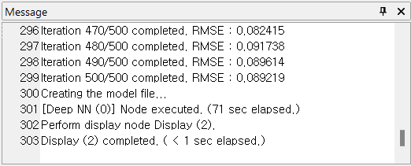

#### Results

The analysis Results are displayed by connecting the modeling node to the Display Node. A new column named **“DNN\_YHAT”** is added to the original data table that represents the predicted value of the model. **“DNN\_Residual”** column is also added which represents the value difference between the dependent variable and the yhat value.

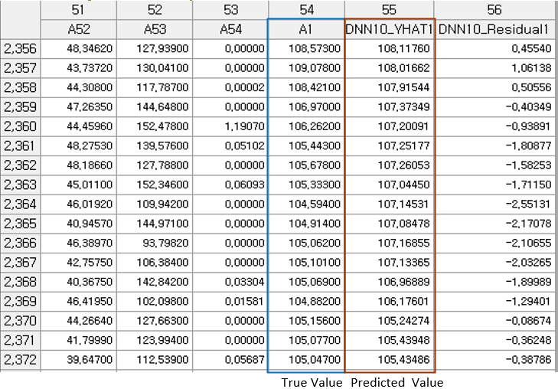

#### Modeling Result

**Click Modeling Result button in Node Property of the diamond Model node or double click the Model node to view the Results. Various results can be viewed by clicking the different tabs at the bottom of the window.** Option Information. It shows which options were used when modeling using NN. This allows you to determine how the results change when the options are changed. Weight Information: The weight information of the node entering Hidden Layer #1 from the input layer and the weight information of the node entering the output layer from Hidden Layer #1 are displayed.

ANOVA TABLE: The **ANOVA (Analysis of Variance) table** is used in regression analysis to evaluate whether the regression model explains a significant portion of the variance in the dependent variable. It breaks down the total variability of the dependent variable into components attributable to the regression model (explained variance) and to residual error (unexplained variance). The F-statistic tests the null hypothesis that all regression coefficients are equal to zero (i.e., the model has no explanatory power). A low p-value (typically < 0.05) indicates that the model as a whole is statistically significant, meaning at least one predictor variable is useful in explaining variation in the response variable. If the p-value is high, the model is not statistically significant, and interpretation of individual regression coefficients may not be meaningful. The total result of the anova table is displayed in a table format under the **Model Info tab.**



Confusion Matrix: Applicable only for classification. A **confusion matrix** is a table used to evaluate the performance of a classification model by comparing its **predicted class labels** to the **actual class labels**. According to the confusion matrix table the **total number of misclassifications** is calculated as well as the **misclassification rate**. The **misclassification rate** reflects the proportion of incorrect predictions made by the model. Overall, the confusion matrix not only quantifies prediction outcomes but also helps identify specific types of errors, offering valuable insight for **model evaluation and improvement**. This result is displayed in a table format under the **Model Info tab.**





Standard Error Information: This applies only to regression analysis and indicates the fitting and predictive power of the model. It displays four key evaluation metrics – R-squared, Adjusted R2, RMSE, MAE, and MAPE – which represent the error between the original value and the predicted value of the dependent variable. **R-square (coefficient of determination):** It is a value that checks whether the derived regression equation is representative of the measured values. **Adjust R2:** It adjusts the r-squared value by considering the degree of freedom of the model. **RMSE (Root-Mean Square Error):** The square root of the average squared differences between the predicted values and the dependent variable. **MAE (Mean Absolute Error):** The average of the absolute differences between the predicted values and the dependent variable. **MAPE (Mean Absolute Percentage Error):** The average of the absolute differences between the predicted values and the dependent variable as a percentage. $MAPE= \frac{\sum_{i=1}^{n}{\left|{(y}_{i}- \hat{y_{i}}\right)/y_{i}|}}{n}×100$

### 3.4.8 ElmanNet



ElmanNet is type of the recurrent neural with a single hidden layer, commonly used for predictive analysis (Regression). It features a context layer that stores information from previous time steps, allowing the network to make predictions based on past data.

#### Overview

ElmanNet is a recurrent neural network with a single hidden layer. It includes a Context Layer, which serves as a memory component, retaining information about previous states. The Context Layer has the same number of nodes as the hidden layer and stores the hidden layer's state values through recurrent feedback. By using the influence of independent variables from previous time points, ElmanNet predicts the dependent variable at each time point. It is commonly used for predictive tasks and is classified as a supervised neural network.

#### Applications

Independent variable must be continuous. Dependent variable must be continuous. Since the dependent variable is continuous, only predictive analysis is performed, and the activation function is fixed to the identity function. ElmanNet has only one hidden layer.

#### Usage

Read the data using Input Node. Specify the type of data using Type Change Node. (independent, or target) Connect Type Change Node to ElmanNet Node and select the options. Connect ElmanNet Node to Display Node. An example of ElmanNet stream is as follows.

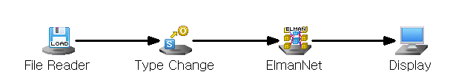

#### Node Properties

|  |  |  |  |  |
| --- | --- | --- | --- | --- |
| Property group | **Property Name** | **Description** | **Misc.** | **Note** |
| Model File | Save Model File | Decide whether to save model file. | Required | Yes, No |
| Model File Path | Set the path for the model file to be saved. | Conditionally Required |  |
| Selection options | Number of Nodes | Specify the number of nodes in the hidden layer. | Required | Integer < 100 |
| Hidden Layer Activation Function | Specify the activation function of the hidden layer. | Required | Sigmoid |
| Weighting Initialization Specification | Specify whether to manually set the initial weights of the neural network. | Required | Yes, No |
| Initial Weighting From | Specify the starting point of the random range for weight initialization. | Selection options | -1 **≤** Real Number **≤** 1. -0.5 by default |
| Initial Weighting To | Specify the ending point of the random range for weight initialization. | Selection options | -1 ≤ Real Number ≤ 1. 0.5 by default |
| Number of Epochs | Specifies **the maximum number of epochs** for performing the algorithm | Required | natural number |
| Target Error | Specify the maximum allowable target error for learning. | Required | 0≤real number≤1 |
| Learning Rate | Specify the step size when calculating the weight for the gradient direction during training. | Required | 0≤real number≤1 |
| Momentum | Specify the extent to which the previous step's direction is incorporated when calculating the weight for the gradient direction during training. | Required | 0≤real number≤1 |
|  | Batch Size | Specify the batch size to be used for the BPTT(Back Propagation Through Time) algorithm during training. | Required | natural number ≤ 200 |
|  | Learning Log | Specify the interval for displaying logs during training | Required | Natural Number |

#### Results

Prediction results are displayed using Display Node.

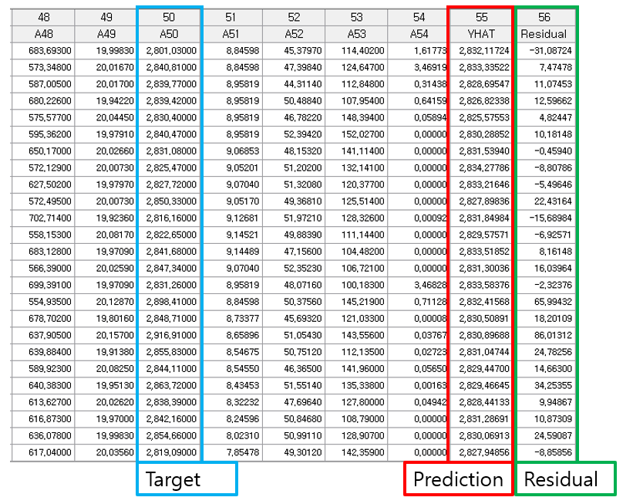

#### Graphic Result

Click Graphic Result button in Node Property of Model node to view the charts. The results can also be viewed in the Modeling Result of Model node. RMSE Plot: Monitor the change in error rate (learning rate) according to the number of repetitions during the model learning process. Compare Plot: Compare the distribution of actual values and values predicted by the model. Residual Plot: Examine the residual between the actual value and the predicted values generated by the model.

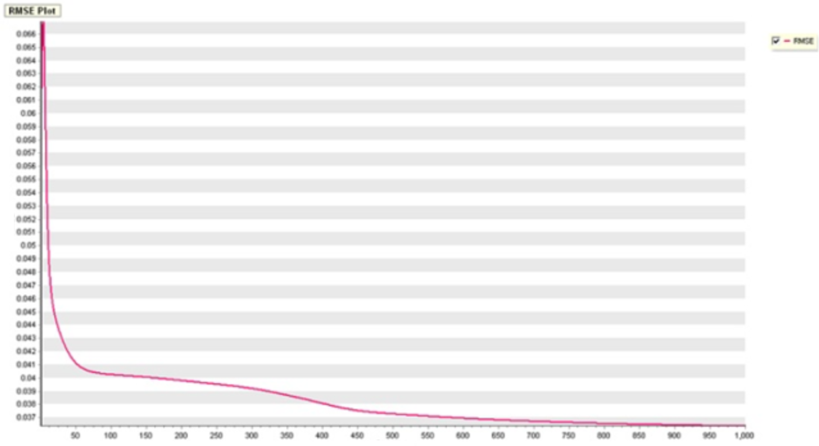

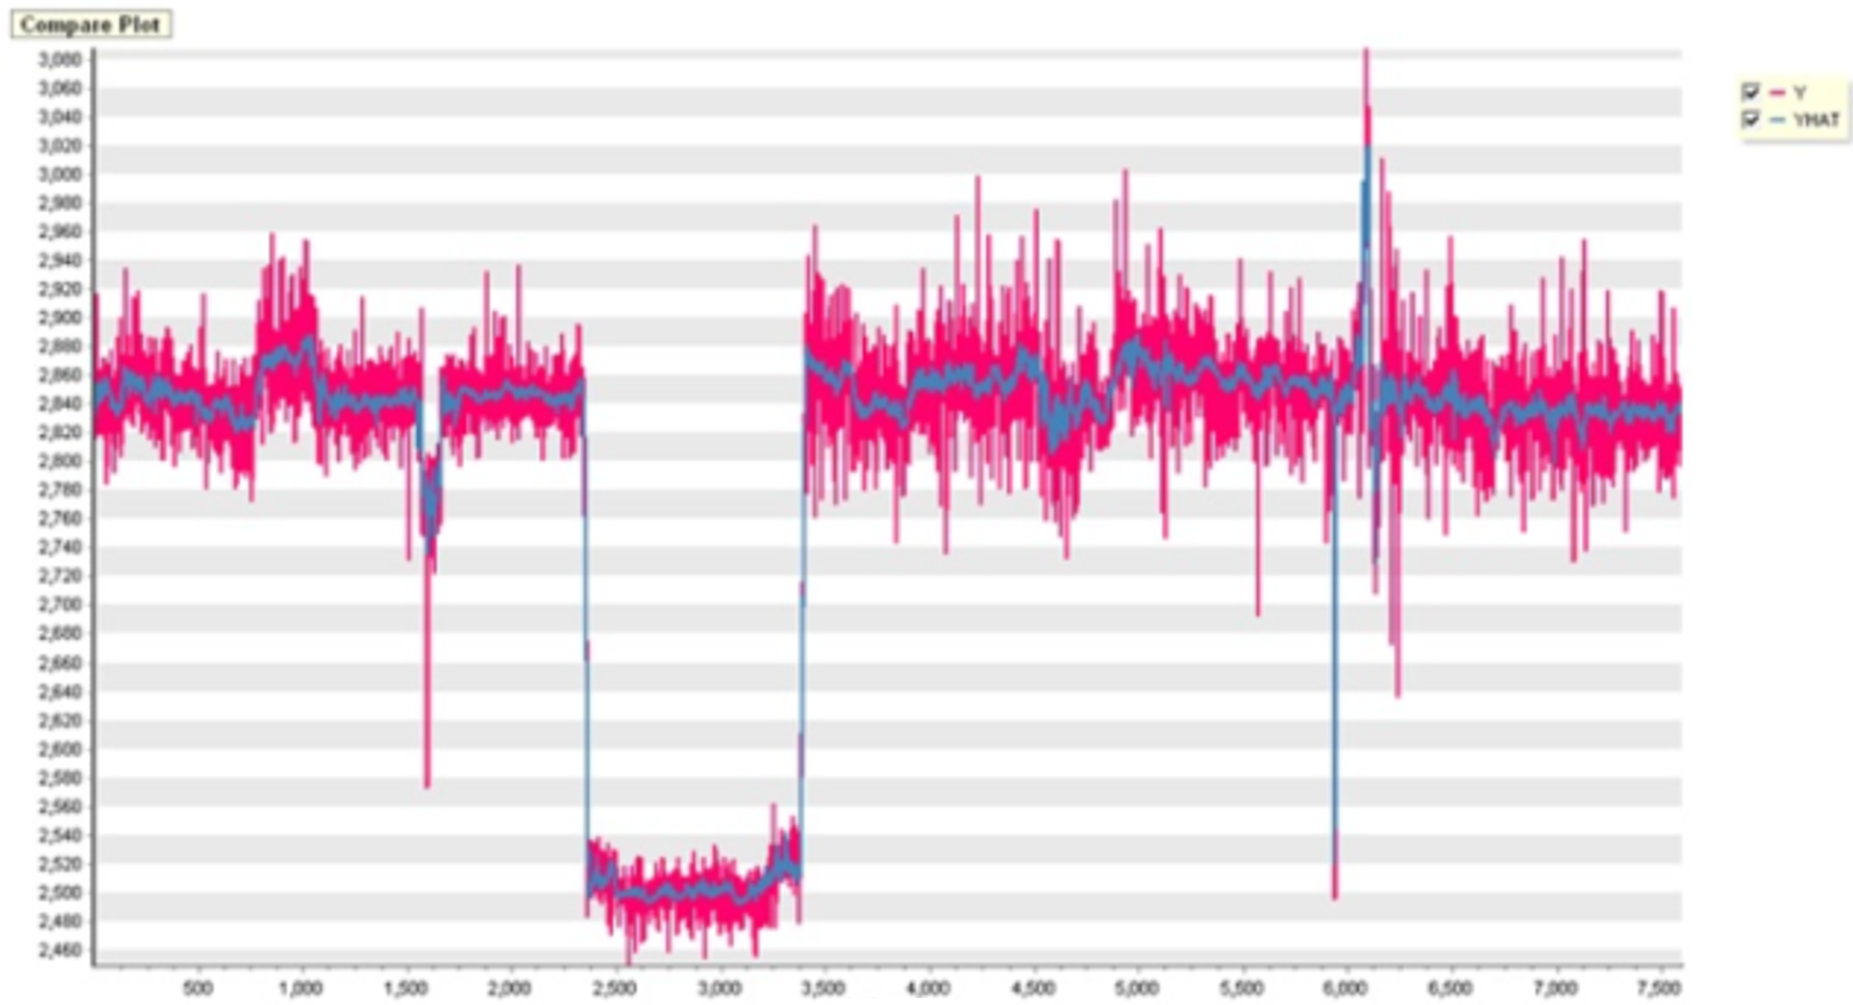

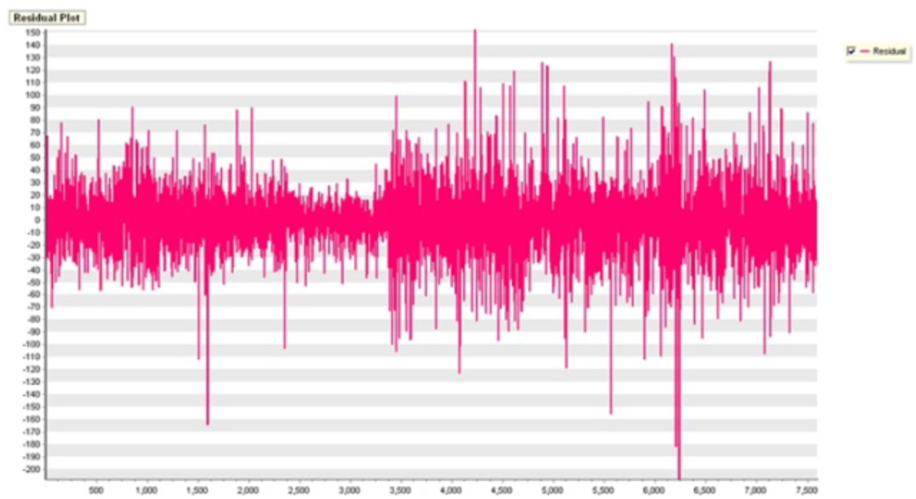

#### Modeling Result

Click Modeling Result button in Node Property of Model node to view the analysis results. Error information about dependent variable. Provides ANOVA Table and Standard Error information.

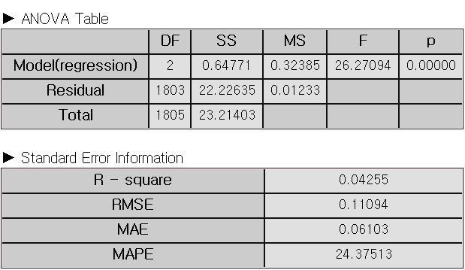

### 3.4.9 Factor Analysis

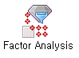

**Factor analysis** is the statistical technique that extracts a common factor among various variables. This allows you to analyze or connect multiple factors.

#### Overview

Factor Analysis is a methodology that explains observed variables with small numbers of variables. The small numbers of variables are called common factors and are difficult to find because these are not observed. The purpose of Factor Analysis is to find unobserved common factors and know how the unobserved common factors affect each observed variable.

For example, several students have grades in math, English, Korean, social studies, science, and technology. Empirically, students who are good at math are often good at science and technology, and students who are good at Korean are often good at English and social studies. This may be because grades in mathematics, science, and technology are greatly influenced by human quantitative abilities, and Korean, English, and social studies are greatly influenced by human linguistic abilities.

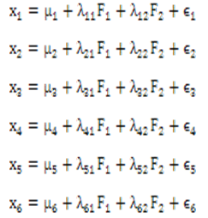

The above mathematical formula describes the followings: $x_{i}$ represents the grade of subject $i$, $μ_{i}$ refers to the population average of the grade of subject $i$. The set of $λ$ is called factor loading and is represented as follows; , . F1 can be a common factor which represents human quantitative abilities and F2 can be a common factor which represents human linguistic abilities. $ε_{i}$ represents the part that is not explained by common factors of subject $i$.

#### Applications

Only explanatory variables (independent variable) are included in factor analysis. All variables must be continuous. The Factor Analysis node contains standardized pre-processing.

#### Usage

Read the data using Input Node. Connect Input Node to Factor Analysis Node and select the options. Connect Factor Analysis Node to Display Node. An example of Factor Analysis stream is as follows.

#### Node Properties

|  |  |  |  |  |
| --- | --- | --- | --- | --- |
| **Property group** | **Property Name** | **Description** | **Misc.** | **Note** |
| **Model File** | Save Model File | Decide whether to save model file. | Required | Yes, No |
| Model File Path | Set the path for the model file to be saved. | Conditionally Required |  |
| **Selection options** | Number of Factors | Enter the number of common factors. The number of common factors must be less than the number of input variables. | Required | natural number |
| Pre-processing Method | Choose standardization as a pre-processing method. | Required | standardization. |
| Optimization Method | Choose the extraction method of common factors. You can choose maximum likelihood estimation as the extraction method of common factors. | Required | Maximum Likelihood  Estimation |
| Maximum Optimization Iterations | Set the maximum number of iterations of the optimization algorithm. | Required |  |
| Rotation Method | Choose the rotation method: None, Equimax, Varimax, Quartimax. | Required | None, Equimax, Varimax, Quartimax |

#### Results

**The analysis results are displayed using Display Node.** The results of factor analysis are displayed by using **Trend Chart** or **Enhanced Basic Chart**.

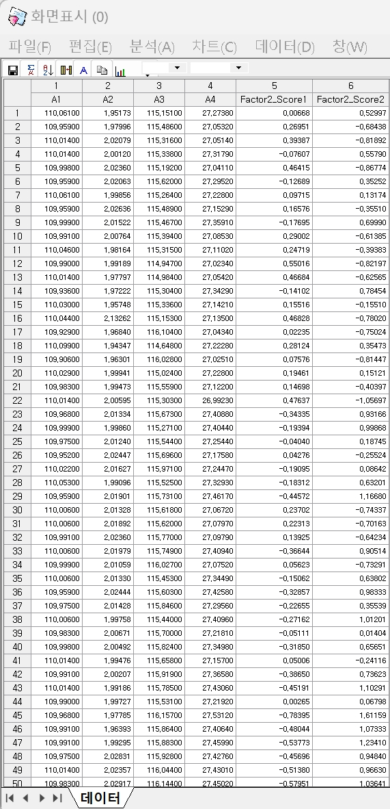

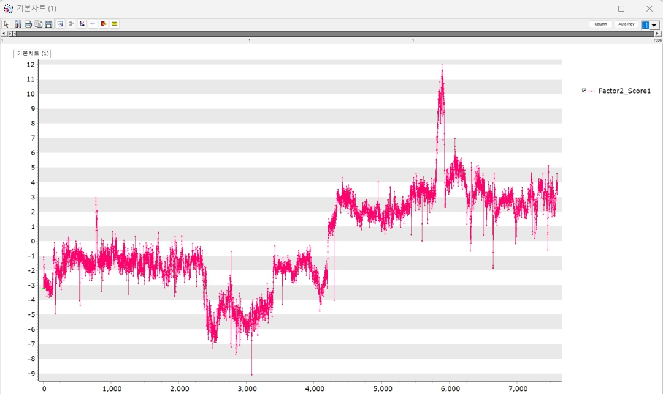

#### Graphic Result

Click Graphic Result in Node Property of Model node to view the charts. The results can also be viewed in the Modeling Result of Model node. Control Chart: The Control Chart shows the distribution of rotation/non-rotation of a common factor. The example of control chart is as follows. Loading Plot: The Loading Plot shows the factor loading value of a common factor or data which are included in a circle. Scree Plot: The Scree Plot shows the eigenvalue of a common factor. A common factor can be decided at the point that the eigenvalue is changed largely. Contribution: 1. After two groups that have large variation in a control chart are set for analysis target, the first group should be dragged like the first group, and then the dragged data would be extracted by clicking the second button. The second group should perform like the first group. 2. If data selection is finished, you can choose a common factor and group data. After this, you can click the drawing button to display contribution plot as follows.

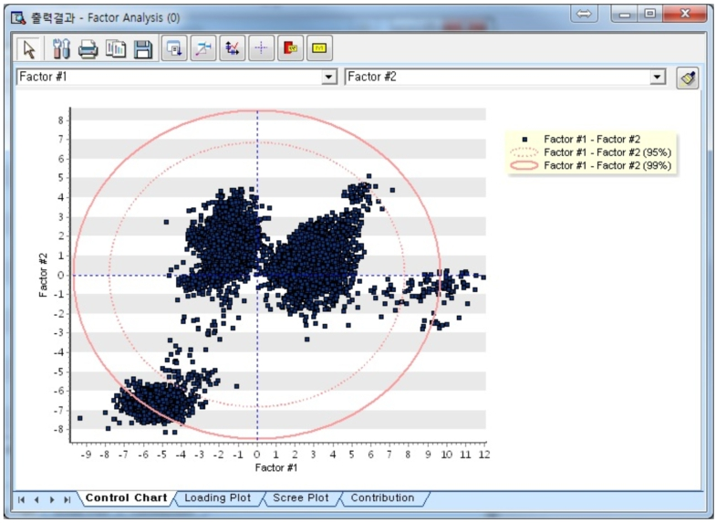

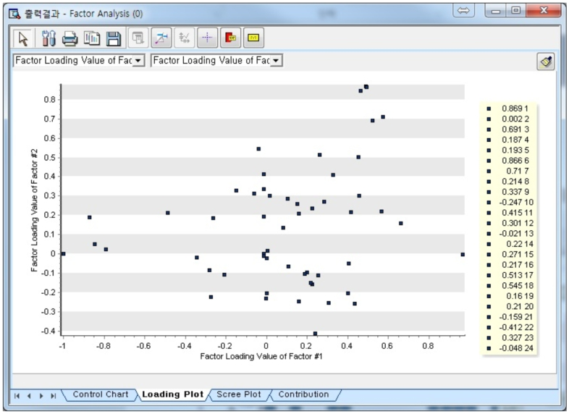

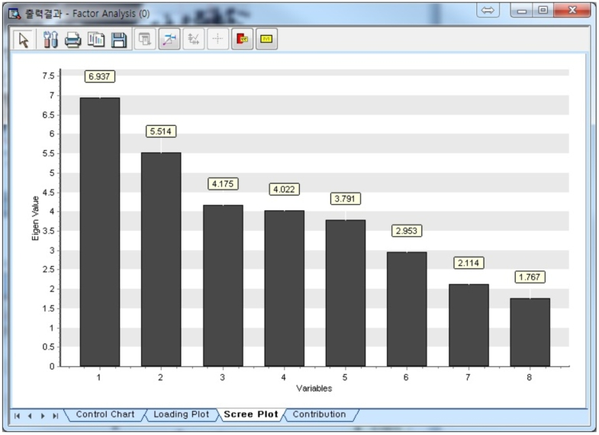

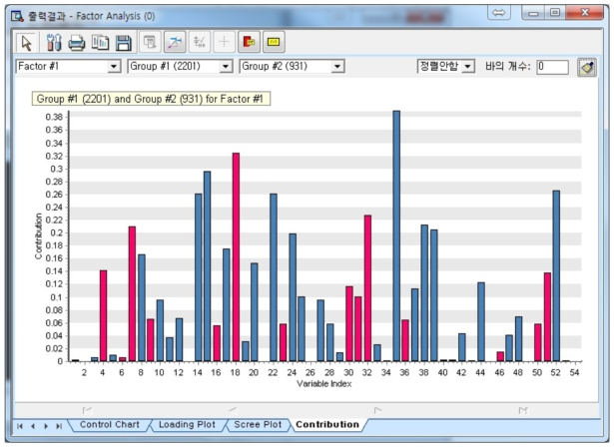

#### Modeling Result

Click Modeling Result button in Node Property of Model node to view the analysis results. Factor Loading Values (With Rotation): Factor loading by the rotated method. Factor Loading Values (No Rotation): Factor loading without rotation. Eigenvalue Information: Information about variance proportion explained by the factor. Correlation Coefficient Information by Factor. Coefficient of each factor. Control Limit by Factor











### 3.4.10 Hierarchical Clustering

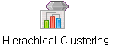

**Hierarchical Clustering** is grouping data objects with similar characteristics.

#### Overview

**Hierarchical clustering** is a useful method for small datasets. It generates a dendrogram, a tree-like structure that illustrates how data objects are grouped. The vertical axis of the dendrogram shows the similarities (or distances) between clusters.

**Distance Measure:** Hierarchical clustering differs depending on **distance measure** and **linkage method**. The distance between clusters or data points influences whether they are merged or not. If p=1 for Minkowski, then it corresponds to the **Manhattan distance**. If p=2 for Minkowski, then it corresponds to the **Euclidean distance**. **Hamming distance** and **Jaccard distance** are effective for evaluating similarity of binary vectors or text.

|  |  |
| --- | --- |
| **Name** | **formula** |
| Euclidean | $$d_{euclidean}\left(p, q\right)=\sqrt{\sum_{i=1}^{n}{{\left(p_{i}-q_{i}\right)}^{2}}}$$ |
| Squared Euclidean | $$d_{sqr_euclidean}\left(p, q\right)=\sum_{i=1}^{n}{{\left(p_{i}-q_{i}\right)}^{2}}$$ |
| Manhattan |  |
| Minkowski |  |

**Linkage Method: Linkage method** determines the distance criteria used to decide whether clusters should be merged. This approach ensures that the impact on the overall structure of the clustering is kept as small as possible. Linkage methods are as follows.

|  |  |
| --- | --- |
| Name | **Description** |
| Single | Minimum distance between points in two clusters |
| Complete | Maximum distance between points in two clusters |
| Average | Average distance between points in two clusters |
| Centroid | Distance between their centroids (mean vector on each cluster) |
| Ward | Minimize the increase in the total within-cluster variance across all clusters. |

**Cluster Criterion:** Users can select a **Cluster criterion** based on their objectives. 1. The **Number of clusters** specifies how many groups will be formed. 2. **Distance threshold** is to cut the dendrogram at a certain level to determine the number of clusters. The advantage of **Distance threshold** is that users do not have to fix the number of clusters. If the distance threshold is low, you will get more clusters. If the distance threshold is high, you will get fewer clusters.

**Preprocessing Method:** Two preprocessing techniques, **standardization** and **mean correction**, can be applied before clustering. **Standardization** scales the dataset so that it has a mean of 0 and a variance of 1. **Mean correction** subtracts the mean from each data point, resulting in an adjusted dataset with a mean of 0.

#### Applications

Dependent variable is not used. (Clustering is an unsupervised learning method.)

#### Usage

Read the data using Input Node. Connect Input Node to Hierarchical Clustering Node and select the options. Connect Hierarchical Clustering Node to Display Node. An example of Hierarchical Clustering stream is as follows.

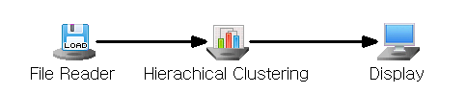

#### Node Properties

|  |  |  |  |  |
| --- | --- | --- | --- | --- |
| Property group | Property Name | Description | Misc. | Note |
| Model File | Save Model File | Decide whether to save model file. | Required | Yes, No |
| Model File Path | Set the path for the model file to be saved. | Conditionally Required |  |
| Selection options | Cluster Criterion | Specify the cluster criterion. | Required | Number of Clusters, Distance Threshold |
| Number of Clusters | Enter the number of clusters if **Cluster Criterion** is **Number of Clusters**.Default is 5. | Conditionally  Required | Integer |
| Distance Threshold | To cut the dendrogram at a certain level to determine the number of clusters. If **Cluster Criterion** is **Distance threshold, set the value.** Default is 100 | Conditionally  Required | real number |
| Distance Measure | A distance metric (e.g., Euclidean distance) between two data points | Required | Euclidean,  Squared Euclidean,  Manhattan,  Minkowski  Hamming, Jaccard |
| Linkage Method | How distances between clusters are calculated | Required | Single, Complete,  Average, Centroid, Ward |
| Minkowski  Coefficient | Set the coefficients when **distance measurement** is **Minkowski distance**.  If the coefficient is 1, it is same as the **Manhattan distance.** If it is 2, it is same as **Euclidean distance**. | Conditionally Required |  |
| Preprocessing Method | Standardization, Mean Correction | Required | None,  Standardization, Mean Correction |

#### Results

Clustering results are displayed using Display Node.

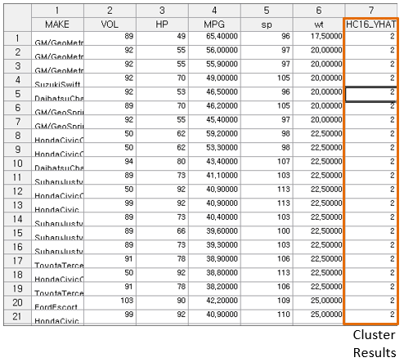

#### Graphic result

Click Graphic Result in Node Property of Model node to view the clustering result. The results can also be viewed in the Modeling Result of Model node.

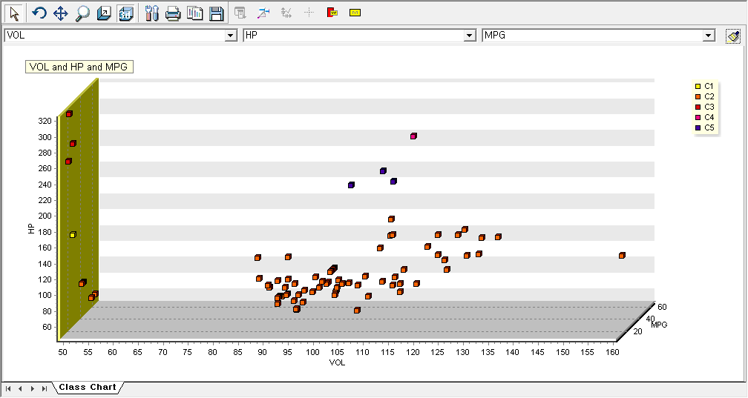

#### Modeling Result

Click Modeling Result in Node Property of Model node to view the results. Options of cluster analysis. Cluster Information: Information of then number of objects in each cluster and the distance between data within the cluster. Number of elements within a cluster: Provides the frequency and percentage of elements belonging to each cluster. Cluster Centroid of Variables: Centroid of variables in each cluster. Distance between clusters. Dendrogram Result: A dendrogram is a tree-like diagram that summarizes the clustering process. Records are displayed at the bottom of the chart. Similar records are connected by vertical lines, the length of which reflects the distance between records. This allows you to see at a glance the process by which each observation is grouped.

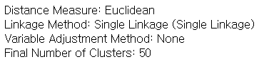

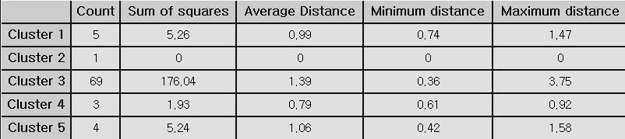

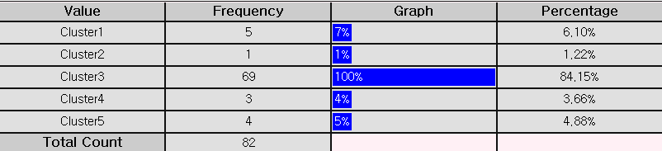

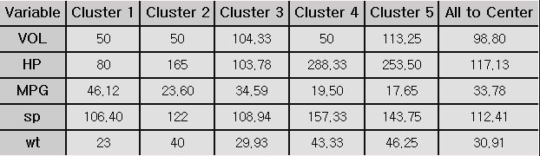

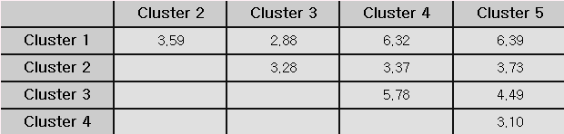

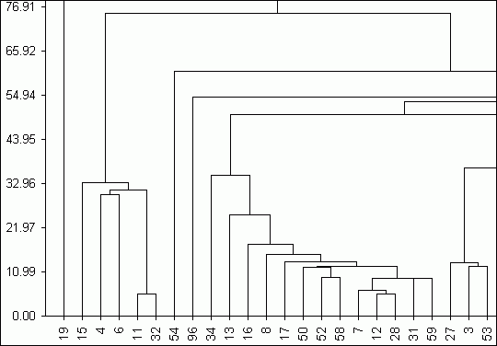

#### Example file

Run “ClusterAnalysis.ecm”

### 3.4.11 K-MEANS

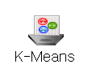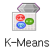

**K-means** is a popular clustering method. K-means algorithm is to partition a dataset into k-clusters **until the centroid no longer change significantly**.

#### Overview

K-means is non-HIERARCHICAL cluster method assigns data points to k-clusters. The process of cluster analysis is as follows. (1) k-cluster: Choose the number of clusters k . (2) Initialization: Randomly assign K initial cluster centroids. (3) Assign data to cluster: Assign each data point to the closest centroid by the specified distance measure. (4) Update Centroid: Update of the centroids by taking the mean of data points assigned to each cluster. (5) Iteration: Repeat the assigning data and the update centroid to maximum iteration number or no longer change centroid significantly (Repeat Steps 3 and 4 are repeated) Clustering results are shown in Graphic Results

#### Applications

Independent variables must be continuous. Dependent variable is not used. It is an unsupervised method.

#### Usage

Read the data using Input Node. Connect Input Node to K-MEANS Node and select the options. Connect K-MEANS Node to Display Node. An example of K-MEANS stream is as follows.

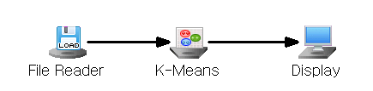

#### Node Properties

|  |  |  |  |  |
| --- | --- | --- | --- | --- |
| Property group | Property Name | Description | Misc. | Note |
| Model File | Save Model File | Decide whether to save model file. | Required | Yes, No |
| Model File Path | Set the path for the model file to be saved. | Conditionally Required |  |
| Selection options | Number of Clusters | Enter the number of clusters. | Required | Integer |
| Max Iteration | Maximum number of iterations. Default is 100 | Required | Integer |
| Initial Runs | Number of times the algorithm will run with different centroid seeds | Required | Integer |
| Distance Measure | Select the distance metric.  Default is Euclidean. | Required | Euclidean,  Squared Euclidean, Manhattan, Minkowski |
| Minkowski  Coefficient | Set the coefficients when distance measurement is Minkowski distance.  If the coefficient is 1, it is same as the Manhattan distance. If it is 2, it is same as Euclidean distance. | Conditionally Required |  |
| Preprocessing Method | Standardization, Mean Correction | Required | None,  Standardization, Mean Correction |

#### Results

Clustering results are displayed using Display Node.

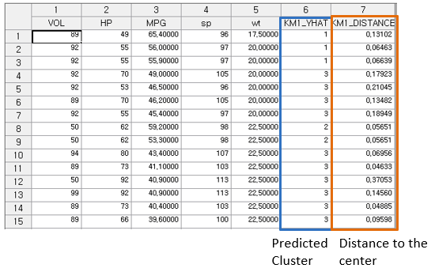

#### Graphic result

Click Graphic Result in Node Property of Model node to view the result of clustering. The results can also be viewed in the Modeling Result of Model node.

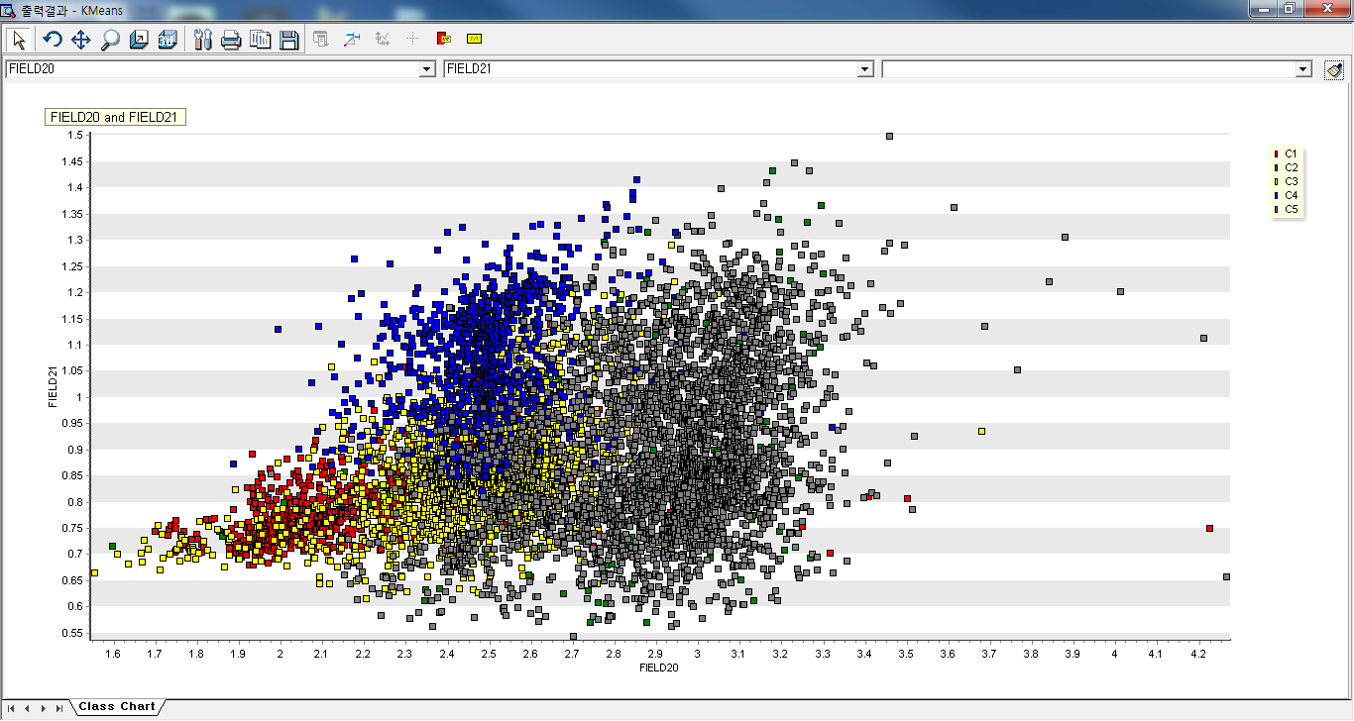

#### Modeling Result

Click Modeling Result in Node Property of Model node to view the results. Number of elements within a cluster. Provides the frequency and percentage of elements belonging to each cluster. Cluster Centroid of Variables: Centroid of variables in each cluster. Distance between clusters

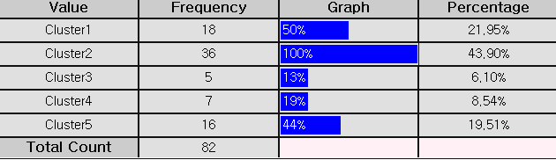

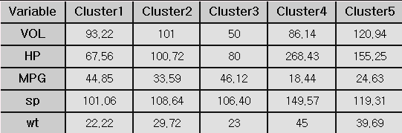

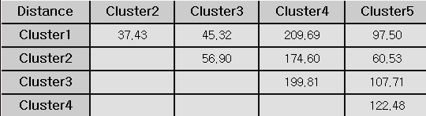

#### Example file

Run the “Clustering.ecm”

### 3.4.12 K-NN

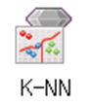

**K-Nearest Neighbor(K-NN)** is a simple non-parametric method for classification analysis to classify data.

#### Overview

**K-Nearest Neighbor (K-NN)** is a non-parametric machine learning algorithm that assumes no specific data distribution. Each sample is treated as a point in an n-dimensional space, with new samples classified based on the most common category among their k nearest neighbors in this space. **K-NN** uses train data, but it doesn’t derive rules from the train data. **K-NN** finds the closest samples in the train data to the new sample and classifies the new sample into the most common category among these nearby samples.

(1) K-Value selection: The choice ‘k’ is crucial for new data point to assign to the category. A small **k** can lead to overfitting, while a large **k** might result in underfitting. Cross-Validation helps test various k-values to identify the optimal one for the model. (2) Data Preprocessing: If data preprocessing is need, then you may do Standardization or Mean Correction in the Preprocessing Method option. Mean Correction is adjusting the data each variable's mean to zero. (3) Leave-One-Out setup: Leave-One-Out setup is the process of evaluating each data individually to ensure thorough assessment of the model's performance, reducing bias, and improving generalization. In Leave-One-Out Cross-Validation (LOOCV), the model is trained on all data except one, which is used for testing. This process repeats for each data, ensuring each is tested once. The final LOOCV error is the average error rate across all iterations, offering an unbiased estimate of the model's generalization error.

#### Applications

Independent variables must be continuous. Dependent variable must be discrete.

#### Usage

Read the data using Input Node. Specify the type of data using Type Change Node. (independent, or target) Connect Type Change Node to K-NN Node and select the options. Connect K-NN Node to Display Node. An example of K-NN stream is as follows.

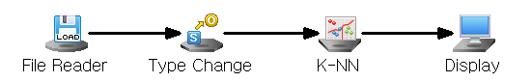

#### Node Properties

|  |  |  |  |  |
| --- | --- | --- | --- | --- |
| **Property group** | **Property Name** | **Description** | **Misc.** | **Note** |
| **Model File** | Save Model File | Decide whether to save model file. | Required | Yes, No |
| Model File Path | Set the path for the model file to be saved. | Conditionally Required |  |
| **Selection options** | k-Value | Set the number of nearest neighbors to consider. | Required | integer |
| Preprocessing Method | Set the data preprocessing method before performing the K-NN. | Required | No Preprocessing, Standardization,  Mean Correction |
| Leave-One-Out | Decide whether to use Leave One Out. | Required | Yes, No |

#### Results

Classification analysis results are displayed using Display Node.

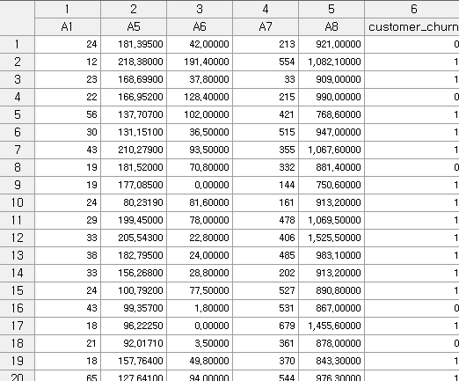

#### Modeling Result

Click Modeling Result button in Node Property of Model node to view the analysis results. Average of independent variables by class. When performing KNN, it provides information about the number of classes and K, and preprocessing method. Statistical Information: Variable sorting table. Sort and output the preprocessed sample data. Confusion Matrix: If you select the Leave-One-Out option as Yes in the properties window of the K-NN node, you can check the misclassification rate.

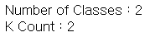

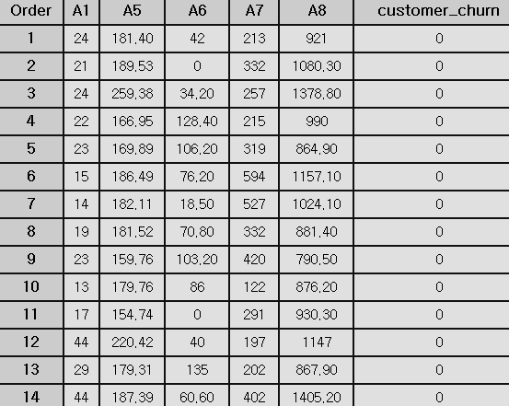

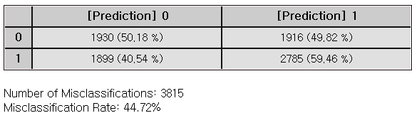

#### Example File

Run the “KNN.ecm”

### 3.4.13 LDA(Linear Discriminant Analysis)

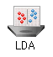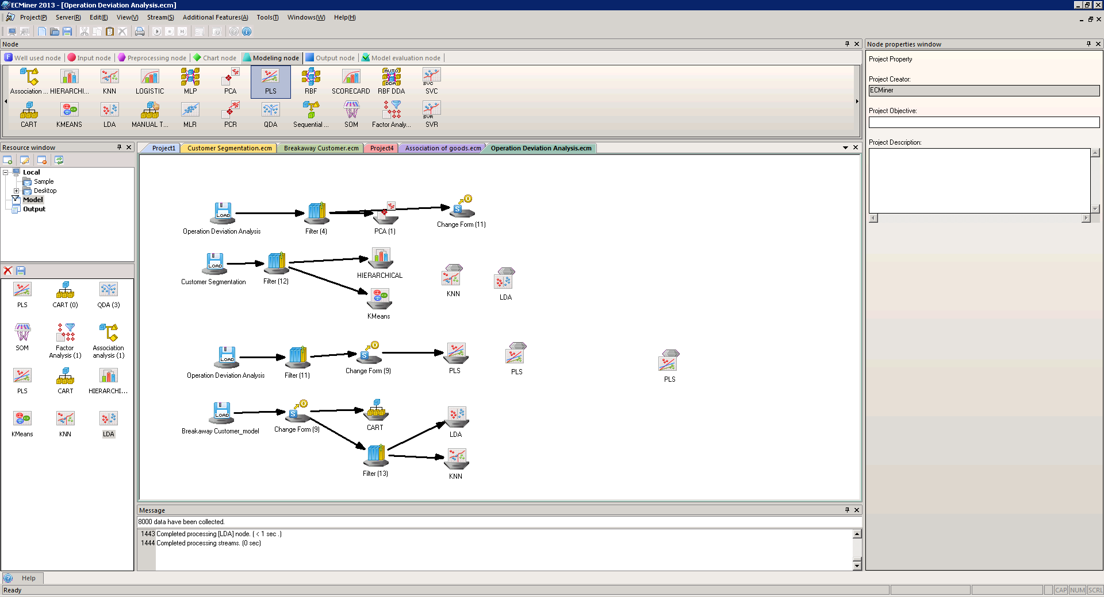

**LDA (Lin**ear Discriminant Analysis) is a supervised classification algorithm, assuming all classes share a common covariance matrix. It maximizes between-class separation while minimizing within-class variance, resulting in linear decision boundaries.

#### Overview

Each object is represented by p variables $x'=(X_{1},...,X_{p})$, and it is assumed that each object belongs to either Category 1 or Category 2. The mean vector and the **variance-covariance matrix** is as follows. $E[x]=\left\{\begin{matrix}μ_{1} & x is in category 1 \\ μ_{2} & x is in category 2\end{matrix}\right.$ $Var\left[x\right]=Σ (same regardless of category)$ Fisher's method transforms a linear combination of the original variables, and then creating a classification rule based on this new variable. A linear combination of the original variables is referred to as a discriminant function. $Z=w_{1}X_{1}+w_{2}X_{2}+...+w_{p}X_{p}=w'x$ By determining the coefficient vector 𝑤 of the discriminant function, we classify object 𝑥 into one of the categories according to the following classification rules: $If |\hat{w}'(x-{\bar{x}}^{(1)})|≤|\hat{w}'(x-{\bar{x}}^{(2)})|, classify x as category 1.$ $If \left|{\hat{w}}^{'}\left(x-{\bar{x}}^{\left(1\right)}\right)\right|>\left|{\hat{w}}^{'}\left(x-{\bar{x}}^{\left(2\right)}\right)\right|, classify x as category 2.$

#### Applications

Independent variables can be either continuous or discrete. Dependent variable must be discrete. The feature vector 𝑥 follows a multivariate normal distribution. The covariance matrices are assumed as the same for all classes.

#### Usage

Read the data using Input Node. Specify the type of data using Type Change Node. (independent, or target) Connect Type Change Node to LDA Node and select the options. Connect LDA Node to Display Node. Additional option: Set the Occupancy ratio.

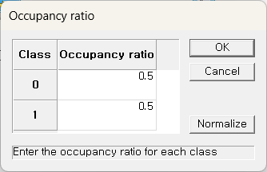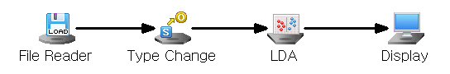

#### Node Properties

|  |  |  |  |  |
| --- | --- | --- | --- | --- |
| Property group | Property Name | Description | Misc. | Note |
| Model File | Save Model File | Decide whether to save model file. | Required | Yes, No |
| Model File Path | Set the path for the model file to be saved. | Conditionally Required |  |
| Selection options | Prior Probability | Decide whether to manually input the prior probabilities. Manual prior is useful for imbalanced data | Required | Base Value, Manual Input |

#### Results

Classification analysis results are displayed using Display Node.

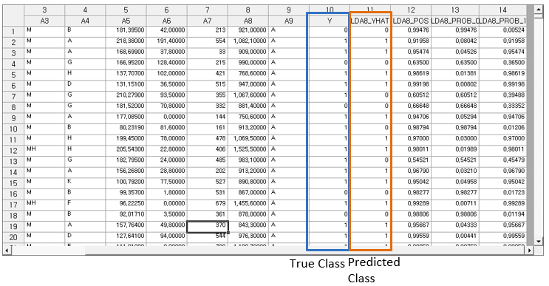

#### Modeling Result

Click Modeling Result in Node Property of Model node to view the results. Average of independent variables by class. Indicates the average value of variables for each classified class. Variance-covariance matrix of the class: Since the variance-covariance is assumed to be the same for each group, a single variance-covariance matrix is output. Prior probability: Shows the probability value for each class specified in the prior probability option. Linear Discriminant Function: Indicates the constants and coefficients of the linear function for each class. Confusion Matrix

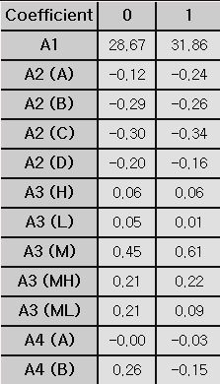

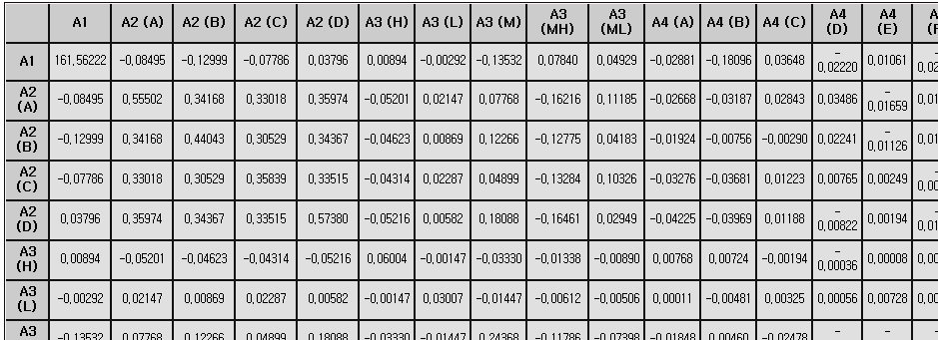

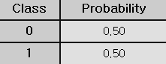

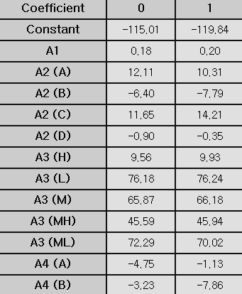

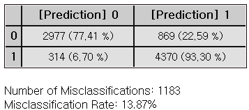

#### Example File

Run the “LDA,QDA.ecm”

### 3.4.14 Local Outlier Factor(LOF)

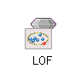

**Local Outlier Factor (LOF)** detects outliers by evaluating the local density of a data point relative to its neighbors. Data points with significantly lower density than other neighbor points are defined as outliers.

#### Overview

Local Outlier Factor (LOF) is a density-based method used for **outlier** **detection**, which identifies data points that deviate significantly from their neighbors. One of the key inputs in LOF is the **number of neighbors (k)**, which determines how many neighboring points are considered computing the local density. To identify whether a point is an outlier, LOF compares the densities of each point to its neighbors. If a point has a lower density compared to its neighbors, it is considered an anomaly. The extent of this deviation is quantified through an outlier threshold score, which determines the boundary between normal points and potential anomalies. The LOF score for point A is calculated as: 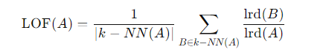 The **distance measurement method** is a key parameter. In LOF, when applying the Minkowski distance, the **Minkowski coefficient** can be adjusted to various distance metrics.

#### Applications

Independent variables must be continuous.

#### Usage

Read the data using Input Node. Connect Input Node to LOF Node and select the options. Connect LOF Node to Display Node. An example of a LOF stream is as follows.

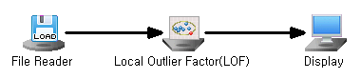

#### Node Properties

|  |  |  |  |  |
| --- | --- | --- | --- | --- |
| Property group | Property Name | Description | Misc. | Note |
| Model File | Save Model File | Decide whether to save model file. | Required | Yes, No |
| Model File Path | Set the path for the model file to be saved. | Conditionally Required |  |
| Selection options | Number of Neighbors | Determine the number of Neighbors. | Required | Integer |
| Outlier Detection | Identify data points with lower local density to detect anomalies. | Required | Yes, No |
| Outlier Threshold | Set a threshold to identify anomalies | Required | Real number |
| Distance Measure | Select the distance metric: Euclidean, Manhattan, and Minkowski. | Required | Euclidean, Manhattan, Minkowski |
| Minkowski Coefficient | Enter the coefficient if Distance Measurement is Minkowski. | If you enter Minkowski | Real number |

#### Results

The analysis results are displayed using Display Node.

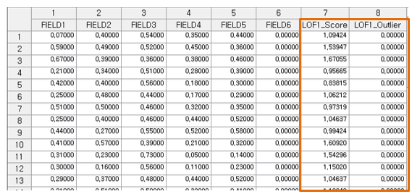

#### Modeling Result

Click Modeling Result button in Node Property of Model node to view the analysis results. Score Information: If LOF1\_Outlier value exceeds Outlier Threshold, the data is indicated as an outlier. A point with a high LOF score is considered an outlier because it resides in a low-density. Threshold can be specified based on domain knowledge or the LOF scores' distribution. LOF Score Plot.

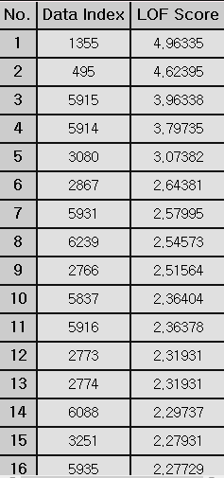

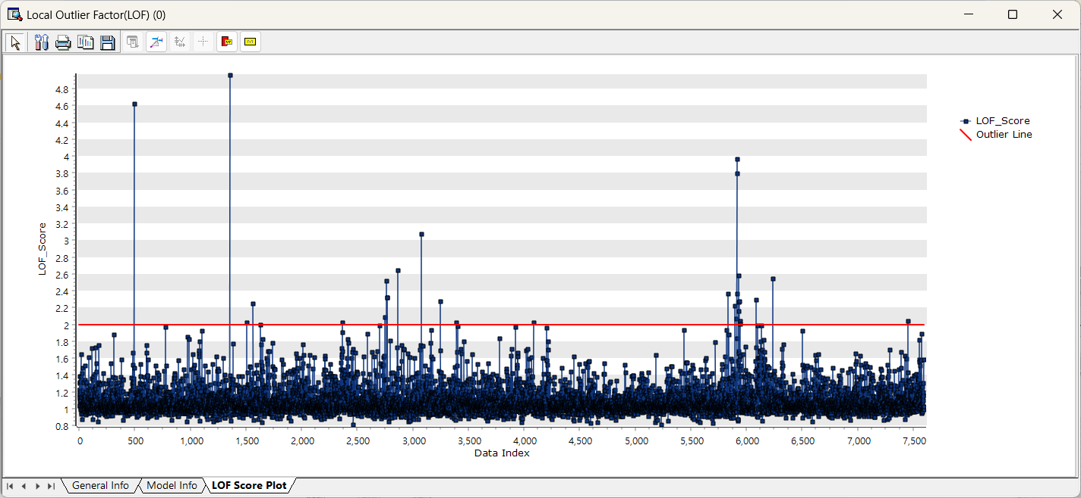

Example File

* Run the “LOF.ecm”

### 3.4.15 Logistic

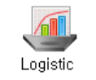 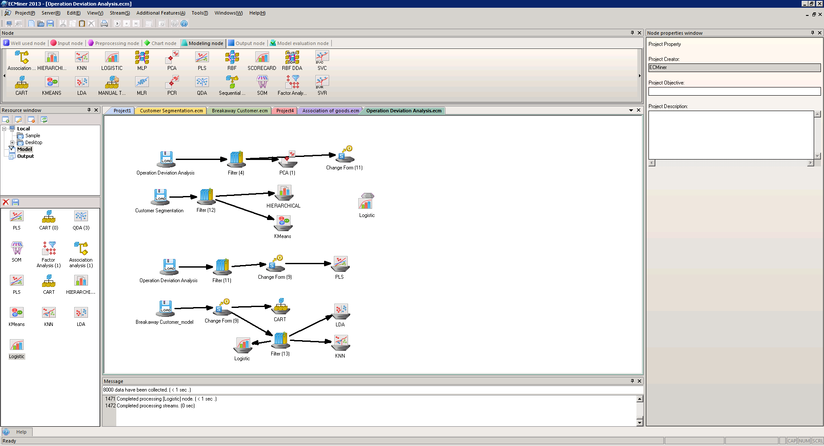

**Logistic regression** is a statistical method used for classification that the outcome is categorical typically binary but sometimes with more than two categories. Logistic regression predicts the probability that a given case belongs to a specific category (yes/no, 0/1).

#### Overview

**Logistic regression** is a classification analysis used to predict outcomes in categories with two values, such as yes/no or success/failure. If the dependent variable has three or more categories, use Nominal Logistic Regression

Variable Selection: Variable selection is the process of selecting important variables. In the **Variable Selection Technique** option, you can choose Stepwise, Forward, Backward, or None. **Forward** selection adds from the most important variable to least important one in the model, while **Backward** selection removes unimportant variables from a full model. **Stepwise** selection combines with Forward, Backward methods to iteratively add or remove variables, refining the model with significant predictors.

Link Function: The link function transforms the nonlinear relationship between independent and dependent variables into probabilities. Link functions such as **Logit, Probit (Normit)**, and **Gompertz** can be selected from the options.

|  |  |  |
| --- | --- | --- |
| **Name** | **distribution** | **function** |
| Logit | Binomial, Multinomial | $$logit(p)=log(\frac{p}{1-p}​)$$ |
| Probit | Binomial | $$probit(p)=Φ^{-1}(p)$$ |
| Gompertz | Binomial | $$cloglog(p)=log(-log(1-p))$$ |

Log-likelihood Function: The log-likelihood function measures how well the model parameters fit the given data, and by maximizing this function, the optimal parameters of the model are determined. The log-likelihood function varies depending on the distribution that the data follows. $Bernoulli Dist. \sim log{L}=\sum_{i=1}^{n}{y_{i}}\left(β_{0}+β_{1}X_{i}\right)-\sum_{i=1}^{n}{\log{(}1+e^{β_{0}+β_{1}X_{i}})}Binomial Dist. \sim log L=\prod_{i=1}^{n}{\left(\begin{matrix}r_{i} \\ y_{i}\end{matrix}\right){P_{i}}^{y_{i}}(1-P_{i})^{r_{i}-y_{i}}}$ In the optimization process, the **Maximum Run Count** and **Convergence Error** options are used to control the iterative estimation of parameters.

Binary Threshold: The parameters $(β_{k})$ estimated from the above likelihood function are used to fit the model below. $Logit(p_{i})=β_{0}+β_{1}X_{1}+...+β_{k}X_{k}$ The categories are classified based on the calculated $p_{i}$. The default is 0.5. ${if P}_{i}>0.5, class, y object i as{{}_{}^{'}1}^{'}$ ${if P}_{i}≤0.5, class, y object i as '0'$ The threshold can be adjusted in the **Splitting Threshold** option. You can evaluate how well the model fits the data by using the Pearson statistic through the **Goodness-of-Fit Test** option.

#### Applications

Independent variable can be either continuous or discrete. Dependent variable must be discrete.

#### Usage

Read the data using Input Node. Specify the type of data using Type Change Node. (independent, or target) Connect Type Change Node to Logistic Node and select options. Connect Logistic Node to Display Node. An example of Logistic stream is shown below.

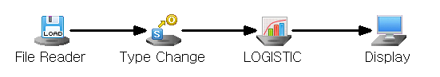

#### Node Properties

|  |  |  |  |  |
| --- | --- | --- | --- | --- |
| **Property group** | **Property Name** | **Description** | **Misc.** | **Note** |
| **Model File** | Save Model File | Decide whether to save model file. | Required | Yes, No |
| Model File Path | Set the path for the model file to be saved. | Conditionally Required |  |
| **Selection options** | Maximum Run Count | Enter the maximum number of iterations. | Required | 0<integer |
| Variable Selection Technique | Set the method of variable selection. | Required | Stepwise, Forward, Backward, None |
| Significance Level for Entry | Enter Significance Level of Entry if **Variable Selection** **Technique** is **Stepwise** or **Forward**. The smaller the significance level, the fewer independent variables are added to the model. | Conditionally Required | Default:0.15 |
| Significance Level for Removal | Enter Significance Level of Removal if **Variable Selection** **Technique** is **Stepwise** or **Backward**. The bigger the significance level, the fewer independent variables are likely to be added to the model. | Conditionally Required | Default:0.15 |
| Splitting Threshold | Enter the threshold(cut-off) to use for binary split. | Required |  |
| Link Function | Select the Link function to use for binary analysis. | Required | Logit, Probit, Gompertz |
| Goodness-of-Fit Test | Decide whether to display the Goodness-of-Fit test results. | Required | Yes, No |
| Convergence Error | Set the convergence error value for the iterative method. | Required |  |

#### Results

Classification analysis results are displayed using Display Node.

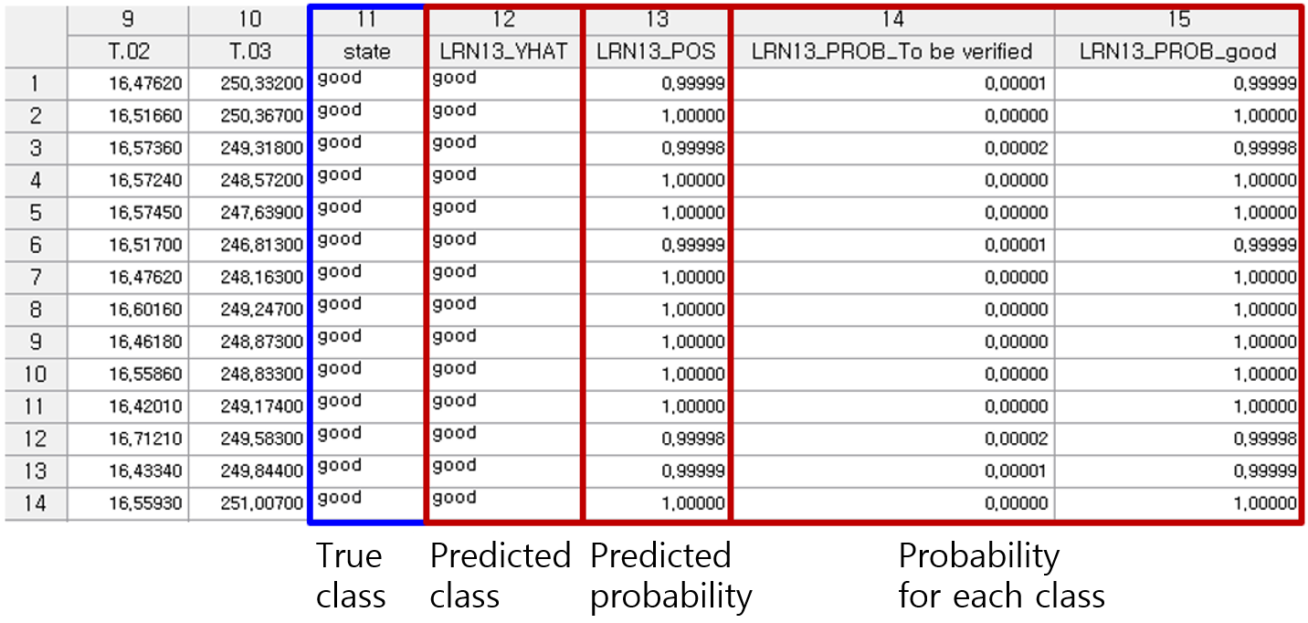

#### Modeling Result

Click Modeling Result in Node Property of Model node to view the results. Number of Classes and Total Number of trials. The number of classes in the dependent variable and the total number of trials the algorithm was run on can be found. Y Value Shows the frequency and ratio of dependent variable Y by class. Logistic Table: **Parameter Estimate**: The coefficient value of each variable. **Standard Error**: The standard error of each coefficient (Beta). **z-value**: The number of standard deviations a data point (or estimate) is from the mean. In regression analysis, the z-value measures how significant a regression coefficient is relative to its standard error. It is used to assess the statistical significance of a predictor variable. **p-value**: The probability that the observed effect occurred by random chance. Typically, if the P-value is less than the significance level, the variable is considered statistically significant. **Odds Ratio**: A value that indicates the degree of influence of input variables on the classification decision. An odds ratio less than 1 means that the input variable xi has a negative influence, and an odds ratio greater than 1 means that the input variable xi has a positive influence. If the value appears like 1. #IO, 1#QO, or 1.#INF, the value is either too large or too small. Confusion Matrix.

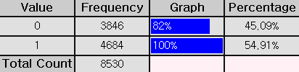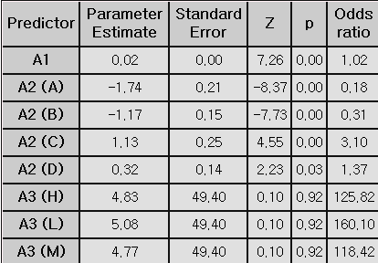

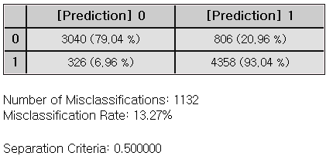

#### Example File

Run the “Logistic.ecm”

### 3.4.16 MLR

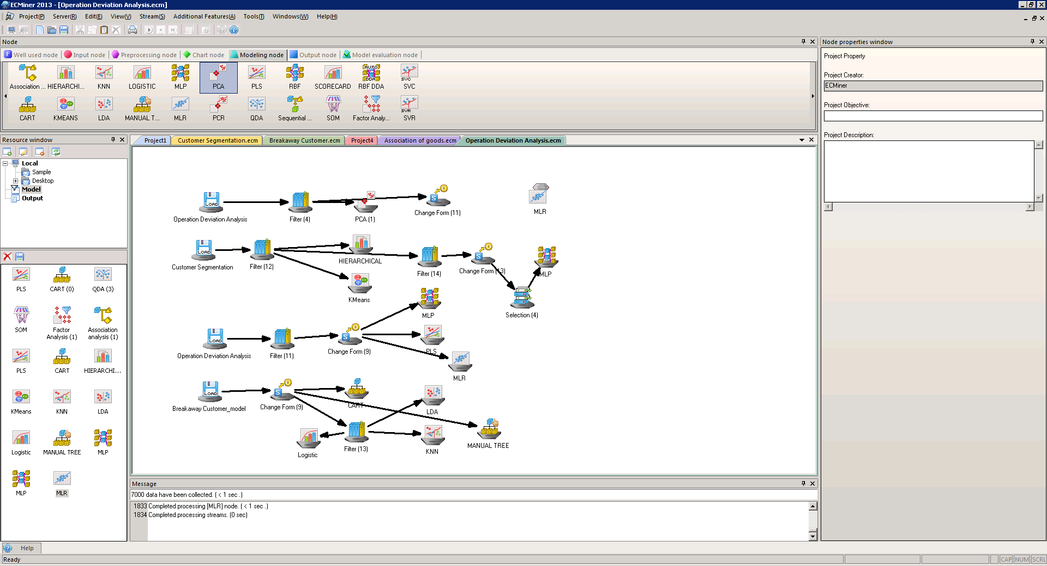

**Multiple Linear Regression (MLR)** is a statistical technique that models the linear relationship between a dependent variable and two or more independent variables.

#### Overview

Regression models are used to predict the dependent variable through the linear equation of independent variables. : Dependent variable, : Independent variables. : Intercept : Coefficients corresponding to each independent variable (the impact of each independent variable on the dependent variable) $ϵ$: Error term

The four assumptions of linear regression. For valid regression model, the following assumptions should be met. **Linearity**: The relationship between the independent and dependent variables is linear. **Independence of Errors**: Residuals (errors) are independent of each other. **Homoscedasticity**: The variance of the errors should be constant for all values of the independent variables. **Normality** **of** **Errors**: Residuals (errors) is normally distributed

Variable selection is the process of selecting important variables. In the **Variable Selection** option, you can choose Stepwise or General. **Stepwise** selection combines with Forward, Backward methods to iteratively add or remove variables, refining the model with significant predictors. (\* **Forward** selection adds from the most important variable to least important one in the model, while B**ackward** selection removes unimportant variables from a full model.) General selection includes all the input independent variables.

Multicollinearity occurs due to high correlations between independent variables. Using the Variance Inflation Factor (VIF), variables with VIF>10 needs to be double-checked. The **Calculate VIFs** option gives VIF values, and the **Remove Multicollinearity** option allows to remove variables with VIF values over 10.

#### Applications

Independent variable can be either continuous or discrete. Dependent variable must be continuous. The four assumptions of regression should be checked for valid prediction model.

#### Usage

Read the data using Input Node. Specify the type of data using Type Change Node. (independent, or target) Connect Type Change Node to MLR Node and select options. Connect MLR Node to Display Node. An example of MLR stream is as follows.

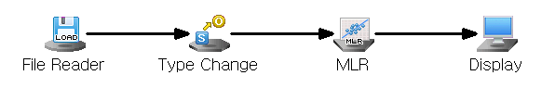

#### Node Properties

|  |  |  |  |  |
| --- | --- | --- | --- | --- |
| Property group | Property Name | Description | Misc. | Note |
| Model File | Save Model File | Decide whether to save model file. | Required | Yes, No |
| Model File Path | Set the path for the model file to be saved. | Conditionally Required |  |
| Selection options | Variable selection | Set the method of variable selection. | Required | General,  Stepwise |
| Significance Level for Entry | Enter **Significance Level of Entry** for **Stepwise.** The smaller the **significance level**, the fewer independent variables are likely to be added to the model. | Required |  |
| Significance Level for Removal | Enter **Significance Level of Removal** for **Stepwise.** The bigger the **significance level**, the fewer independent variables are likely to be added to the model. | Required |  |
| Calculate VIFs | Decide whether to **calculate VIFs**.  Multicollinearity is considered present if the VIF exceeds 10. | Required | True,  False |
| Save Confidence Intervals | Decide whether to save 95% Confidence Intervals for the dependent variable. | Required | True,  False |
| Save Prediction Intervals | Decide whether to save 95% of prediction intervals. | Required | True,  False |
| Remove Multicollinearity | Decide whether to remove variables to mitigate multicollinearity among independent variables. | Required | True,  False |

#### Result

Prediction analysis results are displayed using Display Node. Residual plot is displayed using the Trend Chart or Enhanced Basic Chart. If the regression model is well-fitted, the errors should have a mean of 0 and constant variance. Running the Chart Node with Data Index on the X-axis and Residual (MLR\_RES) on the Y-axis will produce a plot similar to the one shown above.

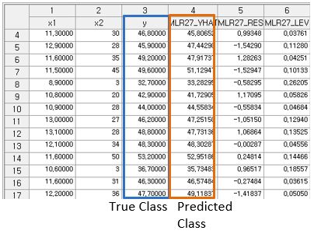

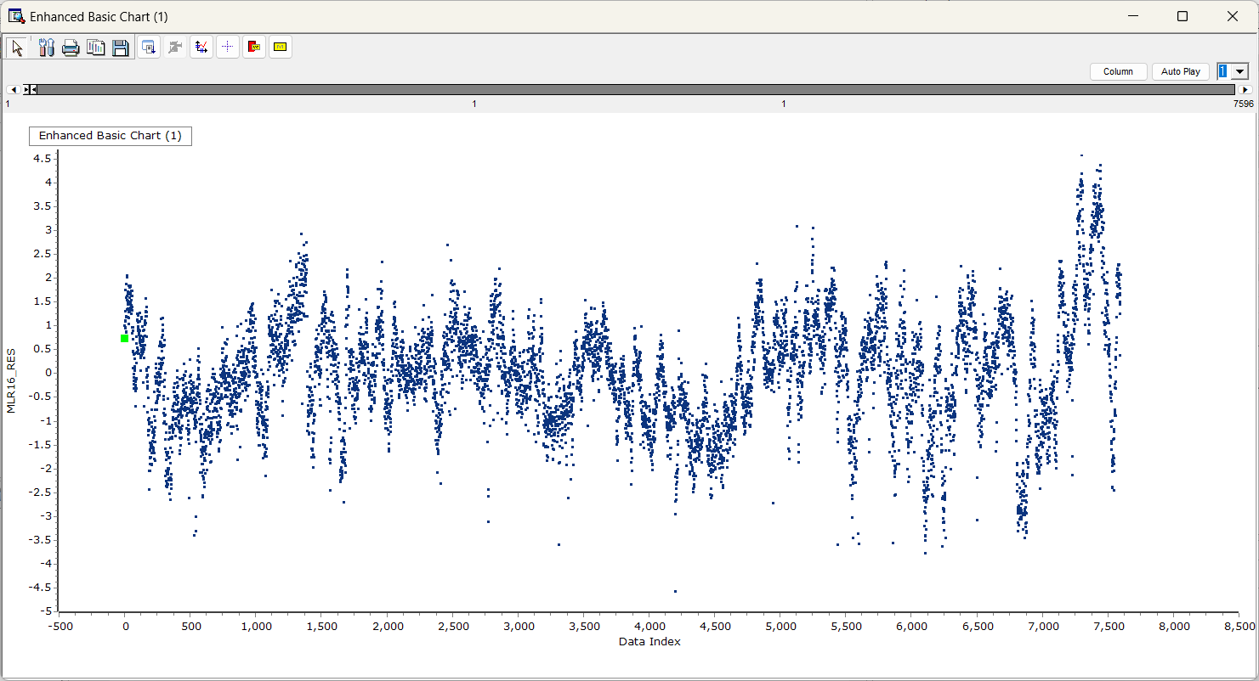

#### Graphic Result

Click Graphic Result in Node Property of Model node to view the charts. The results can also be viewed in the Modeling Result of Model node. Coefficient Plot: The graph displays coefficients for each independent variable. Data Chart: The graph displays the difference between actual value and predicted value, residual, contribution for each observation.

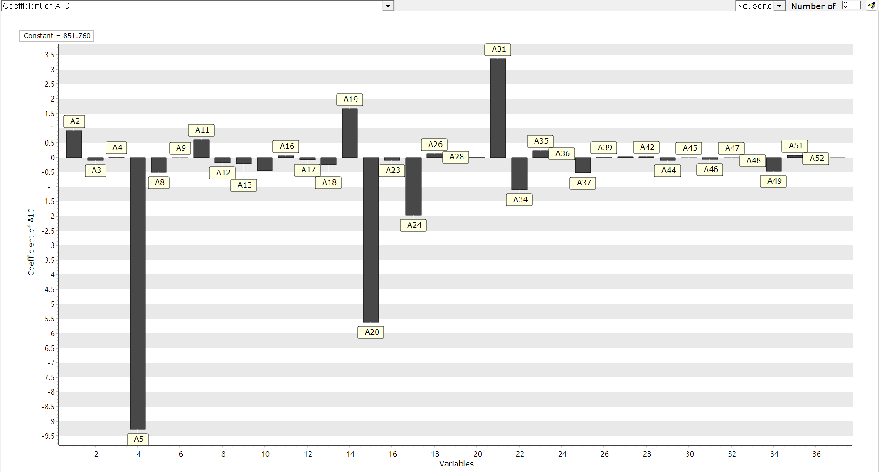

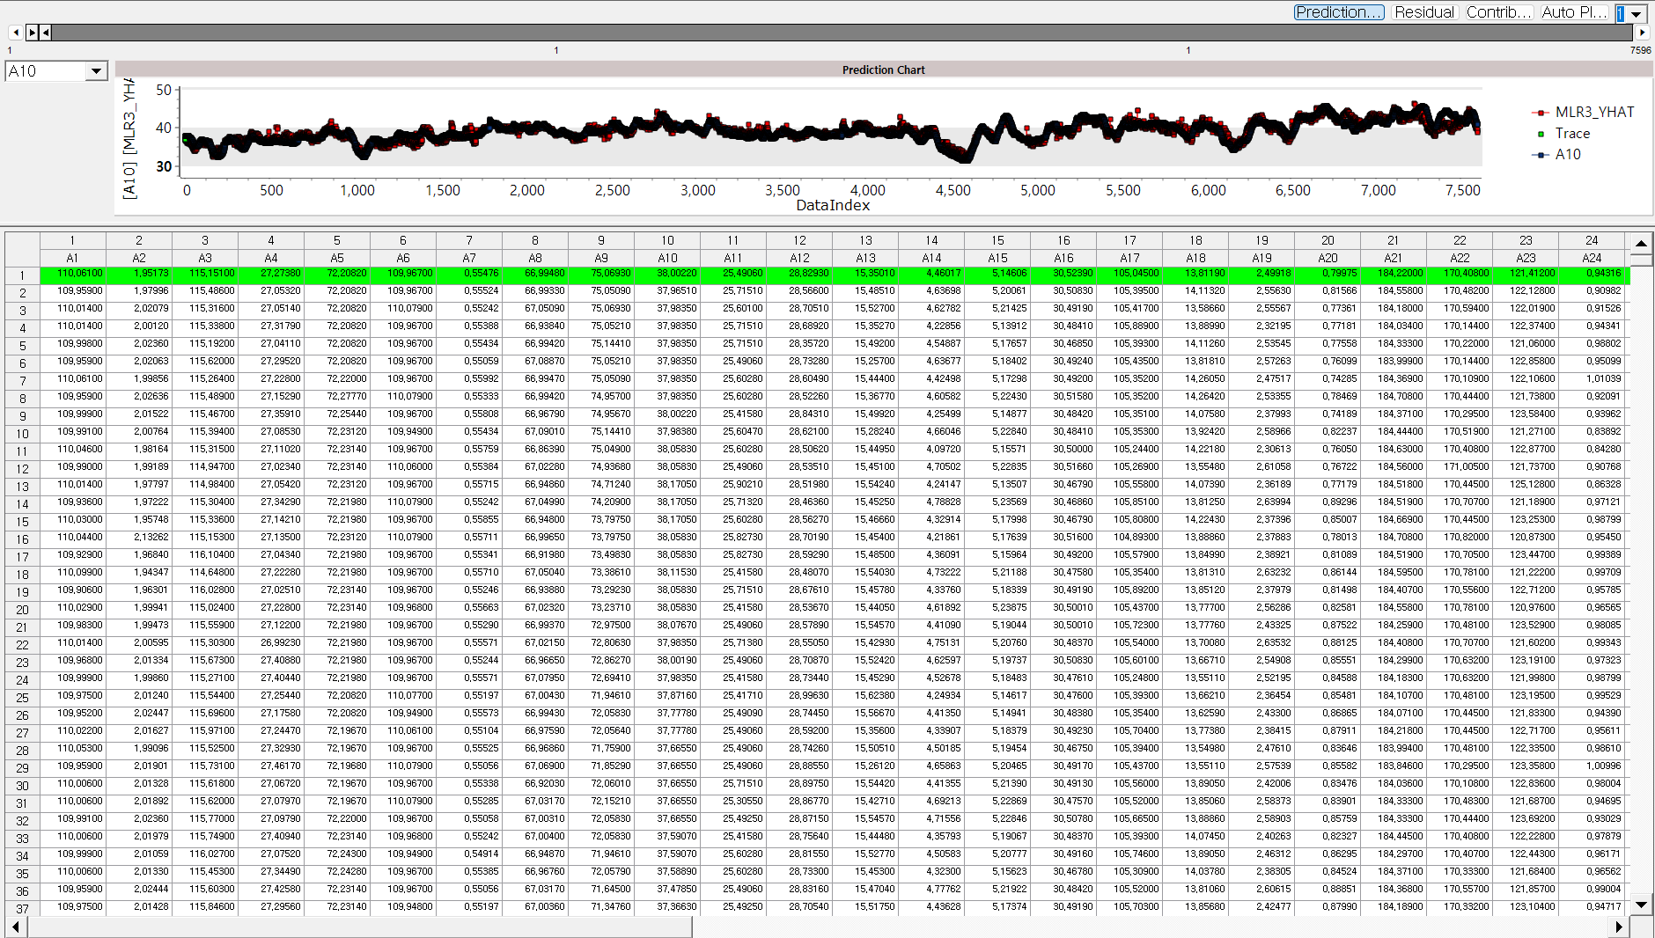

#### Modeling Result

Click Modeling Result in Node Property of Model node to view the results. Regression Equation & Regression table. Determine the significance and regression coefficient value of each independent variable. Regression coefficient estimation $B={\left(X^{'}X\right)}^{-1}X'Y$ Dependent variable prediction $\hat{Y}=XB$

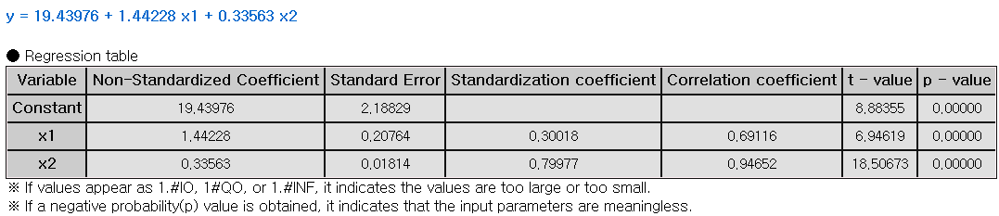

**Non-Standardized Coefficient:** The actual effect of each independent variable on the dependent variable in its original units. **Standard Error:** The measure of uncertainty around the estimate of a regression coefficient. It shows how precise the estimate is. **Standardization Coefficient:** The change in the dependent variable, measured in standard deviations, for a one standard deviation change in the independent variable. **t-value:** A statistic used to test if a regression coefficient is significantly different from zero. It compares the coefficient to its standard error to assess its significance. **p-value:** The probability that the observed effect occurred by chance. If the p-value is less than the significance level, the effect is statistically significant, and the null hypothesis can be rejected. **ANOVA TABLE:** F-test is a test whether the independent variable is statistically significant in explaining the dependent variable. If the p-value is greater than the significance level then it is not significant, the interpretation of the regression coefficient is meaningless.

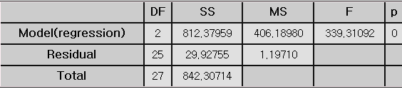

**DF (Degree of Freedom):** The number of independent variables. **SS (Sum of Squares):** Total variations in the data. It is a calculation of the squared deviations from the mean value. **MS (Mean Square):** The average of the squared deviations. (SS/DF) **F-value:** The ratio of the mean square for the residual variance and the independent variable variance. 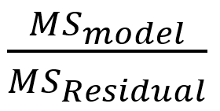 **p-value:** probability of observing the data if the null hypothesis is true. Lower p-value suggests that the group variances are statistically significant.

**Standard Error Information. R-square (coefficient of determination):** It is a value that checks whether the derived regression equation is representative of the measured values. **Adjust R2:** It adjusts the r-squared value by considering the degree of freedom of the model. **RMSE (Root-Mean Square Error):** The square root of the average squared differences between the predicted values and the dependent variable. **MAE (Mean Absolute Error):** The average of the absolute differences between the predicted values and the dependent variable. **MAPE (Mean Absolute Percentage Error):** The average of the absolute differences between the predicted values and the dependent variable as a percentage. Numbers (3) to (5) all represent the error between the original value and the predicted value of the dependent variable. The smaller the value, the better the model.

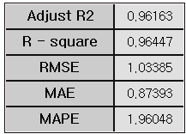

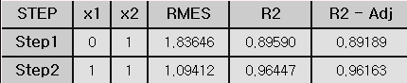

**Trace and Statistical Table.** This result is output only when the technique option is selected as stepwise. The model for each step is explained and trace values indicate which variables were entered at each step. In Step 1, you can see that only x2 has a trace value of 1. This means that the x2 variable was added to the model in Step 1. In Step2, you can see that the x1 variable has been added to the model. You can see that when x1 variable was added to the model, the R2 (R-Square) value became better than Step1. If Stepwise is selected, only the variables included in the last step in the previous regression table are output, and in the case above, a regression table for variables x1 and x2 is created.

#### Example File

Run the “MLR.ecm”

### 3.4.17 Naive Bayes

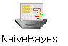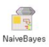

**Naïve Bayes** is a probabilistic machine learning used for classification tasks. It is based on the Bayes’ theorem with assumption that the features are conditionally independent of each other.

#### Overview

The Naïve Bayes model is based on the Bayes’ theorem which describes the probability of an event, based on the knowledge of conditions that might be related to the event. Naïve Bayes model highly relies on the assumption that all features are independent of each other. Naïve Bayes defines probability through the calculations below. $P\left(Y_{i}|x_{1},…,x_{n}\right)=\frac{{P\left(y_{i})P(x_{1},…,\left.x_{n}\right|y_{i}\right)}^{ }}{P\left(x_{1}…x_{n}\right)}$ $P\left(y_{i} | x_{1},…,x_{n}\right)={the probability of the value y in state x}_{1},…,x_{n}$ $y_{i}=dependent variable$ $x_{1}…x_{n}= independent variable$

There are several variations of the Naïve Bayes model, depending whether the feature is continuous or discrete. When the feature is continuous, Gaussian Naïve Bayes is applied assuming that the feature follows a Gaussian distribution. The probability of the feature is calculated using the Gaussian distribution formula. However, if the feature is discrete, multinomial Naïve Bayes is applied especially when the features represent counts or frequencies. The probability of the feature is calculated as the frequency within the given feature class.

**Laplace smoothing** is a technique used in **Naive Bayes** to handle the issue of zero probabilities, which can arise when a feature value that was not observed in the training data needs to be predicted. **For text classification,** a word appears in a test document but was not present in the training documents of a particular class. If a word is never seen in a particular class during training, the model assigns a probability of zero to that word in the test set, which is problematic. The Laplace smoothing value is typically set to 1 and whether to use the technique can be decided in the **Laplace Smoothing** option.

In addition, the amount of influence each feature has on the classification can be personalized by selecting **Manual Input** in the **Weighting** option. If the **Weighting** option is set to **Base Value,** the weight of each feature is set to 1. Features with higher likelihood probabilities for a particular class will influence more, “weight” more heavily, in the decision for that class.

#### Applications

Independent variable can be either continuous or discrete. Dependent variable must be discrete.

#### Usage

Read the data using Input Node. Specify the type of data using Type Change Node. (independent, or target) Connect Type Change Node to NaiveBayes Node and select options. Connect NaiveBayes Node to Display Node. An example of Naïve Bayes stream is as follows. If Weighting is Manual Input, a pop-up window will appear once the stream is executed to set the weight for each data class.

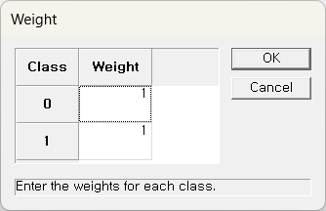

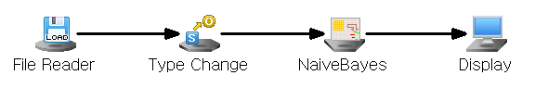

#### Node Properties

|  |  |  |  |  |
| --- | --- | --- | --- | --- |
| **Property group** | **Property Name** | **Description** | **Misc.** | **Note** |
| Model File | Save Model File | Decide whether to save model file. | Required | Yes, No |
| Model File Path | Set the path for the model file to be saved. | Conditionally Required |  |
| Selection options | Weighting | Select the weighting method. | Required | Default, Custom |
| Laplace Smoothing | Decide whether to use Laplace Smoothing. | Required | Yes, No |

#### Results

Classification analysis results are displayed using Display Node.

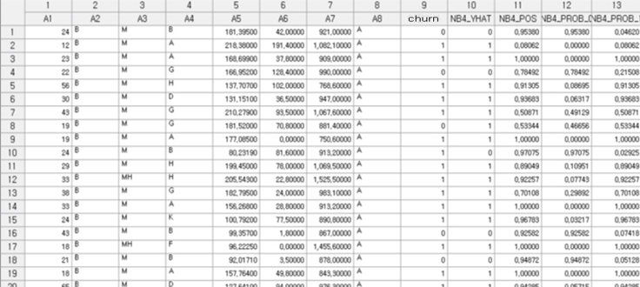

#### Modeling Result

Click Modeling Result in Node Property of Model node to view the results. Summary of Classification Information. If the independent variable is continuous, it indicates the mean and standard deviation information, and if the independent variable is discrete, it indicates the probability for each class. Confusion Matrix table is also presented.

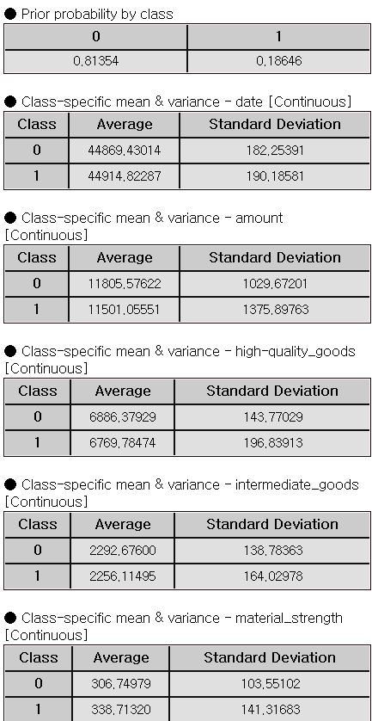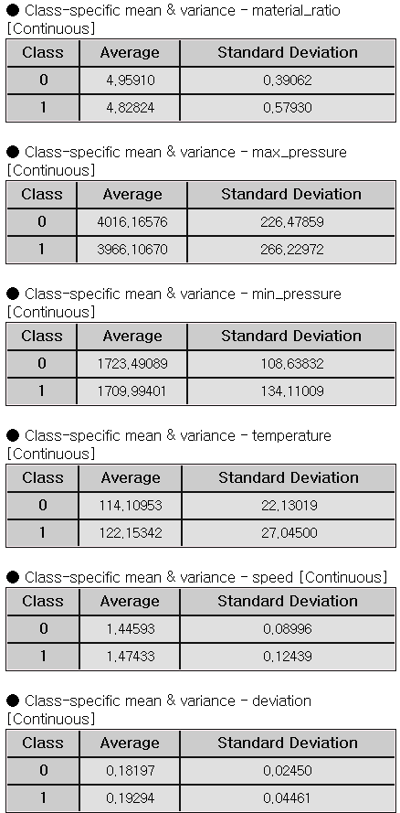

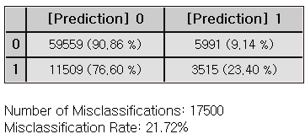

### 3.4.18 PCA

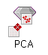

**Principal component analysis** is a multivariate data analysis technique used for dimensionality reduction. PCA transforms the original variables into a set of uncorrelated components (called principal components) that explains the maximum variance in x-space.

#### Overview

The main idea of PCA is to represent the variability in data using new variables (principal components) formed by linear combinations of the original variables in multivariate data. PCA identifies linear relationships between variables, reduces their number, uncovers meaningful new variables, and simplifies the dataset's dimensional structure. PCA can be used for anomaly detection, production deviation analysis, and process monitoring.

#### Applications

Only independent variables. They must be continuous. Standardization is automatically applied.

#### Usage

Read the data using Input Node. Connect Input Node to PCA Node and select the options. Connect PCA Node to Display Node. An example of PCA stream is as follows.

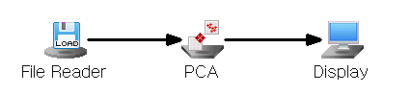

#### Node Properties

|  |  |  |  |  |
| --- | --- | --- | --- | --- |
| **Property group** | **Property Name** | **Description** | **Misc.** | **Note** |
| **Model File** | Save Model File | Decide whether to save model file. | Required | Yes, No |
| Model File Path | Set the path for the model file to be saved. | Conditionally Required |  |
| **Selection options** | View Results | Control Chart, Loading Plot,  T-Square Plot, Scree Plot, Residual Plot, Contribution Plot, and Data Chart are output. | Click | Click after modeling |
| Number of Principal Components | Set the number of principal components (Must be less than the number of independent variables.) | Required | natural number |
| Preprocessing Method | Preprocessing method for the input data. | Required | Standardization, Mean centering |
| Matrix Type | Decide on the matrix type. | Required | Covariance, Correlation |

#### Results

Control Chart: Outliers can be identified through the Control Chart.

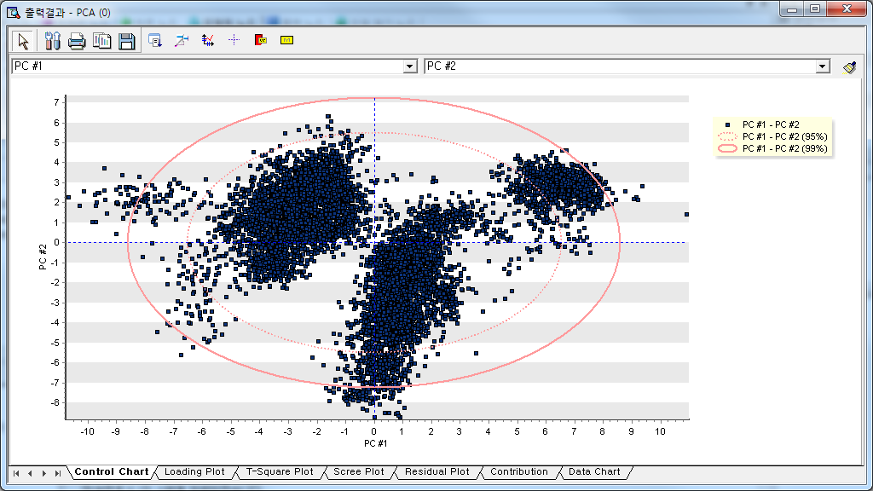

Loading Plot: **Loading values** ("loadings") represent the correlation or relationship between the original variables and the principal components. Higher absolute loading values indicate that the variable has a greater influence on the component. The Loading plot provides information about the loading values of the selected two raw data or principal components.

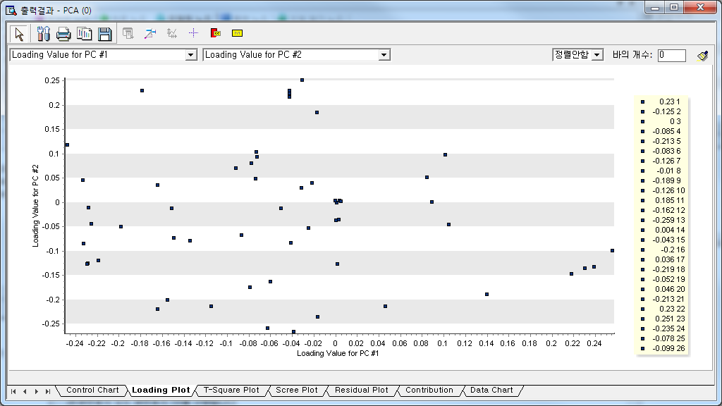

T-Square plot: High T² values suggest that an observation lies far from the center of the data distribution in the principal component space, making it a potential outlier.

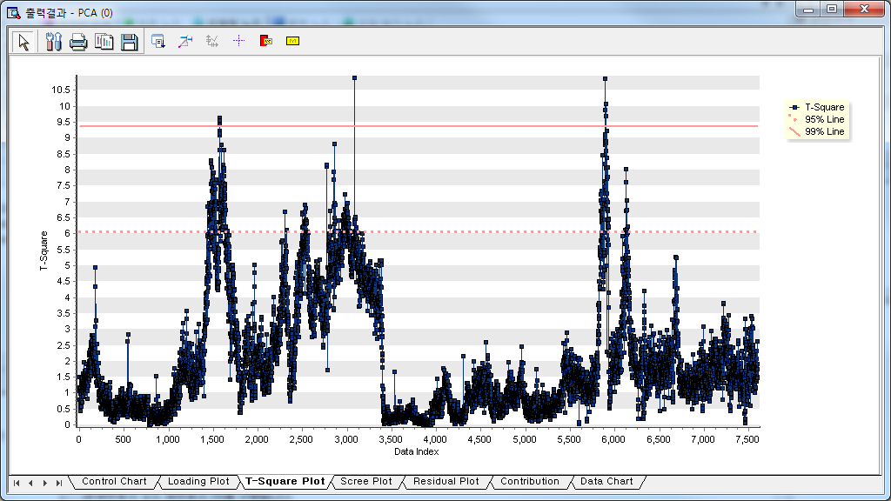

The residual plot shows how far the data is from the reduced space. As the value on the graph increases, it indicates that the distance between the current data and the reduced space is larger, and data that exceeds the displayed guide line can be considered outliers.

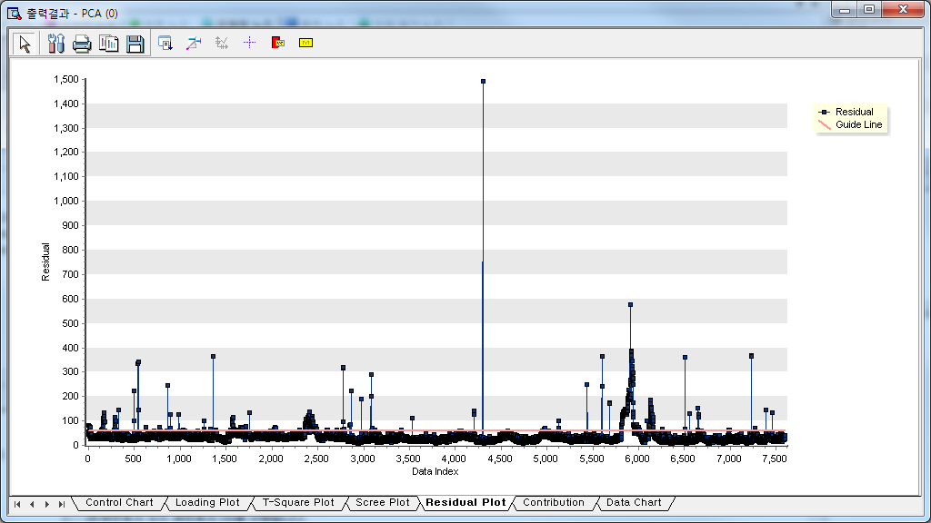

The Scree plot displays the Eigenvalue values for each principal component. It can determine the number of principal components in the step where the Eigenvalue value changes rapidly.

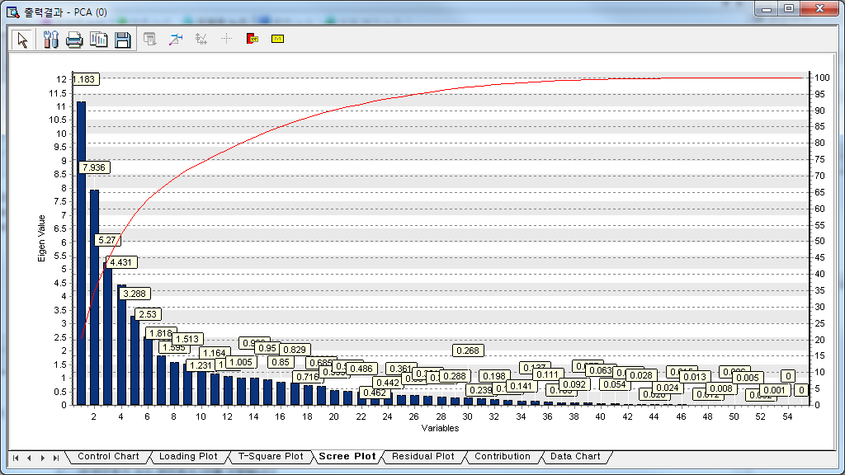

Contribution plot: This chart shows the weight or influence (also called **loadings**) of each variable on a given principal component. Variables with higher absolute loadings contribute more to the corresponding principal component. How to create a group: 1. Select a group with large deviations in the control chart, drag the group as first group and click the second button to extract the data. If there is another group to examine, repeat the same for the group. 2. After extracting data, go to Contribution Plot and choose the principal component and group data, and sorting method. Click the **Draw icon** to get Contribution Plot. The data chart provides a matching function between data and charts by simultaneously showing the chart and the data used for analysis. You can also view multiple charts at once for comparison. You can match data with charts and track progress using the data slider at the top. The buttons in the upper-right corner allow you to view multiple charts. (2) Analysis result information: The score and T-square values of each principal component can be observed in **Display Node**.

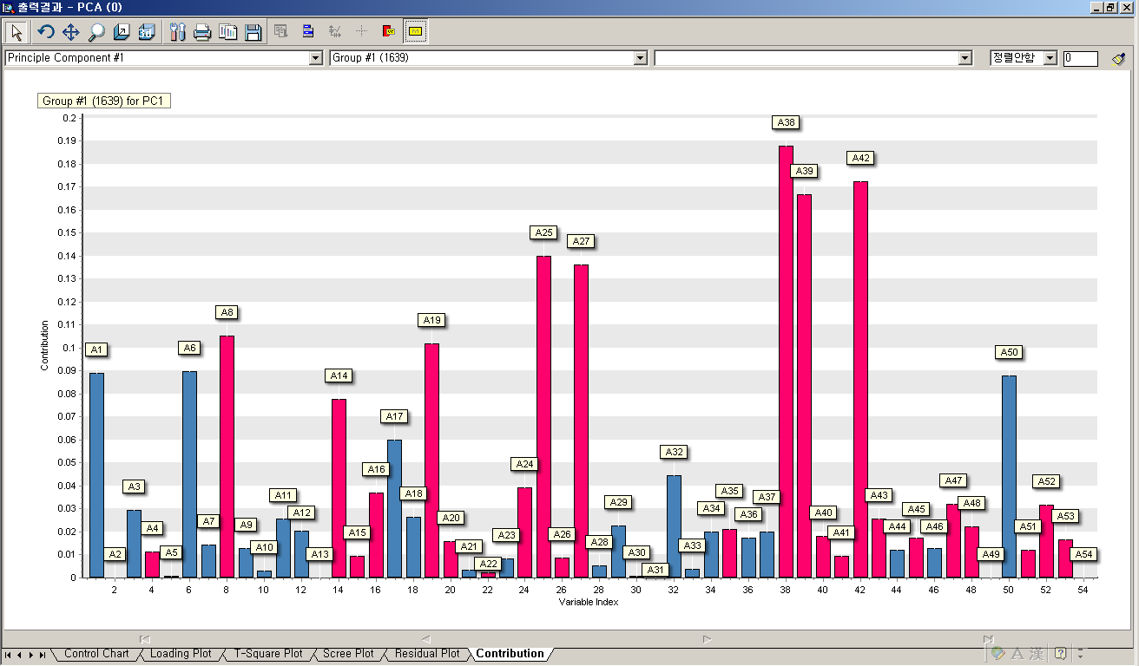

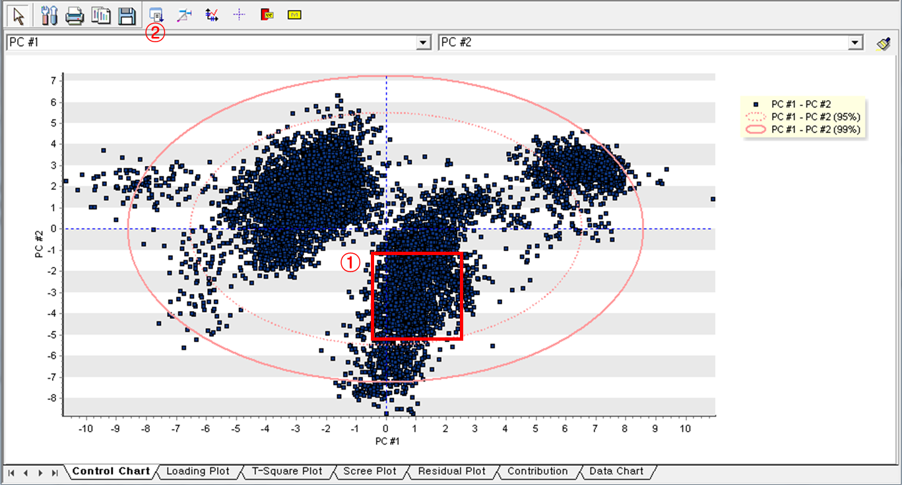

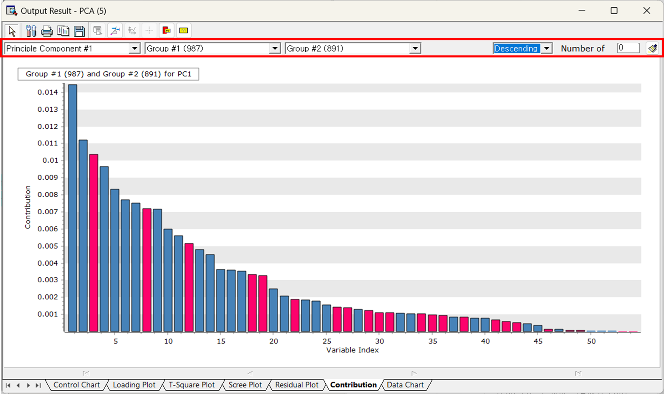

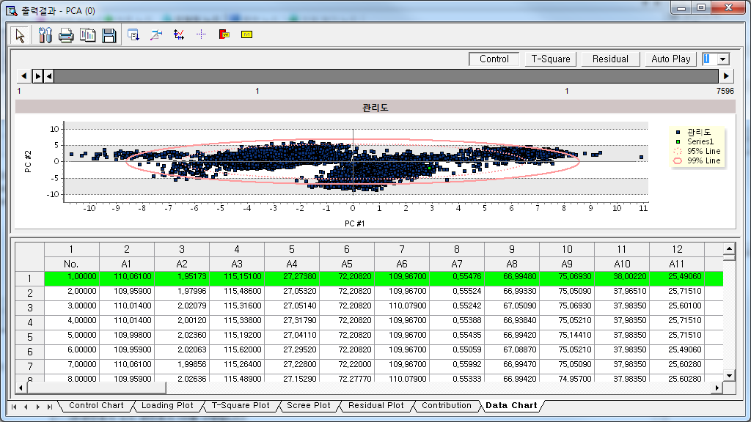

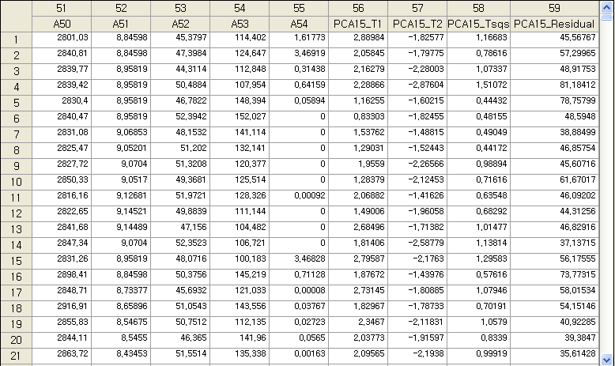

Modeling Result

Click Modeling Result in Node Property of Model node to view the results.

* PCA performance information

Displays the number of principal components reduced from the entire variables and show the T² limit.

* Loading vectors for each component

Principal component is calculated for each variable. For example, principal component 1 is calculated as follows:

PCA 1 = (-0.24360\*A1) + (0.00132\*A2) + (-0.24335\*A3) + …

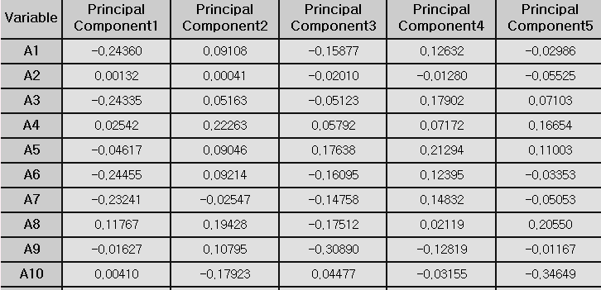

* Variance explanation

Each principal component explains a certain percentage of the total variance in the dataset. Indicates.

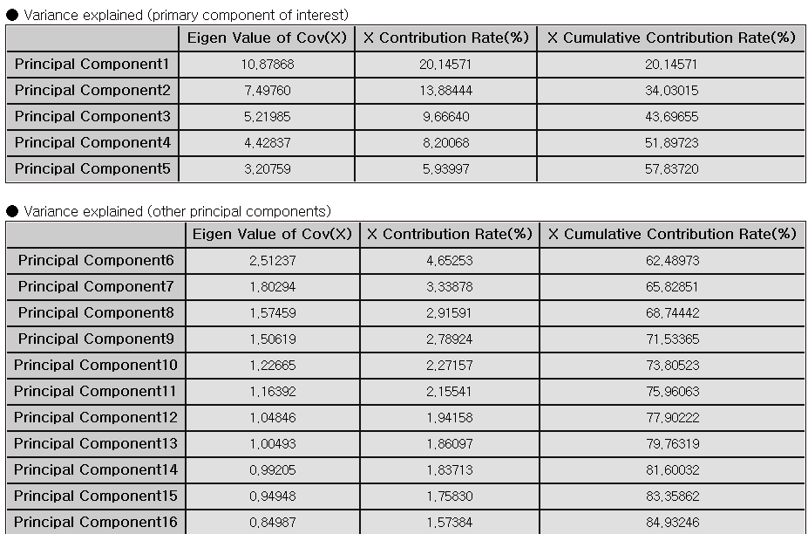.

* Loading Plot

The loading plot of the Modeling node can also be viewed in the Model node. The loading plot provides information about the loading values ​​of the two selected raw data or principal components.

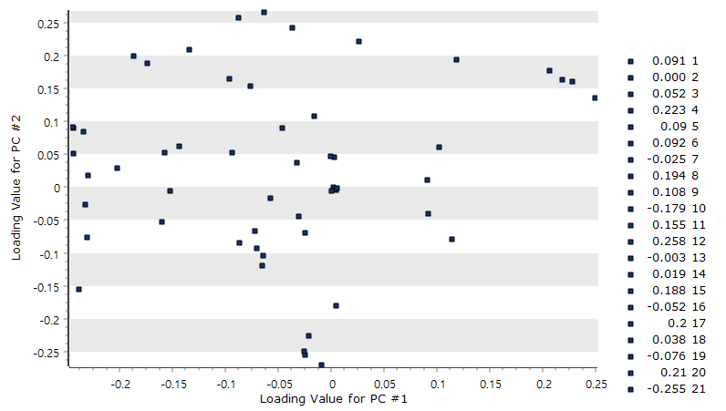

* Scree Plot

The scree plot of the Modeling node can also be viewed in the Model node. The scree plot displays the Eigenvalue value for each principal component. It can determine the number of principal components in numbers where the Eigenvalue value changes rapidly.

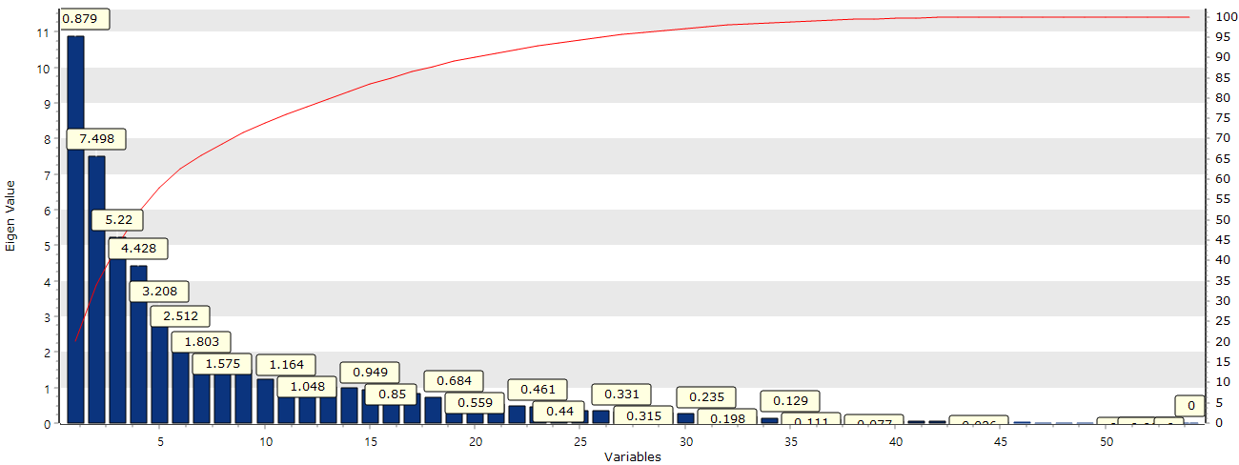

Example File

* Run the “**PCA.ecm”**

### 3.4.19 PCR

Predicted value

 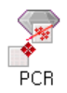

**Principal Component Analysis (PCA)** is a multivariate technique used for dimension reduction. **Principal Component Regression (PCR)** is one of regression technique to handle multicollinearity in multiple linear regression. PCA transforms the original variables into a set of uncorrelated components (called principal components) that explains the maximum variance in x-space.

#### Overview

When Y is a dependent vector and X is the matrix of independent vectors, the regression model for Y is expressed as follows. $Y=Xβ+ε$ Here, β is the regression coefficient vector, and ε is the error vector. If multicollinearity exists among the independent variables (X), use Principal Component (T) for regression. $T=x_{1}p_{1}^{T}+x_{2}p_{2}^{T}+...+x_{A}p_{A}^{T}$ $y=Tq^{T}+f= q_{1}t_{1}+q_{2}t_{2}+...+q_{A}t_{A}+f$ Here, we apply PCA to obtain the principal component score matrix T, and then perform a regression analysis based on this matrix.

#### Applications

Independent and dependent variables must be continuous. Standardization is automatically applied.

#### Usage

Read the data using Input Node. Specify the type of data using Type Change Node. (independent, or target) Connect Type Change Node to PCR Node and select the options. Connect PCR Node to Display Node. An example of PCR stream is as follows.

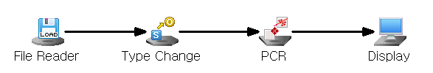

#### Node Properties

|  |  |  |  |  |
| --- | --- | --- | --- | --- |
| **Property group** | **Property Name** | **Description** | **Misc.** | **Note** |
| **Model File** | Save Model File | Decide whether to save model file. | Required | Yes, No |
| Model File Path | Set the path for the model file to be saved. | Conditionally Required |  |
| **Selection options** | Number of Principal Components | Enter the number of principal components to reduce the number of variables.  (Must be less than the number of independent variables**.)** | Required | natural number |
| Confidence Intervals | To save the 95% confidence interval for the specified target. | Required | True, False |
| Prediction Intervals | To save the 95% prediction interval | Required | True, False |

#### Results

Prediction analysis results are displayed using Display Node. Principal component values (PRC\_T\*), estimated Y values (PCR\_YHAT), and residuals (PCR\_Res) are displayed. The 95% confidence and prediction intervals may also be shown if you select the Save Confidence/Prediction Intervals option.

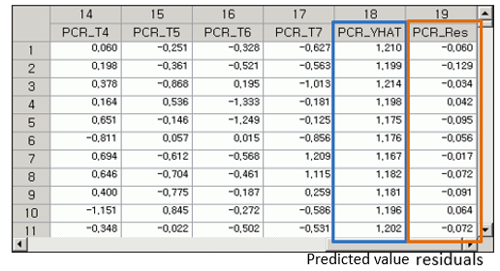

#### Modeling Result

Click **Modeling Result** in Node Property of **Model node** to view the results. Variance explanation: It shows the variance proportion explained by each principal component. Loading vectors for each component: Principal component is calculated for each variable. For example, principal component 1 is calculated as follows: PCA 1 = (-0.00143\*A2) +(0.23957\*A3) +(-0.03681\*A4) +…

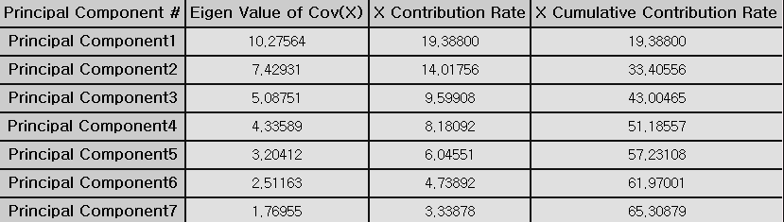

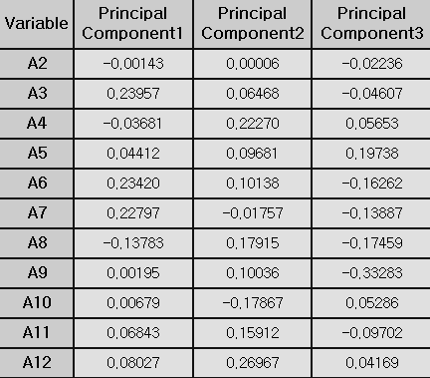

Regression coefficients and model performance measures. The regression coefficients are interpreted as same as in multiple linear regression. **(1) R-square (coefficient of determination):** Represent the percentage of the variance in the dependent variable that is explained by the regression equation. The closer it is to 1, the better the regression equation explains the variability in the data. **(2) Adjust R2:** As more independent variables are added, R-square tends to increase. The adjusted R-square(adj) is considered the number of independent variables. **(3) RMSE (Root-Mean Square Error): $RMSE=\sqrt{MSE}=\sqrt{SSE/(n-p-1) }$**  **(4) MAE (Mean Absolute Error): $MAE= \frac{\sum_{i=1}^{n}{{|y}_{i}- \hat{y_{i}}}|}{n}$**  **(5) MAPE (Mean Absolute Percentage Error): $MAPE= \frac{\sum_{i=1}^{n}{\left|{(y}_{i}- \hat{y_{i}}\right)/y_{i}|}}{n}×100$**  Note that numbers (3) to (5) all represent the error between the original and predicted values of the dependent variable. Therefore, a smaller value indicates a better model.

#### Example File

Run the “pcr.ecm”

### 3.4.20 PLS

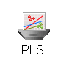 

**Partial least squares (PLS)** is a statistical method commonly used for dimensionality reduction, regression analysis. PLS is used to analyze data where there is a large correlation between independents or where the number of variables is greater than the number of observations. If there is a multicollinearity problem, PLS reduces the number of predictors by transforming them into latent variables. The application fields are chemometrics, bioinformatics, and finance. About Principal Component Analysis (PCA) and PLS, PLS focuses on explaining variance in both predictors and responses while PCA focuses only on explaining variance in the predictors.

#### Overview

PLS is a method of projecting the information of [X(n x k), Y(n x m)] into a low-dimensional space with a small number of latent variables, especially when the number of process variables (k) and the dimension of quality characteristics (m) are very large. The PLS model assumes that X and Y can be decomposed into latent structures. A latent variable is $t_{1},t_{2},...,t_{A}$, matrix T(n x A). $X=TP^{T}+E$ $Y=UQ^{T}+F$***T*** : Scores (latent variables) for X. ***Y*** : Scores (latent variables) for Y. ***P*** and ***Q*** : Loadings (coefficients relating scores to original variables). ***E*** and ***F*** : Residuals (unexplained variation in X and Y) The main idea of PLS is to explain Y with X by maximizing the covariance between T and U.

#### Applications

Independent variable must be continuous. Dependent variable must be continuous. PLS can predict multiple targets. PLS include a standardized pre-processing process.

#### Usage

Read the data using Input Node. Specify the type of data using Type Change Node. (independent, target) Connect Type Change Node to PLR Node and select the options. Connect PLR Node to Display Node. An example of PLR stream is as follows.

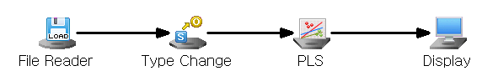

#### Node Properties

|  |  |  |  |  |
| --- | --- | --- | --- | --- |
| Property group | Property Name | Description | Misc. | Note |
| **Model File** | Save Model File | Decide whether to save model file. | Required | Yes, No |
| Model File Path | Set the path for the model file to be saved. | Conditionally Required |  |
| **Selection options** | Number of Latent Variable | Set the number of Latent Variables. | Required | Integer  (less than the number of independent variables) |
| Save Confidence Intervals | Stores the 95% **confidence interval** for the specified target. | Required | True, False |
| Save Prediction Intervals | Save the 95% prediction interval. | Required | True, False |

#### Results

Prediction analysis results are displayed using Display Node. Analysis chart information.

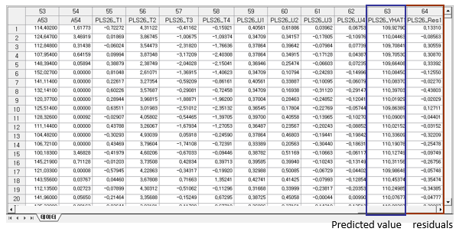

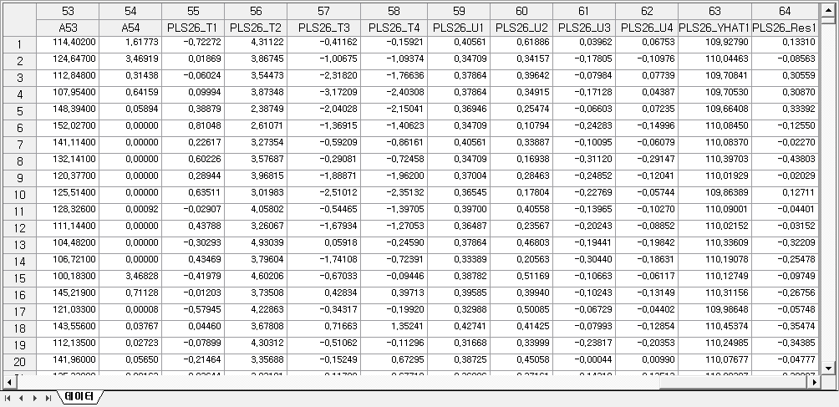

#### Graphic Result

Click **Graphic Result** button in Node Property of **Model node** to view the charts. The results can also be viewed in the **Modeling Result** of **Model node**. Scree Plot of X: This plot shows how much variance of X is explained by each latent variable. Scree Plot of Y: This plot shows how much variance of Y explained by each latent variable. Coefficient Plot: For target variable, you can see which variables have the most impact. In addition, it can be sorted according to coefficient size. Data Chart: With Data Chart, you can see trend charts of target values and forecast values. You can also view the Residual and Contribution charts along with this trend chart.

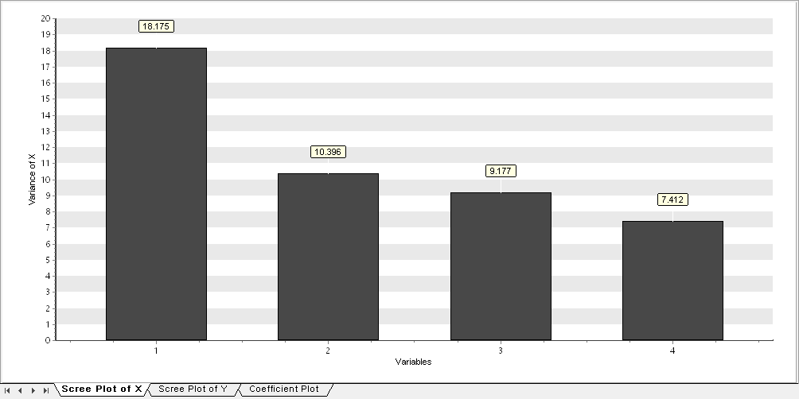

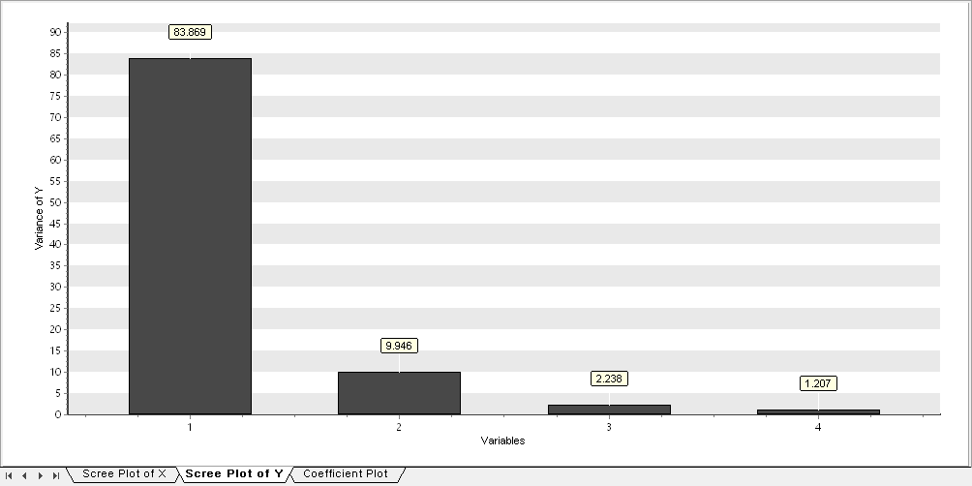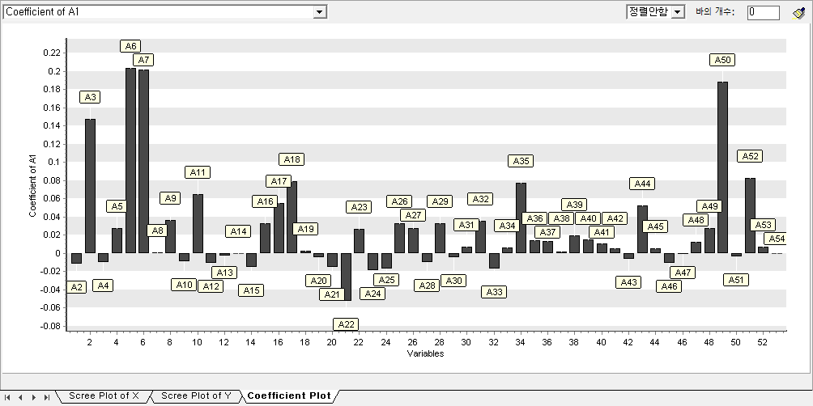

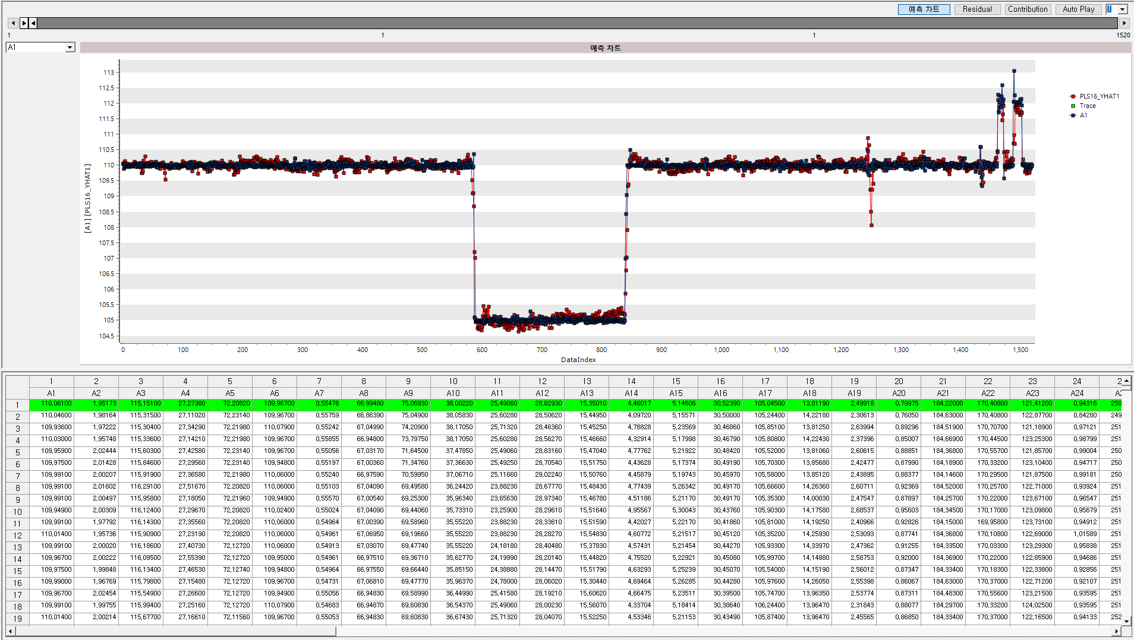

#### Modeling Result

Click **Modeling Result** in Node Property of **Model node** to view the results. Coefficient Information, Variance Information, Standard Error Information.

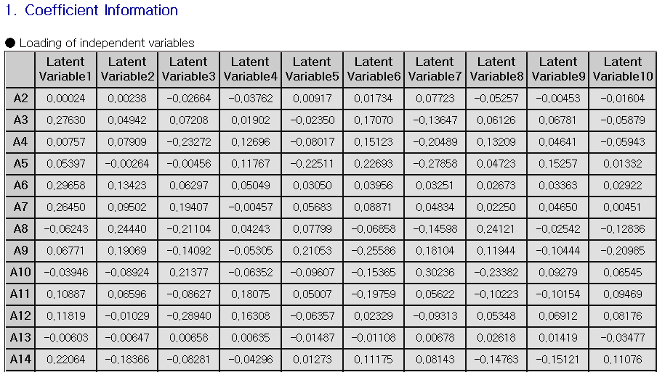

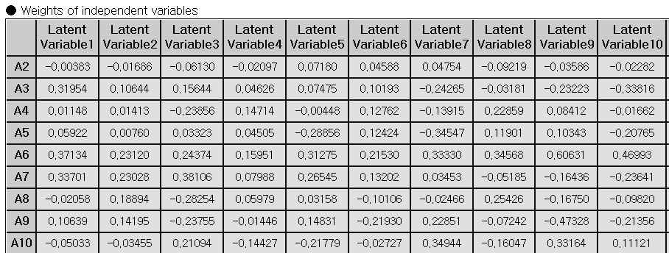

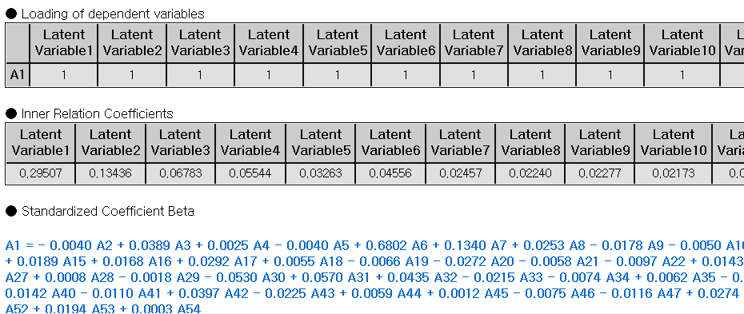



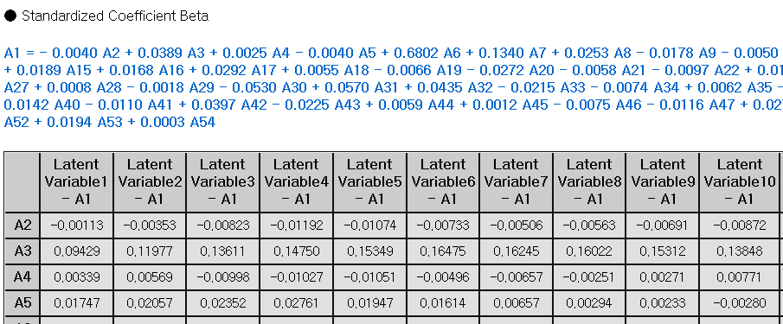

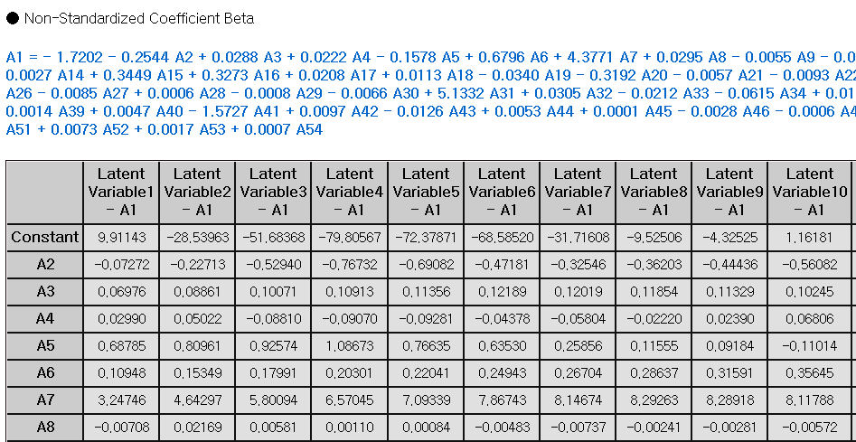

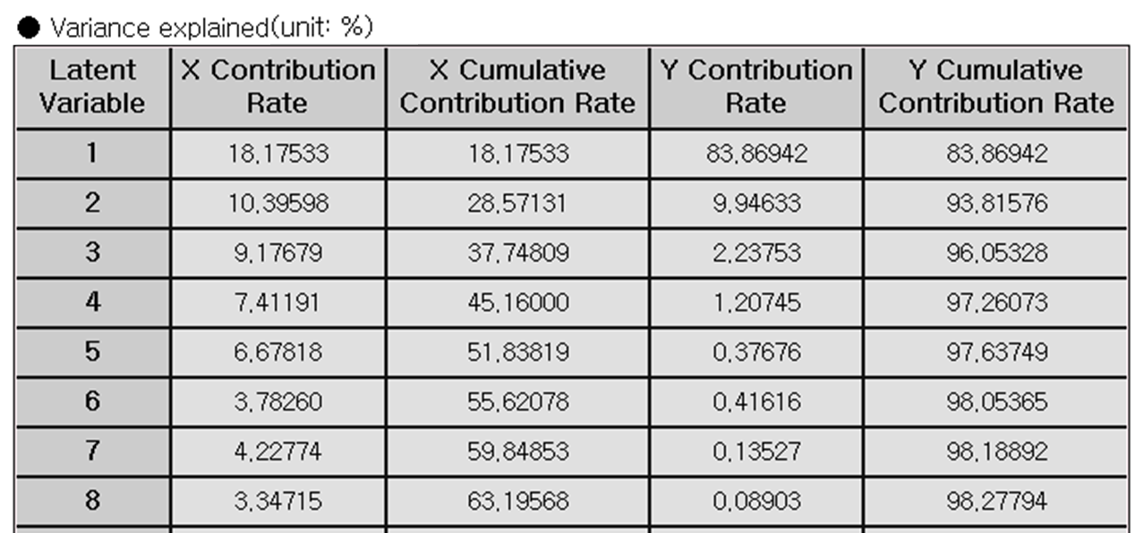

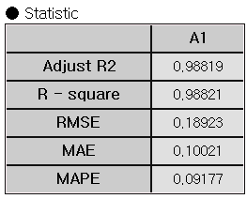

#### Example File

Run the “pls.ecm”

### 3.4.21 QDA

 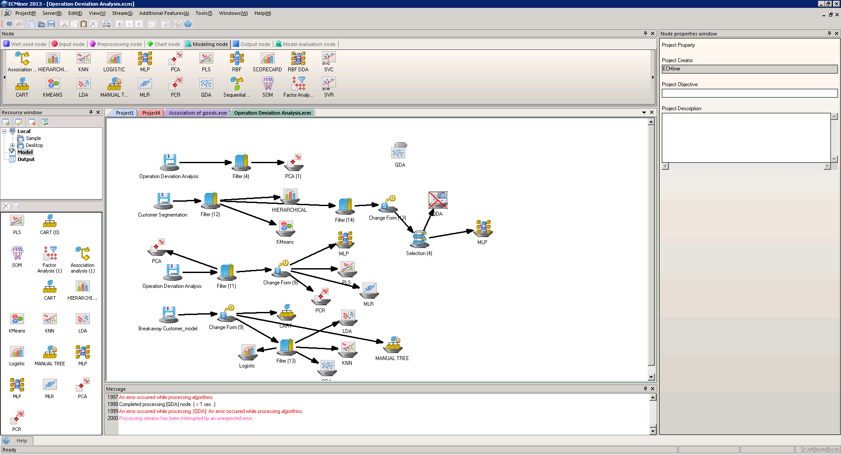

**QDA (Quadratic Discriminant Analysis)** is a supervised classification algorithm allowing non-linear boundaries. QDA maximizes between-class separation while assuming that each class has its own covariance matrix.

#### Overview

LDA assumes that the variance-covariance matrix is the same for all classes. QDA allows the covariance matrix different, and forms quadratic decision boundaries between classes. QDA assumes normality of data within each class same as LDA. (1) Calculate the average vector for each class. ${\hat{μ}}_{j}←{\bar{x}}^{(j)}←\frac{1}{n_{j}}\sum_{i=1}^{n_{j}}{x_{i}^{(j)}}\text{ ,}j=1,2$ (2) Calculate the sample covariance matrix for a class. ${\overset{∧}{Σ}}_{j}←S_{j}←\frac{1}{n_{j}-1}\sum_{i=1}^{n_{j}}{(x_{i}-{\bar{x}}^{(j)})}(x_{i}-{\bar{x}}^{(j)})' j=\text{1,2}$ (3) The discriminant function for class k is shown below. $U_{k}=\ln{π_{k}}-\frac{1}{2}\ln{|}Σ_{k}|-\frac{1}{2}(x-μ_{k})'{Σ_{k}}^{-1}(x-μ_{k})$ (4) The classification rules are as follows. $U_{k}=\max_{j}U_{j} , categorize x into category k$

#### Applications

Independent variable can be either continuous or discrete. Dependent variable must be discrete. The feature vector 𝑥 follows a multivariate normal distribution. The variance-covariance matrix is different for each class.

#### Usage

Read the data using Input Node. Specify the type of data using Type Change Node. (independent, or target) Connect Type Change Node to QDA Node and select the options. Connect QDA Node to Display Node. Select Prior probability and set the appropriate prior. An example of QDA stream is as follows.



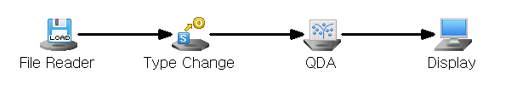

#### Node Properties

|  |  |  |  |  |
| --- | --- | --- | --- | --- |
| **Property group** | **Property Name** | **Description** | **Misc.** | **Note** |
| **Model File** | Save Model File | Decide whether to save model file. | Optional | Yes, No |
| Model File Path | Set the path for the model file to be saved. | Conditionally Required |  |
| **Selection options** | Prior probability | Decide whether to manually input the prior probabilities. Manual prior is useful for imbalanced data | Required | Base Value, Manual Input |

#### Results

Classification analysis results are displayed using Display Node.

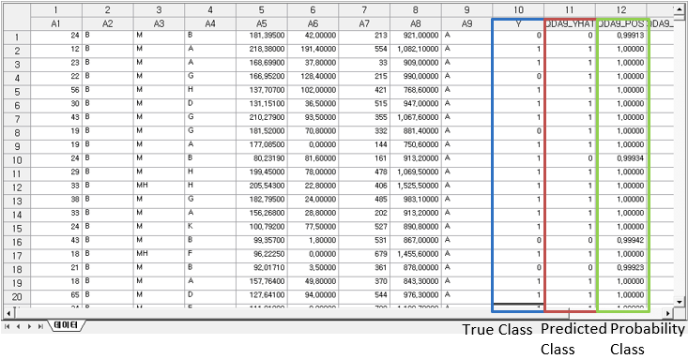

#### Modeling Result

Click **Modeling Result** button in Node Property of **Model node** to view the analysis results. Average of independent variables by class. Indicates the average value of variables for each classified class. Variance-covariance matrix of the class. Since the variance-covariance matrix of each group differs from the class variance-covariance matrix, a separate variance-covariance matrix is output for each group. Prior probability: Shows the probability value for each class specified in the prior probability option. Confusion matrix is shown in a table form.

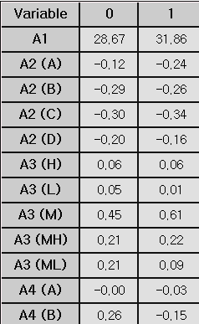

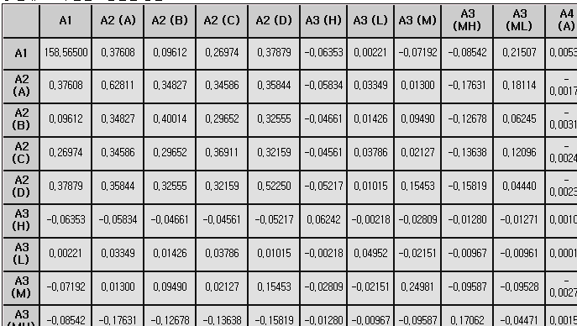

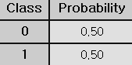

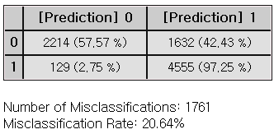

#### Example File

Run the “LDA,QDA.ecm”

### 3.4.22 RandomForest

 

**Random Forest** is a supervised learning algorithm that combines the output of multiple decision trees to improve overall accuracy and stability.

#### Overview

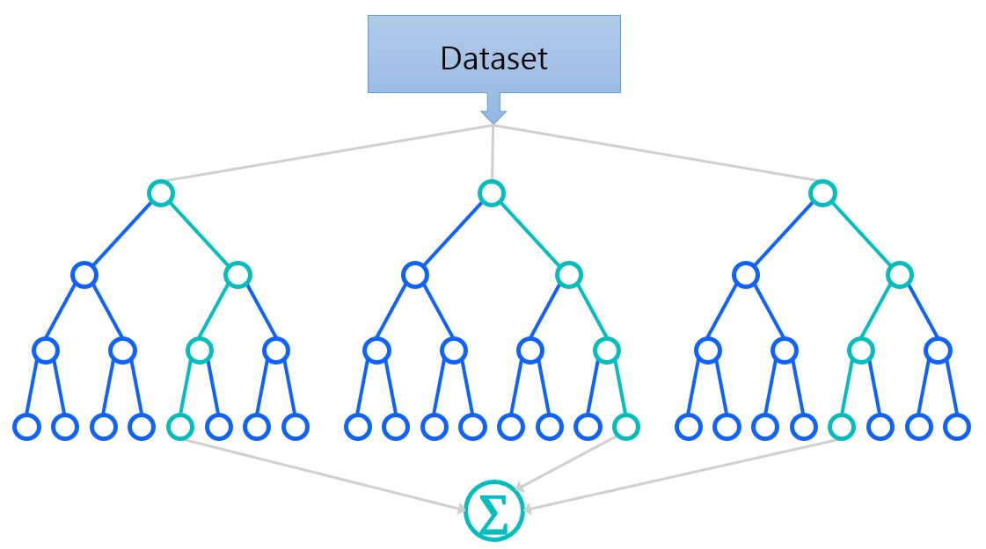

As an ensemble learning technique, bagging is a key idea of the Random Forest model. Bagging, short for Bootstrap Aggregating, creates multiple subsets of the original dataset, allowing repeated instances. The sample size for bagging can be specified as either **Percentage** or **Count** in the **Selected Variable Count** of the **Selection options**. Each bootstrap subset is then used to train an individual decision tree, forming a “forest”. The options for the decision trees are **Total Number of Trees, Maximum Separation Data Size, Maximum Tree Depth, Impurity Condition, Impurity Change Condition** and **Variable Selection Method**. For classification, the final output is determined by majority vote, while for regression, it is the average of the predictions made by all the trees. Out-of-bag (OOB) error is calculated to estimate its internal validation using **OOB** option in the **Selection options**. Since each tree is trained on a bootstrap sample, the remaining data is left out (out-of-bag) and can be used to test the model. After each tree is trained, it is tested on the data points not included in its bootstrap sample. The OOB error is the average error rate across all trees and serves as an unbiased estimate of the model's generalization error.

#### Applications

Independent variables can be either continuous or discrete. Dependent variable can be either continuous or discrete.

#### Usage

Read the data using Input Node. Specify the type of data using Type Change Node. (independent, or target) Connect Type Change Node to RandomForests Node and select the options. Connect RandomForests Node to Display Node. An example of Random Forest stream is as follows.

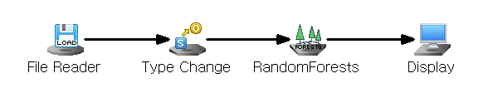

#### Node Properties

|  |  |  |  |  |
| --- | --- | --- | --- | --- |
| Property group | **Property Name** | **Description** | **Misc.** | **Note** |
| Model File | Save Model File | Decide whether to save model file. | Required | Yes, No |
| Model File Path | Set the path for the model file to be saved. | Conditionally Required |  |
| Selection options | Total Number of Trees | Set the number of branches to be generated. (Default : 100) | Required | Natural Number |
| Variable Selection Method | Selection for the number of features in tree. (Default : Automatic, sqrt(k) for classification, and k/3 for regression. k: number of independent variables) | Required | Automatic, Designate |
| Selected Variable Count | Set the number of variables to be used in tree if Variable Selection Method option is set to be Designate. | Required | Natural number |
| Sample Size Specification Method | Set sample size for bagging technique | Required | Percentage, Count |
| Percentage | Specify the sample size as a percentage when ‘Percentage’ is selected for the Sample Size Specification Method. | Optional | 0<real number <100 |
| Count | Specify the sample size as a count when ‘Count’ is selected for the Sample Size Specification Method. | Optional | 0< integer <N  (N: number of data) |
| Impurity Function | Specify the impurity function. (Default : Gini) | Required | Gini, Twoing, Entropy, LSD |
| Use OOB | Decide whether to use Out-of-bag testing. | Required | Yes, No |
| Min Samples Split | Set the minimum number of data required to split a tree node  (Default : 5) | Required |  |
| Max Tree Depth | Specify the maximum depth of each tree. **Default**: None (nodes are expanded until all leaves are pure or contain fewer than Min Samples Split) | Required |  |
| Impurity Threshold | A node becomes a stationary node if its impurity is below the specified impurity threshold. | Required |  |
| Impurity Change Threshold | If the impurity change for a node is below the specified threshold, the node is considered a terminal node. | Required |  |

#### Results

Classification and prediction results can be seen in Display Node.

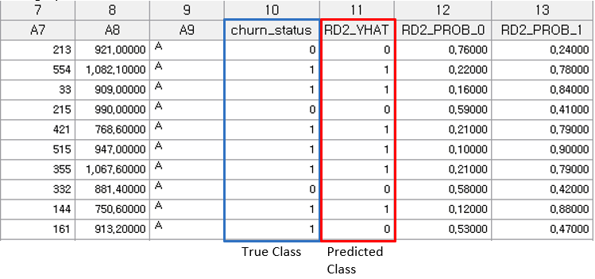

#### Graphic Result

Click **Graphic Result** button in Node Property of **Model node** to view the charts. The results can also be viewed in the **Modeling Result** of **Model node**. Variable importance: Random Forest provides feature importance information for making prediction. Variable importance measure is useful for variable selection. (1) Mean Decrease Accuracy (MDA): measures the impact of each variable on the accuracy of the Random Forest model. It is calculated by removing each variable and observing the reduction in accuracy. The difference in accuracy is averaged for each variable. A larger MDA value indicates that the variable significantly contributes to the model’s classification accuracy. (2) Mean Decrease Impurity (MDI) or Mean Decrease Gini (MDG): represents the average reduction in impurity across all decision trees in the Random Forest. As each decision tree splits based on different variables, MDI quantifies the overall contribution of each variable to reducing impurity throughout the forest. A higher MDI or MDG value indicates that the variable is more important in improving the purity of the splits.

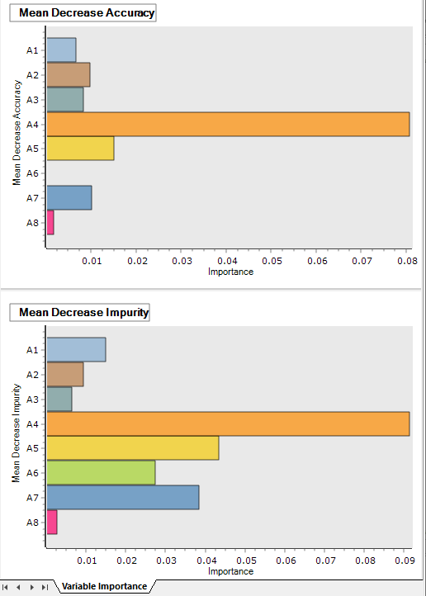



#### Modeling Result

Click **Modeling Result** button in Node Property of **Model node** to view the analysis results. Option Information: It shows which options were used when modeling using RandomForest. Primary Factor Information**, confusion matrix are shown in a table form.**

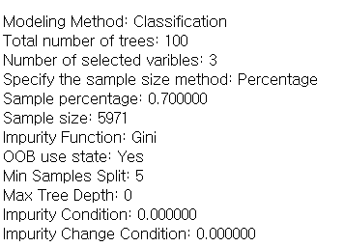

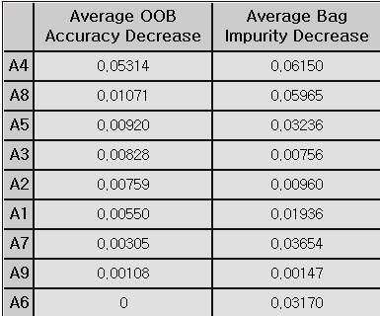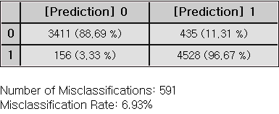

#### Example File

Run the “**RF.ecm**”

### 3.4.23 RBF

 

**RBF(Radial-Basis Function)** network is a supervised neural network with a single hidden layer. Its mathematical form is similar to a standard neural network, but it uses a radial basis function as the combination function in the hidden layer, instead of a typical activation function.

#### Overview

RBF (Radial-Basis Function) network is a supervised neural network often used for tasks like curve fitting by transforming data into a high-dimensional space. RBF network learns by finding a surface that best matches the patterns in the training data within this high-dimensional space. The network has three layers, each with a specific role. The Input layer is responsible for connecting the network to the external environment by receiving data, often referred to as “sensory” information. The hidden layer performs a nonlinear transformation on the input data, altering it in a way that helps the network recognize complex patterns more easily. This layer uses radial-basis functions, which are the core components of the RBF network. Finally. The output layer produces the final result or prediction based on the transformed data from the hidden layer, typically combining the data in a simple, linear way. RBF networks are often used for solving complex pattern classification tasks by transforming the data into a high-dimensional space through a nonlinear process. This transformation makes the patterns more linearly separable compared to those in a lower-dimensional space. As a result, RBF networks typically increase the dimensionality of the hidden layer to improve performance. An important factor to consider is that the dimensionality of this hidden space plays a key role in the accuracy of the network's ability to map input to output. In simple terms, the higher the dimensionality of the hidden layer, the more precisely the network can learn to match the training data.

#### Applications

RBF node automatically selects an appropriate execution method based on the target’s data type, performing predictive analysis when the target is continuous and classification analysis when the target is discrete.

#### Usage

Read the data using Input Node. Define ‘data type’ in Type Change Node. (Specify independent, target) Connect Type Change to RBF Node and select the options. Connect RBF Node to Display Node. An example RBF is as follows.

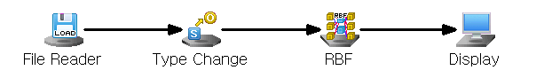

#### Node Properties

|  |  |  |  |  |
| --- | --- | --- | --- | --- |
| Property group | Property Name | Description | Misc. | Note |
| Model File | Save Model File | Decide whether to save model file. | Required | Yes, No |
| Model File Path | Set the path for the model file to be saved. | Conditionally Required |  |
| Selection options | Number of Centers | This is the number of centers of the Radial Basis Function. | Required | 0<Integer<N (number of data) |
| Lambda | Regularization parameter | Required |  |

#### Results

Prediction analysis results are displayed using Display Node. In the case of predictive analysis, you can see the forecast value and residuals, and in the case of classified analysis, you can see the classified results.

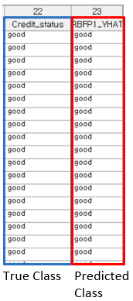

#### Modeling Result

Click **Modeling Result** in Node Property of **Model node** to view the results. Center Information: **Center**: Central values of the RBF for each variable. Classification Accuracy, **Confusion Matrix.**

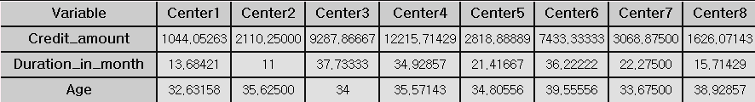

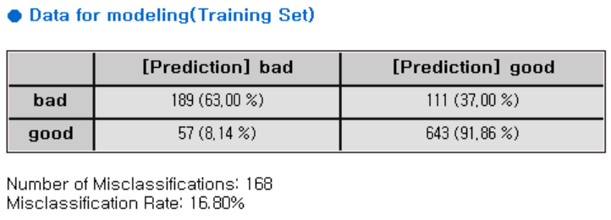

#### Example File

Run “RBF.ecm”

### 3.4.24 RBF DDA

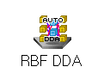 

**RBF DDA** is an algorithm that solves the difficulty of determining the parameters that the user needs to enter to run the algorithm by automatically determining the number of RBFs and the $σ$ value of each RBF.

#### Overview

RBF DDA is an abbreviation of Radial Basis Function with Dynamic Decay Adjustment, and it is an algorithm created to compensate for the shortcomings of existing RBF. The existing RBF algorithm requires that the user specifies the number of RBFs, the σ value of each RBF and so on. However, this is very burdensome for the user who has basic understanding of data. To solve this problem, RBF DDA automatically determines the number of RBFs, and the σ value of each RBF. RBF DDA has the limitation that performs only classification (that is, it cannot perform regression), but it shows better performance than the existing RBF. RBF - The easiest and most concise way to describe the DDA's algorithm is to add RBF when very new data comes in. First of all, the RBF-DDA is expressed as follows. The jth RBF of the ith class has three characteristic values as follows: $\overset{→}{r_{j}^{i}}$: Coordinates of the center of the jth RBF of the ith class. $σ_{j}^{i}$: jth sigma of ith class. $A_{j}^{i}$: jth weight of ith class. At this time, when x data enters the $j^{th}$ RBF of the $i^{th}$ class, the following response value is obtained. $R_{j}^{i}(\vec{x})=\exp\left(-\frac{{\left\|\vec{x} - {\vec{r}}_{j}^{i}\right\|}^{2}}{{\left(σ_{j}^{i}\right)}^{2}}\right)$ Using these response values, the output of each class is as follows; $f^{i}\left(\vec{x}\right)=\sum_{j=1}^{m_{i}}{A_{j}^{i}}*R_{j}^{i}(\vec{x})$ At this time, x data is classified into the class with the largest value above.

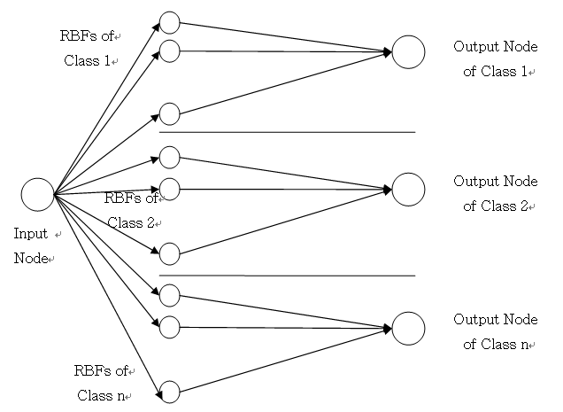

#### Applications

Independent value and target value must be entered. Independent value must be continuous and target value must be discrete. The RBF DDA node itself includes a standardization preprocessing process.

#### Usage

Read the data using Input Node. Specify independent value and target value by using Type Change. Connect RBF DDA to Type Change and select options. An example RBF DDA is as follows.

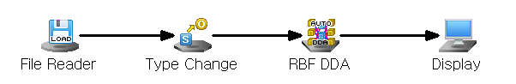

#### Node Properties

|  |  |  |  |  |
| --- | --- | --- | --- | --- |
| Property group | Property Name | Description | Misc. | Note |
| Model File | Save Model File | Decide whether to save model file. | Required | Yes, No |
| Model File Path | Set the path for the model file to be saved. | Conditionally Required |  |
| Selection options | $$θ^{+}$$ | Add a new RBF if the responses of RBFs of the class to which the data belongs to new data are all less than this value, during the RBF DDA training process. | Required |  |
| $$θ^{-}$$ | Set the default value to adjust the value of RBF during the RBF DDA training process. | Required |  |
| Percentage of Min Extraction Data | Set percentage of RBFs to search during the training. This parameter is to speed up the algorithm. Due to the nature of the RBF DDA algorithm, each time new data comes in and a new RBF is created, it changes or adds the value while searching all existing RBFs. Training time can be reduced by selecting only some RBFs in this process. | Required |  |

#### Results

The analysis results are displayed using Display Node. Residual plot is displayed using the Trend Chart or Enhanced Basic Chart.

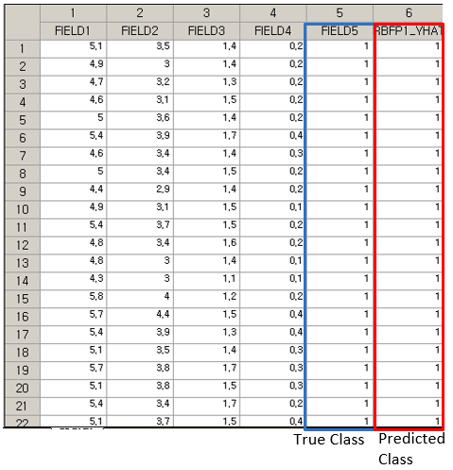

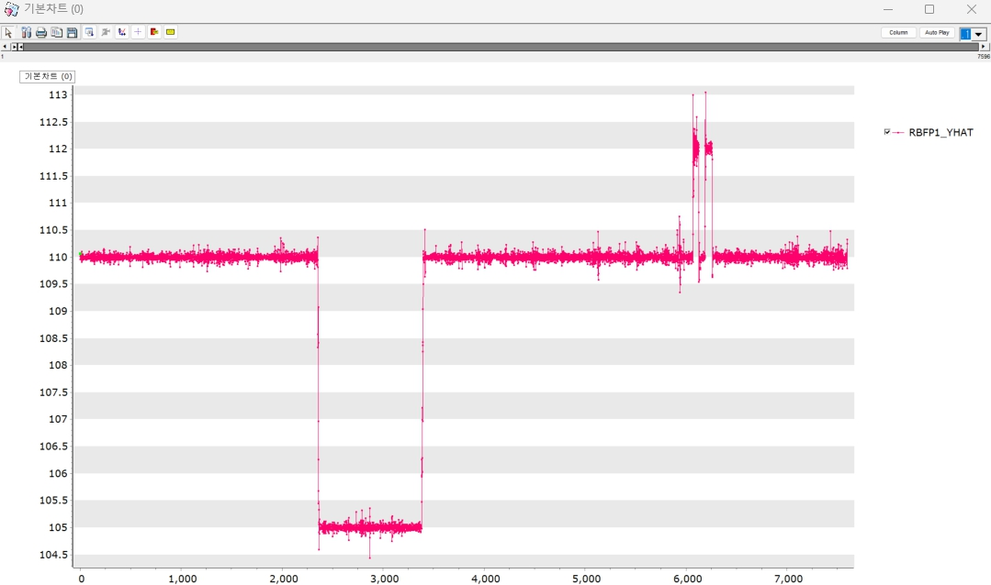

#### Modeling Result

Click Modeling Result in Node Property of Model node to view the results. Weight, Sigma, Center. It shows the value of weight, sigma and center that is obtained on the training of RBF DDA. Confusion Matrix: The confusion matrix shows the number and percentage correctly/incorrectly predicted observations. The cross-tabulation part of the confusion matrix describes the number and percentage of incorrectly predicted observations. The lower the number of misclassifications and the percentage of misclassifications is, the better the model can be judged to be.

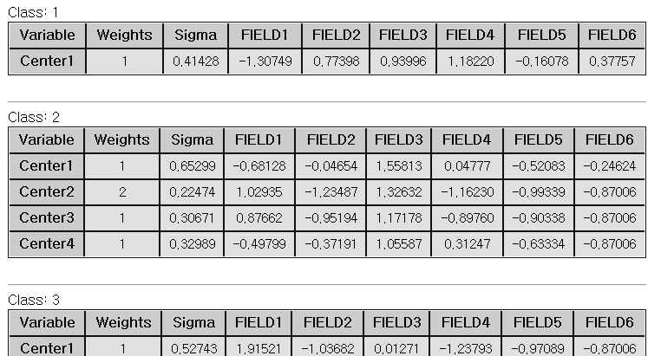

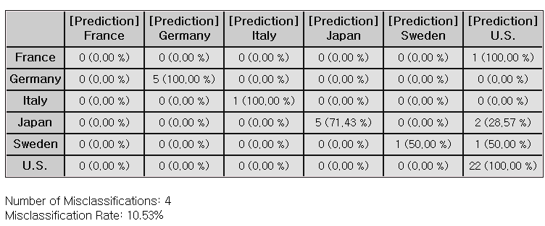

### 3.4.25 Regularized Regression

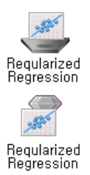

**Regularized regression** is a regression method with a penalty for larger coefficients in order to prevent overfitting and improve model generalization. It is called shrinkage model.

#### Overview

Regression models are used to predict the dependent variable through the linear equation of independent variables. : Dependent variable, : Independent variables. : Intercept. : Coefficients corresponding to each independent variable (the impact of each independent variable on the dependent variable) $ϵ$: Error term. (1) The four assumptions of linear regression: For valid regression model, the following assumptions should be met. **Linearity**: The relationship between the independent and dependent variables is linear. **Independence** **of** **Errors**: Residuals (errors) are independent of each other. **Homoscedasticity**: The variance of the errors should be constant for all values of the independent variables. **Normality** **of** **Errors**: Residuals (errors) is normally distributed. (2) Variable Selection: Variable selection is the process of selecting important variables. In the **Variable Selection** option, you can choose **Stepwise** or **General**. **Stepwise** selection combines with Forward, Backward methods to iteratively add or remove variables, refining the model with significant predictors. (\* **Forward** selection adds from the most important variable to least important one in the model, while **Backward** selection removes unimportant variables from a full model.) General selection includes all the input independent variables. (3) Multicollinearity: Multicollinearity occurs due to high correlations between independent variables. Using the Variance Inflation Factor (VIF), variables with VIF>10 needs to be double-checked. The **Calculate VIFs** option gives VIF values, and the **Remove Multicollinearity** option allows to remove variables with VIF values over 10.

#### Applications

Independent variables can be either continuous or discrete. Dependent variable must be continuous. The four basic assumptions of regression analysis must be satisfied.

#### Usage

Read the data using Input Node. Specify the type of data using Type Change Node. Connect Type Change Node to Regularized Regression Node and select options. Connect Regularized Regression Node to Display Node. An example of Regularized Regression stream is as follows.

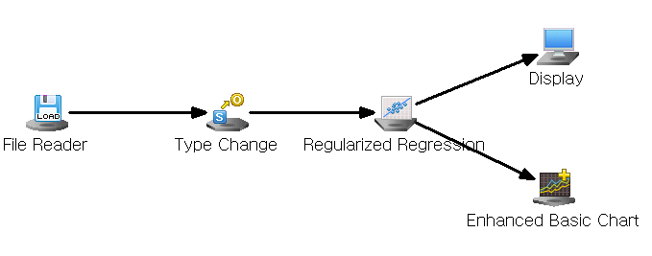

#### Node Properties

|  |  |  |  |  |
| --- | --- | --- | --- | --- |
| **Property group** | **Property Name** | **Description** | **Misc.** | **Note** |
| **Model File** | Save Model File | Decide whether to save model file. | Required | Yes, No |
| Model File Path | Set the path for the model file to be saved. | Conditionally Required |  |
| **Selection options** | Technique | Set the method of variable selection. | Required | General,  Stepwise |
| Significance Level for Entry | Enter Significance Level of Entry if **Technique** is **Stepwise.** The smaller the significance level, the fewer independent variables are likely to be added to the model. | Required |  |
| Significance Level for Removal | Enter Significance Level of Removal if **Technique** is **Stepwise.** The bigger the significance level, the fewer independent variables are likely to be added to the model. | Required |  |
| Calculate VIFs | Decide whether to calculate VIFs.  Multicollinearity is considered present if the VIF exceeds 10. | Required | True,  False |
| Save Confidence Intervals | Decide whether to save 95% Confidence Intervals for the dependent variable. | Required | True,  False |
| Save Prediction Intervals | Decide whether to save 95% of prediction intervals. | Required | True,  False |
| Remove Multicollinearity | Decide whether to remove variables to mitigate multicollinearity among independent variables. | Required | True,  False |
| Regression Method | Select a regression analysis method. | Required | OLS, Ridge, Lasso, Elastic Net |
| Ridge Penalty | Enter the Penalty for Ridge if **Regression Method** is **Ridge.** | Required |  |
| Lasso Penalty | Enter the Penalty for LASSO if **Regression Method** is **Lasso** | Required |  |

#### Results

Prediction analysis results are displayed using Display Node. The residual plot is displayed using the **Trend Chart** or **Enhanced Basic Chart**. If the regression model is well-fitted, the errors should have a mean of 0 and constant variance. Running the Chart Node with Data Index on the X-axis and Residual (MLR\_RES) on the Y-axis will produce a plot similar to the one shown above**.**

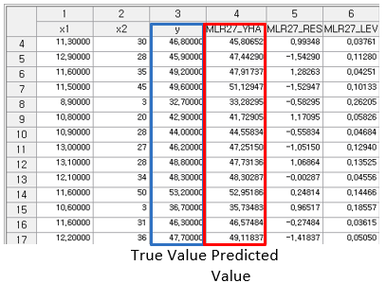



#### Graphic Result

Click **Graphic Result** in Node Property of **Model node** to view the charts. The results can also be viewed in the **Modeling Result** of **Model node**. Coefficient Plot: The graph displays coefficients for each independent variable. Data Chart: The graph displays the difference between actual value and predicted value, residual, contribution for each observation.

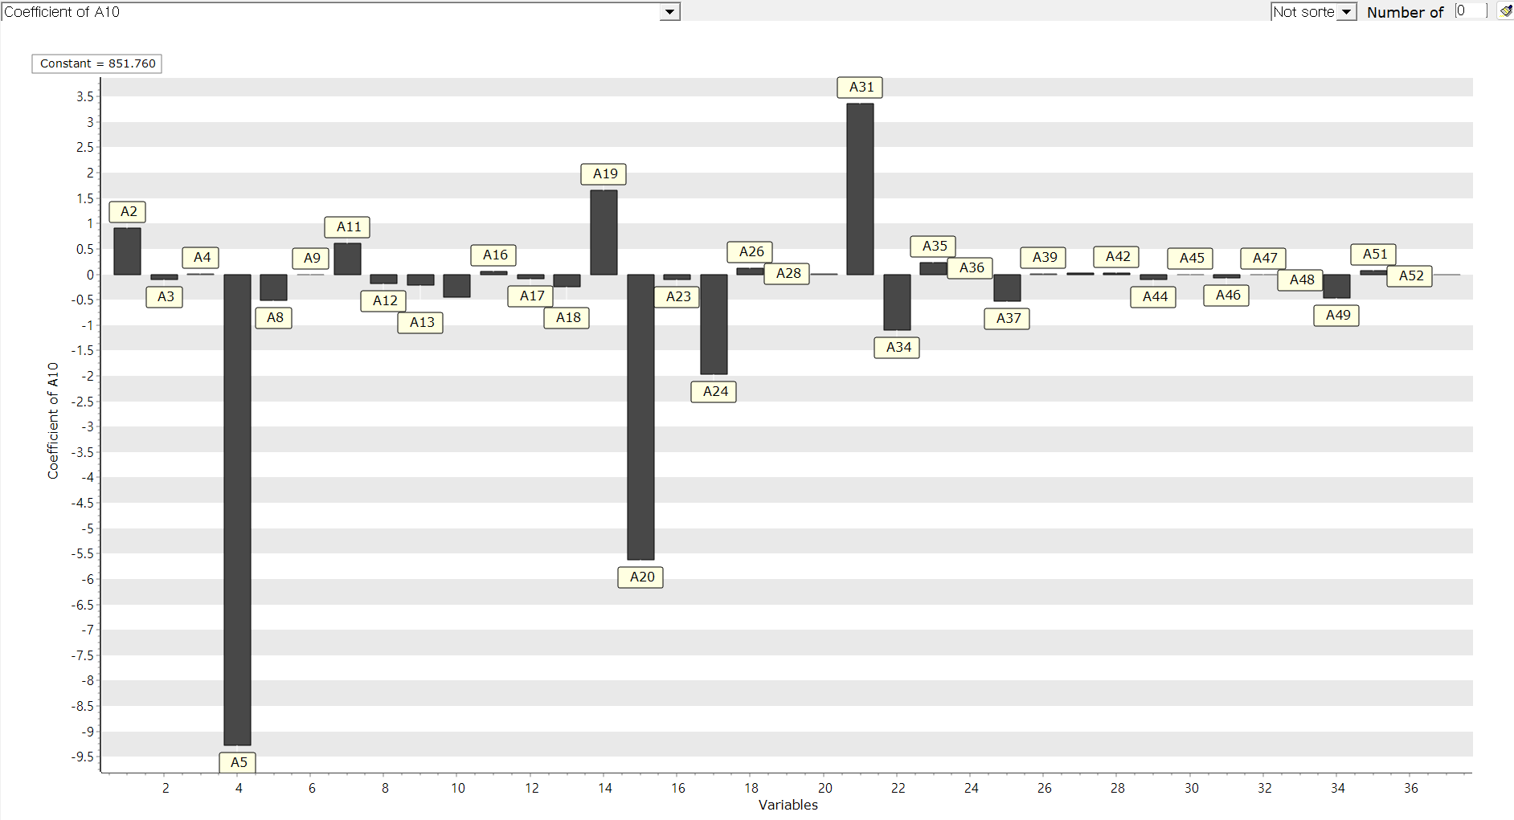

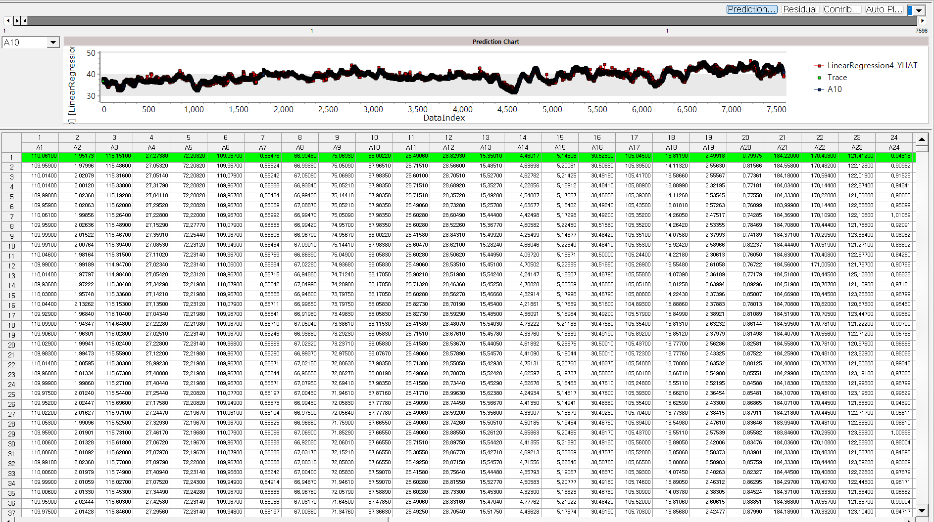

#### Modeling Result

Click **Modeling Result** button in Node Property of **Model node** to view the analysis results. Regression table & Regression Equation. Determine the significance and regression coefficient value of each independent variable. Regression coefficient estimation  Dependent variable prediction  **(1) Non-Standardized Coefficient:** The actual effect of each independent variable on the dependent variable in its original units. **(2) Standard Error:** The measure of uncertainty around the estimate of a regression coefficient. It shows how precise the estimate is. **(3) Standardization Coefficient:** The change in the dependent variable, measured in standard deviations, for a one standard deviation change in the independent variable. **(4) t-value:** A statistic used to test if a regression coefficient is significantly different from zero. It compares the coefficient to its standard error to assess its significance. **(5) p-value:** The probability that the observed effect occurred by chance. If the p-value is less than the significance level, the effect is statistically significant, and the null hypothesis can be rejected.

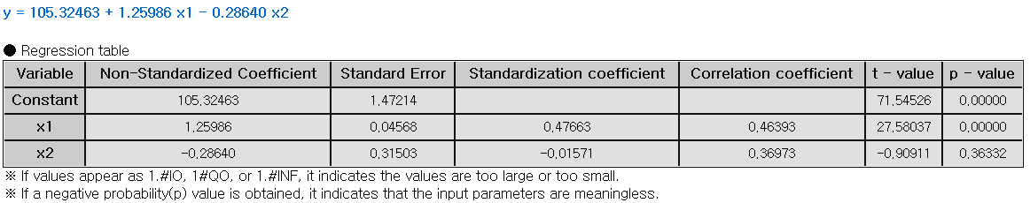

ANOVA TABLE. F-test is a test whether the independent variable is statistically significant in explaining the dependent variable. If the p-value is greater than the significance level then it is not significant, the interpretation of the regression coefficient is meaningless. **(1) DF (Degree of Freedom):** The number of independent variables. **(2) SS (Sum of Squares):** Total variations in the data. It is a calculation of the squared deviations from the mean value. **(3) MS (Mean Square):** The average of the squared deviations. (SS/DF) **(4) F-value:** The ratio of the mean square for the residual variance and the independent variable variance. **(5) p-value:** probability of observing the data if the null hypothesis is true. Lower p-value suggests that the group variances are statistically significant.

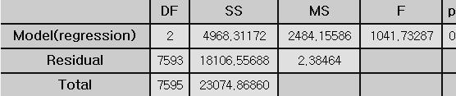

Standard Error Information. **(1) R-square (coefficient of determination):** It is a value that checks whether the derived regression equation is representative of the measured values. **(2) Adjust R2:** It adjusts the r-squared value by considering the degree of freedom of the model. **(3) RMSE (Root-Mean Square Error):** The square root of the average squared differences between the predicted values and the dependent variable. $RMSE=\sqrt{MSE}=\sqrt{SSE/(n-p-1) }$**(4) MAE (Mean Absolute Error):** The average of the absolute differences between the predicted values and the dependent variable. $MAE= \frac{\sum_{i=1}^{n}{{|y}_{i}- \hat{y_{i}}}|}{n}$**(5) MAPE (Mean Absolute Percentage Error):** The average of the absolute differences between the predicted values and the dependent variable as a percentage. Numbers (3) to (5) all represent the error between the original value and the predicted value of the dependent variable. The smaller the value, the better the model.

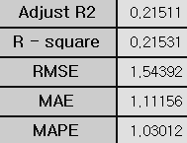

Stepwise result: (1) This result is output only when the technique is selected as stepwise. The model for each step is explained. Trace values ​​indicate which variables were entered at each step. (2) In Step 1, you can see that only x2 has a trace value of 1. This means that the x2 variable was added to the model in Step 1. (3) In Step2, you can see that the x1 variable has been added to the model. You can see that when this x1 variable was added to the model, the R2 (R-Square) value became better than Step1. (4) If Stepwise is selected, only the variables included in the last step in the previous regression table are output, and in the case above, a regression table for variables x1 and x2 is created.



#### Example File

Run the Regression.ecm

### 3.4.26 RL\_AC(Actor Critic)



**Actor Critic (AC)** is a reinforcement learning algorithm in the Policy Gradient method that introduces an additional neural network, allowing two networks to be updated simultaneously. One network approximates the policy, while the other serves as a replacement for the Q function.

#### Overview

The Actor-Critic algorithm is a reinforcement learning method that combines two neural networks: one for estimating the value function and one for determining the policy. The Policy network, known as the “actor”, selects actions based on the current state, while the value function network, known as the “critic”, evaluates the actions chosen by the actor. The actor observes the current state from the environment and determines the optimal action based on the policy. The critic then evaluates the action chosen by the actor using the value function.

#### Applications

Independent and dependent variable used in Environmental Model are required. Independent variable can be either continuous or discrete

#### Usage

Read data using Input Node. Connect Input Node to RL \_AC Node and select the options. Connect the RL\_AC Node to Display Node. An example of RL\_AC stream is as follows.

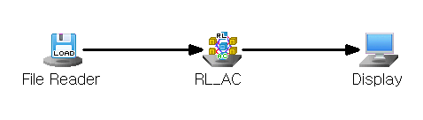

#### Node Properties

|  |  |  |  |  |
| --- | --- | --- | --- | --- |
| Property group | Property Name | Description | Misc. | Note |
| Model File | Save Model File | Decide whether to save model file. | Required | Yes, No |
| Model File Path | Set the path for the model file to be saved. | Conditionally Required |  |
| Selection options | Model Setting | Select the gms file to load as an environment model. | Required |  |
| Discount Rate(gamma) | Set the discount rate(gamma) for the future reward. | Required | 0<real number<1 |
| Actor Learning Rate | Specify the Learning Rate for the Actor neural network. | Required | 0<real number<1 |
| Critic Learning Rate | Specify the learning rate of the Critic neural network. | Required | 0<real number<1 |
| Max Episodes | Specify the maximum number of episodes to learn. | Required | Integer |
| Max Steps | Specify the number of maximum steps in an episode. | Required | Integer |
| Target Variable | Specifies a Target value for the variable to be controlled. | Required | Discrete Variables |
| Target Tolerance | Specify the allowable error margin for the target value when defining the environmental reward. | Required | Integer |
| Target Upper Limit | Specify the condition for ending an episode. The episode ends when the predicted value in the environmental model exceeds the specified value | Required | Real number |
| Target Lower Limit | Specify the condition for ending an episode. The episode ends when the predicted value in the environmental model is below the specified value | Required | Real number |
| Control Variable | Specify the control variables in Environmental Model. | Required |  |
| Control Amount | Specify the Control Amount of the control variable. | Required | Integer |
| Batch Normalization | Decide whether to use batch normalization. | Required | Yes, No |
| Output Layer Activation Function | Specifies the Activation Function of the output layer. | Required | Linear, Sigmoid, ReLU, Leaky ReLU, SoftMax |
| Hidden Layer Configuration | Add Hidden Layer | Add hidden layer | Optional |  |
| Remove Last Hidden Layer | Remove the last hidden layer. | Optional |  |
| Hidden Layer # | Number of nodes | Specify the number of nodes for each specified hidden layer | Required | Integer |
| Activation Function | Select the activation function for the specified hidden layer. | Required | Linear, Sigmoid, ReLU, Leaky ReLU, SoftMax |

#### Results

The analysis Results are displayed by connecting the modeling node to the Display Node. New columns are added to the original data table: **“Recommended amount of control variable”** and **“Forecast Dependent Variable”**. These represent the model's predicted outputs, with the "Forecast Dependent Variable" column containing the predicted values for the target variable.

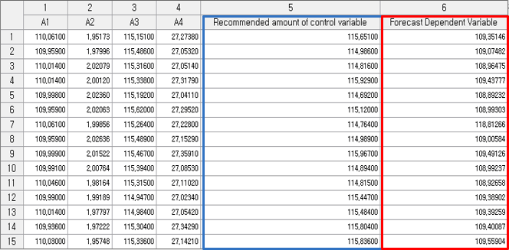

### 3.4.27 RL\_DDPG(Deep Deterministic Policy Gradients)

 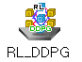

**Deep Deterministic Policy Gradients (DDPGs)** is reinforcement learning algorithm thatpredicts a continuous action. Similar to the Actor-Critic method, it uses one neural network to approximate the policy and another to update the Q function.

#### Overview

DDPG (Deep Deterministic Policy Gradient) is an off-policy, continuous control algorithm that builds upon the Actor-Critic DPG method by integrating deep learning to manage more complex environments. It uses two neural networks: the Actor, which observes the current state and determines the optimal action according to a learned policy, and the Critic, which evaluates the action taken by the Actor using a Q-function. The Critic network is trained to minimize its loss function, thereby improving its ability to assess the Actor's decisions. In turn, the Actor network is updated based on the Critic’s feedback, allowing it to learn a policy that aims to maximize long-term cumulative rewards.

#### Applications

An Environmental Model is needed. Independent and dependent variable used in **Environmental Model** are required. Independent variable can be used for continuous variables in **RL\_DDPG**. Dependent variable is not used in **RL\_DDPG**.

#### Usage

Read data using **Input Node**. Connect Input Node to RL\_DDPG Node and select the options. Connect the RL\_DDPG Node to Display Node. An example of **RL\_DDPG stream** is as follows.

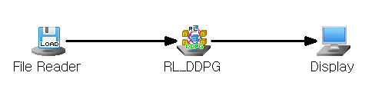

#### Node Properties

|  |  |  |  |  |
| --- | --- | --- | --- | --- |
| Property group | Property Name | Description | Misc. | Note |
| Model File | Save Model File | Decide whether to save model file. | Required | Yes, No |
| Model File Path | Set the path for the model file to be saved. | Conditionally Required |  |
| Selection options | Model Setting | Select the gms file to load in model. | Required |  |
| Discount Rate(gamma) | Set the discount rate(gamma) for the future reward. | Required | 0<real number <1 |
| Actor Learning Rate | Specify the learning rate for the **Actor network.** | Required | 0<real number <1 |
| Critic Learning Rate | Specify the learning rate of the **Critic neural network.** | Required | 0<real number <1 |
| Epsilon | Specify the probability of choosing actions. When the probability is set to 0, the action with the highest Q-value is selected; when set to 1, actions are chosen completely at random. | Required | 0<real number <1 |
| Epsilon Decay Rate | Specify the decay rate of epsilon. | Required | 0<real number <1 |
| Minimum Epsilon Value | Specify the minimum value of Epsilon. | Required | 0<real number <1 |
| Min Replay Memory Size | Specifies the minimum size of replay memory for starting training. | Required | 0<Integer<N |
| Max Replay Memory Size | Specify the maximum number of samples to be stored in replay memory. | Required | Integer |
| Batch Size | Specify the number of sample batches to extract from memory for training. | Required | Integer |
| Max Episodes | Specify the maximum number of episodes to learn. | Required | Integer |
| Max Steps | Specify the number of maximum steps in an episode. | Required | Integer |
| Target Tolerance | Specify the allowable error margin for the target value when defining the environmental reward. | Required | Integer |
| Batch Normalization | Decide whether to use batch normalization. | Required | Yes, No |
| Set control, target Variable | Specify control and target variables | Required, Button |  |
| Output Layer Activation Function | Specifies the Activation Function of the output layer. |  | Linear, Sigmoid, ReLU, Leaky ReLU, SoftMax |
| Hidden Layer Configuration | Add hidden layer | Add hidden layer. | Optional |  |
| Remove Last Hidden Layer | Remove the last hidden layer | Optional |  |
| Hidden Layer # | Number of nodes | Specify the number of nodes for each specified hidden layer | Required | Integer |
| Activation Function | Select the activation function for the specified hidden layer. | Required | Linear, Sigmoid, ReLU, Leaky ReLU, SoftMax |

#### Results

The analysis Results are displayed by connecting the modeling node to the Display Node. New columns are added to the original data table: **“Recommended amount of control variable”** and **“Forecast Dependent Variable”**. These represent the model's predicted outputs, with the "Forecast Dependent Variable" column containing the predicted values for the target variable.

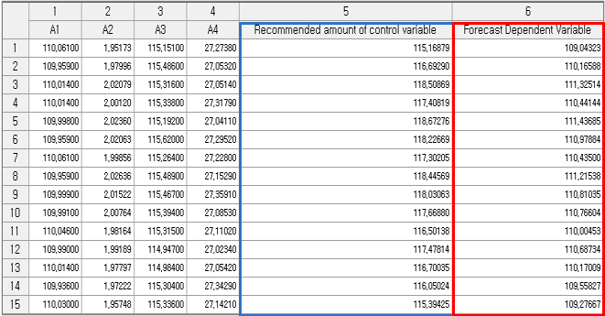

### 3.4.28 RL\_DQN(Deep Q Network)

 

**Deep Q Network (DQN)** is a reinforcement learning algorithm that uses a neural network to perform Q-learning. It works by estimating the value of different actions in a given state and selecting the action with the highest value.

#### Overview

Q-learning is a reinforcement learning technique that learns the optimal policy by learning the Q function, which predicts the sum of expected future rewards when a specific action is taken in a given state. The Q function reflects the concept of policy in the value function, representing the decision of which action the agent will take in a particular state. Based on the Q function, the agent assigns a Q value for every possible state-action pair. This allows the agent to express the potential reward for the next step by using the Q function. The Q function can be expressed as: $\left(Q function\right)=\left(reward\right)+\left(discount rate\right)*\left(next Q function\right)$ The reward represents the immediate value obtained, the discount rate accounts for the decrease in the value of future rewards, and the next Q function refers to the maximum Q value that can be achieved in the next stage. DQN (Deep Q-Network) builds on the State-Action-Reward-State-Action (SARSA) algorithm, applying Q-learning at each time step. To update the Q function, the current Q value is adjusted based on the error between the predicted value and the actual outcome, using a one-step sample. Since the goal of reinforcement learning is maximize cumulative rewards, DQN updates the current Q function by using the maximum possible value of the next Q function to guide the learning process.

#### Applications

Independent and dependent variable used in Model Setting are required. Independent variable can be either continuous or discrete

#### Usage

Read data using Input Node. Connect Input Node to RL\_DQN Node and select the options. Connect the RL\_DQN Node to Display Node. An example of RL\_DQN stream is as follows.

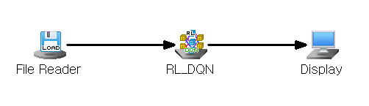

#### Node Properties

|  |  |  |  |  |
| --- | --- | --- | --- | --- |
| Property group | **Property Name** | **Description** | **Misc.** | **Note** |
| Model File | Save Model File | Decide whether to save model file. | Required | Yes, No |
| Model File Path | Set the path for the model file to be saved. | Conditionally Required |  |
| Selection options | Model Setting | Select the gms file to load as an environment model. | Required |  |
| Discount Rate(gamma) | Set the discount rate(gamma) for the future reward. | Required | 0<real number<1 |
| Learning Rate | Set the learning rate of the neural network. | Required |  |
| Epsilon | Specify the probability of choosing actions randomly. When the probability is set to 0, the action with the highest Q-value is selected; when set to 1, actions are chosen completely at random. | Required | 0<Real number<1 |
| Epsilon Decay Rate | Specify the decay rate of epsilon. | Required | 0<Real number<1 |
| Minimum Epsilon Value | Specify the minimum value of Epsilon. | Required | 0<Real number<1 |
| Min Replay Memory Size | Specify the minimum size of replay memory for starting training. | Required | 0<Integer<N |
| Max Replay Memory Size | Specify the maximum number of samples to be stored in replay memory. | Required | Integer |
| Batch Size | Specify the number of sample batches to extract from memory for training. | Required | Integer |
| Max Episodes | Specify the maximum number of episodes to learn. | Required | Integer |
| Max Steps | Specify the number of Maximum Steps in an episode. | Required | Integer |
| Target variable | Specify the variable that contains the target value for the variable to be controlled. | Required | Discrete variables |
| Target Tolerance | Specify the allowable error margin for the target value when defining the environmental reward. | Required | Integer |
| Target Upper Limit | Specify the condition for ending an episode. The episode ends when the predicted value in the environmental model exceeds the specified value | Required | Integer |
| Target Lower Limit | Specify the condition for ending an episode. The episode ends when the predicted value in the environmental model is below the specified value | Required | Integer |
| Control Variable | Specify the control variables in Environmental Model. | Required |  |
| Control Amount | Specify the Control Amount of the control variable. | Required | Integer |
| Batch Normalization | Decide whether to use batch normalization. | Required | Yes, No |
| Output Layer Activation Function | Specifies the Activation Function of the output layer. | Required | Linear, Sigmoid, ReLU, Leaky ReLU, SoftMax |
| Hidden Layer Configuration | Add Hidden Layer | Add hidden layer | Optional |  |
| Remove Last Hidden Layer | Remove the last hidden layer. | Optional |  |
| Hidden Layer # | Number of nodes | Specify the number of nodes for each specified hidden layer. | Required | Integer |
| Activation Function | Select the activation function for the specified hidden layer. | Required | Linear, Sigmoid, ReLU, Leaky ReLU, SoftMax |

#### Results

The analysis Results are displayed by connecting the modeling node to the Display Node. New columns are added to the original data table: **“Recommended amount of control variable”** and **“Forecast Dependent Variable”**. These represent the model's predicted outputs, with the "Forecast Dependent Variable" column containing the predicted values for the target variable.

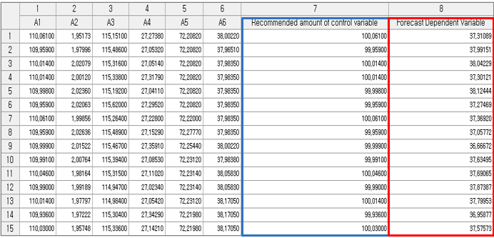

### 3.4.29 RL\_PPO(Proximal Policy Optimization)

 

**Proximal Policy Optimization (PPO)** is a reinforcement learning algorithm that uses clipping mechanism to limit the difference between the old and new policies, ensuring updates happen gradually. This allows for more stable and controlled policy improvements compared to traditional reinforcement learning algorithms.

#### Overview

In Actor-Critic methods, even small changes to the policy parameters can lead to large shifts in the policy itself. Proximal Policy Optimization (PPO) addresses this by applying constraints to ensure that policy updates happen more gradually. PPO uses a clipping mechanism to keep the ratio between the old and new policies within a set range, preventing excessive changes. As a result, PPO ensures that policy updates remain stable and controlled within these constraints.

#### Applications

An Environmental Model is needed. Independent and dependent variable used in Environmental Model are required. Independent variable can be either continuous or discrete. Dependent variable is not used in PPO.

#### Usage

Read data using Input Node. Connect Input Node to RL\_PPO Node and select the options. Connect the RL\_PPO Node to Display Node. An example of RL\_PPO stream is as follows.

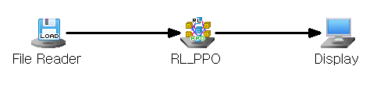

#### Node Properties

|  |  |  |  |  |
| --- | --- | --- | --- | --- |
| Property group | Property Name | Description | Misc. | Note |
| Model File | Save Model File | Decide whether to save model file. | Required | Yes, No |
| Model File Path | Set the path for the model file to be saved. | Conditionally Required |  |
| Selection options | Model Setting | Select the gms file to load as an environment model. | Required |  |
| Discount Rate(gamma) | Set the discount rate(gamma) for the future reward. | Required | 0<real number <1 |
| Actor Learning Rate | Specify the Learning Rate for the Actor neural network. | Required | 0<real number <1 |
| Critic Learning Rate | Specify the learning rate of the Critic neural network. | Required | 0<real number <1 |
| Lambda | Specify the Lambda value. Lambda controls the balance between bias and variance in advantage estimation, where higher values lead to more accurate estimates with increased variability. | Required | 0<real number <1 |
| Learning Epoch | Specify the number of epochs. | Required | Integer |
| Clip value | Specify the Clipping value for the Loss Function. | Required | Real number |
| Batch Size | Specify the number of sample batches to extract from memory for training. | Required | Integer |
| Max Episodes | Specify the maximum number of episodes to learn. | Required | Integer |
| Max Steps | Specify the number of maximum steps in an episode. | Required | Integer |
| Target Tolerance | Specify the allowable error margin for the target value when defining the environmental reward. | Required | Integer |
| Batch Normalization | Decide whether to use batch normalization. | Required | Yes, No |
| Set control, target Variable | Specify control and target variables | Required, Button |  |
| Output Layer Activation Function | Specifies the Activation Function of the output layer. | Required | Linear, Sigmoid, ReLU, Leaky ReLU, SoftMax |
| Hidden Layer Configuration | Add hidden layer | Add hidden layer. | Optional |  |
| Remove Last Hidden Layer | Remove the last hidden layer | Optional |  |
| Hidden Layer # | Number of nodes | Specify the number of nodes for each specified hidden layer | Required | Integer |
| Activation Function | Select the activation function for the specified hidden layer. | Required | Linear, Sigmoid, ReLU, Leaky ReLU, SoftMax |

#### Results

The analysis Results are displayed by connecting the modeling node to the Display Node. New columns are added to the original data table: **“Recommended amount of control variable”** and **“Forecast Dependent Variable”**. These represent the model's predicted outputs, with the "Forecast Dependent Variable" column containing the predicted values for the target variable.

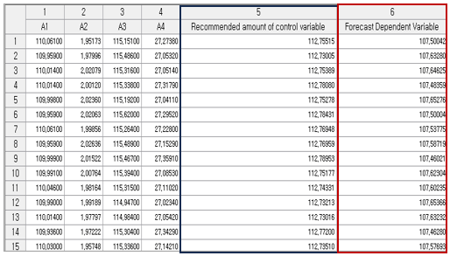

### 3.4.30 RL\_PG(Policy Gradient)

 

**Policy Gradient (PG)** is a reinforcement learning algorithm that helps a system learn the best actions to take by gradually improving its decisions.

#### Overview

The Policy Gradient algorithm is a reinforcement learning approach that directly optimizes the policy to maximize rewards, instead of relying on the value function. This method aims to achieve the maximum reward by optimizing an objective function, which is the sum of the expected rewards along a given path. In policy-based reinforcement learning, the goal is to adjust the policy to maximize this objective function. This is done by updating the neural network parameters in the direction that increases the objective function, a process known as Gradient Ascent. The gradient of the objective function is called the Policy Gradient. The objective function can be adjusted by introducing a discount factor to the rewards. Policy Gradient training often uses the Monte-Carlo method, where the policy is updated after each complete episode, a process known as Monte-Carlo Policy Gradient training.

#### Applications

The independent variable in the RL\_PG Node, representing the state or observation, can be either continuous or discrete.

#### Usage

Read data using Input Node. Connect Input Node to RL\_PG Node and select the options. Connect RL\_PG Node to Display Node. An example of RL\_PG stream is as follows.

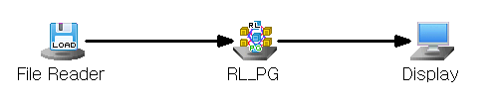

#### Node Properties

|  |  |  |  |  |
| --- | --- | --- | --- | --- |
| Property group | Property Name | Description | Misc. | Note |
| Model File | Save Model File | Decide whether to save model file. | Required | Yes, No |
| Model File Path | Set the path for the model file to be saved. | Conditionally Required |  |
| Selection options | Model Setting | Select the gms file to load as an environment model | Required |  |
| Discount Rate(gamma) | Set the discount rate(gamma) for the future reward. | Required | 0<real number<1 |
| Learning Rate | Set the learning rate of the neural network. | Required | 0<real number<1 |
| Max Episodes | Specify the maximum number of episodes to learn. | Required | Integer |
| Max Steps | Specify the maximum number of steps in an episode. | Required | Integer |
| Target variable | Specify the value for the variable to be controlled. | Required | Discrete Variables |
| Target Tolerance | Specify the allowable error margin for the target value when defining the environmental reward. | Required | Integer |
| Target Upper Limit | Specify the condition for ending an episode. The episode ends when the predicted value in the environmental model exceeds the specified value | Required | Real Number |
| Target Lower Limit | Specify the condition for ending an episode. The episode ends when the predicted value in the environmental model is below the specified value | Required | Real Number |
| Control Variable | Specify the control variables | Required |  |
| Control Amount | Specify the amount of control for the control variable. | Required | Integer |
| Batch Normalization | Decide whether to use batch normalization. | Required | Yes, No |
| Output Layer Activation Function | Specify the activation function for the output layer. | Required | Linear, Sigmoid, ReLU, Leaky ReLU, SoftMax |
| Hidden Layer Configuration | Add Hidden Layer | Add a hidden layer. | Optional |  |
| Remove Last Hidden Layer | Remove the last hidden layer. | Optional |  |
| Hidden Layer # | Number of nodes | Specify the number of nodes for each specified hidden layer. | Required | natural number |
| Activation Function | Select the activation function for the specified hidden layer. | Required | Linear, Sigmoid, ReLU, Leaky ReLU, SoftMax |

#### Results

The analysis Results are displayed by connecting the modeling node to the Display Node. New columns are added to the original data table: **“Recommended amount of control variable”** and **“Forecast Dependent Variable”**. These represent the model's predicted outputs, with the "Forecast Dependent Variable" column containing the predicted values for the target variable.

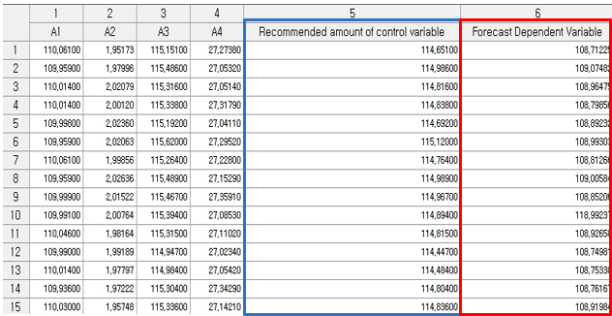

### 3.4.31 RL\_TD3(Twin Delayed DDPG)

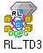 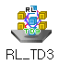

**Twin Delayed DDPG (TD3**) is a reinforcement learning algorithm that uses two Critic Networks to improve stability and prevent overestimation errors, offering more reliable learning compared to the single Critic Network used in DDPG.

#### Overview

Twin Delayed DDPG(TD3) is a reinforcement learning algorithm designed to address the instability and overestimation issues in DDPG. Unlike DDPG, TD3 uses two Critic Networks and updates them by taking the minimum of Q-value from both, leading to more stable approximation. While the Critic Networks are updated at every step, the Actor Network is updated less frequently, after a set number of steps, which reduces policy changes and makes the learning process more stable.

#### Applications

An Environmental Model is needed. Independent and dependent variable used in Environmental Model are required. Independent variable can be either continuous or discrete. Dependent variable is not used.

#### Usage

Read data using Input Node. Connect Input Node to RL\_TD3 Node and select the options. Connect the RL\_TD3 Node to Display Node. An example of RL\_TD3 stream is as follows.

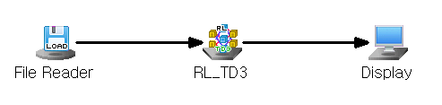

#### Node Properties

|  |  |  |  |  |
| --- | --- | --- | --- | --- |
| Property group | Property Name | Description | Misc. | Note |
| Model File | Save Model File | Decide whether to save model file. | Required | Yes, No |
| Model File Path | Set the path for the model file to be saved. | Conditionally Required |  |
| Selection options | Model Setting | Select the gms file to load in model | Required |  |
| Policy Delay | Specify the update frequency for the Actor network. | Required | Integer |
| Action Clip Value | Specify the target policy smoothing constant value. | Required | Real number |
| Discount Rate(gamma) | Set the discount rate(gamma) for the future reward. | Required | 0<real number <1 |
| Actor Learning Rate | Specify the Learning Rate for the Actor neural network. | Required | Real number |
| Critic Learning Rate | Specify the learning rate of the Critic neural network. | Required | Real number |
| Epsilon | Specify the probability of choosing actions randomly. When the probability is set to 0, the action with the highest Q-value is selected; when set to 1, actions are chosen completely at random. | Required | 0<real number <1 |
| Epsilon Decay Rate | Specifies the decay rate of Epsilon. | Required | 0<real number <1 |
| Minimum Epsilon Value | Specifies the minimum value of Epsilon. | Required | 0<real number <1 |
| Min Replay Memory Size | Specify the minimum size of replay memory for starting training. | Required | 0<Integer<N |
| Max Replay Memory Size | Specify the maximum number of samples to be stored in replay memory. | Required | Integer |
| Batch Size | Specify the number of sample batches to extract from memory for training. | Required | Integer |
| Max Episodes | Specify the maximum number of episodes to learn. | Required | Integer |
| Max Steps | Specify the number of maximum steps in an episode. | Required | Integer |
| Target Tolerance | Specify the allowable error margin for the target value when defining the environmental reward. | Required | Integer |
| Batch Normalization | Decide whether to use batch normalization. | Required | Yes, No |
| Set control, target Variables | Specify control and target variables**.** | Required, Button |  |
| Output Layer Activation Function | Specifies the Activation Function of the output layer. | Required | Linear, Sigmoid, ReLU, Leaky ReLU, SoftMax |
| Hidden Layer Configuration | Add hidden layer | Add hidden layer. | Optional |  |
| Remove Last Hidden Layer | Remove the last hidden layer | Optional |  |
| Hidden Layer # | Number of nodes | Specify the number of nodes for each specified hidden layer | Required | Integer |
| Activation Function | Select the activation function for the specified hidden layer. | Required | Linear, Sigmoid, ReLU, Leaky ReLU, SoftMax |

#### Results

The analysis Results are displayed by connecting the modeling node to the Display Node. New columns are added to the original data table: **“Recommended amount of control variable”** and **“Forecast Dependent Variable”**. These represent the model's predicted outputs, with the "Forecast Dependent Variable" column containing the predicted values for the target variable.

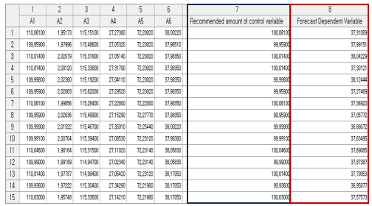

### 3.4.32 RL\_SAC(Soft Actor-Critic)

 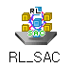

**Soft Actor-Critic (SAC)** is a reinforcement learning algorithm that promotes action diversity by incorporating entropy into the value function.

#### Overview

**Soft Actor-Critic (SAC)** is a reinforcement learning algorithm that addresses the issue of biased action selection in traditional Actor-Critic methods. In traditional Actor-Critic, as the training progresses, actions tend to become biased toward certain choices. To prevent this, SAC incorporates entropy into the value function, encouraging more diverse action selection throughout training.

#### Applications

An Environmental Model is needed. Independent and dependent variable used in Environmental Model are required. Independent variable can be either continuous or discrete. Dependent variable is not used in RL\_SAC.

#### Usage

Read data using Input Node. Connect Input Node to RL\_SAC Node and select the options. Connect RL\_SAC Node to Display Node. An example of RL\_SAC stream is as follows.

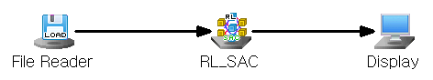

#### Node Properties

|  |  |  |  |  |
| --- | --- | --- | --- | --- |
| Property group | Property Name | Description | Misc. | Note |
| Model File | Save Model File | Decide whether to save model file. | Required | Yes, No |
| Model File Path | Set the path for the model file to be saved. | Conditionally Required |  |
| Selection options | Model Setting | Select the gms file to load as an environment model. | Required |  |
| Actor Policy | Specify policy for the actor neural network. | Required | Gaussian  Deterministic |
| Actor Learning Rate | Specify the learning rate for the Actor neural network. | Required | Real number |
| Critic Learning Rate | Specify the learning rate for the Critic neural network. | Required | Real number |
| Discount Rate(gamma) | Set the discount rate(gamma) for the future reward. | Required | 0<real number<1 |
| Max Replay Memory Size | Specify the maximum number of samples to be stored in replay memory. | Required | Integer |
| Batch Size | Specify the number of sample batches to extract from memory for training. | Required | Integer |
| Target Neural Network Update | Specify the interval of episodes for updating the target neural network. | Required | Integer |
| Max Episodes | Specify the maximum number of episodes to learn. | Required | Integer |
| Max Steps | Specify the number of maximum steps in an episode. | Required | Integer |
| Target Tolerance | Specify the allowable error margin for the target value when defining the environmental reward. | Required | Integer |
| Batch Normalization | Decide whether to use batch normalization. | Required | Yes, No |
| Set control, target Variable | Specify control and target variables. | Required, Button |  |
| Output Layer Activation Function | Specifies the Activation Function of the output layer. | Required |  |
| Hidden Layer Configuration | Add hidden layer | Add hidden layer. | Optional |  |
| Remove Last Hidden Layer | Remove the last hidden layer | Optional |  |
| Hidden Layer # | Number of nodes | Specify the number of nodes for each specified hidden layer | Required | Integer |
| Activation Function | Select the activation function for the specified hidden layer. | Required |  |

#### Results

The analysis Results are displayed by connecting the modeling node to the Display Node. New columns are added to the original data table: **“Recommended amount of control variable”** and **“Forecast Dependent Variable”**. These represent the model's predicted outputs, with the "Forecast Dependent Variable" column containing the predicted values for the target variable.

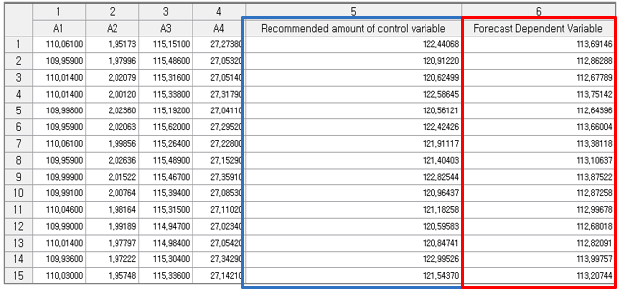

### 3.4.33 ScoreCard

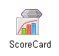

**Scorecard** is a modeling method that uses the logistic regression algorithm to calculate the impact of independent variables on the dependent variable (Discrete Type) in the form of a score. This modeling method allows to easily understand the influence of independent variables. It is commonly used in the financial sector for evaluating customer credit scores.

#### Overview

Scorecard uses the methodology of logistic regression analysis. In order to perform the scorecard function, it is necessary to first divide variables into bins using a binning node. With these binned variables, you can create a scorecard using the Scorecard node.

#### Applications

ECL file which set dependent variable is required in order to use Binning Node. The dependent variable must be discrete and has two classes. Scorecard algorithm can only accept discrete variables.

#### Usage

Read data using Input Node. Change the type of data to discrete variable and set dependent and independent variables by using Type Change Node. Use Binning Node to create interval variables with independents. Use Column Filter Node to exclude variables other than interval variables and dependent variable. Create a Scorecard using ScoreCard Node.

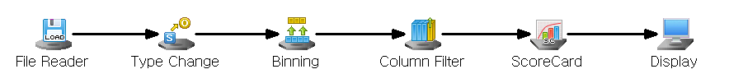

#### Node Properties

|  |  |  |  |  |
| --- | --- | --- | --- | --- |
| Property group | Property Name | Description | Misc. | Note |
| Model File | Save Model File | Decide whether to save model file. | Required | Yes, No |
| Model File Path | Set the path for the model file to be saved. | Conditionally Required |  |
| Selection options | Maximum Run Count | Determine the maximum number of iterations when maximum likelihood Estimate for logistic regression analysis. | Required |  |
| Maximum Value | Set the Maximum Value of Score. | Required |  |
| Minimum Value | Set the Minimum Value of the Score. | Required |  |

#### Results

The analysis Results are displayed by connecting the modeling node to the Display Node. A new column named **“SC\_YHAT”** is added to the original data table that represents the predicted value of the model. In addition to the “**SCORE”, “POS”, “PROB”** columns.

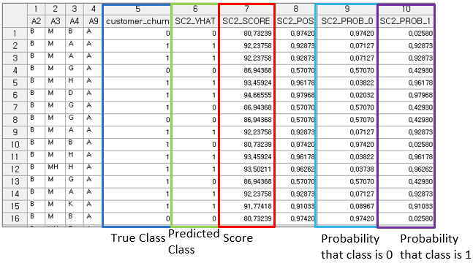

#### Modeling Result

Click Modeling Result button in Node Property of the diamond Model node or double click the Model node to view the Results. Various results can be viewed by clicking the different tabs at the bottom of the window.

In ECMiner™, classification model results include several key statistical outputs for evaluating model behavior and variable significance. The **Number of Classes** indicates how many categories exist in the dependent variable, while the **Number of Iterations** shows how many times the algorithm executed during training. The **Y Value** section presents the frequency and ratio of each class in the dependent variable, offering insight into class distribution. The **Logistic Table** provides detailed regression statistics: **Parameter Estimate** refers to the coefficient (Beta) of each input variable, representing its weight in the model. **Standard Error** indicates the uncertainty or variability in the estimated coefficient. **z-value** measures how far a coefficient is from zero in terms of standard deviations, helping determine the significance of the variable. **p-value** reflects the probability that the coefficient is significantly different from zero by chance; a lower p-value (typically < 0.05) suggests statistical significance. **Odds Ratio** quantifies the effect of each variable on the classification outcome, with values greater than 1 indicating a positive influence and values less than 1 indicating a negative influence on the predicted class.

**Score Table** provides a clear and interpretable summary of the logistic regression analysis results. It displays the model’s predicted scores for each instance, which reflect the confidence level or likelihood of classification into a specific class—typically the positive class. This table allows users to quickly assess how well the model distinguishes between classes, evaluate the distribution of predicted scores, and identify cutoff thresholds for decision-making. It is especially useful for validating classification performance and supporting business or operational decisions based on model output.

Confusion Matrix: Applicable only for classification. A **confusion matrix** is a table used to evaluate the performance of a classification model by comparing its **predicted class labels** to the **actual class labels**. According to the confusion matrix table the **total number of misclassifications** is calculated as well as the **misclassification rate**. The **misclassification rate** reflects the proportion of incorrect predictions made by the model. Overall, the confusion matrix not only quantifies prediction outcomes but also helps identify specific types of errors, offering valuable insight for **model evaluation and improvement**. This result is displayed in a table format under the **Model Info tab.**

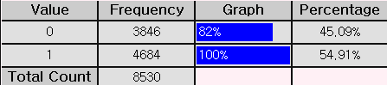

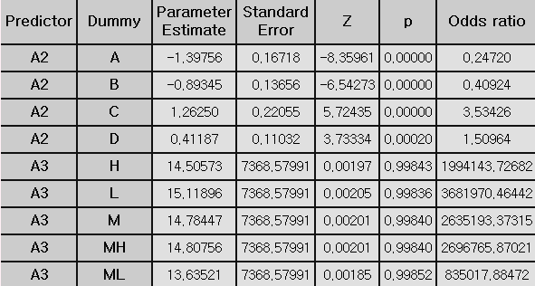

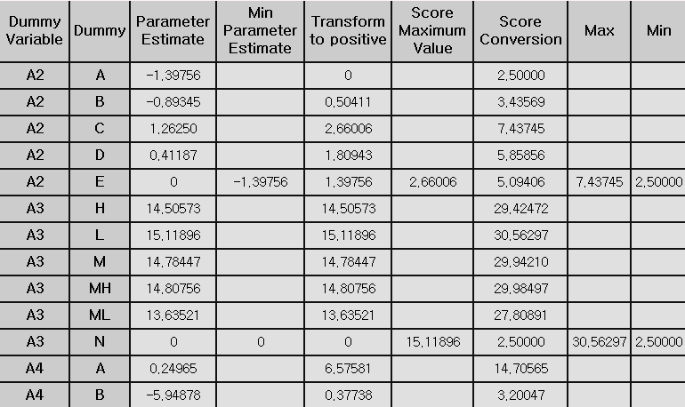

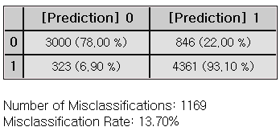

#### Example File

Run the ScoreCard.ecm

### 3.4.34 Sequential AR

|  |  |
| --- | --- |
|  |  |

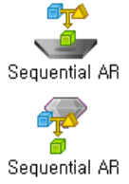

**Sequential AR** is a technique used to discover relationships between products or services over time and find meaningful rules from them.

#### Overview

**Sequential Association Rules (Sequential AR)** extend the capabilities of traditional Association Rules (AR) by incorporating the temporal order of events. Like AR, it is an exploratory data analysis method used to identify meaningful correlations or relationships within a dataset. However, Sequential AR focuses specifically on patterns that occur in sequence, making it particularly useful for analyzing behaviors or events regarding time.

#### Applications

Both continuous and discrete data type is allowed. Variables must consist of only three variables in the following order: customer ID (CID), time (TID), and product (ITEMID). An example of the data file is shown below.

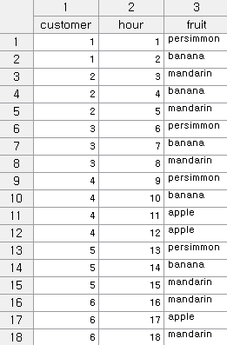

#### Usage

Read data using Input Node. Connect Input Node to Sequential AR Node select the options. Connect Sequential AR Node to Display Node. An example of Sequential AR stream is as follows.

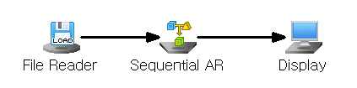

#### Node Properties

|  |  |  |  |  |
| --- | --- | --- | --- | --- |
| Property group | Property Name | Description | Misc. | Note |
| Model File | Save Model File | Decide whether to save model file. | Required | Yes, No |
| Model File Path | Set the path for the model file to be saved. | Conditionally Required |  |
| Selection options | Min Support | Set the minimum support value  (default value is 0.5) | Required | Natural Number |
| Max Itemsize | Maximum itemset size  The algorithm will generate itemsets of all possible lengths (starting from 1 itemset up to the maximum possible length) | Required | >1 |
| Min Confidence | Minimum confidence value  (default value is 0.5) | Required | 0-1 |

#### Modeling Result

Click Modeling Result button in Node Property of the diamond Model node or double click the Model node to view the Results. Various results can be viewed by clicking the different tabs at the bottom of the window.



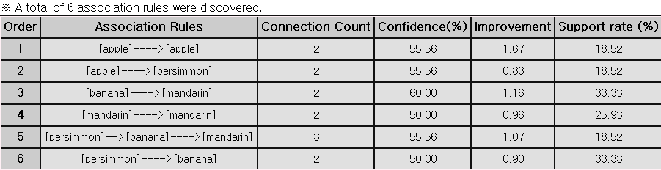

In ECMiner™, Association Rule Analysis identifies relationships between items in transaction data. A rule in the form [A → B] means “If product A is purchased, product B is also likely to be purchased.” The Connection Count refers to the number of transactions that contain both A and B. Confidence (%) represents the probability that item B is purchased when item A is purchased, calculated as the proportion of transactions containing both A and B divided by the number of transactions containing A. Improvement (Lift) measures how much more likely B is purchased when A is purchased compared to B being purchased randomly; a Lift greater than 1 indicates a meaningful relationship. Support Rate (%) is the proportion of total transactions that include both A and B, showing the overall frequency of the item pair. Guide: For association rules to be considered significant, the Support must meet a minimum threshold to ensure the rule is not based on rare occurrences, and the Lift should be greater than 1 to confirm the association provides useful insight beyond chance.

#### Example File

Run the “**AR.ecm**“

### 3.4.35 SimpleRNN

|  |  |
| --- | --- |
|  |  |

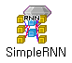 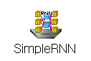

**RNN (Recurrent Neural Network)** is a neural network designed for sequential data, like time series, by using previous steps to inform the current step.

#### Overview

SimpleRNN is a type of recurrent neural network, which is an artificial neural network with two or more hidden layers. While the original form of this recurrent neural network is DeepRNN, SimpleRNN features a simpler structure with up to three hidden layers. Each hidden layer includes a context layer, which helps the network remember previous states. The context layer has the same number of nodes as the hidden layer and retains the state values of the hidden layer through the recurrent feedback. To generate predictions for each time step, SimpleRNN calculates the influence of independence at the previous time points and uses it for prediction. This makes it a supervised neural network, suitable for a variety of applications.

#### Applications

Both independent and target variables must be continuous. Since the target is continuous, it is a predictive model. The activation function is fixed to the identity function. SimpleRNN supports up to 3 hidden layers. SimpleRNN allows setting the number of nodes for each hidden layer.

#### Usage

Read data using Input Node. Specify the type of data using Type Change Node. (independent, or target) Connect Type Change Node to SimpleRNN Node and select the options. Connect SimpleRNN Node to Display Node. An example of SimpleRNN stream is shown below.

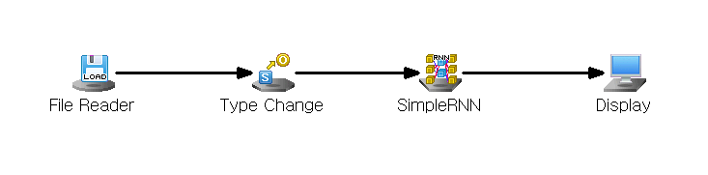

#### Node Properties

|  |  |  |  |  |
| --- | --- | --- | --- | --- |
| Property group | Property Name | Description | Misc. | Note |
| Model File | Save Model File | Decide whether to save model file. | Required | Yes, No |
| Model File Path | Set the path for the model file to be saved. | Conditionally Required |  |
| Selection options | Number of hidden layers | Enter the number of hidden layers. | Required | Integer ≤ 3 |
| Number of Nodes of hidden layers #1 | Enter the number of nodes in the first hidden layer. | Required | Integer ≤ 100 |
| Number of Nodes of hidden layers #2 | Enter the number of nodes in the second hidden layer. | Conditionally Required | Integer ≤ 100 |
| Number of Nodes of hidden layers #3 | Enter the number of nodes in the third hidden layer. | Conditionally Required | Integer ≤ 100 |
| Hidden Layer Activation Function | Specifies the activation function of the hidden layer. | Required | ReLU, Tanh, Sigmoid |
| Weighting Initialization Specification | Set the initial weight setting method for the neural network. | Required | Xavier, He, Custom |
| Weighting Initialization Standard Deviation | Set the standard deviation of the initial weight values of the neural network. | Conditionally Required | 0.001≤real number≤100 |
| Number of Epochs | Specifies the maximum Number of Epochs for algorithm execution. | Required | natural number |
| Target Error | Specifies the maximum allowable target error for training. | Required | 0≤real number |
| Optimization Technique | Select Optimization Technique. | Required | SGD with Momentum, RMSProp, ADAM |
| Learning Rate | When calculating the weight for the gradient direction during learning, enter the size of the degree of reflection of the direction from the previous step. | Required | 0≤real number≤1 |
| Momentum | In Gradient descent with momentum Optimization Technique, we set the degree to which the weight reflects the existing direction of movement. | Conditionally Required | 0≤real number≤1 |
| Beta1 | In ADAM Optimization Technique, sets the degree to which the weight reflects the existing direction of movement. | Conditionally Required | 0≤real number≤1 |
| Beta2 | Sets the rate at which ADAM Optimization Technique remembers previously updated weights. | Conditionally Required | 0≤real number≤1 |
| Gamma | Sets the rate at which previously updated weights are remembered in the RMSProp Optimization Technique. | Conditionally Required | 0≤real number≤1 |
| Batch Size | Specifies the Batch Size to be used when performing the BPTT algorithm for learning. | Required | Integer ≤ 200 |
| Batch-Wise Method for Setting Initial Hidden Layer Value | Select how to set the initial state of the hidden layer for each batch. | Required | Stateful, Stateless |
| Batch-Wise Initial Hidden Layer Value | If you select Stateless as the method for setting the initial state of the hidden layer, enter the initial state setting value of the hidden layer for each batch. | Conditionally Required | 0≤real number≤1 |
| Dropout | If you select Stateless as the method for setting the initial state of the hidden layer, enter the initial state setting value of the hidden layer for each batch. | Required | Use, Not use |
| Dropout Proportion | If you want to use Dropout, set the ratio to apply it. | Conditionally Required | 0≤real number≤1 |
| Learning Log | Sets the iteration frequency for displaying learning logs. |  |  |

#### Results

The analysis Results are displayed by connecting the modeling node to the Display Node. A new column named **“YHAT”** is added to the original data table that represents the predicted value of the model. In addition to the **“Residual”** column.



#### Graphic result

In ECMiner™, graphical evaluation results of a model can be accessed by clicking **Graphic Result** in the **Node Property** of the model node or through the **Modeling Result** section. The **RMSE Plot** shows how the error rate changes over training iterations, helping to monitor the learning progress of the model. The **Compare Plot** visualizes the distribution of actual versus predicted values, allowing users to assess how accurately the model replicates real outcomes. The **Residual Plot** displays the differences between actual and predicted values, helping identify any systematic errors or biases in the model’s predictions. These visual tools collectively support a more intuitive understanding of model performance.

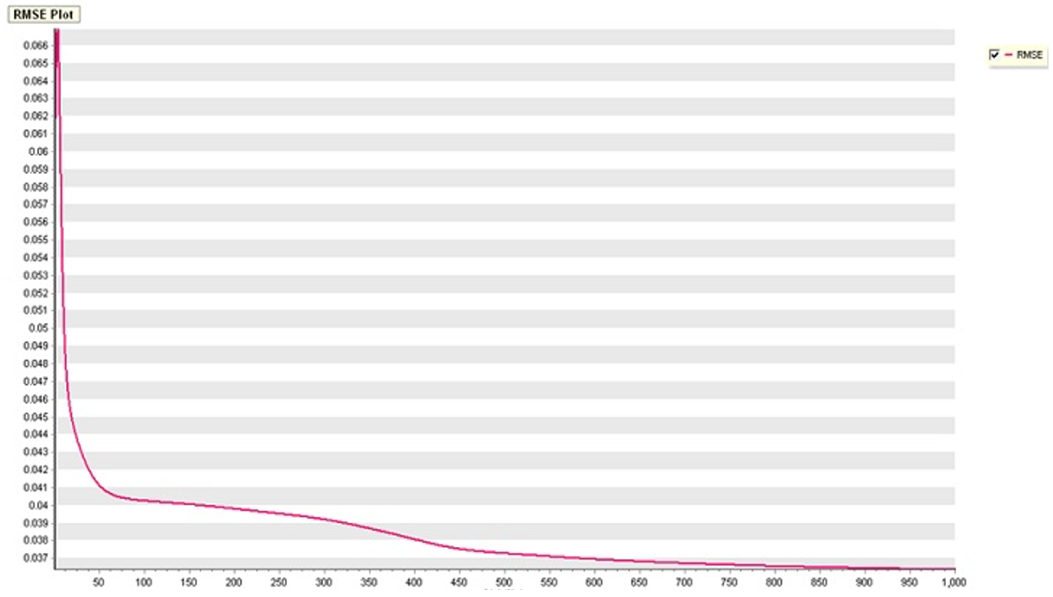

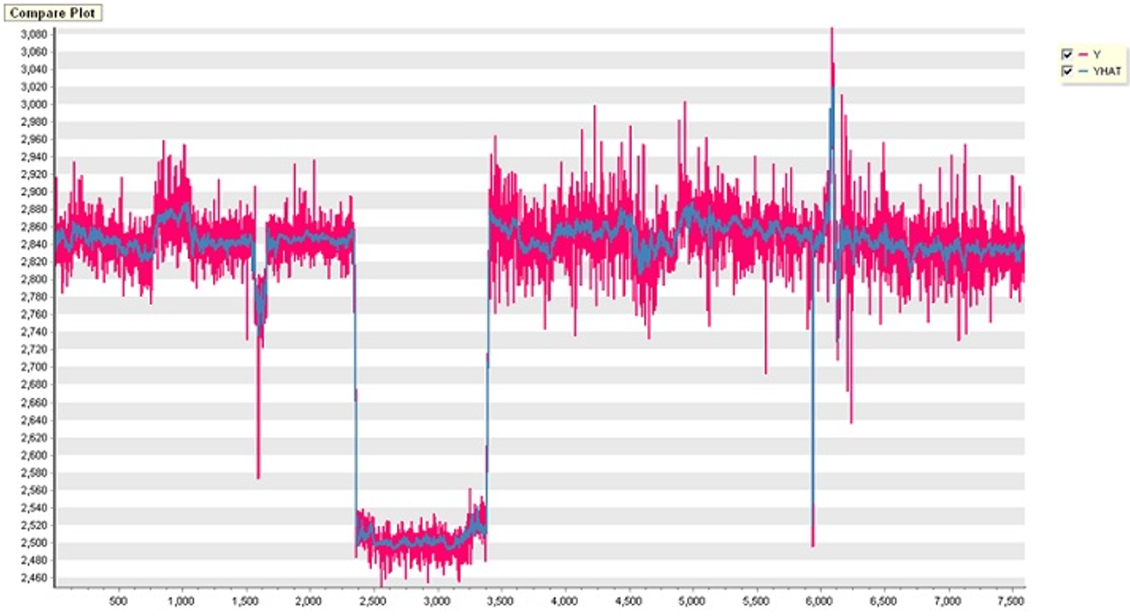

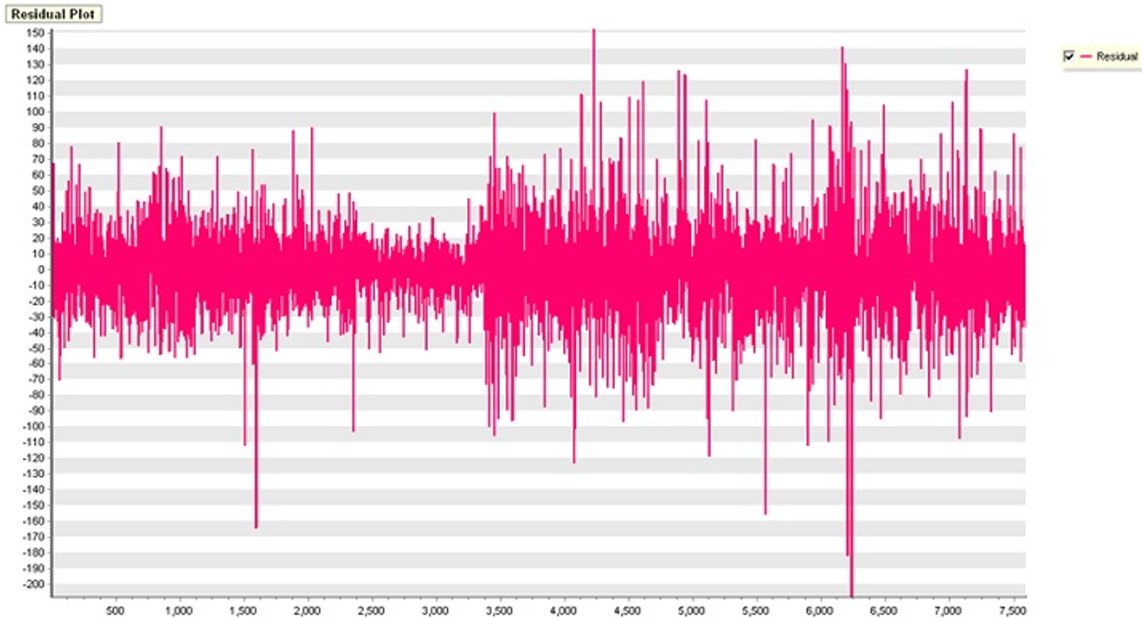

#### Modeling Result

Click Modeling Result button in Node Property of the diamond Model node or double click the Model node to view the Results. Various results can be viewed by clicking the different tabs at the bottom of the window.

ANOVA TABLE: The ANOVA (Analysis of Variance) table is used in regression analysis to evaluate whether the regression model explains a significant portion of the variance in the dependent variable. It breaks down the total variability of the dependent variable into components attributable to the regression model (explained variance) and to residual error (unexplained variance). The F-statistic tests the null hypothesis that all regression coefficients are equal to zero (i.e., the model has no explanatory power). A low p-value (typically < 0.05) indicates that the model as a whole is statistically significant, meaning at least one predictor variable is useful in explaining variation in the response variable. If the p-value is high, the model is not statistically significant, and interpretation of individual regression coefficients may not be meaningful. The total result of the anova table is displayed in a table format under the Model Info tab.

Standard Error Information: This applies only to regression analysis and indicates the fitting and predictive power of the model. It displays four key evaluation metrics – R-squared, Adjusted R2, RMSE, MAE, and MAPE – which represent the error between the original value and the predicted value of the dependent variable. R-square (coefficient of determination): It is a value that checks whether the derived regression equation is representative of the measured values. Adjust R2: It adjusts the r-squared value by considering the degree of freedom of the model. RMSE (Root-Mean Square Error): The square root of the average squared differences between the predicted values and the dependent variable. MAE (Mean Absolute Error): The average of the absolute differences between the predicted values and the dependent variable. MAPE (Mean Absolute Percentage Error): The average of the absolute differences between the predicted values and the dependent variable as a percentage. $MAPE= \frac{\sum_{i=1}^{n}{\left|{(y}_{i}- \hat{y_{i}}\right)/y_{i}|}}{n}×100$



### 3.4.36 SOM

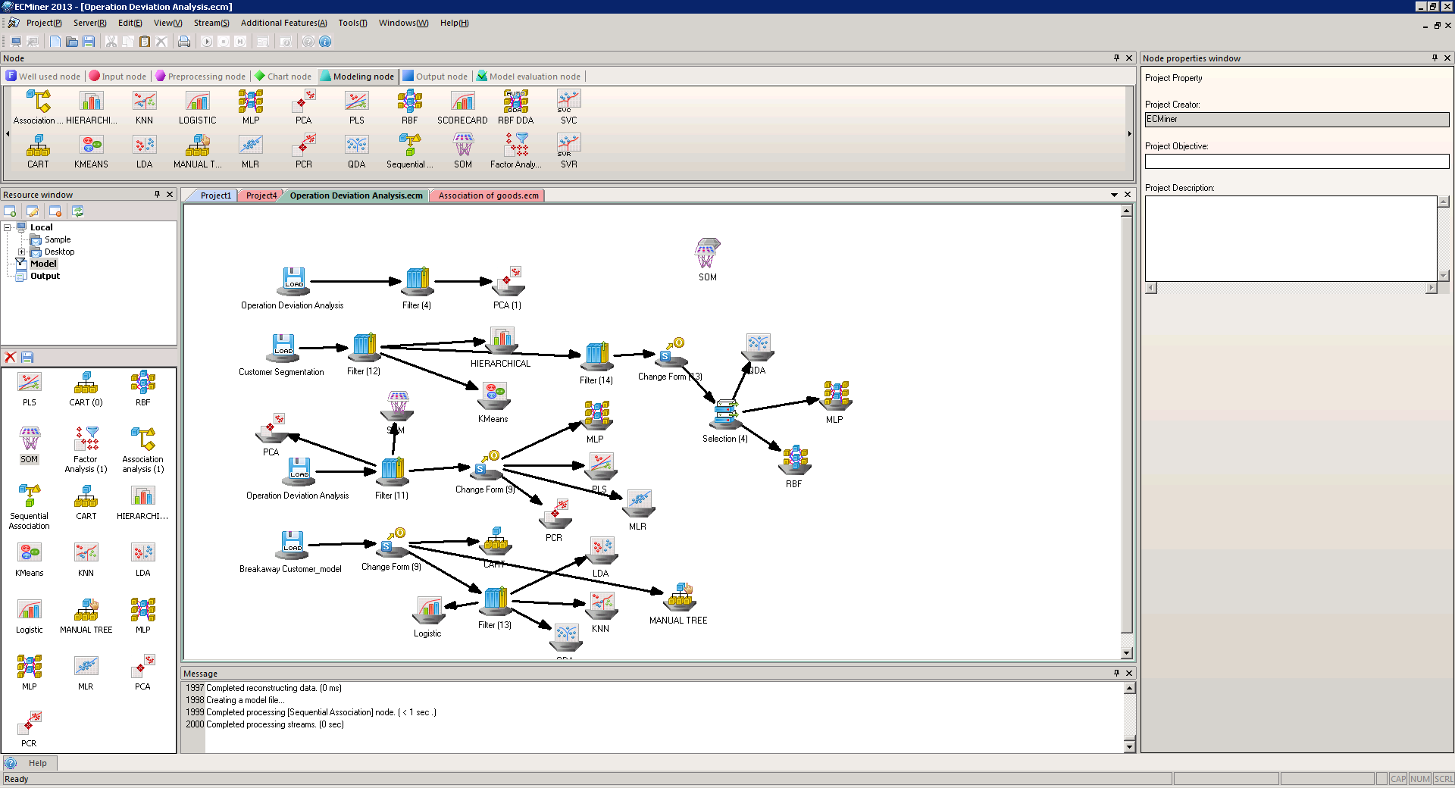 

**Self-Organizing Map (SOM)** is aneural network algorithm inspired by the structure of the human cerebral cortex, where different regions perform specific functions. SOMs allow high-dimensional data to be visualized and interpreted in lower-dimensional spaces.

#### Overview

**A Self Organizing Map (SOM)**, also known as a Self-Organizing Feature Map, is a type of neural network inspired by how the visual cortex in the brain works. It’s an unsupervised learning method used for clustering data and visualizing it by reducing dimensions. SOMs learn by themselves and generate low-dimensional (usually two-dimensional) maps. These maps provide a simplified version of the input data while trying to maintain the structure and relationships found in the original high-dimensional space. SOMs are great for converting complex, high-dimensional data into simpler, more visual forms. SOM operates in two phases: training and mapping. Training involves creating the map using input data, which is done through competitive process called vector quantization. Mapping is when new data is automatically categorized based on the training results.

#### Applications

Only independent variables. Variables must be continuous. SOM node includes a standardized pre-processing procedure.

#### Usage

Read data using Input Node. Connect Input Node to SOM Node and select the options. Connect SOM Node to Display Node. An example of SOM stream is shown below.

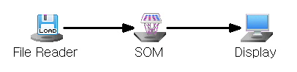

#### Node Properties

|  |  |  |  |  |
| --- | --- | --- | --- | --- |
| Property group | Property Name | Description | Misc. | Note |
| Model File | Save Model File | Decide whether to save model file. | Required | Yes, No |
| Model File Path | Set the path for the model file to be saved. | Conditionally Required |  |
| Selection options | Number of Horizontal Grid Points | Enter the number of horizontal grids in the topology. | Required | Natural Number |
| Number of Vertical Grid Points | Enter the number of vertical grids in the topology. | Required | Natural Number |
| Maximum Iteration Count | Enter the maximum number of iterations for the algorithm. | Required |  |
| Topology Selection | There are two topologies available: Choose a topology between Hexagonal and Grid. | Required | Grid, Hexagonal |
| Initial Learning Rate | As the algorithm repeats, the Learning Rate continues to decrease. Enter the learning rate value used when training starts. | Required |  |
| Initial Neighbor Radus | As the algorithm iterates, the value of the neighborhood radius becomes continuously smaller. Be sure to enter a value for the neighborhood radius that Training will use when it starts. | Required |  |

#### Results

The analysis Results are displayed by connecting the modeling node to the Display Node. A new column named **“SOMYHAT”** is added to the original data table that represents the predicted value of the model.

**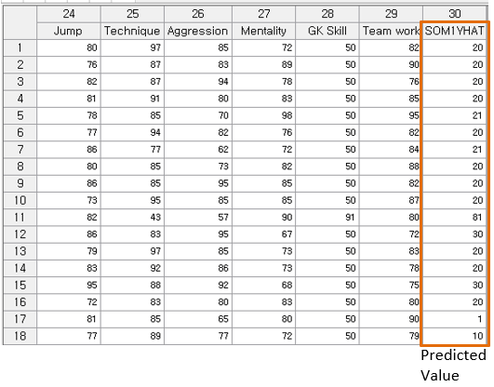**

#### Graphic Result

In ECMiner™, clicking the **Graphic Result** button in the **Node Property** of a model node or accessing the **Modeling Result** section allows users to view various charts related to Self-Organizing Maps (SOM). The **SOM Weight Position Chart** visualizes the spatial arrangement of weight vectors and their connections. The **SOM Topology Structure Chart** shows the structure of the SOM topology, such as a hexagonal layout. The **SOM Hit Chart** indicates how many data points are mapped to each node in the topology, revealing the density of data distribution. The **SOM Weight Plane Chart** displays the value of each weight component across the map, where lighter colors represent higher values and darker colors represent lower values; for example, in ECMiner™, if a component’s value is greater than 0, it appears yellowish, and if it is less than 0, it appears black. Lastly, the **SOM Statistics** section presents the specific component values of the weight vectors as placed on the topology grid, along with their respective grid positions indicated by **SOM\_YHAT**.

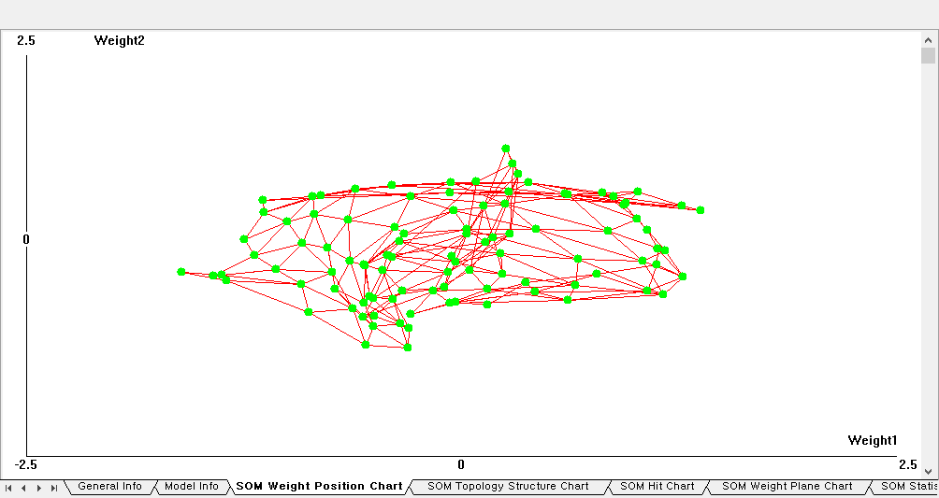

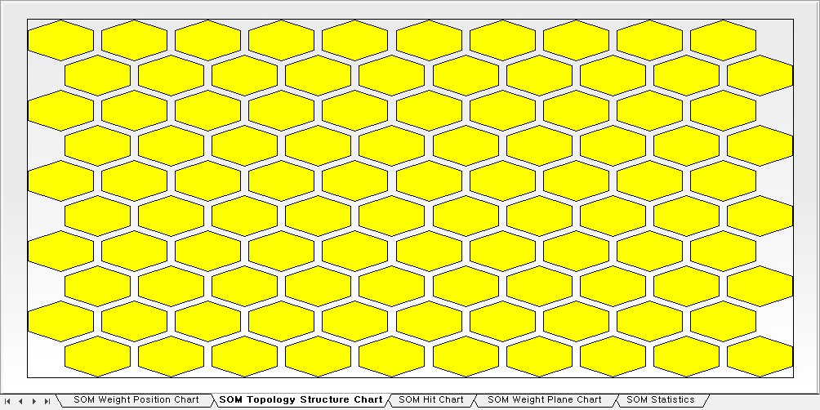

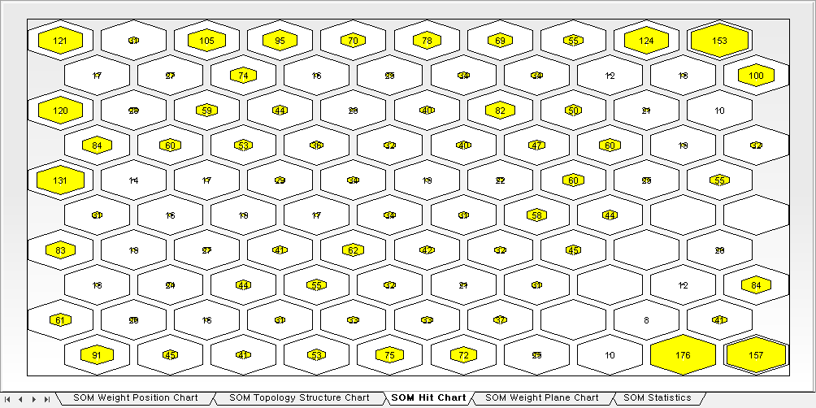

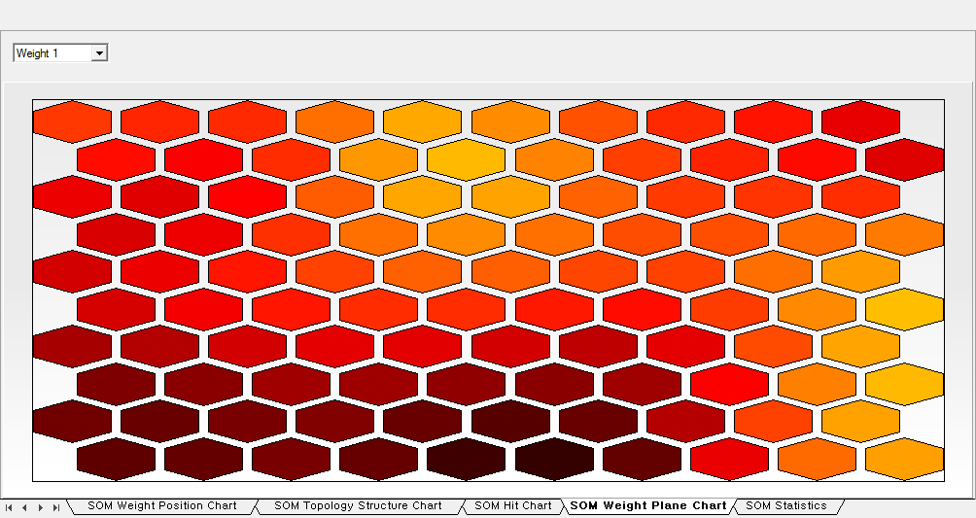

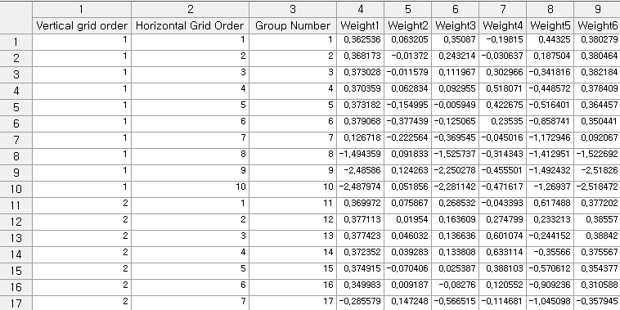

#### Example File

Run SOM.ecm

### 3.4.37 SVC

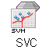 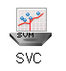

**Support Vector Classification (SVC)** is based on the Support Vector Machine theory that classifies data with multiple attributes or variables into one of the predetermined classes or categories.

#### Overview

SVC (Support Vector Classification) is a supervised machine learning algorithm designed to find the optimal hyperplane that maximizes the margin between classes for classification tasks. When the data is not linearly separable, SVC applies a **kernel function** to transform the input data into a higher-dimensional space where a clear separation becomes possible. The available kernel types include **LINEAR**, **POLY**, **RBF**, and **SIGMOID**, which can be selected using the *Kernel Type* option. The **LINEAR** kernel is used for linearly separable data and requires no additional settings. The **POLY** (polynomial) kernel involves a *Degree* parameter (default = 3) that controls complexity, and optionally, *Gamma* (a scaling factor) and *Coef0* (a constant term). The **RBF** (Radial Basis Function) kernel is a non-linear Gaussian kernel that uses *Gamma* to define the width of the Gaussian curve. The **SIGMOID** kernel, similar to a neural network activation function, uses *Gamma* and *Coef0* to shift and scale the decision boundary. SVC also includes a **regularization parameter C**, which balances maximizing the margin and minimizing classification errors. A smaller *C* yields a wider margin but may allow misclassifications, while a larger *C* aims for perfect training accuracy, with the risk of overfitting. The default value of *C* is 1. The *Degree* parameter is used only with the 'poly' kernel, while *Gamma* applies to the 'rbf', 'poly', and 'sigmoid' kernels. For both the 'poly' and 'sigmoid' kernels, **Coef0** is used to define the constant term in the decision function.

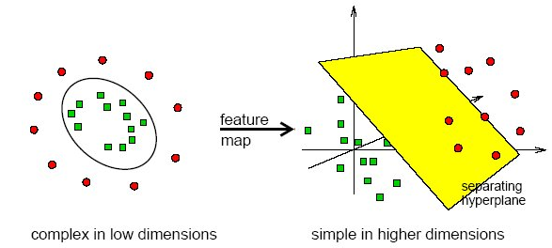

#### Applications

Independent variables must be continuous. Dependent variable must be discrete.

#### Usage

Read the data using Input Node. Specify the type of data using the Type Change Node. Connect Type Change Node to SVC Node and select the options. Connect SVC Node to Display Node. An example of SVC stream is shown below.

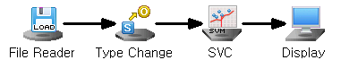

#### Node Properties

|  |  |  |  |  |
| --- | --- | --- | --- | --- |
| Property group | Property Name | Description | Misc. | Note |
| Model File | Save Model File | Decide whether to save model file. | Required | Yes, No |
| Model File Path | Set the path for the model file to be saved. | Conditionally Required |  |
| Selection options | Type | Select the type of SVC algorithm. | Required | SVC(C), SVC(Nu) |
| Kernel Type | Select the kernel function. | Required | LINEAR, POLY, RBF, SIGMOID |
| Degree | Set the degree of the polynomial kernel if Kernel Type is POLY. Default is 3 | Optional |  |
| Gamma | Set the scaling factor of the kernel if Kernel Type is either POLY, RBF, or SIGMOID. | Optional |  |
| Coef0 | Set the constant term of the kernel if Kernel Type is either POLY or SIGMOID. | Optional |  |
| Nu | Set the Nu value of the SVC(Nu) if Type is SVC(Nu). | Optional | **(**0<Nu≤1) |
| C | The parameter C controls how much you want to avoid misclassifying. Set the C value of the SVC if Type is SVC(C). Default is 1 | Optional |  |
| Optimal Parameter Estimation | Estimate the optimal Nu and C values. | Required | Yes, No |

#### Results

The analysis Results are displayed by connecting the modeling node to the Display Node. A new column named **“SVC\_YHAT”** is added to the original data table that represents the predicted value of the model.

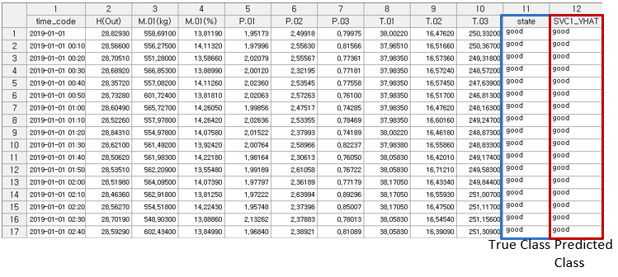

#### Modeling Result

**Click Modeling Result button in Node Property of the diamond Model node or double click the Model node to view the Results. Various results can be viewed by clicking the different tabs at the bottom of the window.** Confusion Matrix: Applicable only for classification. A **confusion matrix** is a table used to evaluate the performance of a classification model by comparing its **predicted class labels** to the **actual class labels**. According to the confusion matrix table the **total number of misclassifications** is calculated as well as the **misclassification rate**. The **misclassification rate** reflects the proportion of incorrect predictions made by the model. Overall, the confusion matrix not only quantifies prediction outcomes but also helps identify specific types of errors, offering valuable insight for **model evaluation and improvement**. This result is displayed in a table format under the **Model Info tab.**

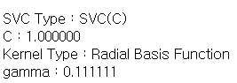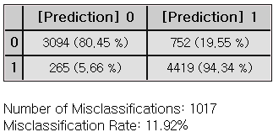

#### Example File

Run the SVC.ecm

### 3.4.38 SVR

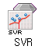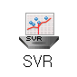

**Support Vector Regression (SVR)** is a regression analysis technique that implies the principles of the SVM algorithms. It is used to determine the degree and the direction of the influence of one are more variables on another variable.

#### Overview

VR(Nu) (ν-Support Vector Regression) and SVR(Epsilon) (ϵ-Support Vector Regression) are two variants of Support Vector Regression used for regression tasks, differing primarily in how they manage the trade-off between model complexity and prediction error. **SVR(Epsilon)** introduces the ε parameter to define a margin of tolerance (the “Epsilon tube”) around the regression function, within which deviations are not penalized. Errors outside this margin incur penalties, and the C parameter serves as a regularization term that balances the trade-off between model complexity and training error. A larger ε allows greater tolerance, whereas a smaller ε forces the model to fit the data more closely. In contrast, **SVR(Nu)** uses the ν parameter, which simultaneously controls the fraction of support vectors and the number of margin violations, offering a more direct mechanism to adjust model complexity and handle outliers. The ν value ranges between 0 and 1, with higher values allowing more flexibility in fitting the data. Both models use the same kernel types available in SVM: **LINEAR**, which requires no additional settings and applies a dot product in input space; **POLY**, which maps input data into a polynomial space and requires tuning of degree, gamma (scaling factor), and coef0 (constant term); **RBF**, a Gaussian kernel requiring the gamma parameter to define the curve’s width; and **SIGMOID**, which resembles neural network activation functions and involves gamma and coef0 to shift and scale the boundary. The choice between SVR(Epsilon) and SVR(Nu) depends on the desired level of control over error tolerance versus model sparsity and flexibility.

#### Applications

Independent variables must be continuous. Dependent variable must be continuous.

#### Usage

Read the data using Input Node. Specify the type of data using the Type Change Node. Connect Type Change Node to SVR Node and select the options. Connect SVR Node to Display Node. An example of SVR stream is as follows.

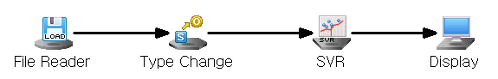

#### Node Properties

|  |  |  |  |  |
| --- | --- | --- | --- | --- |
| Property group | Property Name | Description | Misc. | Note |
| Model File | Save Model File | Decide whether to save model file. | Required | Yes, No |
| Model File Path | Set the path for the model file to be saved. | Conditionally Required |  |
| Selection options | Type | Select the type of SVR algorithm. | Required | SVR(Epsilon)  SVR(NU) |
| Kernel Type | Select the kernel function. | Required | LINEAR, POLY, RBF, SIGMOID |
| Degree | Set the degree of the polynomial kernel if Kernel Type is POLY. | Optional |  |
| Gamma | Set the scaling factor of the kernel if Kernel Type is either POLY, RBF, or SIGMOID. | Optional |  |
| Coef0 | Set the constant term of the kernel if Kernel Type is either POLY or SIGMOID. | Optional |  |
| C | The parameter C controls how much you want to avoid misclassifying. Default is 1 | Optional |  |
| Nu | Set the Nu value of the SVR(Nu) if Type is SVR(Nu). | Optional | (0<Nu≤1) |
|  | Epsilon | Set the Nu value of the SVR(Epsilon) if Type is SVR(Epsilon). Epsilon defines the margin of tolerance where no penalty is given to errors (default = 0.1) | Optional |  |

#### Results

The analysis Results are displayed by connecting the modeling node to the Display Node. A new column named **“SVR\_YHAT”** is added to the original data table that represents the predicted value of the model.

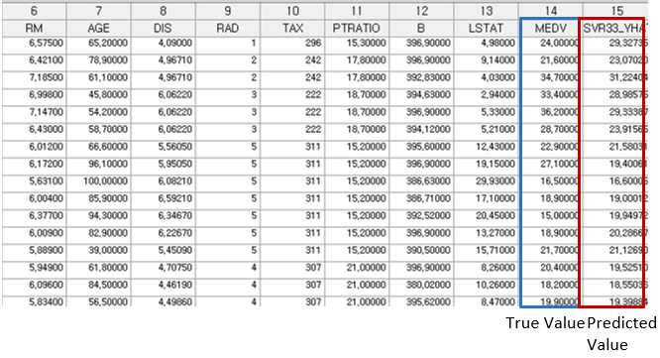

#### Modeling Result

**Click Modeling Result button in Node Property of the diamond Model node or double click the Model node to view the Results. Various results can be viewed by clicking the different tabs at the bottom of the window.**

ANOVA TABLE: The **ANOVA (Analysis of Variance) table** is used in regression analysis to evaluate whether the regression model explains a significant portion of the variance in the dependent variable. It breaks down the total variability of the dependent variable into components attributable to the regression model (explained variance) and to residual error (unexplained variance). The F-statistic tests the null hypothesis that all regression coefficients are equal to zero (i.e., the model has no explanatory power). A low p-value (typically < 0.05) indicates that the model as a whole is statistically significant, meaning at least one predictor variable is useful in explaining variation in the response variable. If the p-value is high, the model is not statistically significant, and interpretation of individual regression coefficients may not be meaningful. The total result of the anova table is displayed in a table format under the **Model Info tab.**

Standard Error Information: This applies only to regression analysis and indicates the fitting and predictive power of the model. It displays four key evaluation metrics – R-squared, Adjusted R2, RMSE, MAE, and MAPE – which represent the error between the original value and the predicted value of the dependent variable. **R-square (coefficient of determination):** It is a value that checks whether the derived regression equation is representative of the measured values. **Adjust R2:** It adjusts the r-squared value by considering the degree of freedom of the model. **RMSE (Root-Mean Square Error):** The square root of the average squared differences between the predicted values and the dependent variable. **MAE (Mean Absolute Error):** The average of the absolute differences between the predicted values and the dependent variable. **MAPE (Mean Absolute Percentage Error):** The average of the absolute differences between the predicted values and the dependent variable as a percentage. $MAPE= \frac{\sum_{i=1}^{n}{\left|{(y}_{i}- \hat{y_{i}}\right)/y_{i}|}}{n}×100$





#### Example File

Run the SVR.ecm

### 3.4.39 t-SNE

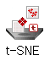

**t-SNE (t-distributed Stochastic Neighbor Embedding)** is a multivariate data analysis technique that visualizes the classification and distribution in low dimensions through non-linear dimensionality reduction. It outperforms traditional linear dimensionality reduction methods, such as PCA and MDS, in visualizing data classification.

#### Overview

**t-SNE (t-distributed Stochastic Neighbor Embedding)** is a non-linear dimensionality reduction technique use for visualizing high-dimensional data in lower dimensions. It helps uncover patterns in the data by preserving the similarity between points as they are reduced to two or three dimensions, which are easier to visualize. t-SNE maintains the relationships between data points more effectively, allowing for better data classification and visualization. Using N observations from independent D individual input matrix, t-SNE maps data points into a lower-dimensional space d (≤ D). The points generated in this process are called map points. Each time the algorithm operates, a random process is involved, such as selecting a reference point from the input data, which can lead to variation in the results even with the same input.

#### Applications

Only independent variables. They must be continuous. t-SNE Node itself includes a standardization preprocessing process.

#### Usage

Read the data using Input Node. Connect Input Node to t-SNE node and select the options. Among t-SNE Node settings, Initial Perplexity must be less than 1/3 of the number of input data (number of input matrix rows). t-SNE Node does not create model files. An example of t-SNE stream is as follows.

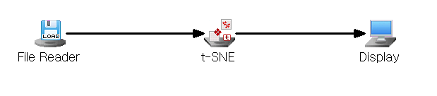

#### Node Properties

|  |  |  |  |  |
| --- | --- | --- | --- | --- |
| Property group | Property Name | Description | Misc. | Note |
| Model File | Save Model File | Decide whether to save model file. | Required | Yes, No |
| Model File Path | Set the path for the model file to be saved. | Conditionally Required |  |
| Selection options | Execution Count | Set the total number of learning iterations. | Required | integer≥0  Default: 1000 |
| Initial Perplexity | Set the initial Perplexity value. | Required | The value should be between 5 and 50. However, it must be less than 1/3 of the number of input data (number of input matrix rows). |
| Learning Rate Constant | Set the Learning Rate Constant value. | Required | The default is 100, and may be adjusted depending on the case. |
| Threshold | Set the precision of calculation. | Required | The closer the threshold value is to 0, the higher the accuracy, but the longer the calculation time. Set to a real value greater than or equal to 0. Default: 0.5 |
| Initial Momentum | Set the initial momentum value. | Required | The Initial Momentum value is used for learning until the Number of Epochs reaches 250.  Default: 0.5. |
| Final Momentum | Set the final momentum value. | Required | The Final Momentum value is used for learning until the Number of Epochs reaches 250.  Default: 0.8 |
| Dimension Reduction | Set the number of lower-dimensional dimensions you want to reduce. | Required | The dimensions that are easiest for visualization are 2D or 3D, so it is usually set to 2 or 3. Default: 2. |

#### Results

The analysis Results are displayed by connecting the modeling node to the Display Node. New columns are added to the original data table that represents the t-SNE result values. Which can be visualized in 2D or 3D using the linked Chart Node. Running the Chart Node with **TSNE\_Y1** on the X-axis and **TSNE\_Y2** on the Y-axis will produce a plot similar to the one shown above**.** As for the differentiation of classes, select **Separate by Series** on **Group Display** option and select the appropriate group variable.

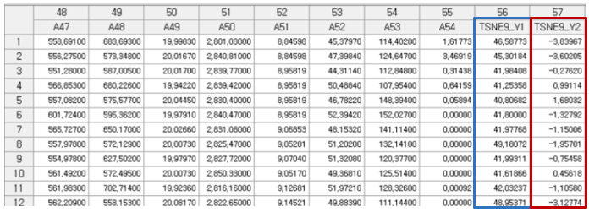

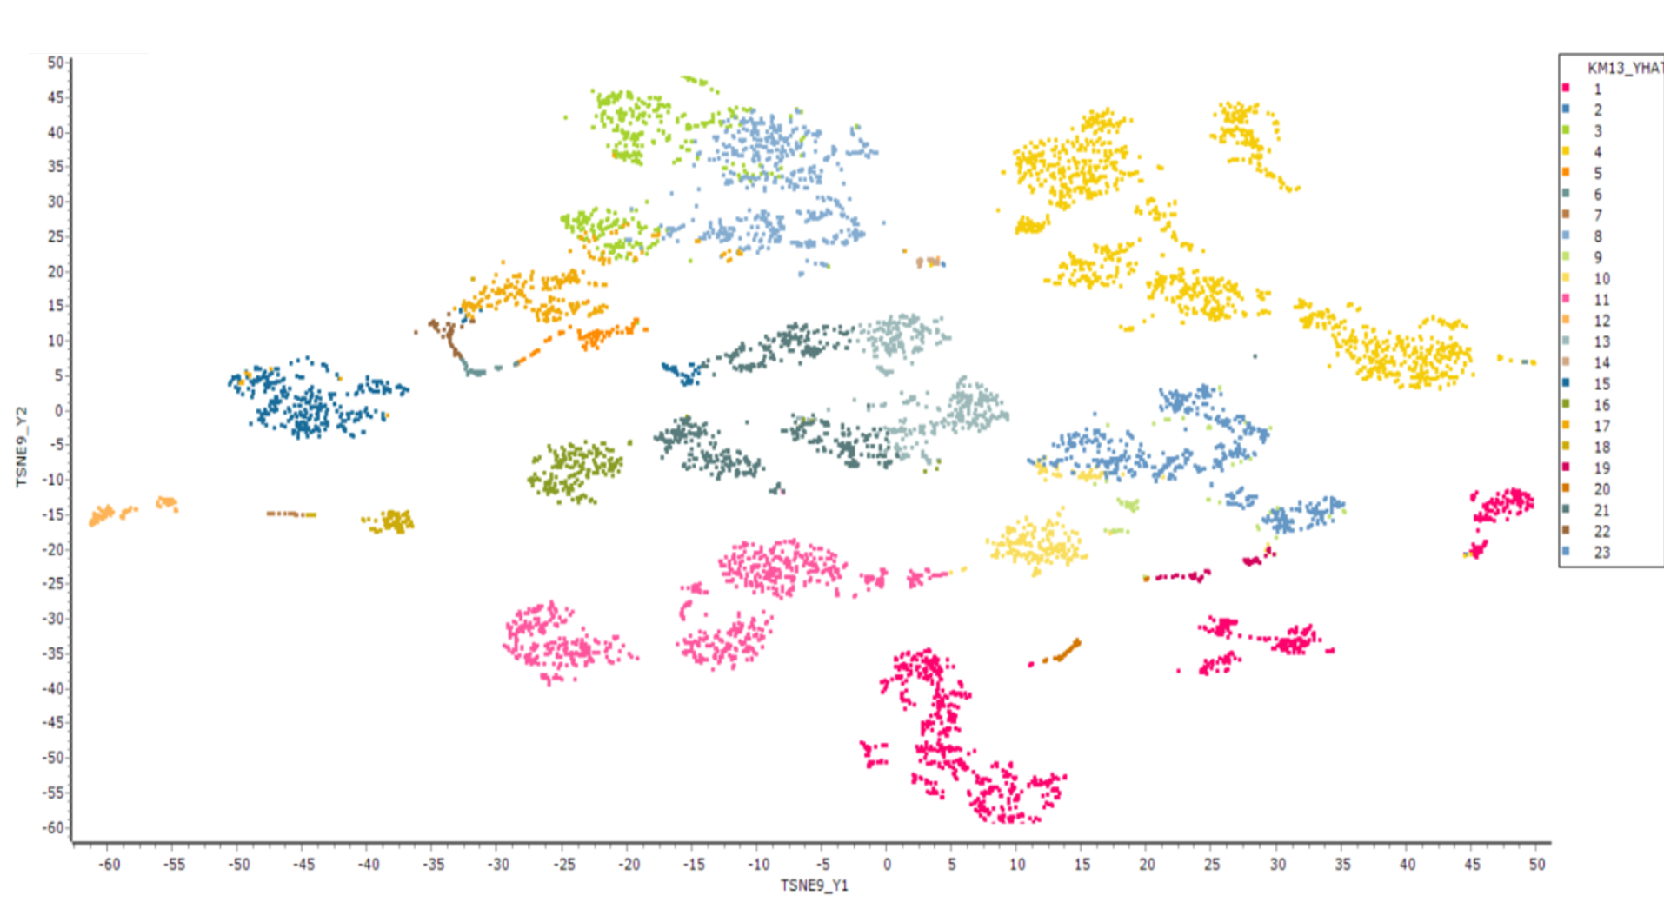

## 3.5 Output Node

**Output** node is a tool used to save the output file, including predicted modeling values, in various database formats.

ECMiner™ provides the following data output nodes:

* [ODBC Writer](#_3.5.1_ODBC_Writer)

Store data in a database using ODBC.

* [OLEDB Writer](#_3.5.2_OLEDB_Writer)

Store data in a database using OLE DB technology. It can manipulate dbases with better performance than ODBC.

* [Result Pivoting](#_3.5.3_Pivot_Node)

Perform pivoting according to the entered information.

* [Oracle DB Writer](#_3.5.4_Oracle_DB_1)

Store data in Oracle database.

* [Statistics](#_3.5.5_Statistics)

Perform statistical analysis of a variable.

* [File Writer](#_3.5.6_File_Writer)

Save data to a file.

* [Display](#_3.5.7_Display)

Display a result on screen.

* [Separate File](#_3.5.8_Separate_File)

Separate and store data.

### 3.5.1 ODBC Writer



ODBC Writer is a node that stores data in a database using ODBC (Open Database Connectivity) technology.

#### Usage

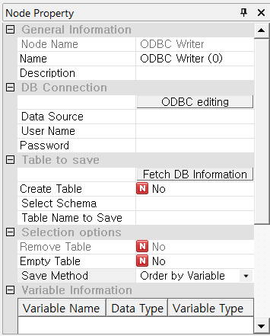

In the ODBC Writer node of ECMiner™, users can connect to a specified database by entering the **Data Source**, **User Name**, and **Password**, and if the target database is not available, a new DSN (Data Source Name) can be added via the system's ODBC configuration. After connection, clicking the **‘Fetch DB Information’** button retrieves metadata from the database, allowing users to select a **schema** and specify the **table name** where data will be saved. If the **‘Create Table’** option is enabled, additional options such as **‘Remove Table’** and **‘Empty Table’** become active, giving users control over whether to overwrite or clear existing data. The **‘Save Method’** defines how the data is ordered during saving, and the lower section displays **Variable Information**, including the name, data type, and variable type of each column. When executed, the node writes the processed data to the designated table in the connected database.

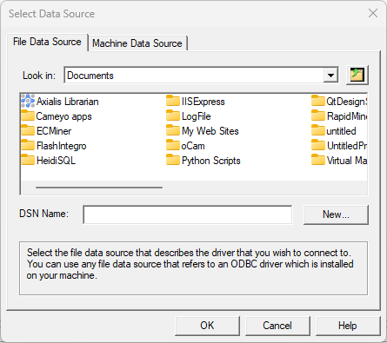

#### Node Properties

|  |  |  |  |  |
| --- | --- | --- | --- | --- |
| Property group | Property Name | Description | Misc. | Note |
| DB Connection | ODBC Editing | Create a new DSN (Data Source Name) to connect ODBC. | button |  |
| Data Source | Select the DSN to use in the list of ODBC DSNs which are registered on a PC. Add the DSN by using ODBC editing if the DSN does not exist. | Required |  |
| User Name | Enter the user’s name to access a database. | Required |  |
| Password | Enter the user password to access a database. | Required |  |
| Table to save | Fetch DB Information | Load the information such as the schema, table and view, etc of a database by using database connection information. | button |  |
| Create Table | Select ‘Yes’ to create a new table. Select ‘No’ to use an existing table. |  | Yes, No |
| Select  Schema | Select the database schema to be listed in table. Supports tables and views. |  | All, Table, View |
| Table Name to Save | Specify the table name to be saved in a DB. |  |  |
| Selection options | Remove  Table | Removes the existing table when ‘Create Table’ option is ‘Yes’. |  |  |
| Empty  Table | Decide whether to delete all data (Yes) from an existing table, or to leave it and save more (No). Activated when ‘Create Table’ is ‘No’. |  |  |
| Save Method | Choose whether to match in order of variables or by name of variables. | Required |  |
| Variable Information | Variable Information | Show the field name and type of the variable to be saved in a DB. |  |  |

### 3.5.2 OLEDB Writer

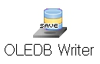

OLEDB Writer is the node that stores data in a database using OLEDB (Object Linking and Embedding, Database) technology. Data is saved correspondingly by directly selecting a table or entering a new table name. OLEDB is recommended when a database supports both ODBC and OLEDB.

#### Usage

In ECMiner™, the OLEDB Writer (or ODBC Writer) node is used to export data to an external database by specifying the connection details and target table. Users must select the appropriate driver and input the **DB server connection information**, including **user name** and **password**. By clicking **‘Fetch DB Information’**, the node retrieves metadata from the database, allowing users to **select a schema** and specify the **table name** where the data will be saved. If the **‘Create Table’** option is set to **Yes**, the system allows enabling **‘Remove Table’** or **‘Empty Table’** to determine whether to delete or clear an existing table before saving new data. It’s important to ensure that **variable types match** existing table structures to avoid errors. Users can also review the variable structure in the lower **Variable Information** panel before saving. If saving to an existing table, but the **‘Remove Table’** option is not activated while **‘Create Table’** is set to **Yes**, a conflict error may occur. Data is written to the specified table upon execution, and the **Save Method** option allows ordering data by variables if desired.

#### Node Properties

|  |  |  |  |  |
| --- | --- | --- | --- | --- |
| Property group | Property Name | Description | Misc. | Note |
| DB Connection | Select the Driver | Select the OLEDB driver to be connected in database. ECMiner™ accesses the database through the selected OLEDB driver. | Required |  |
| DB Server Connection Information | Enter IP address of a database server in SQL server. Enter TNS name in case of Oracle. | Required |  |
| User Name | Enter the user’s name to access a database. | Required |  |
| Password | Enter the user password to access a database. | Required |  |
| Table to save | Fetch DB Information | Load the information about the schema, table and view | button |  |
| Create Table | Select ‘Yes’ to create a new table. Select ‘No’ to use an existing table. | Required | Yes, No |
| Select Schema | Select the database schema to be listed in table. Supports tables and views. |  |  |
| Table Name to Save | Specify the table name to be saved in a DB. | Required |  |
| Selection options | Remove Table | Removes the existing table when ‘Create Table’ option is ‘Yes’. | Required | Yes, No |
| Empty Table | Decide whether to delete all data (Yes) from an existing table, or to leave it and save more (No). Activated when ‘Create Table’ is ‘No’. | Required | Yes, No |
| Save Method | Choose whether to match in order of variables or by name of variables. |  | Order of a variable, Match variable name |
| Variable Information | Variable Information | Show the field name and type of the variable to be saved in a DB. |  | Integer, Real,  Character, Date |

### 3.5.3 Pivot Node



Pivot is a node that shows a data variable as a table by grouping the rows and columns of data

#### Usage

In ECMiner™, the **Pivot node** allows users to restructure and summarize data by grouping and aggregating values. To configure the Pivot operation, click the **‘Configure Pivoting Information’** button in the node property window. In the **Input Pivot Information** dialog, drag and drop variables from the variable list into designated areas to define the pivot logic. Specify **Column Grouping Variables** (e.g., A2) to determine how columns will be formed, and set **Row Grouping Variables** (e.g., churn\_status) to define the rows. Select one or more **Data Variables** (e.g., A1) and assign an aggregation function, such as **Average**, to summarize the data. You can also choose to **Save as File** and specify the **File Path** if you want to export the pivoted result. Once configured, the Pivot node will generate a reshaped dataset where values are aggregated according to the selected row and column groupings, offering a compact and interpretable summary of the original data.

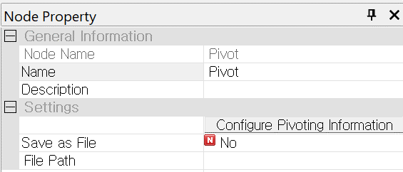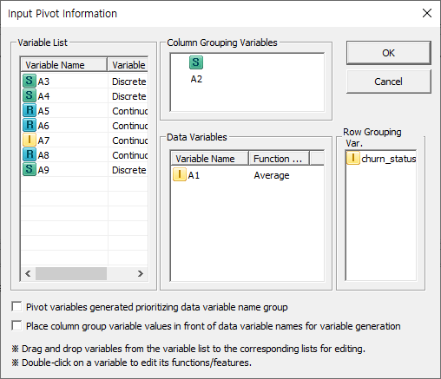

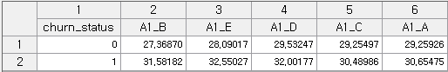

#### Node Properties

|  |  |  |  |  |
| --- | --- | --- | --- | --- |
| Property group | **Property Name** | **Description** | **Misc.** | **Note** |
| Settings | Configure Pivoting Information | Specify row and column grouping variables and data variables. | Required |  |
| Save as File | Choose whether to save data as a file. | Optional | Yes, No |
| File Path | Save a file in specified file path. | Optional |  |

### 3.5.4 Oracle DB Writer



Oracle DB Writer is a node that stores Oracle data in a database.

#### Usage

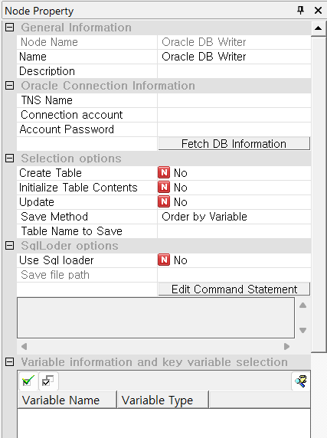

In ECMiner™, the Oracle DB Writer node is used to save data into an Oracle database. To establish the connection, users must enter the TNS Name, Connection Account, and Password under the Oracle Connection Information section. Clicking the ‘Fetch DB Information’ button retrieves schema and table metadata from the connected database. Users can then select the appropriate schema and enter the table name where data will be saved. Activating the ‘Create Table’ option enables the ‘Initialize Table Contents’ and ‘Update’ options, allowing for table creation, clearing, or updating data. The Save Method allows users to choose how data is written, such as "Order by Variable." If desired, the SqlLoader option can be enabled for high-performance data loading, with the associated file path and command editable via the Edit Command Statement button. When the node is executed, the processed data is written to the specified Oracle database table.

#### Node Properties

|  |  |  |  |  |
| --- | --- | --- | --- | --- |
| Property group | **Property Name** | **Description** | **Misc.** | **Note** |
| Oracle Connection Information | TNS Name | Enter TNS name of the Oracle database you connect. | button |  |
| Connection Account | Enter connection account name of a database. | Required |  |
| Account Password | Enter connection account password of a database. | Required |  |
| Selection options | Fetch DB Information | Load the information such as the schema, table and view, etc of a database by using database connection information. The information is showed at the bottom. | button |  |
| Create Table | Select ‘Yes’ to create a new table. Select ‘No’ to use an existing table. |  | Yes, No |
| Initialize Table Contents | Initialize table contents. |  | All, Table, View |
| Update | Update the data matching the selected key variable. |  |  |
| Save Method | Choose whether to match in order of variables or by name of variables. |  |  |
| Table Name to Save | Select the table name to save. |  |  |
| SqlLoader options | Use Sql loader | Decide whether to use Sql Loader. |  |  |
| Save file path | Specify the path of the file to save. |  |  |
| Edit Command Statement | Edit a query statement. |  |  |
| Variable Information | Variable Information | Show the field name and type of the variable to be saved in a DB. |  |  |

### 3.5.5 Statistics

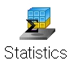

Statistics Node is a node that displays the result of statistical analysis.

#### Usage

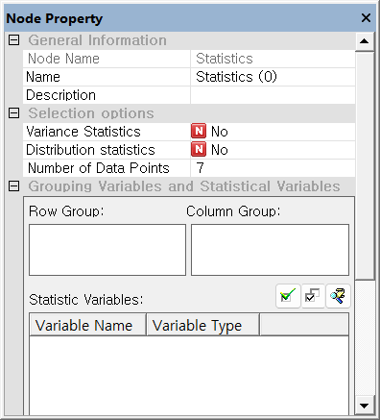

The Statistics Node in ECMiner™ enables users to perform statistical analysis by selecting variables for computation or grouping by rows and columns. In the Node Property interface, users can define Row Group and Column Group variables, and select Statistic Variables for analysis. Options such as Variance Statistics and Distribution Statistics can be toggled on for more detailed output. The toolbar includes buttons to select all variables, invert selections, and apply Variable Conditional Selection, which filters variables based on data type (e.g., Integer, Real, String, Date) or name using wildcards (\*, ?, #, $). To use this node, users first enable the desired statistical measures in the Selection Options, then select variables to analyze and assign grouping variables as needed.

#### Node Properties

|  |  |  |  |  |
| --- | --- | --- | --- | --- |
| Property group | **Property Name** | **Description** | **Misc.** | **Note** |
| Selection options | Variance Statistics | Variance, standard deviation, and kurtosis of a continuous variable. | Required | Yes, No |
| Distribution Statistics | Skewness, median, Q0, Q1, Q2, Q3, Q4 and IQR of a continuous variable. | Required | Yes, No |
| Number of Data Points | Specify how many discrete variables are displayed in a descending order. | Required |  |
| Grouping Variables and Statistical Variables | Row Group | Select a variable for row grouping |  |  |
| Column Group | Select a variable for column grouping |  |  |
| Statistic Variables | Select the variable field for which you want to obtain the result of statistic. |  |  |

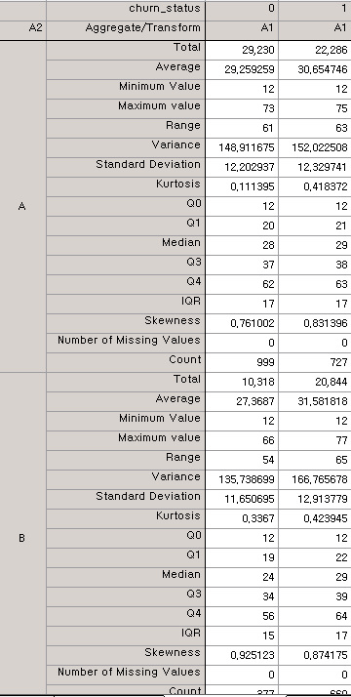

### 3.5.6 File Writer



File Writer is a node that save the result of data analysis.

#### Usage

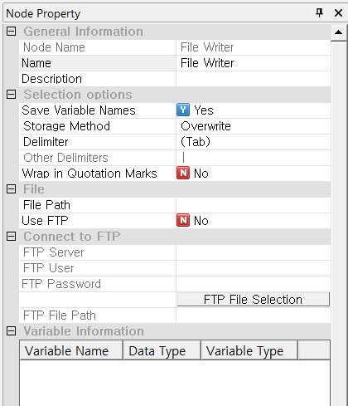

The File Writer node in ECMiner™ is used to save data into a specified file path. Users can choose whether to include variable names in the output by setting the "Save Variable Names" option to 'Yes' or 'No'. The "Storage Method" can be set to 'Overwrite' if the intention is to overwrite existing data. When defining how the data fields are separated, a predefined character delimiter (such as Tab) can be selected under the "Delimiter" field. If the desired delimiter is not listed, it can be entered manually in the "Other Delimiters" field. Additionally, the file can be saved to a local path or via FTP by specifying the server, user, and password if "Use FTP" is enabled.

#### Node Properties

|  |  |  |  |  |
| --- | --- | --- | --- | --- |
| Property group | **Property Name** | **Description** | **Misc.** | **Note** |
| Selection options | Save Variable Names | Select 'Yes' in the 'Save Variable Names' field saves it. Select 'No' creates a variable name automatically. | Optional | Yes, No |
| Storage Method | Select 'overwrite' in the 'Storage Method' will discard existing data and write new data. If an identical file exists, the data will not be saved, and an error will occur. | Optional | Overwrite, Error if same file exists |
| Delimiter | Select the type of delimiter. Supported delimiters are tab, space, bar, comma, semicolon, and colon. To use a different delimiter, select the 'Other' option. | Required | (tab) (Space) (|) (,) (;) (:) (Other) |
| Other Delimiter | Set other delimiters in case the property of a delimiter is (Other). | Required |  |
| Wrap in Quotation Marks | Choose whether to wrap a string in quotation marks on a file. | Required | Yes, No |
| File | File Path | Enter the name and path of a file to save. | Required |  |
| Use FTP | Select whether to save and upload a file into an FTP server. | Required | Yes, No |
| Connect to FTP | FTP Server | Choose an FTP server to use. |  |  |
| FTP User | Enter user ID of FTP. |  |  |
| FTP Password | Enter password of FTP. |  |  |
| FTP File Selection | Select the file of FTP. | Button |  |
| FTP File Path | Enter the path to save a file on an FTP server. |  |  |
| Variable Information | Variable Information | Show the field name of the variable which save in a file. |  |  |

### 3.5.7 Display

|  |  |
| --- | --- |
|  |  |



**Display Node** is a node that displays the results of data analysis in a table on a screen.

#### Usage

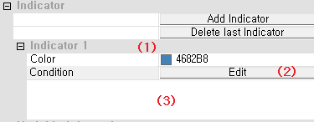

To add indicators for specifying a specific row in ECMiner™, first click the “Add Indicator” button to create the desired number of indicators. Each indicator allows for color customization, which can be done by selecting the indicator and choosing a color from the dialog box. To define the logic for highlighting a row, click the “Edit” button next to the Condition field to open the formula editor and enter the desired condition. You can review or modify the entered condition anytime by returning to the formula editor through the same “Edit” button. This setup helps in visually emphasizing rows that meet specific criteria.

#### Node Properties

|  |  |  |  |  |
| --- | --- | --- | --- | --- |
| Property group | **Property Name** | **Description** | **Misc.** | **Note** |
| Selection options | Create Table | Select 'No' to generate a single output table during execution. Select 'Yes' to generate a new output table for each run. | Optional (Default Value: No) | Yes, No |
| Indicator | Add Indicator | Add a color indicator to distinguish a specific row from other rows. | button |  |
| Delete Last Indicator | Delete a last indicator among the added indicators. | button |  |
| Variable Information | Variable Information | Show the name and type of the variable which shows in a table. |  |  |

### 3.5.8 Separate File

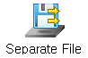

The Separate File node is used to divide and save data based on user-defined purposes. It is particularly useful when handling large volumes of data, as it allows for more manageable processing by separating the dataset into smaller parts. This node is especially efficient when the number of records in each separated file is less than 30 million, enabling smoother and faster data processing operations in ECMiner™.

#### Usage

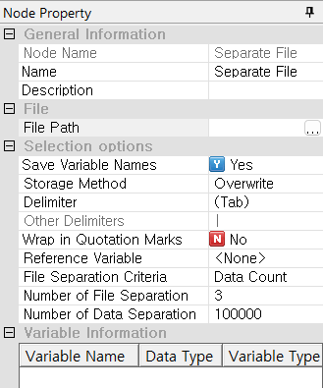

The **Separate File** node allows users to divide and save data efficiently by specifying the file name and path through the **File Path** field. Users can determine whether to include variable names in the output using the **Save Variable Names** option and decide how to handle duplicate file names using the **Storage Method** (e.g., overwrite or raise an error). Delimiters can be set using the **Delimiter** or **Other Delimiters** options, while quotation settings are adjusted via **Wrap in Quotation Marks**. For data separation, users can choose a **File Separation Criteria** (e.g., data count), define a **Reference Variable** if needed, and specify the **Number of File Separations** and **Number of Data Separations**, making it effective for handling large datasets by distributing them into smaller, more manageable files.

#### Node Properties

|  |  |  |  |  |
| --- | --- | --- | --- | --- |
| **Property group** | Property Name | Description | Misc. | Note |
| **File** | File Path | Specify the name and path of a file to save. | Required |  |
| **Selection options** | Save Variable Names | Specify whether to save a variable name. | Optional (Default: Yes) | Yes, No |
| Storage Method | Select 'overwrite' in the 'Storage Method' will discard existing data and write new data. If an identical file exists, the data will not be saved, and an error will occur. | Optional (Default: Overwrite) | Overwrite, Error if a file exists |
| Delimiter | Select the type of delimiter. Supported delimiters are tab, space, bar, comma, semicolon, and colon. To use a different delimiter, select the 'Other' option. | Required | (tab) (Space) (|) (,) (;) (:) (Other) |
| Other Delimiter | Set other delimiters in case the property of a delimiter is (Other). |  |  |
| Wrap in Quotation Marks | Choose whether to wrap a string in quotation marks on a file. | Optional  (Default: No) | Yes, No |
| Reference Variable | Select the variable which is criteria of a file separation. Once the Reference Variable option is defined, refer to <Separated storage method when a reference variable is set> below. | Required | None |
| File Separation Criteria | Specify the criteria for separating a file. Options include the number of data entries, the number of files, or the category of the reference variable. | Required | Data Count, Number of Files, Reference Variable by Category |
| Number of File Separation | Select this option if file separation is based on the number of files. | Conditionally Required |  |
| Number of Data Separation | Select this option if file separation criteria is based on the number of data entries. | Conditionally Required |  |
| **Variable Information** | Variable Information | Show the name and type of the variable which is displayed in a table. |  |  |
| <Separated storage method when a reference variable is set>   * If file separation criteria is based on the number of data entries.   For example, the option for the number of data entries to separate takes precedence over a reference variable. If the separation number is set to 10 and the reference variable is set to 'A', data are initially separated based on 10 entries. The 10th and 11th values of variable 'A' are then compared:  A. If the values are identical, they are combined to form a set of 11 data entries.  B. If the values differ, the 10 data entries are saved separately.  After saving, the next group of 10 data entries is separated and processed in the same manner. This process continues, dividing a large data file into multiple smaller files.   * If file separation criteria is based on the number of files.   When setting the number of files, the data separation number must be internally defined to divide the entire dataset. The dataset is divided based on the specified number of files.  Example: If 100 rows of data are separated into 6 files, the separation number is 17. | | | | |

## 3.6 Model Evaluation Node

The **Model Evaluation Nodes** in ECMiner™ are designed to compare and assess the performance of various models. These nodes include the **ROC Chart** node, which visualizes the ROC curves for each model to evaluate classification performance; the **Model Evaluation** node, which generates a comprehensive report comparing key metrics of all models; and the **Profit Chart** node, which illustrates profit-based performance to help determine the most cost-effective model. These tools collectively enable thorough evaluation and informed model selection.

### 3.6.1 ROC Chart

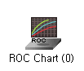

**ROC Chart** draws ROC curves of each model. The specificity and the sensitivity of the classification models are used to create the ROC curves.

In classification analysis, model performance is often evaluated using a confusion matrix, which categorizes predictions as follows: True Positive (TP) and True Negative (TN) represent correct classifications, while False Positive (FP) and False Negative (FN) represent misclassifications. From this matrix, Sensitivity (also called the true positive rate) is calculated as TP / (TP + FN) and indicates how well the model identifies actual positives. Specificity (true negative rate) is calculated as TN / (TN + FP) and reflects how well the model identifies actual negatives. The ROC (Receiver Operating Characteristic) curve visualizes model performance by plotting sensitivity against 1 - specificity across varying classification thresholds (cutoff values from 0 to 1), helping to assess the trade-off between true positives and false positives.

#### Applications

Among the current classification models, only LDA, QDA, and Logistic Regression can be connected with the ROC Chart.

#### Usage - Diagram Example

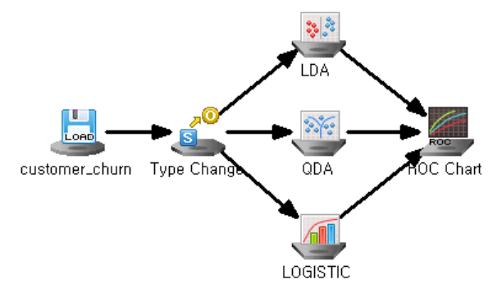

#### Node Properties

|  |  |  |  |  |
| --- | --- | --- | --- | --- |
| Property group | **Property Name** | **Description** | **Misc.** | **Note** |
| Selection options | Target Grade | Enter the number of target grade. | Required | Natural Number |
| Number of Classification Criteria | Enter the number of classification thresholds for the ROC curve. | Required |  |

#### Results

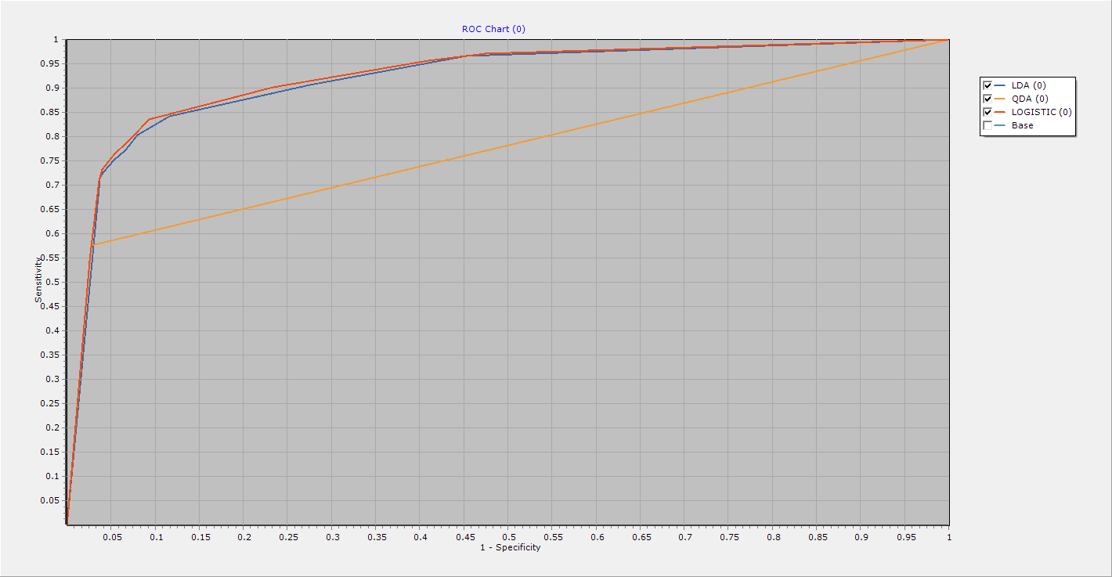

The ROC curve shows the performance of the generated model. In the above case, we can see that the QDA model has the lowest sensitivity at a certain specificity. This means that this model has the highest misclassification rate at that specificity, making it the worst of the three models. If your model's ROC curve is exactly diagonal, this indicates that your modeling has no effect at all. This is because specificity and sensitivity are the same for all classification criteria, so the frequency of diagonal elements in the misclassification matrix is ​​the same as the frequency of off-diagonal elements.

### 3.6.2 Model Evaluation Node

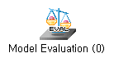

**Model Evaluation Node** is to evaluate the performance of various model techniques based on prediction and classification accuracy.

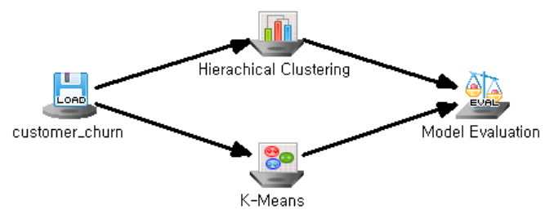

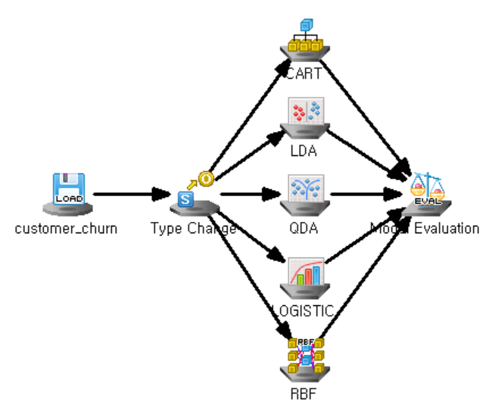

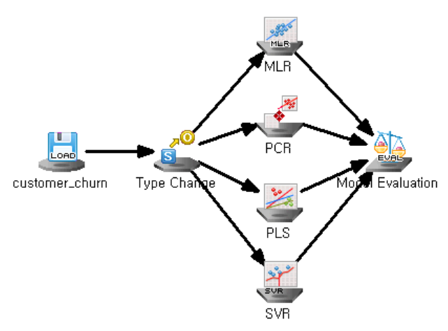

#### Results

The Model Evaluation Node in ECMiner™ provides tools for comparing and analyzing the performance of models across different tasks. For **clustering tasks**, it displays results including the number of elements per cluster, cluster centers (e.g., average values of variables per cluster), and distance matrices between clusters. For **classification tasks**, it provides confusion matrices showing true/false positives and negatives, along with the misclassification count and rate, as illustrated in the CART and LDA examples. For **regression tasks**, evaluation results include an ANOVA table and standard error information, such as Adjusted R², R-squared, RMSE, MAE, and MAPE, as seen in the MLR output. These detailed outputs help users assess model accuracy, variability, and overall performance across various modeling approaches.

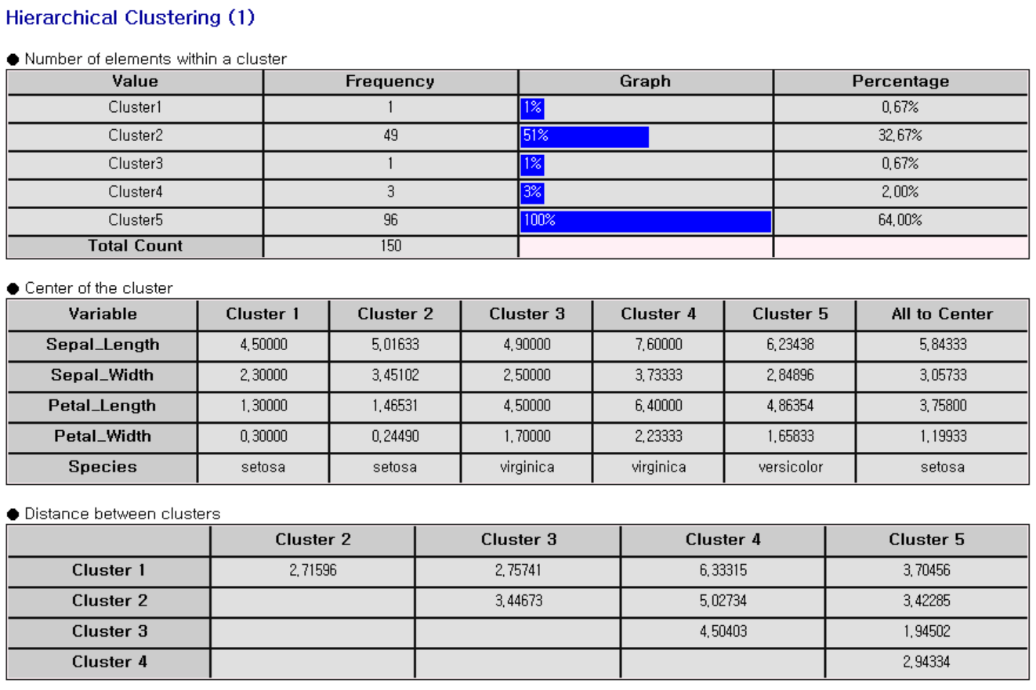

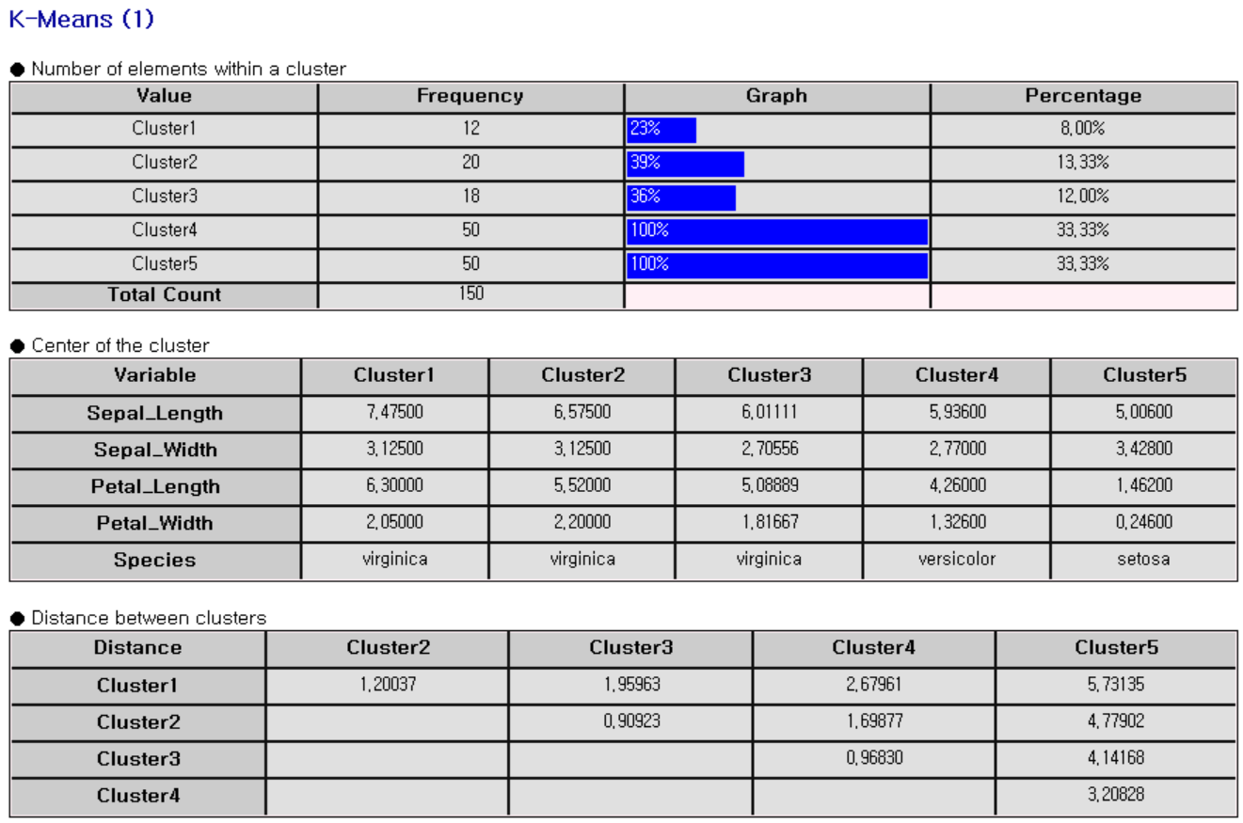

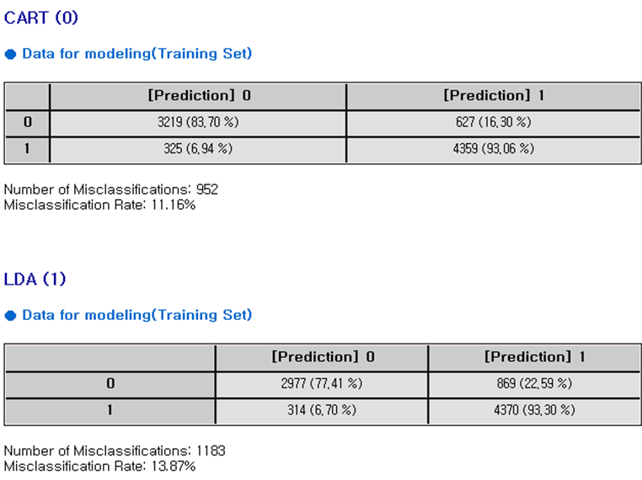

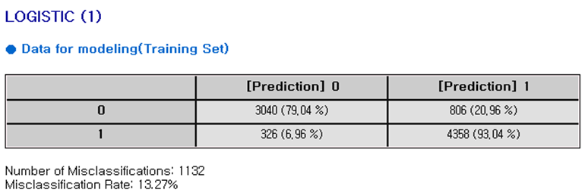

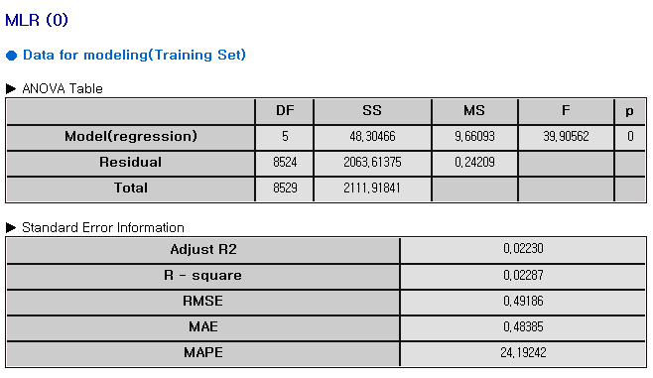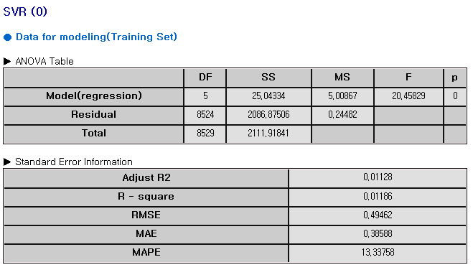

### 3.6.3 Profit Chart Node

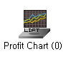

**Profit Chart** is to evaluate classification models using posterior probability values. **Profit Chart** performs model evaluation through four values: Captured Response, Response, Lift, and Gain.

#### Considerations

Among the current classification models, only LDA, QDA, Logistic, CART, and Random Forest Model Nodes can be connected with Profit Chart Node.

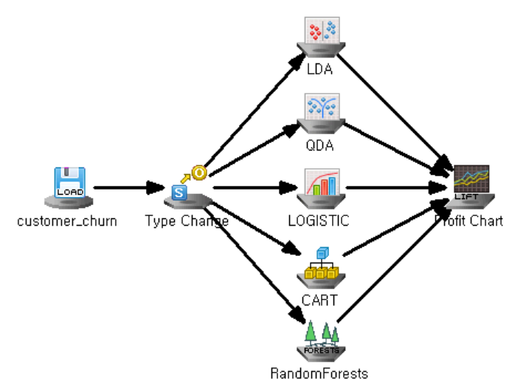

#### Node Properties

|  |  |  |  |  |
| --- | --- | --- | --- | --- |
| Property group | **Property Name** | **Description** | **Misc.** | **Note** |
| Selection options | Target Grade | Enter the number of target grade. | Required | Natural Number |
| Grade Ratio | Set the percentage of the total data for each grade through the Grade Ratio. | Required |  |
| Accumulated | Select whether or not to show the captured response cumulatively through the Accumulated option | Required | Yes or No |

#### Results

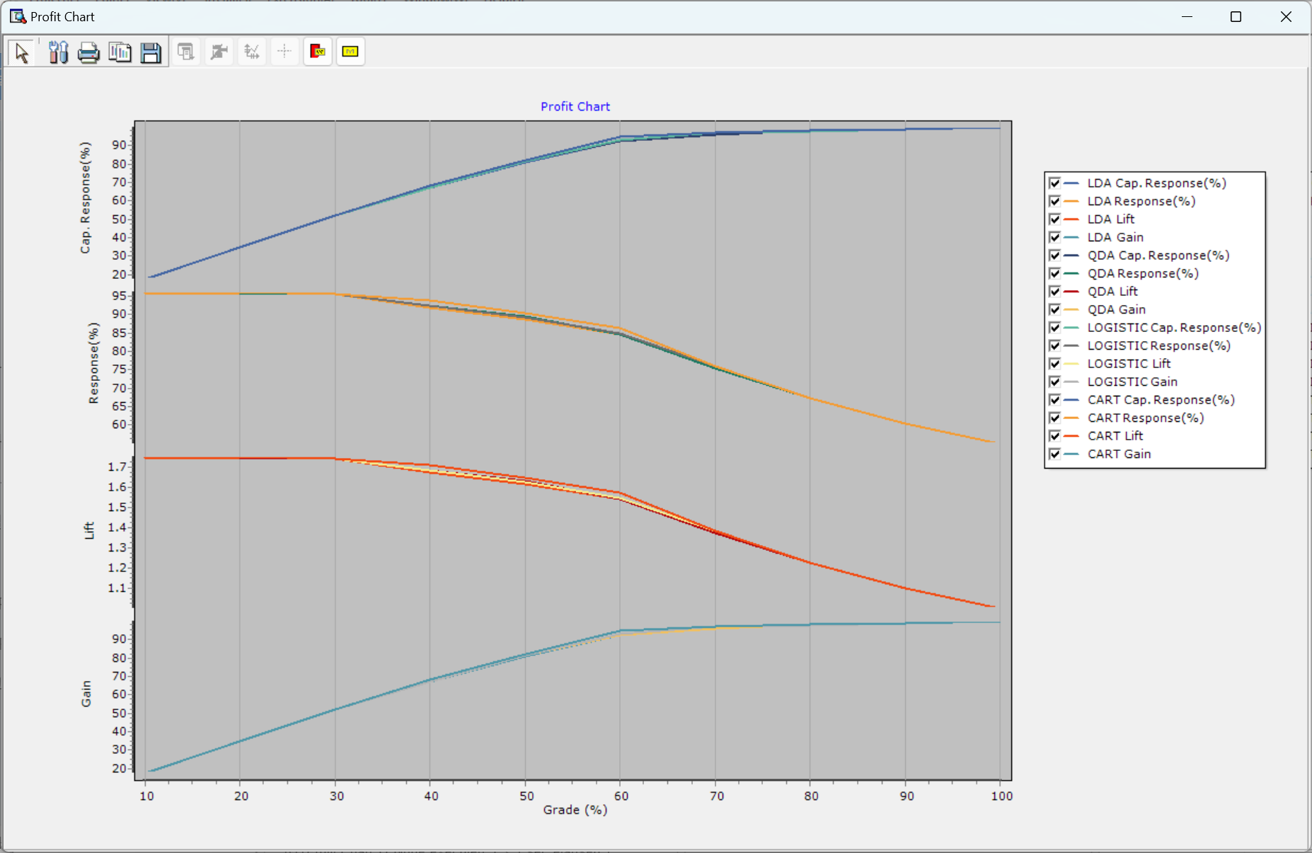

**Captured Response**: the proportion of positive outcomes successfully identified within a specific targeted group. **Response**: the overall rate of positive outcomes in the entire dataset. **Lift**: a measure of how much better the targeted response rate is compared to random selection. **Gain**: the cumulative percentage of positive outcomes captured by targeting a specific percentage of the dataset.

# Chapter 4 Data Browser

Data Browser includes data exploration and basic analysis. Data Browser can be used in the following Input Node and Output Node. Input Node: File Reader, File Reader2, Excel Reader, Copy&Paste Input, Access Reader, ODBC Reader, OLEDB Reader, Oracle Reader. Output Nodes: Display Node, Result Pivoting. In the case of Display Node, it is automatically executed when the project is performed. To run the project directly, you can double-click the Display Node in the output window of the Resource window after executing the project.In Data Browser, the data is shown in a table format with rows and columns. Each column represents a variable, and each row is a record. The top menu includes basic functions like file editing, analysis, and chart creation. You can scroll to explore the dataset and switch between multiple open data tabs.

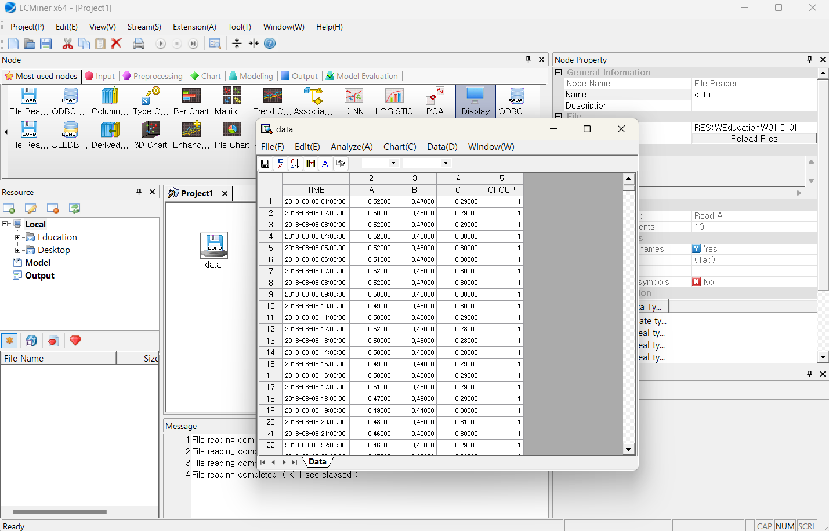

## 4.1 UI

### 4.1.1 Data Browser Screen Layout

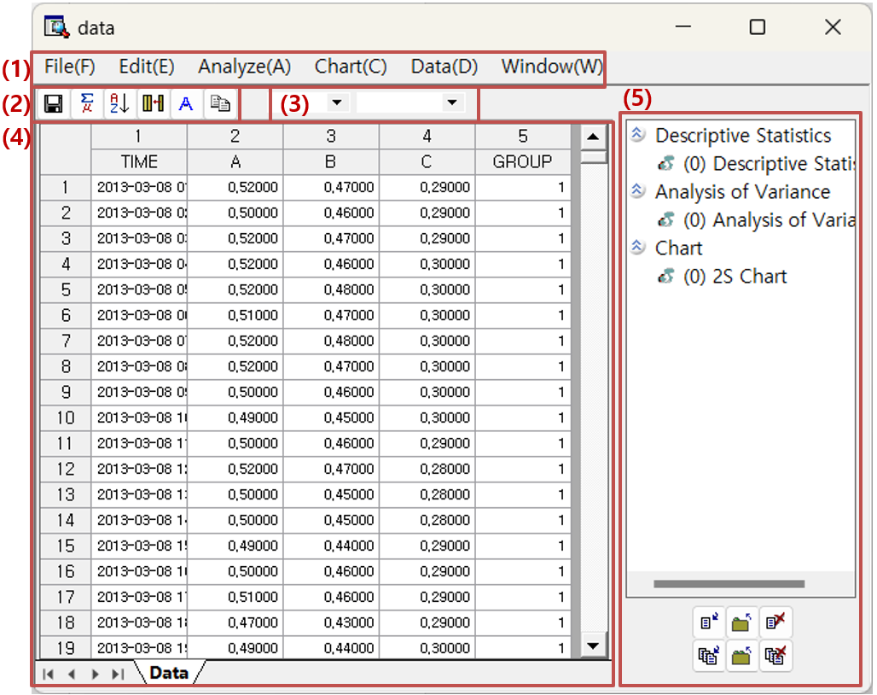

#### Data Browser Windows Description

|  |  |  |  |
| --- | --- | --- | --- |
| **No.** | Type of window | Function | Note |
| **1** | Menu | Menus in Data Browser | Additional description provided |
| **2** | Toolbar | Toolbar menus in Data Browser | Additional description provided |
| **3** | Variable Type | Specify and change data types and role | Data type: discrete, continuous  Roles: independent variables, dependent variables |
| **4** | Viewer | Displays data or analysis results | Additional description provided |
| **5** | Results | Use the output management toolbar below to manage outputs like charts, statistical results, and variance analysis content. | Additional description provided |

### 4.1.2 Main Menu

#### Menu

|  |  |  |  |  |  |  |
| --- | --- | --- | --- | --- | --- | --- |
| Menu Group | Name | | | | | Description |
| File | Reload | | | | | Reloads the data |
| Save | | | | | Save data from Data Browser as a file. |
| Edit | Copy | | | | | Copy selected parts of rows, columns, and data areas. |
| Find | | | | | Find data across the entire data. |
| Find (In Field) | | | | | Find data in the data area for the selected field. |
| Select All | | | | | Select the entire data. |
| Analyze | Data  Summary  Analysis | All Data | | | | Summary statistics for all data |
| Continuous Data | | | | Summary statistics of continuous data |
| Discrete Data | | | | Frequency summary of discrete data |
| Basic  Statistics | Descriptive Statistics | | | | Descriptive statistics for the selected variable |
| Correlation Analysis | | | Display on Screen | Correlation values between continuous data |
| Save to File | Save the correlation values |
| Correlation Wheel | Correlations among continuous fields using a visual network. |
| Mean Comparison Analysis | | | One-Sample t-Test | One sample t-test for the specified mean |
| Two sample t-Test | Test for difference of mean for two groups |
| Paired t-Test | Paired Samples t-test |
| Proportion Test | | | One Sample Proportion Test | Test for one sample proportion whether it is significant from the hypothesized(specified) proportion |
| Two Sample Proportion Test | Test for two independent groups whether it is significant difference between them |
| One Sample Poisson Test | Test to determine if the observed rate of events (or counts) in a sample follows a specified Poisson distribution |
| Two Sample Poisson Test | Test the rates of events between two independent samples to determine if they are significantly different. Counts of events follow a Poisson distribution |
| Variance Test | | | One Sample Variance Test | Test whether the variance (or standard deviation) of a population is equal to a specified value |
| Two Sample Variance Test | Test for two independent groups whether variances of two groups are significantly different. |
| Normality Test | | | | Test whether the data values in the selected field follow a normal distribution. |
| Poisson Test | | | | Test whether the data follows a Poisson distribution. |
| Variance  Analysis | One-Way ANOVA | | | | One-way analysis of variance with one factor |
| Two-Way ANOVA | | | | Perform two-way analysis of variance with two factors |
| General Linear Model | | | | General form of ANOVA |
| Regression Analysis | Multiple Linear Regression | | | | Multiple linear regression through the linear equation of two or more independent variables. |
| Orthogonal Regression | | | | Regression to minimize the sum of squared distances from the observed points to the fitted line in all directions. |
| Nonlinear Regression | | | | Non-linear regression |
| SPC | Process Capability Analysis | | | | A process capability monitors process data within the desired specifications. |
| Process Capability Result | | | | Display whether the data is within the specified process |
| Acceptance Sampling | | | Attributes Acceptance Sampling | Attribute sampling plan for acceptance and rejection in random sample taken from the batch. |
| Quantitative Acceptance Sampling | Variable sampling plan for acceptance and rejection in random sample taken from the batch. |
| Tolerance Intervals | | | | Tolerance interval to satisfy the specified minimum proportion and confidence level |
| Time Series Analysis | Time Series Models | | | Time Series Decomposition | Analyze and understand time series data through the decomposition of its integral components. |
| Moving Average | Calculate the average of past data to smooth current data trends and forecast future values. |
| Exponential Smoothing | Apply higher weights to recent data to forecast future values using a smoothing process. |
| Trend Analysis | Examines data patterns over time to forecast future directions in trend analysis. |
| ARIMA | Use to obtain the basic trend of time series data |
| GARCH | Measures and predicts volatility. |
| VAR | Models the relationships among a specific set of variables by considering multiple time series variables that influence one another |
| ARMAX | Show time series data, fitted values, and the upper and lower limits of the fitted values. |
| Time Series Test | | | Unit Root Test | Test whether a time series has a unit root. |
| Granger Causality | Tests whether one time series is useful for predicting another time series. |
| Cointegration Test | Test whether two time series are cointegrated. |
| ARCH Test | Tests whether one time series can predict the time-varying volatility. |
| Time Series Correlation | | | Cross-Correlation | Measure the similarity between two time series. |
| Autocorrelation, Partial Autocorrelation | Correlation between the values of time series data and past data. |
| Table | Frequency Table | | | | Frequency of specific values for a field |
| Cross Table | | | | Frequency of values common to two variables for each field. |
| Univariate Chi-Square Test | | | | Test whether the collected data follows a multinomial distribution |
| Independence Test | | | | Test whether two categorical variables are independent. |
| Probability  Distribution | Parameter Estimation | | | | Estimate the parameters that best fit the data and calculate the confidence interval of the estimated parameters based on the confidence level. |
| Individual Distribution Identification | | | | Calculate the Anderson-Darling statistic to test whether the given data conforms to a specific distribution. |
| Nonparametric Test | | | One-Sample | | Test whether the median of given data differs with a specified median. |
| Independent Samples | | Test whether the median between two groups is different. |
| Paired Samples | | Test whether the medians for each paired sample are different |
| ANOVA - One-way | | Test whether there are the differences among three or more medians. |
| Accuracy Measurement | | | Classification | | Evaluate the model's accuracy by comparing the predicted variables with the actual labels. |
| Regression | | Provide R-square, MAPE, MAD, and MSD using dependent and predictor variables. |
| Gage R&R | | Gage Run Chart | | | Shows the total observations obtained through the experiment. |
| Gage Linearity and Bias Study | | | **Bias** is difference between the **average measured value** and the **true or reference value. T**he bias increases or decreases with the magnitude of the measurement, the gage is said to have poor linearity |
| Gage R&&R Study (Crossed Design) | | | Evaluate the measurement system is reliable and that its variability is minimal compared to the overall process variability |
| Gage R&&R Study (Nested Design) | | | Each part is measured only in a single measurement system. |
| Chart | 2D Chart | | | | | Two-dimensional chart. |
| 3D Chart | | | | | Three-dimensional chart. |
| Bar Chart | | | | | Bar chart. |
| Box Chart | | | | | Box chart. |
| Matrix Chart | | | | | Matrix chart. |
| Pareto Chart | | | | | Pareto chart. |
| Pie Chart | | | | | Pie chart. |
| Multi-Chart | | | | | Multiple variables chart |
| Data | Sort | | | | | Sort data by the selected variable |
| Derived Variables | | | | | Create a new derived variable |
| Apply | | | | | Construct a stream of the manipulated preprocessing in the data browser |
| Filter | | | | | Filter data by the specified variable option |
| Freeze Interest Variables | | | | | Specify the variable of interest by selecting the column to freeze. |
| Box-Cox Transformation | | | | | Transformation applied for non-normal data to nearly normal |
| Johnson Transformation | | | | | Transformation applied for non-normal data to nearly normal |
| Window | Results | | | | | Manage the output results |

### 4.1.3 Sub-menu (using mouse and keyboard)

The submenu in the Data Browser pops up right-clicking. Delete Column: Right-click on the column number or field name in the data area column header, and a menu will be shown. The selected column will be deleted from the data browser. After executing 'Apply' following the column deletion, a filter node will be added to the stream, removing the selected column.Delete Row: Right-click on the row number in the row header of the data area and a menu will be shown. The selected row will be deleted from the data browser. After executing 'Apply' following the row deletion, a Row Select Node will be added to the stream, removing the selected row.Hide Column: Right-click on the column number or field name in the data area column header and a menu will be shown. The selected column will be hidden in the Data Browser. Cancel Hide Column: Right-click on the column number or field name in the data area column header to show the hidden column number and field name. etc. [Copy]/[Copy with column names]/[Select all]/[Export Data to Excel] functions are additionally provided.

### 4.1.4 Toolbar

Toolbar in the Data Browser

#### Toolbar Menu

|  |  |  |  |
| --- | --- | --- | --- |
| **Menu** | Icon | Description | Note |
| **Save** | dataexplorer_toolbar_saveas | Save the current data to a file. |  |
| **Descriptive Statistics** | dataexplorer_toolbar_descstat | Calculates descriptive statistics for the specified variable. |  |
| **Sort** | dataexplorer_toolbar_sort | Sorts the data for the specified variable. |  |
| **Derived Variable** | dataexplorer_toolbar_derive | Create derived variables. |  |
| **Chart** | dataexplorer_toolbar_chart | Select and configure the chart to be displayed in the data explorer. |  |
| **Apply** | dataexplorer_toolbar_apply | Apply the actions performed in the data explorer to the stream configuration. |  |
| **Result** | dataexplorer_toolbar_outputmgr | Show or hide the results management window. |  |
| **Variable Type** |  | Display and set the variable type. |  |

### 4.1.5 Data Area

You can explore data and edit rows and columns in the original datasheet.

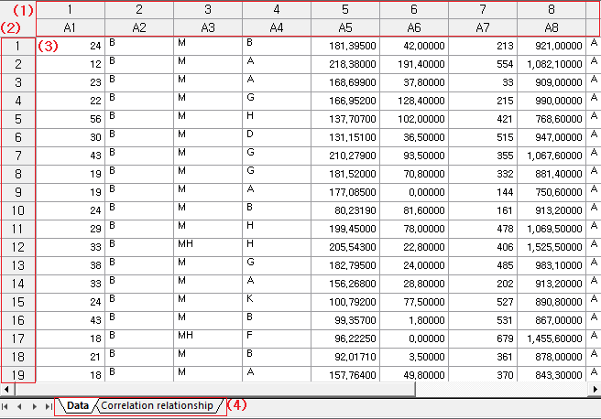

#### Data window Description

|  |  |  |  |
| --- | --- | --- | --- |
| **No.** | Type of window | Function | Note |
| **1** | Column header | **Column numbers** and **names i**n the data table. Right-click options: **Delete Column, Hide Column, Copy, Copy with column names, Select All,** and **Send Data to Excel**. Double-click the column border to auto-adjust the width. |  |
| **2** | Row header | **Row numbers** and **names** in the data table. Right-click options: **Delete Row, Copy, Copy with column names, Select All,** and **Send Data to Excel.** |  |
| **3** | Data Area | **Copy**, **Copy with column names**, **Delete**, **Select All**, and **Send Data to Excel**. |  |
| **4** | Sheet tab | This tab controls the data. It adds sheets such as Data Distribution and Correlation. |  |

### 4.1.6 Results

Manage the results in the Data Browser by clicking [Window] - [Results] or the 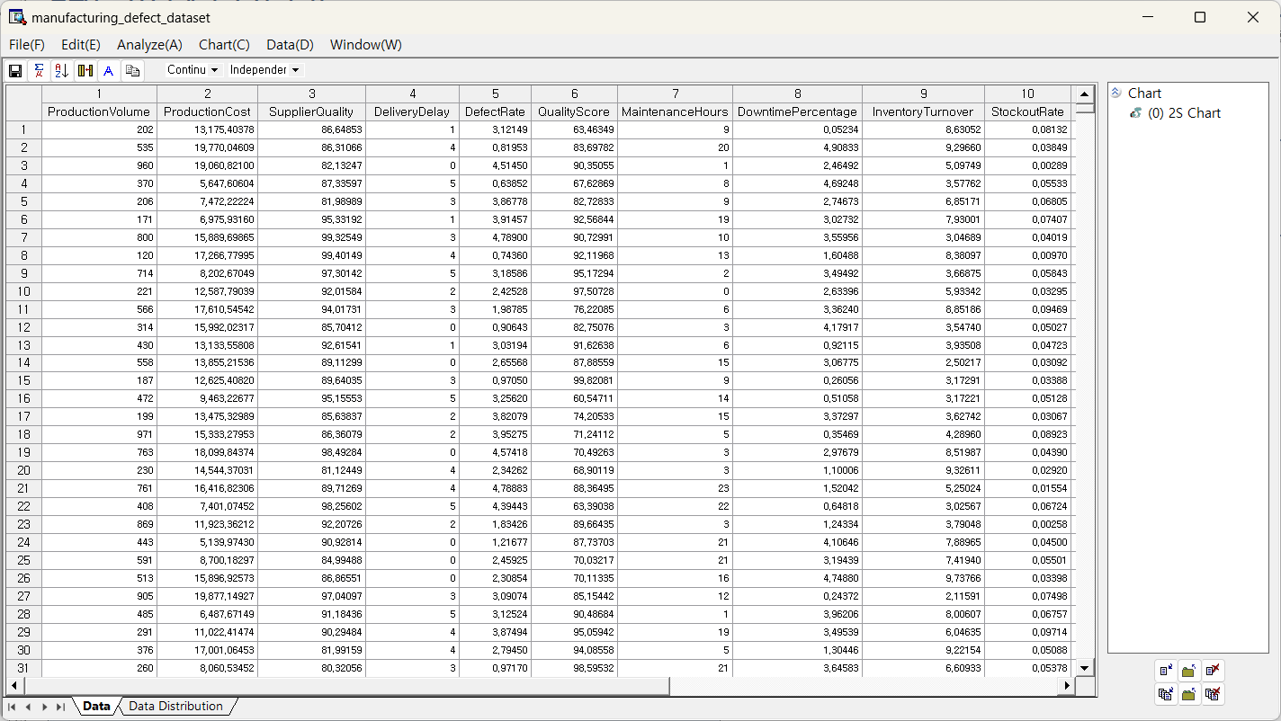"Results" icon on toolbar. The results are grouped by type into categories such as “Chart” and “Descriptive Statistics”.

#### Window Layout

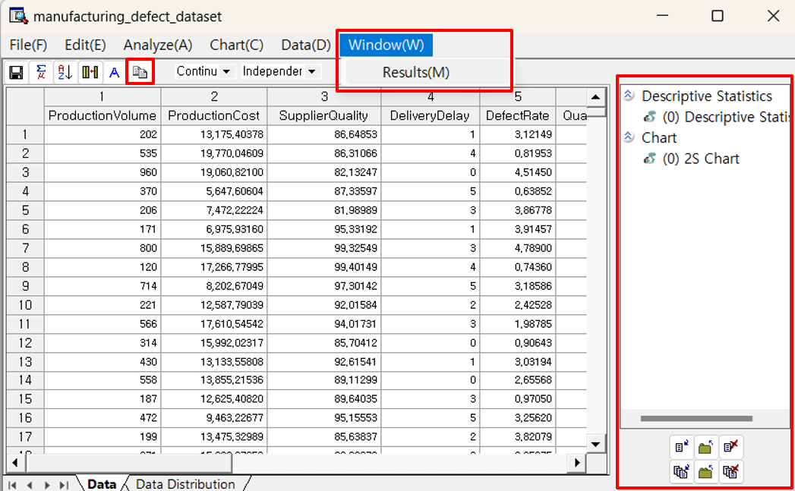

#### Results Toolbar Menu

|  |  |  |
| --- | --- | --- |
| **Menu** | Icon | Description |
| **Show** | dataexplorer_outputmanager_show Single window with arrow. | Show the selected results window. |
| **Show all** | dataexplorer_outputmanager_showall Multiple windows with arrow. | Show all results windows. |
| **Close** | dataexplorer_outputmanager_closeSingle window with arrow. | Close the selected results window. |
| **Close all** | dataexplorer_outputmanager_closeallMultiple windows with arrow. | Close all results windows. |
| **Remove** | dataexplorer_outputmanager_destroySingle window with an X. | Remove the selected results window. |
| **Remove all** | dataexplorer_outputmanager_destroyallMultiple windows with an X | Remove all results windows. |

## 4.2 File

### 4.2.1 Reload

Reloads the data from a file or DB. **[File(F)] - [Reload(R)]** in the menu.

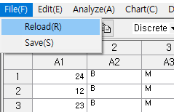

### 4.2.2 Save

Save the data. **[File(F)] - [Save(S)]** in the menu or the ”save” icon on the toolbar.

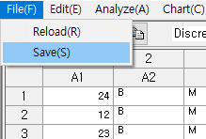

Save file: Files can be saved with extensions such as "txt", "csv", and “ecl".

## 4.3 Analyze

### 4.3.1 Data Summary Statistics

#### All Data

Data Summary Statistics – All Data displays summary statistics of all the variables. How to run: **[Analyze] – [Data Summary Statistics] – [All Data].** Results**:** The Data Distribution tab provides a summary of each variable in the dataset, including variable type, data count, missing values, and basic statistics such as average, minimum, maximum, and range. For discrete variables, frequency and percentage are also shown. Box plots are displayed for continuous variables to visualize their distribution.

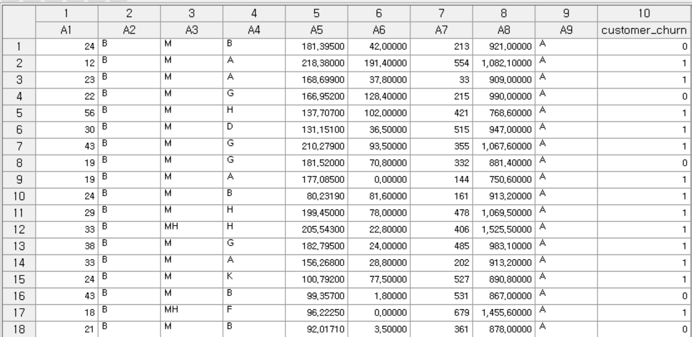

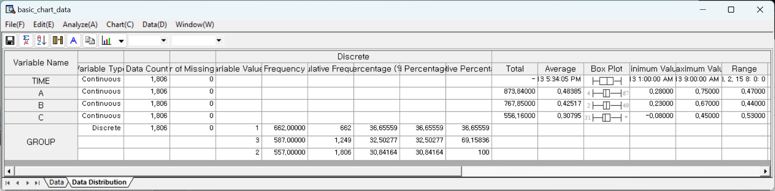

#### Continuous Data

Data Summary Statistics – Continuous Data shows descriptive statistics with box plot for all continuous data. How to run: **[Analyze] – [Data Summary Statistics] – [Continuous Data].** Results**:** The Continuous Distribution tab displays summary statistics for each continuous variable, including total, average, minimum, maximum, range, and a box plot for visualizing the distribution. Missing values are also counted. Outliers are shown at the ends of the box plot, and an asterisk (\*) is displayed if the number of outliers exceeds 100.

**Output Statistics**

Total, Average, Box plot, Number of Missing Values, Minimum Value, Maximum Value, Range, Variance, Standard Deviation, Kurtosis, Skewness, Median, and Quartile are supported.

***NOTE*** *The numbers at either end of the box plot indicates the number of outliers. If the number of outliers exceeds 100, it is displayed as '\*'.*

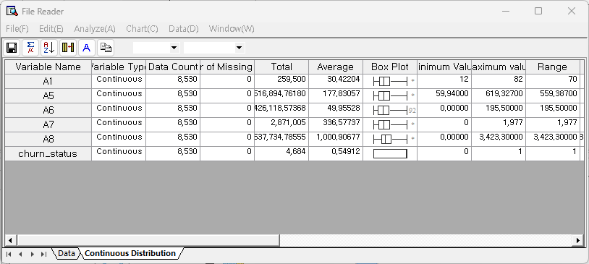

#### Discrete Data

Data Summary Statistics – Discrete Data shows descriptive statistics for discrete data. How to run: **[Analyze] – [Data Summary Statistics] – [Discrete Data]**. Results: The Discrete Distribution tab provides frequency statistics for discrete variables. It includes the count of each value, cumulative frequency, percentage, valid percentage, and cumulative percentage. Missing values and the number of distinct categories are also shown.

**Output Statistics**: Number of Missing Values, Variable Values, Frequency, Cumulative Frequency, Percentage, Valid Percentage, and Cumulative Percentage.

**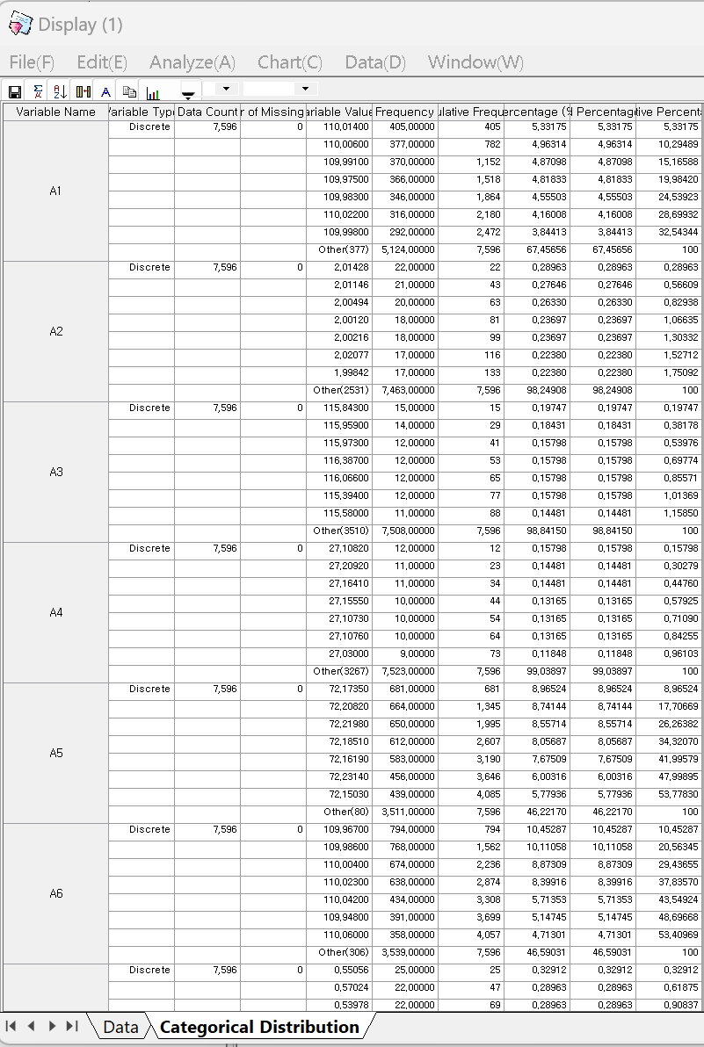**

### 4.3.2 Basic Statistics

#### 4.3.2.1 Descriptive Statistics

Basic Statistics – Descriptive Statistics shows descriptive statistics of the selected variables.

##### How to run

**[Analyze] – [Basic Statistics] – [Descriptive Statistics]**.

##### Descriptive Statistics options

Add a variable or remove a variable using Add and Delete button. Select the variable for the descriptive statistics. Button is another way to select the column header in the data browser. Click the boxes to select or deselect the statistics.

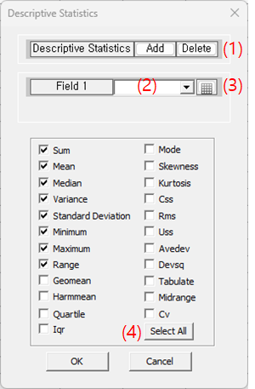

##### Results

This result table displays basic descriptive statistics for a selected variable. It includes measures such as total sum, mean, minimum and maximum values, and range. It also provides statistical indicators like variance, standard deviation, kurtosis, and skewness. Additionally, it shows the median and quartile values (Q1, Q2, Q3), which help describe the distribution and spread of the data.

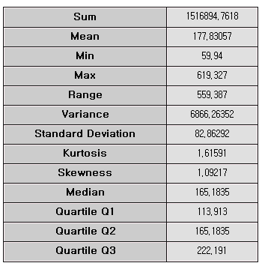

###### Output Statistics

The chosen statistics are shown. For all of the statistics, Sum, Mean, Median, Variance, Standard Deviation, Minimum, Maximum, Range, Geamean, Harmmean, Quartile, Iqr, Mode, Skewness, Kurtosis, Css, Rms, Uss, Avedev, Devsq, Tabulate, Midrange, and Cv are supported.

#### 4.3.2.2 Correlation Analysis

There are three methods available for performing correlation analysis: **Display on Screen**, **Save to File**, and **Correlation Wheel**.

##### (1) Display on Screen

Correlation Analysis – Display on Screen shows the correlation.

###### How to run

**[Analyze] – [Basic Statistics] – [Correlation Analysis] – [Display on Screen]**

###### Results

The correlation analysis is presented in a matrix format that allows independent interpretation without relying on the original interface. In the lower triangle of the table, the actual correlation coefficients (Cor) and the number of data points (N) are displayed numerically for each pair of variables. The diagonal shows the distribution of each individual variable as bar charts. In the upper triangle, circles are used to visually represent the strength and direction of the correlation: red circles indicate positive correlation, while blue circles indicate negative correlation. The size of each circle corresponds to the magnitude of the correlation—the stronger the correlation, the larger the circle.

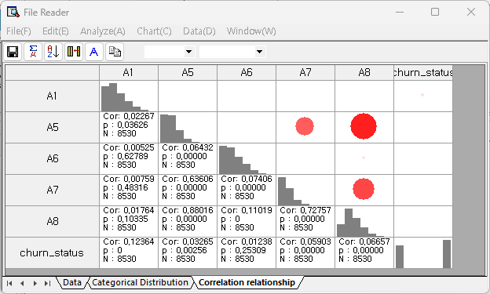

Output Statistics

Cor (correlation value), and p (p-value)

Correlation chart

Distribution chart with a trend line is displayed double-clicking the selected correlation table.

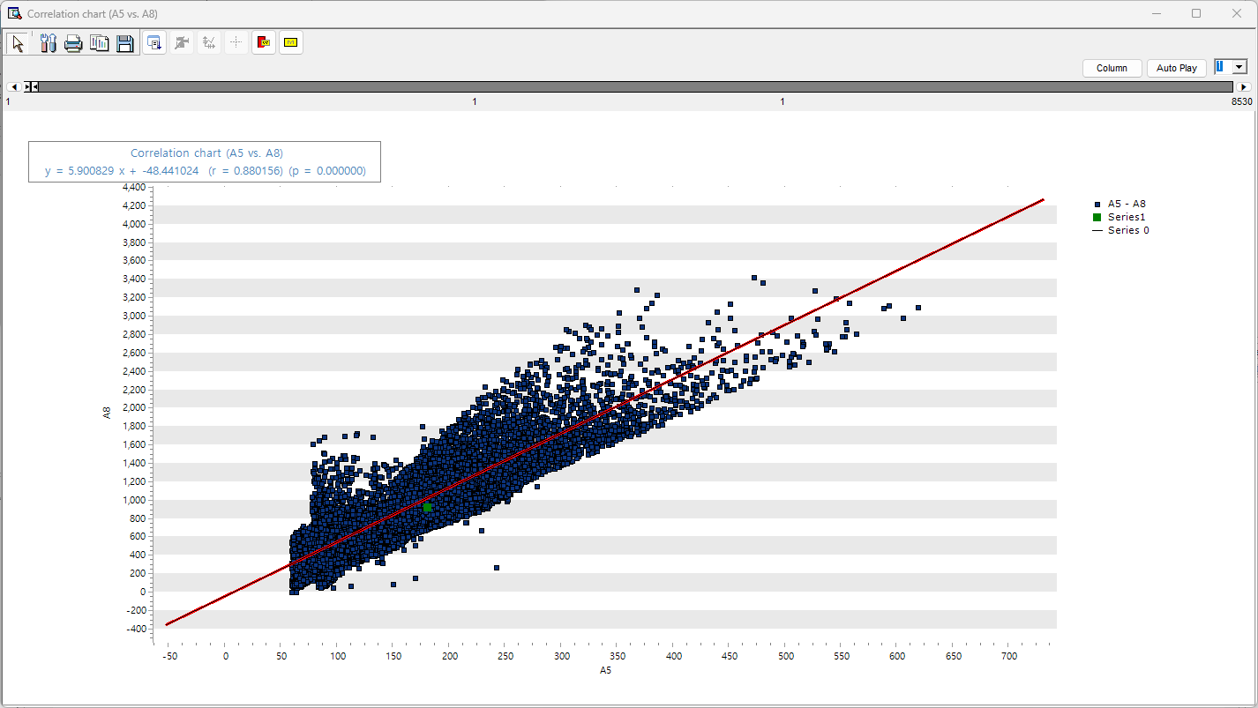

##### (2) Save to File

Correlation Analysis – Save to File do save the correlation table as text file.

###### How to run

**[Analyze] – [Basic Statistics] – [Correlation Analysis] – [Save on File].**

Specify the file name, directory, and the correlation coefficient value. Results are stored only for variables that have correlation $≥$ the specified value.

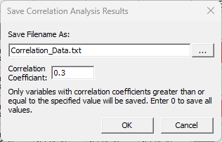

###### **Results**

The results of the correlation analysis are saved in a text file (.txt) format. The file contains a table of Pearson correlation coefficients between variables, with variable names listed as both row and column headers. The diagonal values are always 1, representing the correlation of each variable with itself, while the other cells contain the correlation coefficients as floating-point numbers.

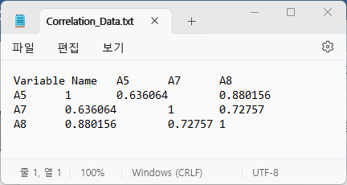

##### (3) Correlation Wheel

Correlation Analysis – Correlation Wheel shows the correlation between variables using the color and thickness of the connecting lines.

###### How to run

**[Analyze] – [Basic Statistics] – [Correlation Analysis] – [Correlation Wheel]**

###### Results

Red means positive correlation, blue means negative correlation, and the thicker the connecting line, the larger the absolute value of the correlation coefficient. On the top right corner, there is a menu to adjust the coefficient threshold value, line thickness, and tension. The coefficient threshold allows you to selectively view the meaningful correlation between variables.

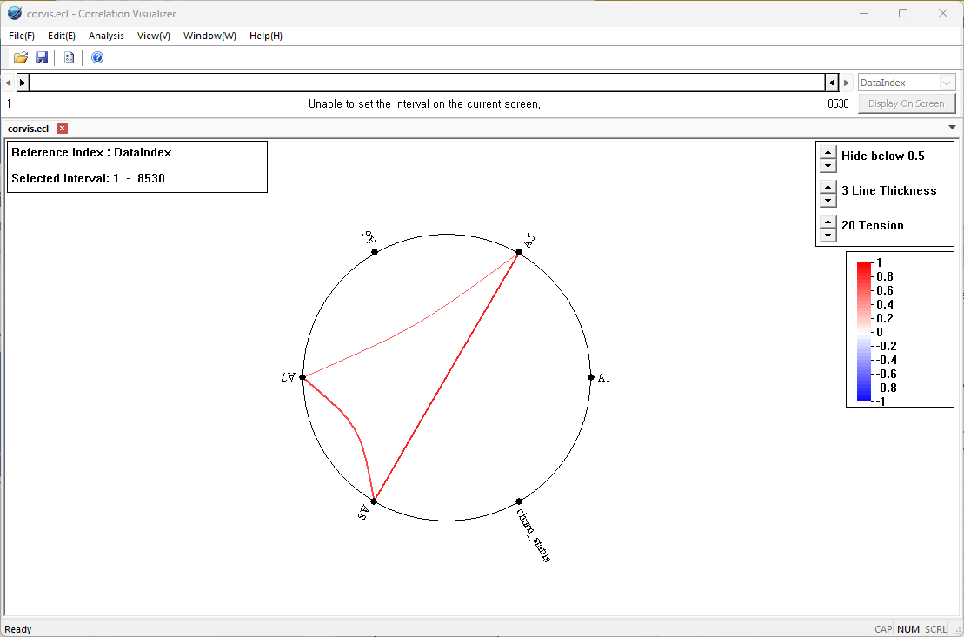

#### 4.3.2.3 Mean Comparison Analysis

There are three methods available for performing Mean Comparison Analysis: **One-Sample t-test**, **Two Sample t-Test**, and **Paired Samples**.

##### (1) One-Sample t-test

One-sample t-test is to test whether the mean of one sample differs significantly from the specified mean.

###### How to run

**[Analyze]-[Basic Statics]-[Mean Comparison Analysis]-[One Sample t-Test].** Select a variable, and define the hypothesized mean, and confidence level.

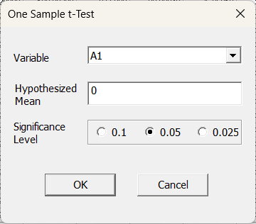

###### Result

One-sample t-test statistics result presents the output of a one-sample t-test, which is divided into two main sections. The first section, titled "One-Sample Statistics," displays basic summary statistics for the variable A1, including the sample size, mean, standard deviation, and standard error of the mean. These values provide a preliminary understanding of the data distribution prior to hypothesis testing.

The second section, labeled "One-Sample Test," shows the outcome of the t-test, including the t-statistic, degrees of freedom, two-sided p-value, the average difference from the hypothesized value (typically zero), and the 95% confidence interval for the mean difference. This section is used to determine whether the sample mean is statistically significantly different from the specified reference value.

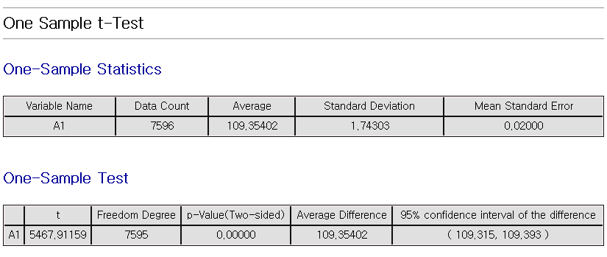

##### (2) Two Sample t-Test

Two Sample t-Test is to compare the average of two independent samples.

###### How to run

**[Analyze]-[Basic Statics]–[Mean Comparison Analysis]-[Two Sample t-Test]**. Select **analysis variables** and **Group variable.**

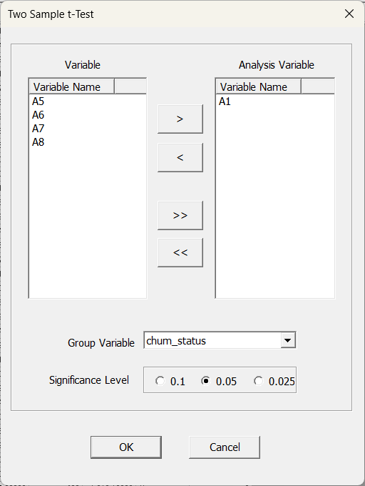

###### Result

The result provides both **Group Statistics** and a **Two Sample Test**. Group Statistics shows the number of data points, mean, standard deviation, and standard error of the mean for each of the two groups. The Two Sample Test presents the results of the t-test under two assumptions: assuming equal variance and not assuming equal variance. For each assumption, the table includes the F-value, Levene’s significance probability, degrees of freedom, two-sided p-value, mean difference, standard error of the difference, and the 95% confidence interval of the difference.

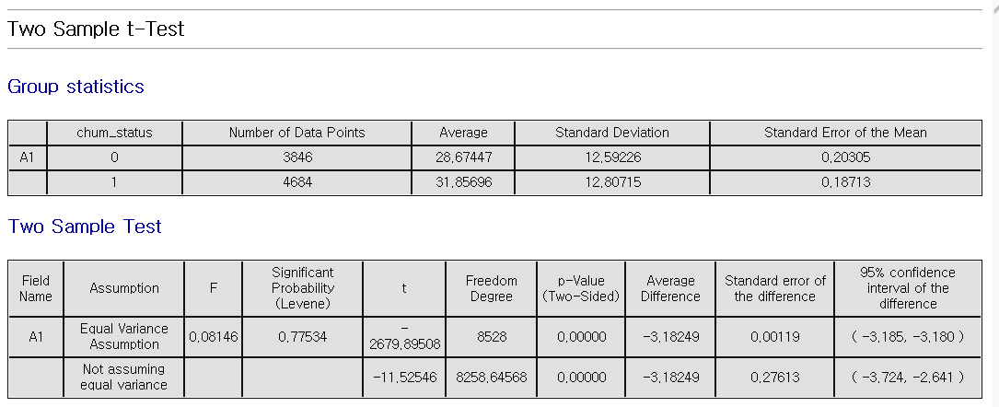

##### (3) Paired Samples

Paired t-test is to test whether the mean difference between two paired observations. Measurements are taken on the same subjects before and after a treatment, or paired observation

###### How to run

**[Analyze]-[Basic Statics]–[Mean Comparison Analysis]-[Paired t-Test]**

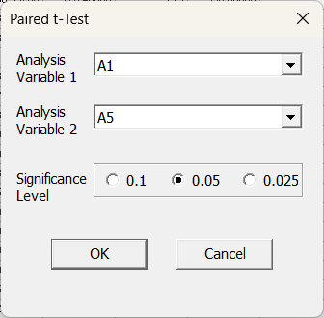

###### Result

Result provides **Paired Sample Statistics** and a **Paired Sample Test**. Paired Sample Statistics shows the number of data points, mean, standard deviation, and standard error of the mean for each of the two paired variables. Paired Sample Test provides the results of the t-test performed on the differences between the paired values. The table includes the mean difference, standard deviation, standard error of the mean, 95% confidence interval of the difference, t-value, degrees of freedom, and two-sided p-value.

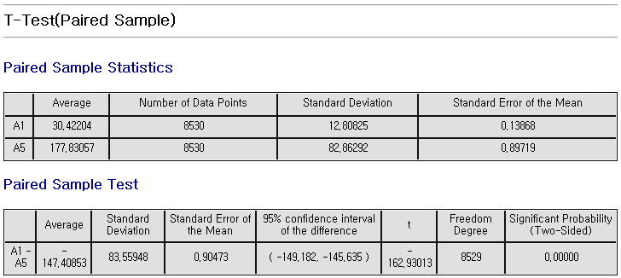

#### 4.3.2.4 Proportion Test

##### (1) One sample Proportion Test

One sample proportion test of the specified ratio with confidence interval.

###### How to run

**[Analyze] - [Basic Statistics] - [Proportion Test] - [One sample Proportion Test].** Select a variable. Choose event class among the class of variable. Set hypothesis parameter. Set confidence interval.

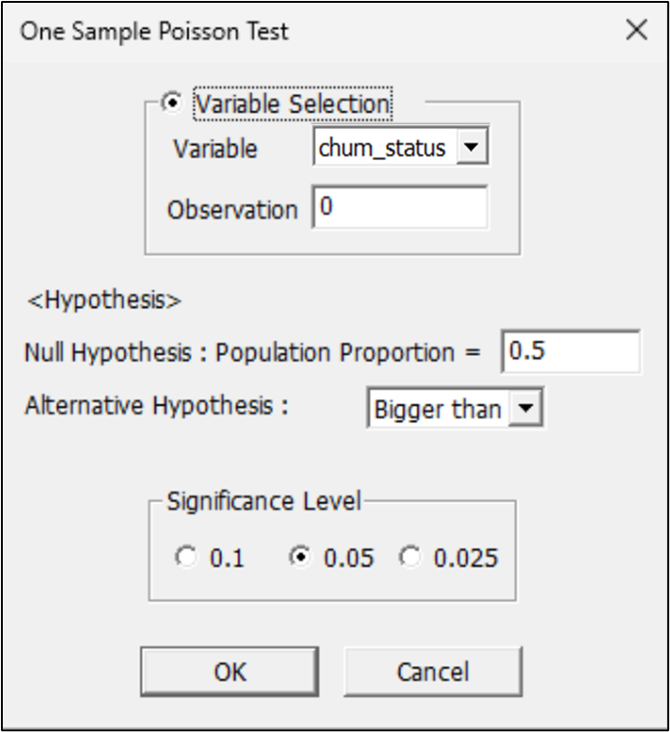

###### Results

The smaller a P-value is, the greater the possibility of rejecting a null hypothesis is. This result presents the output of a one-sample proportion test, consisting of a hypothesis statement and a result table. The hypothesis section specifies the null and alternative hypotheses, including the assumed population proportion and the direction of the test. The table includes columns for the number of observations, number of events, sample ratio, confidence interval, z-value, and p-value. These components are used to assess whether the observed proportion significantly differs from the hypothesized value.

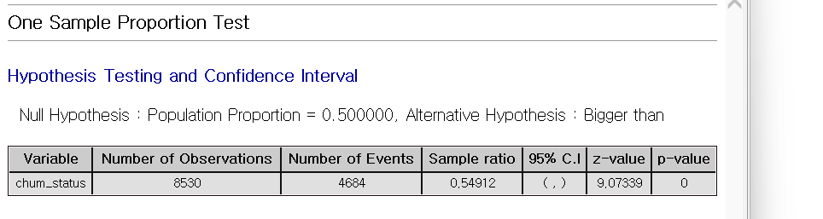

##### (2) Two sample Proportion Test

Two sample proportion test is to test significant difference between two groups.

###### How to run

**[Analyze] - [Basic Statistics] - [Proportion Test] - [Two Sample Proportion Test].** Select variables. Choose event class among the class of variable. Set hypothesis parameter. Set confidence level.

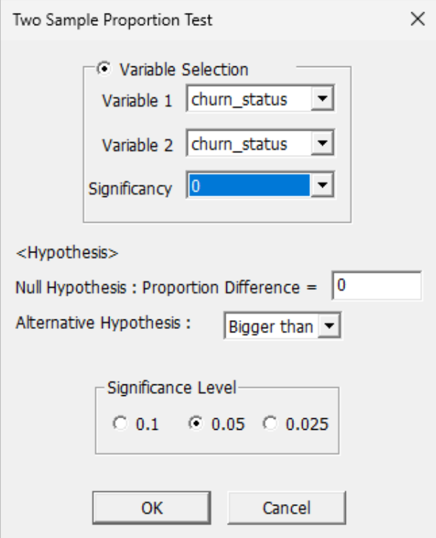

###### Results

The smaller a P-value is, the greater the possibility of rejecting a null hypothesis is. Therefore, the proportion difference between two populations can be claimed like the type of an alternative hypothesis.

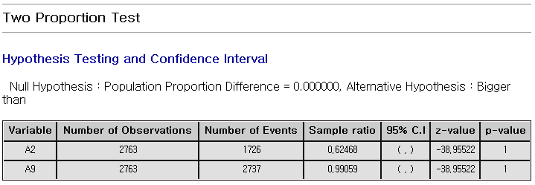

##### (3) One-Sample Poisson Test

Tests whether the event rate in a sample follows a Poisson distribution and matches the expected value.

###### How to run

**[Analyze] - [Basic Statistics] – [Proportion Test] – [One Sample Poisson Test]**

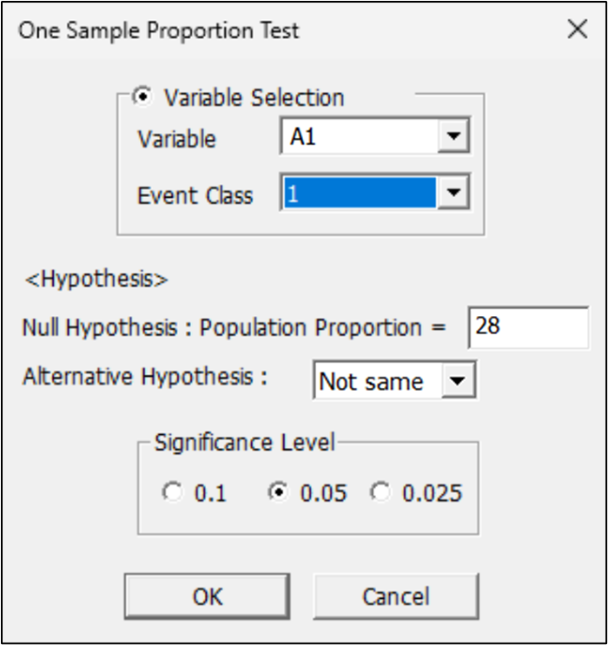

The following procedures are performed after a desired method is chosen between variable selection method and manual input method. The variable selection method uses an integer variable and selects a corresponding variable and decides the length of an observation value. In the manual input method, the number of a trial and the number of an event occurrence is entered directly. For verification the population ratio is set in a null hypothesis, and the type and significance level of an alternative hypothesis is selected.

###### Results

The test results of a chosen method are presented in a table as follows; The smaller a P-value is, the greater the possibility of rejecting a null hypothesis is. Therefore, the population proportion can be claimed like the type of an alternative hypothesis.

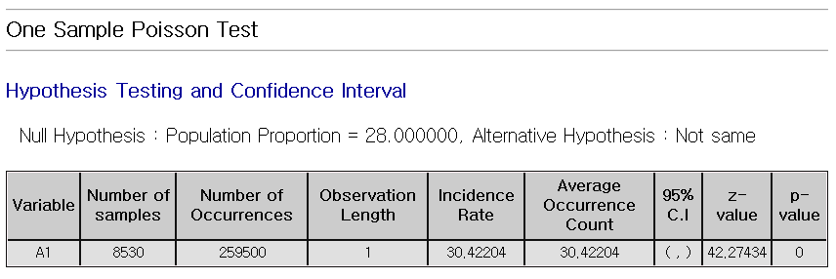

##### (4) Two Sample Poisson Test

Tests whether the event rates of two independent samples, assumed to follow Poisson distributions, are significantly different.

###### How to run

**[Analyze] - [Basic Statistics] – [Proportion Test] – [Two Sample Poisson Test]**

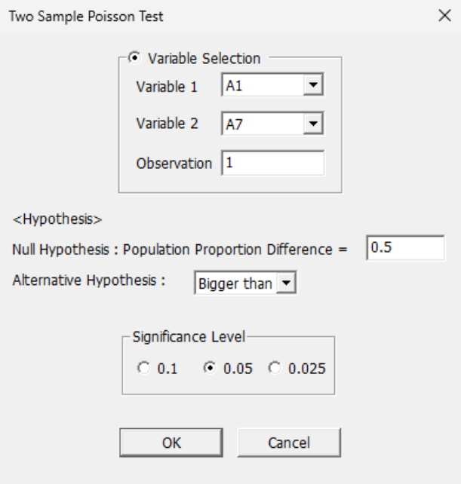

The following procedures are performed after a desired method is chosen between variable selection method and manual input method. The variable selection method uses an integer variable and selects corresponding two variables and decides the length of an observation value. In the manual input method, the number of two trials and the number of an event occurrence is entered directly. For verification the population ratio is set in a null hypothesis, and the type and significance level of an alternative hypothesis is selected.

###### Results

The test results of a chosen method are presented in a table as follows; The smaller a P-value is, the greater the possibility of rejecting a null hypothesis is. Therefore, the difference of the population proportion of 2-sample Poisson can be claimed like the type of an alternative hypothesis.

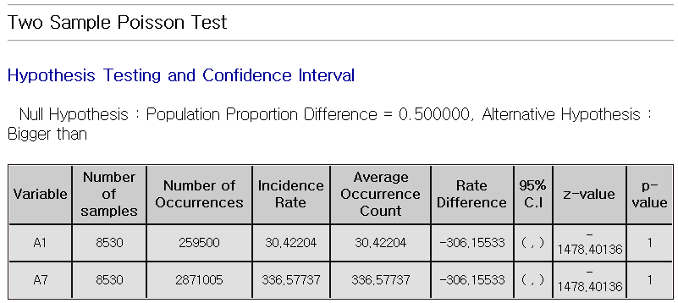

#### 4.3.2.5 Variance Test

##### (1) One Sample Variance Test

Data explorer provides the function of single sample variance test that calculates the confidence interval and tests a hypothesis for the variance of a continuous variable.

###### How to run

**[Analyze] - [Basic Statistics] - [Variance Test] - [One Sample Variance Test]**

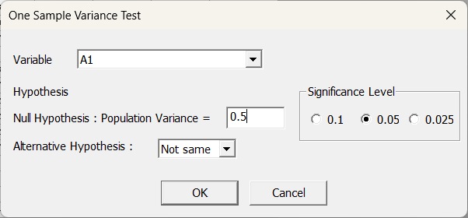

A target variable is chosen for single sample variance test. For verification, the variance value of a population is set in a null hypothesis and the type and significance level of an alternative hypothesis is selected.

###### Results

The smaller a P-value is, the greater the possibility of rejecting a null hypothesis is. Therefore, the variance of a population can be claimed like the type of an alternative hypothesis

Single Sample Variance Test result displays the output of a single sample variance test, which includes a statement of the null and alternative hypotheses regarding the population variance. The accompanying table presents the number of observations, sample standard deviation, sample variance, the 95% confidence interval for the variance, degrees of freedom, the chi-square test statistic, and the p-value. This format is used to determine whether the sample variance significantly differs from a specified population variance.

.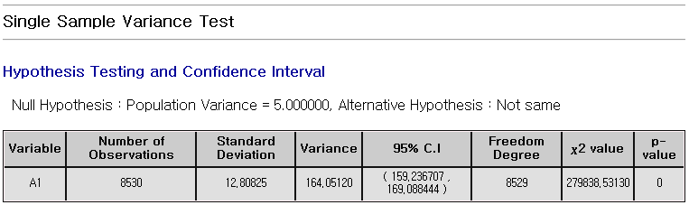

##### (2) Two Sample Variance Test

Data explorer provides the function of double sample variance test that calculates the confidence interval and tests a hypothesis for the ratio of the variance of two continuous variables.

###### How to run

**[Analyze] - [Basic Statistics] - [Variance Test] - [Two Sample Variance Test]**

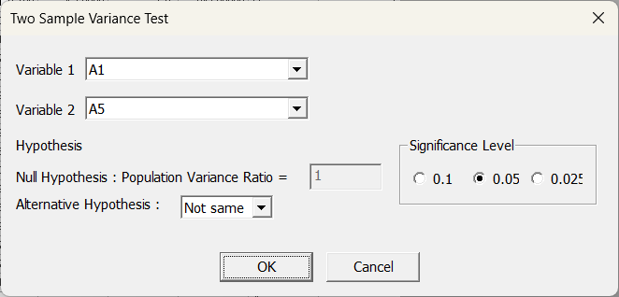

Two variables are chosen for double sample variance test. For verification, the variance ratio of a population is set in a null hypothesis and the type and significance level of an alternative hypothesis is selected.

###### Results

The test results of a chosen method are presented in a table as follows; The smaller a P-value is, the greater the possibility of rejecting a null hypothesis is. Therefore, the ratio of the variance of two populations can be claimed like the type of an alternative hypothesis.

Two Sample Variance Test result presents the output of a two-sample variance test, including a hypothesis statement specifying that the null hypothesis assumes equal population variances, while the alternative hypothesis tests whether one variance is greater than the other. The table includes values for each sample, such as the number of observations, standard deviation, variance, variance ratio, confidence interval for the ratio, degrees of freedom for both groups, the F statistic, and the corresponding p-value. This format is used to assess whether there is a significant difference in variance between the two groups.

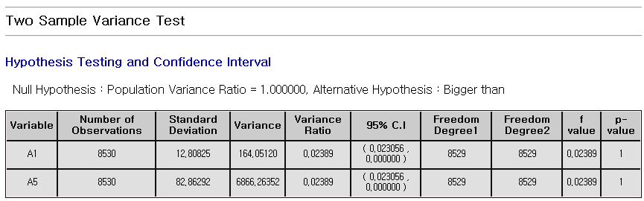

#### 4.3.2.6 Normality Test

Normality test is for testing whether data is normally distributed. It takes Anderson-Darling and Kolmogorov-Smirnov tests.

###### How to run

**[Analyze] – [Basic Statistics] - [Normality Test]**

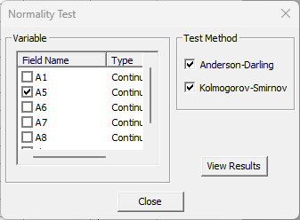

Select a variable and choose the test method (Anderson-Darling, Kolmogorov-Smirnov) and Click the “View Results” button.

###### Results

The smaller a p-value is, the more normal distribution is not. Normality test output includes the results of multiple methods, such as Anderson-Darling and Kolmogorov-Smirnov, each providing a test statistic and a corresponding p-value. The Kolmogorov-Smirnov test is adjusted using the Lilliefors significance level. Basic descriptive statistics like the mean and standard deviation are also provided at the bottom. The format is used to assess whether the sample data follows a normal distribution.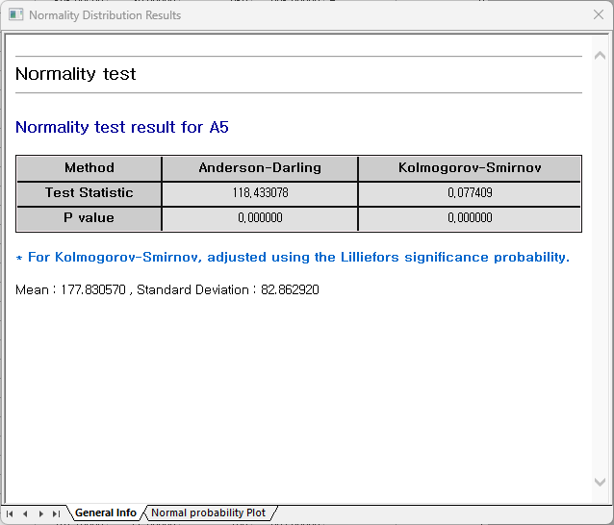

Normality test output also provides a normal probability plot. Normal probability plot shows whether data follows a normal distribution. If the data points form a roughly straight line, it suggests that the data is normally distributed.

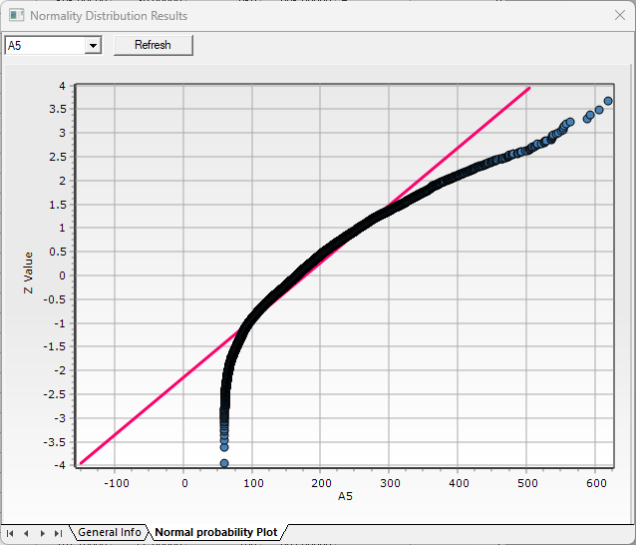

#### 4.3.2.7 Poisson Test

The Poisson goodness-of-fit test is a technique that tests whether the collected data follows a Poisson distribution.

###### How to run

**[Analyze] – [Basic Statistics] – [Poisson Test]**

Select a variable for the Poisson distribution goodness-of-fit test. To display a distribution chart comparing observed and expected values, check the corresponding option.

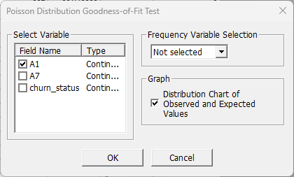

###### Results

The analysis results include the Poisson probability, an expected value, and chi-square test statistic for each variable. Poisson Distribution Goodness-of-Fit Test output provides a summary of how well observed data align with a Poisson distribution based on an estimated mean. The table includes category ranges, observed counts, expected values calculated from Poisson probabilities, and each category’s contribution to the overall chi-square statistic. This format allows for evaluation of model fit by comparing observed and expected frequencies across categories.

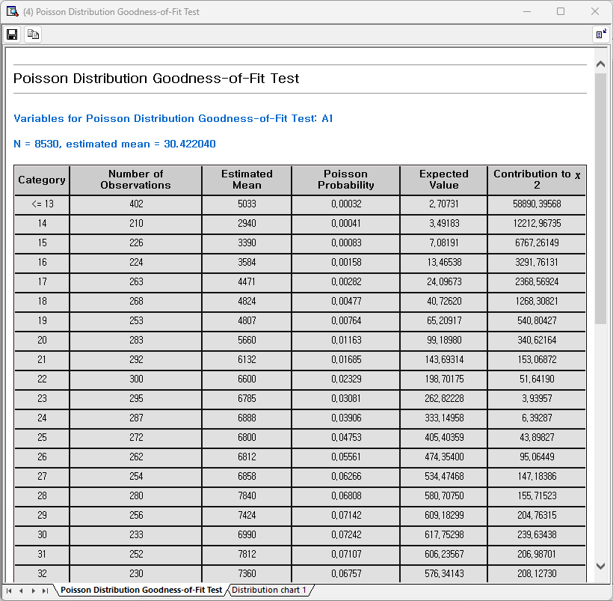

In the Poisson distribution tab of the results window, you can view the distribution chart of observed and expected values.

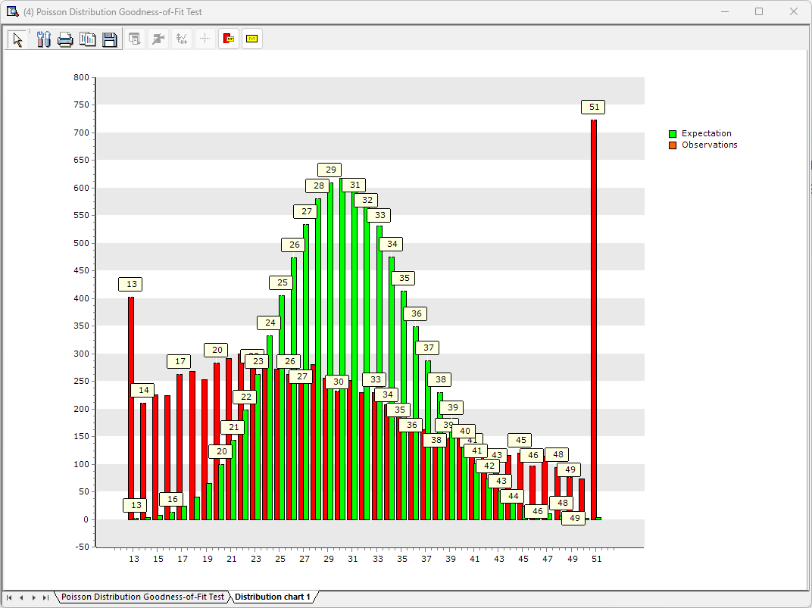

### 4.3.3 Variance Analysis

#### 4.3.3.1 One-way ANOVA

One-way ANOVA is a statistical method that involves one factor and is used to determine whether there are significant differences in the means of three or more independent groups.

###### How to run

**[Analyze] - [Variance Analysis] - [One-way ANOVA]**

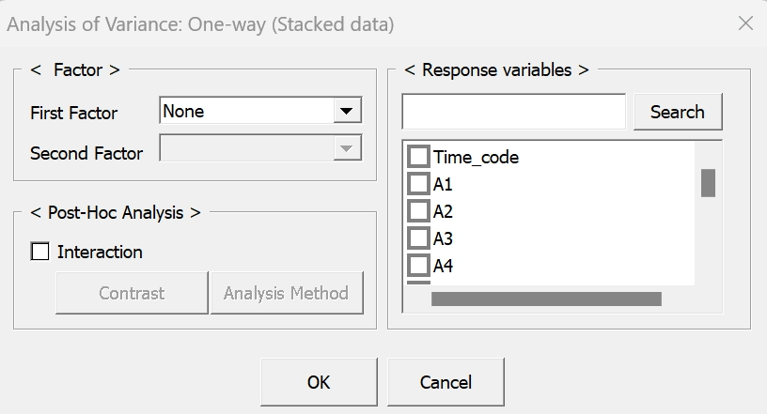

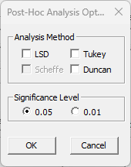

Select the Factor. **Factor**: Select one discrete variable which has different groups or categories. **Observed Value**: Select continuous variables that affect the group means. Post-Hoc analysis: Select the analysis method which identify which groups differ from each other. Moreover, select desired significance level depending on your needs. **LSD**: more sensitive to small differences than **Tukey**. **Tukey**: robust and reliable than **LSD**. **Duncan**: useful when larger pairs of means are being compared. And check the Response variables.

###### Result

One-way ANOVA output consists of two main sections. The first is the ANOVA table, which summarizes the variation between groups and within groups, reporting degrees of freedom, sum of squares, mean square values, the F statistic, and its associated p-value. This table is used to determine whether there are statistically significant differences among group means.

The second section presents the results of the LSD (Least Significant Difference) method for post-hoc comparison. It includes the significance level, calculated least significant difference value, and grouping information that indicates which group means are not significantly different from each other. Groups sharing the same grouping label are considered statistically similar based on the LSD test.

|  |
| --- |
|  |

#### 4.3.3.2 Two-way ANOVA

Two-way ANOVA is a statistical method that involves two factors and interaction between the two factors. It is used to determine whether there are significant differences in the means of three or more independent groups.

###### How to run

**[Analyze] - [Variance Analysis] - [Two-way ANOVA]**

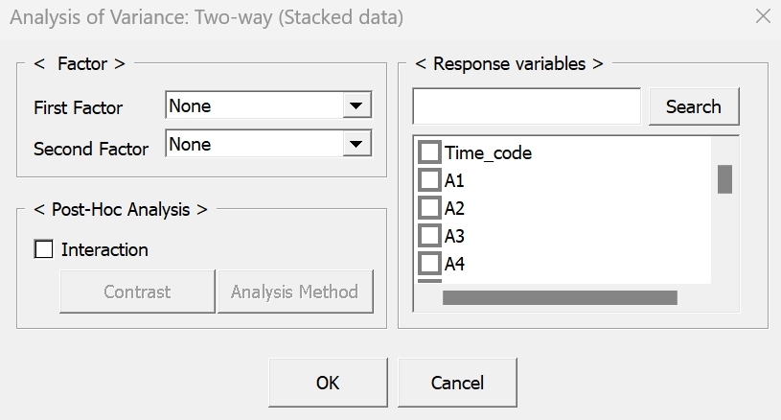

Select the factors. **First/Second Factor**: Select two discrete variables that which has different groups or categories. **Observed Value**: Select continuous variables that affect the group means. And check the Response variables.

###### Result

Two-way ANOVA table output summarizes the effects of two independent factors on a dependent variable. It displays the degrees of freedom, sum of squares (variability), mean squares (average variability), F-values, and corresponding p-values for each factor. It also includes residual error and total variability. This format is used to determine whether each factor has a statistically significant effect on the observed outcome.

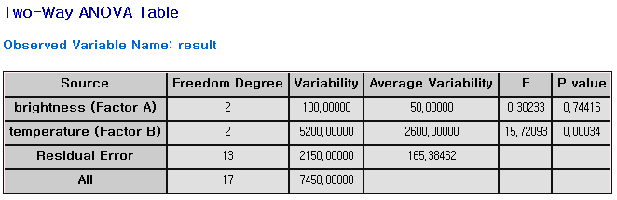

#### 4.3.3.3 GLM (General Linear Model)

General Linear Model can handle imbalanced data that often appears in real situations and can also handle covariates.

###### How to run

**[Analyze] – [Variance analysis] – [General Linear Model]**

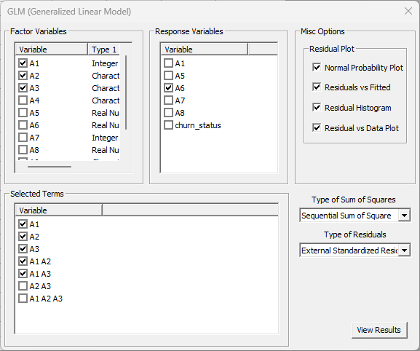

**Factor Variables**: Enter the variables corresponding to the factors used in the experiment. At this time, the selected continuous variable is automatically processed as a covariate. **Response Variables**: Multiple selections are possible, and if multiple selections are made, you can obtain results for analysis of variance and linear regression models for multiple response variables. **Selected Terms**: Select interaction terms you may want. **Residual Plot**: Selected residual plots will be displayed on the results page. **Type of sum of Squares**: Choose whether to use **Modified** or **Sequential Sum of Square**. **Type of Residuals**: Choose whether to use **Residuals**, **Standardized Residuals**, or **External Standardized Residuals**.

###### Result

General Linear Model output includes an ANOVA table and regression analysis results for a specified response variable. The ANOVA table shows sources of variation such as main effects, interaction terms, and residual error, with corresponding degrees of freedom, sum of squares (SS), mean squares (MS), F-values, and p-values. Below the table, R-squared and adjusted R-squared values are provided to indicate the model's explanatory power. This format is used to evaluate the significance of predictors and their interactions in explaining the variation in the response variable.

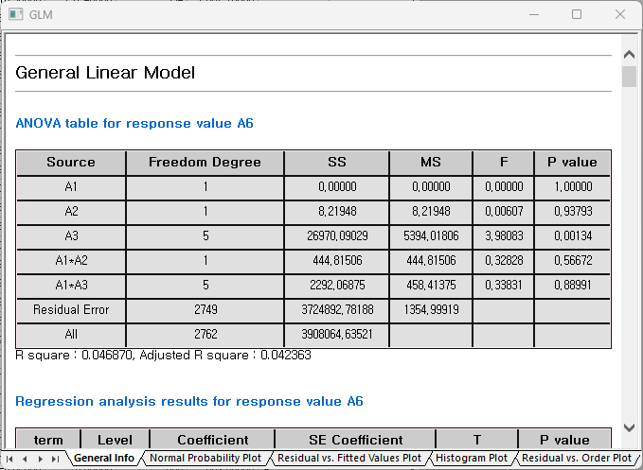

Normal Probability Plot: More data points near the red line indicate that the residuals are closer to a normal distribution. Residual vs. Fitted Values Plot: Plot with residuals on the horizontal axis and fitted values on the vertical axis. Histogram Plot: Distribution of residuals. Residual vs. Order Plot: Residuals to the order of the data points.

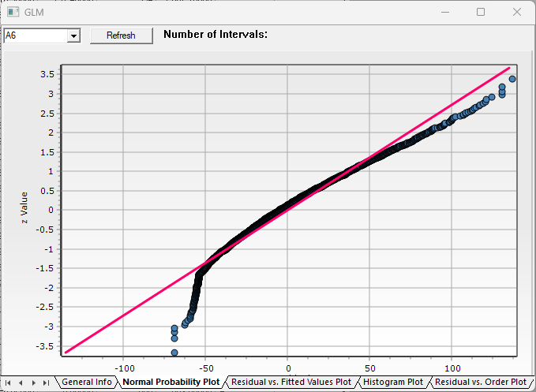

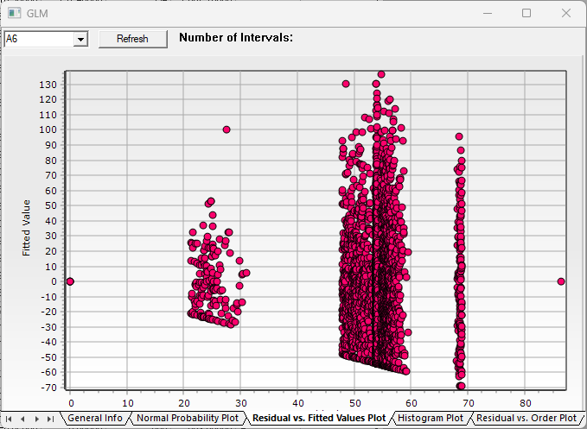

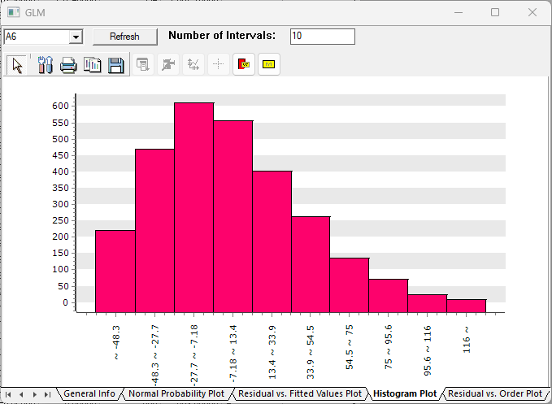

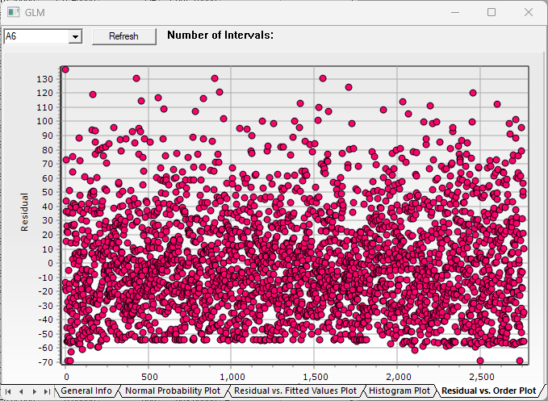

### 4.3.4 Regression Analysis

#### 4.3.4.1 Multiple Linear Regression

Multiple Linear Regression predicts the dependent variable through the linear equation of two or more independent variables. MLR settings can be chosen between Stepwise or General where Stepwise technique combines Forward, Backward methods to iteratively add or remove variables, refining the model with significant predictors.

###### How to run

**[Analyze] – [Regression Analysis] – [Multiple Linear Regression]**

Select Dependent Variable from the dropdown selection box and Independent Variables through clicking the Variable Filter button. Then in the Model Setting, choose the Multiple Linear Regression technique between General and Stepwise. When Stepwise is chosen, also set the options of significance levels. Then click Execute button to see the results.

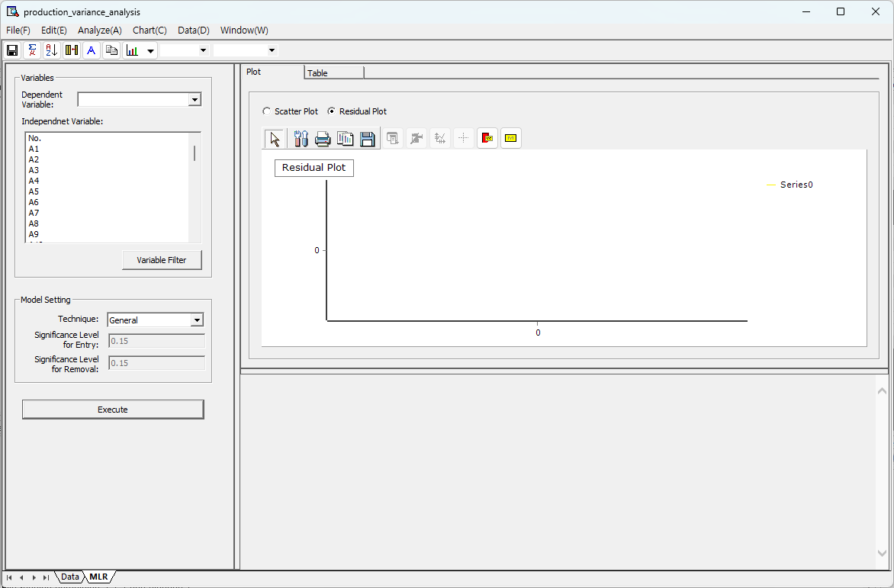

###### Results

The analysis results include Residual/Scatter Plots and MLR result table, where each result can be viewed through Plot and Table tab, respectively. The multiple linear regression analysis interface provides an integrated environment for model fitting, diagnostic visualization, and result interpretation. The layout consists of the following key components. 1. Variable Selection Panel: On the left, users can select a dependent variable and multiple independent variables from a list. A variable filter option is also available to refine the selection. Below that, model settings such as the technique type and significance levels for variable entry and removal can be configured. Once configured, clicking the "Execute" button performs the regression analysis. 2. Model Expression and Output Summary: The main panel displays the regression equation with estimated coefficients for selected variables. Variables excluded due to multicollinearity are also listed. An ANOVA table summarizes the model's statistical performance, including degrees of freedom, sums of squares, mean squares, F-statistic, and p-value. This section is used to assess the model's overall significance. 3. Plot Tab: The “Plot” tab offers two visualization modes. 1) Residual Plot: Displays predicted values (YHAT), actual values (Y), and residuals. This plot is used to assess model fit and detect patterns or biases in residuals. 2) Scatter Plot: Shows the relationship between predicted values and actual values. It helps evaluate the correlation and goodness of fit. 4. Table Tab: The “Table” tab presents a detailed numerical summary of the dataset and regression results. It includes original variable values along with calculated fields such as predicted values (YHAT), residuals, and leverage statistics. This tab allows users to inspect individual observations and diagnose potential outliers or influential data points. This structure supports both visual and tabular interpretation of regression results, making it suitable for thorough model evaluation.

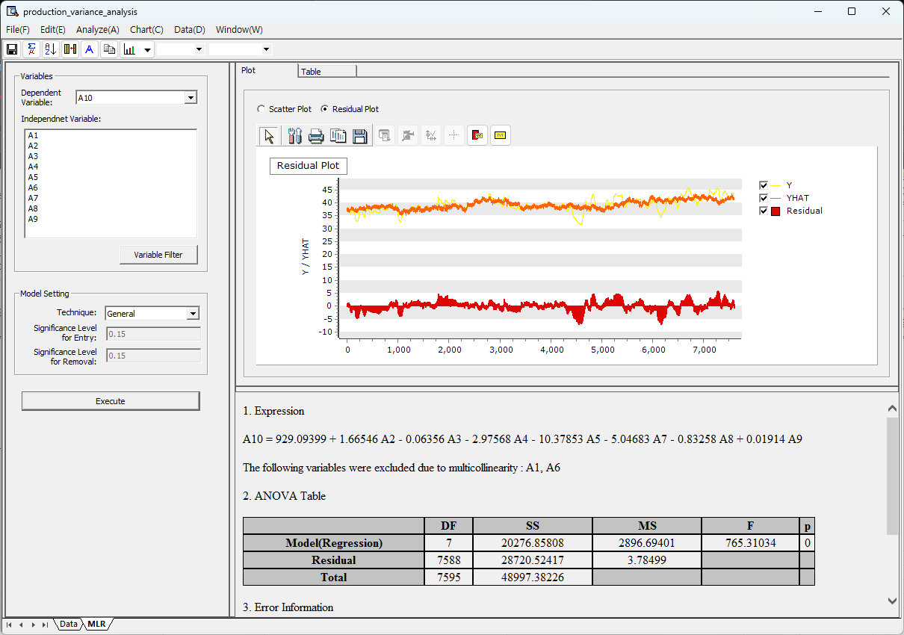

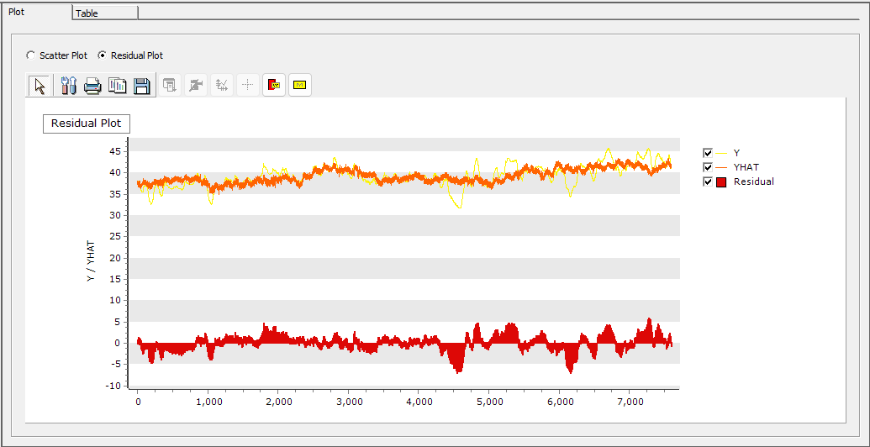

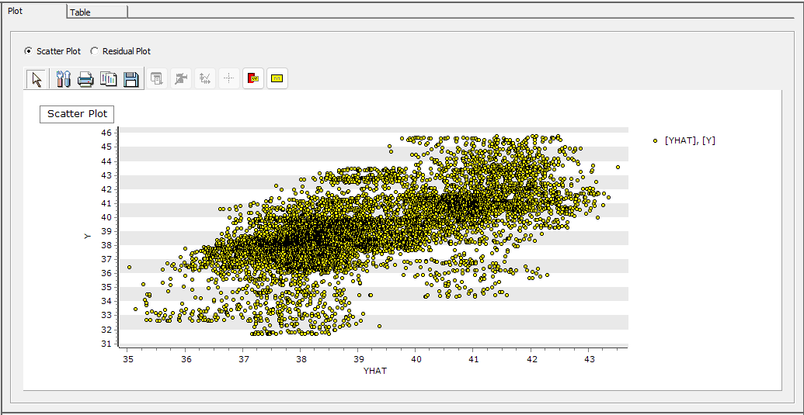

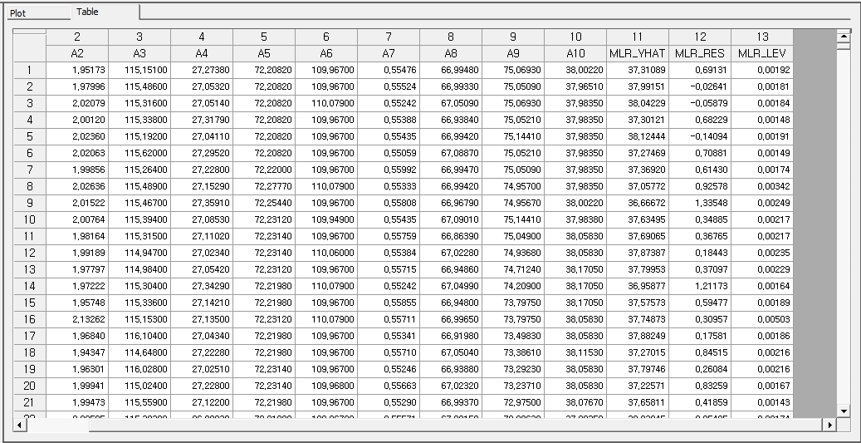

Below, the regression equation, ANOVA table, and Standard Error Information table are displayed.

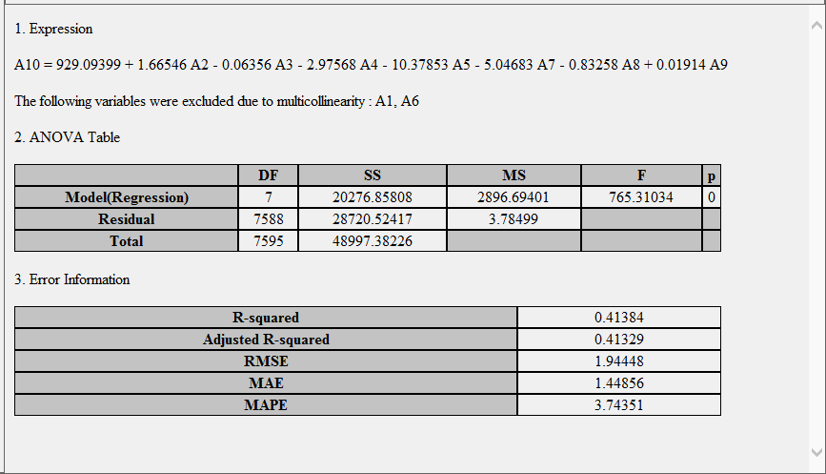

#### 4.3.4.2 Orthogonal Regression Analysis

Orthogonal regression assumes errors in both independent and dependent variables and minimizes the sum of squared orthogonal distances between the observations and the regression line. Unlike ordinary least squares (OLS), which only considers errors in the dependent variable, orthogonal regression accounts for errors in both variables, yielding a more accurate regression line.

###### How to run

**[Analyze] – [Regression Analysis] – [Orthogonal Regression Analysis]**

Select Independent Variable and Dependent Variable and input Error Variance Ratio (Variance of the Dependent Variable’s Error/ Variance of the Independent Variable’s Error).

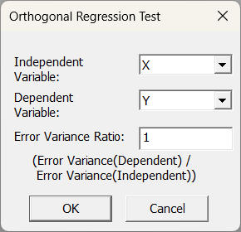

###### Results

The analysis results include the orthogonal regression equation, a regression coefficient estimates, and the error variance for each variable. In the Orthogonal regression line tab of the results window, you can view the graph of the observed values and the orthogonal regression line.

Orthogonal regression test output consists of two main components: a numerical summary and a regression plot. The numerical summary includes the error variance ratio between the response and predictor variables, the regression equation, and detailed coefficient estimates. For each term in the model, it reports the estimated coefficient, standard error, z-value, p-value, and confidence interval. Error variances for both the response and predictor variables are also provided. The accompanying regression plot visualizes the orthogonal regression line overlaid on the scatter plot of the observed data points. This helps in visually assessing the fit of the model when both variables are subject to measurement error. Two tabs are available: one for the regression output summary and one for the regression plot. This format is used to perform and interpret orthogonal regression analysis where error is assumed in both X and Y.

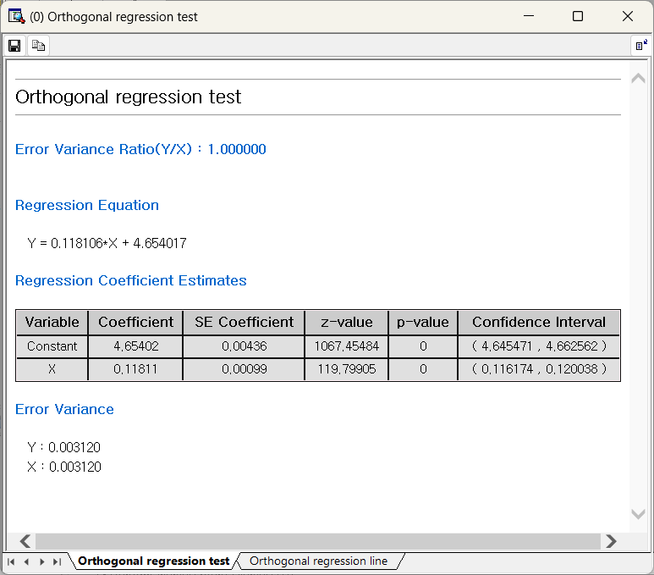

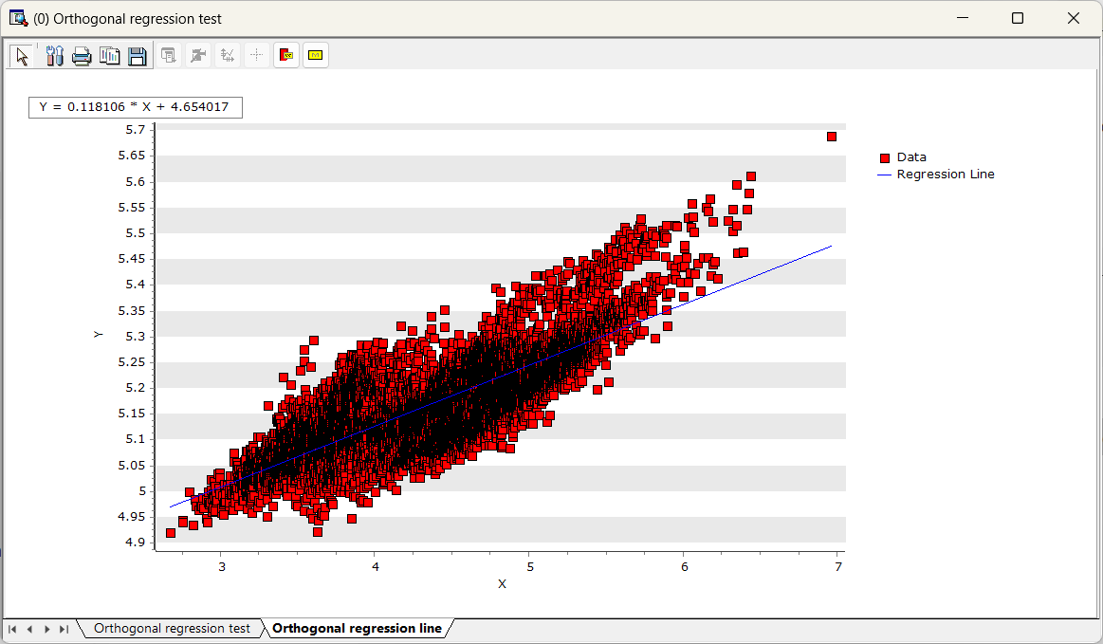

#### 4.3.4.3 Nonlinear Regression

###### Overview

Nonlinear Regression is applied when the relationship between the independent and dependent variables is **nonlinear**, with the regression equation expressed as a nonlinear function (such as polynomial, exponential, or logarithmic functions).

Nonlinear Least Square Regression: ECMiner™ Nonlinear Regression uses the Levenberg-Marquardt algorithm, a high-performance method widely used for nonlinear regression and optimization problems. The Levenberg-Marquardt algorithm performs an optimization process to minimize the Nonlinear Least Square Regression (as shown in the equation above) and efficiently adjusts parameters by combining the Gauss-Newton method and gradient descent.

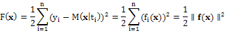

Curve Fitting in ECMiner™ - 1) **Standard Expression**: ECMiner™ supports various standard regression analyses that can be linearized for parameter estimation and generally provides accurate predictions.: Polynomial Function, Logarithm Function, Exponential Function, Power Law Function, Rational Function. 2) **Custom Expression**: If you input a desired function shape, the algorithm will find the best-fitting parameters.

###### How to run

**[Analyze] – [Regression Analysis] – [Nonlinear Regression Analysis].** Specify either Custom Expression or Standard Expression. If you select the Standard Expression, define the independent and dependent variables. When you specify variables, select the form of the function, and press the Run button, you can view the estimated results (plot and regression analysis results) as follows. If you select Residuals, the scatterplot of the time series data and fitted values. You can select different types of residuals. If you select the Custom Expression, click the 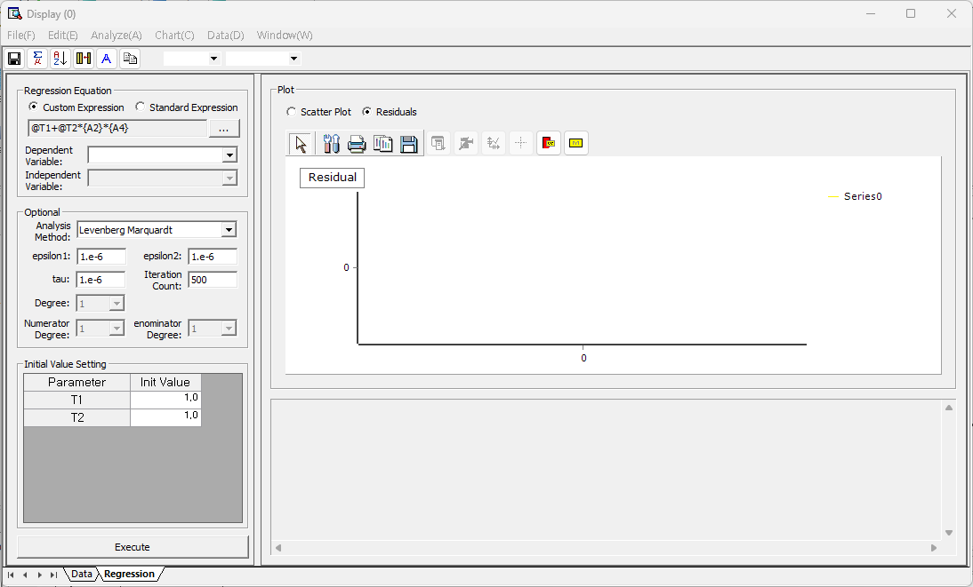 button and specify the formula you want. (At this time, please note that the name of the parameter to be estimated must be written in the form @T1, @T2, etc.). If there are two variables used as independent variables above, the following 3D plot can be obtained as a result. If you select the Residuals radio button, you can view the actual time series data, fitted values, and residual trends as follows.

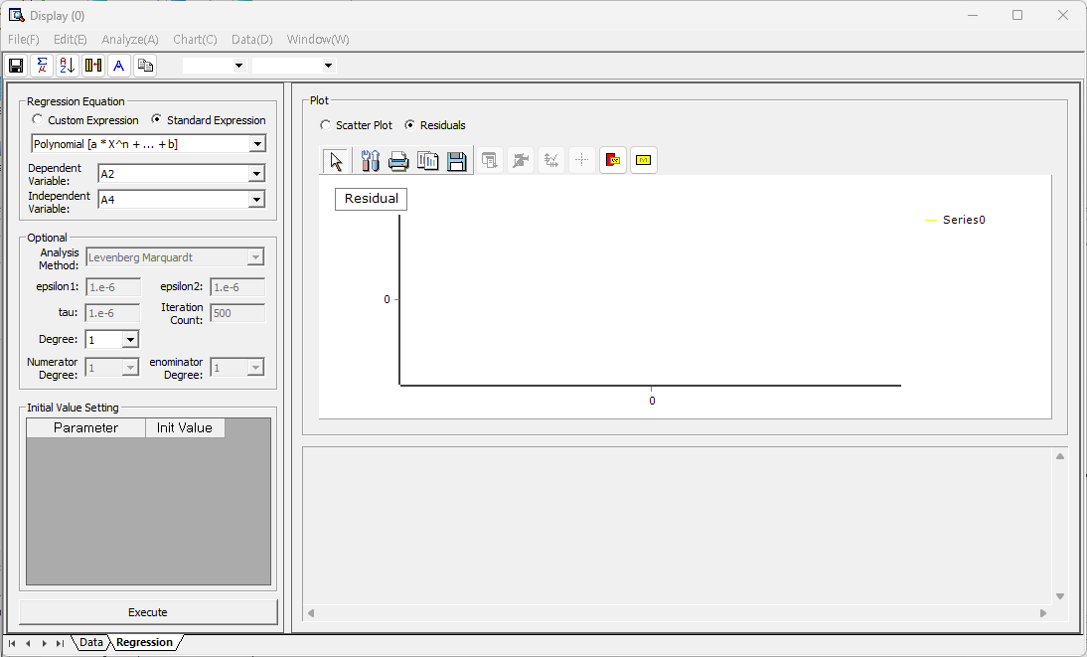



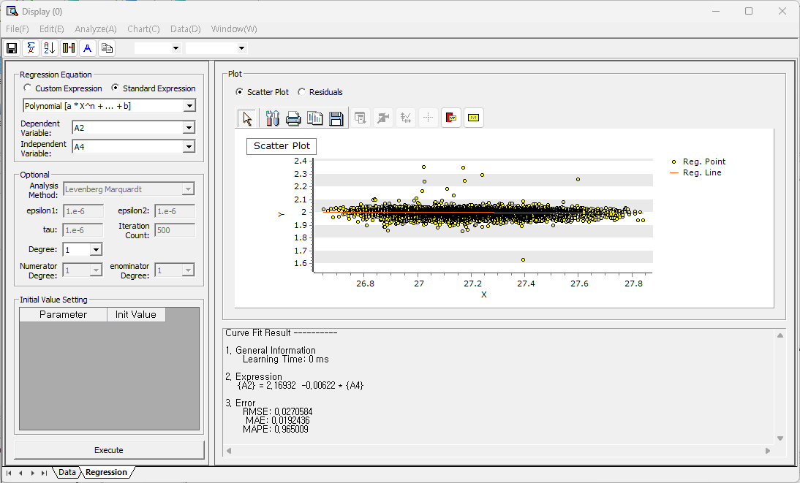

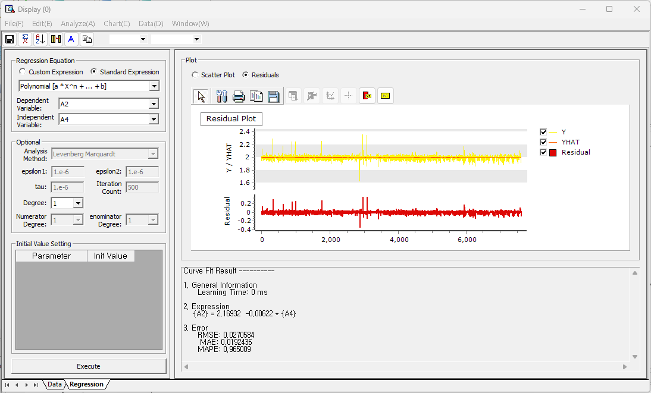



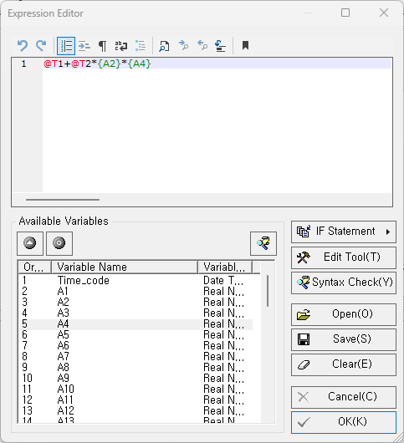

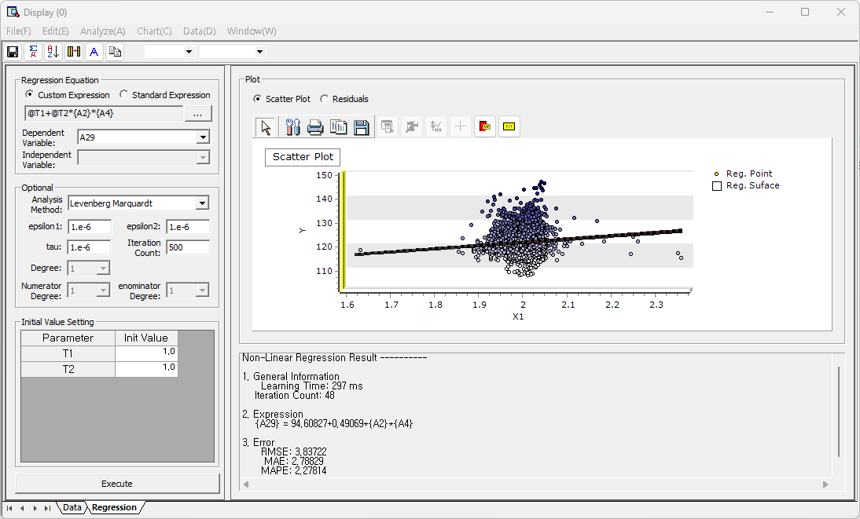

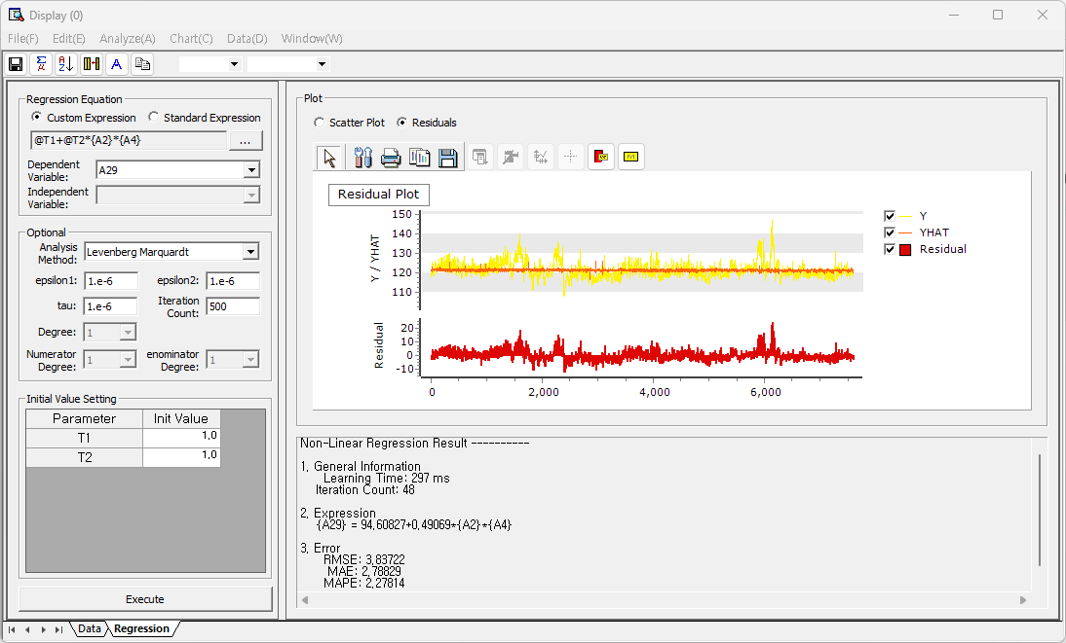

### 4.3.5 SPC (Statistical Process Control)

#### 4.3.5.1 Process Capability Analysis

Process Capability Analysis is for evaluating whether data is distributed within the desired specification.

###### How to run

**[Analyze] - [SPC] - [Process Capability Analysis].** Click [Settings] button, and select the target variable. Select Target Variable (multiple selections are possible) and set the LSL, USL, TSL, Subgroup Size, and Number of bins or histograms.

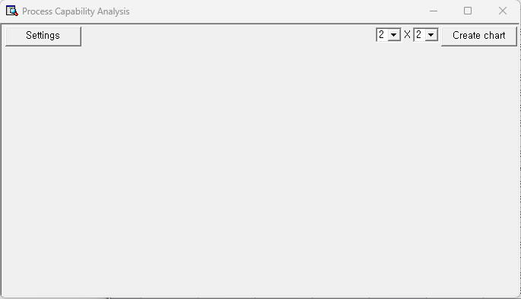

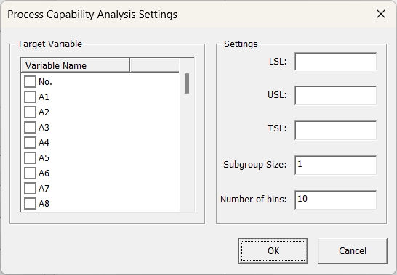

###### Results

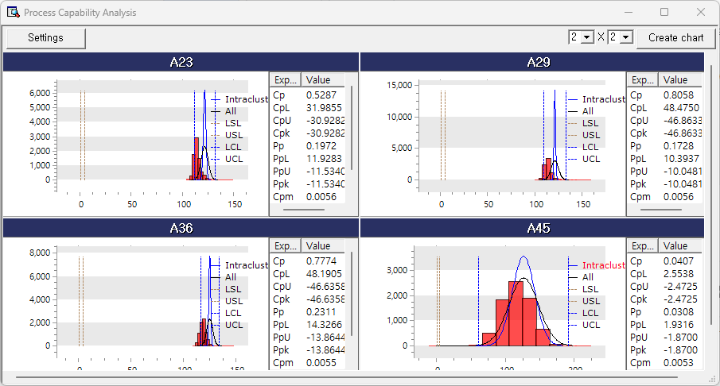

|  |  |  |
| --- | --- | --- |
| **Terminology** | Description | etc. |
| **Histogram** | Histogram |  |
| **Intracluster** | Normal distribution curve using the mean of and the standard deviation within the subgroup. | The chart varies by **group size** |
| **All** | Normal distribution curve using the mean and standard deviation |  |
| **LSL** | Lower specification limit. The lower limit on the process specification. | It depends on **LSL** in the **[Settings]** window. |
| **USL** | Upper specification limit. The upper limit on the process specification | It depends on **USL** in the **[Settings]** window. |
| **LCL** | Lower control limit. LCL is used as a threshold  (LCL = mean - 3 \* standard deviation) |  |
| **UCL** | Upper control limit. UCL is used as a threshold  (UCL = mean + 3 \* standard deviation) |  |
| **Cp** | Process Capability Index (PCI). PCI is a criterion used to evaluate process capability.  Cp = (USL - LSL)/(6 \* within-group standard deviation) |  |
| **CpL** | CpL is a measure of how close the subgroup average is to the LSL. The lower the CpL, the higher the likelihood of producing defects.  CpL = (mean – LSL)/(3 \* within-group standard deviation) |  |
| **CpU** | CpU is a measure of how close the subgroup average is to the USL. The lower the CpU, the higher the likelihood of producing defects.  CpU = (USL – mean)/(3 \* within-group standard deviation) |  |
| **Cpk** | Cpk considers the shift in the process mean. Unlike Cp, Cpk measures how well a process is centered between specification limits |  |
| **Pp** | Process capability index (PCI) for the entire process without considering subgroups.  Pp = (USL – LSL)/(6 \* standard deviation) |  |
| **PpL** | Overall average of the process is to the LSL.  PpL = (mean – LSL)/(3 \* standard deviation) |  |
| **PpU** | PpU is a measure of how close the overall average of the process to the USL.  PpU = (USL – mean)/(3 \* standard deviation) |  |
| **Ppk** | Ppk considers the shift in the overall process mean. Unlike Pp, Ppk measures how well a process is centered between specification limits |  |
| **Cpm** | A Process Capability Index (PCI) that indicates how close the process is to the target value. Calculated as the deviation from the process average and target value |  |

#### 4.3.5.2 Process Capability Result

Process Capability Summary provides summary report for a specific field whether data is distributed within the desired process specification area.

###### How to run

**[Analyze] - [SPC] - [Process Capability Result].** Click [Settings] button, and select the target variable. Select Target Variable and set the LSL, USL, TSL, Subgroup Size, and Numbers of bins for multiple charts.

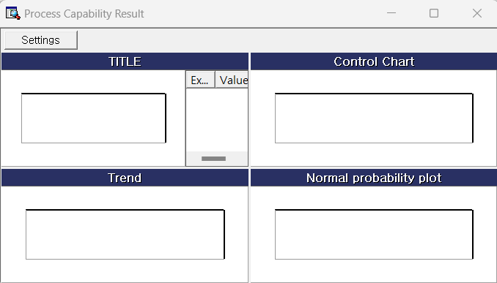

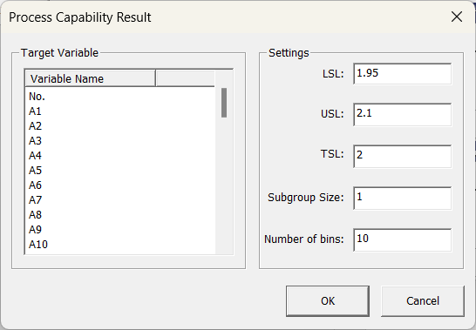

###### Results

Process capability summary output provides a comprehensive evaluation of process performance and stability. It is typically divided into four panels: 1. **Histogram with Capability Indices**  
This panel displays a histogram of the measurement data overlaid with specification limits and fitted distribution curves. It includes key process capability indices such as Cp, Cpk, Pp, and Ppk, along with performance-related statistics. These values help assess how well the process meets specification requirements. 2. **Control Chart:** This chart monitors process stability over time. It includes an individual values chart (I Chart) and a moving range chart (MR Chart), each showing control limits and center lines. These plots are used to detect any signals of instability or special cause variation in the process. 3. **Trend Chart:** The trend chart shows the progression of sample values or subgroup statistics over time. It helps in identifying shifts, drifts, or patterns that may affect process consistency. 4. **Normal Probability Plot**: This plot compares the distribution of the observed data to a theoretical normal distribution. It is used to assess whether the data approximately follow a normal distribution, which is an assumption for many capability indices. Together, these components provide a complete picture of both process capability and statistical control.

**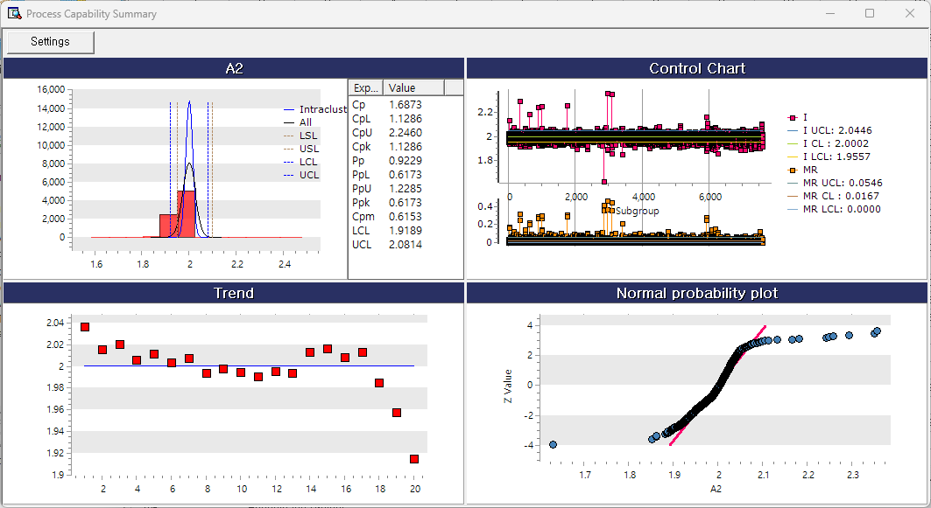**

#### 4.3.5.3 Acceptance Sampling

Acceptance Sampling is a technique that determines whether a lot accept or fails a sample product randomly drawn from the lot. If you are counting defective or non-defective items, choose Attributes Acceptance Sampling. If you are testing a variable against a specific threshold to determine whether it is defective, choose Variable Acceptance Sampling.

###### **(1) Attributes Acceptance Sampling**

How to run

**[Analyze] – [SPC] – [Acceptance Sampling] – [Attributes Acceptance Sampling].** Select General Sampling Plan. The result gives you the optimal sample size and number of acceptances. If you want to compare several sample sizes and number of acceptances, choose Comparison among User-defined acceptance sampling plan. The result will display sampling inspection plan using all the combinations of sample sizes and number of acceptances.

Select Measurement Type and Unit of Quality Level, and set a value.

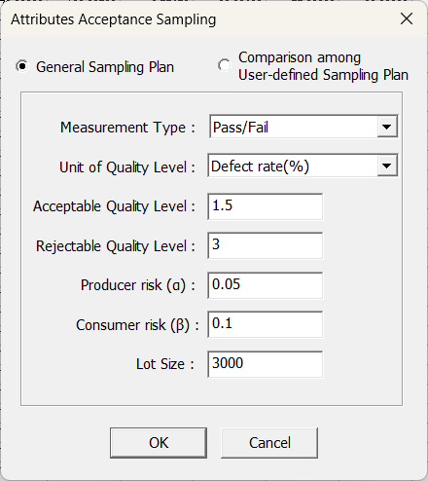

Results

An optimal sampling inspection plan is suggested based on given criteria.Attributes acceptance sampling output is divided into two main sections: sampling plan information and the generated sampling plan. The **Sampling Plan Information** section provides the basic settings used for plan generation. It specifies the measurement type as pass/fail and the unit of quality level as defect rate (%). Key parameters include the acceptance quality level (AQL), failure quality level (FQL), producer's risk (α), consumer's risk (β), and lot size. These values define the statistical criteria for accepting or rejecting a lot. The **Generated Sampling Plan** section presents the calculated sample size and acceptance number based on the input criteria. It also includes a table showing the acceptance and failure probabilities for specified defect rates, along with associated metrics such as average entry and exit quality and average total inspection quantity. This format supports decision-making for quality control based on attribute data.

Tabs at the bottom allow users to switch between numerical results and graphical representations of the sampling characteristics.

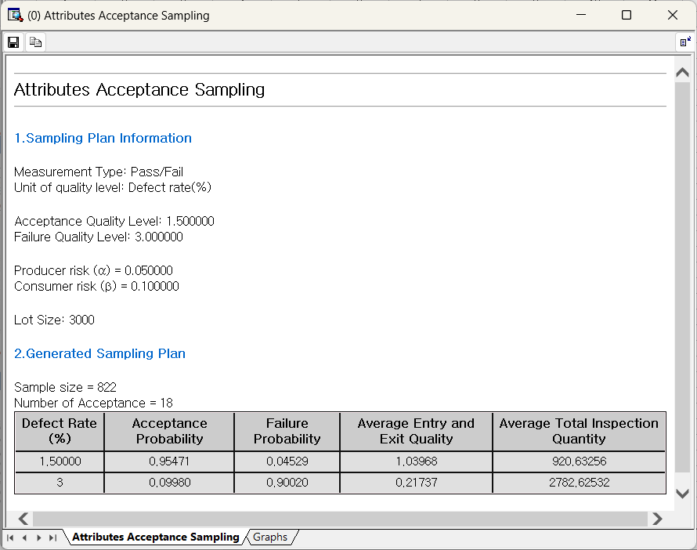

Select Graphs bottom, OC curve, AOQ, and ATI charts are displayed. **OC (Operating Characteristic) Curve:** This plot displays the probability of lot acceptance as a function of the lot defect rate. It illustrates how the sampling plan discriminates between good and bad lots, helping to visualize the producer’s and consumer’s risks. **AOQ (Average Outgoing Quality) Curve:** This curve shows the average quality of accepted lots, factoring in both inspected and uninspected items. It provides insight into the overall quality level that passes through the inspection process. **ATI (Average Total Inspection) Curve:** This plot represents the average number of units inspected for various lot defect rates. It reflects the inspection effort required under the specified sampling plan.

Each graph supports understanding of how the sampling plan performs under different quality conditions and complements the numerical results shown in the previous tab.

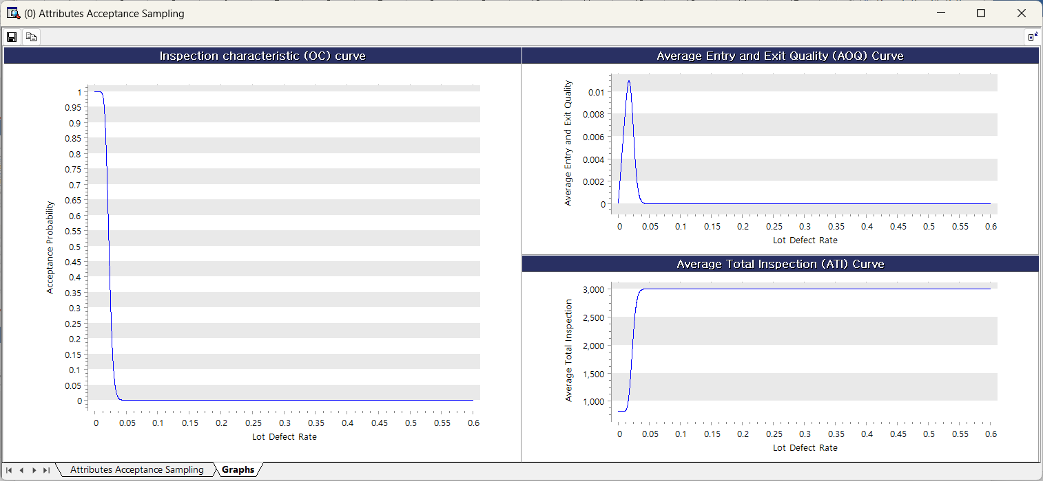

###### **(2) Quantitative** Acceptance **Sampling**

How to run

**[Analyze] – [SPC] – [Acceptance Sampling] – [Quantitative Acceptance Sampling].** Select General Sampling Plan. The result gives you the optimal sample size and critical distance. If you want to compare several sample sizes with specific critical distance, choose Comparison among User-defined quantitative sampling plan. The result will display sampling inspection plan using all the combinations of sample sizes and critical distance. Fill all the blanks and define Unit of Quality Level.

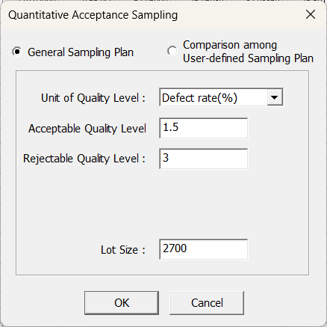 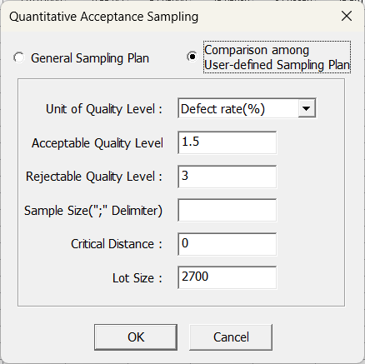

Results

The Quantitative Acceptance Sampling results is organized into two sections: sampling plan information and the generated sampling plan. The **Pass Sampling Plan Information** section defines the parameters for generating the plan, including the unit of quality level (defect rate in %), the acceptance quality level (AQL), the failure quality level (FQL), and the lot size. These values are used to determine the appropriate sampling strategy for quantitative measurements. The **Generated Sampling Plan** section provides the calculated sample size and the critical distance (cutoff value) for acceptance. A condition is stated indicating that if the test statistic exceeds the critical value, the entire lot is accepted or rejected accordingly. A summary table shows the acceptance and failure probabilities at given defect rates, along with the average entry and exit quality and the average total inspection quantity. This layout allows for interpretation of the sampling plan’s effectiveness under different quality levels.

Tabs at the bottom allow users to switch between tabular results and related graphical analysis.

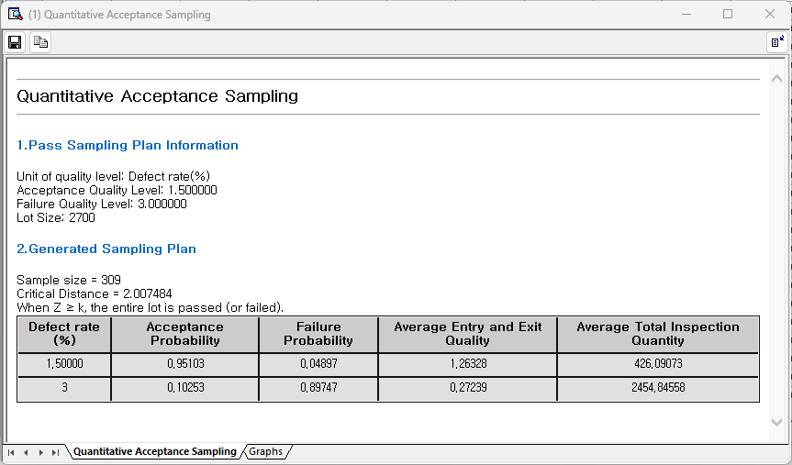

Select Graphs bottom, OC curve, AOQ, and ATI charts are displayed. **OC (Operating Characteristic) Curve:** This chart shows the probability of accepting a lot as a function of the lot defect rate. It illustrates the discriminating ability of the sampling plan and reflects producer and consumer risks. **AOQ (Average Outgoing Quality) Curve:** This plot depicts the average quality level of accepted lots, considering both inspected and uninspected units. It is used to estimate the average outgoing quality under the given plan. **ATI (Average Total Inspection) Curve:** This graph displays the average number of units inspected at different defect levels. It helps evaluate the inspection effort required depending on the actual quality of the lot. These curves are used together to understand the trade-offs between inspection efficiency and quality control effectiveness in quantitative acceptance sampling.

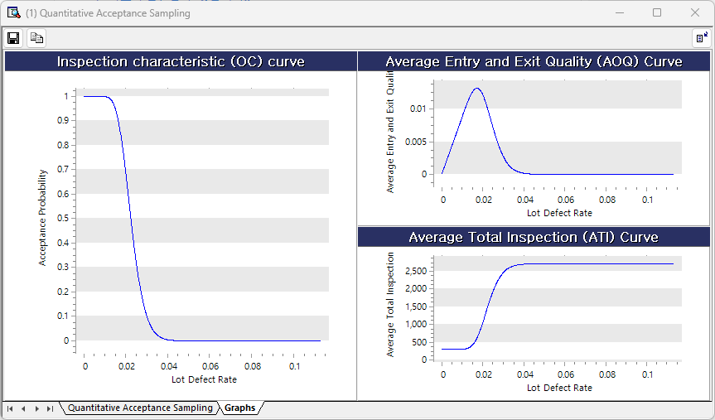

#### 4.3.5.4 Tolerance Intervals

###### How to run

**[Analyze] – [SPC] – [Tolerance Intervals]**

Select the variable to get Tolerance Intervals from the Variable Selection list (multiple selections are possible), and set the Confidence Level and Coverage Proportion (0 to 1 value). Finally, select the Interval Direction (Both Side/Upper Limit/Lower Limit).

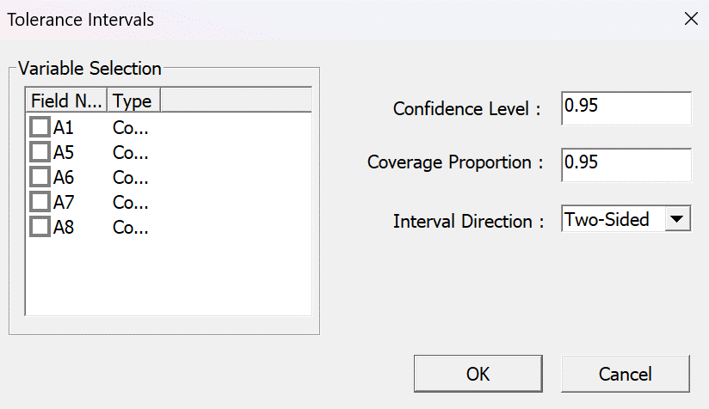

###### Results

Tolerance IntervalsResult provide these. **Statistics**: average, and standard deviation. **Tolerance Intervals**: Satisfy the specified Confidence Level and **Coverage Proportion** from the selected variable are calculated and displayed using normal distribution or non-parametric methods. **Normality Test**: Use the Anderson-Darling statistics test whether the selected variable follows normal distribution. If the p-value is closed to 1, the variable follows a normal distribution. **Histogram**: A chart for distribution of the selected variable.

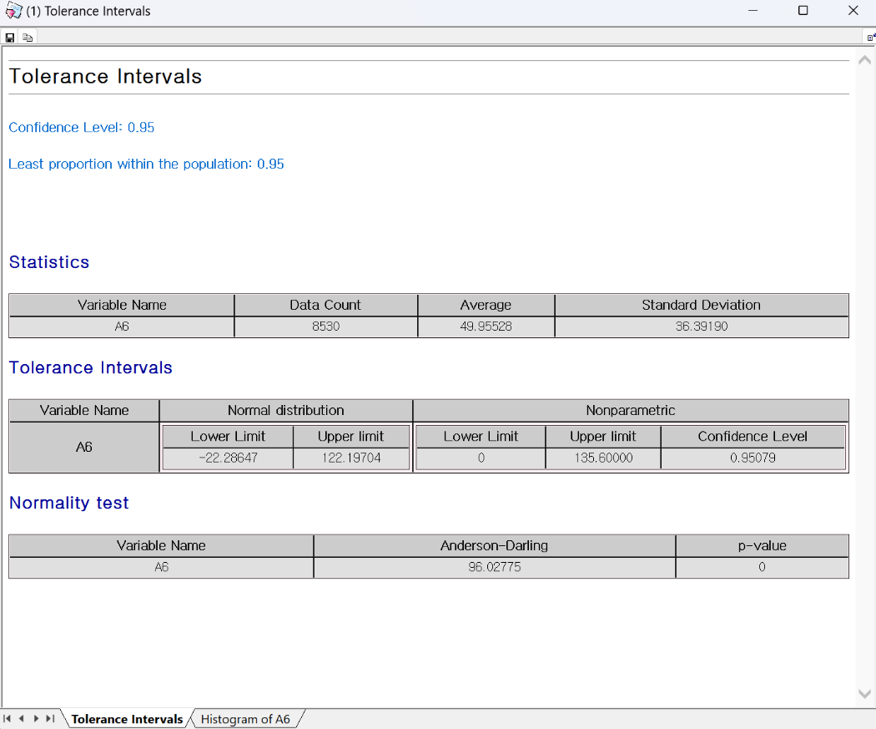

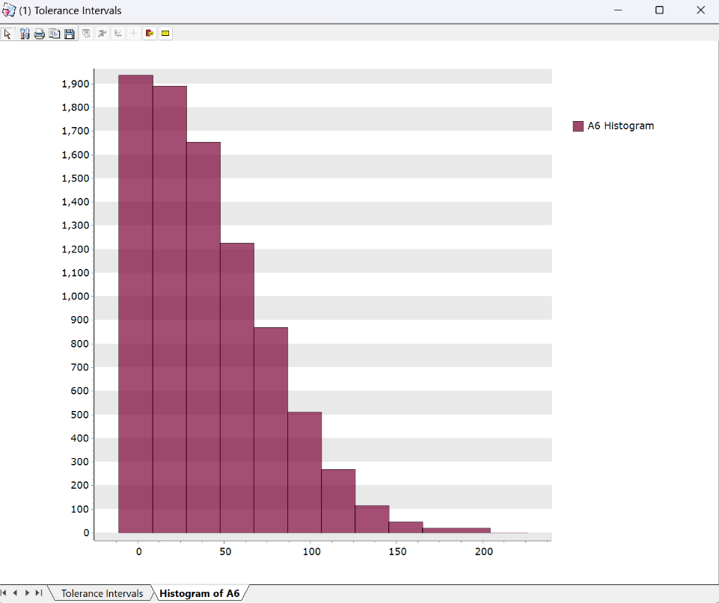

### 4.3.6 Time Series Analysis

#### 4.3.6.1 Time Series Models

##### (1) Time Series Decomposition

###### Overview

Time series decomposition is a method of breaking down a time series into several distinct components to better understand underlying patterns in the data. These components typically include trend, seasonality, cyclical variations, and irregular (residual) effects. Classical decomposition methods are categorized into two main types: **multiplicative decomposition** and **additive decomposition**. In the **multiplicative model**, the observed value at time *t* (yt) is expressed as the product of its components: yt = TRt × SNt × CLt × IRt, where TRt is the trend, SNt is the seasonal effect, CLt is the cyclical component, and IRt is the irregular component. In contrast, the **additive model** expresses the observed value as a sum: yt = TRt + SNt + CLt + IRt. Both methods aim to isolate and analyze these components. The decomposition process typically outputs various statistics, including Trend Data (tr\_t), Detrended Data, Seasonal Index (S\_t), Deseasonalized Data (y\_t - S\_t), Fitted Value (ŷ\_t), and Residuals, which help in understanding the structure and behavior of the time series. If needed, the trend component can also be excluded from the analysis depending on the goal.

###### How to run

The menu path for Time Series Decomposition from the Data Browser window is: [Analyze] – [Time Series Analysis] – [Time Series Models] – [Time Series Decomposition]. Select time series data on the main screen, select the length of the season, and whether to use Multiplicative Decomposition or Additive Decomposition, and then select either Trend+Seasonal or Seasonal. If you want a forecast, click Generate Forecast and enter Forecast Lag.

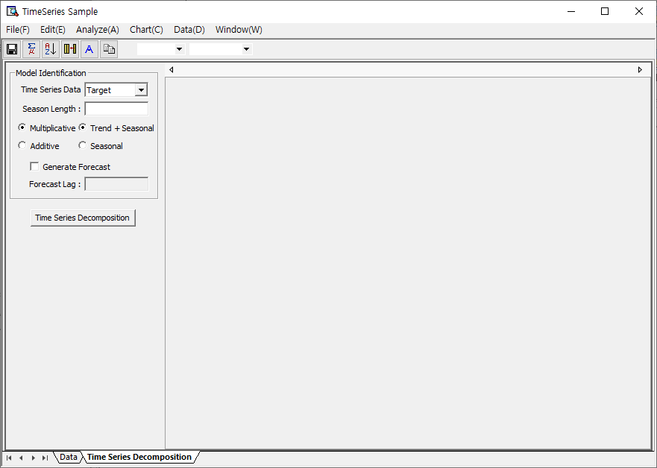

###### Results

After the “Time Series Decomposition” has been executed, the results are displayed in multiple tabs. In the “Model Report” tab, “General Info” and “Model Info” can be viewed. The “**General Info”** tab summarizes the basic details of the time series data, such as the selected target variable and season length. The “**Model Info”** tab presents the decomposition results, including the **fitted trend equation** (e.g., 3540384.436303 + 313.398615 \* t) and the **seasonal index** for each period, which quantifies the seasonal effect across different time points. If the "Generate Forecast" option is checked, forecast results are also generated based on the decomposition components. The “Plot” tab offers visual interpretations through three key types of plots: the Time Series Decomposition Plot, which compares the original data to the fitted values; the Time Series Property Plot, which visualizes individual decomposition components like trend or seasonality; and Residual Plots, which analyze residuals using histograms, normal probability plots, and scatter plots of residuals versus order or fitted values. Additionally, the “Statistics” tab presents the decomposition results in a tabular format and includes an option to export the data for further use.

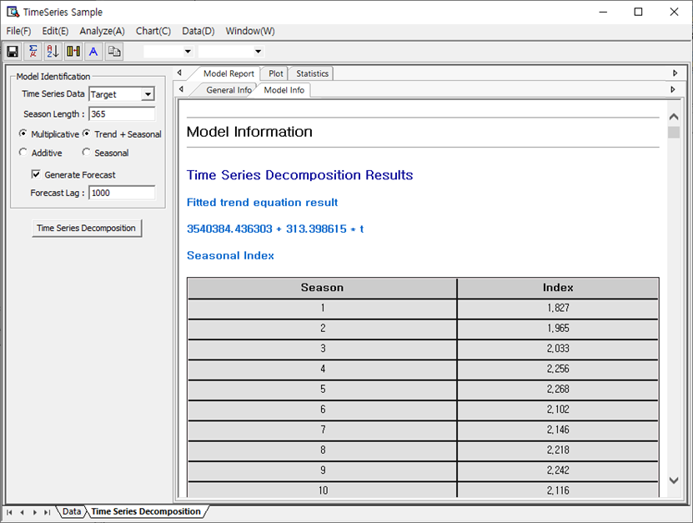

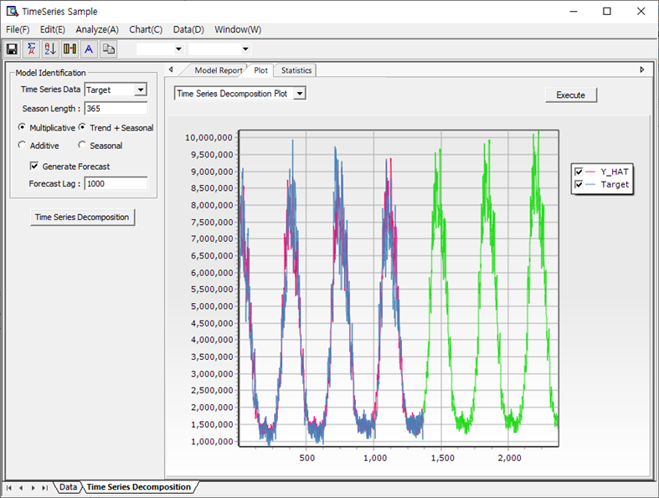

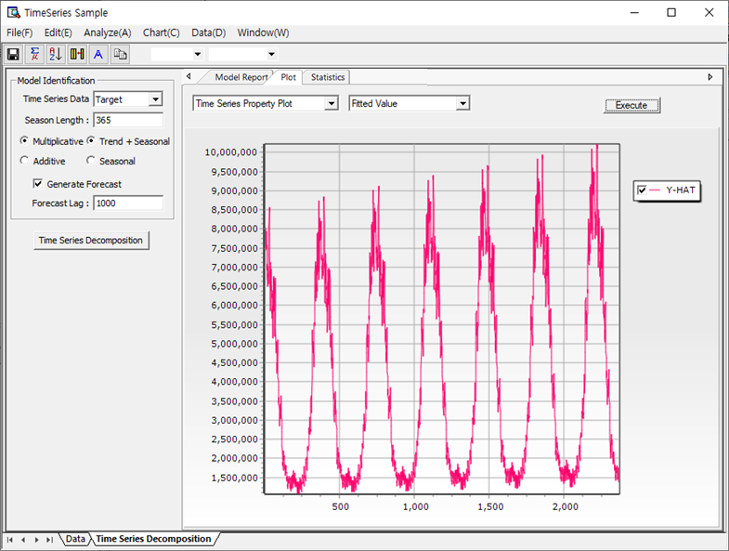

##### (2) Moving Average

###### Overview

The Moving Average method refers to the average value of several data from the present, past, and future. The method is a widely used one in its simplest form along with its expanded Centered Moving Average.

###### How to run

The menu path for Moving Average from the Data Browser window is: [Analyze] – [Time Series Analysis] – [Time Series Models] – [Moving Average]. Select Time Series Data on the main screen and enter the length of the Moving Average, Centered Moving Average option, and Forecast Lag if you want to make a forecast. After completing the input, click the [Start Moving Average Analysis] button.

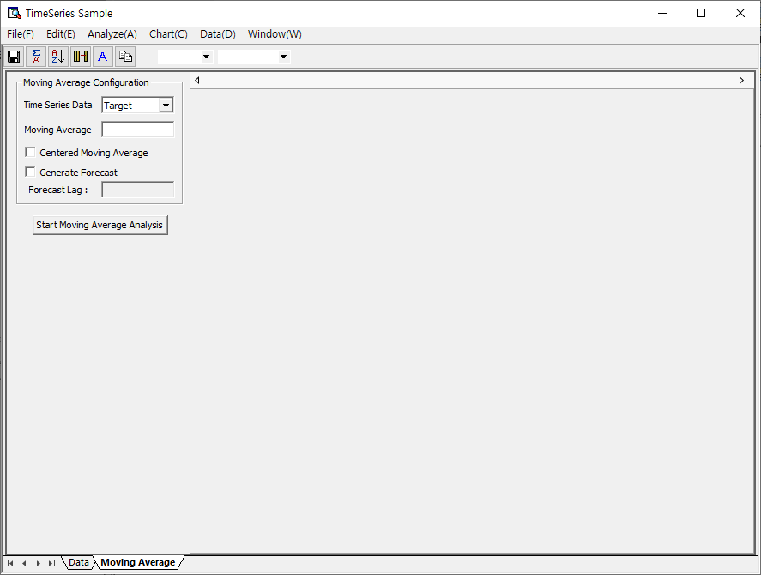

###### Results

After the “Moving Average” has been executed, the results are displayed in multiple tabs. In the “Model Report” tab, “General Info” and “Model Info” can be viewed. The “**General Info”** tab summarizes the basic details of the time series data, such as the selected target variable and season length. The “Model Info” tab provides information on the results of the Moving Average analysis. You can also view the results of the prediction accuracy based on MAPE, MAE and MSD. The “Plot” tab offers visual interpretations through three key types of plots: Moving Average plot shows time series data, fitted values, and prediction-related statistics. You can get the results the following Residual Plots (Histogram, Normal Probability Plot, Residual vs. Order, Residual vs. Fitted Values). Additionally, the “Statistics” tab presents the data obtained through Moving Average analysis is displayed in table form. It also provides a function to save it.

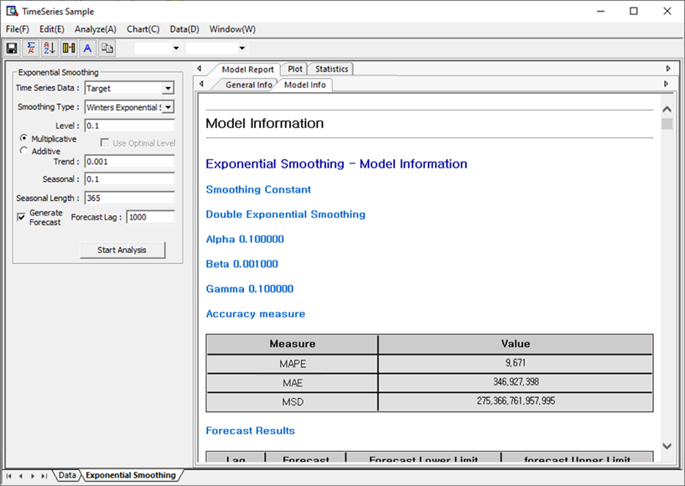

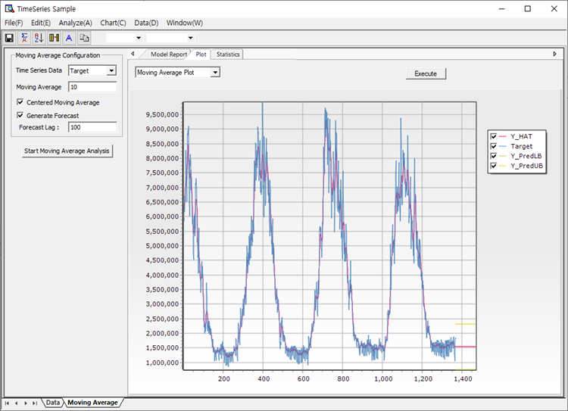

##### (3) Exponential Smoothing

###### Overview

Exponential smoothing methods are widely used for time series forecasting, and they vary depending on the presence of trend and seasonality in the data. Single Exponential Smoothing is applied to time series data without trend or seasonality, where more weight is given to recent observations to estimate the level component, unlike the equal weighting in simple averaging. This method addresses the limitations of equal weights by exponentially decreasing weights for older observations. Double Exponential Smoothing extends the single method by incorporating a trend component, making it suitable for time series data that exhibits a consistent upward or downward trend. When the model parameters (such as level and trend) are allowed to change over time, this method provides dynamic adaptability. Winters’ Methods further enhance smoothing by addressing both trend and seasonality. The Multiplicative Winters’ Method is appropriate when the seasonal effect changes proportionally with the level of the series—ideal for multiplicative seasonality. In contrast, the Additive Winters’ Method is used when seasonal fluctuations are roughly constant across time, representing additive seasonality. The additive form is a modified version of the multiplicative one and is particularly suitable for time series where seasonal variations are independent of the level.

###### How to run

**The menu path for Exponential Smoothing** **from the Data Browser window is: [Analyze] – [Time Series Analysis] – [Time Series Models] – [Exponential Smoothing]** On the main screen, select Time Series Data and select which smoothing type to use. At this time, when using Single Exponential Smoothing, the user can enter the level value directly, or check ‘Use Optimal Level’ to automatically enter the optimal level value between 0 and 1. When selecting Double Exponential Smoothing, enter level and trend smoothing constants. When using the Winters’ Method, select multiplicative and additive and enter level, trend, seasonal smoothing constants, and seasonal length. If you want to make a prediction, please enter Forecast Lag.

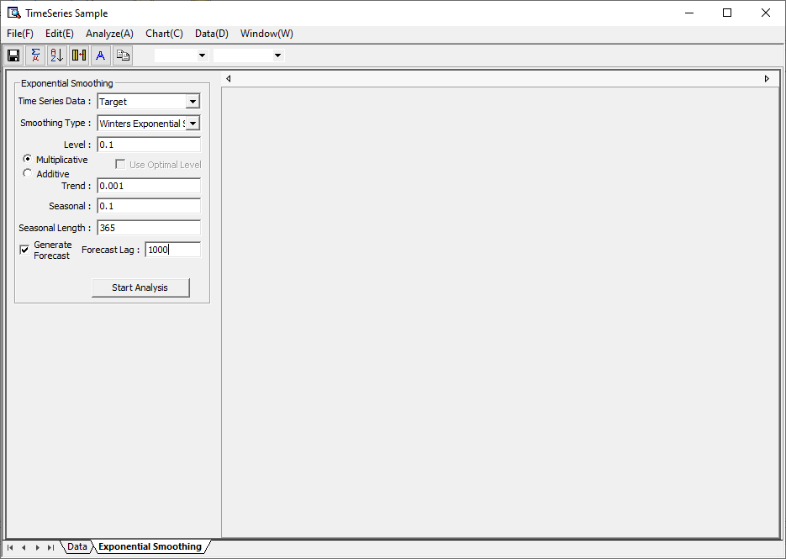

###### Results

The Exponential Smoothing analysis supports forecasting by accounting for various components of time series data, such as level, trend, and seasonality. It includes methods like Single Exponential Smoothing, which applies exponentially decreasing weights to past observations and assumes no trend or seasonality, and Double Exponential Smoothing, which extends the single method by incorporating a trend component. Winters’ methods—Multiplicative and Additive—further include seasonal components and are suitable for series with both trend and seasonality. Within the software interface, users can choose the smoothing type, set smoothing constants (level, trend, seasonal), and generate forecasts with specified seasonal length and lag. The Model Report provides constants (Alpha, Beta, Gamma) and evaluation metrics such as MAPE, MAE, and MSD to assess prediction accuracy. The Plot tab visually presents the fitted values, observations, and prediction intervals through Exponential Smoothing Plot. Residuals can be analyzed using various residual plots including Histogram, Normal Probability Plot, Residual vs. Order, and Residual vs. Fitted Values to assess model adequacy. Additionally, the Statistics tab summarizes the numerical results and allows data export for further analysis.



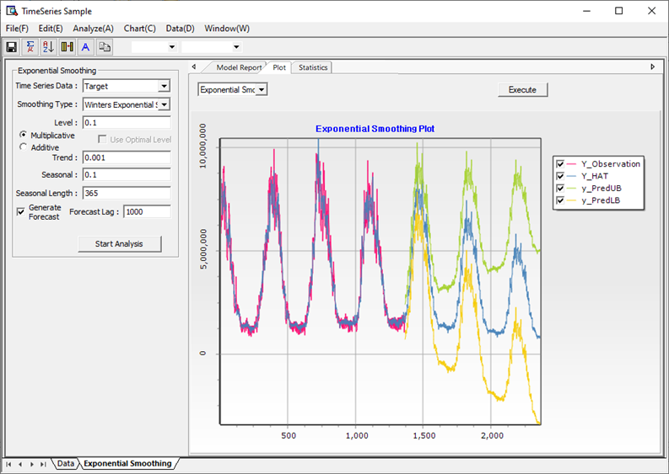

##### (4) ARIMA

###### Overview

The ARIMA (AutoRegressive Integrated Moving Average) model is one of the most widely used methods in univariate time series analysis and is expressed by the equation:  
**Φ(B)(1 − B)^d zₜ = θ(B)aₜ**, where *aₜ* is independently and identically distributed (i.i.d.) normal white noise. In the case of ARIMA(p, d, q), this equation expands as: **(1 − φ₁B − φ₂B² − ⋯ − φₚBᵖ)(1 − B)^d zₜ = (1 − θ₁B − θ₂B² − ⋯ − θ\_qB^q)aₜ**, or equivalently, **(1 − φ₁B − φ₂B² − ⋯ − φ\_{p+d}B^{p+d})zₜ = (1 − θ₁B − θ₂B² − ⋯ − θ\_qB^q)aₜ**. The goal of ARIMA modeling is to estimate the coefficients (φ's and θ's), evaluate the model's adequacy and fit through diagnostics, and then use the validated model for forecasting future values.

The Box-Jenkins method outlines a systematic approach to time series analysis and forecasting using ARIMA models. It begins with postulating a general class of models based on theory and practical understanding, such as ARIMA or ARCH. Next, a more manageable candidate model (e.g., ARIMA(1,1,1)) is tentatively identified using preliminary data exploration and expert knowledge. Then, the parameters of this candidate model are estimated—initial rough estimates may be refined through iterative methods. Following estimation, diagnostic checking is conducted to evaluate model adequacy; this involves testing residuals for randomness and identifying any patterns suggesting poor fit. If the model fails the diagnostic checks, the process loops back to the identification step and continues iteratively until a satisfactory model is found. Once validated, the final model is then used for forecasting or control.

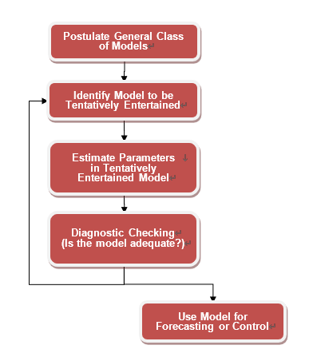

###### How to run

**The menu path for ARIMA** **from the Data Browser window is: [Analyze] – [Time Series Analysis] – [Time Series Models] – [ARIMA]** On the ARIMA main screen, you can run the Model Identification process and ARIMA Model Estimation process. Through Model Identification, you can see the autocorrelation, partial autocorrelation, and scatter plot of the differential time series data, which can help users determine the orders of the ARIMA model needed when estimating the ARIMA model. Below are examples of autocorrelation, partial autocorrelation, and scatter plot. In this way, models are identified and orders are determined through Autocorrelation, Partial Autocorrelation, and Scatter Plot. If you click the Options button, you can select the ARIMA methodology (Conditional Least Square, Maximum Likelihood) as follows and enter constant settings related to Levenberg Marquardt used for Parameter Optimization, and initialization method.

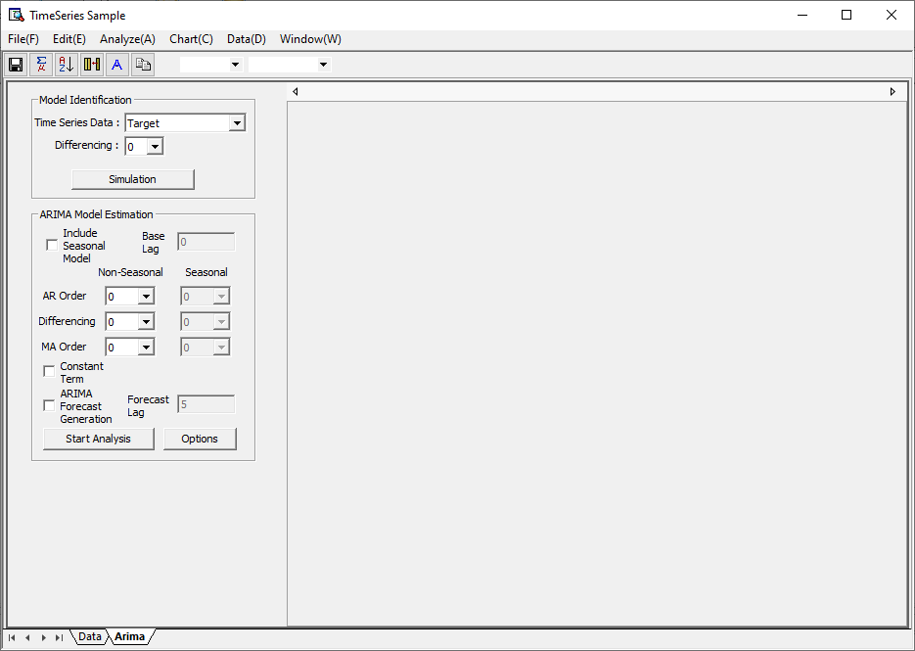

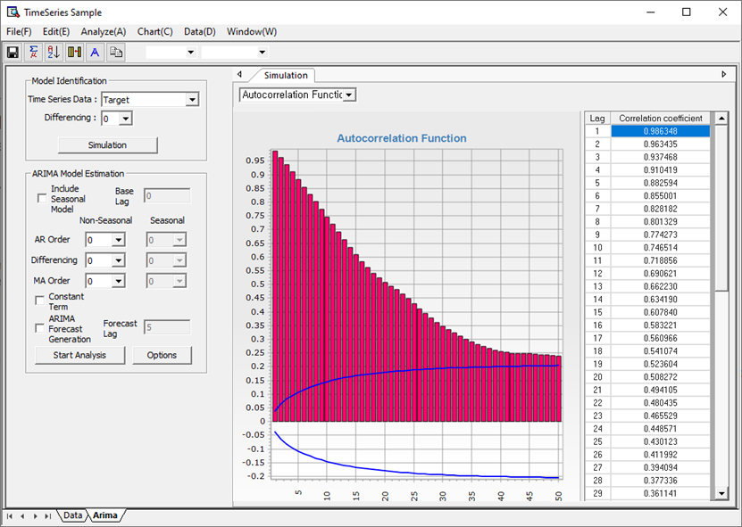

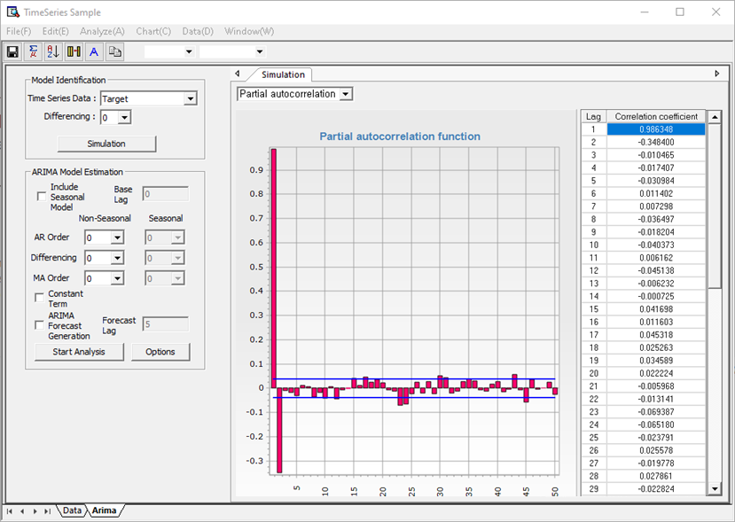

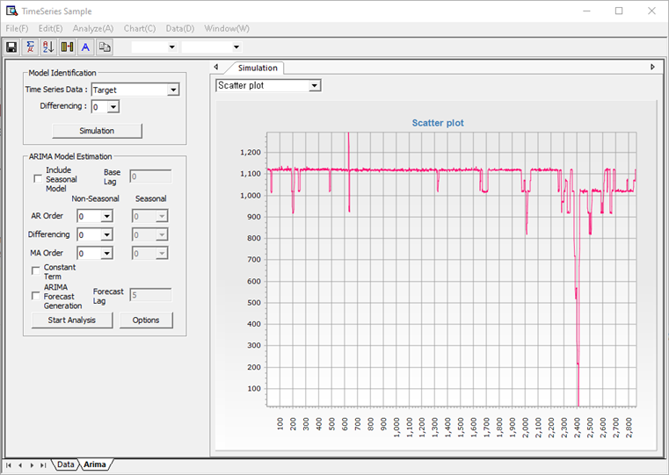

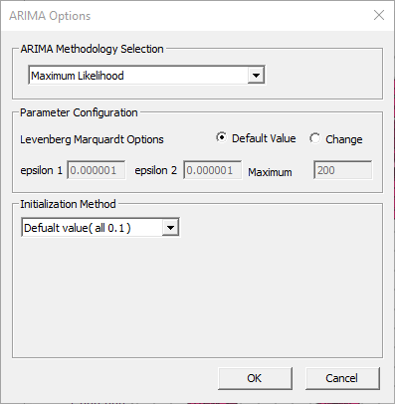

###### Results

After executing “ARIMA” the results are organized into several tabs, including “Model Report” and “Plot.” In the “Model Report” tab, the “General Info” section presents basic information about the time series data, while the “Model Info” section displays the analysis results, including model structure, parameter details, parameter optimization outcomes, and forecast results. Additionally, diagnostic checks can be conducted using the Residual Autocorrelation Function (ACF) and Partial Autocorrelation Function (PACF). The “Plot” tab provides visual representations of the ARIMA model’s results, allowing users to examine observed data, fitted values, forecasted values, and the upper and lower bounds of prediction intervals through time series plots. The “Statistics” tab can view the data obtained after creating the model in a table. It also provides a function to save the information obtained in this way.

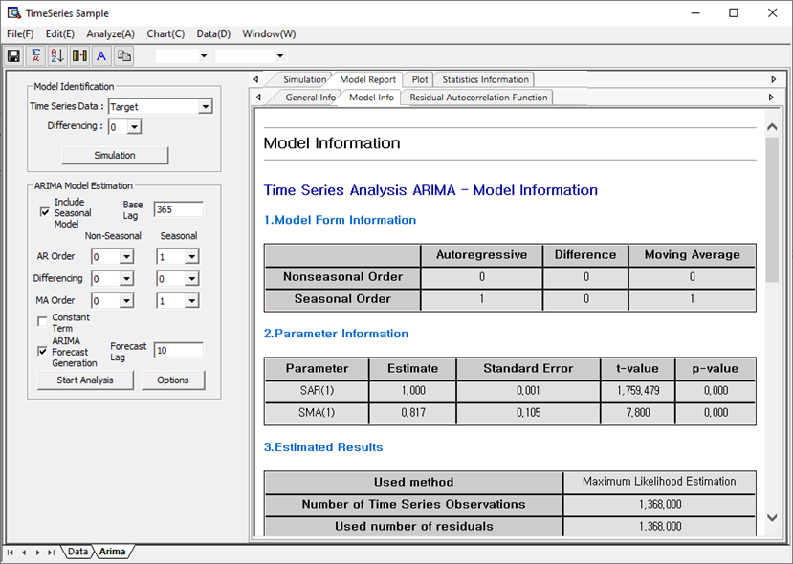

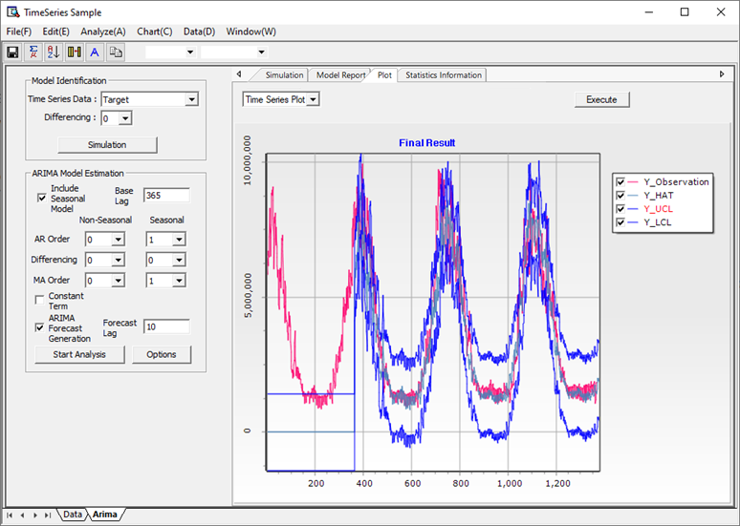

##### (5) Trend Analysis

###### Overview

Trend analysis is a method used to identify fundamental patterns in time series data by modeling the relationship between time (on the horizontal axis) and observed values (on the vertical axis). It assumes that time is the primary explanatory variable and explores how the data evolves over time through specific functional forms, typically including linear, quadratic, exponential growth, and logarithmic models. The parameters for each of these trend functions are estimated using the Least Squares method, which provides closed-form solutions to minimize the difference between the observed and predicted values.

###### How to run

**The menu path for Trend Analysis from the Data Browser window is: [Analyze] – [Time Series Analysis] – [Time Series Models] – [Trend Analysis]** In the window, select what type of function to fit, and if you want to make a forecast, enter Forecast Lag and click the Start Trend Analysis button.

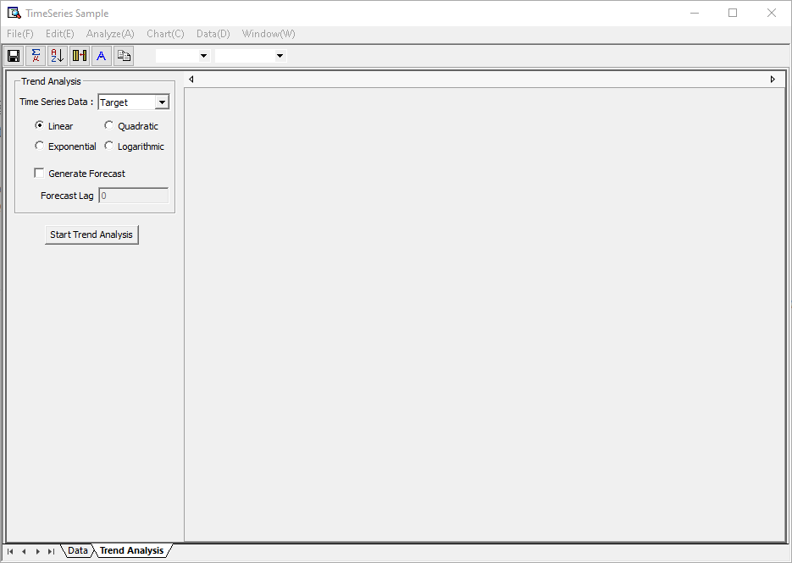

###### Results

After the “Trend Analysis” has been executed, the results are displayed in multiple tabs. In the “Model Report” tab, “General Info” and “Model Info” can be viewed. The “**General Info” s**hows basic information about time series data. The “**Model Info**” provides regression equations, accuracy measures, and forecast results obtained through trend analysis. The “Plot” tab visually displays the original and fitted data obtained through trend analysis. The Trend Analysis interface enables users to identify underlying patterns in time series data by selecting one of several model types—Linear, Quadratic, Exponential, or Logarithmic—and then fitting the chosen model to the data. Using the Least Squares method, the system estimates the trend function parameters and plots the fitted trend line (Y\_HAT) alongside the observed data (Y\_Observation) in the chart. The forecast option allows users to project future values based on the fitted trend, with the length of the forecast controlled via the Forecast Lag setting. The “Statistics” tab can view the data obtained after creating the model in a table. It also provides a function to save the information obtained in this way.

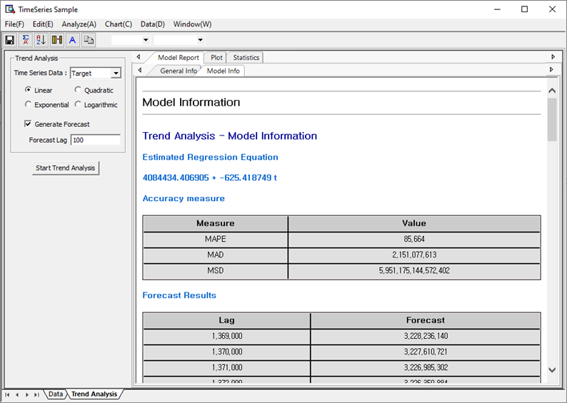

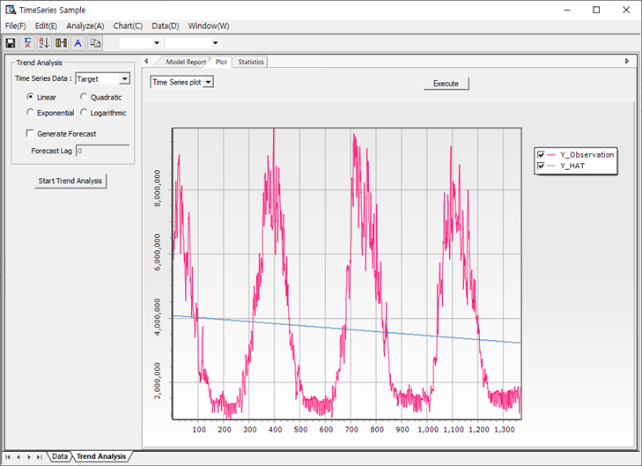

##### (6) GARCH

###### Overview

The ARCH (Autoregressive Conditional Heteroskedasticity) methodology was proposed in the 1980s, and Robert Engle, who proposed this method, received the Nobel Prize in Economics in 2003. The innovative aspect of this methodology is to modify the assumption that random shocks have constant variance in the time series analysis so far, and introduce the assumption that random shocks have constant variance unconditionally, but the conditional variance depend on time t. Robert Engle proposed the ARCH Model in 1982, and the generalized ARCH model, that is, the GARCH model, was proposed by Bollerslev in 1986 and various modified models such as EGARCH, GARCH-M, and GJR have been presented since then. The reason why many modified models of ARCH have been presented and received a lot of attention is because with the development of financial economics, not only time series prediction but also measurement and prediction of volatility (variance) have become very important. In many capital asset pricing models, the volatility of the underlying asset has been considered an important factor affecting the price of the asset, but the methodology for measuring and predicting this volatility had not been developed before ARCH. Research related to this has continued steadily not only in the 1980s, but also since then, and even recently, the GARCH model is now used in various engineering fields, especially network traffic analysis, in addition to financial economics.

###### How to run

**The menu path for** GARCH **from the Data Browser window is: [Analyze] – [Time Series Analysis] – [Time Series Models] – [GARCH]** On the main screen, enter the basic information required for GARCH analysis. Select Dependent Variable (Response Variable) and Independent Variable (Explanatory Variable) and select ARCH order and GARCH order. Finally, choose whether you want to generate predictions or not and you're all set. More specific settings can be set in the Option window below. GARCH's Parameter Estimation is very demanding. In some cases, Estimation frequently ends at Local Optimum. Therefore, ECMiner™ presents several optimization methodologies for users to choose from. Users can perform optimization using multiple methodologies and choose the best solution. Parameter settings are options to set when performing the optimization algorithm. Forecast-related options determine which data to use for modeling. The initial value selection method determines how to select the initial value.

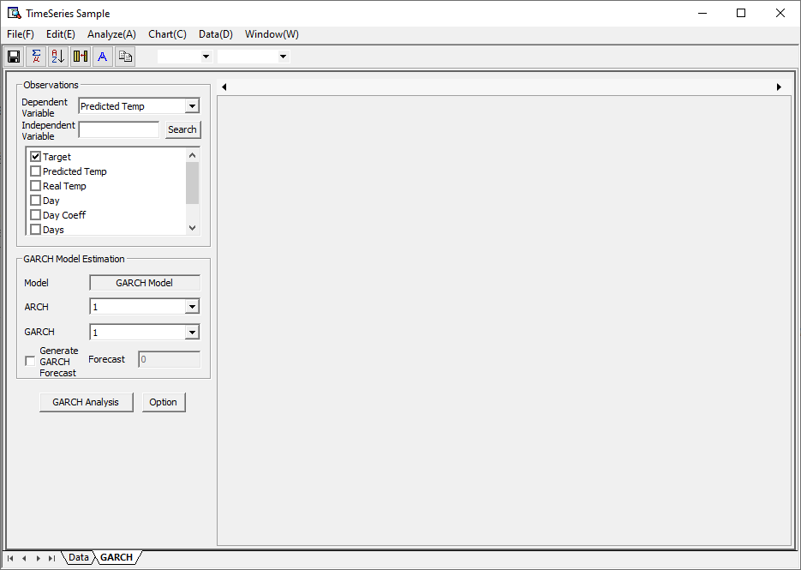

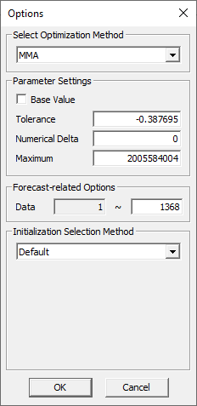

###### Results

After executing “**GARCH Analysis**” the results are organized into several tabs, including “Model Report,” “Plot,” and “Statistics.” In the **“Model Report”** tab, the “General Info” section provides basic information about the time series data, while the “Model Info” section displays parameter estimates, statistical values, and forecast results obtained from the GARCH model. Additionally, the “Residual Chart” section allows users to check model adequacy by examining the Residual Autocorrelation Function and Residual Partial Autocorrelation Function. The **“Plot”** tab visually presents results from GARCH analysis, including time series plots showing observed data, fitted values, and their upper and lower confidence limits. It also includes plots of conditional volatility, squared residuals, and residual diagnostics such as Histogram, Normal Probability Plot, Residual vs. Order, and Residual vs. Fitted Values, which help assess the distribution and randomness of residuals. The **“Statistics”** tab displays key statistical outputs from the analysis in table format and provides an option to save them for further reference.

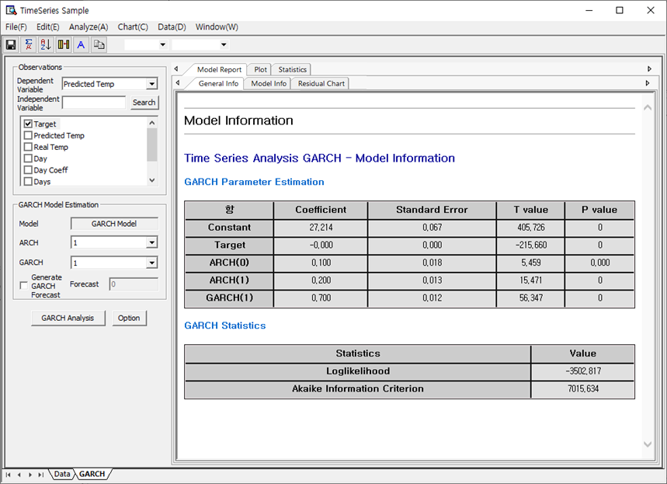

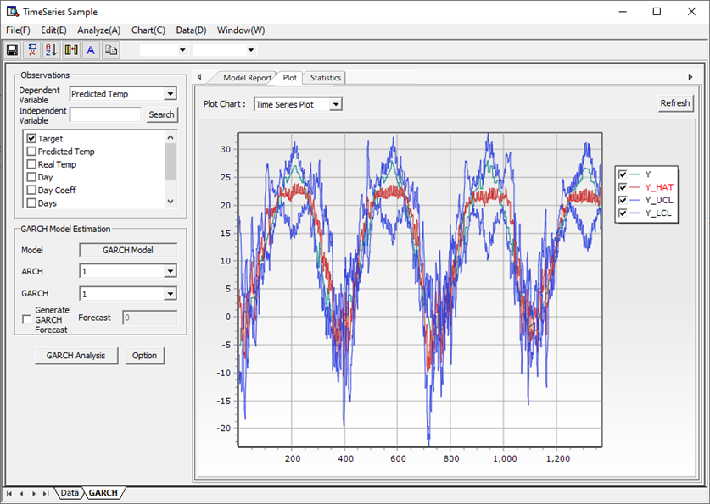

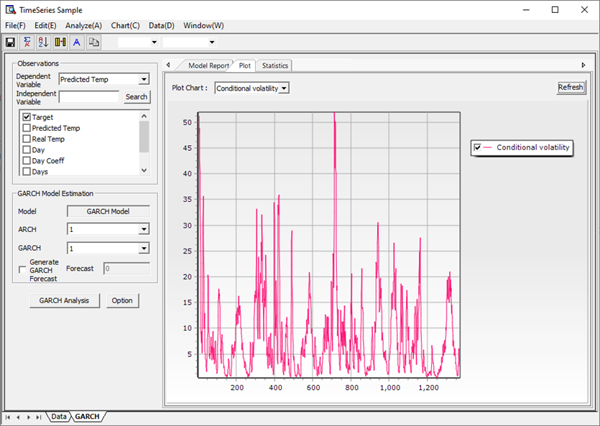

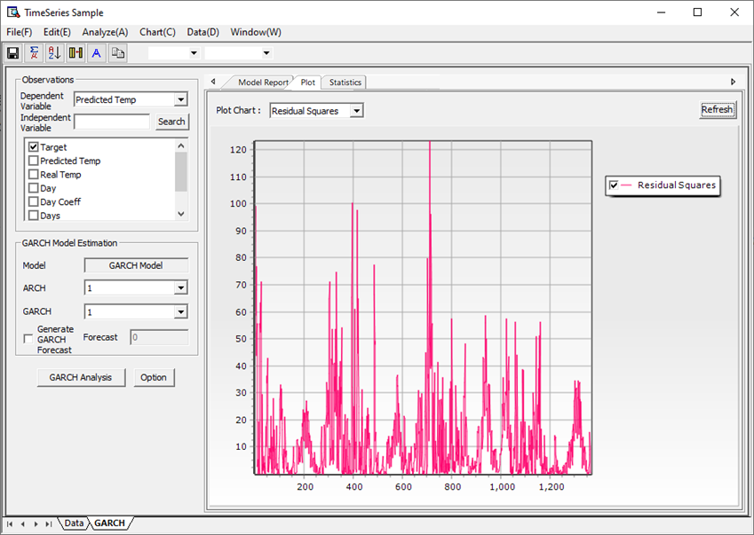

##### (7) VAR

###### Overview

After executing “**Vector Autoregressive (VAR) Model Analysis**,” the results are organized into several tabs, including **“Model Report”** and **“Plot.”** In the **“Model Report”** tab, the *General Info* section provides an overview of the multivariate time series data used. The *Model Info* section contains estimated coefficients, standard errors, t-values, and p-values for each variable in the VAR equations, as well as information on lag structure and diagnostic checks. The **“Plot”** tab visually displays the relationships and dynamics among the variables, such as impulse response functions and forecast error variance decompositions, enabling interpretation of interdependencies. The **“Statistics”** tab presents model fit criteria (e.g., AIC, BIC), and residual diagnostics, and also offers an option to save results for further analysis.

###### How to run

**The menu path for VAR from the Data Browser window is: [Analyze] – [Time Series Analysis] – [Time Series Models] – [VAR]** On the main screen, enter the basic information required for VAR analysis. When selecting Dependent Variable (Response Variable) and Independent Variable (Explanatory Variable), you can select multiple variables as dependent variables, and you may or may not select Independent Variable. When entering the degree of a dependent variable and the degree of an independent variable, enter the starting and ending degrees.

If you select default for **Dependent Variable** Lag Selection, the order set on the main screen is set. If you do not select default option, user can enter Specific Lag. (At this time, the order is divided by space.) If you select default for **Independent Variable** Lag Selection, the order set on the Main screen is set. If you do not select default option, user can enter Specific Lag. (At this time, the order is divided by space.) In the forecast-related options, you can select the data to be used for modeling and perform N step ahead forecast by selecting a specific step ahead when selecting to perform model verification. ECMiner™ performs N step ahead forecast starting immediately after the modeling data. Through this, analysts can assess whether the model created through modeling is useful for future predictions.

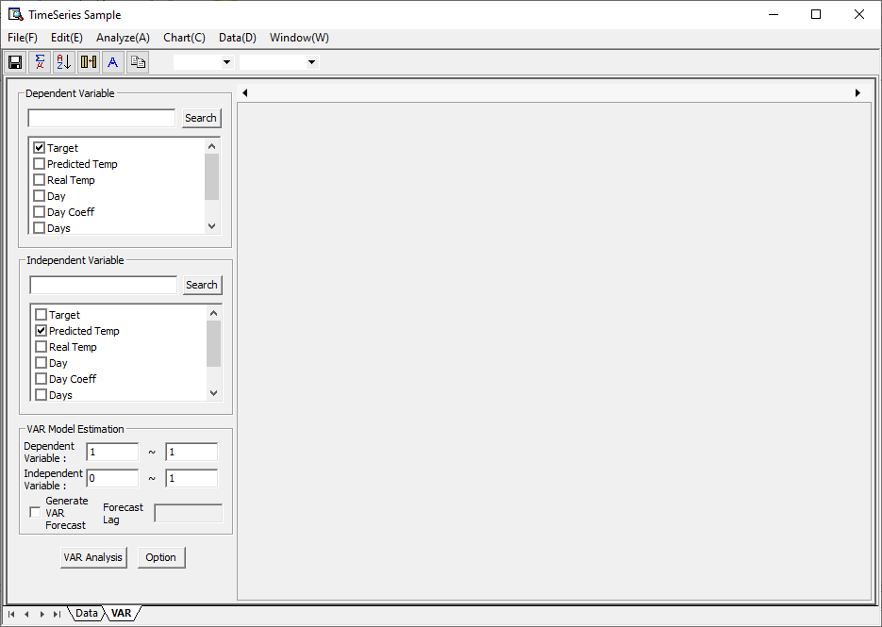

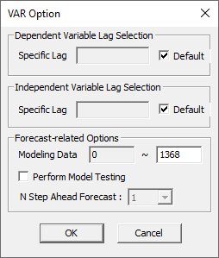

###### Results

After executing “VAR Analysis,” the results are organized into several tabs, including “Model Report,” “Plot,” and “Statistics.” In the “Model Report” tab, the “General Info” section shows basic information about the time series data, while the “Model Info” section provides detailed results from the VAR analysis, such as estimated coefficients, standard errors, T-values, P-values, and key statistics like R-squared, F-value, SST, and Sigma². The “Plot” tab visually presents the analysis results, including a time series plot showing observed data, fitted values, and upper/lower control limits, as well as residual diagnostic plots such as histogram, normal probability plot, residual vs. order, and residual vs. fitted values. Finally, the “Statistics” tab displays all relevant statistical metrics from the analysis and allows users to save them for further use.

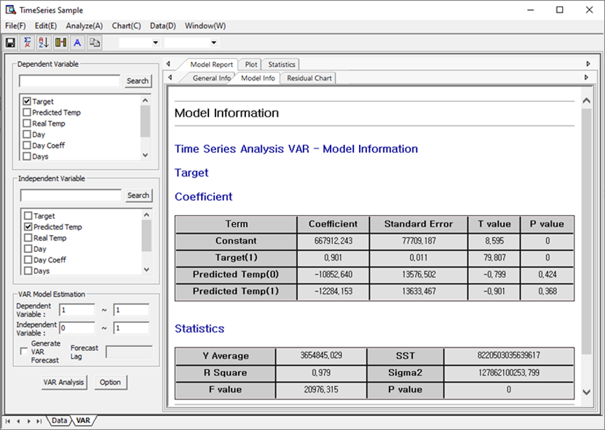

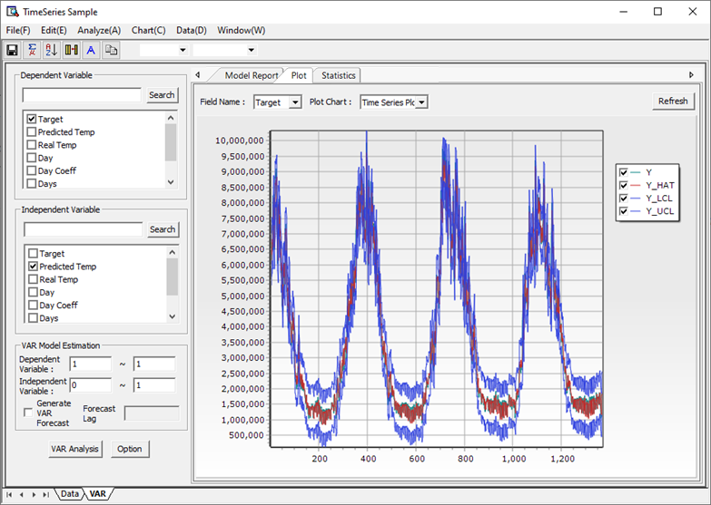

##### (8) ARMAX

###### Overview

ARMAX, which stands for AutoRegressive Moving Average with Exogenous Variables, is an extension of the ARMA model that incorporates external variables to enhance model performance. It is defined as ϕ(B)(yₜ − μ − xₜ₁β₁ − ⋯ − xₜₘβₘ) = θ(B)aₜ, where xₜ represents the exogenous variables and β represents their corresponding coefficients. Parameter estimation and forecasting in ARMAX follow the same procedure as in ARMA, with the key difference being the inclusion of exogenous inputs. By adjusting the dependent variable to account for the influence of these external variables, ARMAX allows for more accurate modeling of time series data that cannot be sufficiently explained by ARMA alone.

###### How to run

**The menu path for** ARIMAX **from the Data Browser window is: [Analyze] – [Time Series Analysis] – [Time Series Models] – [ARMAX]** On main screen, you can enter basic information required for ARMAX analysis. When selecting Dependent Variable (Response Variable) and Independent Variable (Explanatory Variable), the independent variable may not be selected. In this case, you will get the same results as traditional ARIMA. Analysts can add seasonality or differences as in traditional ARIMA. ARMAX analysis can be performed through various order settings displayed on the main screen.

In addition, you can make more advanced settings through the ARMAX Options window. If you want to enter the AR order as the order specified by the analyst, uncheck the Default check box. Then, you can specify the AR order in space units. If you want to enter the MA order as the order specified by the analyst, uncheck the Default check box. Then you can specify the MA degree in space units. As to which method to use to estimate the parameters of ARMAX, you can choose between Maximum Likelihood and Conditional Least Square. Levenberg Marquardt and Quasi Newton are provided as optimization methods. By using these two methods, users can use the better parameters of the two. If you want to change the parameters used for optimization, set the Parameter Change Status as ‘Change’. This allows you to decide whether to optimize further or not. Forecast-related Options allow you to select the data used for modeling and decide whether to perform model validation. When ‘Perform Model Validation’ is checked, the predicted values are calculated from the modeling data. Through this, you can gauge how accurate the model obtained through modeling is. The Initial Value Selection Method is intended to compensate for the limitations of Nonlinear Optimization. It helps to find the optimal solution by setting various initial values.

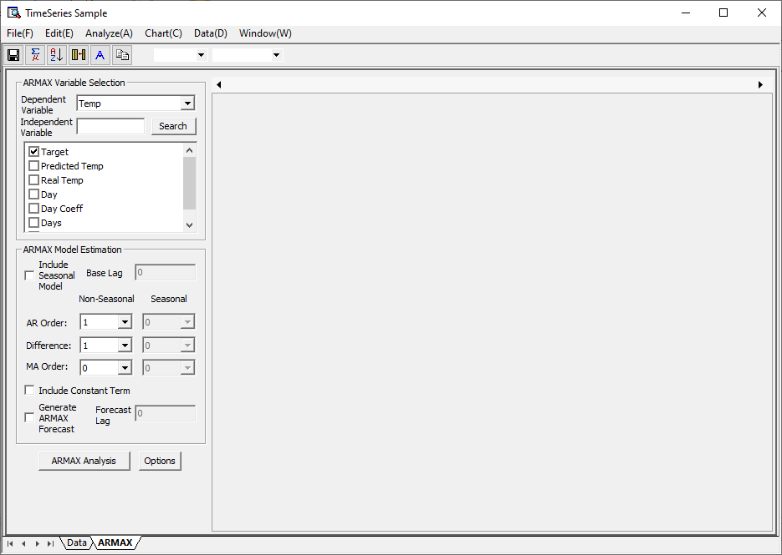

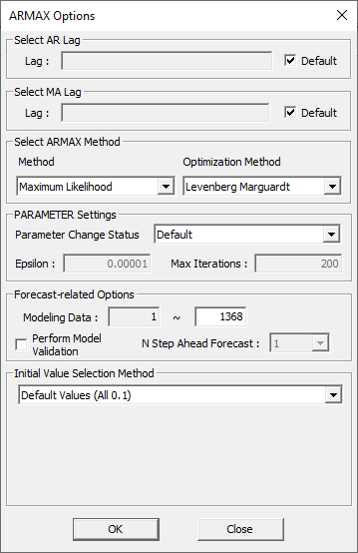

###### Results

After executing “ARMAX,” the results are organized into several tabs, including “Model Report” and “Plot.” In the “Model Report” tab, the “General Info” section displays basic information about the time series data, while the “Model Info” section presents the parameters, statistics, and forecast results derived from the ARMAX analysis. Additionally, the “Residual Chart” tab provides diagnostic tools such as the Residual Autocorrelation Function and Residual Partial Autocorrelation Function. The “Plot” tab visually shows the outcomes of the ARMAX analysis, including a Time Series Plot with observed values, fitted values, and the upper and lower prediction limits. Lastly, the “Statistics” tab summarizes the statistical outputs from the ARMAX model and includes options for saving the table.

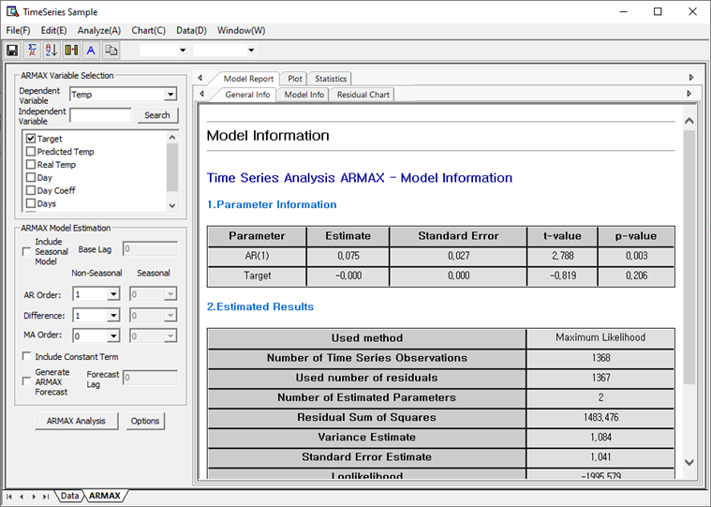

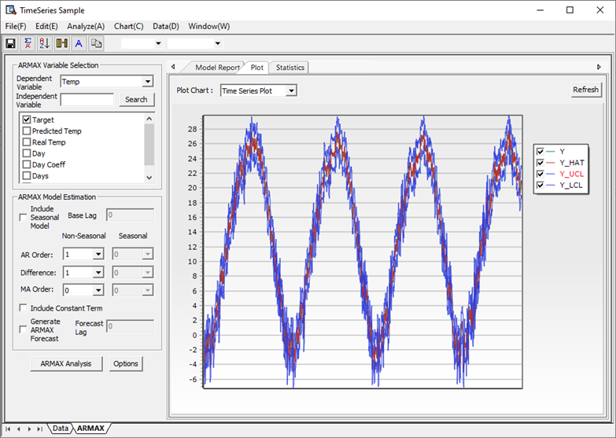

#### 4.3.6.2 Time Series Test

##### (1) Unit Root Test

###### Overview

Non-stationary time series have a characteristic root of 1 when expressed as an autoregressive model. That is, it has a unit root. The Time Series Test menu supports KPSS (Kwiatkowski & Phillips & Schmidt & Shin) test and ADF (Augmented Dickey-Fuller) test. The null hypothesis of the ADF test is that a unit root exists in the variable, and the null hypothesis of the KPSS test is that the unit root does not exist in the variable. Decide whether to accept or reject the null hypothesis through test statistics (TAU) and significance probability (p-value).

###### How to use

The menu path for Unit Root Test from the Data Browser window is: [Analyze] – [Time Series Analysis] – [Time Series Test] – [Unit Root Test] In the window, select which test method to use, select/enter the parameters required for each method, and then select the variable to be tested. Click the OK button and the Time Series Test will be performed. For the dropdown choices of the Test methods of the Unit Root Test, the Augmented Dickey-Fuller (ADF) Test is used to determine the stationarity of time series data, and the form of the test model varies depending on whether a constant and/or a deterministic trend is included. When neither is included (Type = none), the test model is the simplest form. If only a constant is included (Type = Drift), the model adjusts accordingly, and when both a constant and deterministic trend are included (Type = Trend), the model reflects this added complexity. The Lag parameter represents the number of first-order autoregressive terms in the regression equation and is critical for determining the p-value; thus, a Lag greater than 1 must be selected to ensure accurate test results.

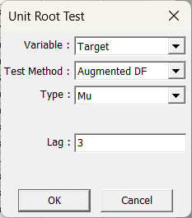

###### Results

After executing the Unit Root Test, the results are presented through the Augmented Dickey-Fuller (ADF) Test and the KPSS (Kwiatkowski–Phillips–Schmidt–Shin) Test. In the ADF test, the model type must be selected based on whether the time series includes a constant or deterministic trend (None, Drift, or Trend), and the lag order must be greater than 1 to yield valid results. The output includes the tau statistic, critical values at different significance levels (1%, 5%, 10%), and the regression analysis table with coefficients, standard errors, t-values, and p-values. The KPSS test, which evaluates stationarity, also provides a test statistic along with critical values for various significance levels (1%, 2.5%, 5%, 10%). The KPSS test calculates the statistic using the cumulative residuals derived from the model type selected (Mu or Tau). Both tests output various statistical indicators such as coefficients (intercept, trend, lag terms), R-square values, F-statistics, and p-values, enabling the user to assess the presence of unit roots and the stationarity of the time series.

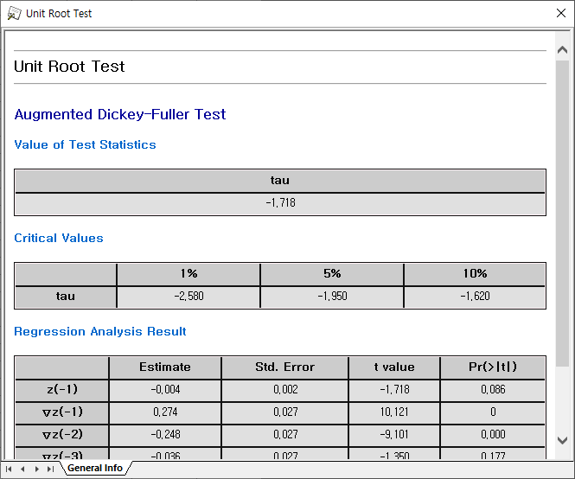

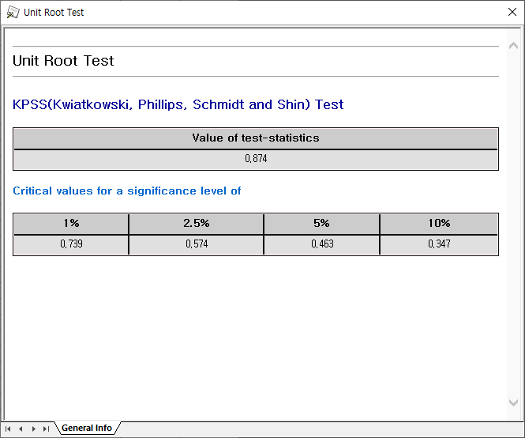

##### (2) Granger Causality

###### Overview

The Granger causality test is a statistical hypothesis test that tests whether the one time series is useful for predicting the other time series. Through t-test and F-test, we test whether Independent Variable provides statistically significant information about the future of Dependent Variable.

###### How to run

The menu path for Granger Causality from the Data Browser window is: [Analyze] – [Time Series Analysis] – [Time Series Test] – [Granger Causality] In the window select Dependent Variable and Independent Variable. If you check “Save Significant Results to File”, you can save the test result, a list of independent variables whose p-value is less than the value entered by the user, and the p-value value as a text file. Click the View Results button to perform Granger causality.

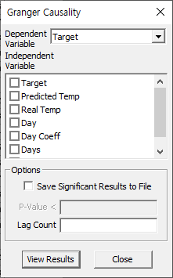

###### Results

After executing the Granger Causality Test, the results are displayed in a table format showing the independent variable, the F-statistics value, and the corresponding p-value. These outputs allow users to assess whether one time series (e.g., Real Temp) Granger-causes another, based on statistical significance. A low p-value (typically below 0.05) indicates that the independent variable contains predictive information about the dependent variable.

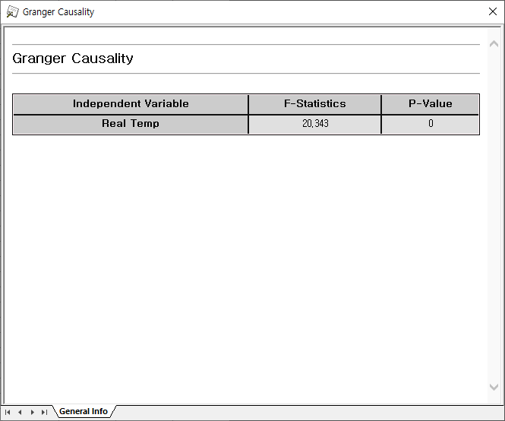

##### (3) Cointegration Test

###### Overview

When two or more time series are individually integrated, but some of their linear combinations are low order, these time series are said to be cointegrated. Cointegration Test tests how cointegrated two or more time series are. There are methods such as The Engle-Granger two-step method, The Johansen’s procedure, and Phillips-Ouliaris Cointegration Test, and the Johansen’s procedure is used in the Cointegration Test menu.

###### How to run

**The menu path for Cointegration Test from the Data Browser window is: [Analyze] – [Time Series Analysis] – [Time Series Test] – [Cointegration Test]** Select the dependent and independent variables in the window. In the Type menu, you can select None, Constant, or Trend. After executing the Cointegration Test, users are required to select both a dependent and one or more independent variables to test whether a long-term equilibrium relationship exists among them. The “Type” field allows the user to specify the model form—such as None, Drift, or Trend—depending on whether the series includes constants or deterministic trends. The “Lag” parameter specifies the number of lags to include in the test. Once configured and executed, the test determines whether the variables are cointegrated, indicating a statistically significant long-run relationship despite possible short-term deviations.

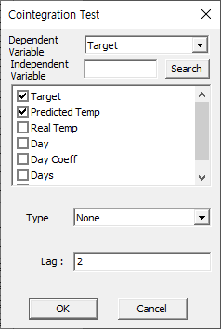

###### Results

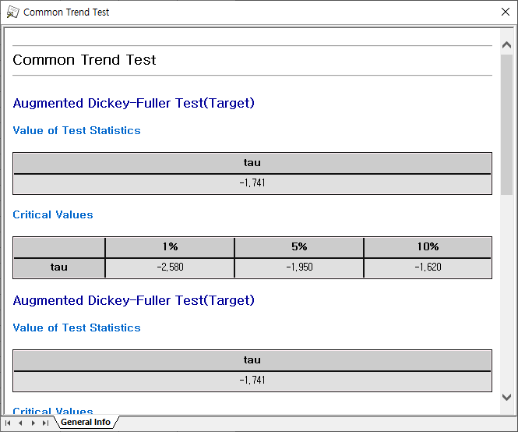

After executing the “Common Trend Test,” the results are displayed using the Augmented Dickey–Fuller (ADF) test for each variable, such as “Target.” The output includes the test statistic value (tau) and critical values at 1%, 5%, and 10% significance levels, which are used to determine the presence of a unit root. This helps assess whether multiple variables share a common stochastic trend, indicating they may be cointegrated or move together over the long term despite short-term fluctuations.

##### (4) ARCH Test

###### Overview

The ARCH model is a heteroskedastic conditional autoregressive model for predicting the volatility of a time series that changes over time. The ARCH test is used to determine whether the current variance can be predicted by the past variance.

###### How to run

The menu path for ARCH Test from the Data Browser window is: [Analyze] – [Time Series Analysis] – [Time Series Test] – [ARCH Test] Select the dependent and independent variables in the window. Enter the maximum disparity value. Arch Test is performed by clicking the View Results button. The ARCH Test interface allows you to assess the presence of autoregressive conditional heteroskedasticity in a time series. You specify the dependent variable (e.g., "Target") and can optionally include independent variables. You also set the maximum lag order, which defines how many past residuals' squared terms to include in the test. After configuration, selecting “View Results” performs the test and checks for time-varying volatility patterns—helpful in modeling financial and meteorological time series where variance changes over time.

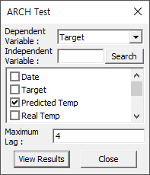

###### Results

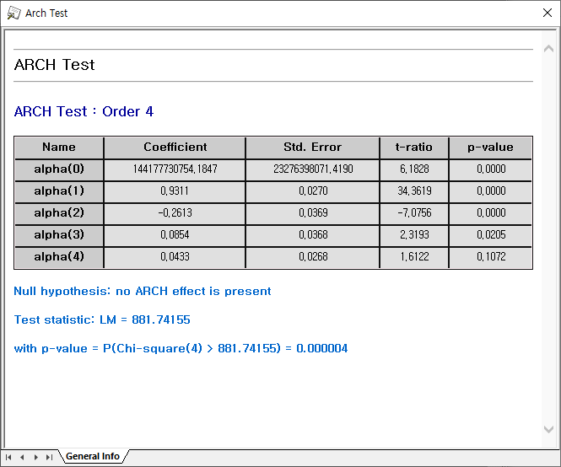

The **ARCH Test: Order 4** result provides evidence of **conditional heteroskedasticity** in the time series data. The null hypothesis assumes **no ARCH effect** is present. However, the **test statistic** (LM = 881.74155) and corresponding **p-value (0.000004)** strongly reject this null hypothesis at conventional significance levels, indicating the presence of ARCH effects. Additionally, several lag coefficients (e.g., alpha(1), alpha(2)) are statistically significant with very low p-values, further supporting this conclusion. Thus, modeling time-varying volatility (e.g., with ARCH/GARCH models) is appropriate for this data.

#### 4.3.6.3 Time Series Correlation

##### (1) Cross-Correlation

###### Overview

Cross-correlation is a statistical measure that quantifies the similarity or linear dependency between two time series, X and Y, at different time lags. It is particularly useful for identifying whether one time series leads or lags another and is commonly applied to detect recurring patterns or signals within a noisy dataset. The **k-time lagged cross-correlation coefficient** rkr\_k between two time series is calculated using the formula shown, which normalizes the covariance between XtX\_t and Yt+kY\_{t+k} by the product of their standard deviations. This helps evaluate how the value of one time series at time tt is related to the value of another at time t+kt + k.

###### How to run

**The menu path for Cross-Correlation from the Data Browser window is: [Analyze] – [Time Series Analysis] – [Time Series Correlation] – [Cross-Correlation]** Open the Settings dialog from the menu “File>Settings”. Select dependent and independent variables in the window. Cross-Correlation is executed when you click the OK button. This settings window is used to configure parameters for a Cross-Correlation Analysis. You can specify the Lag Count, which defines the number of time lags to include in the analysis (here set to 10), select the Dependent Variable (e.g., "Target"), and choose one or more Independent Variables (such as "Predicted Temp" or "Real Temp"). Each variable is shown along with its Data Type (e.g., Integer type, Real Number type), helping users ensure compatibility for the analysis. Once selections are made, clicking OK will initiate the analysis using the specified parameters.

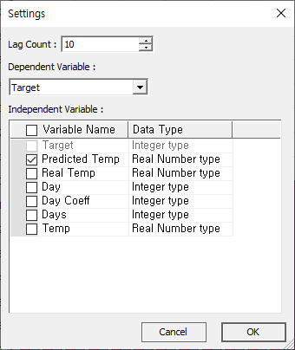

###### Results

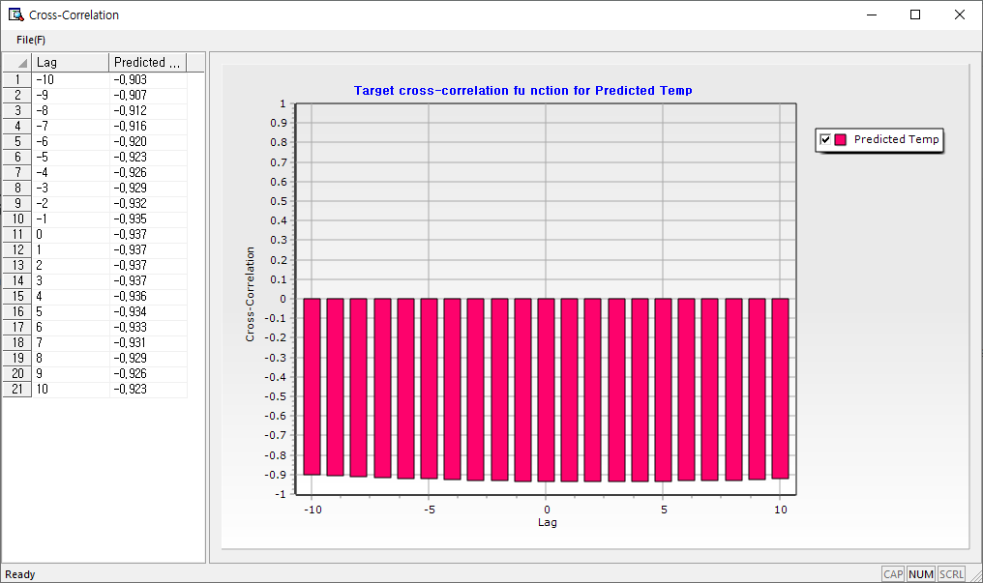

This window shows the results of a **Cross-Correlation Analysis** between the dependent variable “Target” and the independent variable “Predicted Temp.” The table on the left lists lag values from -10 to +10 alongside their corresponding cross-correlation coefficients, all of which are strongly negative (around -0.92 to -0.94), indicating a consistent inverse relationship across all lags. The bar graph on the right visually displays these coefficients, where the x-axis represents lag and the y-axis represents the cross-correlation value. The analysis helps identify whether changes in “Predicted Temp” lead or lag changes in “Target” and by how much.

##### (2) Autocorrelation, Partial Autocorrelation

###### Overview

Autocorrelation measures how current values in a time series are correlated with their past values, indicating how well past data can predict the present. Higher autocorrelation suggests greater predictive potential from previous observations. However, to isolate the true correlation at a specific lag without the influence of shorter lags, **partial autocorrelation** is used. For example, in the given AR(2) model, the second-order autocorrelation may appear significant, leading an analyst to suspect influence from AR(2) or even AR(3) structure. Partial autocorrelation clarifies this by measuring the second-order correlation after eliminating the effect of the first lag. As a result, while autocorrelation may be high, the partial autocorrelation at the same order could be low, highlighting the need for both measures in time series analysis.

###### How to run

**The menu path for Autocorrelation and Partial Autocorrelation from the Data Browser window is: [Analyze] – [Time Series Analysis] – [Time Series Correlation] – [Autocorrelation, Partial Autocorrelation]** Select the type of correlation function in the window. The analyst can select the autocorrelation function or partial autocorrelation function and select the variable to be analyzed along with it. By determining the maximum number of lags, the analyst can determine how much lag the correlation function will be obtained.

###### Results

The first image shows an example of an Autocorrelation Function (ACF), which visualizes the correlation between a time series and its past values at different lags. The plot includes bars representing correlation coefficients, blue lines indicating confidence intervals, and a summary table listing the correlation coefficient, t-statistic, and Ljung-Box Q-test statistic. The Q-test assesses whether the series is independently distributed — in other words, whether the observed autocorrelations are statistically significant or due to randomness. The second image presents a Partial Autocorrelation Function (PACF), which shows the direct effect of a lagged term after removing the influence of shorter lags. It helps in identifying the appropriate lag order for AR models by showing which lags have a meaningful partial correlation with the current value. The PACF values are visualized similarly, with bars, confidence bands, and a table of coefficients and t-statistics.

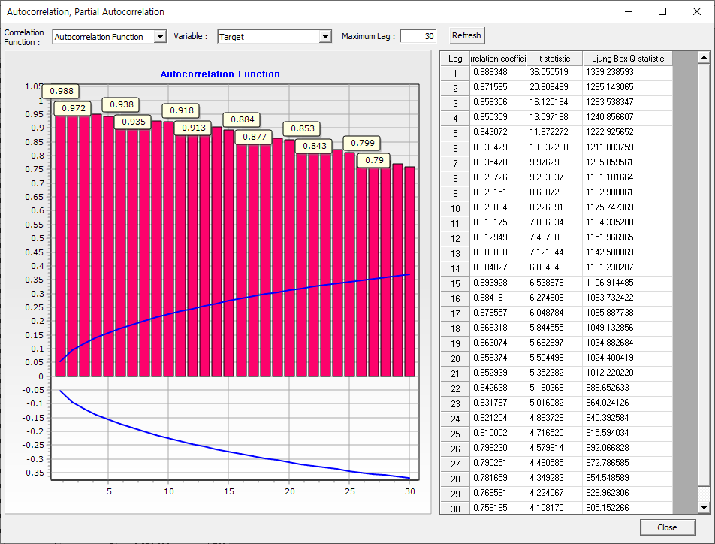

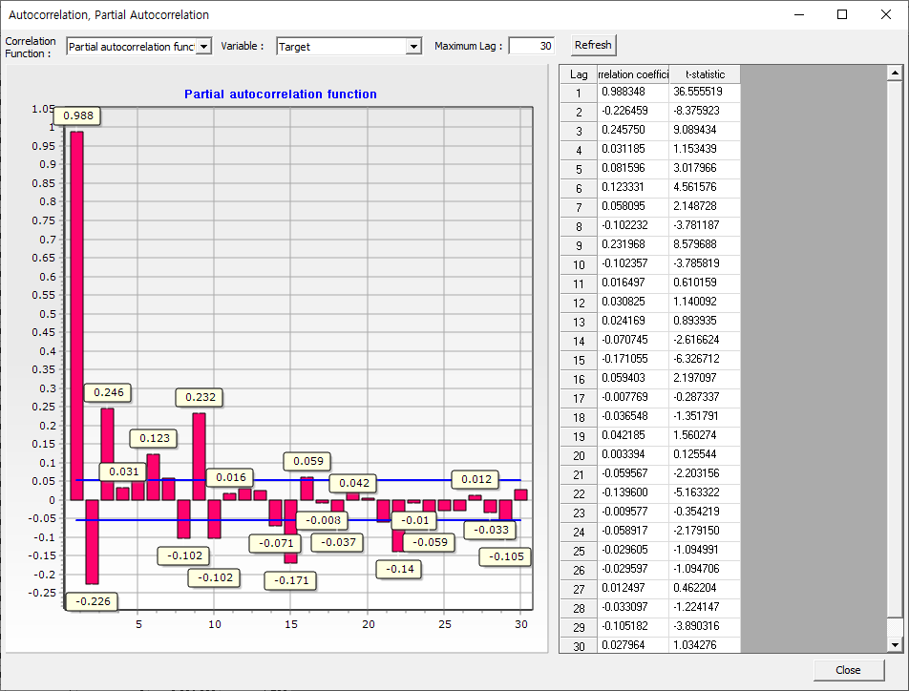

### 4.3.7 Table

#### 4.3.7.1 Frequency Table

The Frequency Statistics Table function in ECMiner provides a detailed summary of categorical data by displaying frequency distributions. For each discrete variable, the table includes the count (frequency), percentage, cumulative frequency, and cumulative percentage, allowing users to quickly understand the distribution and concentration of values within a dataset.

###### How to run

The menu path for Frequency Table from the Data Browser window is: [Analyze] – [Table] – [Frequency Table]. The Frequency Table pop-up window allows users to select discrete variables for frequency analysis by moving desired variables from the left-side “Variable” list to the right-side “Analysis Variable” list using arrow buttons.

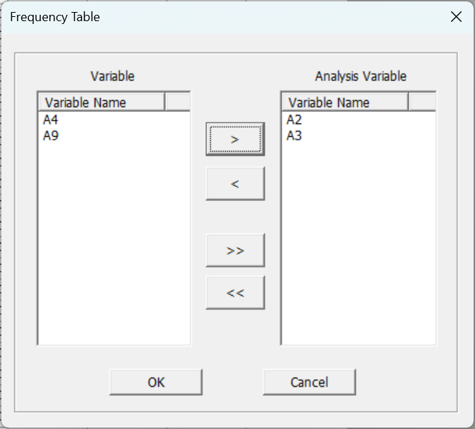

###### Results

The Frequency Table function in ECMiner provides a statistical summary of categorical variables by displaying the frequency count, percentage, cumulative frequency, and cumulative percentage for each category. These statistics are presented in tabular form, where each row corresponds to a unique category within the selected variable. The table includes a total row summarizing the overall counts and percentages, allowing users to easily interpret the distribution and proportion of each category within the dataset.

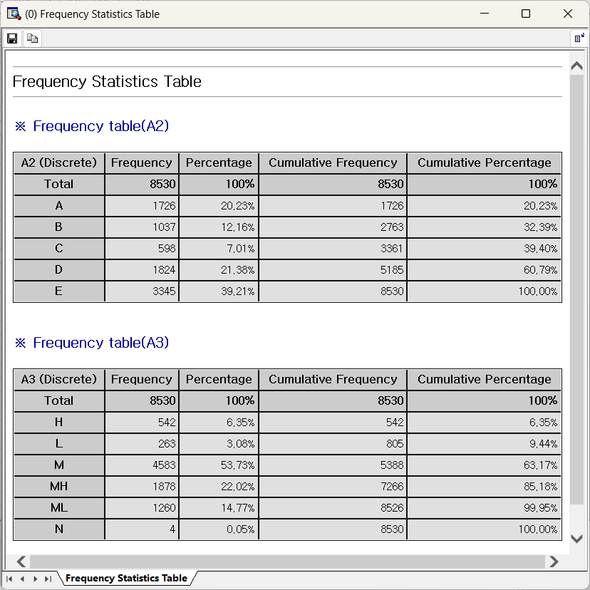

#### 4.3.7.2 Cross Table

The Cross Table function in ECMiner provides a two-dimensional frequency analysis that displays the joint distribution of two categorical variables. It presents the counts of observations for each combination of categories in a matrix format, along with row and column totals. Additionally, it can include row percentages, column percentages, and overall percentages, allowing users to assess the relationship or association between variables. This function is useful for identifying patterns, dependencies, or potential correlations between categorical variables within a dataset.

###### How to run

**The menu path for** Cross Table **from the Data Browser window is: [Analyze] – [Table] – [Cross Table].** The Cross Table function in ECMiner is used to analyze the relationship between two categorical variables by displaying the frequency of their combinations in a matrix format. Users can assign a variable to the row and another to the column to generate a cross-tabulated table. The output can include raw frequencies along with optional percentage displays: row percentages, column percentages, and total percentages, allowing for flexible interpretation of distribution patterns. Additionally, statistical measures can be selected to evaluate the strength of association between the row and column variables. These statistics are based on the chi-square test and include the Contingency Coefficient and Phi and Cramér’s V, both of which range from 0 to 1, with values closer to 1 indicating a stronger association. This function is particularly useful for understanding categorical interactions, such as customer behavior, churn prediction, or classification analysis.

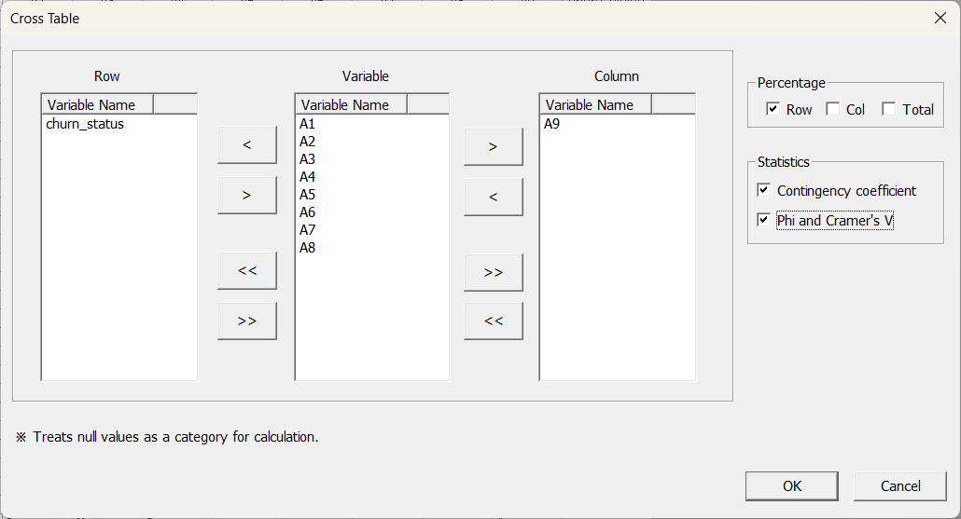

###### Results

The Cross Table function in ECMiner provides a detailed summary of the relationship between two categorical variables by outputting a cross-tabulation table and associated statistical measures. The cross-tabulation table shows the count of observations for each combination of row and column categories, along with optional row-wise, column-wise, or total percentage distributions to help users interpret how data is distributed across categories. Additionally, the function calculates nominal statistics—**Phi**, **Cramer’s V**, and the **Contingency Coefficient**—which quantify the strength of association between the two variables based on a chi-square test. These values range from 0 to 1, with higher values indicating a stronger association. Among them, **Cramer’s V** is most appropriate when the numbers of categories differ between the two variables. By examining the count, percentage distribution, and these statistical indicators together, users can evaluate whether a meaningful relationship exists between the selected variables.

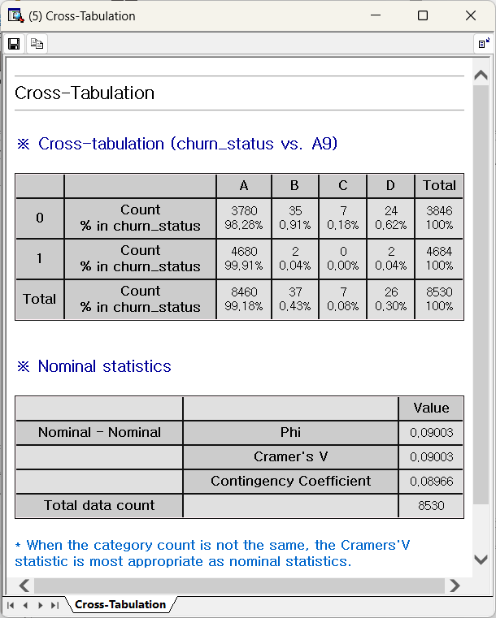

#### 4.3.7.3 Univariate Chi-Square Test

The Univariate Chi-Square Test function in ECMiner is used to determine whether the observed frequency distribution of a single categorical variable significantly differs from an expected distribution. This test evaluates how well the actual data aligns with a theoretically expected distribution, such as a uniform or user-defined distribution. The function outputs key statistical results including the chi-square test statistic, degrees of freedom, and p-value. A small p-value (typically less than 0.05) indicates that the observed distribution is significantly different from the expected one, suggesting that certain categories occur more or less frequently than would be expected by chance. This function is particularly useful for identifying irregularities or patterns in categorical data within a single variable.

###### How to run

**The menu path for Univariate Chi-Square Test from the Data Browser window is: [Analyze] – [Table] – [Univariate Chi-Square Test].** The Univariate Chi-Square Test function in ECMiner evaluates whether the observed frequency distribution of a categorical variable differs significantly from an expected distribution, thereby testing the goodness-of-fit. Users begin by selecting a test variable (categorical) and optionally a frequency variable, and then specify the expected frequency type: either Equal Ratios (assuming all categories are equally likely) or Specific Ratios (custom ratios provided by the user, separated by semicolons). After defining expectations, ECMiner calculates the Chi-Square statistic and returns results that show whether the differences between observed and expected values are statistically significant. It also offers a visual chart comparing the observed and expected distributions, enhancing interpretability. A significant Chi-Square value indicates that the actual category frequencies deviate meaningfully from the expected pattern, signaling potential trends or anomalies in the data.

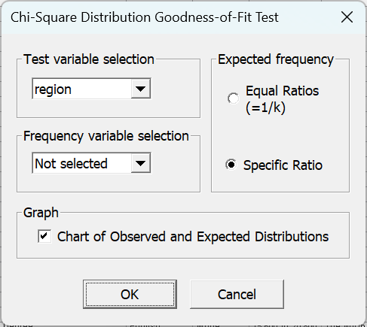

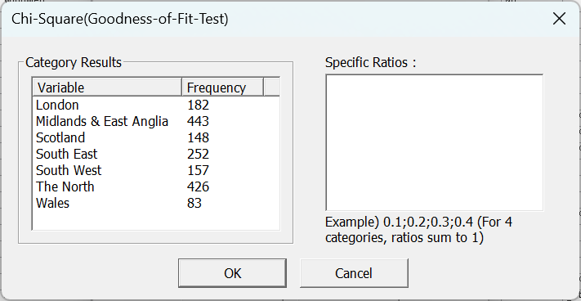

###### Results

The Univariate Chi-Square Goodness-of-Fit Test function in ECMiner is used to evaluate whether the distribution of a categorical variable differs significantly from an expected distribution. Users can select the test variable (categorical), optionally assign a frequency variable, and define the expected frequency either by assuming equal distribution across categories or by entering specific ratios. The output provides detailed results for each category, including the number of observed cases, expected values, test ratio, and the individual contribution of each category to the chi-square statistic. A summary table presents the overall chi-square value, degrees of freedom, and p-value, which indicates whether the differences between observed and expected frequencies are statistically significant. Additionally, the results window includes a distribution chart that visually compares observed and expected frequencies for each category, facilitating intuitive interpretation of the goodness-of-fit.

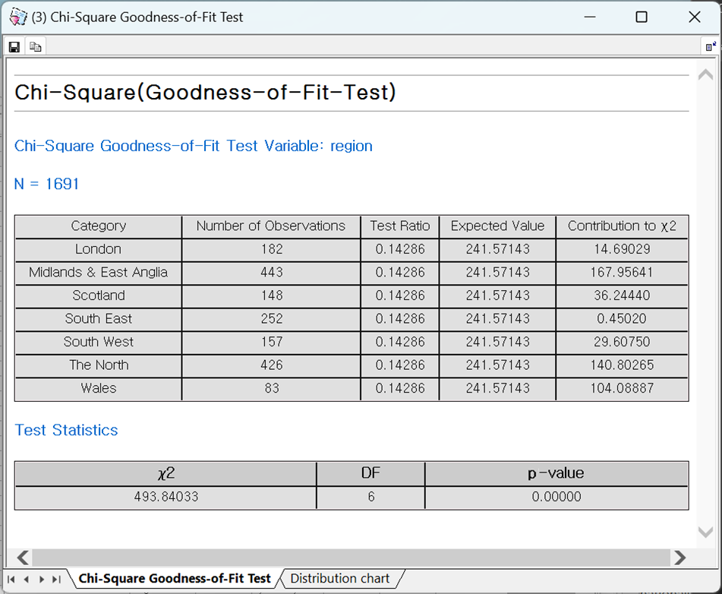

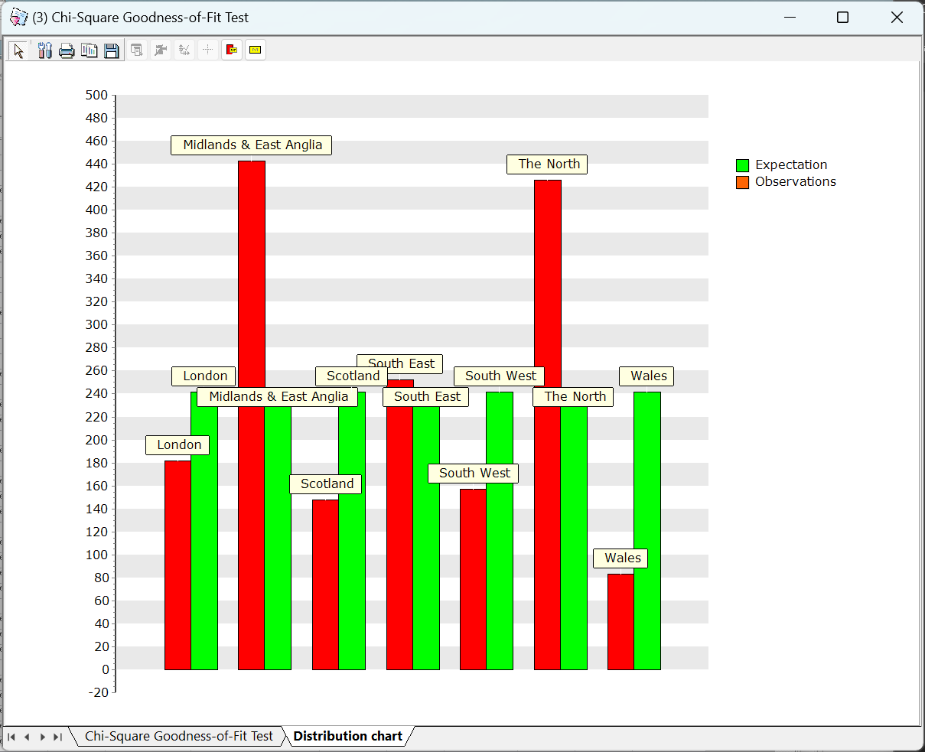

#### 4.3.7.4 Independence Test (Chi-Square Test)

The Independence Test – Chi-Square Test function in ECMiner is used to assess whether there is a statistically significant association between two categorical variables, effectively testing the null hypothesis that the variables are independent. Users can specify one variable for the row and another for the column to construct a contingency table, which displays the observed frequency distribution of the variable combinations. The function calculates expected frequencies under the assumption of independence and compares them with the observed values to compute the chi-square statistic and corresponding p-value. If the p-value is below a chosen significance level, it suggests that the variables are not independent and that there is a relationship between them. This test is particularly useful for uncovering potential associations in categorical data and is commonly applied in exploratory data analysis or hypothesis testing involving nominal or ordinal variables.

###### How to run

**The menu path for** Independence Test **from the Data Browser window is: [Analyze] – [Table] – [Independence Test].** To run the Independence Test – Chi-Square Test function in ECMiner, begin by selecting the two categorical variables you wish to test: one for the row and the other for the column. From the central variable list, use the arrow buttons to assign the desired variables into the appropriate Row and Column sections. Optionally, you may choose to include null values in the analysis by checking the "Consider Null Values" box. Additionally, you can set the desired significance level (0.1, 0.05, or 0.025) depending on how strict you want your threshold for statistical significance to be. Once all selections are made, click the "OK" button to execute the test and generate results.

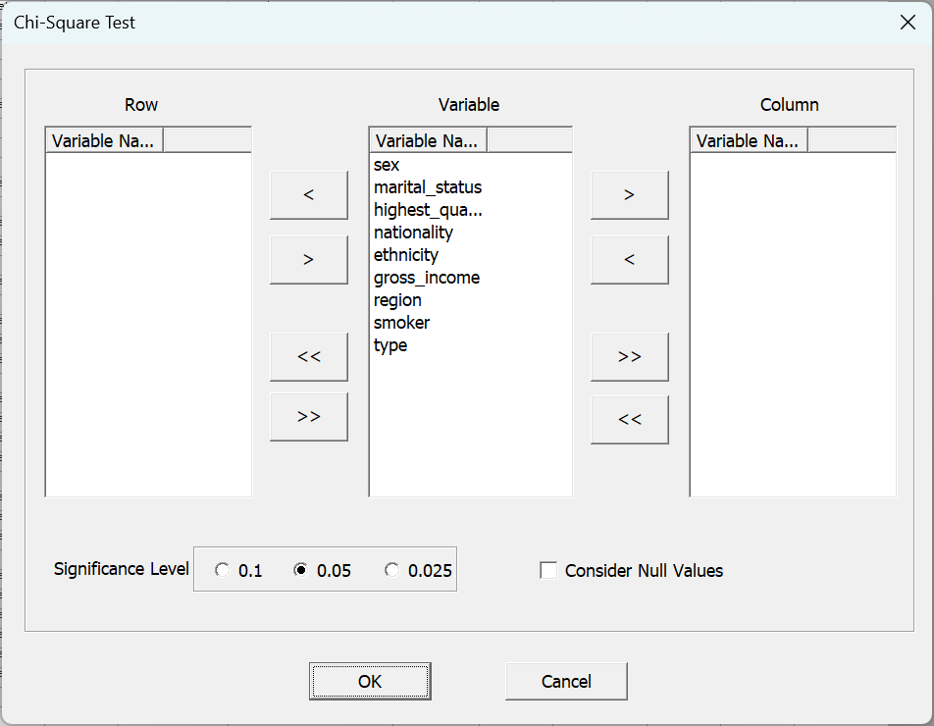

###### Results

The results of the Independence Test in ECMiner are presented in two parts: a cross-tabulation table and test statistics. The cross-tabulation (e.g., "sex vs. smoker") shows the count and percentage distributions across the combination of the two categorical variables. Each cell provides the count and the percentage relative to its row, column, and the total sample, which helps users understand how data points are distributed across categories. Below the table, the test statistics (Pearson Chi-Square and Likelihood Chi-Square) are provided along with their corresponding degrees of freedom (DF) and p-values. These statistics test the null hypothesis that the two variables are independent. If the p-value is less than the selected significance level (commonly 0.05), the null hypothesis is rejected, suggesting a significant association between the variables. In this example, both p-values are greater than 0.05, indicating no statistically significant relationship between sex and smoking status.

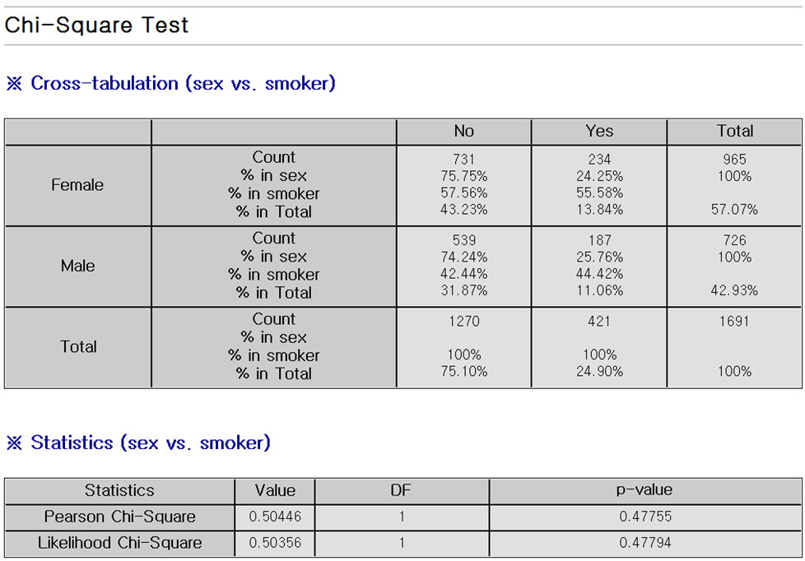

### 4.3.8 Probability Distribution

#### 4.3.8.1 Parameter Estimation

There are several methods to estimate the parameters of a probability distribution, including Method of Moment and Maximum Likelihood. ECMiner™ optimizes and estimates the parameters of a probability distribution using the Maximum Likelihood method based on the given data, and it provides confidence intervals for the estimated parameters to indicate their reliability. ECMiner™ provides 12 distribution methods which are, beta distribution, binomial distribution, extreme value distribution, exponential distribution, gamma distribution, log-normal distribution, negative binomial distribution, normal distribution, poisson distribution, Rayleigh distribution, continuous uniform distribution, and Weibull distribution.

##### How to run

**The menu path for** Parameter Estimation **from the Data Browser window is: [Analyze] – [Probability Distribution] – [Parameter Estimation].** There are 12 distributions. The user can select the distribution to fit the data, specify which field contains the data, and choose the desired confidence level for the estimation. After making these selections, clicking "View Results" will display the output.

##### (1) Beta Distribution

###### Estimation method

The **probability density function (pdf)** of the Beta distribution is given by: f(x \mid \alpha, \beta) = \frac{\Gamma(\alpha + \beta)}{\Gamma(\alpha)\Gamma(\beta)} x^{\alpha - 1} (1 - x)^{\beta - 1}, \quad 0 \leq x \leq 1, \; \alpha > 0, \; \beta > 0 The **likelihood function** for a set of observations x1,x2,…,xnx\_1, x\_2, \dots, x\_nx1​,x2​,…,xn​ is: L(x\_i \mid \alpha, \beta) = \prod\_{i=1}^{n} \frac{\Gamma(\alpha + \beta)}{\Gamma(\alpha)\Gamma(\beta)} x\_i^{\alpha - 1} (1 - x\_i)^{\beta - 1} To simplify the maximization, we take the **log-likelihood**: \ln L(x\_i \mid \alpha, \beta) = n \ln \Gamma(\alpha + \beta) - n \ln \Gamma(\alpha) - n \ln \Gamma(\beta) + (\alpha - 1) \sum\_{i=1}^{n} \ln x\_i + (\beta - 1) \sum\_{i=1}^{n} \ln (1 - x\_i) The values of α\alphaα and β\betaβ that maximize this log-likelihood are the **maximum likelihood estimators (MLEs)**. Since this function does not have a closed-form solution for the MLEs, **ECMiner™ uses the Nelder-Mead Simplex algorithm** to numerically maximize the log-likelihood function. **Caution**: All data used in Beta Distribution estimation must lie strictly within the interval [0,1][0, 1][0,1].

##### (2) Binomial Distribution

###### Estimation method

The **probability mass function (pmf)** of the Binomial distribution is: f(x \mid n, p) = \binom{n}{x} p^x (1 - p)^{n - x} Given observed data x1,x2,…,xnx\_1, x\_2, \dots, x\_nx1​,x2​,…,xn​, the **likelihood function** is: L(x\_i \mid n, p) = \prod\_{i=1}^{n} \binom{n}{x\_i} p^{x\_i} (1 - p)^{n - x\_i} Taking the **log-likelihood function** simplifies the expression: \ln L(x\_i \mid n, p) = \sum\_{i=1}^{n} \left[ \ln \binom{n}{x\_i} + x\_i \ln p + (n - x\_i) \ln (1 - p) \right] To find the **maximum likelihood estimator (MLE)** for ppp, take the partial derivative with respect to ppp and set it to zero: \frac{\partial}{\partial p} \ln L(x\_i \mid n, p) = \sum\_{i=1}^{n} \left( \frac{x\_i}{p} - \frac{n - x\_i}{1 - p} \right) = 0 Solving the above gives the MLE for ppp: \hat{p} = \frac{\sum\_{i=1}^{n} x\_i}{n \cdot n} = \frac{\bar{x}}{n} Here, xˉ\bar{x}xˉ is the sample mean of the observed binomial counts.

##### (3) Extreme Value Distribution

###### Estimation method

The **probability density function (pdf)** of the Extreme Value Distribution is given as: f(x \mid \mu, \sigma) = \frac{1}{\sigma} \exp\left( -\frac{x - \mu}{\sigma} - \exp\left( -\frac{x - \mu}{\sigma} \right) \right) From this, we derive the **log-likelihood function** for a sample x1,x2,…,xnx\_1, x\_2, \dots, x\_nx1​,x2​,…,xn​: \ln L(\mu, \sigma) = -n \ln \sigma - \sum\_{i=1}^{n} \left( \frac{x\_i - \mu}{\sigma} \right) - \sum\_{i=1}^{n} \exp\left( -\frac{x\_i - \mu}{\sigma} \right) To find the **maximum likelihood estimators (MLE)** for parameters μ\muμ and σ\sigmaσ, we take the partial derivatives of the log-likelihood function with respect to each parameter and set them equal to zero. This yields two equations. The first can be rearranged as an expression for one parameter in terms of the other. The strategy is to first solve the equation with respect to σ\sigmaσ, and then substitute that result into the equation for μ\muμ. To solve the nonlinear equation for σ\sigmaσ, the **Newton-Raphson method** is used. Define the following function: g(\sigma) = \text{[first-order derivative of the log-likelihood w.r.t. } \sigma \text{]} Then, apply the **Newton-Raphson iteration**: \sigma\_{k+1} = \sigma\_k - \frac{g(\sigma\_k)}{g'(\sigma\_k)} Once the MLE for σ\sigmaσ is obtained through iteration, it is substituted into the corresponding formula to estimate μ\muμ. This method involves solving a system of equations where analytical solutions are not straightforward. Numerical optimization is essential, and special care must be taken for convergence in Newton-Raphson steps.

##### (4) Exponential Distribution

###### Estimation method

The **probability density function (pdf)** of the Exponential Distribution is: f(x \mid \lambda) = \lambda e^{-\lambda x}, \quad x \geq 0, \lambda > 0 The **likelihood function** for a sample x1,x2,…,xnx\_1, x\_2, \dots, x\_nx1​,x2​,…,xn​ is: L(\lambda) = \prod\_{i=1}^{n} \lambda e^{-\lambda x\_i} Taking the natural logarithm of the likelihood function to obtain the **log-likelihood function**: \ln L(\lambda) = \sum\_{i=1}^{n} \ln(\lambda) - \lambda \sum\_{i=1}^{n} x\_i = n \ln(\lambda) - \lambda \sum\_{i=1}^{n} x\_i To find the **maximum likelihood estimator (MLE)**, take the derivative with respect to λ\lambdaλ and set it to zero: \frac{d}{d\lambda} \ln L(\lambda) = \frac{n}{\lambda} - \sum\_{i=1}^{n} x\_i = 0 Solving for λ\lambdaλ, the MLE is: \hat{\lambda} = \frac{n}{\sum\_{i=1}^{n} x\_i} This estimator is the reciprocal of the sample mean, which aligns with the intuition that the Exponential Distribution is governed by its rate parameter.

##### (5) Gamma Distribution

###### Estimation method

The **probability density function (pdf)** of the Gamma distribution is: f(x \mid \alpha, \beta) = \frac{1}{\beta^\alpha \Gamma(\alpha)} x^{\alpha - 1} e^{-x / \beta}, \quad x > 0,\ \alpha > 0,\ \beta > 0 The **likelihood function** for a sample x1,x2,…,xnx\_1, x\_2, \dots, x\_nx1​,x2​,…,xn​ is: L(x\_i \mid \alpha, \beta) = \prod\_{i=1}^{n} \frac{1}{\beta^\alpha \Gamma(\alpha)} x\_i^{\alpha - 1} e^{-x\_i / \beta} Taking the natural logarithm, the **log-likelihood function** becomes: \ln L(x\_i \mid \alpha, \beta) = -n\alpha \ln \beta - n \ln \Gamma(\alpha) + (\alpha - 1) \sum\_{i=1}^{n} \ln x\_i - \frac{1}{\beta} \sum\_{i=1}^{n} x\_i To find the **maximum likelihood estimators (MLEs)**, take partial derivatives and set them to zero: **Partial derivative with respect to α\alphaα:** \frac{\partial}{\partial \alpha} \ln L = -n \ln \beta + \sum\_{i=1}^{n} \ln x\_i - n \frac{\partial \ln \Gamma(\alpha)}{\partial \alpha} = 0 This equation requires numerical methods to solve. **Newton-Raphson** is typically used: \hat{\alpha}\_{\text{new}} = \alpha - \frac{f(\alpha)}{f'(\alpha)}

Where: f'(\alpha) = -n \frac{\partial^2 \ln \Gamma(\alpha)}{\partial \alpha^2} + \frac{n}{\alpha} **Partial derivative with respect to β\betaβ:** \frac{\partial}{\partial \beta} \ln L = -\frac{n\alpha}{\beta} + \frac{1}{\beta^2} \sum\_{i=1}^{n} x\_i = 0 Solving for β\betaβ, the MLE is: \hat{\beta} = \frac{\bar{x}}{\hat{\alpha}}, \quad \text{where } \bar{x} = \frac{1}{n} \sum\_{i=1}^{n} x\_i

##### (6) Log-Normal Distribution

###### Estimation method

A random variable X that follows a log-normal distribution satisfies the condition: Y=log⁡(X)∼NormalY = \log(X) \sim \text{Normal}Y=log(X)∼Normal. In other words, a variable that becomes normally distributed when a logarithmic transformation is applied is said to follow a log-normal distribution. The probability density function (pdf) is as follows: f\_X(x; \mu, \sigma) = \frac{1}{x \sigma \sqrt{2\pi}} \exp\left( -\frac{(\ln(x) - \mu)^2}{2\sigma^2} \right), \quad x > 0 From this, the **log-likelihood function** is derived: \ln L(\mu, \sigma^2 | \mathbf{x}) = -\sum\_{i=1}^{n} \ln(x\_i) - n \ln(\sigma \sqrt{2\pi}) - \sum\_{i=1}^{n} \frac{(\ln(x\_i) - \mu)^2}{2\sigma^2} To estimate the parameters, we take the partial derivatives of the log-likelihood function with respect to each parameter and find the parameter values that maximize the function. The resulting parameter estimates are: \hat{\mu} = \frac{1}{n} \sum\_{i=1}^{n} \ln(x\_i), \quad; \hat{\sigma}^2 = \frac{1}{n} \sum\_{i=1}^{n} \left( \ln(x\_i) - \hat{\mu} \right)^2 The **confidence interval** for these estimates is given by: \mu \in \left[ \mu \pm \frac{z\_{\alpha/2}}{\sqrt{n}} \right], \quad; \sigma \in \left[ \sqrt{ \frac{(n-1)s^2}{\chi^2\_{1 - \alpha/2, n-1}} }, \sqrt{ \frac{(n-1)s^2}{\chi^2\_{\alpha/2, n-1}} } \right] The reason the quantiles of the normal and chi-square distributions appear in the confidence interval formula is because log⁡(X)\log(X)log(X) follows a normal distribution.

##### (7) Negative Binomial Distribution

###### Estimation method

The **probability mass function (pmf)** of the Negative Binomial Distribution is: f(x \mid r, p) = \binom{x + r - 1}{x} p^r (1 - p)^x, \quad x = 0, 1, 2, \dots,\ r > 0,\ 0 < p < 1 Using the observed data x1,x2,…,xnx\_1, x\_2, \dots, x\_nx1​,x2​,…,xn​, the **likelihood function** is: L(x\_i \mid r, p) = \prod\_{i=1}^{n} \binom{x\_i + r - 1}{x\_i} p^r (1 - p)^{x\_i} Taking the logarithm of the likelihood function, the **log-likelihood function** becomes: \ln L(x\_i \mid r, p) = \sum\_{i=1}^{n} \left[ \ln \binom{x\_i + r - 1}{x\_i} + r \ln p + x\_i \ln(1 - p) \right] Since this function is **nonlinear in both parameters** rrr and ppp, it is not possible to obtain closed-form maximum likelihood estimators (MLEs) analytically. To estimate the parameters rrr and ppp that **maximize the log-likelihood**, ECMiner™ applies the **Nelder and Mead Simplex method**, a popular **derivative-free optimization algorithm**. **Note:** All input data must be **non-negative integers (≥ 0)**.

##### (8) Normal Distribution

###### Estimation method

The **probability density function (pdf)** of the Normal Distribution is given as: f(x \mid \mu, \sigma^2) = \frac{1}{\sqrt{2\pi \sigma^2}} \exp\left( -\frac{(x - \mu)^2}{2\sigma^2} \right) Given a sample x1,x2,…,xnx\_1, x\_2, \dots, x\_nx1​,x2​,…,xn​, the **likelihood function** is: L(x\_i \mid \mu, \sigma^2) = \prod\_{i=1}^{n} \frac{1}{\sqrt{2\pi \sigma^2}} \exp\left( -\frac{(x\_i - \mu)^2}{2\sigma^2} \right) Taking the logarithm, we obtain the **log-likelihood function**: \ln L(x\_i \mid \mu, \sigma^2) = -\frac{n}{2} \ln(2\pi) - \frac{n}{2} \ln(\sigma^2) - \frac{1}{2\sigma^2} \sum\_{i=1}^{n} (x\_i - \mu)^2 To find the **Maximum Likelihood Estimators (MLEs)** for μ\muμ and σ2\sigma^2σ2, take partial derivatives and set them to zero: For μ\muμ: \frac{\partial}{\partial \mu} \ln L = \frac{1}{\sigma^2} \sum\_{i=1}^{n} (x\_i - \mu) = 0 \Rightarrow \hat{\mu} = \frac{1}{n} \sum\_{i=1}^{n} x\_i For σ2\sigma^2σ2: \frac{\partial}{\partial \sigma^2} \ln L = -\frac{n}{2\sigma^2} + \frac{1}{2\sigma^4} \sum\_{i=1}^{n} (x\_i - \mu)^2 = 0 \Rightarrow \hat{\sigma}^2 = \frac{1}{n} \sum\_{i=1}^{n} (x\_i - \hat{\mu})^2 These MLEs are the **sample mean** and the **(biased) sample variance**, respectively. Note: XαX\_{\alpha}Xα​ is the α-quantile of the standard Normal Distribution, commonly used for confidence intervals or hypothesis testing.

##### (9) Poisson Distribution

###### Estimation method

The **probability mass function (pmf)** of the Poisson Distribution is given by: f(x \mid \lambda) = \frac{\lambda^x}{x!} e^{-\lambda} Given a sample x1,x2,…,xnx\_1, x\_2, \dots, x\_nx1​,x2​,…,xn​, the **likelihood function** is: L(x\_i \mid \lambda) = \prod\_{i=1}^{n} \frac{\lambda^{x\_i}}{x\_i!} e^{-\lambda} Taking the natural logarithm, the **log-likelihood function** becomes: \ln L(x\_i \mid \lambda) = \sum\_{i=1}^{n} \left[ x\_i \ln \lambda - \lambda - \ln(x\_i!) \right] = \left( \sum\_{i=1}^{n} x\_i \right) \ln \lambda - n\lambda - \sum\_{i=1}^{n} \ln(x\_i!) To find the **Maximum Likelihood Estimator (MLE)** for λ\lambdaλ, take the derivative of the log-likelihood with respect to λ\lambdaλ and set it equal to zero: \frac{\partial}{\partial \lambda} \ln L = \frac{1}{\lambda} \sum\_{i=1}^{n} x\_i - n = 0 Solving for λ\lambdaλ, we get: \hat{\lambda} = \frac{1}{n} \sum\_{i=1}^{n} x\_i Thus, the MLE for λ\lambdaλ is the **sample mean** of the observed data.

##### (10) Rayleigh Distribution

###### Estimation method

The **probability density function (pdf)** of the **Rayleigh distribution** is given by: f(x \mid \sigma) = \frac{x}{\sigma^2} e^{-x^2 / (2\sigma^2)} \quad \text{for } x \geq 0, \sigma > 0 Using this, the **likelihood function** for a sample x1,x2,…,xnx\_1, x\_2, \dots, x\_nx1​,x2​,…,xn​ is: L(\sigma) = \prod\_{i=1}^n \frac{x\_i}{\sigma^2} e^{-x\_i^2 / (2\sigma^2)} Taking the natural logarithm, the **log-likelihood function** becomes: \ln L(\sigma) = \sum\_{i=1}^n \left[ \ln x\_i - 2\ln \sigma - \frac{x\_i^2}{2\sigma^2} \right] = \sum\_{i=1}^n \ln x\_i - 2n \ln \sigma - \frac{1}{2\sigma^2} \sum\_{i=1}^n x\_i^2 To obtain the **maximum likelihood estimator (MLE)** of σ\sigmaσ, take the derivative with respect to σ\sigmaσ, set it equal to zero, and solve: \frac{\partial}{\partial \sigma} \ln L(\sigma) = -\frac{2n}{\sigma} + \frac{1}{\sigma^3} \sum\_{i=1}^n x\_i^2 = 0 Solving this yields the MLE: \hat{\sigma} = \sqrt{ \frac{1}{2n} \sum\_{i=1}^n x\_i^2 } **Confidence Interval for σ\sigmaσ.** To construct a **confidence interval** for σ\sigmaσ, we use the fact that: \frac{2n \hat{\sigma}^2}{\sigma^2} \sim \chi^2\_{2n} Thus, a 100(1−α)%100(1 - \alpha)\%100(1−α)% confidence interval for σ\sigmaσ is: \left[ \sqrt{ \frac{2n \hat{\sigma}^2}{\chi^2\_{1-\alpha/2, 2n}} }, \; \sqrt{ \frac{2n \hat{\sigma}^2}{\chi^2\_{\alpha/2, 2n}} } \right] where χγ,2n2\chi^2\_{\gamma, 2n}χγ,2n2​ denotes the γ\gammaγ-quantile of the chi-square distribution with 2n2n2n degrees of freedom.

##### (11) Continuous Uniform Distribution

###### Estimation method

The probability density function (pdf) of the Continuous Uniform Distribution over the interval [a,b][a, b][a,b] is: f(x \mid a, b) = \frac{1}{b - a}, \quad \text{for } a \leq x \leq b Given a random sample x1,x2,…,xnx\_1, x\_2, \dots, x\_nx1​,x2​,…,xn​ from this distribution, the maximum likelihood estimators (MLEs) for the parameters aaa and bbb are: \hat{a} = \min(x\_1, x\_2, \dots, x\_n) \\

\hat{b} = \max(x\_1, x\_2, \dots, x\_n) These estimators are intuitive: since all values are equally likely in the interval [a,b][a, b][a,b], the most likely endpoints for the observed sample are simply its minimum and maximum values.

##### (12) Weibull distribution

###### Estimation method

The probability density function (pdf) of the Weibull distribution is given by: f(x \mid \alpha, \beta) = \frac{\beta}{\alpha} \left(\frac{x}{\alpha}\right)^{\beta - 1} e^{-\left(\frac{x}{\alpha}\right)^\beta}, \quad x \ge 0, \ \alpha > 0, \ \beta > 0 Log-Likelihood Function: Given a sample x1,x2,…,xnx\_1, x\_2, \dots, x\_nx1​,x2​,…,xn​, the log-likelihood function is: \ln L(\alpha, \beta) = n \ln \beta - n \ln \alpha + (\beta - 1) \sum\_{i=1}^n \ln x\_i - \sum\_{i=1}^n \left(\frac{x\_i}{\alpha}\right)^\beta Partial Derivatives: To find the Maximum Likelihood Estimators (MLEs), take partial derivatives and set them to zero: \frac{\partial}{\partial \alpha} \ln L = -\frac{n}{\alpha} + \frac{\beta}{\alpha^2} \sum\_{i=1}^n x\_i^\beta e^{-\left(\frac{x\_i}{\alpha}\right)^\beta} = 0 \frac{\partial}{\partial \beta} \ln L = \frac{n}{\beta} + \sum\_{i=1}^n \ln x\_i - \sum\_{i=1}^n \left(\frac{x\_i}{\alpha}\right)^\beta \ln \left(\frac{x\_i}{\alpha}\right) = 0 MLE Estimation: An approximate solution for α\alphaα can be computed by: \hat{\alpha} = \left( \frac{1}{n} \sum\_{i=1}^n x\_i^\beta \right)^{1/\beta} To solve for β\betaβ, we apply the Newton-Raphson method: \beta^{(t+1)} = \beta^{(t)} - \frac{f(\beta^{(t)})}{f'(\beta^{(t)})} Where f(β)f(\beta)f(β) and its derivative f′(β)f'(\beta)f′(β) are calculated using the log-likelihood expression and its derivatives.

#### 4.3.8.2 Individual Distribution Identification

To check the distribution of data, one can apply various distributions and utilize the obtained Anderson-Darling statistic along with its P-value to determine the most similar distribution to the data.

##### How to run

**The menu path for Individual Distribution Identification from the Data Browser window is: [Analyze] – [Probability Distribution] – [Individual Distribution Identification]** From the variable list, select the variable for which distribution identification is desired (multiple selections are allowed), and then choose which distributions to apply from the distribution selection (multiple selections are allowed).

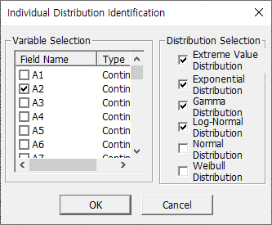

##### Result

**Variable information**: Provides basic statistics of the selected variable(s). **Distribution Parameter Estimation**: Estimates the parameters of the selected distribution based on the relevant variable. **Test statistic**: Provides the Anderson-Darling statistic and P-value, indicating how well the variable fits the chosen distribution. Note: If the P-value exceeds 0.05, it can be concluded that variable adheres to the specified distribution.

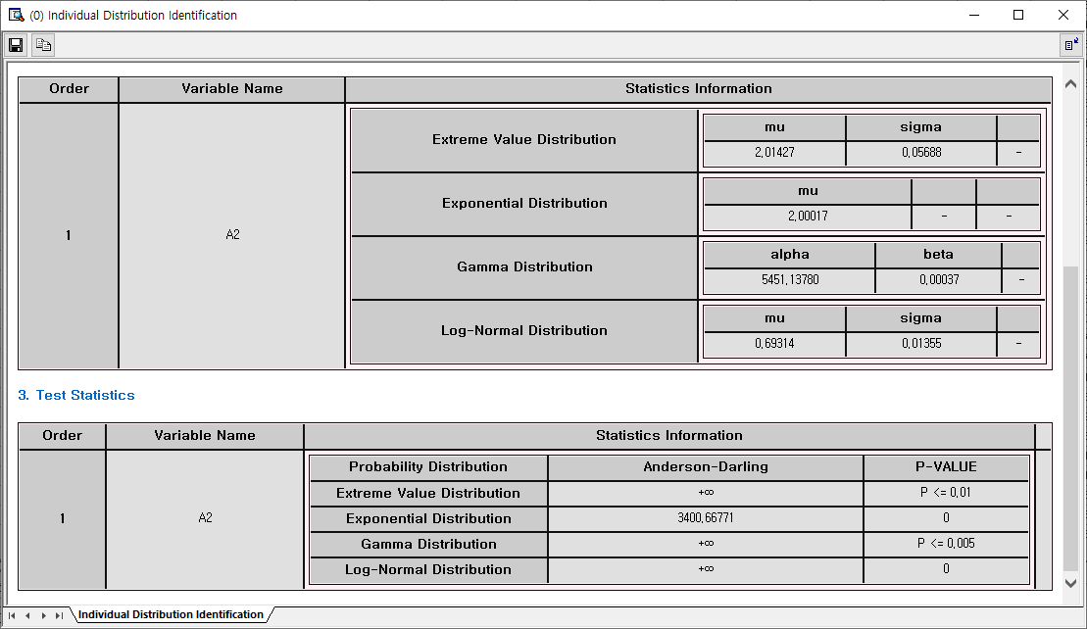

### 4.3.9 Nonparametric Test

#### 4.3.9.1 One-Sample

A non-parametric one-sample test is used to evaluate whether the median of a sample differs from a hypothesized value. It does not assume a specific distribution and is useful when the data is not normally distributed. Our software supports the Wilcoxon signed-rank test, which takes into account the rank of values.

##### How to run

**The menu path for Nonparametric Test from the Data Browser window is: [Analyze] – [Nonparametric Test]** Select Analysis **Variable** and enter the **hypothesized median**. Set the **Significance level**. Choose **one** of two testing methods.

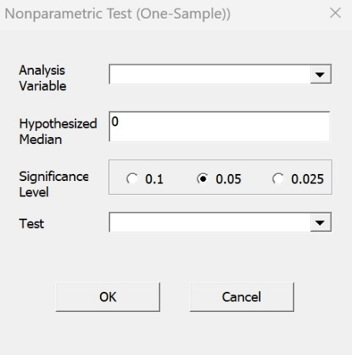

##### Result

The One-Sample Nonparametric Test in ECMiner™ evaluates whether the median of a single variable differs significantly from a specified value without assuming a normal distribution. In this example, the variable A1 has a data count of 7,596, with a median of 109.99100 and a mean of 109.35402. The test used is the Sign Test, which compares the observed median to the hypothesized value (0 in this case). The result yields a p-value of 0 (two-sided), indicating extremely strong evidence against the null hypothesis. As a result, the conclusion is to reject the null hypothesis, suggesting that the true median of A1 is statistically significantly different from 0. A normal approximation was used to derive the test statistic due to the large sample size.

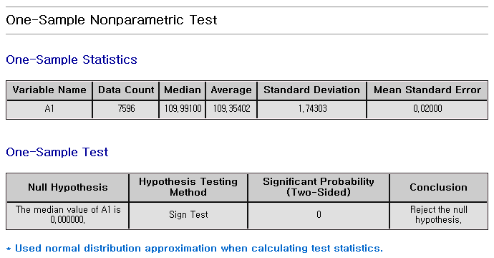

#### 4.3.9.2 Independent Samples

Non-parametric independent samples tests are used to compare two or more groups without assuming a specific distribution. Our software provides the Mann-Whitney U statistic method.

##### How to run

**The menu path for Independent Samples from the Data Browser window is: [Analyze] – [Nonparametric Test] - [Independent Samples]** Select **Analysis Variable**, and **Group variable**. Set the **Significance level**.

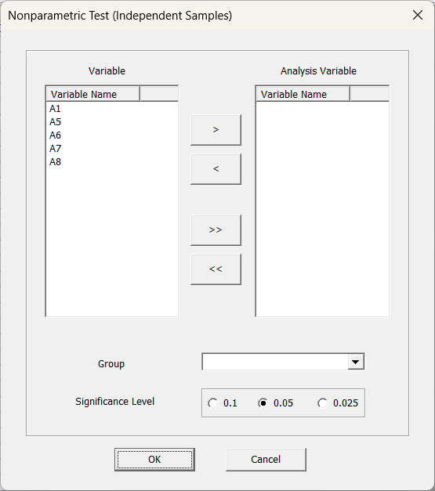c

##### Result

The Nonparametric Independent Samples Test in ECMiner compares the distributions of a variable across two or more independent groups without assuming a specific distribution. In this example, the variable A1 is compared across two groups of the variable churn\_status. Group 0 has 5 data points with all values equal to 0, while Group 1 has 19 data points with a mean of approximately 17.74. The Mann-Whitney U Test is applied to determine if the distributions differ significantly. The resulting p-value is 0.00001, which is below the typical significance level (e.g., 0.05), leading to the conclusion that the null hypothesis—stating that the distribution of A1 is identical across both churn\_status groups—should be rejected. This indicates a statistically significant difference in A1 between the two groups.

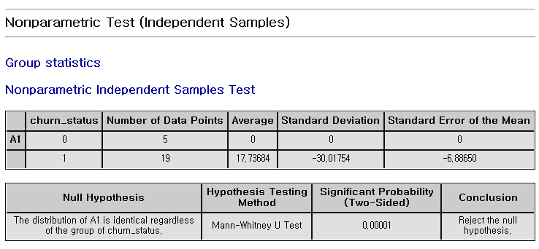

#### 4.3.9.3 Paired Samples

For non-parametric paired samples, there are two tests, the sign test and Wilcoxon signed-rank test.

##### How to run

**The menu path for Paired Samples from the Data Browser window is: [Analyze] – [Nonparametric Test] - [Paired Samples]** Select two variables, **variable1** and **variable2**. Set the **Significance** **level**.

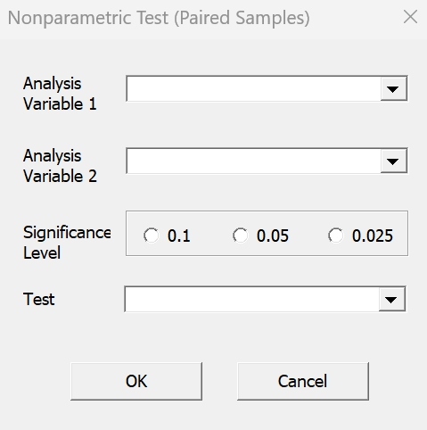

##### Result

The Nonparametric Test for Paired Samples in ECMiner is used to determine whether there is a significant difference between two related variables. In this result, A1 and A5 are compared across 24 paired observations using the Wilcoxon Signed Rank Test, a nonparametric alternative to the paired t-test that does not assume normality. The median of A1 is 24, while the median of A5 is approximately 146.99, indicating a substantial difference in central tendency. The test yields a two-sided p-value of 0.00002, which is well below common significance levels (e.g., 0.05), leading to the rejection of the null hypothesis. This result suggests that the median difference between A1 and A5 is statistically significant, confirming that the two paired variables differ meaningfully. The test uses a normal approximation to derive the test statistic.

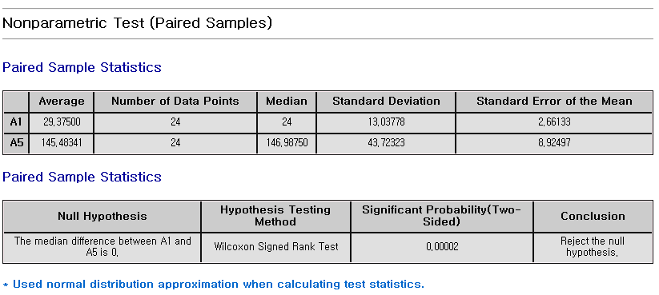

#### 4.3.9.4 ANOVA- One-way

The Kruskal-Wallis test is a non-parametric method used to compare the medians of three or more independent groups. It’s an alternative to one-way ANOVA for non-normally distributed data.

##### How to run

**The menu path for ANOVA-One-way from the Data Browser window is: [Analyze] – [Nonparametric Test] - [ANOVA-One-way]** Specify the **group** as **Factors** and select **Variables.**

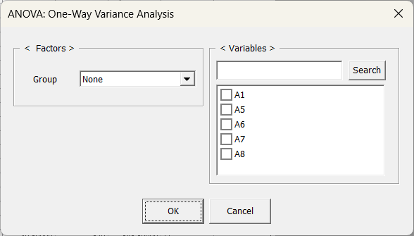

##### Result

The Nonparametric One-Way ANOVA function in ECMiner uses the Kruskal-Wallis Test to assess whether the distribution of a continuous variable differs significantly across two or more independent groups. This test is a nonparametric alternative to the traditional one-way ANOVA and does not assume normality of the data. The result table displays the test statistic, degrees of freedom, p-value, and the conclusion regarding the null hypothesis. A high p-value indicates insufficient evidence to reject the null hypothesis, suggesting that the distributions across groups are statistically similar. In contrast, a low p-value would indicate a significant difference between at least two of the groups. Additionally, group-level statistics such as the mean, median, average rank, and standard deviation are provided to aid in interpretation of central tendency and variability across the groups.

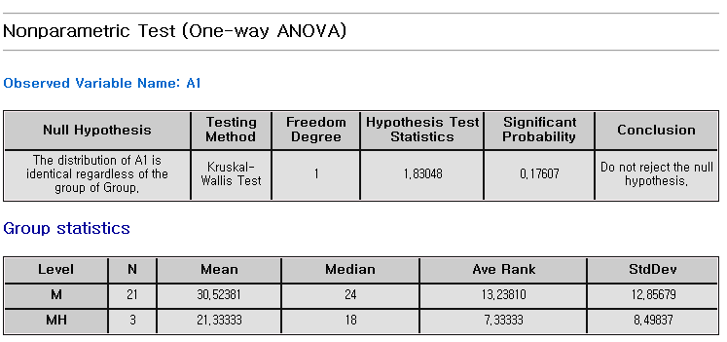

### 4.3.10 Accuracy Measurement

The model's accuracy and validity can be measured by comparing the true(original) values with the predicted values.

##### How to run

**The menu path for** Accuracy Measurement **from the Data Browser window is: [Classification] or [Regression] from the submenu of [Analyze] – [Accuracy Measurement].**

#### 4.3.10.1 Classification

##### Estimation method

The **classification** analysis predicts each class label. A **confusion matrix** is a table used to evaluate the performance of a classification model. **Confusion matrix** is a 2x2 table with the frequency of true target class and predicted class. It shows true positive rate, true negative rate, false positive rate, and false negative rate.

##### Example

The Classification Accuracy Measurement function in ECMiner evaluates the performance of classification models by comparing predicted values with actual values for a specified dependent variable. Upon selecting the dependent and predictor variables and executing the function, the result includes a confusion matrix that summarizes the counts and proportions of correct and incorrect classifications for each class. It also reports the total number of misclassifications and the misclassification rate, which reflects the percentage of incorrect predictions out of all predictions made. Additionally, a frequency table provides the distribution of actual values for the dependent variable, offering insight into class imbalance. These outputs help users assess the model's classification effectiveness, identify which classes are more prone to misclassification, and make informed decisions about model refinement.

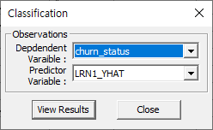

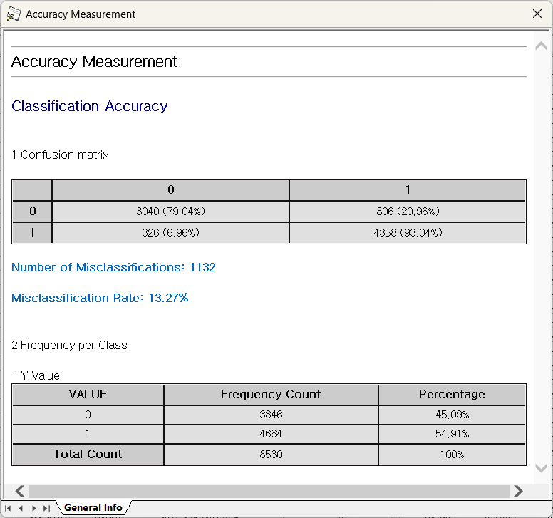

#### 4.3.10.2 Regression

##### Estimation method

**R-square, Mean Absolute Percentage Error (MAPE), Mean Absolute Error (MAE), and Root Mean Squared Error (RMSE)** (1) **R-square:** R-square is a statistical measure that indicates how well the independent variables explain the variability of the dependent variable in a regression model. It ranges from 0 to 1, with values closer to 1 suggesting a better fit. An R-square of 0.9, for instance, means that 90% of the variance in the dependent variable is explained by the model. (2) **MAPE (Mean Absolute Percentage Error):** MAPE measures the average magnitude of errors in percentage terms. It is calculated by taking the mean of the absolute percentage differences between the actual and predicted values. It is useful for understanding the relative size of errors, especially in forecasting. Lower MAPE values indicate better predictive accuracy. (3) **MAE (Mean Absolute Error):** MAE is the average of the absolute differences between predicted values and actual values. It provides a straightforward interpretation of the average error in the same units as the original data. A smaller MAE value reflects better model performance. (4) **RMSE (Root Mean Squared Error) :**RMSE is the square root of the average of the squared differences between predicted and actual values. Because it squares the errors before averaging, it gives more weight to larger errors compared to MAE. RMSE is sensitive to outliers and is useful when large errors are particularly undesirable.

##### Example

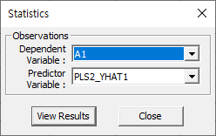

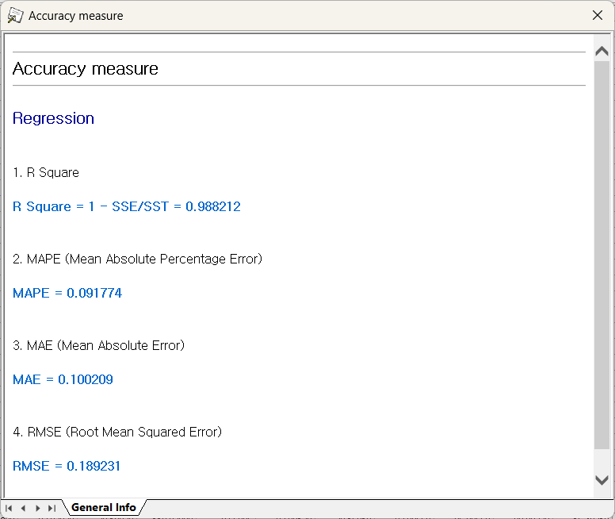

### 4.3.11 Gage R&R

Gage R&R (Gage Repeatability and Reproducibility) is a statistical method used to evaluate the amount of variation in a measurement system arising from the measurement device (repeatability) and the people taking the measurements (reproducibility).

#### 4.3.11.1 Gage Run Chart

**Gage Run Chart** is a visual tool used to assess the consistency of a measurement system by plotting measurement values based on **Part Number**, **Operator**, **Measurement Data**, and **Iteration Count**. The chart displays the measurements taken by different operators over several iterations and compares them against a **Measurement Average** or **calculated mean** to evaluate the stability and variability of the measurement system over time.

An example of the data used is shown below.

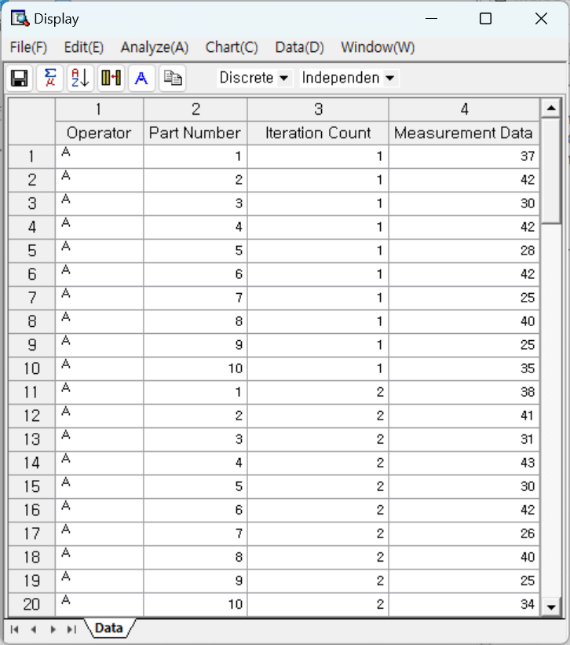

##### How to run

**[Analyze] – [Gage R&R] – [Gage Run Chart]**

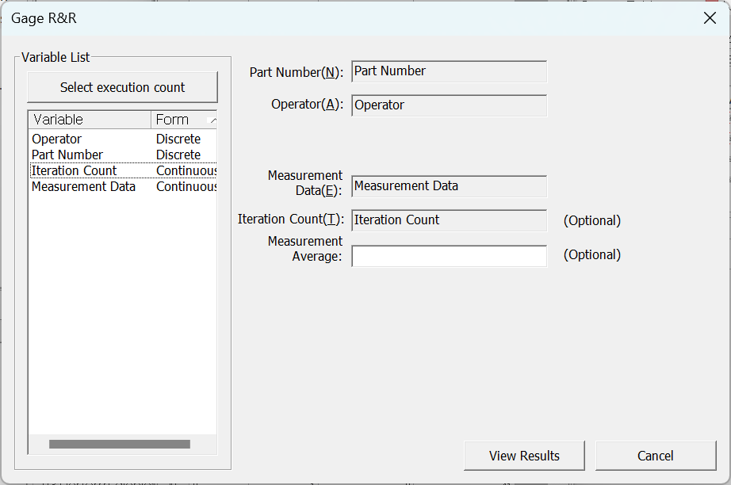

* **Part Number**: Select the parts (Must be discrete)
* **Operator**: Select the one who takes measures (Must be discrete)
* **Measurement Data**: Select the measured data (Must be continuous)
* **Iteration Count (Optional)**: Repeated measure count for the same part by the same operator. **(Must be continuous)**
* **Measurement Average (Optional)**: Enter a Measurement Average to compare the part’s measurements. By default, calculated mean of all measurements is shown.

##### Results

Example using 3 operators, 10 types of parts, and 3 repetitions.

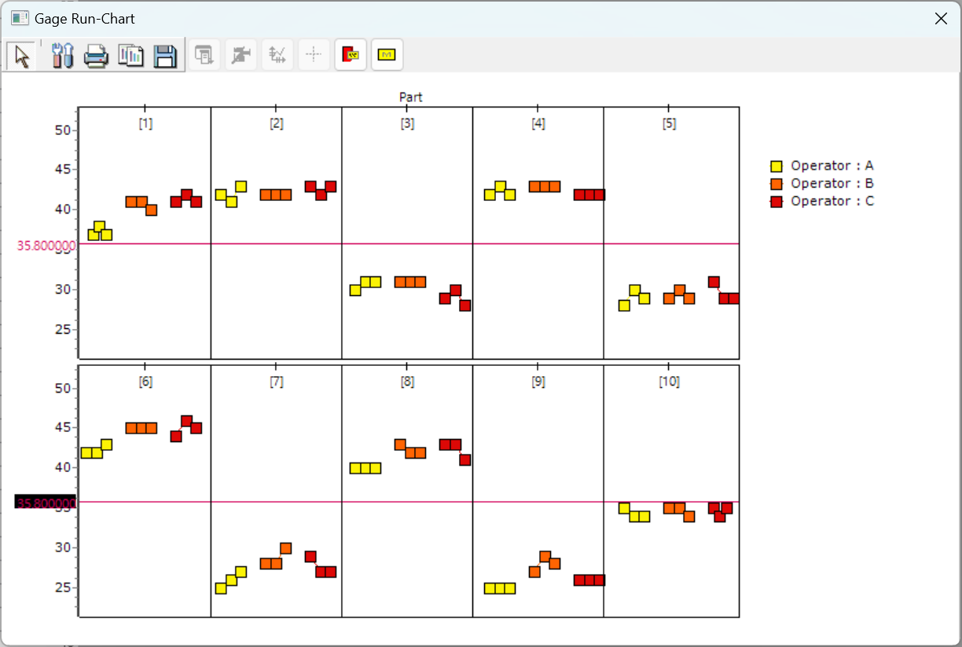

#### 4.3.11.2 Gage Linearity and Bias Study

**Gage Linearity and Bias Study** evaluates the accuracy and consistency of the measurement system using various **Part Number**, their **Standard Value**, and **Measurement Data**. The difference between the measured values and the standard values identifies as the bias, while considering **Process Variation** to analyze whether linearity is maintained across the full measurement range.

An example of the data used is shown below.

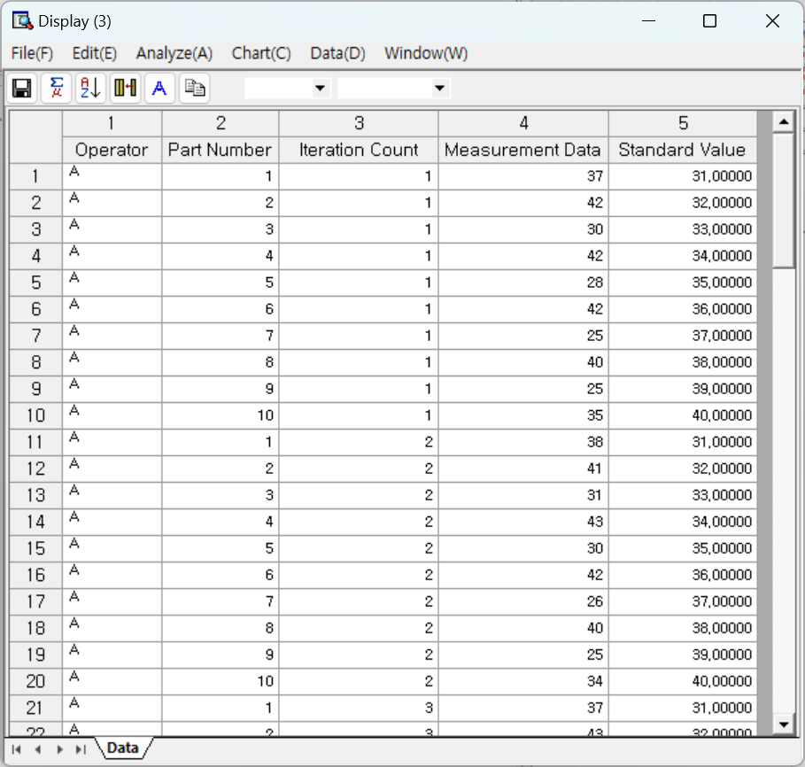

##### How to run

**[Analyze] – [Gage R&R] – [Gage Linearity and Bias Study]**

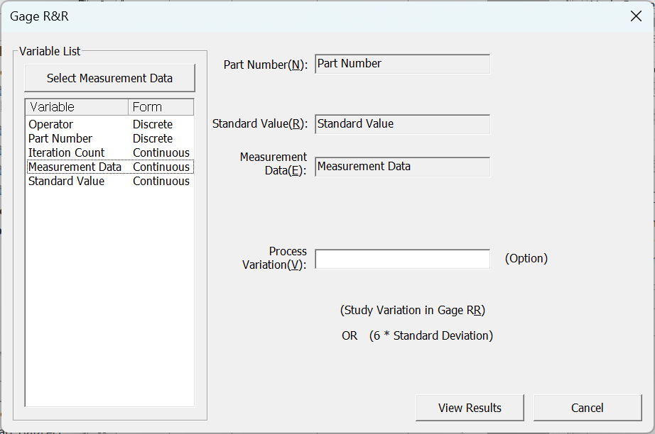

* **Part Number**: Select the parts. (Must be discrete)
* **Standard Value**: Select the standard value of the measurement (Must be continuous)
* **Measurement Data**: Select the measured data (Must be Continuous)
* **Process Variation**: Enter the process standard deviation which represents the study variation value from a Gage R&R study or 6 \* standard deviation.

##### Results

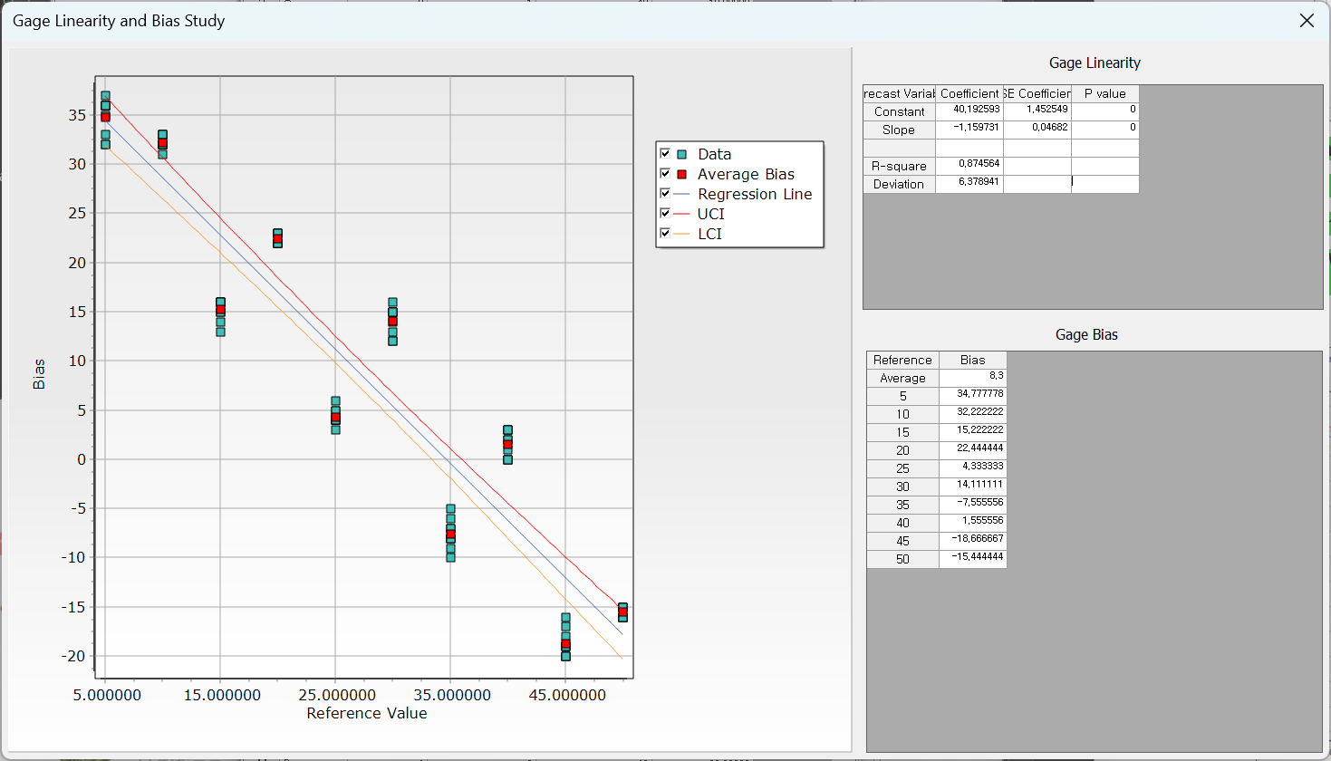

The chart on the left shows the linear relationship between bias and the data, and the table on the right provides values related to linearity and bias.

#### 4.3.11.3 Gage R&R Study (Crossed Design)

In a crossed design, every operator measures every part multiple times. It determines suitability of the measurement system. There are two methods: **Variance Analysis** and **X-bar and R** methods. If the user wants to analyze the interaction between operators and parts, a crossed design is preferable.

##### How to run

**[Analyze] – [Gage R&R] – [Gage R&R Study (Crossed Design)]**

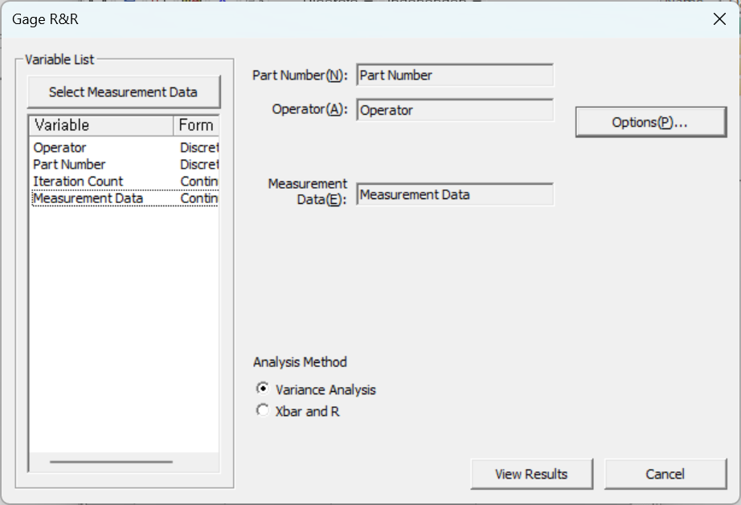

* **Part Number**: Select the parts (Must be discrete)
* **Operator**: Select the one who takes measures (Must be discrete)
* **Measurement Data**: Select the measured data (Must be continuous)
* **Analysis Method**: Choose either **Variance analysis** or **X-bar and R** method.

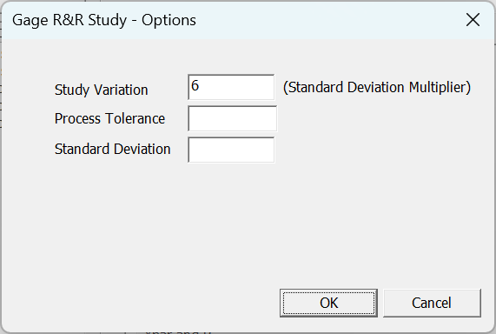

* **Study Variation**: Enter the coefficient to obtain the Study Variation.
* **Process Tolerance**: Enter an empirically known tolerance to calculate %tolerance.
* **Standard Deviation**: Enter an empirically known Historical Standard to calculate %process.

##### Results

* General Information

Shows the results of ANOVA (only when variance analysis is selected) and Gage R&R analysis results.

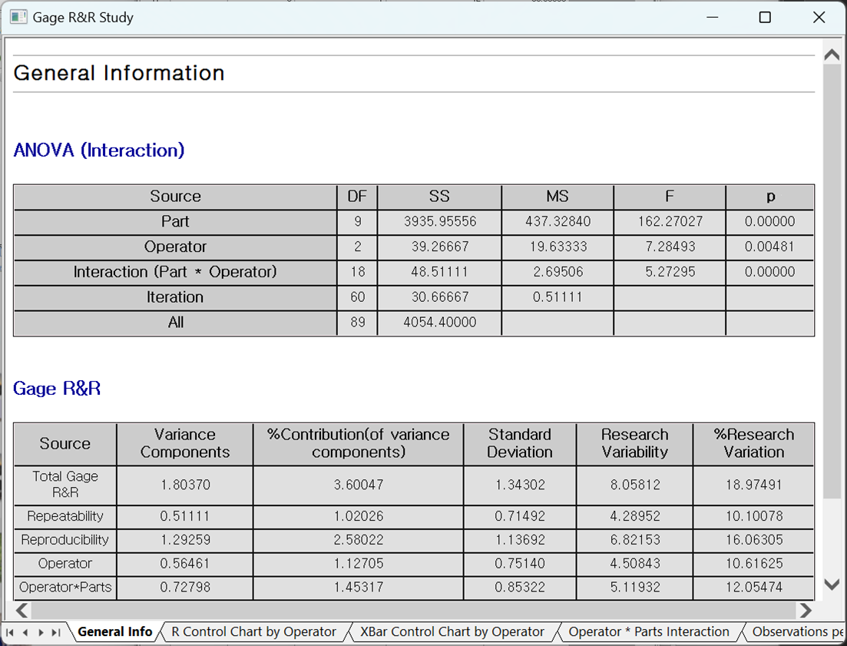

* R Control Chart by Operator:

Each point displays the difference in the smallest and the biggest measurement of the same part by each operator.

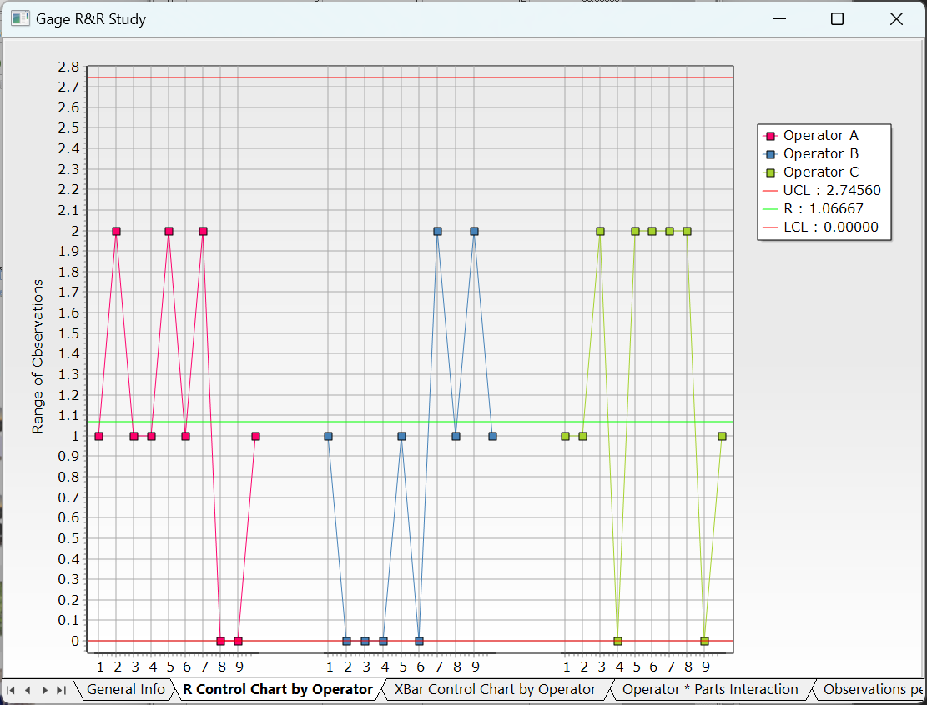

* X-Bar Control Chart by Operator

Each point displays the average measurement of the same part by each operator.

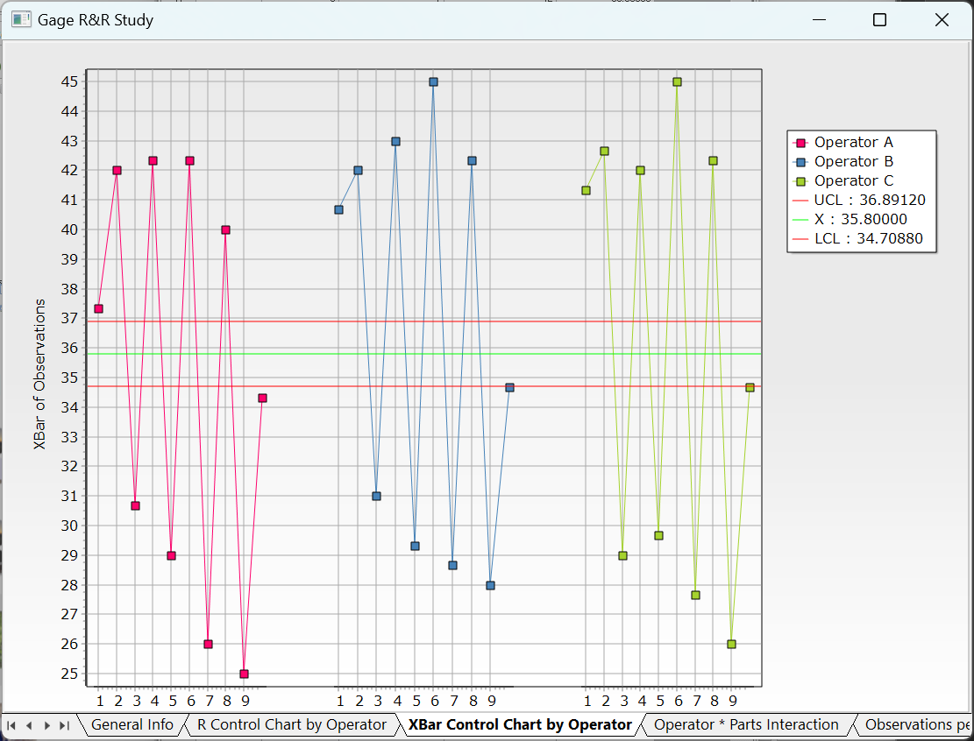

* Operator\*Parts Interaction:

Displays How different operators interact with various parts during the measurement process.

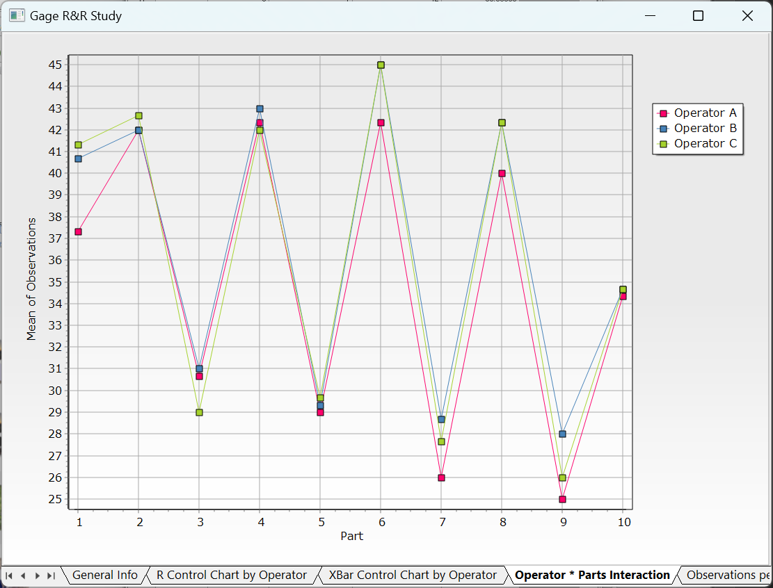

* Observations per Operator

Displays box plots of all measurements for each operator, with the solid line representing the mean.

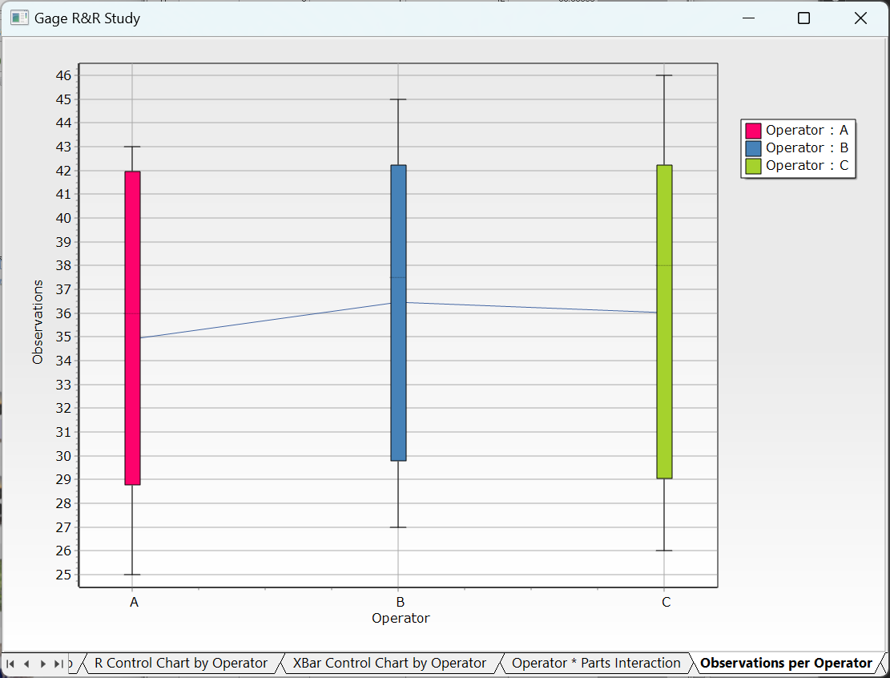

* Observations by Part:

Displays observations per part only, with the solid line representing the mean.

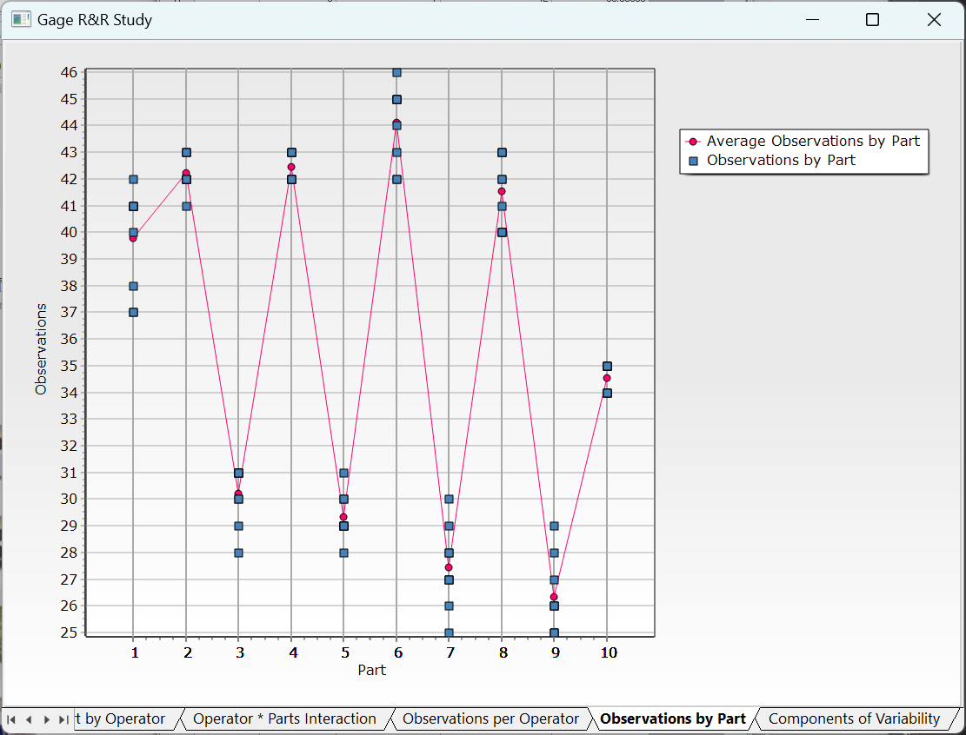

* Components of Variability

Displays where the variation in observed values originates.

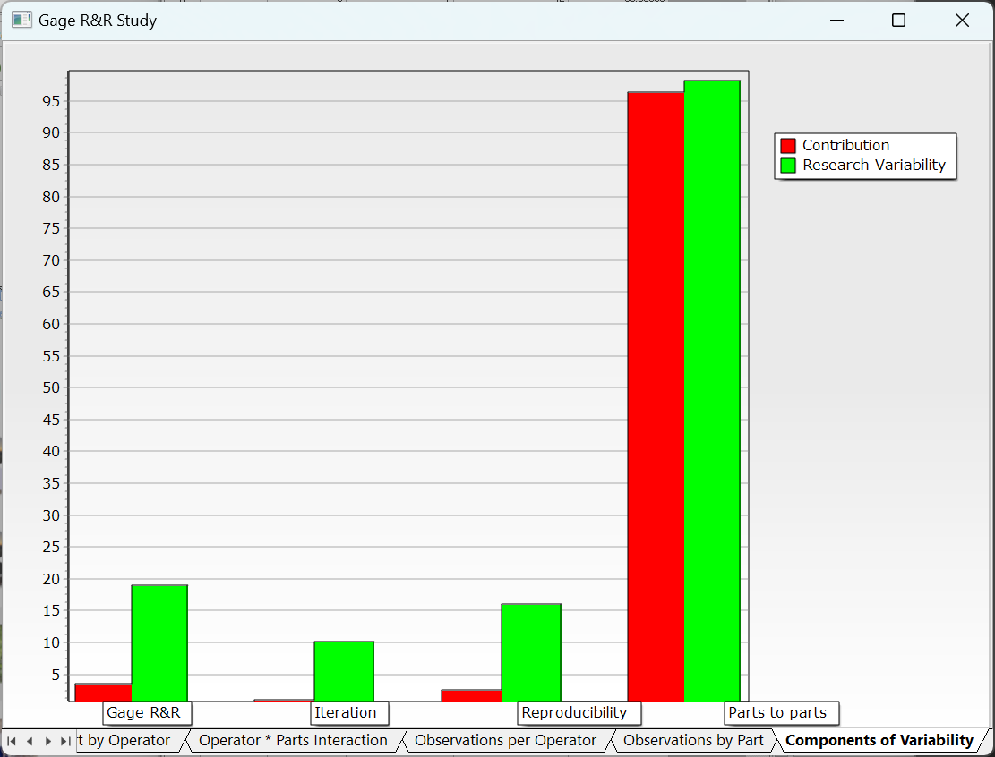

#### 4.3.11.4 Gage R&R Study (Nested Design)

**Gage R&R Study (Nested Design)** is a technique which each part is measured by only one operator. It is commonly used in destructive testing and in systems where once one operator measures a part, no other operator can measure the same part. It is essential to assume that parts within each batch are nearly identical. If this assumption is violated, operators will measure different parts, making it unclear whether the variation is due to part differences or issues in the measurement system. In nested designs, total variation is divided into part-to-part, reproducibility, and repeatability, allowing for accurate identification of measurement variability sources.

##### How to run

**[Analyze] – [Gage R&R] – [Gage R&R Study (Nested Design)]**

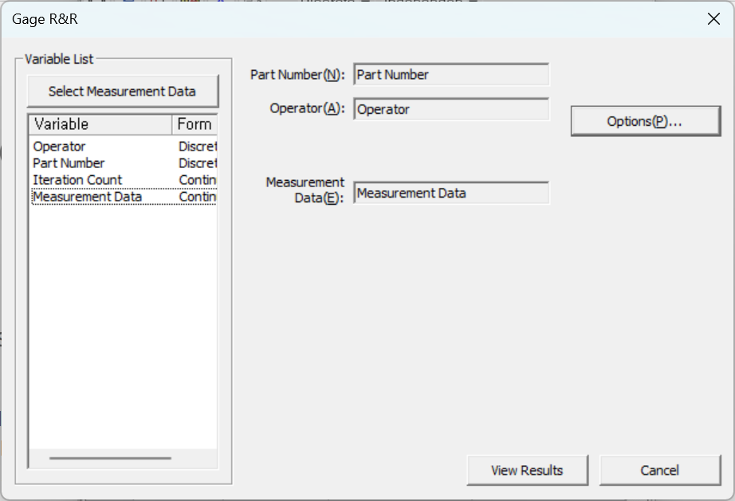

* **Part Number**: Select the parts (Must be discrete)
* **Operator**: Select the one who takes measures (Must be discrete)
* **Measurement** **Data**: Select the measured data (Must be continuous)

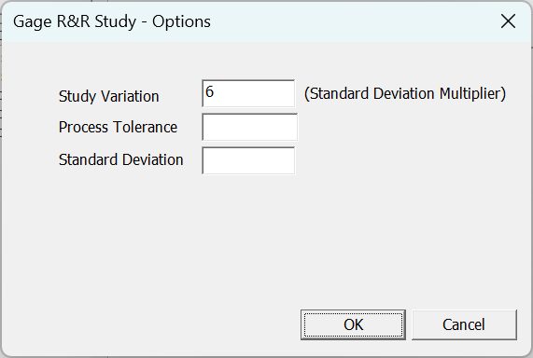

* **Study Variation**: Enter the coefficient to obtain the Study Variation.
* **Process Tolerance**: Enter an empirically known tolerance to calculate %tolerance.
* **Standard** **Deviation**: Enter an empirically known Historical Standard to calculate %process.

**Results**

* General Information

Shows the results of ANOVA and Gage R&R analysis results.

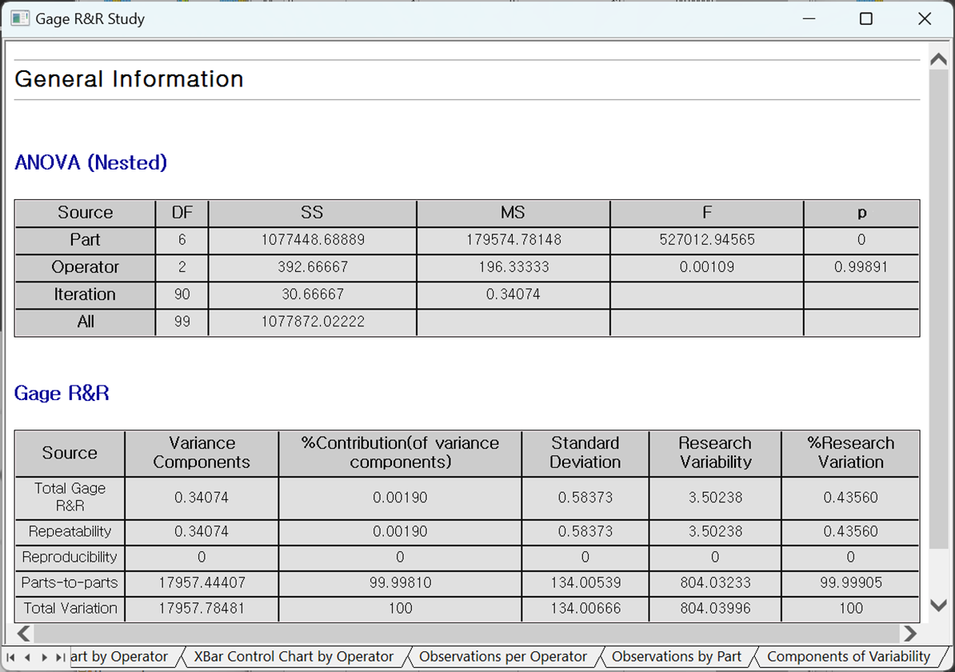

* R Control Chart by Operator

Each point displays the difference in the smallest and the biggest measurement of the same part by each operator.

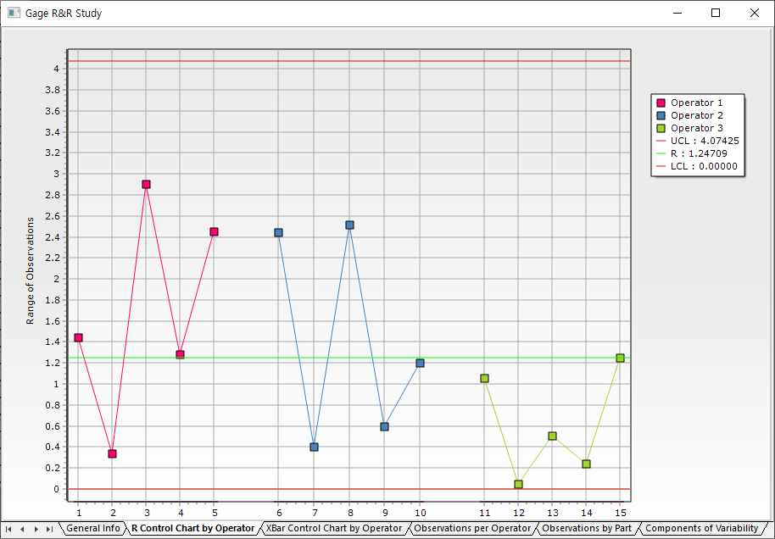

* X-Bar Control Chart by Operator

Each point displays the average measurement of the same part by each operator.

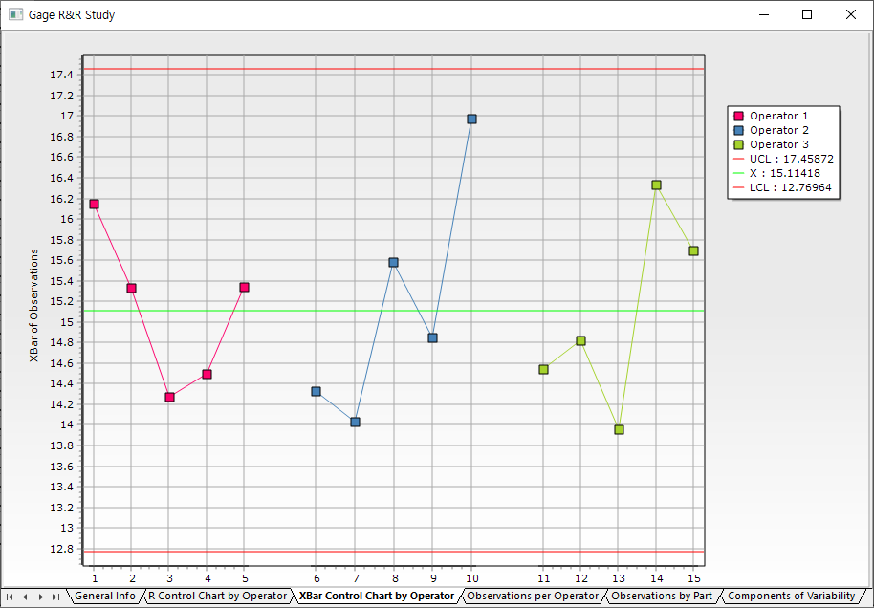

* Observations per Operator

Displays box plots of all measurements for each operator, with the solid line representing the mean.

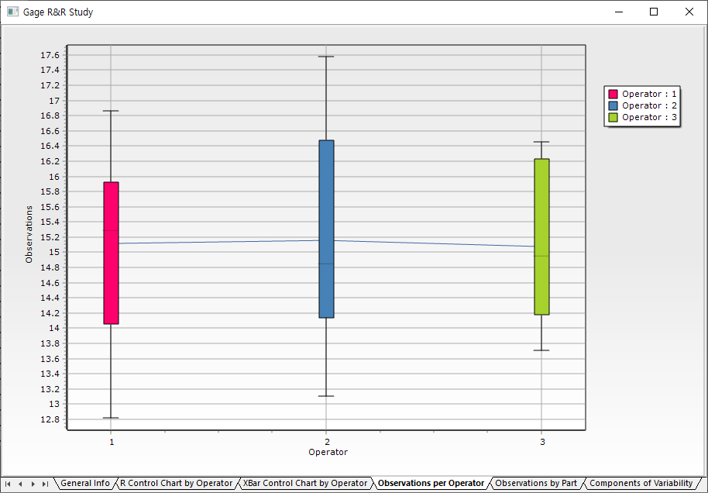

* Observations by Part

Displays observations per part only, with the solid line representing the mean.

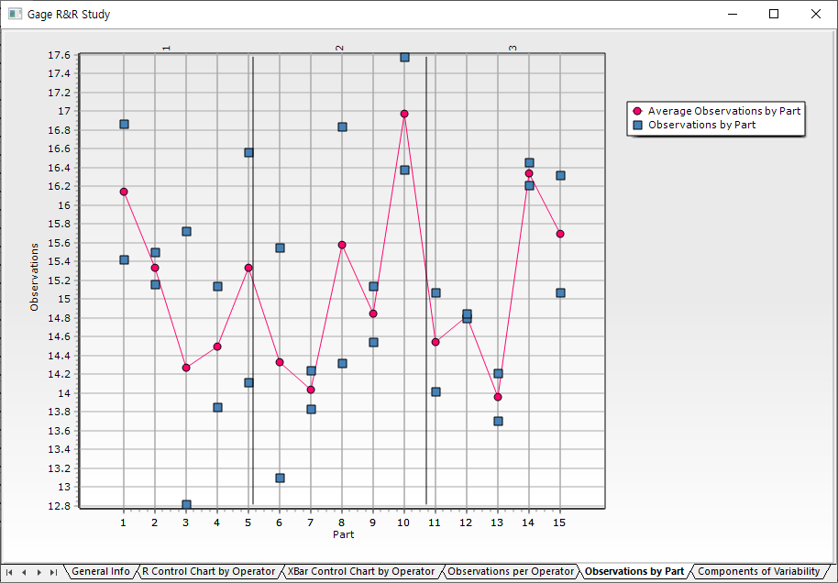

* Components of Variability

Displays where the variation in observed values originates.

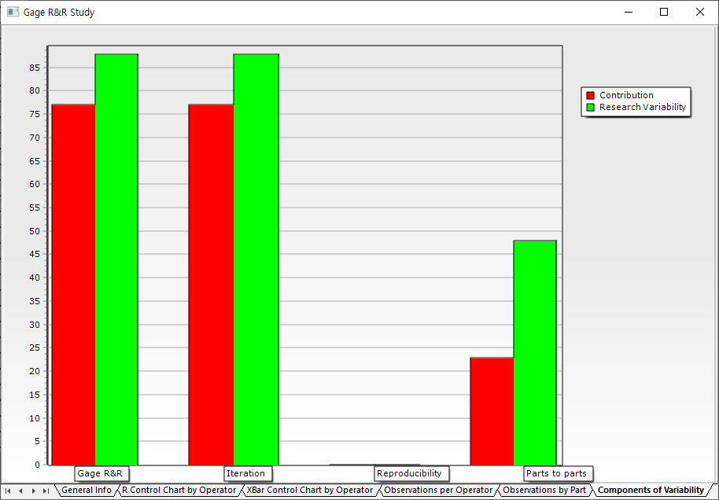

## 4.4 Chart

Data Browser provides various charting functions: 2D chart, 3D chart, Bar chart, Box chart, Matrix chart, Pareto chart, Pie chart and Multi-chart functions.

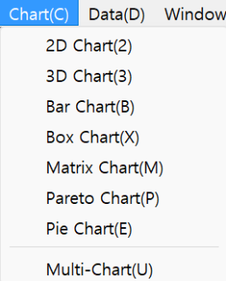

### 4.4.1 Basic Charts

In the **[Chart]** tab**,** you can chart a two-dimensional chart. Add/delete. Add more chart or delete chart. Select variables for chart. You may select a variable field in data browser instead selecting a variable. Then you can show 2D chart, Pie chart.

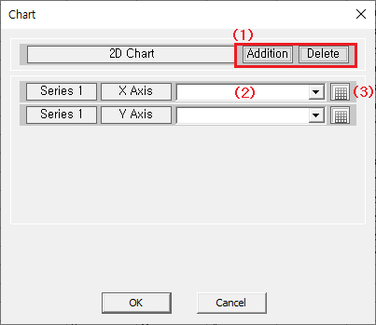

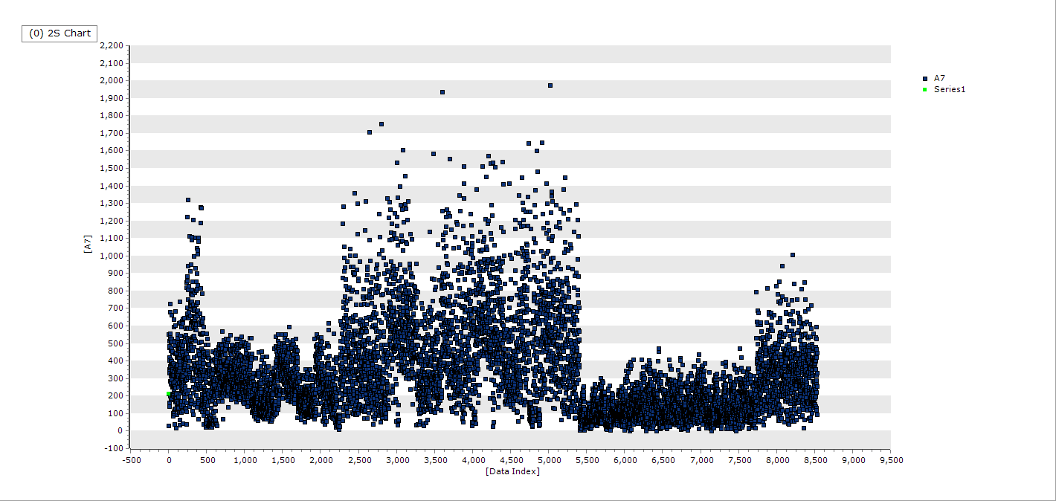

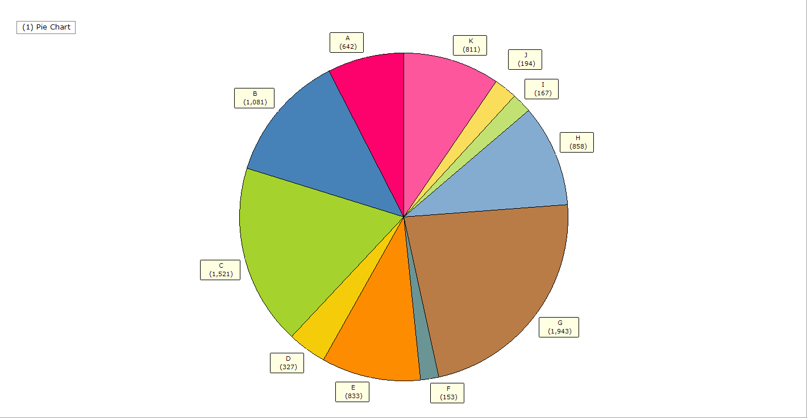

### 4.4.2 Multi chart

Multi-chart is an unique chart of ECMiner™ which makes it easy to see the characteristics of multiple variables. How to run: **[Analyze] – [Chart] - [Multi-chart]**

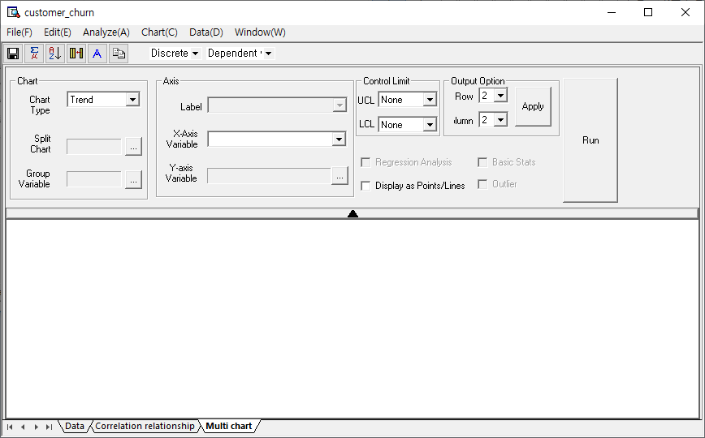

The chart settings allow for customization of the visualizations. Users can choose the **chart** **type**, such as a trend chart, box plot chart, distribution chart, or correlation chart, from a dropdown menu. The **split chart** option allows for segmentation by a group variable, where each group is displayed separately. This enables easier comparison between different groupings based on the selected variable. In the **axis settings**, users can define the variables that appear on the X-axis and Y-axis. The **X-axis** variable can be selected from available data, and its label can be customized for clarity. Similarly, a **Y-axis** variable can be selected to correspond with the chosen X-axis. The **control limit** section allows users to set upper and lower control limits (UCL, LCL) for the chart. If these limits are not required, they can be set to "None." For **output options**, the user can specify how the chart’s data will be displayed in terms of rows and columns, with the ability to adjust the layout to fit the desired presentation. Once all settings are configured, clicking "Run" will execute the chart generation. Additionally, several checkboxes are available for additional analysis and visualization: **Regression Analysis**: Adds regression lines to the chart if applicable. **Basic Stats**: Displays basic statistics like mean, median, etc. **Display as Points/Lines**: Option to either connect the points with lines or display them as individual points. **Outlier**: Marks any data points that are considered outliers, helping users identify unusual values in the dataset. Additionally, there are settings under **Other Options**: **Output Option (Row)**: Allows the user to set how many charts should be shown horizontally in the layout. **Output Option (Column)**: Allows the user to set how many charts should be shown vertically. **Control Limit**: Provides options for defining the basis for displaying control lines on the chart, helping to visualize acceptable ranges or limits for the data. When both **Basic Statistics** and **Outliers** are selected, the chart will display key statistics along with markers for any outliers, offering a more detailed analysis of the data distribution.

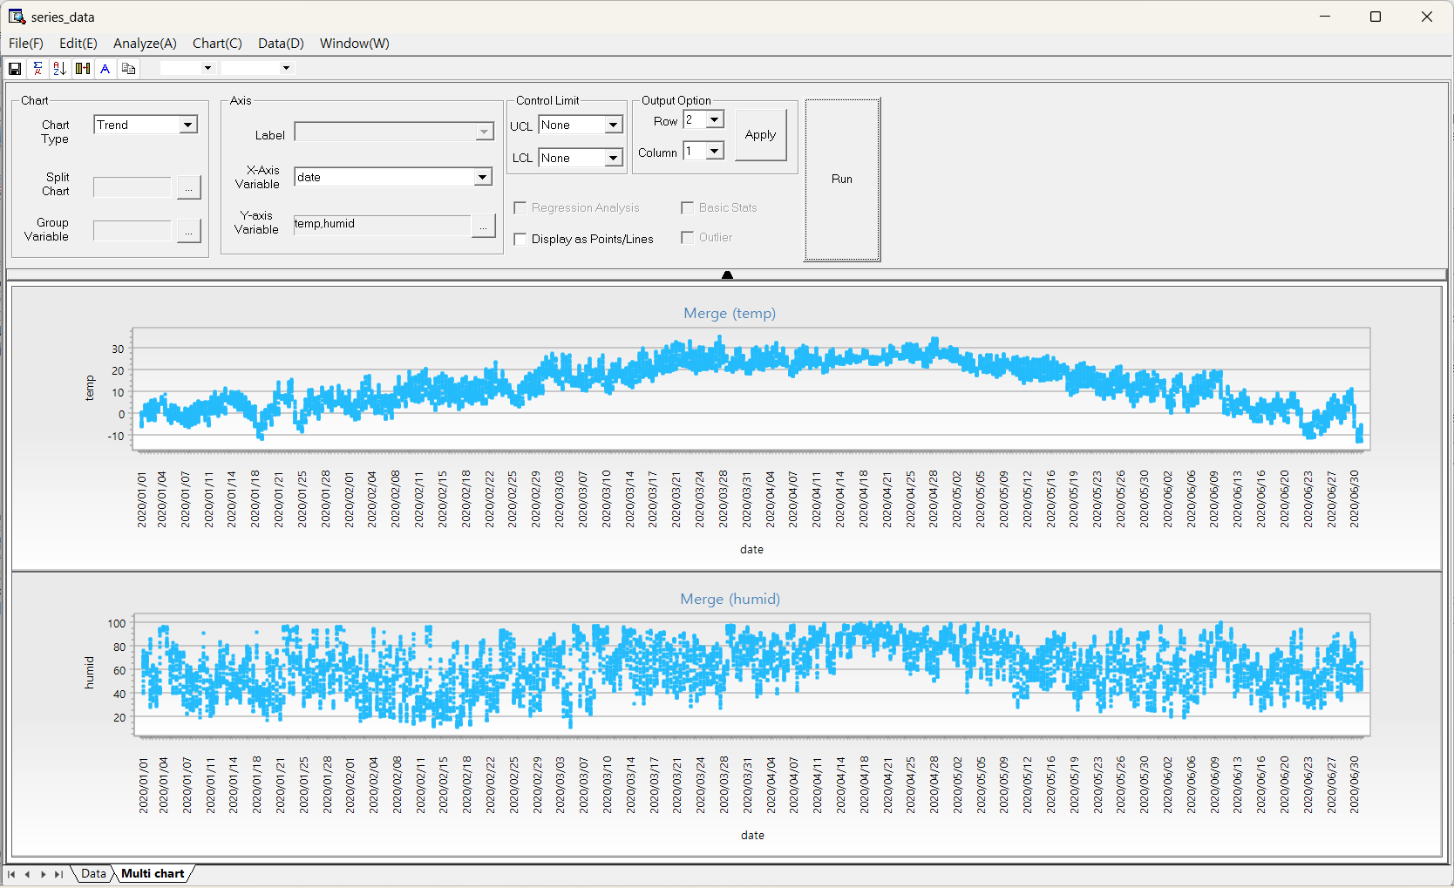

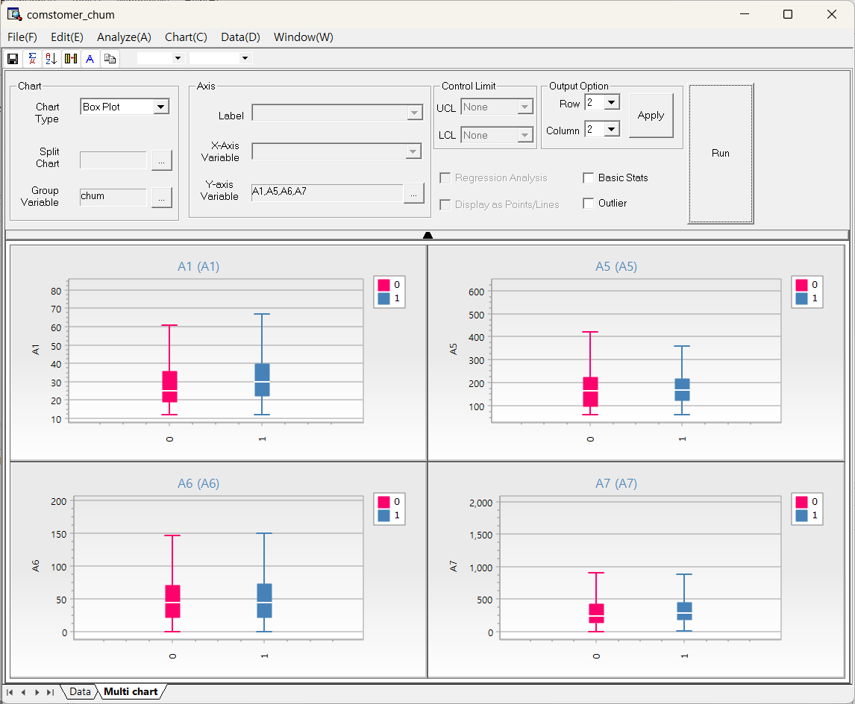

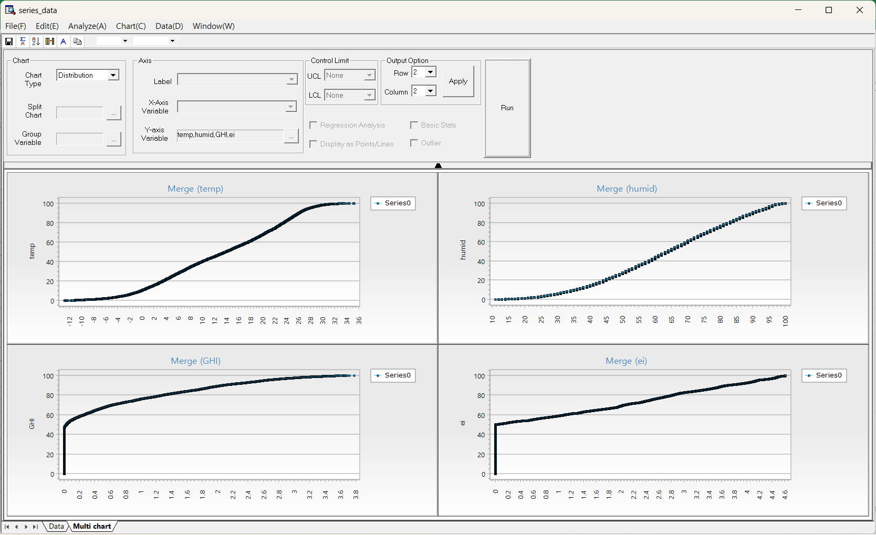

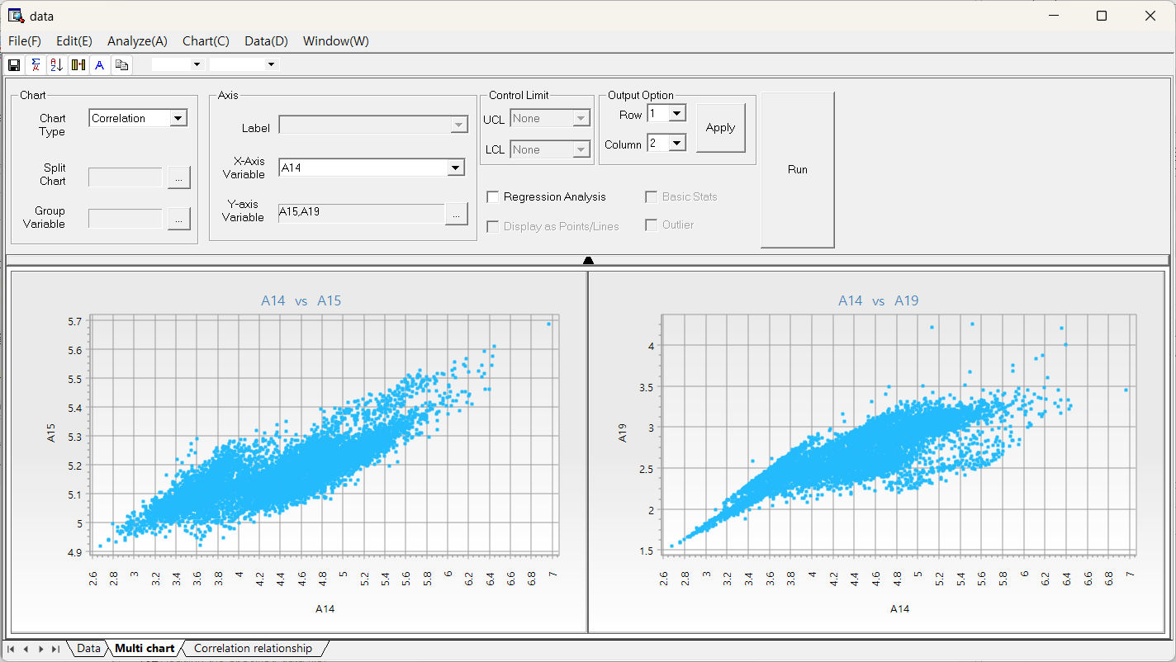

## 4.5 Data

### 4.5.1 Data Sorting

The Data Browser supports multiple column sorting. This function works the same as the Sort Node in the Preprocessing Nodes. How to run: **[Data] - [Sort]**. Sort the data in ascending or descending order by clicking the direction icon. To sort by multiple fields, select additional fields for multi-level sorting.

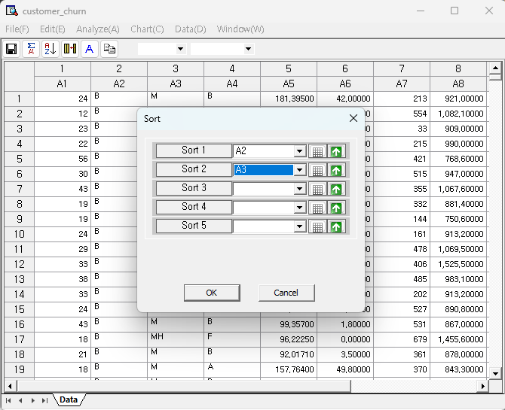

### 4.5.2 Derived Variables

The Data Browser supports creating derived variables. This function works the same as the Derived Column Node in the Preprocessing Nodes. How to run: **[Data] - [Derived Variables].** You can create or delete derived variables using the **Derived Variable** window. Clicking **Add** creates a new entry, and Delete removes a selected derived variable. However, if only one item remains in the list, the delete button is disabled and cannot remove it. To define a derived variable, first enter a name in the input field. Then, click the calculator icon to open the **Expression Editor**, where you can enter the formula used to compute the derived value based on other variables in the dataset. Results: The new derived variable appears as a column at the end of the dataset. The column name is user-defined and shows the calculated values based on the expression.

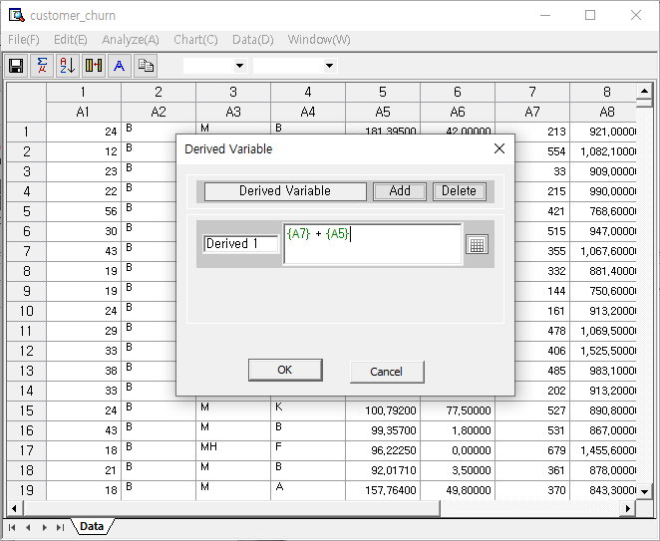

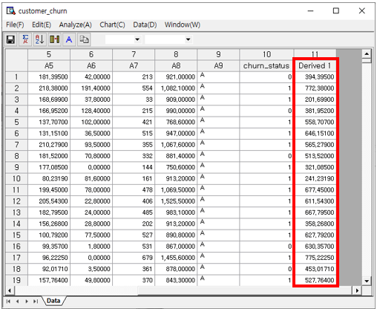

### 4.5.3 Apply

The Data Browser supports creation of streams onto the Workspace. The preprocessing functions that are applied in the Data Browser can be created into a stream with the Apply function. How to run: **[Data] - [Apply].**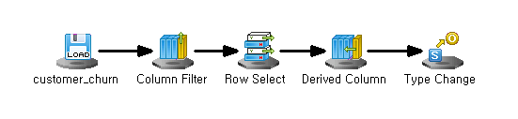

#### Examples

##### Delete column

Press right click on the column that you want to delete and click ‘Delete Column’ in the Data Browser. Then run the **Apply** function to create a stream that applies the preprocessing methods. In the Workspace, the **File Reader Node** is automatically connected to the **Column Filter Node** that deletes the selected column.

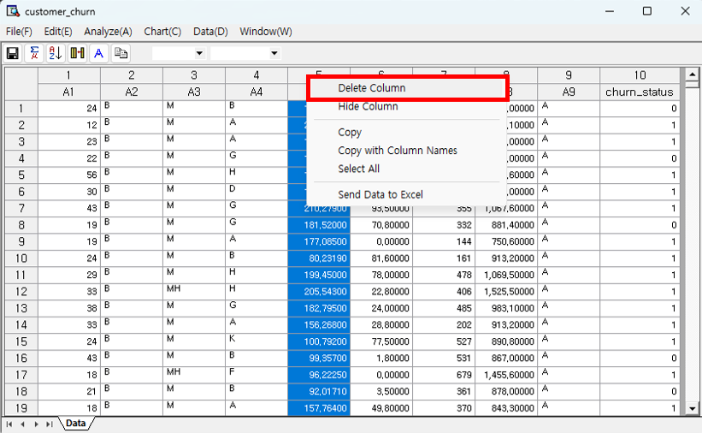

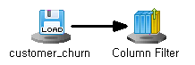 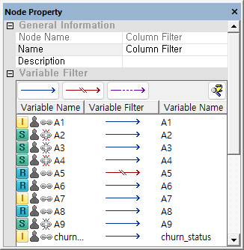

##### Delete row

Press right click on the row that you want to delete and click ‘Delete Row’ in the Data Browser. Then run the **Apply** function to create a stream that applies the preprocessing methods. In the Workspace, the **File Reader Node** is automatically connected to the **Row Select Node** that deletes the selected column.

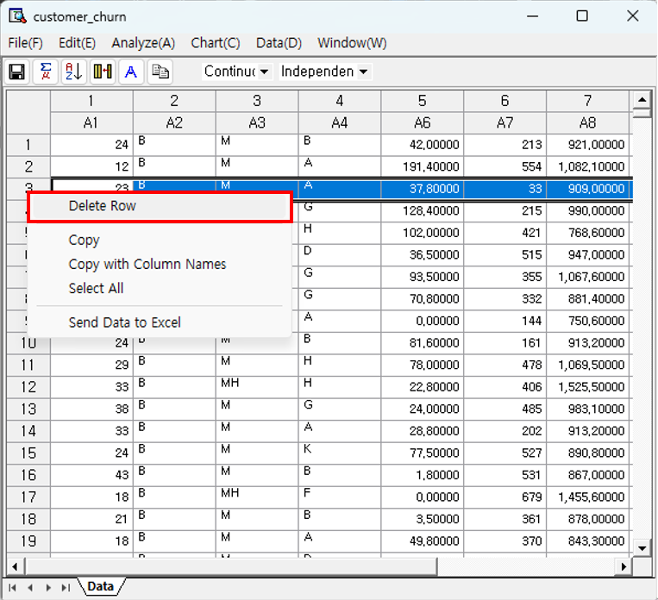

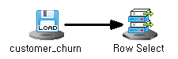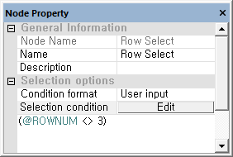

***NOTE*** (@ROWNUM <> 3) is a conditional statement that means "a row whose row index is not 3".

##### Derived Variables

After the Derived Variable function in the Data Browser is applied, run the **Apply** function to create a stream. In the Workspace, the **File Reader Node** is automatically connected to the **Derived Column Node** that creates a new variable with the defined conditional statement.



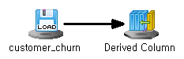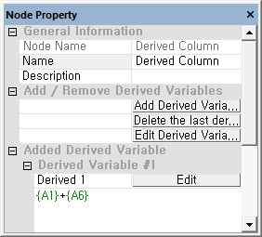

***NOTE (****{A1} + {A6}*) is a conditional statement that means "add the values of A1 and A6 variables".

##### Sort

After the Sort function in the Data Browser is applied, run the **Apply** function to create a stream. In the Workspace, the **File Reader Node** is automatically connected to the **Align Node** that sorts the selected variable.



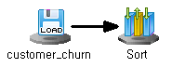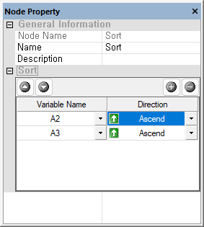

##### Apply multiple preprocessing

Preprocessing results can be applied one by one as in the example above, but multiple preprocessing results can also be applied at once. Below is the created stream after applying multiple preprocessing

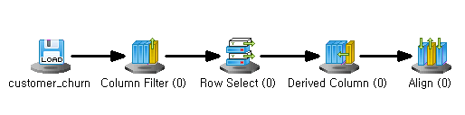

### 4.5.4 Filter

The Data Browser supports Filtering. This function works similar to the Derived Column Node in the Preprocessing Nodes, but in the data browser the filter function applies to all variables. How to run: **[Data] – [Filter].** Usage:1. "Add" to add a condition. "Delete" to remove the last one 2. Select statistical conditions, such as standard deviation. 3. Choose comparison operators >, =, <, etc. 4. Specify the value for comparison.

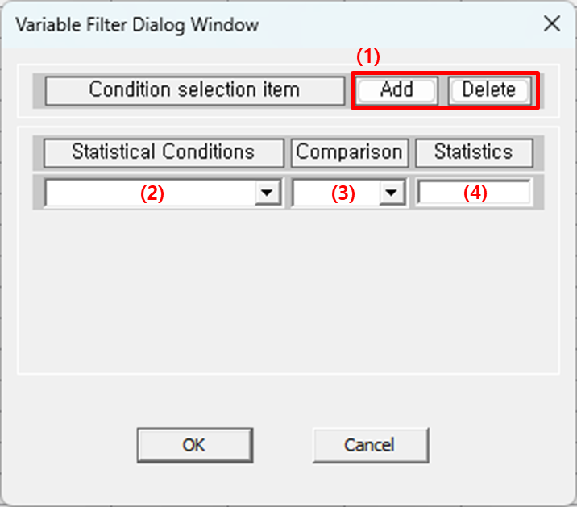

### 4.5.5 Freeze Columns

#### Usage

The more data columns you have, the more likely you’ll need to scroll horizontally to view variables. When comparing distant columns, it’s difficult to do so visually. With 'Freeze Coumns,' the specified column is pinned, allowing the remaining columns to be visible when scrolling. How to run: **[Data] - [Freeze Columns]. Number of Columns**: Select how many columns to freeze from the first column.

#### Results

If you freeze the first column, it stays fixed on the left while the rest of the columns scroll to the right.

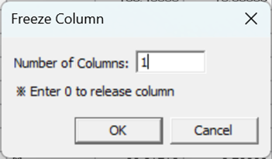

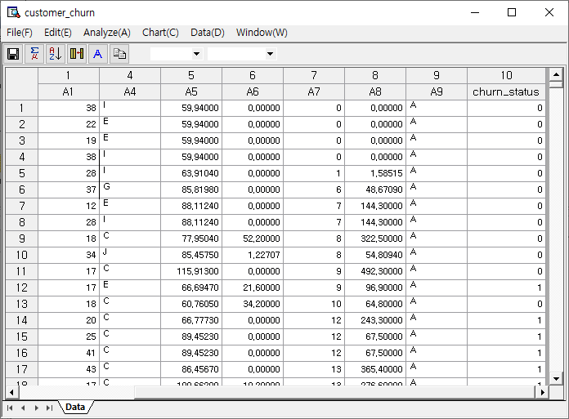

### 4.5.6 Box-Cox Transformation

#### Usage

To apply a control chart, the data must follow a normal distribution, which is often not the case. The Box-Cox Transformation provides a method to convert non-normal data into a normal distribution. How to run: **[Data] – [Box-Cox Transformation].**

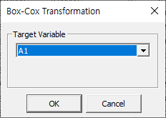

#### Results

It provides the estimated lambda to define the transformation formula and offers normality test statistics before and after transformation, showing the improvement in normality. The conversion formula can be applied for a new variable using the Derived Variable Node. 1. Normal Probability Plot (before transformation): This graph shows how closely the data follows a normal distribution before transformation. If a lot of data is distributed around the red line, the data can be said to follow normality. The more it deviates from the red line, the more it violates the assumption of normality. 2. Normal Probability Plot (after Transformation): This graph shows how well the data transformed by the estimated transformation formula follows the normal distribution. If a lot of data is distributed around the red line, the data can be said to follow normality. The more it deviates from the red line, the more it violates the assumption of normality. 3. Lambda Estimation: The transformation formula is determined using the lambda with the maximum likelihood as an estimate, and a graph showing the change in likelihood depending on the lambda is provided.

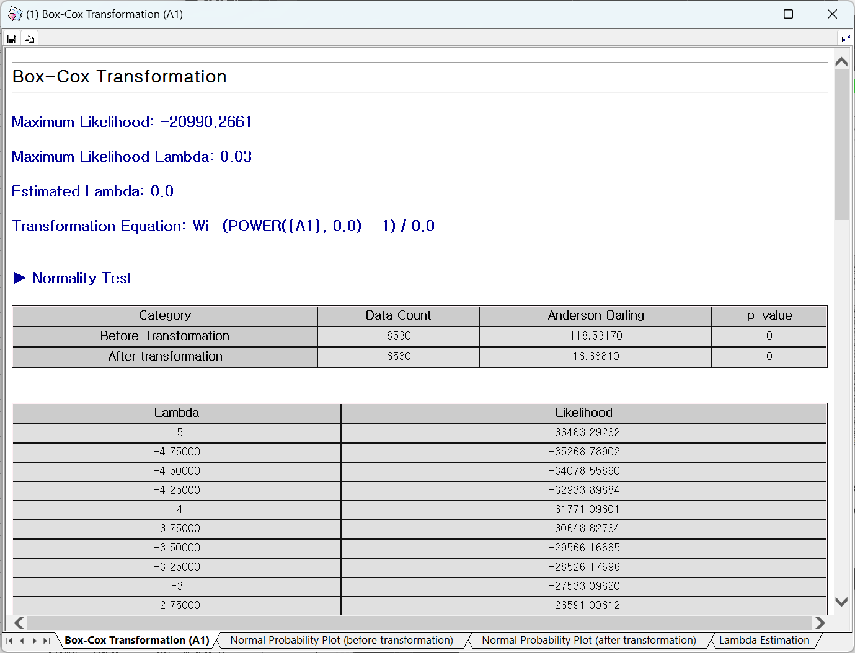

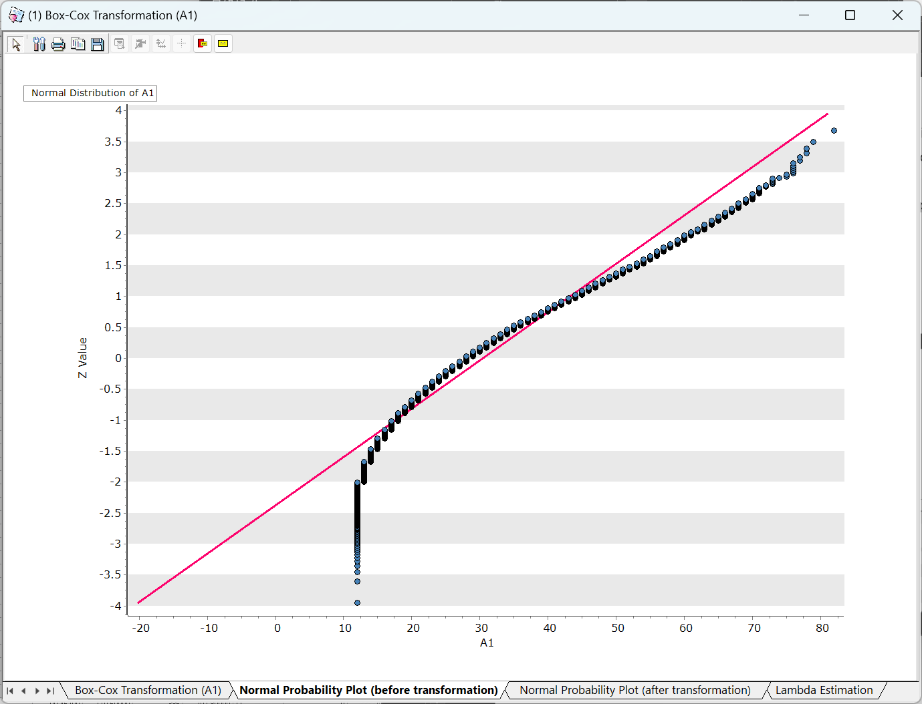

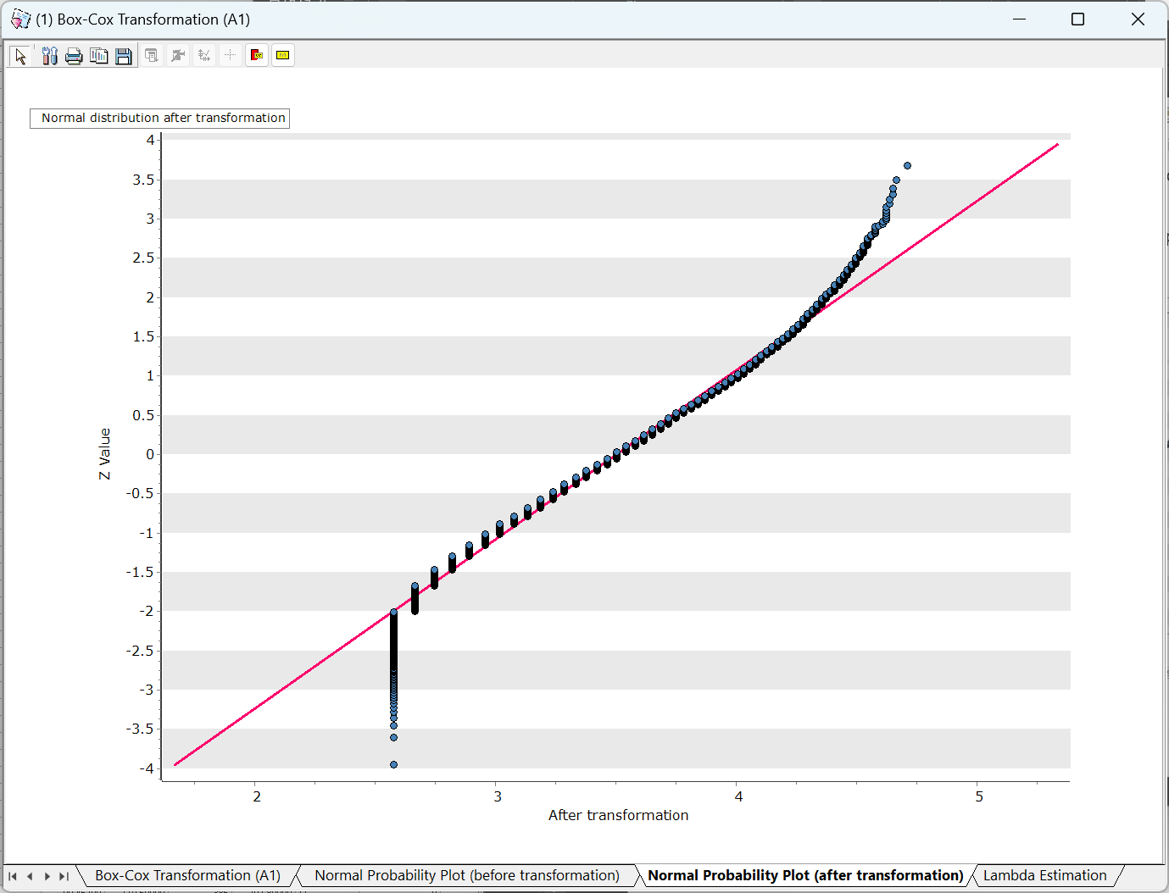

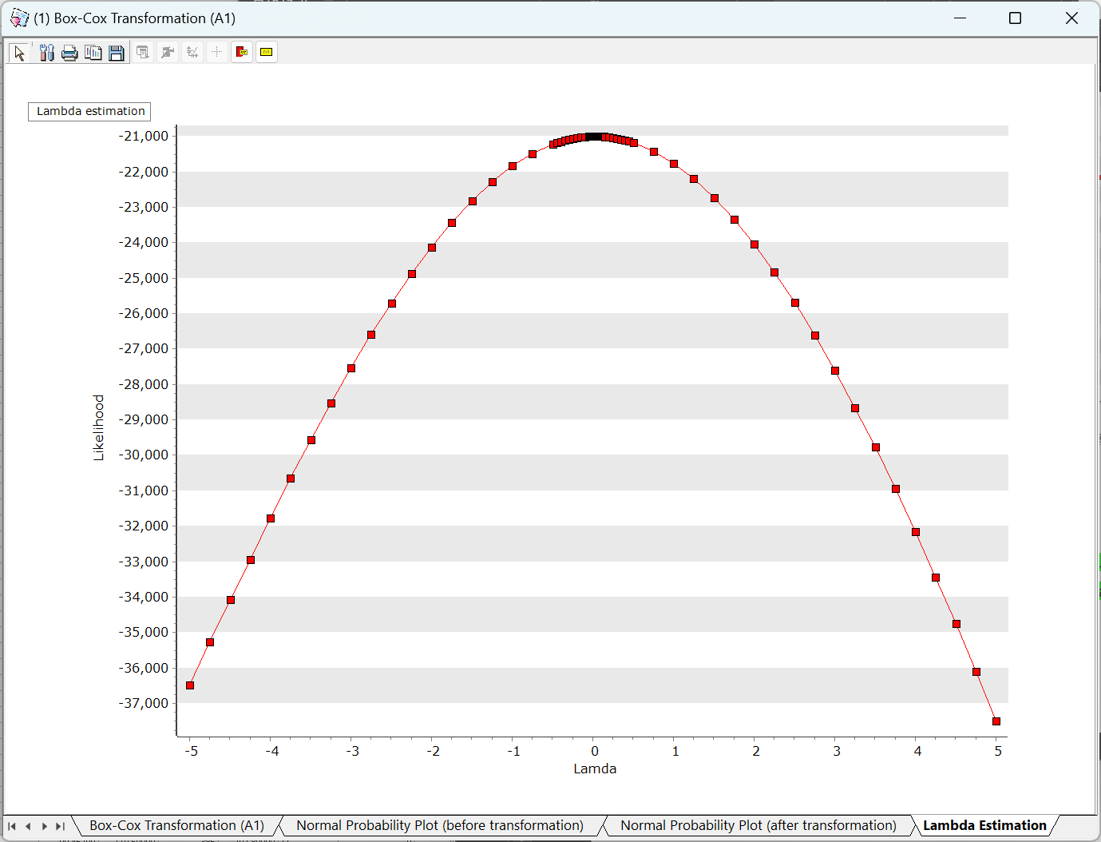

### 4.5.7 Johnson Transformation

#### Usage

The Johnson Transformation offers a formula to convert non-normal data into a normal distribution, allowing it to be used in control charts. How to run: **[Data] – [Johnson Transformation]**. Select the Target Variable.

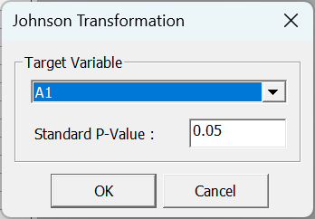

#### Results

1. Optimal Transformation Function: Provides the estimated transformation function that best fits a normal distribution. This function can be applied as a transformed variable using the Derived Variable Node. 2. Normality Test: Anderson-Darling statistic and p-value to evaluate how the variable follows a normal distribution. A p-value greater than 0.05 indicates normality. 3. Normal Probability Plot (before transformation): This graph shows how closely the data follows a normal distribution before transformation. If a lot of data is distributed around the red line, the data can be said to follow normality. The more it deviates from the red line, the more it violates the assumption of normality. 4. Normal Probability Plot (after transformation): This graph shows how the transformed data follows the normal distribution. The more it deviates from the red line, the more it violates the assumption of normality. 5. Transformation Estimate: Provides a graph that allows you to understand the extent to which transformation data that varies depending on the Z value follows a normal distribution (p-value). The larger the p-value, the more it can be said to satisfy normal distribution.

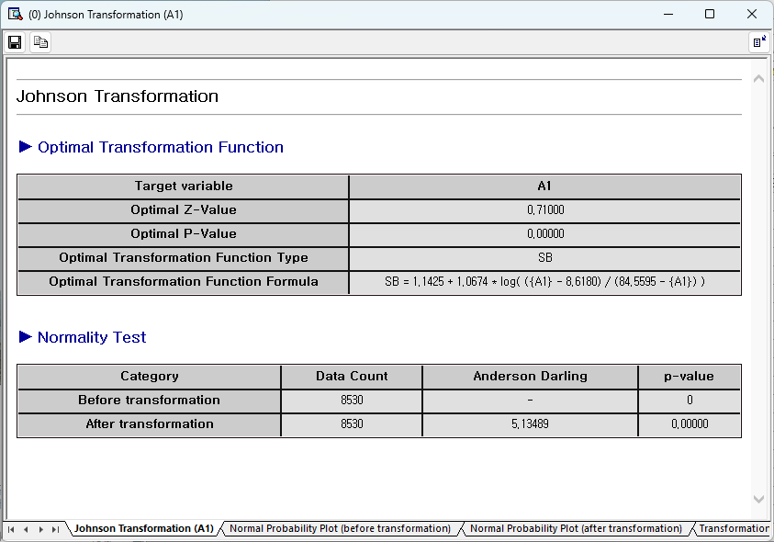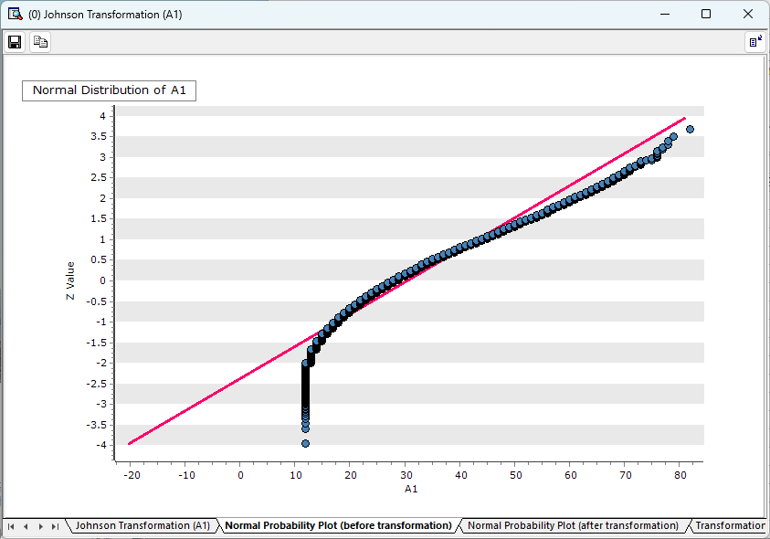

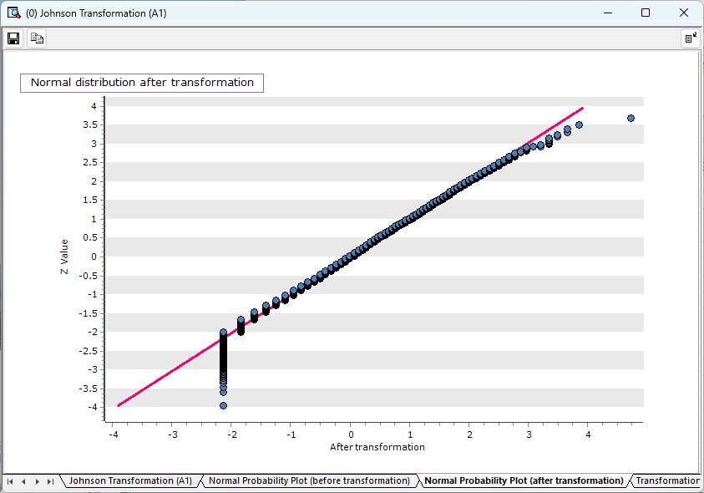

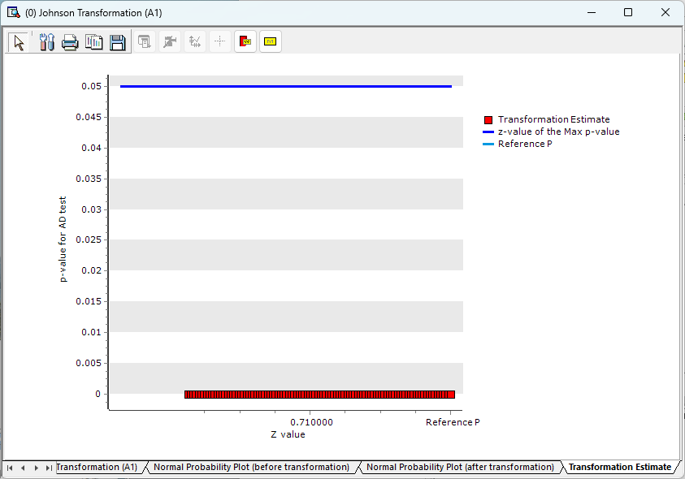

# Chapter 5 AI

AI Wizard can train neural network models such as DNN (Deep Neural Network), CNN (Convolutional Neural Network), RNN (Recurrent Neural Network), and Language Models. ECMiner™ AI wizard provides a step-by-step interface for defining neural network models and configuring model options. The stream configuration is divided into four steps as follows: Step 1. Model Definition, Step 2. Data Input, Step 3. Option Settings, Step 4. Definition Results.

## Usage

Step 1. Model Definition: Select the neural network model to train. There are four available models.

|  |  |  |  |
| --- | --- | --- | --- |
| **Category** | Description | Supported Models | Applications |
| **DNN** | DNN is an artificial neural network with a multi-layer structure, capable of learning nonlinear patterns through multiple hidden layers. It uses deep layers to model complex relationships and is applied in various fields. | DNN, AutoEncoder | Regression analysis, Classification analysis, Feature extraction |
| **CNN** | CNN uses convolutional layers to detect spatial patterns, making it highly effective for image processing. It reduces the number of parameters by using local connections and shared weights. It is widely used in image classification, object detection, and other applications. | Lenet, AlexNet, VGGNet, ResNet, EfficientNet | Image analysis |
| **RNN** | RNN is a neural network designed for recurrent structure that remember previous information in sequential data. By repeatedly processing previous computation results along with the current input, it can model the flow of data over time. | SimpleRNN, LSTM, GRU | Sequential data prediction analysis |
| **Language Model** | Language Model (LM) is used for tasks like text generation, translation, and speech recognition. Model that learns from text data to predict the probability distribution of words or sentences. It is used to generate the next word or understand a sentence in a given context, and is applied in various natural language processing tasks such as translation, chatbots, and more. | Seq2Seq, Seq2Seq w/attention, Transformer | Translation, Text generation |

Step 2. Data Input: Specify the data type, variable type, and whether each column should be used. The interface allows you to specify the data type and variable type for each column, as well as whether the column should be used in the analysis. The data types for each column, such as integer, string, and real type, are displayed, and you can select the appropriate options for each variable type, such as independent variables. This is a critical step in preparing your dataset for further analysis and ensuring it aligns with the chosen neural network model. A preview of up to 50 items is available to help verify the selections.

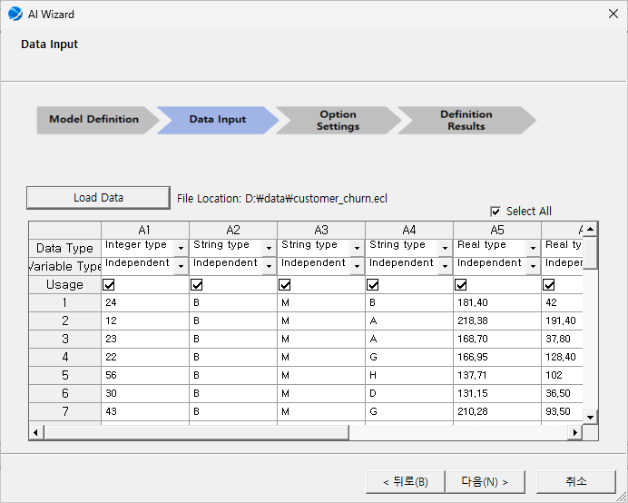

Step 3. Option Settings: Define the structure of the neural network. Options vary according to the chosen model. The following options are general settings for all models.

|  |  |  |  |
| --- | --- | --- | --- |
| **Options group** | Options Name | Description | Note |
| **Network Option** | Number of Hidden Layers | Set the number of hidden layers in a neural network. The deeper the neural network, the more sophisticated the model can be produced, but the higher the risk of overfitting. | 1~10 |
| Layer #1~n Number of Nodes | Set the number of nodes in each hidden layer. | integer |
| Activation Function | Set the activation function. Activation function is a mathematical transformation applied to its input. | Linear,  Sigmoid,  Tanh, ReLU,  LeakyReLU,  ELU |
| **Train Option** | Epochs | Set the number of iterations. | integer |
| Batch Size | Set the number of data samples to be used in a single training step. | integer |
| Learning Rate | Set the percentage to update the weights at each learning stage. Excessively large values can disrupt learning, while excessively small values can slow it down. | 0<real number≤1 |
| Target Loss | Specify the target loss; stops learning when the value of the loss function in the model reaches the target loss. | 0<real number≤1 |
| Optimization Method | Set up an algorithm to update the weight of the model. | SGD, RMSprop, Adagrad, Adam |
| Scaling Method | Set how to standardize your input data. Improve learning stability and performance. | Min-Max Scaler (0,1),  Min-Max Scaler (-1,1),  Standard Scaler, None |

Step 4. Definition Results: Review of the options set by the user is available, along with the neural network python code and a diagram of the neural network structure.

Neural network python code

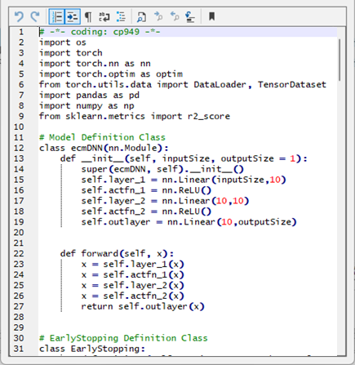

Neural network structure

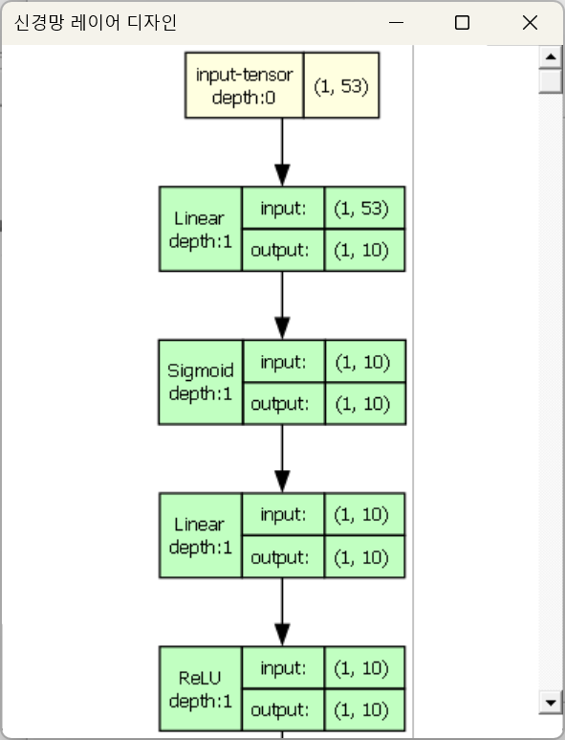

## 5.1 DNN

An artificial neural network with a multi-layer structure, capable of learning nonlinear patterns through multiple hidden layers. It uses deep layers to model complex relationships and is applied in various fields.

### 5.1.1 DNN

#### Overview

DNN (Deep Neural Networks) is an extension of traditional neural networks, such as Multi-Layer Perceptron (MLP), incorporating multiple hidden layers to learn complex patterns. This neural network can learn complex patterns from different types of data by using advanced methods. DNNs are used for tasks such as classification, prediction, and pattern recognition. Components are Input Layer, Hidden Layers, Output Layer. Input Layer is responsible for receiving the input data into the neural network. Hidden Layers: process the data, extracting complex features and patterns through multiple stages. Output Layer: produces the prediction or classification results based on the learned features. Working Principle: The network learns by adjusting the weights and activation functions of connections between nodes based on the data it is trained on, making it highly effective at handling complex and high-dimensional data.

#### Options

|  |  |  |  |
| --- | --- | --- | --- |
| **Options group** | Options Name | Description | Note |
| **Network Option** | Number of Hidden Layers | Set the number of hidden layers. The deeper the neural network, the more sophisticated the model can be produced, but the higher the risk of overfitting. | 1~10 |
| Layer #1~n Number of Nodes | Set the number of nodes in each hidden layer. | integer |
| Activation Function | Set the activation function. Activation function is a mathematical transformation applied to its input. | Linear,  Sigmoid,  Tanh, ReLU,  LeakyReLU,  ELU |
| **Train Option** | Epochs | Set the number of iterations. | integer |
| Batch Size | Set the number of data samples to be used in a single training step. | ingeter |
| Learning Rate | Set the percentage to update the weights at each learning stage. Excessively large values can disrupt learning, while excessively small values can slow it down. | 0<real number≤1 |
| Target Loss | Specify the target loss; stops learning when the value of the loss function in the model reaches the target loss. | 0<real number≤1 |
| Optimization Method | Set up an algorithm to update the weight of the model. | SGD, RMSprop, Adagrad, Adam |
| Scaling Method | Set how to standardize your input data. Improve learning stability and performance. | Min-Max Scaler (0,1),  Min-Max Scaler (-1,1),  Standard Scaler, None |

### 5.1.2 AutoEncoder

#### Overview

An Autoencoder is a type of neural network consisting of an encoder that compresses the input data and a decoder that reconstructs the original data from the compressed representation. This model is mainly used to learn the key features of the data and for dimensionality reduction. Components are Encoder, Decoder, Loss Function. Encoder converts input data into a lower-dimensional representation. Decoder expands the lower-dimensional representation back to the original dimensions to reconstruct the data. Loss Function measures the difference between the original data and the reconstructed data, guiding the learning process. Working Principle: The Autoencoder learns by extracting important features from the data using the encoder, then reconstructing the original data using the decoder. This process, which falls under unsupervised learning, is useful for tasks such as noise removal and dimensionality reduction. By focusing on the most relevant features, Autoencoders can efficiently compress and reconstruct data.

#### Options

|  |  |  |  |
| --- | --- | --- | --- |
| **Options group** | Options Name | Description | Note |
| **Network Option** | Number of Hidden Layers | Set the number of hidden layers. The deeper the neural network, the more sophisticated the model can be produced, but the higher the risk of overfitting. | 1~10 |
| Feature Hidden Layer #1~n: Number of Nodes | Sets the number of nodes in Feature hidden layer. more nodes can produce more sophisticated models, but also higher computational costs. | integer |
| Feature Hidden Layer Activation Function | Sets the activation function of Feature hidden layer. The activation function adds nonlinearity to the model, allowing it to learn more complex patterns. | Linear,  Sigmoid,  Tanh, ReLU,  LeakyReLU,  ELU |
| Symmetric Hidden Layer #1~n: Number of Nodes | Sets the number of nodes in the symmetric hidden layers. The number of nodes should gradually decrease from the first hidden layer to the feature hidden layer. | integer |
| Symmetric Hidden Layer #1~n: Activation Function | Sets the activation function for the symmetric hidden layers. The activation function adds nonlinearity to the model, allowing it to learn more complex patterns. | Linear,  Sigmoid,  Tanh, ReLU,  LeakyReLU,  ELU |
| **Train Option** | Epochs | Set the number of iterations. | integer |
| Batch Size | Set the number of data samples to be used in a single training step. | ingeter |
| Learning Rate | Set the percentage to update the weights at each learning stage. Excessively large values can disrupt learning, while excessively small values can slow it down. | 0<real number≤1 |
| Target Loss | Specify the target loss; stops learning when the value of the loss function in the model reaches the target loss. | 0<real number≤1 |
| Optimization Method | Set up an algorithm to update the weight of the model. | SGD, RMSprop, Adagrad, Adam |
| Scaling Method | Set how to standardize your input data. Improve learning stability and performance. | Min-Max Scaler (0,1),  Min-Max Scaler (-1,1),  Standard Scaler, None |

## 5.3 CNN

Neural network specialized in processing high-dimensional data such as images. By utilizing convolution and pooling operations to extract features, it effectively recognizes patterns while preserving spatial information. It is widely used in image classification, object detection, and other applications. Data Input Format: The folder names will be designated as training labels, and the training image data corresponding to each label must be stored within the respective folders. The folder structure for training data should be as follows:The training data for the model should be organized in a specific folder structure. The folder names should represent the labels, and the images inside each folder correspond to that label. The table that lists the file paths of the images should map the image files to the corresponding labels or categories, ensuring that each image is correctly associated with its class. The training image data needs to be formatted in this way for the model to correctly process and learn from the dataset.

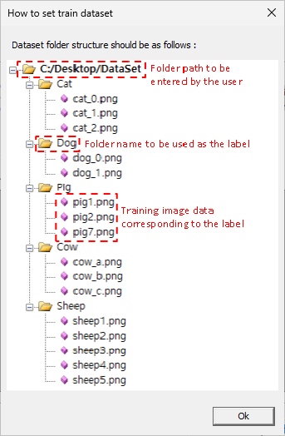

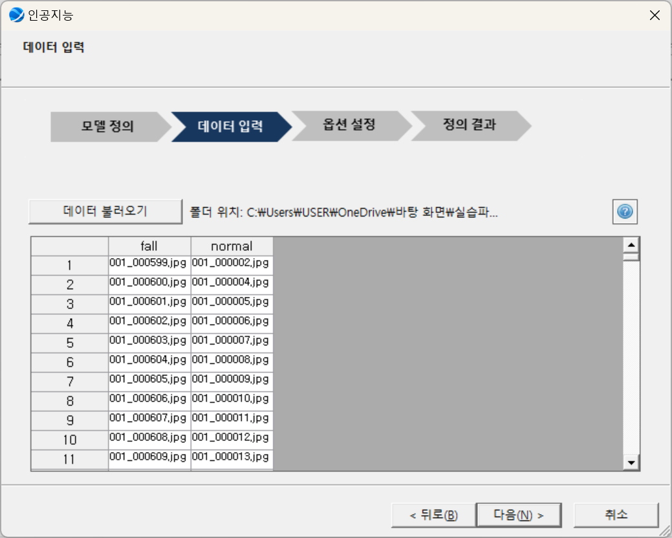

### 5.3.1 LeNet

#### Overview

LeNet is one of the early convolutional neural networks, and was originally designed for handwritten digit recognition, specifically for the MNIST dataset. Though its structure is simple, it introduced the fundamental ideas and structural characteristics of modern CNNs. Components are Convolutional Layers, Average Pooling Layers, Fully Connected Layers. Convolutional Layers extract low-level features from the input image. Average Pooling Layers reduce the size of feature maps and improve robustness by down sampling the data. Based on the extracted features, Fully Connected Layers make the final classification decision. Working Principle: LeNet extracts features through convolution and pooling layers, and then uses the fully connected layers to predict the final class.

#### Options

The architecture of the LeNet model is provided in a fixed form.

|  |  |  |  |
| --- | --- | --- | --- |
| **Options group** | Options Name | Description | Note |
| **Network Option** | Number of input channels | The number of color channels in an image; a grayscale image has 1 channel, while an RGB image has 3 channels. | 1 |
| Width | The width of the input data (image) in pixels. | 32 |
| Height | The height of the input data (image) in pixels. | 32 |
| Convolutional Layers | A layer that extracts features from the input data. The first layer receives input with a single channel and generates 6 feature maps, while the second layer takes these as input and produces 16 feature maps. | 2 |
| Fully Connected layers | A fully connected layer in the neural network, which performs the final prediction based on the given features. | 3 |
| **Train Option** | Epochs | Set the number of iterations. | integer |
| Batch Size | Set the number of data samples to be used in a single training step. | ingeter |
| Learning Rate | Set the percentage to update the weights at each learning stage. Excessively large values can disrupt learning, while excessively small values can slow it down. | 0<real number≤1 |
| Target Loss | Specify the target loss; stops learning when the value of the loss function in the model reaches the target loss. | 0<real number≤1 |
| Optimization Method | Set up an algorithm to update the weight of the model. | SGD, RMSprop, Adagrad, Adam |
| Scaling Method | Scaling Method is set to Min-Max Scaler (0,1). | Min-Max Scaler (0,1) |

### 5.3.2 AlexNet

#### Overview

AlexNet is an expanded and deeper version of LeNet, which gained worldwide recognition when it won the 2012 ImageNet competition. This model was one of the first to apply modern deep learning techniques and demonstrated the power of deep learning with GPUs and large datasets for image classification tasks. Components are Convolutional Layers, ReLU Activation Function, Max Pooling Layers, Dropout. Convolutional Layers extract high-level features from the images. ReLU Activation Function helps solve non-linear problems and accelerates training by enabling faster convergence. Max Pooling Layers reduce the size of the data while preserving important features. Dropout technique helps prevent overfitting during training by randomly disabling a portion of the neurons. Working Principle: AlexNet extracts complex image features through deep convolutional layers and reduces data size using max pooling layers. The ReLU activation function accelerates training by enabling faster convergence. Dropout is also used to prevent overfitting during training. Afterward, fully connected layers process the high-level features for classification.

#### Options

The architecture of the AlexNet model is provided in a fixed form.

|  |  |  |  |
| --- | --- | --- | --- |
| **Options group** | Options Name | Description | Note |
| **Network Option** | Number of input channels | The number of color channels in an image; a grayscale image has 1 channel, while an RGB image has 3 channels. | 3 |
| Width | The width of the input data (image) in pixels. | 227 |
| Height | The height of the input data (image) in pixels. | 227 |
| Convolutional Layers | A layer that extracts features from the input data, generating feature maps based on the output of the previous layer. The 5 layers sequentially produce feature maps with 64, 128, 256, and 512 channels. | 5 |
| Fully Connected layers | A fully connected layer in the neural network, which performs the final prediction based on the given features. | 3 |
| **Train Option** | Epochs | Set the number of iterations. | integer |
| Batch Size | Set the number of data samples to be used in a single training step. | ingeter |
| Learning Rate | Set the percentage to update the weights at each learning stage. Excessively large values can disrupt learning, while excessively small values can slow it down. | 0<real number≤1 |
| Target Loss | Specify the target loss; stops learning when the value of the loss function in the model reaches the target loss. | 0<real number≤1 |
| Optimization Method | Set up an algorithm to update the weight of the model. | SGD, RMSprop, Adagrad, Adam |
| Scaling Method | Scaling Method is set to Min-Max Scaler (0,1). | Min-Max Scaler (0,1) |

### 5.3.3 VGGNet

#### Overview

VGGNet is known for its simple architecture, where convolutional and pooling layers are stacked uniformly. This model demonstrated that increasing the depth of the network with smaller convolutional filters (3x3) can improve performance. It is especially popular for transfer learning tasks. Components are Convolutional Layers, Max Pooling Layers. Convolutional Layers use kernels of the same size to extract features from the input data. Max Pooling Layers simplify the feature maps and enhance computational efficiency. Working Principle: VGGNet is built by stacking several layers of 3x3 convolutions and 2x2 max pooling. The idea behind using small filters is that multiple small filters (3x3) can capture more complex features while reducing computational complexity.

#### Options

The architecture of the VGGNet model is provided in a fixed form.

|  |  |  |  |
| --- | --- | --- | --- |
| **Options group** | Options Name | Description | Note |
| **Network Option** | Number of input channels | The number of color channels in an image; a grayscale image has 1 channel, while an RGB image has 3 channels. | 3 |
| Width | The width of the input data (image) in pixels. | 224 |
| Height | The height of the input data (image) in pixels. | 224 |
| Convolutional Layers | A layer that extracts features from the input data, generating feature maps based on the output of the previous layer. The 13 layers sequentially produce feature maps with 64, 128, 256, and 512 channels. | 13 |
| Fully Connected layers | A fully connected layer in the neural network, which performs the final prediction based on the given features. | 3 |
| **Train Option** | Epochs | Set the number of iterations. | integer |
| Batch Size | Set the number of data samples to be used in a single training step. | integer |
| Learning Rate | Set the percentage to update the weights at each learning stage. Excessively large values can disrupt learning, while excessively small values can slow it down. | 0<real number≤1 |
| Target Loss | Specify the target loss; stops learning when the value of the loss function in the model reaches the target loss. | 0<real number≤1 |
| Optimization Method | Set up an algorithm to update the weight of the model. | SGD, RMSprop, Adagrad, Adam |
| Scaling Method | Scaling Method is set to Min-Max Scaler (0,1). | Min-Max Scaler (0,1) |

### 5.3.4 ResNet

#### Overview

ResNet features residual connections that were introduced to solve the vanishing gradient problem in deep neural networks. This architecture allows the network to improve performance as the layers get deeper, enabling it to learn more complex patterns without losing effectiveness. Components are Residual Blocks. Each block contains a set of convolutional layers, but with the addition of skip connections that allow the input to bypass certain layers and be added directly to the output. This helps address the problem of vanishing gradients in very deep networks. Working Principle: ResNet uses the skip connection technique which passes the input through multiple residual blocks and adds the original input back to the output. This allows the model to learn residual functions (the difference between the desired output and the input), rather than the entire output directly. This approach enables the training of deep networks without suffering from the vanishing gradient problem.

#### Options

The architecture of the ResNet model is provided in a fixed form.

|  |  |  |  |
| --- | --- | --- | --- |
| **Options group** | Options Name | Description | Note |
| **Network Option** | Number of input channels | The number of color channels in an image; a grayscale image has 1 channel, while an RGB image has 3 channels. | 3 |
| Width | The width of the input data (image) in pixels. | 224 |
| Height | The height of the input data (image) in pixels. | 224 |
| Convolutional Layers | A layer that extracts features from the input data, generating feature maps based on the output of the previous layer. The 20 layers sequentially produce feature maps with 64, 128, 256, and 512 channels. | 20 |
| Fully Connected layers | A fully connected layer in the neural network, which performs the final prediction based on the given features. | 1 |
| **Train Option** | Epochs | Set the number of iterations. | integer |
| Batch Size | Set the number of data samples to be used in a single training step. | integer |
| Learning Rate | Set the percentage to update the weights at each learning stage. Excessively large values can disrupt learning, while excessively small values can slow it down. | 0<real number≤1 |
| Target Loss | Specify the target loss; stops learning when the value of the loss function in the model reaches the target loss. | 0<real number≤1 |
| Optimization Method | Set up an algorithm to update the weight of the model. | SGD, RMSprop, Adagrad, Adam |
| Scaling Method | Scaling Method is set to Min-Max Scaler (0,1). | Min-Max Scaler (0,1) |

### 5.3.5 EfficientNet

#### Overview

EfficientNet introduces a method for balancing the scaling of the network's depth, width, and resolution to achieve higher performance with fewer parameters compared to traditional models. Compound Scaling uniformly scales depth, width, and resolution using a fixed set of scaling coefficients, optimizing the model’s efficiency. Working Principle: EfficientNet works by applying the compound scaling method to find the optimal balance between depth, width, and resolution. Instead of manually tuning each of these hyperparameters separately, EfficientNet scales them in a way that maximizes performance while minimizing computational costs.

#### Options

The architecture of the EfficientNet model is provided in a fixed form.

|  |  |  |  |
| --- | --- | --- | --- |
| **Options group** | Options Name | Description | Note |
| **Network Option** | Number of input channels | The number of color channels in an image; a grayscale image has 1 channel, while an RGB image has 3 channels. | 3 |
| Width | The width of the input data (image) in pixels. | 240 |
| Height | The height of the input data (image) in pixels. | 240 |
| Convolutional Layers | A layer that extracts features from the input data, generating feature maps based on the output of the previous layer. The 50 layers sequentially produce feature maps with 64, 128, 256, and 512 channels. | 50 |
| Fully Connected layers | A fully connected layer in the neural network, which performs the final prediction based on the given features. | 1 |
| **Train Option** | Epochs | Set the number of iterations. | integer |
| Batch Size | Set the number of data samples to be used in a single training step. | integer |
| Learning Rate | Set the percentage to update the weights at each learning stage. Excessively large values can disrupt learning, while excessively small values can slow it down. | 0<real number≤1 |
| Target Loss | Specify the target loss; stops learning when the value of the loss function in the model reaches the target loss. | 0<real number≤1 |
| Optimization Method | Set up an algorithm to update the weight of the model. | SGD, RMSprop, Adagrad, Adam |
| Scaling Method | Scaling Method is set to Min-Max Scaler (0,1). | Min-Max Scaler (0,1) |

## 5.4 RNN

Neural network constructed with a recurrent structure that can remember previous information in sequential data. By repeatedly processing previous computation results along with the current input, it can model the flow of data over time.

### 5.4.1 SimpleRNN

#### Overview

RNN (Recurrent Neural Network) is a type of neural network specialized for processing sequence data. This structure maintains the hidden states that captures information about previous inputs, allowing it to model the flow of data over time. It is widely used in fields such as natural language processing and time series analysis. Components are Recurrent Node, State Vector, Output Layer.

At each sequence step, Recurrent Node takes the input and the previous step's state, and outputs the current state. State Vector stores and transfers the current and past information of the sequence. Output Layer generate the final result. Working Principle: At each time step, the input and the previous state combine to pass information through the network, modeling the temporal dependencies of the sequence. This allows the network to capture the dynamics of time-series data or sequential information.

#### Options

|  |  |  |  |
| --- | --- | --- | --- |
| **Options group** | Options Name | Description | Note |
| **Network Option** | Number of Hidden Layers | Sets the number of hidden layers inside the RNN cell. The deeper the neural network, the more sophisticated the model can be produced, but the higher the risk of overfitting. | 1~10 |
| Number of Nodes | Sets the number of nodes in the hidden state within the RNN cell. The larger the number of nodes, the more sophisticated the model can be created, but the computational cost also increases. | integer |
| Activation Function | Set the activation function. Activation function is a mathematical transformation applied to its input. | Linear,  Sigmoid,  Tanh, ReLU,  LeakyReLU,  ELU |
| Drop-Out | Sets a random percentage of the nodes to be deactivated at each learning stage. When used properly, the model can learn more generalized features and prevent overfitting. | 0<real number≤1 |
| **Train Option** | Epochs | Set the number of iterations. | integer |
| Batch Size | Set the number of data samples to be used in a single training step. | integer |
| Learning Rate | Set the percentage to update the weights at each learning stage. Excessively large values can disrupt learning, while excessively small values can slow it down. | 0<real number≤1 |
| Target Loss | Specify the target loss; stops learning when the value of the loss function in the model reaches the target loss. | 0<real number≤1 |
| Optimization Method | Set up an algorithm to update the weight of the model. | SGD, RMSprop, Adagrad, Adam |
| Scaling Method | Set how to standardize your input data. Improve learning stability and performance. | Min-Max Scaler (0,1),  Min-Max Scaler (-1,1),  Standard Scaler, None |

### 5.4.2 LSTM

#### Overview

LSTM (Long Short-Term Memory) is a type of RNN designed to solve the long-term dependency problem. Compared to basic RNNs, LSTM has a more complex structure and excels at retaining information over long periods. Components are Input Gate, Forget Gate, Output Gate, Cell State. Input Gate controls the amount of new information that is added to the cell state from the current input. Forget Gate determines how much of the previous state information should be forgotten. Output Gate controls how much of the current state should be output to the next layer. Cell State stores past information and updates it over time. Working Principle: LSTM selectively removes unnecessary information and retains the important information through the operation of each gate. This allows to capture long-term dependencies and retrain information over long sequences, overcoming the vanishing gradient problem.

#### Options

|  |  |  |  |
| --- | --- | --- | --- |
| **Options group** | Options Name | Description | Note |
| **Network Option** | Number of Hidden Layers | Sets the number of hidden layers inside the RNN cell. The deeper the neural network, the more sophisticated the model can be produced, but the higher the risk of overfitting. | 1~10 |
| Number of Nodes | Sets the number of nodes in the hidden state within the RNN cell. The larger the number of nodes, the more sophisticated the model can be created, but the computational cost also increases. | integer |
| Activation Function | Set the activation function. Activation function is a mathematical transformation applied to its input. | Linear,  Sigmoid,  Tanh, ReLU,  LeakyReLU,  ELU |
| Drop-Out | Sets a random percentage of the nodes to be deactivated at each learning stage. When used properly, the model can learn more generalized features and prevent overfitting. | 0<real number≤1 |
| **Train Option** | Epochs | Set the number of iterations. | integer |
| Batch Size | Set the number of data samples to be used in a single training step. | integer |
| Learning Rate | Set the percentage to update the weights at each learning stage. Excessively large values can disrupt learning, while excessively small values can slow it down. | 0<real number≤1 |
| Target Loss | Specify the target loss; stops learning when the value of the loss function in the model reaches the target loss. | 0<real number≤1 |
| Optimization Method | Set up an algorithm to update the weight of the model. | SGD, RMSprop, Adagrad, Adam |
| Scaling Method | Set how to standardize your input data. Improve learning stability and performance. | Min-Max Scaler (0,1),  Min-Max Scaler (-1,1),  Standard Scaler, None |

### 5.4.1.3 GRU

#### Overview

GRU (Gated Recurrent Unit) is a type of recurrent neural network with a simplified structure, making it computationally efficient. It can maintain information over long periods while processing complex sequence data, making it widely used in tasks like natural language processing and time series analysis. Components are Update Gate, Reset Gate, Recurrent Node. Update Gate determines how much of the previous state’s information should be retained. Reset Gate decides how much of the previous information should be forgotten. Recurrent Node combines the input with the previous step's state and outputs the current state. Working Principle: By selectively retaining only the necessary information through the update and reset gates, GRU effectively models the temporal dependencies in sequences.

#### Options

|  |  |  |  |
| --- | --- | --- | --- |
| Options group | Options Name | Description | Note |
| Network Option | Number of Hidden Layers | Sets the number of hidden layers inside the RNN cell. The deeper the neural network, the more sophisticated the model can be produced, but the higher the risk of overfitting. | 1~10 |
| Number of Nodes | Sets the number of nodes in the hidden state within the RNN cell. The larger the number of nodes, the more sophisticated the model can be created, but the computational cost also increases. | integer |
| Activation Function | Set the activation function. Activation function is a mathematical transformation applied to its input. | Linear,  Sigmoid,  Tanh, ReLU,  LeakyReLU,  ELU |
| Drop-Out | Sets a random percentage of the nodes to be deactivated at each learning stage. When used properly, the model can learn more generalized features and prevent overfitting. | 0<real number≤1 |
| Train Option | Epochs | Set the number of iterations. | integer |
| Batch Size | Set the number of data samples to be used in a single training step. | integer |
| Learning Rate | Set the percentage to update the weights at each learning stage. Excessively large values can disrupt learning, while excessively small values can slow it down. | 0<real number≤1 |
| Target Loss | Specify the target loss; stops learning when the value of the loss function in the model reaches the target loss. | 0<real number≤1 |
| Optimization Method | Set up an algorithm to update the weight of the model. | SGD, RMSprop, Adagrad, Adam |
| Scaling Method | Set how to standardize your input data. Improve learning stability and performance. | Min-Max Scaler (0,1),  Min-Max Scaler (-1,1),  Standard Scaler, None |

## 5.5 Language Model

Model that learns from text data to predict the probability distribution of words or sentences. It is used to generate the next word or understand a sentence in a given context, and is applied in various natural language processing tasks such as translation, chatbots, and more. Data Input Format: The training data should be in the form of input-output pairs.

### 5.5.1 Seq2Seq

#### Overview

The Seq2Seq model is designed to convert an input sequence into an output sequence using an encoder-decoder architecture. This model is widely used in tasks such as machine translation and automatic summarization, effectively handling complex sequence data. Components are Encoder, Decoder, Context Vector. Encodes the input sequence into a fixed-size state vector. Decoder uses the state vector received from the encoder to generate the output sequence. Context Vector created by the encoder that compresses all the information from the input sequence. Working Principle: The encoder transforms the information from the input sequence into a context vector. Whereas the decoder then helps to generate the output sequence from the context vector. This process establishes the semantic connection between the input and output, enabling the model to perform complex sequence transformation tasks.

#### Options

|  |  |  |  |
| --- | --- | --- | --- |
| **Options group** | Options Name | Description | Note |
| **Network Option** | Input Size | Sets the size of the dimensions to be used as input to the model. | 128, 256, 512, 1024 |
| Number of Hidden Layers | Sets the number of hidden layers in a neural network. |  |
| Number of Nodes | Sets the number of nodes in the hidden state within the LSTM cell of Encoder/Decoder. | 128, 256, 512, 1024 |
| Sequence Maximum Length | Sets the size of the level to reduce words. The greater the relationship between words, but the calculation cost increases. |  |
| Drop-Out | Sets a random percentage of the nodes to be deactivated at each learning stage. When used properly, the model can learn more generalized features and prevent overfitting. | 0<real number≤1 |
| **Train Option** | Epochs | Set the number of iterations. | integer |
| Batch Size | Set the number of data samples to be used in a single training step. | integer |
| Learning Rate | Set the percentage to update the weights at each learning stage. Excessively large values can disrupt learning, while excessively small values can slow it down. | 0<real number≤1 |
| Target Loss | Specify the target loss; stops learning when the value of the loss function in the model reaches the target loss. | 0<real number≤1 |
| Optimization Method | Set up an algorithm to update the weight of the model. | SGD, RMSprop, Adagrad, Adam |
| Scaling Method | Scaling Method is set to Min-Max Scaler (0,1). | Min-Max Scaler (0,1) |

### 5.5.2 Seq2Seq with attention

#### Overview

Attention is a mechanism that evaluates the importance of different parts of the input sequence, allowing the model to focus more on certain parts when transforming the input sequence into an output sequence. It is applied to models like Seq2Seq in tasks such as machine translation and automatic summarization. Components are Query, Key, Value. Query refers to the information derived from the current output word being generated, based on the input sequence. Key represents each element of the input sequence, which is used to evaluate its similarity with the query. Value is the actual information of the input sequence, which contributes to the output according to the attention weights. Working Principle: The query is compared with the keys to measure their similarity, and attention weights are calculated. These weights are then multiplied by the values and used to generate the final output. This process allows each output word to focus on the most relevant part of the input sequence, helping to prevent information loss, which is a limitation of traditional RNNs.

#### Options

|  |  |  |  |
| --- | --- | --- | --- |
| **Options group** | Options Name | Description | Note |
| **Network Option** | Input Size | Sets the size of the dimensions to be used as input to the model. | 128, 256, 512, 1024 |
| Number of Hidden Layers | Sets the number of hidden layers. |  |
| Number of Nodes | Sets the number of nodes in the hidden state within the LSTM cell of Encoder/Decoder. | 128, 256, 512, 1024 |
| Number of Heads | Sets the number of heads used by the attention mechanism. | 4,8,16 |
| Sequence Maximum Length | Sets the size of the level to reduce words. The greater the relationship between words, but the calculation cost increases. |  |
| Drop-Out | Sets a random percentage of the nodes to be deactivated at each learning stage. When used properly, the model can learn more generalized features and prevent overfitting. | 0<real number≤1 |
| **Train Option** | Epochs | Set the number of iterations. | integer |
| Batch Size | Set the number of data samples to be used in a single training step. | integer |
| Learning Rate | Set the percentage to update the weights at each learning stage. Excessively large values can disrupt learning, while excessively small values can slow it down. | 0<real number≤1 |
| Target Loss | Specify the target loss; stops learning when the value of the loss function in the model reaches the target loss. | 0<real number≤1 |
| Optimization Method | Set up an algorithm to update the weight of the model. | SGD, RMSprop, Adagrad, Adam |
| Scaling Method | Scaling Method is set to Min-Max Scaler (0,1). | Min-Max Scaler (0,1) |

### 5.5.3 Transformer

#### Overview

The core of the Transformer model lies in the self-attention mechanism. This mechanism allows it to process all parts of the input sequence simultaneously and capture long-range dependencies efficiently. Components are Multi-head Attention, Feed-forward Neural Networks, Positional Encoding. Multi-head Attention processes information from different positions in parallel, integrating diverse perspectives and capturing various aspects of the input. Feed-forward Neural Networks Appy identically at each position to further process information within the sequence. Positional Encoding provides the model with information about the position of each element in the sequence, helping preserve the sequence order. Working Principle: The Transformer can process sequences without relying on traditional RNNs or CNNs, significantly improving computational efficiency and learning speed. By evaluating all sequence elements globally, it excels at understanding context and capturing long-range dependencies. In the Multi-Head Self-Attention (MHSA) layer, the input vector must be evenly distributed across each head, so the input size (dimension) should be divisible by the number of heads

#### Options

|  |  |  |  |
| --- | --- | --- | --- |
| **Options group** | Options Name | Description | Note |
| **Network Option** | Input Size | Sets the size of the dimensions to be used as input to the model. | 128, 256, 512, 1024 |
| Number of Hidden Layers | Sets the number of layers of Encoder/Decoder. |  |
| Number of Heads | Sets the number of heads used by the attention mechanism. | 4,8,16 |
| Sequence Maximum Length | Sets the size of the level to reduce words. The greater the relationship between words, but the calculation cost increases. |  |
| Drop-Out | Sets a random percentage of the nodes to be deactivated at each learning stage. When used properly, the model can learn more generalized features and prevent overfitting. | 0<real number≤1 |
| **Train Option** | Epochs | Set the number of iterations. | integer |
| Batch Size | Set the number of data samples to be used in a single training step. | integer |
| Learning Rate | Set the percentage to update the weights at each learning stage. Excessively large values can disrupt learning, while excessively small values can slow it down. | 0<real number≤1 |
| Target Loss | Specify the target loss; stops learning when the value of the loss function in the model reaches the target loss. | 0<real number≤1 |
| Optimization Method | Set up an algorithm to update the weight of the model. | SGD, RMSprop, Adagrad, Adam |
| Scaling Method | Scaling Method is set to Min-Max Scaler (0,1). | Min-Max Scaler (0,1) |